- Exercise
1.1 Storage
- How many bit planes are there for this image?
7（因为2^7=128）
- Which panel is the most visually significant one?
Panel 1
3. How many bytes are required for storing this image? (Don’t consider image headers and
compression.)
1024*2018*7(bit)/8 = 1835008 byte

1.2 Adjacency

- 没有4邻接，因为在q的4邻接的4个数值中没有在V内的
- 如图，长度为4
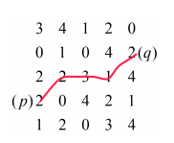
- 如图，长度为5
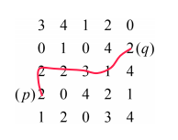
1.3 Logical Operations
- A∩B∩C
- (A∩B)∪(B∩C)∪(A∩C)
- (B-A-C)∪(A∩C- B)

- Program task
2.2 Scaling

1. Down-scale to 192 × 128 (width: 192, height: 128), 96 × 64, 48 × 32, 24 × 16 and 12 × 8,

then manually paste your results on the report. (10 Points)
192*128 | 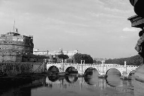
96*64 | 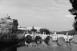
48*32 | 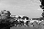
24*16
12*8

2. Down-scale to 300 × 200, then paste your result. (5 Points)
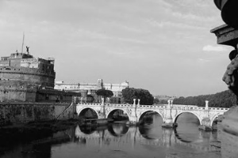

3. Up-scale to 450 × 300, then paste your result. (5 Points)
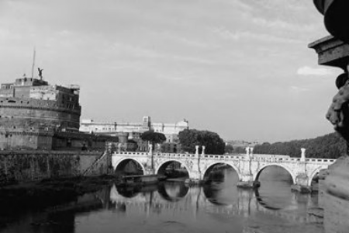

4. Scale to 500 × 200, then paste your result. (5 Points)
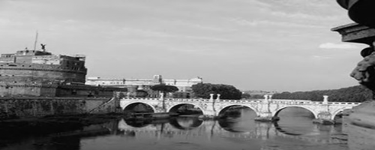

5. Detailedly discuss how you implement the scaling operation
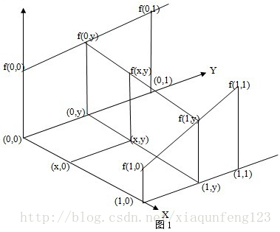
- Sammary：
使用双线性插值的方法对新图像的像素的灰度值进行设置
假设上图是待处理的原图的灰度值，f(x, y)是新图像对应的灰度值，(0, 0)是一个原点，x和y代表小数部分。我们从x和y两个方向求得线性值，最后得到f(x, y)的值。其实f(x, y)是对其周围的四个点的灰度值的综合。
- Detail：
首先求f(0, y)和f(1, y)的值，由等比例公式可知：
(f(0, y) - f(0, 0)) / (f(0, 1) - f(0, 0)) = y / 1 = y
(f(1, y) - f(1, 0)) / (f(1, 1) - f(1, 0)) = y / 1 = y
(f(0, y) - f(x, y)) / (f(0, y) - f(1, y)) = x / 1 = x

也就是说以下等式成立( u = x, v = y)：
(f(0, v) - f(0, 0)) / (f(0, 1) - f(0, 0)) = v / 1 = v
(f(1, v) - f(1, 0)) / (f(1, 1) - f(1, 0)) = v / 1 = v
(f(0, v) - f(u, v)) / (f(0, v) - f(1, v)) = u / 1 = u

由于上面的立体结构，即无论原点取什么值，比例是不变的，就是说：
令(baseX, baseY)代替(0, 0)
(f(baseX,baseY+v) - f(baseX, baseY)) / (f(baseX, baseY+1) - f(baseX, baseY)) = v / 1 = v

(f(baseX+1, baseY+v) - f(baseX+1, baseY)) / (f(baseX+1, baseY+1) - f(baseX+1, baseY)) = v / 1 = v

(f(baseX, baseY+v) - f(baseX+u, baseY+v)) / (f(baseX, baseY+v) - f(baseX+1, baseY+v)) = u / 1 = u

整理可得
f(baseX+u, baseY+v) = (1 - u)*(1 - v)*f(baseX, baseY) + (1 - u) * v * f(baseX, baseY + 1) + u * (1 - v) * f(baseX + 1, baseY) + u * v * f(baseX + 1, baseY + 1)

令f(baseX+u, baseY+v) = f(x, y)
从而得到每个像素点对应的原图的灰度值

实现：
- 首先得到x, y, baseX, baseY, u, v
- 处理边界，当相关的像素点在边界，那就直接取(baseX,baseY)的灰度值
- 使用以上公式进行灰度值的求值
（详情请见代码）

2.3 Quantization (28 Points)

1. Reduce gray level resolution to 128, 32, 8, 4 and 2 levels
128 | 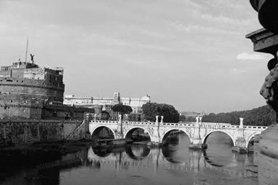
32 | 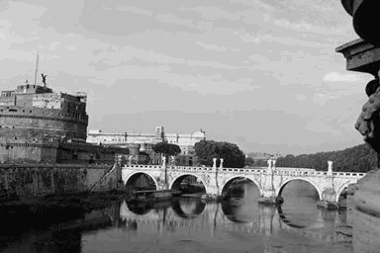
8 | 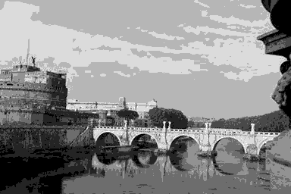
4 | 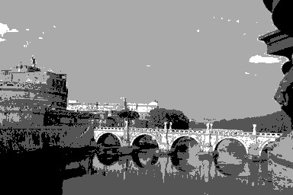
2 | 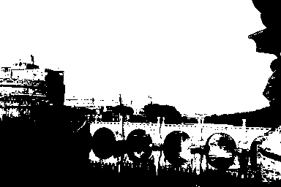
- Sammary:基本的思想就是，如果要把图转为n位图，就让像素的灰度值设为[0, 255]均立的n个值。如，要将图转为2位图，那就将灰度值设为0和255两个值而已。
- Detaility：
- 首先将每个像素的灰度值按比例设为[0, level-1]之间
oriPixel * ((level-1) / 255.0)
- 然后四舍五入，得到均等分立的level个值0, 1...level-1
round(round(oriPixel * ((level-1) / 255.0))
- 然后再将上面得到的值按比例放大为[0, 255]的范围，从而让计算机处理显示
round(round(oriPixel * ((level-1) / 255.0)) * 255.0/(level-1))

