Internship Report

By- Bhavish Saroha
Executive Summary
This project successfully delivered a cutting-edge Conversational AI (ChatBot) solution for BLS International Services Ltd., aimed at significantly enhancing operational efficiency through instant access to the company's internal knowledge base.
The solution was built from the ground up, utilizing Python and advanced Generative AI (GenAI) principles. To ensure reliable, factual, and verifiable responses—a critical requirement for a corporate environment—the Retrieval-Augmented Generation (RAG) architecture was implemented. RAG effectively grounds the Large Language Model's (LLM) output in specific internal documents, thereby mitigating the risk of "hallucinations."
The backend and RAG pipeline were engineered using the LangChain framework for seamless orchestration of components (including data ingestion and vector storage). Furthermore, the project demonstrated advanced workflow management by utilizing LangGraph to model complex, multi-step conversational states and agent behaviors.
This initiative provides BLS International with a secure, state-of-the-art asset for internal knowledge retrieval, proving the ability to architect, develop, and deploy a complete AI solution that translates theoretical AI/ML concepts into practical, valuable business tools.

Table of contents
S.No. | Content | Page No.
1 | Acknowledgement | 1
2 | About BLS | 2
3 | Project Context | 4
4 | Artificial Intelligence | 5
5 | Machine Learning | 6
6 | GenAI | 8
7 | Retrieval Augmented Generation | 9
8 | FastAPI | 13
9 | How to use the code provided | 14
10 | Conclusion | 15
11 | References | 16

Acknowledgement
I would like to express my sincere gratitude to all the individuals who supported me throughout the duration of my three-month internship at BLS International. This hands-on experience has proven to be invaluable, providing me with essential practical exposure and a much deeper insight into the rapidly evolving world of Artificial Intelligence and advanced technology implementation within a professional context.
My deepest and most profound thanks go to Mr. Uday Bhasker, my dedicated mentor. His exceptional technical expertise, patient guidance, and continuous encouragement were absolutely instrumental to the successful conception, development, and deployment of my major project— Chatbot. Mr. Bhasker’s readiness to share intricate domain knowledge, offer critical foresight, and provide highly constructive feedback significantly enhanced my technical skills, particularly in backend development, system integration, and the complexities of modern AI architecture. His mentorship transformed theoretical concepts into practical, deployable skills.
I am also sincerely thankful to the entire team at BLS International for creating such a welcoming, professional, and supportive environment. Their consistent cooperation, shared knowledge, and willingness to assist allowed me to quickly integrate into the workflow and effectively apply my academic foundation to challenging, real-world business requirements. The opportunity to contribute meaningfully to the company's technical framework has been the highlight of my internship.

About BLS
BLS International Services Ltd. is a globally recognized, publicly listed company that acts as a trusted tech-enabled service partner for governments and citizens worldwide. The company specializes in outsourcing consular, visa, and passport services, effectively managing the administrative and non-judgmental tasks for Diplomatic Missions, Embassies, and Consulates.
Key services offered include:
- Visa Services: Managing the entire visa application process, from appointment booking and document submission to biometric enrollment and fee collection for various client governments.
- Passport Services: Handling the application and related administrative tasks for passport, OCI (Overseas Citizen of India), and other travel document services.
- Consular Services: Providing various services related to attestation, legalization of documents, and other consular formalities.
- Biometrics and Identity Management: Offering secure collection of biometric data (fingerprints, photos) for identity verification as part of the application process.
- E-Governance and Citizen Services: Expanding beyond visa outsourcing to manage large-scale government projects, such as establishing and operating Aadhaar Seva Kendras in India, to offer a variety of citizen-facing services.
Global Reach and Business Model
BLS International operates with a significant global footprint, partnering with over 45 client governments across more than 70 countries.
- Asset-Light Model: The Company primarily operates on an asset-light business model. This means that instead of owning large physical assets, it focuses on leveraging its technology platform and human capital in leased office spaces. This allows for efficient capital utilization and scalability when winning new government contracts.
- Technology Integration: BLS heavily utilizes AI-powered and tech-enabled solutions to drive operational efficiency, ensure high levels of data security (holding certifications like ISO 27001), and maintain transparent processes, which is crucial when dealing with sensitive government data.
- Revenue Streams: The company typically earns revenue through service fees collected directly from applicants for the administrative services rendered, often supplemented by optional Value Added Services (VAS) like Premium Lounges, courier delivery, SMS updates, and form filling assistance.

Project Context
The internship at BLS International Services Ltd. was centered on developing cutting-edge solutions within the domain of Artificial Intelligence (AI) and Machine Learning (ML). This period provided an opportunity to move beyond theoretical concepts and implement practical applications of generative technology.
The primary project involved the end-to-end creation of a conversational interface, specifically a ChatBot, designed to enhance operational efficiency by instantly accessing the company's internal knowledge base. This solution utilized the powerful capabilities of Generative AI (GenAI), which forms the foundation of modern Large Language Models (LLMs).
To ensure the ChatBot provided reliable and factual responses—a key necessity in a secure corporate environment—the Retrieval-Augmented Generation (RAG) architecture was implemented. The RAG framework grounds the LLM’s response in specific, verifiable documents, thus mitigating the common challenge of "hallucinations" associated with GenAI.
The entire backend and the RAG pipeline were meticulously engineered using the Python programming language, capitalizing on its extensive ecosystem of data science and AI libraries. The complexity of orchestrating the RAG components (data ingestion, vector storage, and query flow) was managed using LangChain, a powerful framework that simplifies the creation of LLM applications.
For advanced workflow management, the project explored and utilized LangGraph, an extension of LangChain, which was crucial for modeling conversational states and creating cyclical, multi-step agent behaviors within the ChatBot.
This project demonstrated the ability to architect, develop, and deploy a secure, state-of-the-art conversational AI solution from the ground up, providing BLS International with a valuable asset for internal knowledge retrieval.
Artificial Intelligence
Artificial Intelligence is transitioning from a specialized tool to a core component of modern business and societal infrastructure. The current wave of AI is defined by sophisticated models that not only process information but can generate new content, automate complex decision-making, and augment human capabilities across nearly all sectors.
Modern AI is primarily built upon three interlinked technological pillars:
- Machine Learning (ML): The fundamental concept that enables systems to learn patterns directly from vast datasets without explicit programming. This drives predictive systems, recommendation engines, and anomaly detection.
- Deep Learning (DL): A specialized subset of ML using deep, multi-layered Artificial Neural Networks. DL is the engine behind complex AI tasks, enabling state-of-the-art performance in areas like computer vision and natural language understanding.
- Generative AI (GenAI): Models—such as Large Language Models (LLMs) like those powering sophisticated chatbots, and text-to-image generators—that create novel, contextually relevant content (text, code, images, video) based on a user prompt. This capability is fundamentally reshaping creative and knowledge-work workflows.
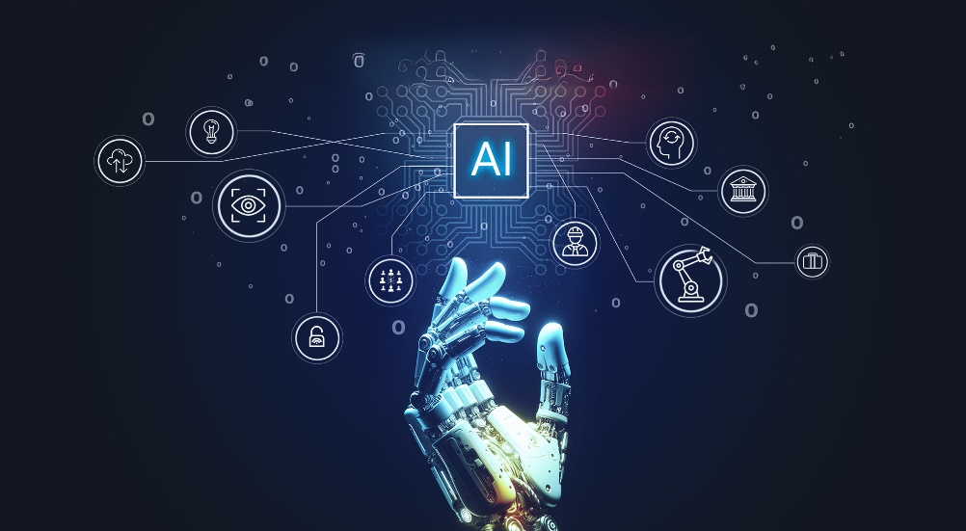
Machine Learning
Machine Learning (ML) is a subset of Artificial Intelligence that focuses on building systems capable of learning directly from data without being explicitly programmed for every scenario. Instead of a developer writing specific rules (e.g., "if X, then do Y"), the ML algorithm develops its own rules by identifying complex patterns, making predictions, and continuously improving its performance based on new experiences.
ML workflow
A typical machine learning project follows a structured process to ensure the model is robust and accurate:
- Data Preprocessing: This is the most time-consuming phase. Raw data is collected, cleaned, handled for missing values, and transformed into a suitable, numerical format (features) that the algorithm can process.
- Model Training: The prepared data (training data) is fed into a chosen algorithm (e.g., a neural network or a decision tree). The model iteratively adjusts its internal parameters (weights and biases) to minimize the error between its predictions and the actual outcome, using an optimization technique like Gradient Descent.
- Model Evaluation: A separate, unseen dataset (test data) is used to measure the model's performance. The goal is to ensure the model can generalize (perform well on new data) and hasn't simply overfit (memorized the training data).
- Deployment and Prediction: The trained model is integrated into an application to make real-time predictions or classifications (inference).

Type | Data Used | Learning Objective | Common Use Cases
Supervised Learning | Labeled Data (input data is paired with the correct output or "answer") | To predict a known outcome or classify a new instance. | Spam detection, image classification (identifying objects), stock price prediction.
Unsupervised Learning | Unlabeled Data (input data only, no correct answers provided) | To discover hidden patterns or structures in the data. | Customer segmentation anomaly detection (finding fraud), data compression.
Reinforcement Learning | No predefined data; learns through trial and error in an environment. | To find the optimal sequence of actions that maximizes a cumulative reward. | Robotics, game AI (teaching a computer to play chess), autonomous vehicle control.

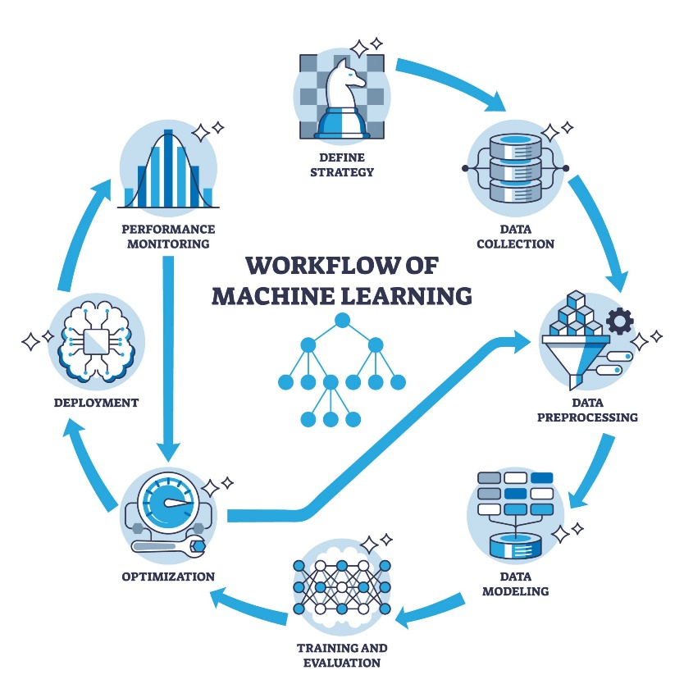
GenAI
Generative AI is a subset of AI machine learning technologies that uses generative models to learn the patterns and structures from vast amounts of existing data (like text, images, or audio). Once trained, it uses this learned knowledge to generate new content that is realistic and often indistinguishable from human-created material.
Capabilities and Outputs
Generative AI can produce a wide variety of content in response to simple natural language prompts (like "Write a poem about a robot"):
- Text & Code: Generating stories, articles, emails, summaries, translations, answers to questions, and even original software code.
- Images & Video: Creating unique art, photorealistic images, graphic designs, new video footage, and special effects based on descriptions.
- Audio & Music: Composing original music, synthesizing realistic speech for voiceovers, and generating sound effects.
- Data & Simulations: Creating synthetic data for training other AI models or running complex simulations for science and engineering.
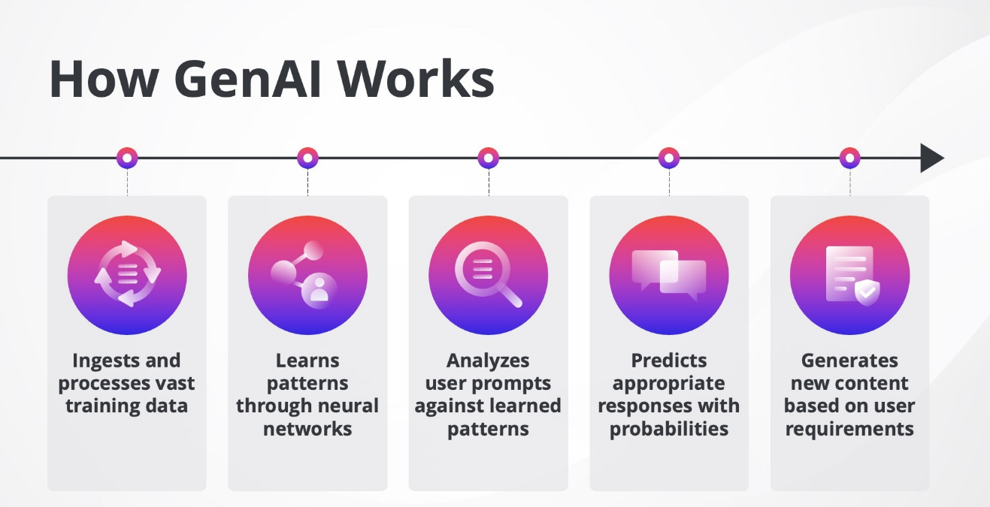
Retrieval-Augmented Generation
Retrieval-Augmented Generation (RAG) is an advanced AI framework that significantly enhances the capabilities and reliability of Large Language Models (LLMs) by grounding their responses in up-to-date, specific, and authoritative external knowledge sources.
It elegantly combines the strengths of two distinct AI paradigms: the Retrieval of relevant information and the Generative power of LLMs.
While LLMs are incredibly powerful, they suffer from two major inherent limitations:
- Stale Knowledge: LLMs are limited to the information present in their training data, which has a knowledge cutoff date. They cannot answer questions about recent events or new organizational data.
- Hallucinations: Without factual grounding, LLMs can sometimes generate plausible-sounding but incorrect or fabricated information.

Phase 1: The Indexing Phase (Preparation)
This phase is conducted before any user query is made and involves preparing the external, proprietary, or specific knowledge source into a searchable format.

Step 1: Data Ingestion and Cleansing
The process begins with collecting the unstructured knowledge sources (e.g., PDFs, internal documents, websites, spreadsheets, transcribed audio).
- Ingestion: The raw data is loaded into the system.
- Cleansing: Any unnecessary noise, formatting elements, headers, footers, or junk data is removed to ensure the quality and accuracy of the text that will be indexed.

Step 2: Chunking (Splitting)
Since Large Language Models (LLMs) have a limited context window (the maximum length of text they can process at one time), the large documents must be broken down.
- Splitting: The cleaned documents are divided into smaller, coherent segments called chunks.
- Strategy: The chunk size is critical; it must be small enough to fit within the LLM's context window but large enough to retain meaningful context (e.g., typically 200-1000 tokens). Overlap between chunks is often used to ensure context is not lost at the split points.

Step 3: Embedding (Vectorization)
This is the core step that converts human language into a mathematical format that computers can search and compare efficiently.
- Embedding Model: An Embedding Model (a specialized neural network) processes each text chunk.
- Vector Creation: The model converts the text chunk into a high-dimensional vector (a list of numbers, e.g., 768 or 1536 dimensions). This vector mathematically represents the semantic meaning of the text. Chunks with similar meanings will have vectors that are numerically "close" to each other in the vector space.

Step 4: Storage in a Vector Database
The generated vectors are stored in a specialized database optimized for fast retrieval based on vector similarity.
- Indexing: The vector database indexes the vectors along with their corresponding original text chunks and source metadata (e.g., document name, page number).
- Search Optimization: The database uses techniques like Hierarchical Navigable Small Worlds (HNSW) to enable extremely fast search and retrieval of the closest vectors when a query is received.

Phase 2: The Retrieval and Generation Phase (Query Execution)
This phase executes every time a user submits a query to the RAG system.

Step 5: Query Embedding
When the user poses a question (the query), the system immediately processes it.
- Consistency: The user's query is passed through the exact same Embedding Model used in Phase 1 (Step 3).
- Query Vector: This results in a new vector that represents the semantic meaning of the user's question.

Step 6: Similarity Search (Retrieval)
The query vector is used to find the most relevant information within the knowledge base.
- Search Execution: The system sends the query vector to the Vector Database.
- K-Nearest Neighbors (k-NN): The database performs a similarity search (usually calculating cosine similarity) to find the top k document chunks whose vectors are closest to the query vector. These are the most relevant pieces of information to answer the question.

Step 7: Prompt Augmentation (Context Creation)
The retrieved chunks and the original query are combined to form a powerful, new prompt for the LLM.
- Construction: The system constructs a final prompt that typically looks like this:
“Use the following context to answer the user's question. If the context does not contain the answer, state that you cannot answer based on the provided information. Context: [Retrieved Chunk 1] [Retrieved Chunk 2]... User Question: [Original User Query]”
- Grounding: By explicitly including the retrieved context, the prompt grounds the LLM, forcing it to focus only on the provided external facts.

Step 8: Grounded Generation
The augmented prompt is sent to the LLM.
- LLM Processing: The LLM uses its vast language generation abilities but is constrained by the provided, high-quality context. It synthesizes the retrieved information to formulate a coherent, factually accurate, and relevant answer.
- Output: The LLM generates the final response, which is delivered to the user. Because the answer is grounded in the indexed documents, RAG systems can often provide citations back to the source documents, increasing transparency and trust.

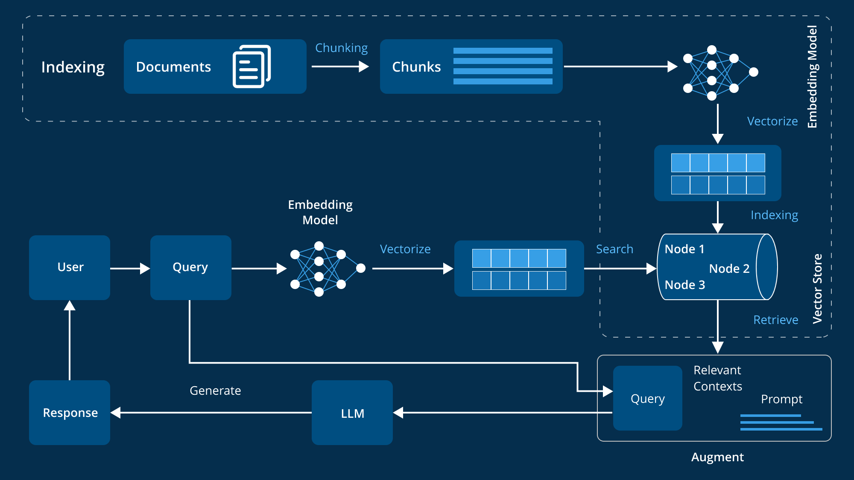

FastAPI
FastAPI is a modern, high-performance Python web framework ideal for building RESTful APIs quickly and efficiently. It's built on top of Starlette (for request handling) and Pydantic (for data validation), making it one of the fastest Python frameworks available, rivaling the speed of Node.js and Go.
Key Features
FastAPI leverages modern Python 3.7+ features, particularly type hints, to deliver a superior developer experience and robust, production-ready code.
- Exceptional Performance: Built on ASGI (Asynchronous Server Gateway Interface) and utilizing async/await from the start, FastAPI handles high concurrency and I/O-bound tasks (like database queries and external API calls) efficiently, making it incredibly fast.
- Automatic Data Validation: It uses Pydantic models to automatically validate request bodies, query parameters, and response data using standard Python type hints. This eliminates a huge source of bugs and ensures data integrity without writing boilerplate validation code.
- Automatic Documentation: FastAPI automatically generates interactive API documentation following the OpenAPI standard (previously Swagger), accessible typically at /docs (Swagger UI) and /redoc (ReDoc). This feature significantly speeds up development and testing.
- Intuitive Code and Editor Support: By using standard Python type hints, FastAPI enables excellent editor support for autocompletion and type checking, drastically reducing the learning curve and time spent debugging.
- Dependency Injection: It has a simple yet powerful built-in Dependency Injection system that manages complex logic, database connections, and security (like OAuth2 and JWT) cleanly and modularly, improving code reusability and testability.
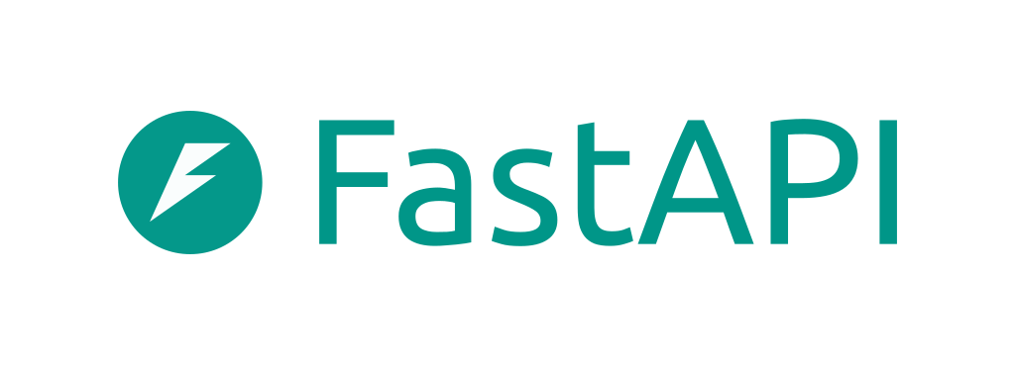

How to use the code provided
Step 1: Run the python script “data_extraction_1.py” (Update the BASE_DIR in)
Step 2: To test the retrieval part run the command “streamlit run data_retieval.py”
Step 3: To run this locally run the python script “llm_integration_with_memory.py”
Step 4: For backend use main.py in the backend folder

Note: Track my application feature has been added to “Final_tracking.py”
Conclusion
This internship report documents the successful completion of a three-month tenure at BLS International Services Ltd., culminating in the development of a functional Retrieval-Augmented Generation (RAG) Chatbot and its comprehensive backend infrastructure. The internship successfully met its primary objectives of bridging theoretical knowledge with practical, industry-grade application in the fields of Artificial Intelligence (AI) and software engineering.
The developed RAG Chatbot represents a significant step towards internal digital transformation at BLS International. By automating the process of accessing complex policy and procedural information, the system offers an immediate reduction in time spent on manual queries and increases the consistency and accuracy of information dissemination.
This project affirms the power of combining Generative AI with structured retrieval methods to create reliable, high-utility business applications. The experience provided a profound understanding of the challenges and rewards associated with deploying cutting-edge AI solutions within a security-conscious, global enterprise environment. The skills and knowledge acquired during this internship will be instrumental in future professional endeavors.

References
• [Backend/API] Monto, S. (n.d.). FastAPI: The modern, fast (high-performance) framework. Retrieved from [https://fastapi.tiangolo.com/].
• [Vector Database] Chroma. (n.d.). Chroma: The AI-native open-source vector database documentation. Retrieved from [https://docs.trychroma.com/docs].
• [LLM Orchestration] LangChain. (n.d.). LangChain Documentation. Retrieved from [https://docs.langchain.com/].
• [Stateful Workflows] LangGraph. (n.d.). LangGraph Overview and Tutorials. Retrieved from [https://docs.langchain.com/oss/python/langgraph/overview].
• [Programming Language] Van Rossum, G., & Drake, F. L. (2009). Python 3 Reference Manual. Scotts Valley, CA: CreateSpace.
• [RAG Concept] Lewis, P., Perez, E., Piktus, A., Petroni, F., et al. (2020). Retrieval-Augmented Generation for Knowledge-Intensive NLP Tasks. Advances in Neural Information Processing Systems (NeurIPS 2020). [https://arxiv.org/abs/2005.11401].
• [Embedding Model] Mixedbread AI. (n.d.). mxbai-embed-large-v1: Technical Specifications and Model Card. Retrieved from [https://huggingface.co/mixedbread-ai/mxbai-embed-large-v1].

