ChatBiobank: An AI-Powered Platform Accelerating Standardized Multi-Omics Biobank Construction
High-quality biobanks are essential for reproducible multi-omics research and precision medicine, yet their construction remains challenging because standardized, end-to-end guidance is often difficult to translate into routine practice across multimodal biospecimen collection and multi-departmental clinical workflows. To address this implementation gap, we developed ChatBiobank, an interactive AI-powered online platform designed to accelerate and democratize the construction of high-quality multi-omics biobanks. ChatBiobank operationalizes a comprehensive “3M” framework encompassing multi-omics, multimodal biospecimen, and multi-departments, and delivers actionable guidance through intuitive dialogue. The platform integrates consolidated biospecimen requirements, hospital pathway-aligned standard operating procedures, ethics and quality management principles, and unified informatics for traceability into an accessible, user-friendly system. By transforming a validated biobank framework into an interactive implementation tool, ChatBiobank helps researchers and institutions adopt best practices more efficiently, thereby improving biospecimen quality, data robustness, and cross-study comparability.
Introduction
High-quality biobanks are the foundational infrastructure enabling reproducible multi-omics research and precision medicine [1, 2]. From disease-centric collections in the 1990s to the genomic resources catalysed by the Human Genome Project, biobanks have evolved into multi-omics data hubs, exemplified by TCGA and the UK Biobank [3]. This evolution reflects the critical synergy: robust biobanks support integrated multi-omics analysis, which in turn drives precision medicine. However, constructing a biobank that meets the rigorous and diverse demands of major omics platforms (genomics, transcriptomics, proteomics, metabolomics, epigenomics) faces significant challenges, including pre-analytical variability from inconsistent protocols, the lack of practical integrated guidance, and the ethical-operational complexity of multimodal sampling [4, 5]. This gap between the need for and the ability to build high-fidelity biobanks impedes translational progress. To address this, we developed the “3M” (Multi-omics, Multimodal biospecimen, Multi-departments) framework. This correspondence introduces this practical blueprint and presents ​ChatBiobank​ (https://chatbiobank.vercel.app/), an AI-powered platform designed to make the framework actionable.
- Integrated Framework for Multi-omics Biobank Construction​
The effective construction of a biobank for integrated multi-omics analysis requires harmonization across three dimensions: technical specifications, clinical operations, and data management. Our "3M" framework is designed to address this by integrating four foundational pillars. First, we established consolidated biospecimen requirements for the construction phase, defining the minimum volume, mass, and quality parameters needed for five major omics types (genomics, transcriptomics, proteomics, metabolomics, epigenomics) and for advanced applications like single-cell and spatial omics. These specifications are curated for diverse sample types, including surgical tissues, biopsies, blood, urine, and feces, providing ​a practical reference for researchers to determine sampling volumes(Appendix 1)​​. Second, we developed ​standardized operational protocols (SOPs)​​ that are critical during the construction and operational phases. These SOPs cover the entire lifecycle—from patient consent and biospecimen acquisition, transport, processing, aliquoting, to long-term storage—with strict temporal and technical benchmarks (e.g., tissue ischemia time, plasma processing windows) [6-8].These protocols are designed to be seamlessly embedded into existing clinical workflows, ensuring feasibility and minimizing pre-analytical variability from the outset.Third, the framework incorporates a ​robust ethics and quality control (QC) system, which is essential for sustainable biobank operation. This includes informed consent templates tailored for multi-omics research and a risk-based QC plan referencing international standards (e.g., ISO 20387) for monitoring sample integrity. Fourth, we outline an ​integrated informatics management system​ for sample accession, release, and rich metadata annotation, ensuring full audit trails and data interoperability, which are crucial for the biobank's long-term utility[9-12].

- Establishment of ChatBiobank based on RAG
To translate the static 3M framework into an accessible and interactive implementation tool, we developed ChatBiobank as an AI-powered conversational platform built on a Retrieval-Augmented Generation (RAG) architecture. The system comprises three layers: a structured knowledge base, a domain-specific retrieval engine, and a large language model (LLM) interface for natural-language interaction.
The knowledge base was constructed by encoding the complete 3M framework content into seven structured HTML documents, covering omics requirements with detailed specimen volume specifications across five major omics types (genomics, transcriptomics, proteomics, metabolomics, epigenomics), standard operating procedures for multimodal biospecimen collection and storage (tissue, blood, urine, saliva, and feces), ethical compliance and informed consent templates, quality control criteria with quantitative thresholds (e.g., OD260/280 ratios, RIN values, tumor cell percentages), and biobank workflow protocols for sample accession, release, and metadata management. In total, the knowledge base encompasses approximately 7,200 words and 50,000 characters of curated, expert-reviewed content, including six structured data tables specifying specimen requirements for each omics platform.
The retrieval engine employs a server-side HTML parser (Cheerio) that performs hierarchical content extraction at initialization. The parser traverses the document object model (DOM) of each knowledge page, identifying semantic sections (sections, sub-sections, specimen types, and workflow steps) and extracting their associated headings, paragraphs, lists, and tables. Notably, HTML tables containing specimen volume specifications are automatically converted to Markdown format to preserve their structured layout for LLM consumption. Each extracted content block is annotated with a source URL pointing to the specific section of the 3M framework website, enabling precise citation and traceability in the generated responses.
The assembled knowledge base is injected into the system prompt of Kimi K2.5, a large language model provided by Moonshot AI, which serves as the conversational backbone. The system prompt includes domain-specific instructions that enforce several key behaviors: faithful reproduction of complete data tables without row merging or value rephrasing, exhaustive reporting of quality control thresholds, automatic insertion of source citations as clickable links, and language matching to respond in the same language as the user query. The chat interface supports real-time streaming via Server-Sent Events (SSE), providing responsive interaction suitable for clinical settings. The entire platform is deployed as a Node.js/Express web application, with the 3M framework content pages and the AI chat interface served from the same origin, enabling seamless bidirectional navigation between the reference documentation and the conversational assistant.

Recognizing that documented standards alone are insufficient for practical implementation, we created ChatBiobank(Figure 2). This platform transforms the static "3M" framework into a dynamic, queryable knowledge base. During biobank construction or daily operation, staff and researchers can use natural language (e.g., “What is the SOP for collecting PAXgene blood RNA tubes?” or “How should fresh tissue for metabolomics be processed?”) to instantly retrieve precise protocols and requirements[18, 19]. This tool lowers the technical barrier to adherence, ensures consistency, and serves as a continuous training resource, which is vital for the successful construction and maintenance of a high-standard biobank.
- Applications ChatBiobank in Clinical practice
The practical value of the “3M” framework was demonstrated through its implementation in the First Affiliated Hospital of Zhengzhou University(Figure 1​)illustrates the synergistic workflow for an oncologic inpatient cohort, showcasing how the framework is embedded within the standard clinical pathway. This integration ensures that multimodal biospecimen (tissue, blood, urine, etc.) collection occurs synchronously with diagnostic and therapeutic procedures, minimizing patient burden and pre-analytical variability[13, 14]. The workflow encompasses the entire process from patient consent and sample collection to quality-assured storage and data annotation, forming a closed-loop, ethical management system[15-17]. (放一部分我们质控的结果)
- Multi-Omics 驱动的样品库未来展望 ()
多组学相比单组学的好处（多样品类型相比单一样品类型的好处）
- Conclusion

Reference
1. Kinkorová, J., Biobanks in the era of personalized medicine: objectives, challenges, and innovation: Overview. Epma j, 2015. 7(1): p. 4.
2. Greely, H.T., The uneasy ethical and legal underpinnings of large-scale genomic biobanks. Annu Rev Genomics Hum Genet, 2007. 8: p. 343-64.
3. Kang, B., et al., Current status, challenges, policies, and bioethics of biobanks. Genomics Inform, 2013. 11(4): p. 211-7.
4. Collins, F.S., et al., New goals for the U.S. Human Genome Project: 1998-2003. Science, 1998. 282(5389): p. 682-9.
5. Cambon-Thomsen, A., et al., Biobanks for genomics and genomics for biobanks. Comp Funct Genomics, 2003. 4(6): p. 628-34.
6. Spruessel, A., et al., Tissue ischemia time affects gene and protein expression patterns within minutes following surgical tumor excision. Biotechniques, 2004. 36(6): p. 1030-7.
7. Kanai, Y., et al., The Japanese Society of Pathology Guidelines on the handling of pathological tissue samples for genomic research: Standard operating procedures based on empirical analyses. Pathol Int, 2018. 68(2): p. 63-90.
8. Li, C., et al., Integrated Omics of Metastatic Colorectal Cancer. Cancer Cell, 2020. 38(5): p. 734-747.e9.
9. Wu, S.Z., et al., Cryopreservation of human cancers conserves tumour heterogeneity for single-cell multi-omics analysis. Genome Med, 2021. 13(1): p. 81.
10. Ghatak, S., R.B. Muthukumaran, and S.K. Nachimuthu, A simple method of genomic DNA extraction from human samples for PCR-RFLP analysis. J Biomol Tech, 2013. 24(4): p. 224-31.
11. Sheng, Q., et al., Multi-perspective quality control of Illumina RNA sequencing data analysis. Brief Funct Genomics, 2017. 16(4): p. 194-204.
12. Mullegama, S.V., et al., Nucleic Acid Extraction from Human Biological Samples. Methods Mol Biol, 2019. 1897: p. 359-383.
13. Chen, Y., et al., A characteristic biosignature for discrimination of gastric cancer from healthy population by high throughput GC-MS analysis. Oncotarget, 2016. 7(52): p. 87496-87510.
14. Rabe, A., et al., Metaproteomics analysis of microbial diversity of human saliva and tongue dorsum in young healthy individuals. J Oral Microbiol, 2019. 11(1): p. 1654786.
15. Shickle, D., The consent problem within DNA biobanks. Stud Hist Philos Biol Biomed Sci, 2006. 37(3): p. 503-19.
16. Munshi, R. and U. Thatte, Compensation for research related injury. Perspect Clin Res, 2013. 4(1): p. 61-9.
17. Henry, L.M., M.E. Larkin, and E.R. Pike, Just compensation: a no-fault proposal for research-related injuries. J Law Biosci, 2015. 2(3): p. 645-668.
18. Sotelo-Orozco, J., et al., A Comparison of Serum and Plasma Blood Collection Tubes for the Integration of Epidemiological and Metabolomics Data. Front Mol Biosci, 2021. 8: p. 682134.
19. Koopaie, M., et al., Evaluation of CSTB and DMBT1 expression in saliva of gastric cancer patients and controls. BMC Cancer, 2022. 22(1): p. 473.

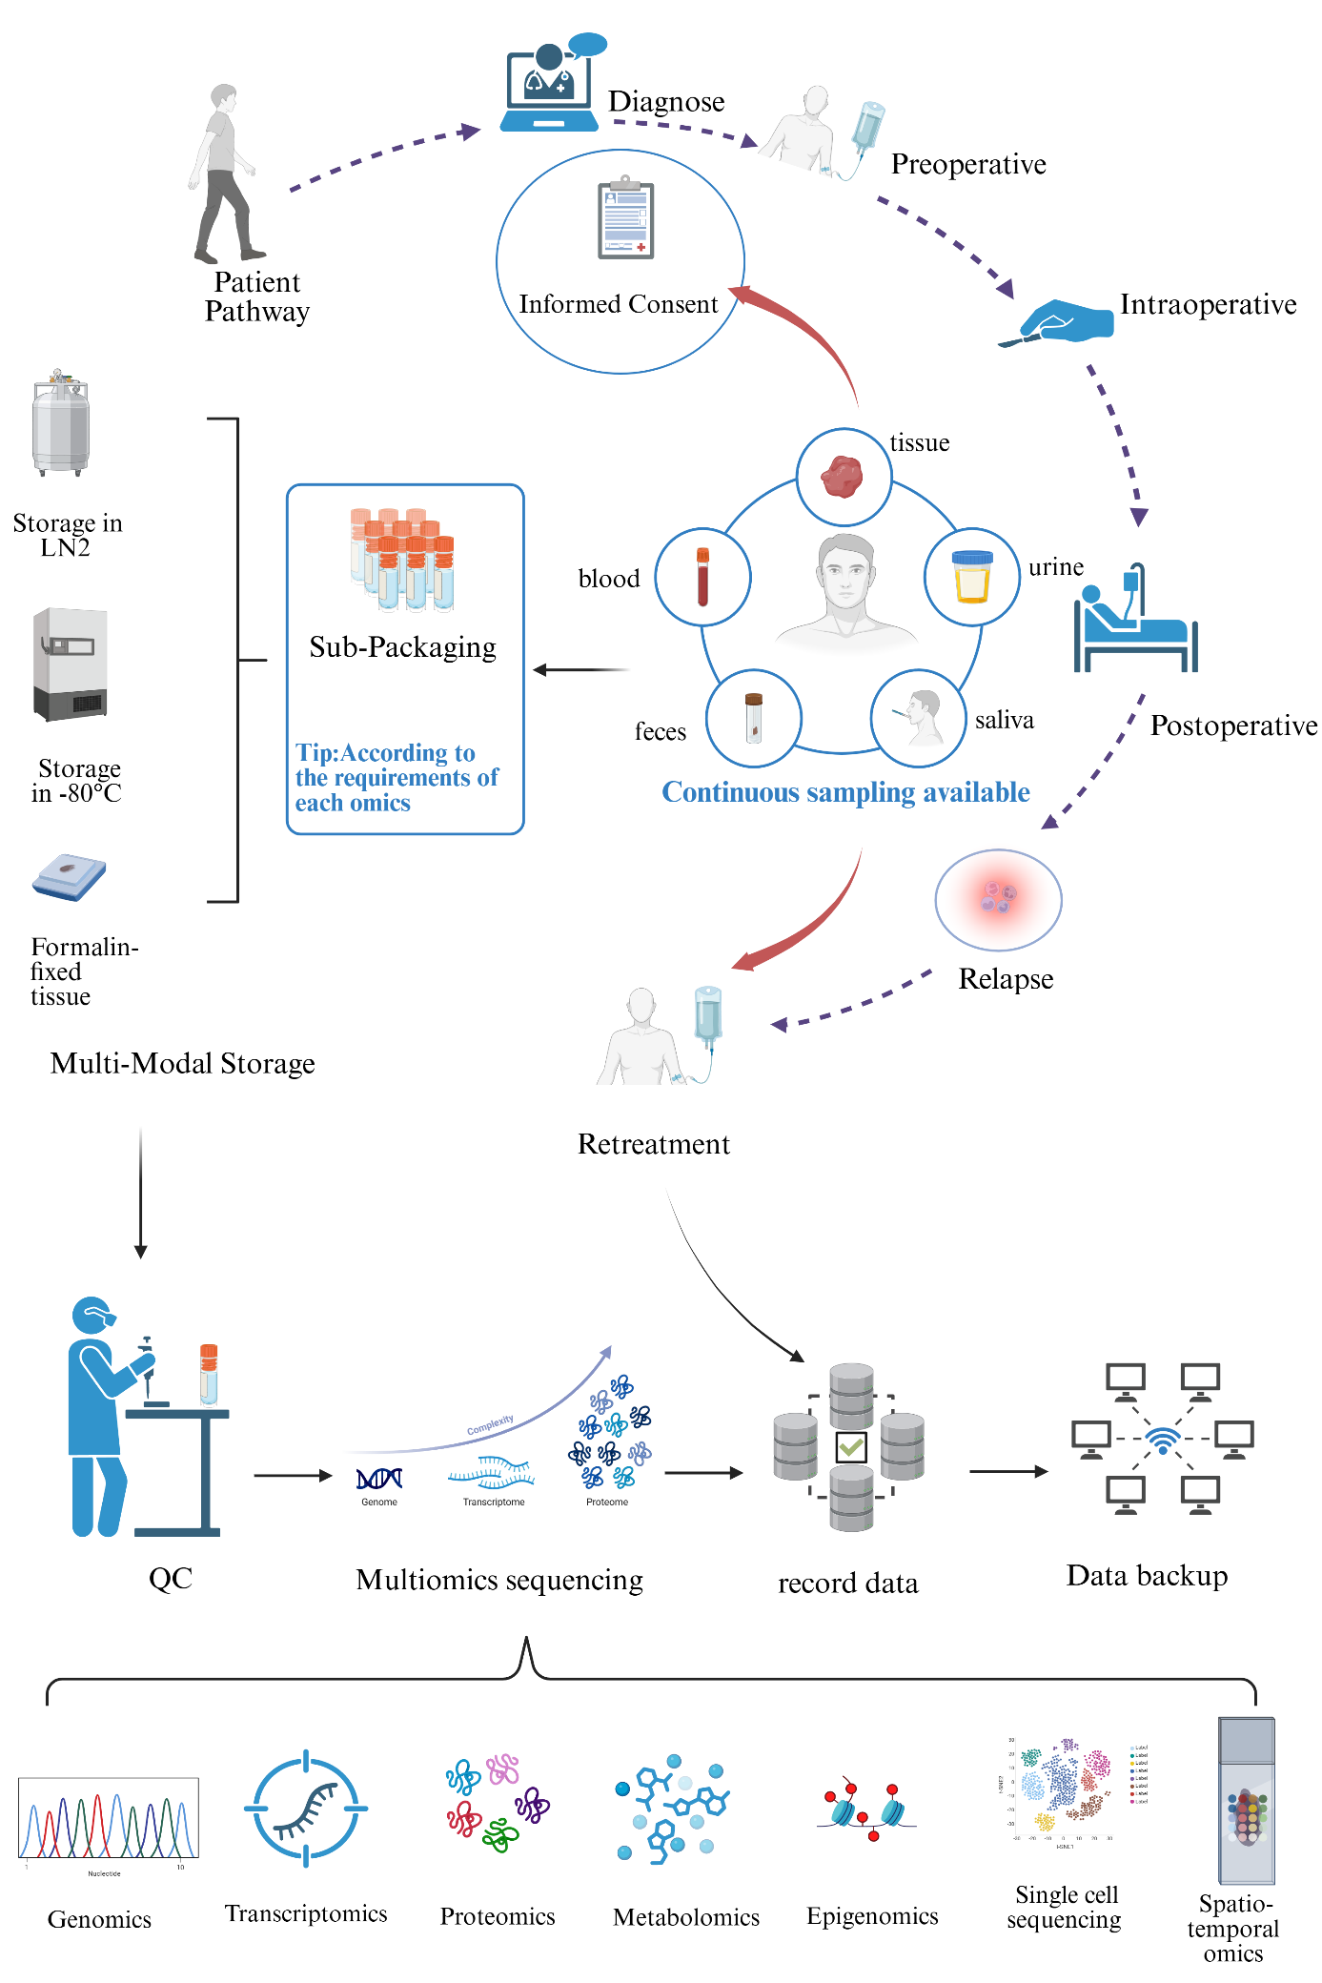
Figure 1: ​ The typical workflow for oncologic inpatient cohorts according to 3M framework.
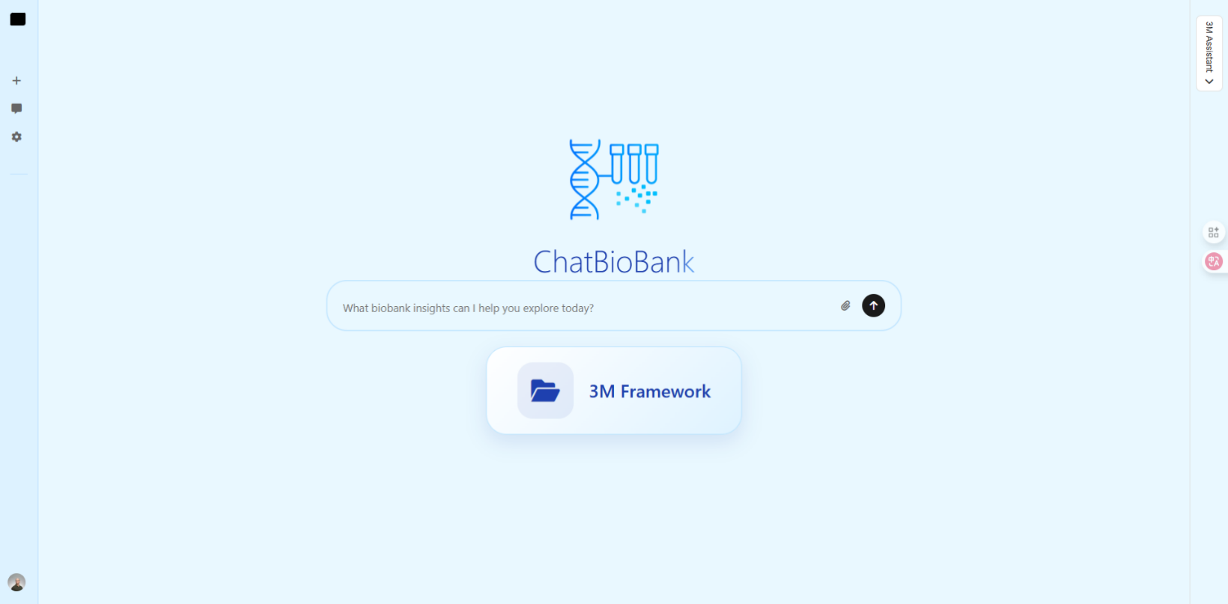
Figure 1 The Screenshot of the developed website for multimodal biospecimen management framework.

