

**Recommendation for a face mask detection and people counter technologies**

**By**

***Mustapha Yakubu Omale***

***Technology Consultant***

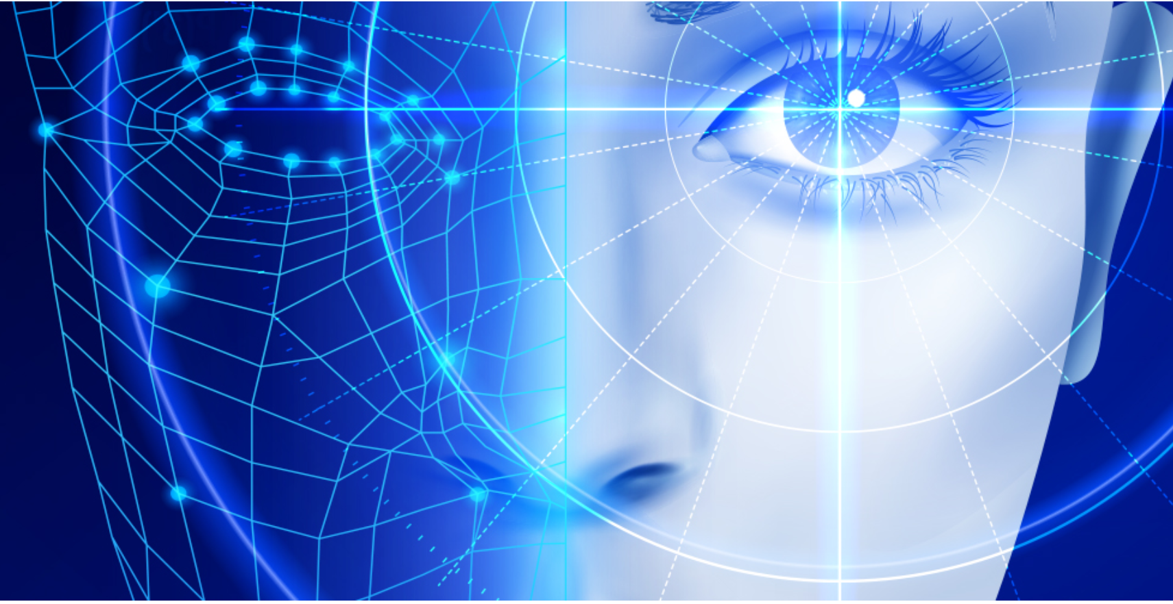

**Problem**

You are a technology consultant and have been resourced on to a project for a large UK Bank. The Bank has recently been fined by the regulator for not conforming to Regulation 1215. Regulation 1215 requires Banks to report on:

•The number of people in their office wearing a mask

•The number of people in their office at any point in time

**Objective**

To carry out an assessment of available technologies that will enable the Bank to report on these metrics to regulators and senior management in order to avoid further fines. This report will also provide some recommendations to be implemented by the bank.

**Various technologies for Desk booking and Face mask detection**

1. **Bringme Desk**: is a visitor registration system that takes care of your entire visitor management. It autonomously receives visitors 24/7, performs more tasks than a real-life receptionist, and maintains a uniform safety protocol, including for your employees.

**Customize Manage & Security**

* Sign-in flow Visitor/ Employee Dashboard
* Visitor/employee badges Directory
* Notifications Multi-tenants
* Registrations Multiple locations
* Legal documents Visitor/Employee reports
* API integration Data security & On-site safety
* Health and hygiene Access control

This technology has its own reporting dashboard and data can be stored on cloud.

1. **Xovis Face Mask Detection Device:** This Sensors recognize if a person is wearing a face mask, compliant with COVID-19 requirements. Xovis 3D sensors now allow you to identify individuals who are wearing face masks. You can benefit from all existing functions and add value simply by installing the Face Mask Detection plugin.

**Features**

* Sensors count all people and recognize whether a person is wearing a face mask or not.
* AI firmware has been trained to visually distinguish individuals if they wear a face mask. When the plugin is activated, the sensor or AI firmware mimics the human eye and can thus detect a masked face.
* Data provide information for an instant alert function or further analytics processing, as needed.
* No additional expensive system is required.
* AI-powered Xovis sensors running an AI-based people counting algorithm provide an embedded solution. This means that everything is computed on the sensor.

Sensors count all people, recognize whether a person is female or male and thus identify this basic target group. Sensors count all people detect the staff exclusion pattern and thus clearly identify employees and exclude them from the counts if need be.

1. **SenSource Face mask detection System:** With Face Mask Detection, monitor customers entering and exiting your facility to see if Face Mask rules are being followed. Audible alerts can play to remind customers to wear a mask. Text messages can be sent to key personnel if a customer is not masked up.

**Features**

• Automated with highly accurate [**smart sensors**](https://sensourceinc.com/hardware/people-counters/)

• Heads-up Display options for improved customer communication

• Push notifications for key personnel so mask rules can be enforced

• Many different styles and types of masks can be detected.

**Various People counter Technologies**

1. **SenSource people counter:** SenSource offers leading people counting technologies that allows companies and organizations to accurately collect actionable foot traffic data, including real-time occupancy counts for pandemic guidelines.SenSource people counters measure footfall, track and count individuals entering, exiting and dwelling with precision.
2. **Irisys People counter:** Also known as footfall counters, door counters, customer counters and visitor counters; these devices work by detecting when a person crosses an invisible count line that has been configured in their settings.
3. **FootfallCam Counter:** This people counter is engineered with reliability and efficiency prioritised in every function of the device. Every aspect is designed with attention to detail, to ensure that our counters provide the most accurate, most reliable, and most cost-effective solution that the market has to offer. As the manufacturer, it ensures that only top-grade materials are used in order to offer you a high quality and long-lasting system.
4. **Retail Sensing:** Retail Sensing systems not only measure footfall and count people, but manage queues, display occupancy, track shoppers around stores, show heat maps of most visited areas, log passenger numbers and provide marketing information. The technology provides the basis for many applications in retail, leisure and other sectors.

**Vendor Comparison for generating report**

|  | Power BI | Tableau | QlikSense |
| --- | --- | --- | --- |
| Free version | Yes | Yes | Yes |
| Price Per Month | Destop: Free  Pro: $9.99/User  Premium: 4.955 | Explore: $70/User  Creator: $42/User  Explorer: $15/User | Business: $30 |
| Free trial | Yes | Yes | Yes |
| Support | Destop Self-service  & Pro  Premium SLA | Standard Support  Extended Support  Premium Support | Qlik sense view  Qlik view  Qlik data integration |
| Ease of Use | Anyone | Trained Data Analyst | Anyone |
| Who it’s for | SMBs | Enterprises | Enterprise |
| Native Connectors | 100+ | 80+ | 100+ |
| Real-time Analysis | Yes | Yes | Yes |
| Collaboration | With Pro & Premium | Yes | Yes |
| Pre-Built Dashboard | Yes | Yes | Yes |
| Mobile Compatibility | Yes | Yes | Yes |
| Integration with Programming softwares | Yes | Yes | Yes |
| Storage Capacity | Pro 1GB/dataset  10GB/User  8 Refreshes/day | 15GB/ workbook or data source  100GB/ Site  8 refreshes/day/user | 6GB/dataset |
| Drill Down Capability | Yes | Yes | Yes |

**Recommendations**

Technology is evolving rapidly which has made many organizations and industries to improve their businesses. While it doesn't always make sense to upgrade a tool or invest in a brand-new solution, sometimes it's more efficient and cost-effective to jump on the latest developments.

Given the cost of certain technologies, it may be a big financial decision to adopt a new tech tool. However, it is important to take advantage of the emerging technologies for safety, efficiency and performance of a business. Hence, based on the problem statement, below are some of the recommended technologies the bank can implement as a solution to the given problem.

The bank should consider implementing the Bringme technology as the desk booking device as it has all-in-one solutions that combines access, visitors, employees and delivery management. The device is affordable, user friendly and easy to implement. Taking advantage of this technology will help improve the bank’s way of working. It also has a cloud computing capability.

Secondly, based on the bank’s requirement to detect and monitor customers entering and exiting the banks facility to see if Face Mask rules are being followed, I would recommend the SenSource facemask detection system due to its interesting capabilities like Audible alerts can play to remind customers to wear a mask. Text messages can be sent to key personnel if a customer is not masked up. This system uses AI and machine learning technology as its base.

Finally as for the people counter machine, I would suggest the company should implement the Retail sensing system as it does not only measure footfall and count people, but manage queues, display occupancy, track shoppers around stores, show heat maps of most visited areas, log passenger numbers and provide marketing information.