LAB 00 – Deliverables

SIP Derivation
Student: Utkarsh Parashar
ID: 801234567
Sum(Digits) = $8+0+1+2+3+4+5+6+7=36$Length("Utkarsh") = 7
Total: $36+7=43K_{session}$: $43 mod 10= 3$Input: 801234567-Utkarsh-3Cerulean

Screenshot 1: Hash Generation
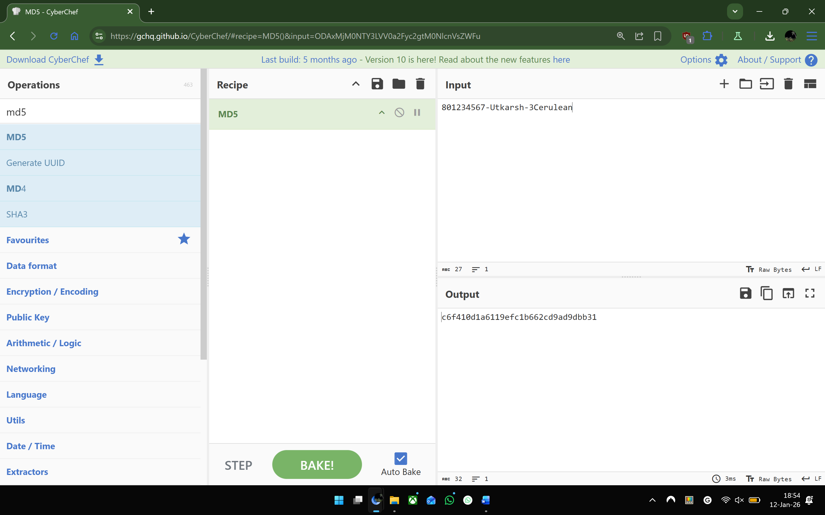

Analysis
- I changed the Cerulean to Zerulean, this caused all the characters of the output to change, I think this means that even the smallest of changes can cause a massive difference in the output of the hash calculation as the small changes keep on propagating throughout the steps.
- The purpose of asking for IDs, Names, or any other parameters and using them to derive unique strings for the purpose of these Labs could be to incorporate non-repudiation (one of the extended pillars of security besides the CIA triad) and anti-plagiarism measures within the labs without much hassle for the students.

