Step 1:

SIP:
Student ID: 801118969

plaintext: Graham Young is learning security
key: 9

output (ciphertext): Pajqjv Hxdwp rb unjawrwp bnldarch
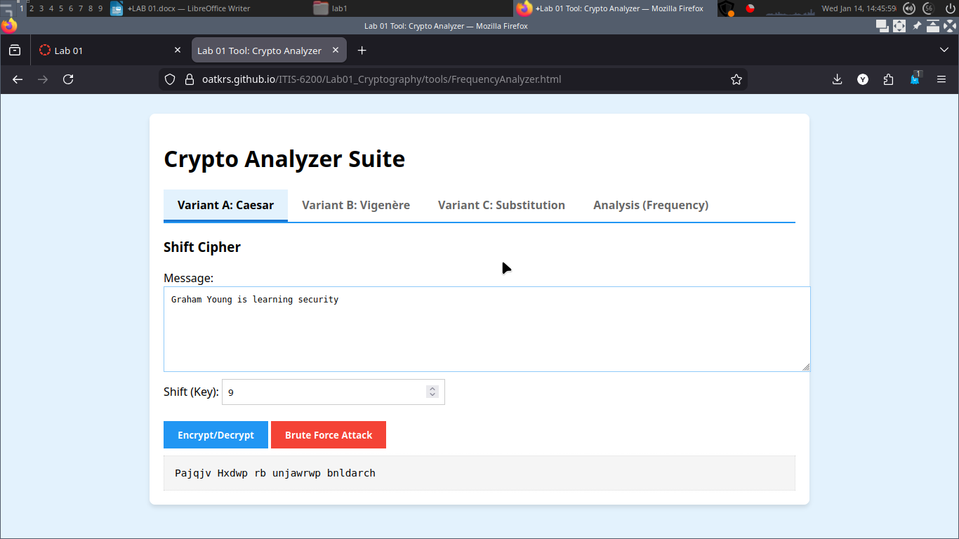
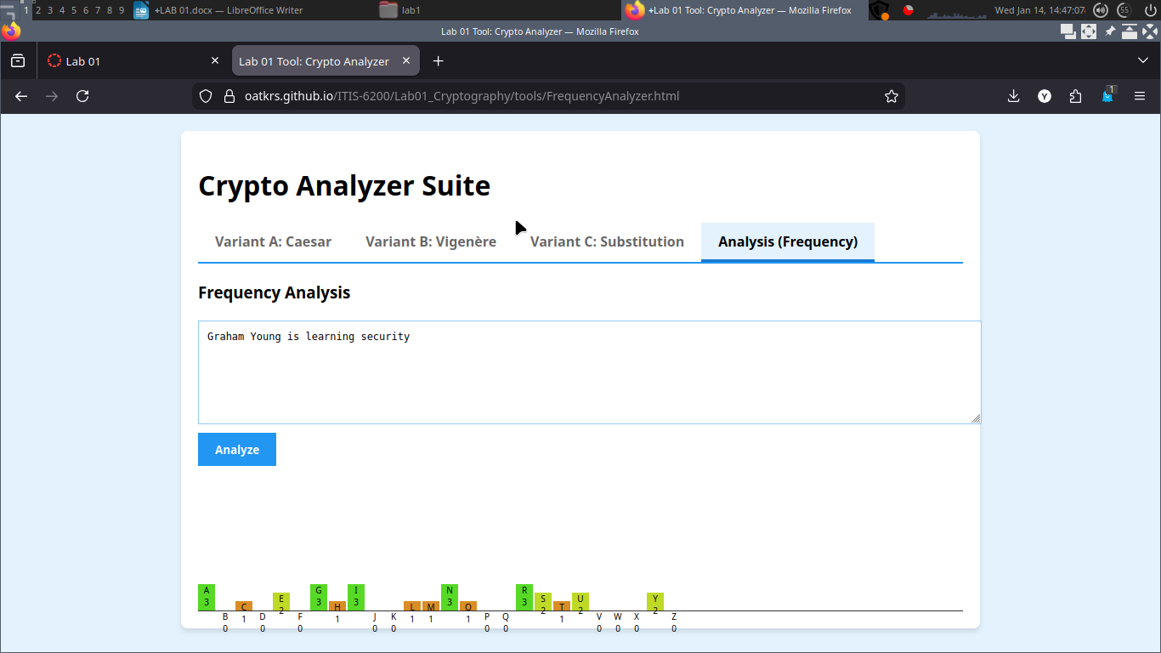

Part 2:

plaintext: Graham Young is learning security
keyword: graham

ciphertext: Miaoay Efuug uy cehrzoeg zeoaiiay
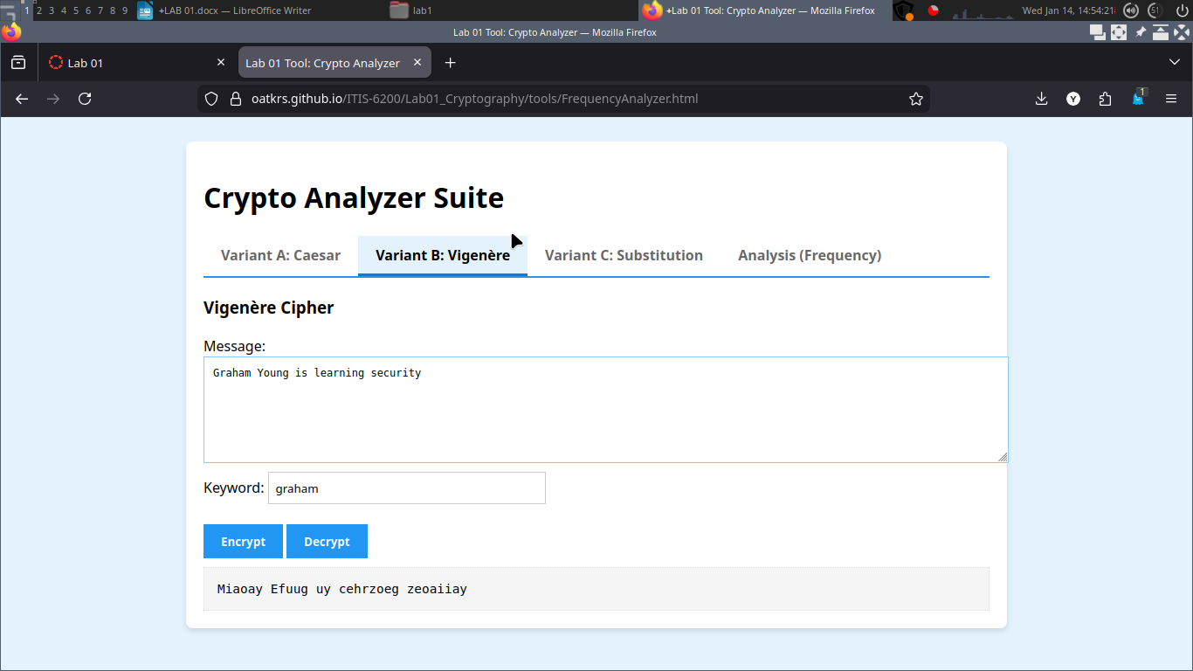

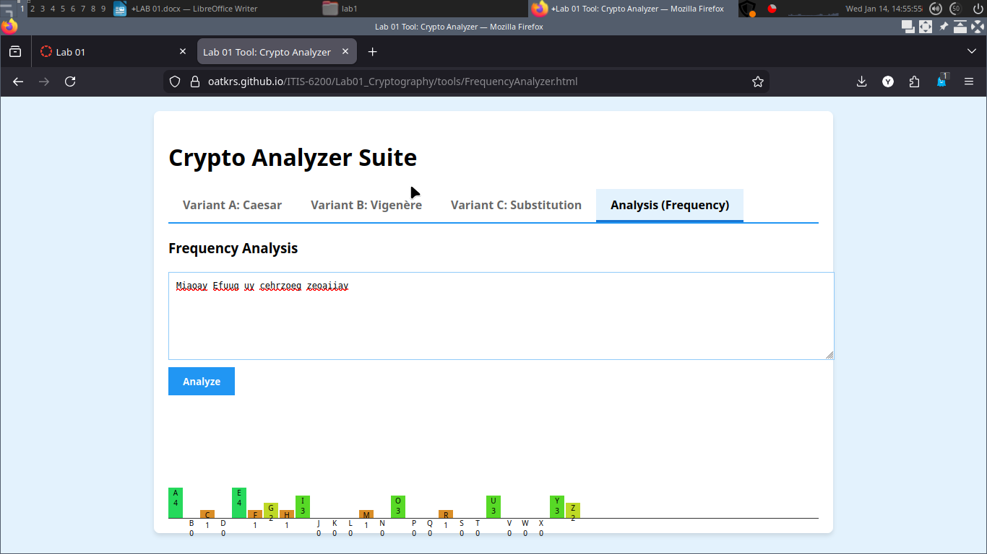

part 3:

plaintext: Graham Young is learning security
key: gyhvfbncmxlsdapotiureqwjzk

ciphertext: NIGCGD ZPEAN MU SFGIAMAN UFHEIMRZ

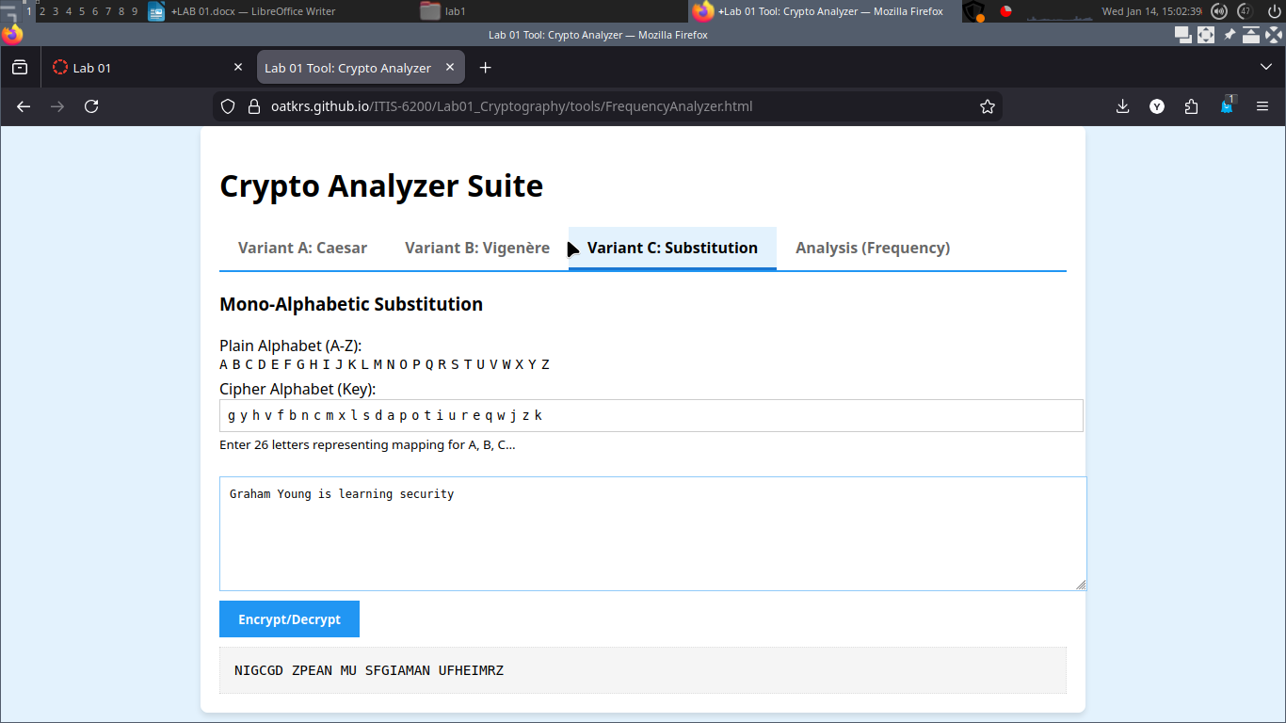

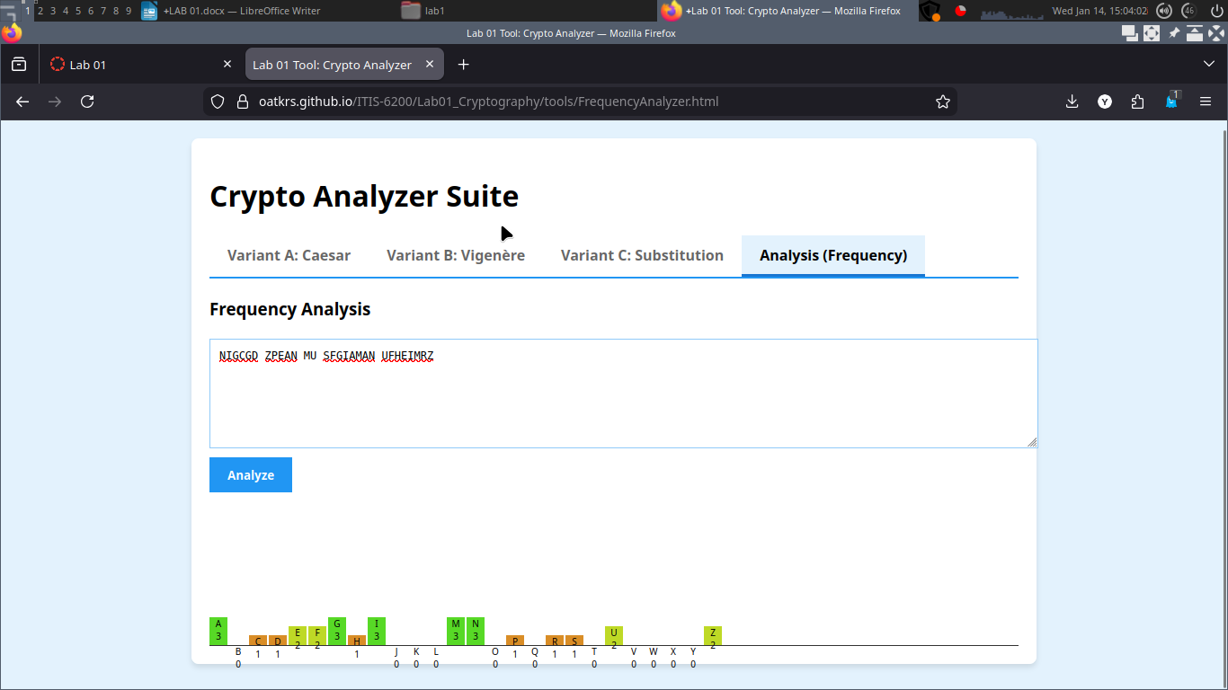

part 4:

SIP:
plaintext: Graham Young is testing AES
key: 801118969secret

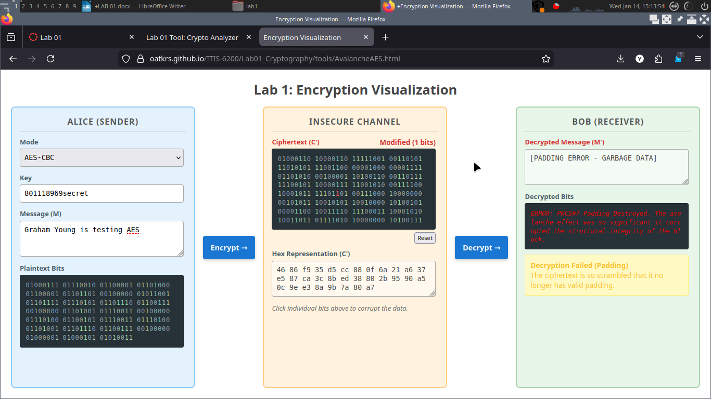

Part 5:

5.1 Keyspace Analysis

Caesar:
1. The frequency of letters in an encrypted message can allow a passive observer (such as Eve) to use cryptanalysis to determine parts of the original message. For instance, she might be able to determine what letters correspond to what other letters by comparing the most frequently used letters to the most frequently occurring letters in the language.

2. In the given situation, it would be possible for Mallory to send a message such as a pangram (for instance: “The quick brown fox jumped over the lazy dog.”) and determine what each character is encoded as in the encryption. She would be able to use this to then find the key for the caesar cipher and thus decrypt and message that used that key.

Vigenere:
1. When I pasted the ciphertext from each cipher, it was clear that there was a much higher frequency of some letters when using the Caesar cipher as compared to the vigenere cipher. As a result, I would say that the vigenere cipher is much more resistant to brute force attacks.

2. When using a different key, the structure and frequency of either ciphertext is mostly the same. I believe that this means that there would be less information that an attacker with access to the ciphertext would be able to use in order to break the encryption. I don’t know if there might be other ways for an attacker to analyze and potentially break the encryption, but based on frequency of letters, I would have to conclude that there isn’t enough information to decrypt it.

5.2 Avalanche Analysis

1. When I flipped just 1 bit the decryption gave an error. Since it gave an error I cannot say how many letters changed, but presumably it would be enough for the original message to be unreadable.

2. I believe the avalanche effect to be desirable because it makes it so that malicious actors cannot alter the content of data for their own purposes. For instance, an attacker might want to change the link in an email to point to a malware site instead of the intended destination, so that when a user clicks that link they get malware instead of what they actually wanted.

5.3 Real World Security Priciples

1. An example I’ve seen of Defense in Depth is a bank. In a bank, there is typically security at the entrance to vet who is entering, but farther inside the bank is a vault to further protect valuables, and further inside that are safe deposit boxes.
An example of Ensure Complete Mediation I’ve come across is at a sports game. At sport’s stadiums there are usually very few entrances. This ensures that only people who have paid for a ticket can enter the stadium, and they can only do so through specific entrances.
Again going back to the bank we see an analogous example of a Trusted Computer Base in the form of the vault. There are many parallels that can be drawn between the two. The primary similarity is that they are both small sections of the overall security system ensuring they can be easily verified.

