Lab 2

Step 1

ECB Mode
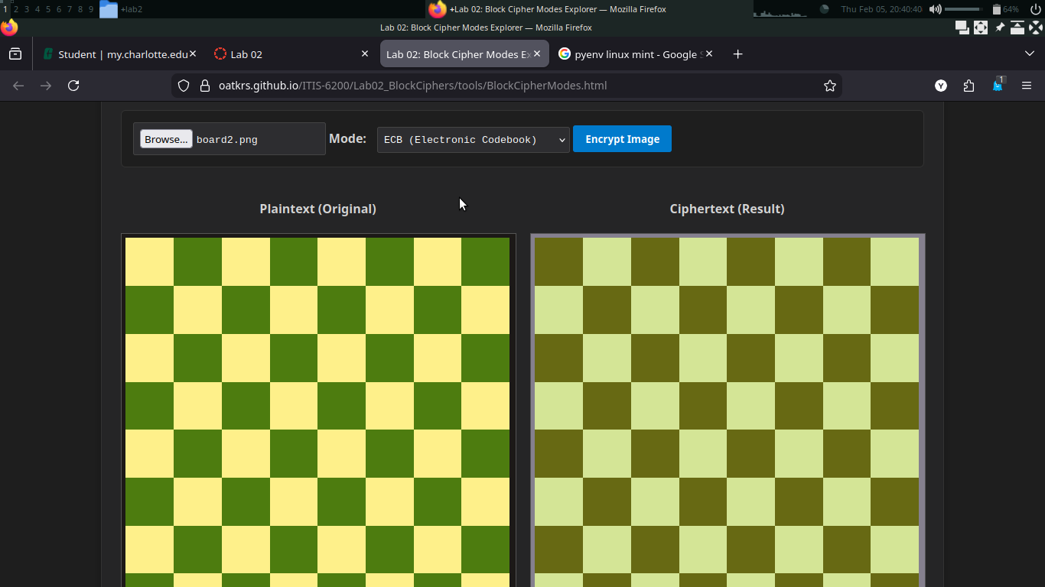
CBC Mode
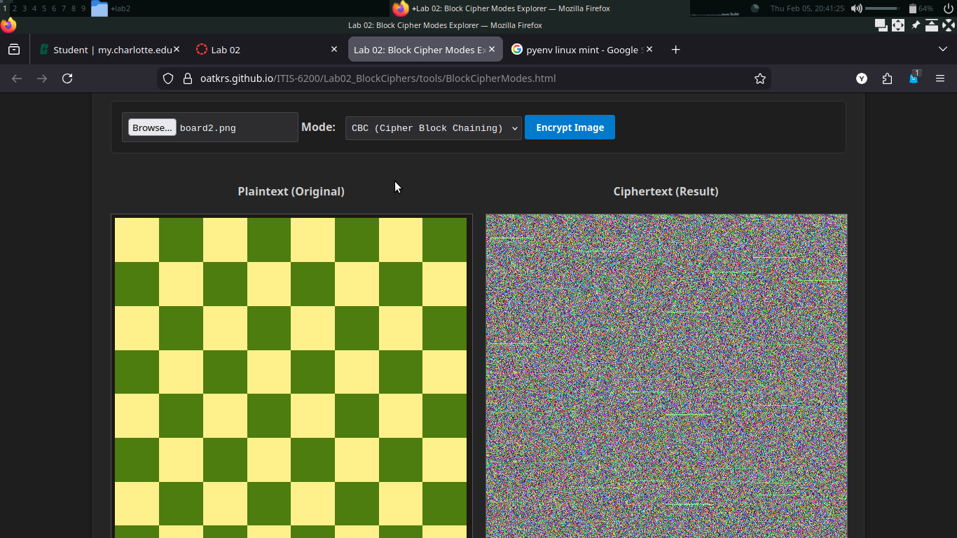
CTR Mode
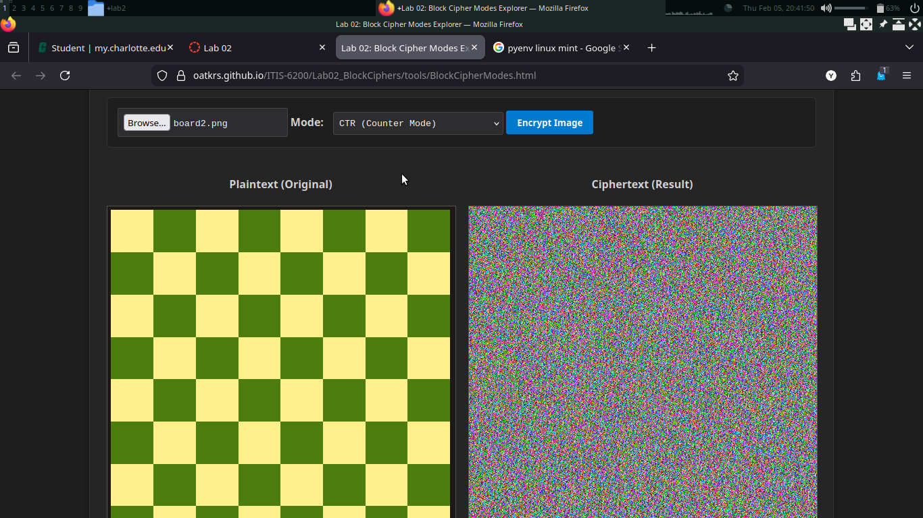
1.3 Analysis

Q1: The ECB mode shows visual patterns in the image because it encrypts every block separately with the same key. ECB mode is deterministic because every block uses the same key, so that means that different blocks that have the same plaintext (such as repeating patterns in an image) will produce the same ciphertext.
Q2: Between ECB and CBC or CTR there is not much similarity in the encrypted images. In CBC and CTR, the image is unrecognizable, whereas ECB there is a clear idea of the patterns of the original image. CTR and CBC are quite similar, but I noticed in the image I used that there is an interesting pattern in the CBC encrypted image that does not show up in the CTR one. I found that very interesting because the two methods should be similar levels of confidentiality in theory, but you can see a pattern in CBC that could reveal information about the original image. Based on that, I believe that CTR is probably the most secure of the three. It seems clear that using a random key for each XOR operation is certainly better than using the same key as in ECB, but I’m not sure exactly why the pattern emerges in CBC and not CTR. My best guess is that since CBC is chaining ciphertexts to the next block in the case of the image I used, it is possible that each block lines up closely with a square in the image, and thus, a compounding pattern of blips appears.
Q3: When I tried different size images, I didn’t notice any drastic differences from the original image in the results for each mode. The only thing I noticed was that the images were different resolutions.

Step 2

ECB Mode
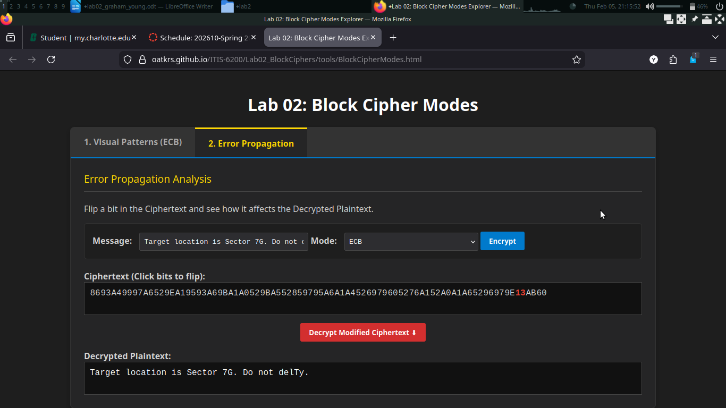

CBC Mode
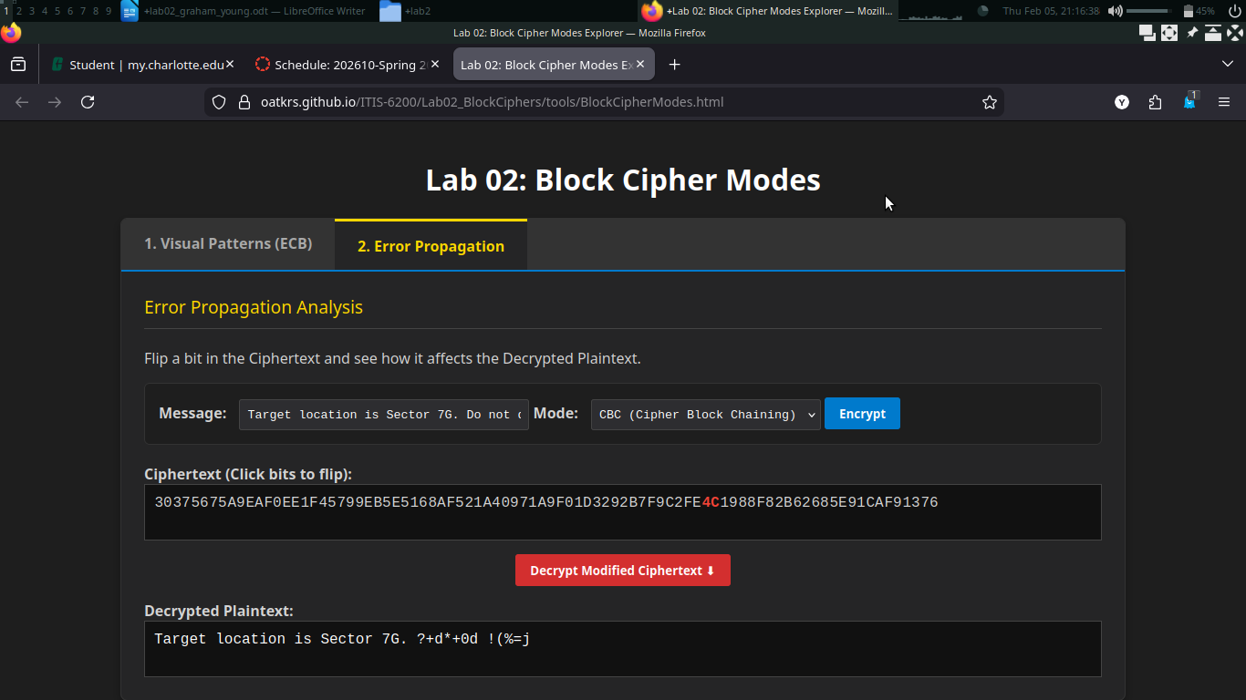

CTR Mode
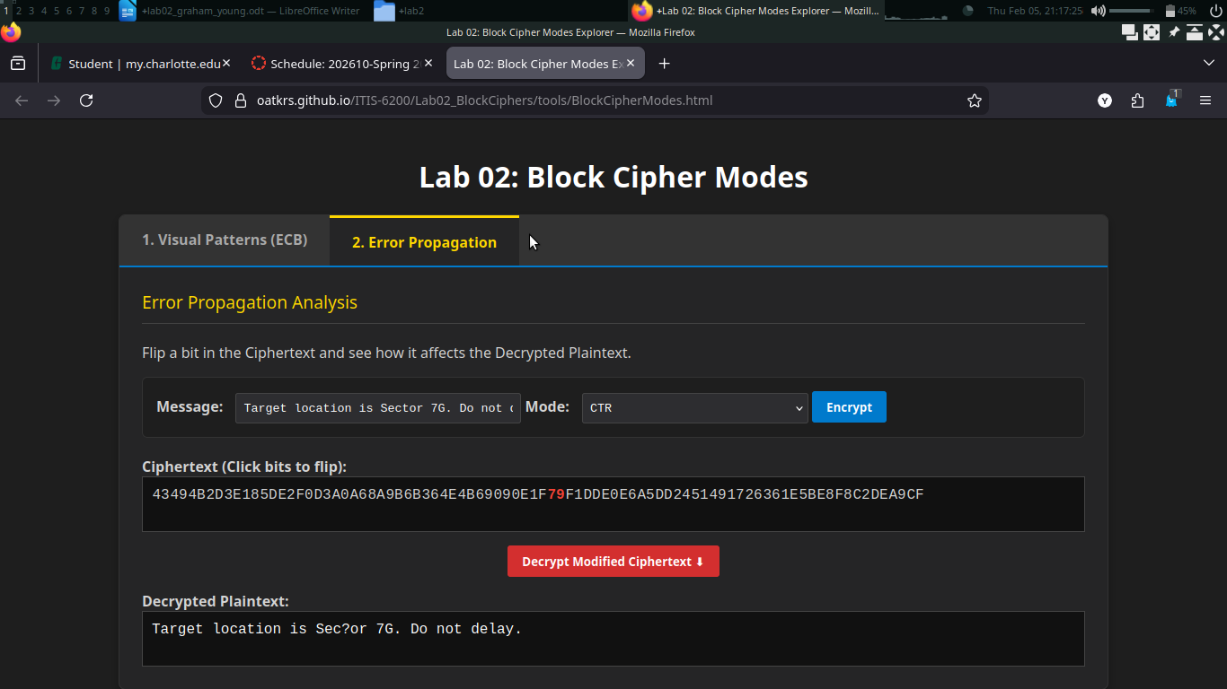

2.3 Analysis

Q4: For ECB and CTR, the only part of the decrypted message that changed was the character relating to the flipped bit. For CBC, the entire message after the flipped bit was affected. For ECB, only one bit was affected since each bit in the ciphertext is directly related to the corresponding bit in the plaintext because ECB encrypts each block to a single key. A similar explanation is true for CTR; the ciphertext has a direct relation to the plaintext, therefore changing a bit in the ciphertext only affects that same bit in the plaintext. For CBC, each block of the ciphertext is affected by the previous block because each block of ciphertext is used to encrypt the next block, and each block is used to decrypt the following block.
Q5: Alice should choose to encrypt her message with CBC because if any bit is flipped, every bit after that is affected when it is decrypted.
Q6: CTR is a better mode of encryption for video streaming because it is more efficient (making it easier to stream higher quality videos) and more importantly if a bit is flipped during transmission the only affected part of the output is that bit meaning the rest of the video will be fine.

Step 3:
(just an FYI, I am running this on a x86_64 Linux machine, and the distribution you gave for macOS/Linux is an arm64 binary, so I had to use wine to run the windows distribution. Just for future reference, it would probably be beneficial to have an x86_64 binary or allow students to compile their own version.)

3.2 Analysis
Q7: The reuse of the IV in CTR causes a much greater security breach than IV reuse in CBC because when the IV is the same, you will always produce the same one-time pad that is then used to encrypt the message. As we know, in a one-time pad encryption scheme if the one-time pad is reused the key for that one-time pad can be found by Eve through a CPA attack. Since encryption is a result of both the key and the IV, this problem can be avoided by either using a new key with the same IV or a new IV with the same key (or a new key and IV).

Q8: CTR is more appropriate in high computation environments. For instance, streaming a video in 4k requires a lot of data (on the order of 50-100 Megabits per second) to be sent and received in real time. This means that the encryption of that stream needs to be processed extremely fast to keep up in real time. To process that data so quickly, the encryption algorithm needs to be able to run in parallel. Since CBC is more reliable under IV reuse, it makes more sense to use it in scenarios where security is more important, or accidental IV reuse is more likely and where speed is less important. An example of that type of scenario would be for file backups. When you backup files you typically don’t need to access that backup very often or very quickly, and because of the properties of CBC, an attacker that tries to mess with an encrypted backup using CBC could cause all data after it to become unusable to them.

Q9: Given that the key and IV have been reused, the calculation compromises CTR because the output of the block encryption (the one-time pad) is always the same meaning that any difference between the two messages is plainly clear in the calculation. If an attacker is able to guess one of the messages (or knows it already through CPA), then the attacker can compute all of the one-time pad keys. Since, M1 XOR M2 = C1 XOR C2 then K = C1 XOR M1 where K is all of the keys output from the block cipher encryption stage. With K, the attacker could decrypt C2 since C2 = K XOR M2.

Step 4:

github repo: https://github.com/younggraham-t/ITIS6200
the file is in lab2/Lab02HashingProgram/

Screenshot showing console output prompting user


Screenshot showing console output after user chooses to generate hash table
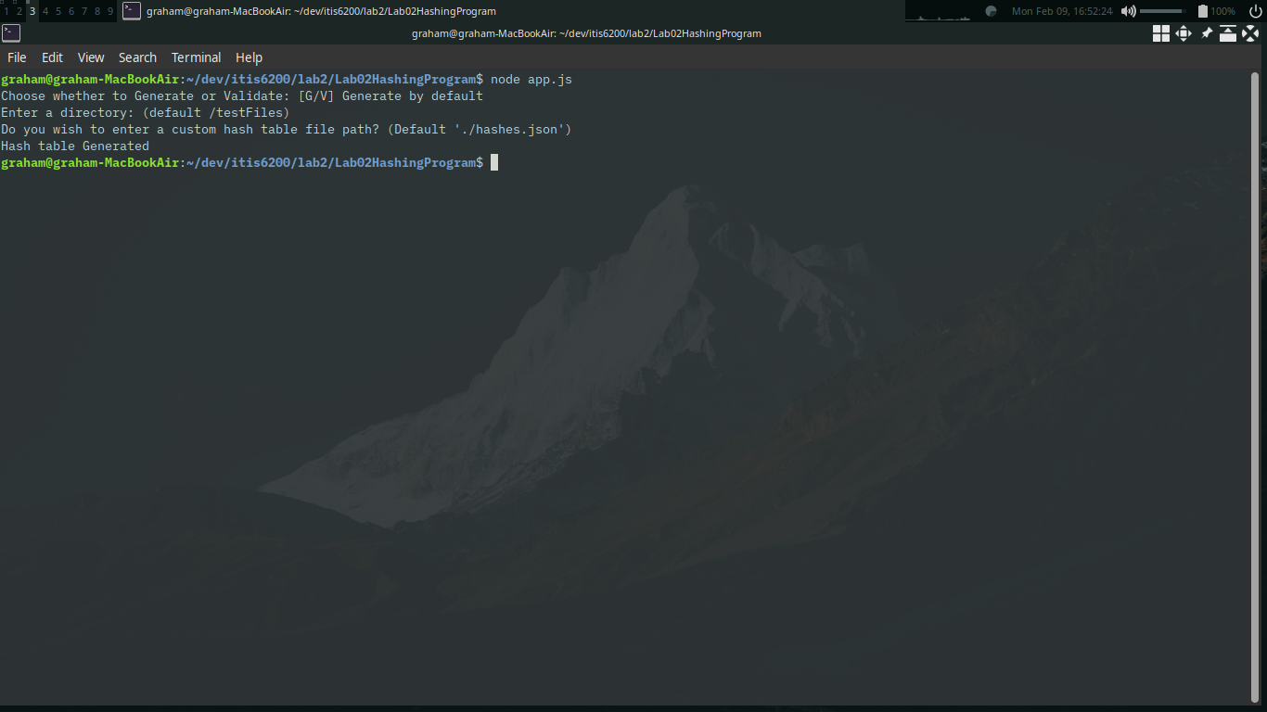

Screenshot showing showing contents of directory and hash table (jq is a tool to pretify json in cat)
(also includes a file that will be renamed for the bonus)
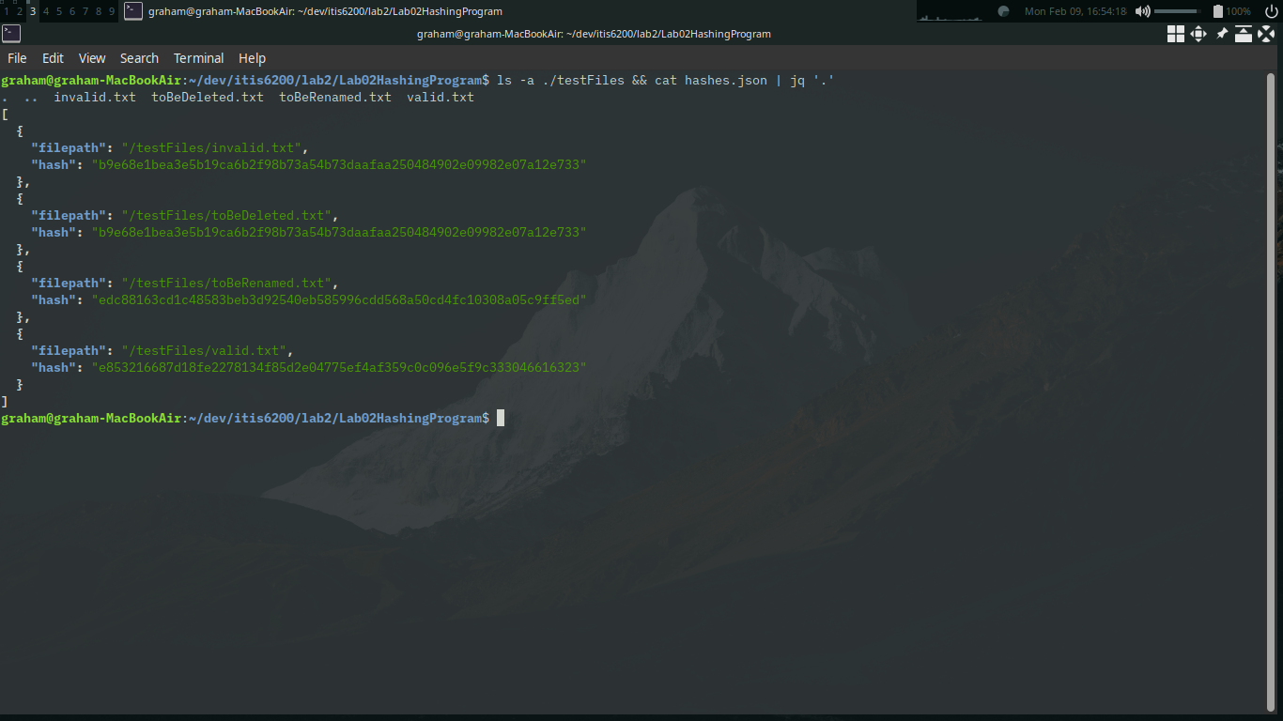

Screenshot showing output when user chooses to validate (also includes file renamed for bonus)

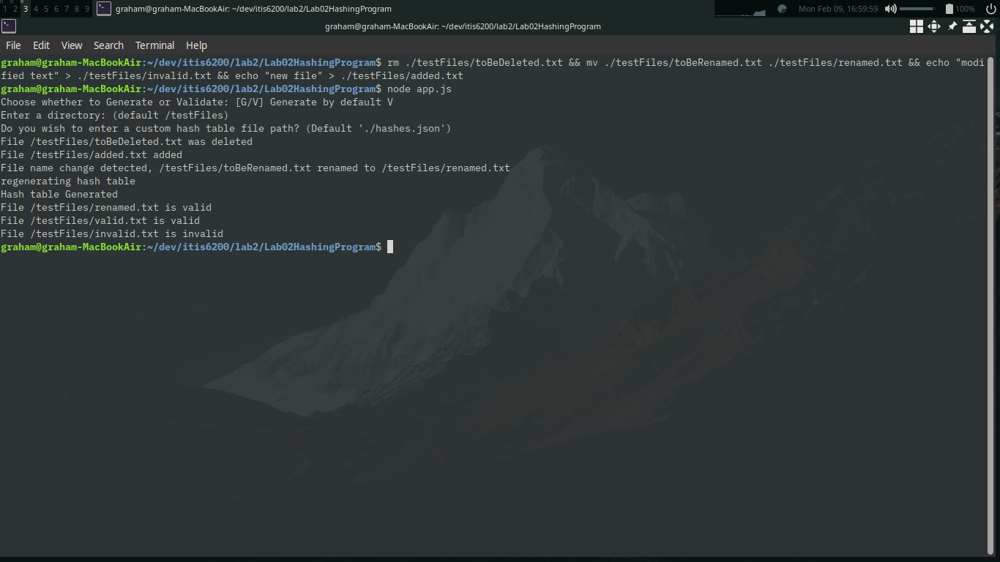

Screenshot showing directory and hash table after renaming