**NAME: WAHAB ADISA**

**MATRIC NO: NCSF/15/0079**

**COURSE CODE: COM 226**

**COURSE TITLE: TROUBLESHOOTING 2**

**DIFFERENTIATE BETWEEN DIGITAL AND ANALOG METER**

|  |  |
| --- | --- |
| **Analog Multimeter** | **Digital Multimeter** |
| It provides measurement in analog form with metal pointer. | It provides measurement in digital form using digits as per resolution needed. |
| It measures current, voltage, resistance. | It measures current, voltage, resistance and impedance. |
| It uses simple display with markings for various ranges as per R, V and I measurements. | It uses LCD display. |
| It does not require ADC converter i.e. analog to digital converter. | It requires ADC converter and quantity to be displayed is in digital form. |
| Accuracy of measurement is lower. | Accuracy of measurement is higher. |
| Input resistance varies as per range to be measured. | Input resistance is constant for all ranges. |
| Highest AC frequency to be measured is lower. | Highest AC frequency to be measured is higher than analog multimeter. |

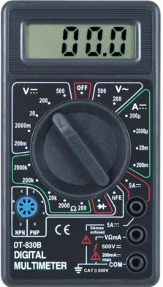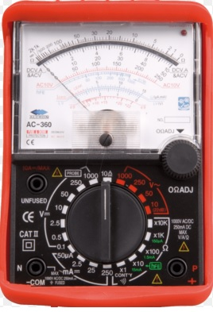

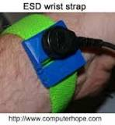**Analog Multimeter Digital Multimeter**

**NAME: WAHAB ADISA**

**MATRIC NO: NCSF/15/0079**

**COURSE CODE: COM 226**

**COURSE TITLE: TROUBLESHOOTING 2**

**LIST AND DESCRIBE THREE TYPES OF PC PORT WITH IMAGES**

**PS/2 Port**

* Used for old computer keyboard and mouse
* Also called mouse port
* Most of the old computers provide two PS/2 port, each for the mouse and keyboard
* 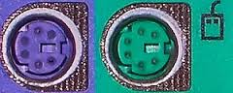IEEE 1284-compliant Centronics port

## Power Connector

* Three-pronged plug.
* 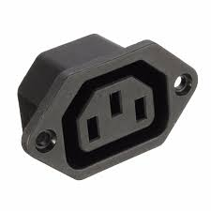Connects to the computer's power cable that plugs into a power bar or wall socket.

## Ethernet Port

* Connects to a network and high speed Internet.
* Connects the network cable to a computer.
* This port resides on an Ethernet Card.
* 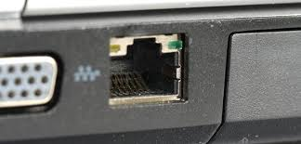Data travels at 10 megabits to 1000 megabits per seconds depending upon the network bandwidth.

**NAME: WAHAB ADISA**

**MATRIC NO: NCSF/15/0079**

**COURSE CODE: COM 226**

**COURSE TITLE: TROUBLESHOOTING 2**

**EXPLAIN THE FUNCTION OF TV CARD IN A PC WITH IMAGE**

A TV card is a kind of televisiontuner that allows television signals to be received by a computer. Most TV tuners also function as video capture cards, allowing them to record television programs onto a hard disk much like the digital video recorder (DVR) does.

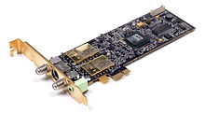

**NAME: WAHAB ADISA**

**MATRIC NO: NCSF/15/0079**

**COURSE CODE: COM 226**

**COURSE TITLE: TROUBLESHOOTING 2**

**DESCRIBE THREE CAUSES OF WINDOWS STARTUP FAILURE AND RECOMMEND POSSIBLE SOLUTION**

|  |  |
| --- | --- |
| **Problems** | **Solutions** |
| **Computer unable to detect hard disk** | **Restart** your computer, and at the first screen that you see, press the key that will take you into its **BIOS** settings. You will find this key on both your computer’ user manual and on the first screen you see when it boots up. Once in the **BIOS** settings, peruse its tabs until you find the **Boot priority order** (or **Boot order**). Highlight **Boot priority order** and press **Enter**, and when you see a list of devices that your computer tries to boot from, make sure that your HDD is on the top of the list. |
| **Corrupted windows file/document** | Perform startup repair |
| **Installed a hardware that is not compatible** | **Remove any hardware that you recently installed and reboot.** |

**NAME: WAHAB ADISA**

**MATRIC NO: NCSF/15/0079**

**COURSE CODE: COM 226**

**COURSE TITLE: TROUBLESHOOTING 2**

**DISTINGUISH BETWEEN CRT AND LCD**

|  |  |
| --- | --- |
| **CRT** | **LCD** |
| CRT stands for “**Cathode Ray Tube**“. | LCD stands for “**Liquid Crystal Display**“. |
| CRT is weighted, bulky and large in size. | LCD is light, compact and thin in size. |
| It consumes High power. | It consumes Low power. |
| Image Flickering is there in CRT. | No Image Flickering is there in LCD. |
| CRT is like Black. | LCD is like White. |
| Image Retension is not there in CRT. | Image Retension is there in LCD. |
| It is less expensive. | It is more expensive. |
| Electron Gun is used to form images. | Liquid crystals are used to form images. |
| CRT having good response. | LCD having slow response. |
| CRT is used in Televisions and was used in  old  computer monitors. |  |

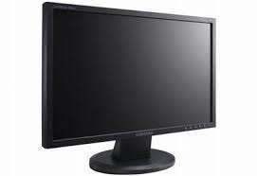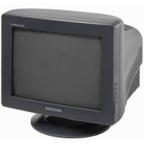 **CRT LCD**

**NAME: WAHAB ADISA**

**MATRIC NO: NCSF/15/0079**

**COURSE CODE: COM 226**

**COURSE TITLE: TROUBLESHOOTING 2**

**LIST AND DESCRIBE THREE MAINTENANCE TOOLS WITH IMAGE**

**Compressed air:** Used to blow away dust and debris from different computer parts without touching the components.



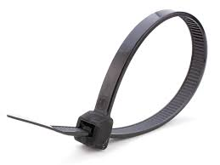**Cable ties:** Used to bundle cables neatly inside and outside of a computer

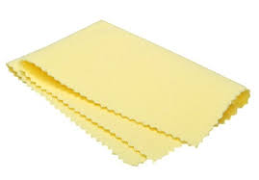**Soft cloth:** Used to clean different computer components without scratching or leaving debris

**NAME: WAHAB ADISA**

**MATRIC NO: NCSF/15/0079**

**COURSE CODE: COM 226**

**COURSE TITLE: TROUBLESHOOTING 2**

**EXPLAIN WHAT YOU UNDERSTAND BY SYSTEM RESTORE**

System Restore is a feature in Microsoft Windows that allows the user to revert their computer's state (including system files, installed applications, Windows Registry, and system settings) to that of a previous point in time, which can be used to recover from system malfunctions or other problems.

To restore a computer the following steps can be taken:

1. Log on to your computer as an administrator.
2. Open the Control Panel by clicking Start, and then clicking Control Panel.
3. Click System and Security, and then click System.
4. Under the Control Panel Home menu, click System protection. ...
5. Click System Restore.
6. Recommended Restore is the default choice.

**NAME: WAHAB ADISA**

**MATRIC NO: NCSF/15/0079**

**COURSE CODE: COM 226**

**COURSE TITLE: TROUBLESHOOTING 2**

**DIFFERENCE BETWEEN SERIAL OF PARALLEL PORT**

|  |  |
| --- | --- |
| **Serial Ports** | **Parallel Ports** |
| Used for serial communication (bit by bit sequences) | Used for Parallel communication (multi bit parallel) |
| Can transmit 1 bit at a time | Can transmit 8 bits or more at a time |
| Slower data transmission | Faster data transmission |
| Transmits a single stream of data | Transmits several streams of data simultaneously |
| Uses less wires for transmission | Uses more wires for transmission |
| Whole byte transmission | Bit by bit transmission |
| Example: LPT printer | Example: Modem, com port |
| Parallel connector has more pins | Serial port uses less pins |
| Can connect devices up to 6 feet | Can connect devices up to 10 feet |
| Uses single loop for transmission | Different loop for outgoing and incoming |

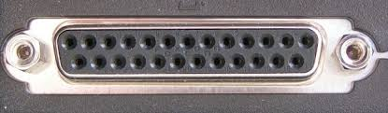 **Serial Ports 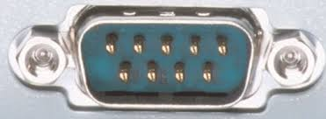 Parallel Ports**

**NAME: WAHAB ADISA**

**MATRIC NO: NCSF/15/0079**

**COURSE CODE: COM 226**

**COURSE TITLE: TROUBLESHOOTING 2**

**WHAT IS THE FUNCTION OF DEFRAGMENTATION**

In the maintenance of [file systems](https://en.wikipedia.org/wiki/File_system), **defragmentation** is a process that reduces the amount of [fragmentation](https://en.wikipedia.org/wiki/File_system_fragmentation). It does this by physically organizing the contents of the [mass storage](https://en.wikipedia.org/wiki/Mass_storage) device used to store [files](https://en.wikipedia.org/wiki/Computer_file) into the smallest number of [contiguous](https://en.wikipedia.org/wiki/Contiguity#Computer_science) regions (fragments). It also attempts to create larger regions of free space using [compaction](https://en.wikipedia.org/wiki/Data_compaction) to impede the return of fragmentation. Some defragmentation utilities try to keep smaller files within a single directory together, as they are often accessed in sequence.

Defragmentation is advantageous and relevant to file systems on electromechanical [disk drives](https://en.wikipedia.org/wiki/Disk_storage). The movement of the [hard drive's read/write heads](https://en.wikipedia.org/wiki/Disk_read-and-write_head) over different areas of the disk when accessing fragmented files is slower, compared to accessing the entire contents of a non-fragmented file sequentially without moving the read/write heads to [seek](https://en.wikipedia.org/wiki/Seek_time) other fragments.

**NAME: WAHAB ADISA**

**MATRIC NO: NCSF/15/0079**

**COURSE CODE: COM 226**

**COURSE TITLE: TROUBLESHOOTING 2**

**DESCRIBE THE FUNCTION OF WRIST STRAP WITH DIAGRAM**

An antistatic wrist strap, ESD wrist strap, or ground bracelet is an antistatic device used to safely ground a person working on very sensitive electronic equipment, to prevent the buildup of static electricity on their body, which can result in electrostatic discharge (ESD)

