Electronic Supplement to:

Upper-crustal seismic anisotropy and its geological controls in southeastern Korea from local earthquake data
By June Baek, Tae-Seob Kang, Dabeen Heo, Junkee Rhie, YoungHee Kim, Kwang-Hee Kim, and Jin-Han Ree

Overview

This document contains Supplementary Figures S1 and S2, which provide additional information supporting the results and interpretations presented in the main text.

Figure S1 shows shear-wave splitting measurements as a function of hypocentral depth.
Figure S2 shows the first-order lithological distribution of the study area.

Figures

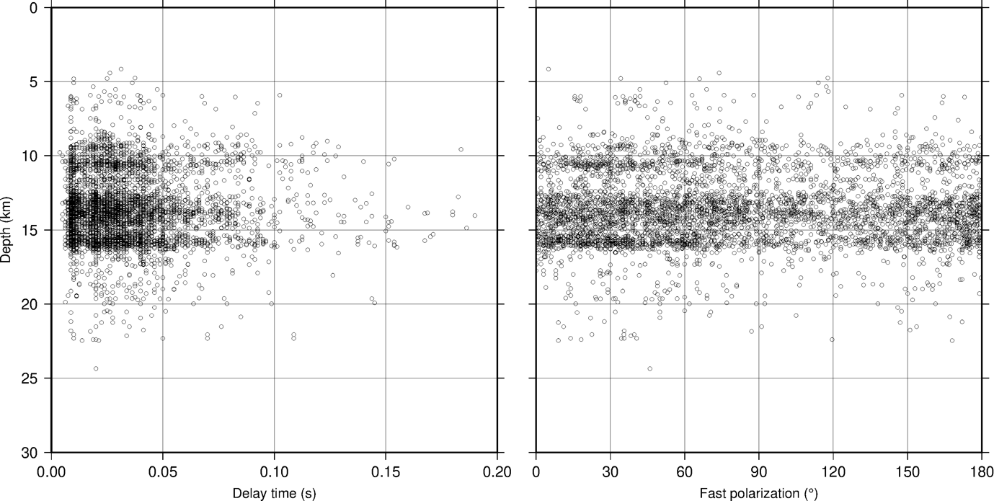
Figure S1. Scatter plots of shear-wave-splitting measurements showing (left) delay time (δt) and (right) fast-polarization direction (𝜙) as functions of hypocentral depth.
Alt-text: Two scatter plots show delay time (δt, left) and fast-polarization direction (𝜙, right) versus hypocentral depth, with depth increasing downward. Most measurements are concentrated between ~8 and 18 km depth. Delay times are mostly less than ~0.05 s but include a few values up to ~0.2 s, and neither δt nor 𝜙 shows a clear monotonic trend with depth.

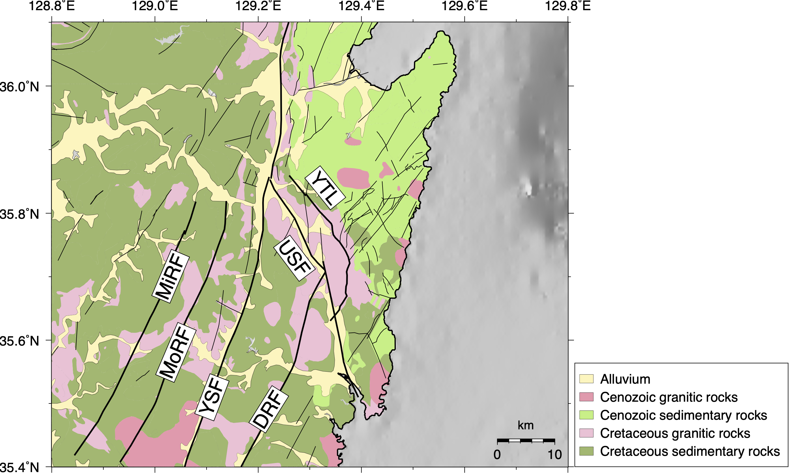
Figure S2. First-order lithological map of the study area showing alluvium, Cenozoic granitic rocks, Cenozoic sedimentary rocks, Cretaceous granitic rocks, and Cretaceous sedimentary rocks, together with major fault traces (modified from Kim et al., 2002). Major structures are labeled as in Figure 1.
Alt-Text: Map showing five first-order lithological units and major fault traces in the study area. Cretaceous sedimentary rocks occupy most of the western and central parts of the map, whereas Cenozoic sedimentary rocks are concentrated east of the Ulsan Fault and near the Yeonil Tectonic Line. Alluvium forms narrow belts, mainly along valleys and fault-parallel corridors. Granitic rocks are scattered; most mapped granitic exposures are Cretaceous and occur west of the Yangsan Fault system and along parts of the Ulsan Fault and Yeonil Tectonic Line. Major structures are labeled as in Figure 1.

Reference
Kim, J.-C., H. J. Koh, S. R. Lee, C.-B. Lee, S. Choi, K.-H. Park, D. H. Kim, J. H. Hwang, K.-Y. Song, B. J. Lee, Y. B. Kim, D.-L. Cho, H. I. Choi, H. Y. Chun, B. C. Kim, W.-S. Kee, P. C. Kang, M. S. Jin, D. W. Park, P.-Y. Choi, and Y. S. Choi (2002). Digital Geologic Map of Korea at 1:250,000 Scale, Korea Institute of Geoscience and Mineral Resources, doi: 10.22747/data.20231227.5375

