Supplemental Material for
The 14 December 2021 Earthquake Mw 4.9 Offshore Jeju Island, Korea, Earthquake: Seismological Observation of an Intraplate Earthquake Provides Insight into Regional Seismotectonics

By Won-Young Kim, Jun Yong Park, Min-Seong Seo, Young Oh Son, Hobin Lim, Sangwoo Han, and YoungHee Kim

This supplemental material contains three tables, seven figures, and a reference list.

Tables
Table S1. Two crustal seismic velocity models used are given. KOR01 is the average two-layer model for the southern Korean Peninsula, and KOR02 has a 2-km thick surface low-velocity layer on top of KOR01 adequate for Jeju Island, Korea.
Table S2. List of eight seismographic stations on Jeju Island used in this study. Distance and azimuth are based on the mainshock location (33.10333ºN, 126.18005ºE, and depth of 13.15 km).
Table S3. List of twelve repeating earthquakes and foreshocks over five years.

Figures
Figure S1. Stacking Pn depth phases to constrain the focal depth of the mainshock.
Figure S2. The time-magnitude plot of the 12 repeating earthquakes that preceded the mainshock. Events were detected over five years in the mainshock epicentral area.
Figure S3. Map views and cross-sections of HYPOINVERSE locations of 36 events, relocated by double-difference (DD) locations using catalog data and waveform cross-correlation data.
Figure S4: Moment magnitude estimation of the 2021 Offshore Jeju Island earthquake sequence.
Figure S5. Change in the Coulomb Failure Stress (ΔCFS) by the mainshock.
Figure S6. Vertical records from the mainshock at 10 stations within 140 km from the epicenter are plotted starting from the first source pulse arrivals to 2.5 s duration.
Figure S7. Map showing the horizontal projection of the P-axis of the mainshock and of 2,347 shallow earthquakes (< 35 km) during 1976 – 2021 around the epicentral region.

Table S1. Velocity models used in this study.
Model | Depth (km) | Layer thickness (km) | V_{P} (km/s) | V_{S} (km/s) | V_{P}/V_{S} | Density (g/cm³) | Q_{P} | Q_{S}
KOR01  (Korean Peninsula) | 0 | 15 | 5.98 | 3.40 | 1.759 | 2.70 | 600 | 350
KOR01  (Korean Peninsula) | 15 | 17 | 6.38 | 3.79 | 1.683 | 2.90 | 1200 | 700
KOR01  (Korean Peninsula) | 32 | 20 | 7.95 | 4.58 | 1.736 | 3.30 | 1500 | 900
KOR02  (Jeju Island) | 0 | 2 | 3.00 | 1.73 | 1.730 | 2.20 | 200 | 100
KOR02  (Jeju Island) | 2 | 13 | 5.98 | 3.40 | 1.759 | 2.70 | 600 | 350
KOR02  (Jeju Island) | 15 | 17 | 6.38 | 3.79 | 1.683 | 2.90 | 1200 | 700
KOR02  (Jeju Island) | 32 | 20 | 7.95 | 4.58 | 1.736 | 3.30 | 1500 | 900

Table S2. List of Stations on Jeju Island used in this study.*
Station code | Distance (km) | Azimuth (º) | Takeoff angle (º)
MRD | 8.1 | 79 | 145
GOS2 | 22.0 | 6 | 117
HA2B | 33.0 | 12 | 109
SGP2 | 34.3 | 59 | 108
JJU2 | 49.7 | 43 | 102
JJB | 58.8 | 48 | 100
PYSB | 65.4 | 64 | 99
UDO | 85.7 | 57 | 69

* Distance and azimuth are based on the mainshock (2021-12-14, 08:19:15) parameters which are latitude=33.10333ºN, longitude=126.18005ºE and depth=13.15 km.

Table S3. Repeating earthquakes and foreshocks*

Date  (year-mo-dy) | Time (UTC)  (hh:mm:sec) | Latitude  (ºN) | Longitude (ºE) | Depth (km) | Magnitude |  | Temp id
 |  |  |  |  | M_{L} | SD | Temp id
2016-12-15 | 23:29:40.1 | 33.103 | 126.178 | 12.9 | 0.64 | 0.16 | 13
2017-12-29 | 08:01:04.3 | 33.106 | 126.177 | 13.2 | 0.85 | 0.02 | 7
2017-12-29 | 08:01:10.9 | 33.106 | 126.177 | 13.2 | 0.76 | 0.01 | 7
2020-03-21 | 17:04:25.0 | 33.102 | 126.173 | 12.0 | 0.43 | 0.09 | 14
2020-06-18 | 10:57:30.4 | 33.106 | 126.177 | 13.2 | 1.18 | 0.05 | 7
2020-10-24 | 01:57:12.4 | 33.106 | 126.177 | 13.2 | 0.75 | 0.02 | 7
2021-04-25 | 12:05:15.8 | 33.107 | 126.174 | 13.2 | 0.07 | 0.07 | 5
2021-04-25 | 12:35:07.6 | 33.107 | 126.174 | 13.2 | 0.32 | 0.07 | 5
2021-06-23 | 02:33:59.5 | 33.106 | 126.177 | 13.2 | 1.32 | 0.05 | 7
2021-11-01† | 19:59:31.0 | 33.0997 | 126.1735 | 12.9 | 1.29 | 0.02 | 10
2021-11-01 | 20:24:45.7 | 33.106 | 126.192 | 13.5 | 0.51 | 0.04 | 10
2021-11-01†† | 20:24:54.4 | 33.1006 | 126.1729 | 12.7 | 1.31 | 0.15 | 13
* Temp id = template event id (see Table 1) that detected the repeating event; only two events among the 12 detected repeating events were locatable and the locations of other events are those of the template events.
† event d01 given in Table 1.
‡ event d02 given in Table 1.

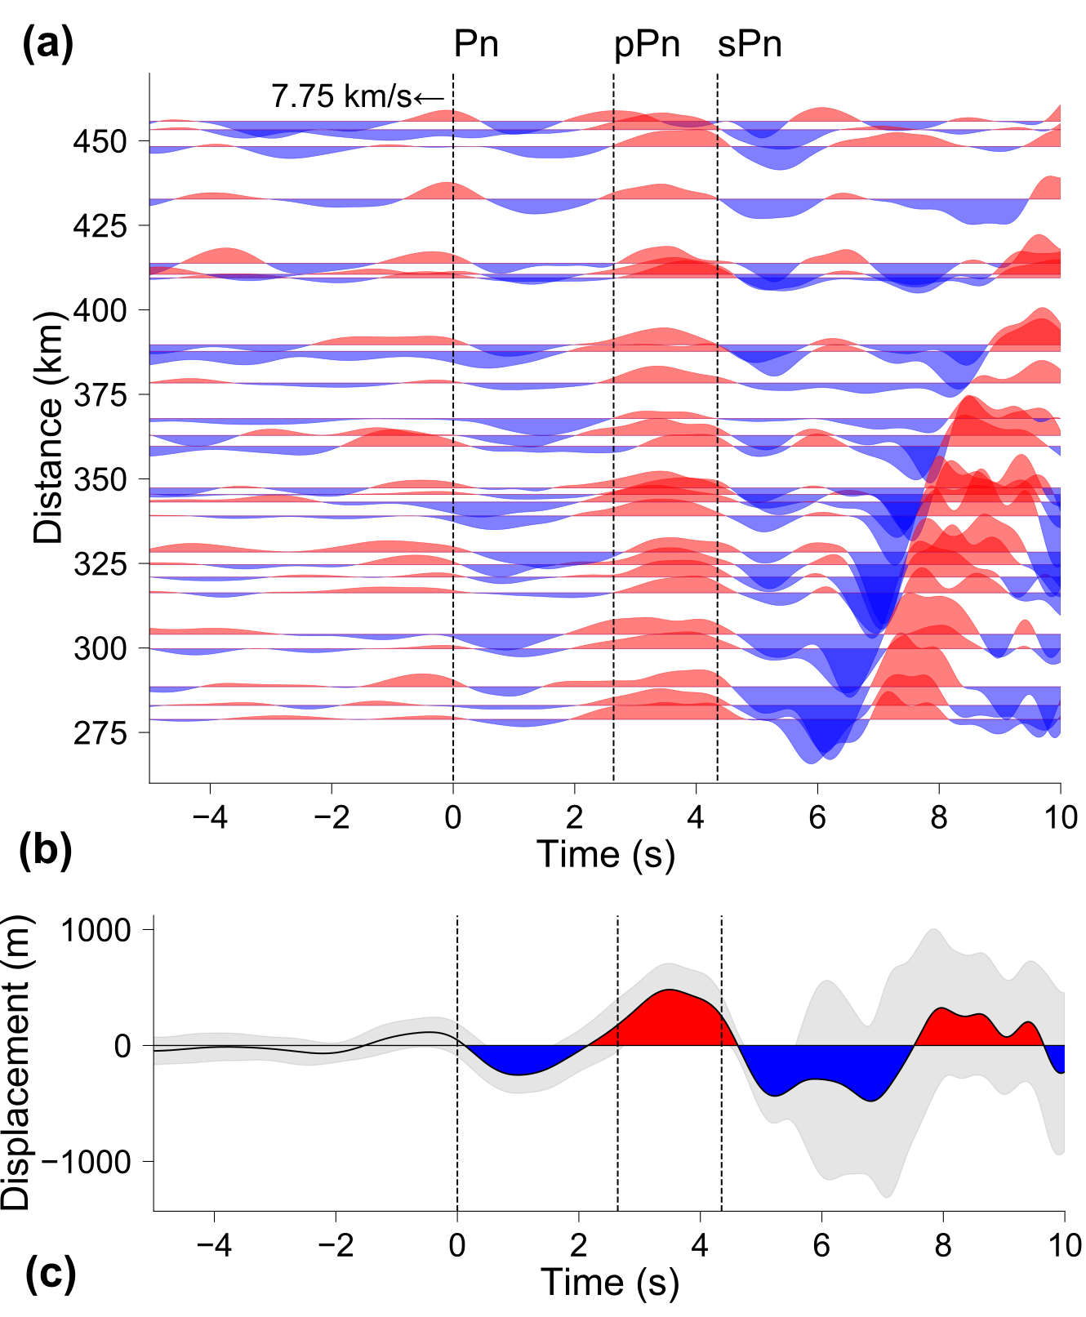
Figure S1. (a) Record section showing Pn and its depth phases at epicentral distances >270 km and in the azimuthal ranges of 32º – 54º. Each trace is aligned on Pn arrival with an apparent velocity of 7.75 km/s (black dashed line). We observe consistent arrivals of Pn, pPn, and sPn. Vertical records are converted to displacement signals, bandpass filtered between 0.1 and 1.0 Hz, and stacked the aligned waveforms. Records from 26 stations with a signal-to-noise ratio over ten are stacked to improve the depth phases and obtain a small standard deviation of the stacked trace up to ~5 s. For observed time delay of sPn-Pn = 4.35 s, focal depths are estimated as 11.5 km. (b) Stacked waveforms with standard deviation in gray shade.

Figure S2. Twelve repeating earthquakes that occurred during 16 December 2016 – 1 November 2021 in the epicentral region of the mainshock are plotted by vertical bars against moment magnitude (left vertical axis). The logarithm of the cumulative seismic moment is plotted as a solid blue line (right vertical axis). Twelve events are only detected by GOS2, and we measure RMS amplitude on three components at GOS2 and calculate average event magnitude. For WCC detected events, they are nearly collocated to templates, and we calculate moment magnitudes of detected events by using the amplitude ratios between the detected and template events as, M_{detected} = M_{template} + log₁₀ (A_{detected} / A_{template}), where A_{detected} and A_{template} are RMS amplitudes measured in the time windows that contain S-wave. M_{template} is the reference moment magnitude of template event determined from the spectral analysis. The time window used starts 0.2 s before S wave onset with a total length of 0.8 s. For 162 events detected with three stations, we measure RMS amplitude ratios at all three stations (MRD, GOS2, and HA2B). Network magnitude is calculated by taking the average of nine estimated magnitudes (three stations, three components).

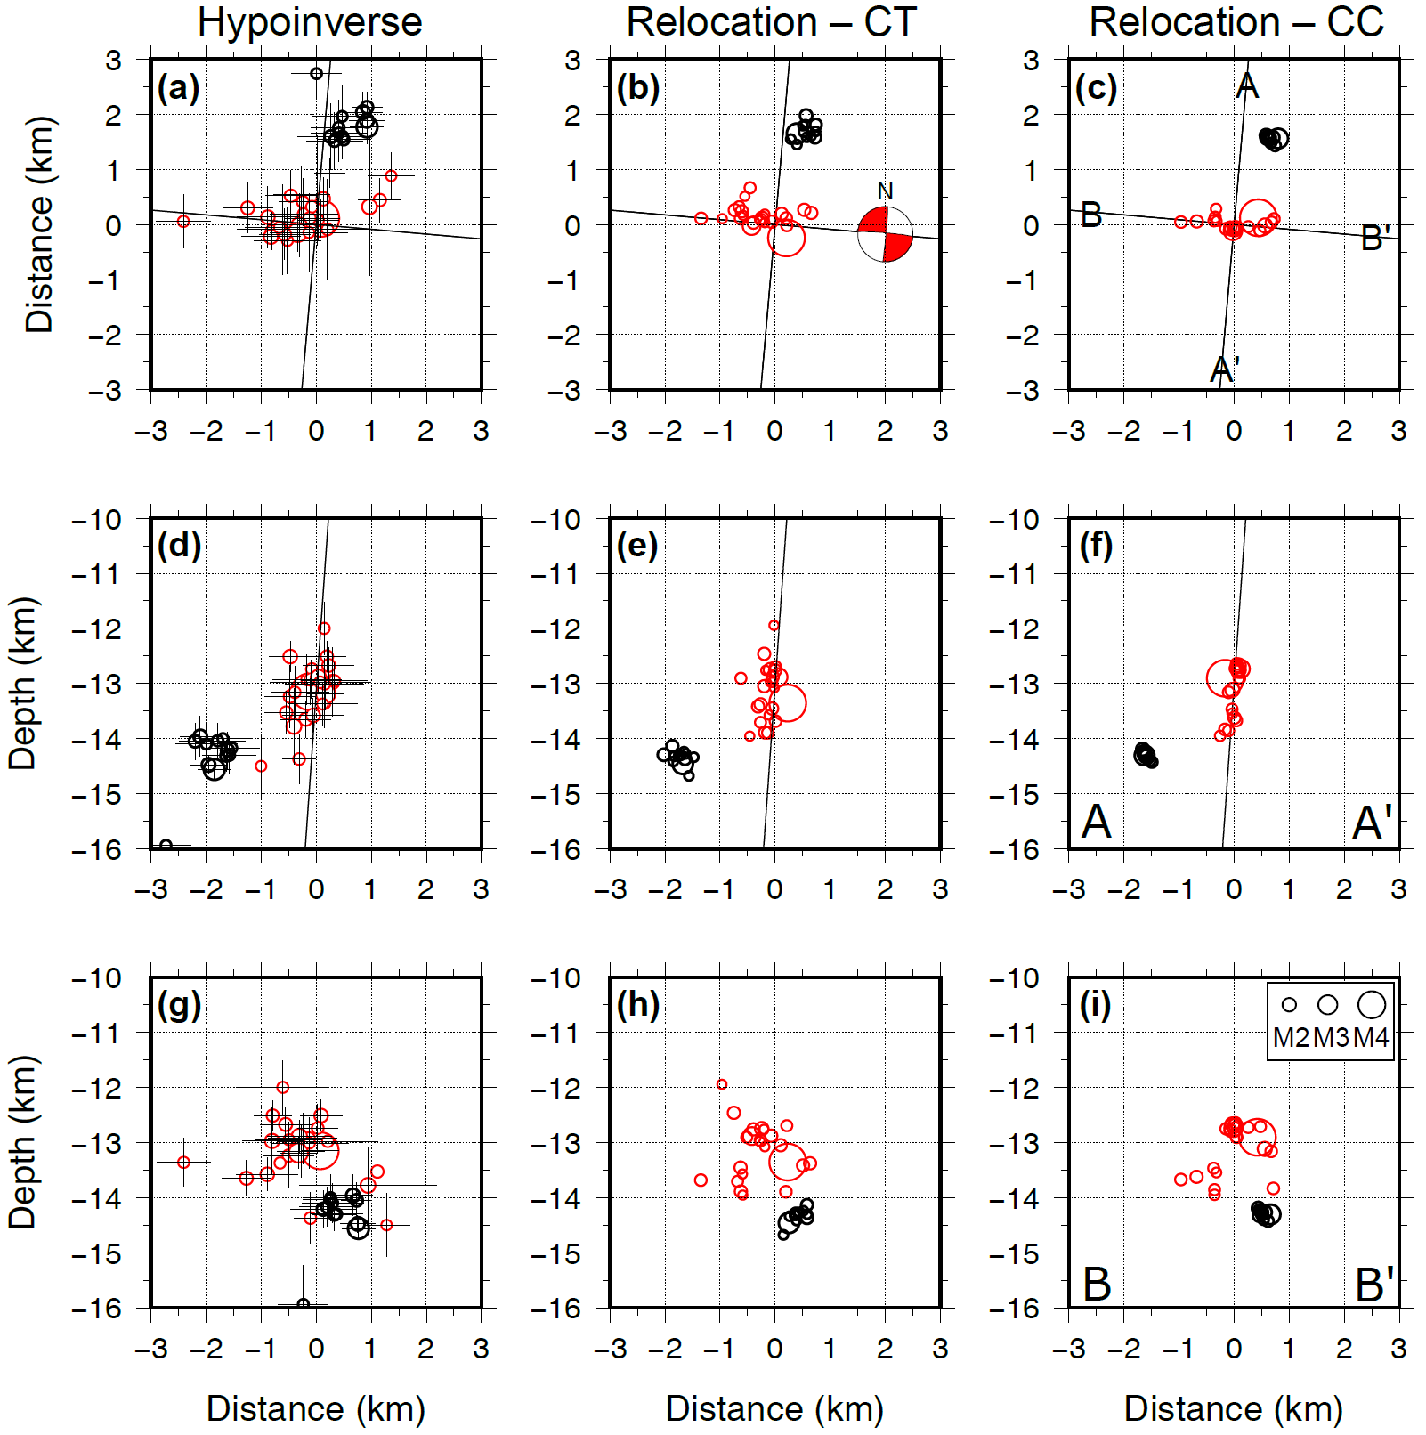
Figure S3. (a) Map view of HYPOINVERSE locations of 36 events. Three located events in cluster 19 are out of range. Horizontal and vertical location errors are indicated by bars; (b) map view of double-difference (DD) locations using only catalog data, event 8 was an outlier and not located. The beach ball indicates focal mechanism; (c) map view of DD locations using phase and waveform cross-correlation data. Events 8 and 11 were not located. A–A´ and B–B´ are two nodal planes; (d) across-strike cross-section of HYPOINVERSE locations; (e) across-strike cross-section of DD locations using only catalog data; (f) across-strike cross-section (A–A´) of DD locations using catalog & WCC data; (g) along-strike cross-section of HYPOINVERSE locations; (h) along-strike cross-section DD locations using only phase data; (i) along-strike cross-section (B–B´) of DD locations using catalog & WCC data. Red circles are the main cluster, including the mainshock, and black circles are the #21 cluster whose primary shock is the largest aftershock 21.

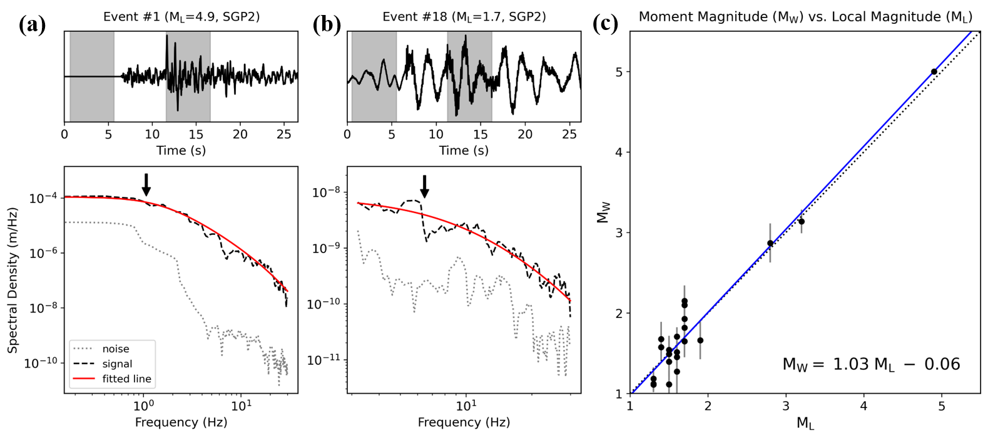

Figure S4. (a) (upper plate) Transverse-component waveform of the mainshock (M_{L} 4.9) at station SGP2 (34.3 km, AZ=59º). Noise- and signal-window are indicated by shaded areas; (lower plate) displacement spectral density for the signal- and noise-window are plotted by the black dashed line and gray dotted line, respectively. The solid red line is the best fit omega-squared source spectrum, and the black arrow indicates the estimated source corner frequency; (b) Same as (a), but for event 18 (M_{L} 1.7); (c) Comparison between M_{L} for 22 earthquakes from KMA catalog and corresponding M_{W} calculated in this study. The solid blue line is the best-fitting line obtained by weighted least-squares linear regression between M_{L} and M_{W}, whereas the black dotted line is the reference line for unity M_{L} = M_{W}. We obtained a linear relationship as, M_{W} = 1.03 M_{L} − 0.06. We used a 5 s-long signal- and noise-window and calculated displacement spectrum of transverse-component by using the multitaper approach (Prieto et al., 2009). We fit the omega-squared model to the observed spectrum to obtain the low-frequency level (Ω₀) via the iterative integration method (Andrews, 1986; Snoke, 1987). We obtained seismic moment (M₀) from Ω₀ assuming S-wave velocity=3.5 km/s, density=2.7 g/cm³, free surface amplification factor=2, and radiation pattern coefficient=0.63. We then calculated the event M_{W} from the geometric mean of M₀ for each station.

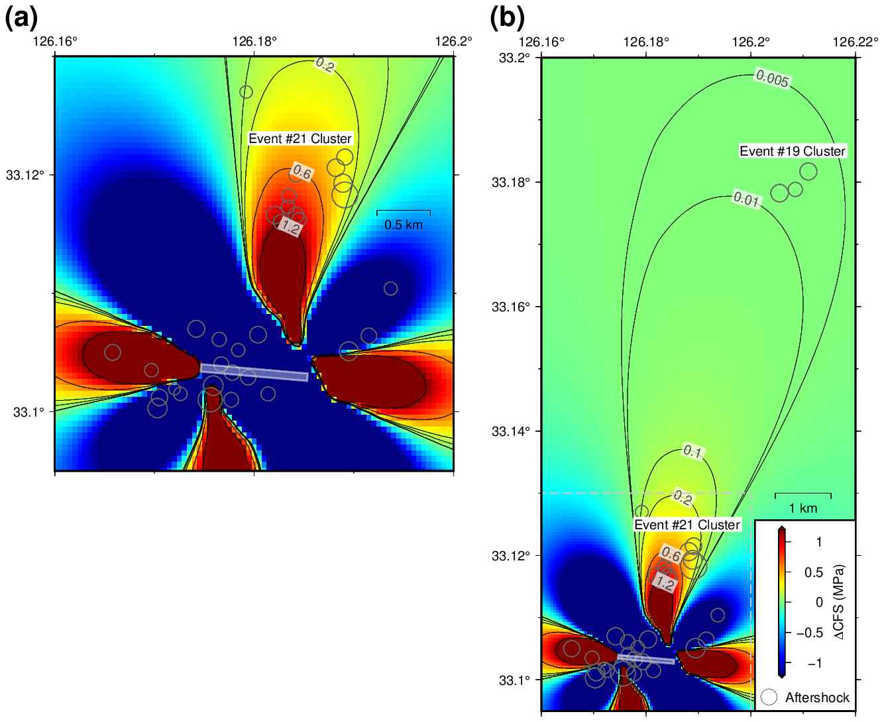
Figure S5. (a) Change in the Coulomb Failure Stress (ΔCFS) by the mainshock at regions close to the mainshock and #21 cluster is plotted. ΔCFS is calculated by using the program Coulomb 3.3 (Toda et al., 2011). The mainshock is assumed to be a uniform rupture on a square of 1 km, and its projection to the surface is indicated as a light blue rectangle. Iso-contours of the ΔCFS are indicated as black lines at 0.2, 0.6, and 1.2 MPa; (b) ΔCFS map of the wider area including the #19 cluster. Iso-contours of the ΔCFS are extended to 0.1, 0.01, and 0.005 MPa. #19 and #21 clusters are included in the region where the ΔCFS is positive, suggesting that the mainshock induced these clusters. The ΔCFS amplitude for the #21 cluster is 0.2 – 1.2 MPa. The amplitude for the #19 cluster is 0.005 – 0.01 MPa. The assumption behind this calculation of the ΔCFS was that the #21 cluster had the same focal mechanism as that of the mainshock. All calculations were performed for a depth of 11 km in half-space with Young’s modulus of 8×10⁴ MPa and Poisson’s ratio of 0.25.

Figure S6. Raw broadband, vertical records from the mainshock at the stations within 140 km from the epicenter are plotted according to their azimuth (away from the mainshock fault plane 79.6º – 331.9º). 2.5 s records starting P arrivals from the first event are plotted with their polarity reverse for clarity. Notice that two source pulses – the first one at 0.5 s and the second one at about 1.35 s, are clearly seen. The peak of the source pulses is indicated by solid triangles. Two pulses are separated by ~0.85 s at most of the stations, then the pulses at the north arrive with a shorter interval. Signals ~0.3 s before the first source pulse are those from two small subevents.

Figure S7. The horizontal projection of the P-axis of 2,347 shallow earthquakes (< 35 km) during 1976 – 2021 around the epicentral region from the Global Centroid Moment Tensor (GCMT) catalog. P-axis orientation is shown as a thick bar whose direction is the trend, and the length represents the plunge. Inset bar shows plunge= 0º (horizontal). P-axis orientation of the 14 December 2021 Offshore Jeju Island earthquake is consistent with those events in the offshore western Kyushu and along Okinawa Trough farther south.

References
Andrews, D. J. (1986). Objective determination of source parameters and similarity of earthquakes of different size, in Earthquake Source Mechanics, S. Das, J. Boatwright, and C. H. Scholz (Editors), American Geophysical Union, Washington, D.C., 37 259–267.
Prieto, G. A., Parker, R. L., and Vernon Iii, F. L. (2009). A Fortran 90 library for multitaper spectrum analysis. Comput. Geosci. 35 1701-1710.
Snoke, J. A. (1987). Stable determination of (Brune) stress drops. Bull. Seismol. Soc. Am. 77 530-538.
Toda, S., Stein, R.S., Sevilgen, V., and Lin, J. (2011). Coulomb 3.3 Graphic-rich deformation and stress-change software for earthquake, tectonic, and volcano research and teaching—user guide: U.S. Geological Survey Open-File Report 2011-1060, 63 p., available at http://pubs.usgs.gov/of/2011/1060/.

