Project
2025-04-04

R Markdown
This is an R Markdown document. Markdown is a simple formatting syntax for authoring HTML, PDF, and MS Word documents. For more details on using R Markdown see http://rmarkdown.rstudio.com.
When you click the Knit button a document will be generated that includes both content as well as the output of any embedded R code chunks within the document. You can embed an R code chunk like this:
library(dplyr)
##
## 载入程序包：'dplyr'
## The following objects are masked from 'package:stats':
##
## filter, lag
## The following objects are masked from 'package:base':
##
## intersect, setdiff, setequal, union
datas <- read.csv("C:\\COMP2501\\vgsales.csv")
head(datas)
## Rank Name Platform Year Genre Publisher NA_Sales EU_Sales
## 1 259 Asteroids 2600 1980 Shooter Atari 4.00 0.26
## 2 545 Missile Command 2600 1980 Shooter Atari 2.56 0.17
## 3 1768 Kaboom! 2600 1980 Misc Activision 1.07 0.07
## 4 1971 Defender 2600 1980 Misc Atari 0.99 0.05
## 5 2671 Boxing 2600 1980 Fighting Activision 0.72 0.04
## 6 4027 Ice Hockey 2600 1980 Sports Activision 0.46 0.03
## JP_Sales Other_Sales Global_Sales
## 1 0 0.05 4.31
## 2 0 0.03 2.76
## 3 0 0.01 1.15
## 4 0 0.01 1.05
## 5 0 0.01 0.77
## 6 0 0.01 0.49
# 分析平台的热门趋势
platform_trends <-datas |> select(Platform, Year) |>
group_by(Year) |>
count(Platform)
head(platform_trends)
## # A tibble: 6 × 3
## # Groups: Year [5]
## Year Platform n
## <int> <chr> <int>
## 1 1980 2600 9
## 2 1981 2600 46
## 3 1982 2600 36
## 4 1983 2600 11
## 5 1983 NES 6
## 6 1984 2600 1
platform_trends_filtered <- platform_trends |>
group_by(Year) |>
top_n(5, n)
platform_trends_filtered$Platform <- reorder(platform_trends_filtered$Platform,
-platform_trends_filtered$n,
FUN = mean)
tail(platform_trends_filtered)
## # A tibble: 6 × 3
## # Groups: Year [2]
## Year Platform n
## <int> <fct> <int>
## 1 2015 XOne 79
## 2 2016 3DS 35
## 3 2016 PC 38
## 4 2016 PS4 107
## 5 2016 PSV 60
## 6 2016 XOne 54
library(ggplot2)
library(ggthemes)
library(ggrepel)
ggplot(platform_trends_filtered, aes(x = Year, y = n, fill = Platform)) +
geom_bar(stat = "identity") +
labs(title = "Popularity trends of game platforms",
x = "Year",
y = "Number of games released on the platform")
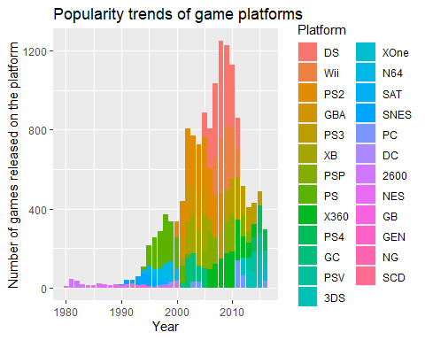
Note that the echo = FALSE parameter was added to the code chunk to prevent printing of the R code that generated the plot.
# 分析各个年份最热门的游戏平台
most_popular_platform_trend <- platform_trends |>
group_by(Year) |>
top_n(1, n)
ggplot(most_popular_platform_trend, aes(x = Year, y = n, fill = Platform)) +
geom_col() +
geom_text_repel(aes(label = Platform), vjust = -0.5, angle = 30,
max.overlaps = 5) +
labs(title = "The most popular gaming platform every year",
x = "Year",
y = "Number of games released on the platform")
## Warning: ggrepel: Repulsion works correctly only for rotation angles multiple
## of 90 degrees
## Warning: ggrepel: 24 unlabeled data points (too many overlaps). Consider
## increasing max.overlaps
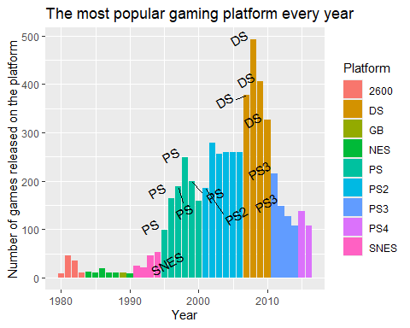
# 游戏平台市占率（市占率最高的几个）
# 所有平台的游戏销售量
total_sales_allplatform <- sum(datas$Global_Sales, na.rm = TRUE)
region_platform_data <- datas |>
group_by(Platform) |>
summarise(platform_sale = sum(Global_Sales, na.rm = TRUE)) |>
# 各个平台的市占率
mutate(percentage = platform_sale / total_sales_allplatform * 100)
head(region_platform_data)
## # A tibble: 6 × 3
## Platform platform_sale percentage
## <chr> <dbl> <dbl>
## 1 2600 86.6 0.981
## 2 3DO 0.1 0.00113
## 3 3DS 246. 2.79
## 4 DC 16.0 0.181
## 5 DS 819. 9.28
## 6 GB 254. 2.88
# 市占率最高的几个平台
region_platform_filtered <- region_platform_data |>
top_n(5, percentage)
head(region_platform_data)
## # A tibble: 6 × 3
## Platform platform_sale percentage
## <chr> <dbl> <dbl>
## 1 2600 86.6 0.981
## 2 3DO 0.1 0.00113
## 3 3DS 246. 2.79
## 4 DC 16.0 0.181
## 5 DS 819. 9.28
## 6 GB 254. 2.88
library(RColorBrewer)
myPalette <- brewer.pal(5, "Set2")
plot1 <- pie(region_platform_filtered$platform_sale,
labels = c("DS: 9.28%", "PS2: 13.98%", "PS3: 10.76%", "Wii: 10.31%",
"X360: 10.99%"),
radius = 1,
border="white", col=myPalette)
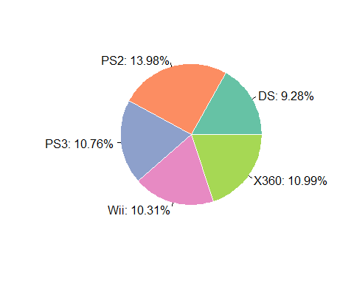
# 研究各个地区的游戏平台市占率
# 日本
total_sales_jp = sum(datas$JP_Sales, na.rm = TRUE)
jp_platform <- datas |>
group_by(Platform) |>
summarise(Japan_platform = sum(JP_Sales, na.rm = TRUE)) |>
# 计算各平台在日本地区的销售占比
mutate(percentage = Japan_platform / total_sales_jp * 100)
head(jp_platform)
## # A tibble: 6 × 3
## Platform Japan_platform percentage
## <chr> <dbl> <dbl>
## 1 2600 0 0
## 2 3DO 0.1 0.00779
## 3 3DS 97.3 7.58
## 4 DC 8.56 0.667
## 5 DS 175. 13.6
## 6 GB 85.1 6.63
jp_platform_filtered <- jp_platform |>
top_n(5, percentage) |>
arrange(desc(percentage))
head(jp_platform_filtered)
## # A tibble: 5 × 3
## Platform Japan_platform percentage
## <chr> <dbl> <dbl>
## 1 DS 175. 13.6
## 2 PS 140. 10.9
## 3 PS2 138. 10.7
## 4 SNES 117. 9.08
## 5 NES 98.6 7.68
myPalette <- brewer.pal(5, "Set2")
plot2 <- pie(jp_platform_filtered$percentage,
labels = c("DS: 13.63%", "PS: 10.88%", "PS2: 10.71%", "SNES: 9.08%",
"NES: 7.68%"),
radius = 1,
border="white", col=myPalette)
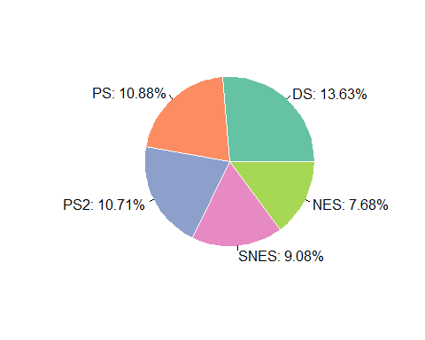
# 北美
total_sales_NA = sum(datas$NA_Sales, na.rm = TRUE)
na_platform <- datas |>
group_by(Platform) |>
summarise(NA_platform = sum(NA_Sales, na.rm = TRUE)) |>
# 计算各平台在日本地区的销售占比
mutate(percentage = NA_platform / total_sales_NA * 100)
head(na_platform)
## # A tibble: 6 × 3
## Platform NA_platform percentage
## <chr> <dbl> <dbl>
## 1 2600 80.8 1.86
## 2 3DO 0 0
## 3 3DS 78.0 1.80
## 4 DC 5.43 0.125
## 5 DS 389. 8.97
## 6 GB 114. 2.62
na_platform_filtered <- na_platform |>
top_n(5, percentage) |>
arrange(desc(percentage))
head(na_platform_filtered)
## # A tibble: 5 × 3
## Platform NA_platform percentage
## <chr> <dbl> <dbl>
## 1 X360 594. 13.7
## 2 PS2 573. 13.2
## 3 Wii 497. 11.5
## 4 PS3 389. 8.97
## 5 DS 389. 8.97
myPalette <- brewer.pal(5, "Set2")
plot3 <- pie(na_platform_filtered$percentage,
labels = c("X360: 13.72%", "PS2: 13.22%", "Wii: 11.48%", "PS3: 8.97%",
"DS: 8.97%"),
radius = 1,
border="white", col=myPalette)
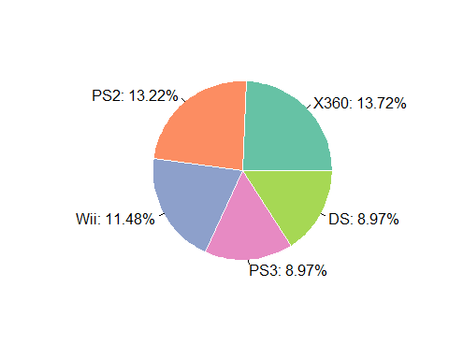
# 欧盟
total_sales_EU = sum(datas$EU_Sales, na.rm = TRUE)
EU_platform <- datas |>
group_by(Platform) |>
summarise(EU_platform = sum(EU_Sales, na.rm = TRUE)) |>
# 计算各平台在日本地区的销售占比
mutate(percentage = EU_platform / total_sales_EU * 100)
head(EU_platform)
## # A tibble: 6 × 3
## Platform EU_platform percentage
## <chr> <dbl> <dbl>
## 1 2600 4.86 0.202
## 2 3DO 0 0
## 3 3DS 58.3 2.42
## 4 DC 1.69 0.0702
## 5 DS 194. 8.06
## 6 GB 47.5 1.97
EU_platform_filtered <- EU_platform |>
top_n(5, percentage) |>
arrange(desc(percentage))
head(EU_platform_filtered)
## # A tibble: 5 × 3
## Platform EU_platform percentage
## <chr> <dbl> <dbl>
## 1 PS3 340. 14.1
## 2 PS2 333. 13.8
## 3 X360 278. 11.5
## 4 Wii 264. 11.0
## 5 PS 212. 8.82
myPalette <- brewer.pal(5, "Set2")
plot4 <- pie(EU_platform_filtered$percentage,
labels = c("PS3: 14.13%", "PS2: 13.81%", "X360: 11.54%", "Wii: 10.97%",
"PS: 8.82%"),
radius = 1,
border="white", col=myPalette)
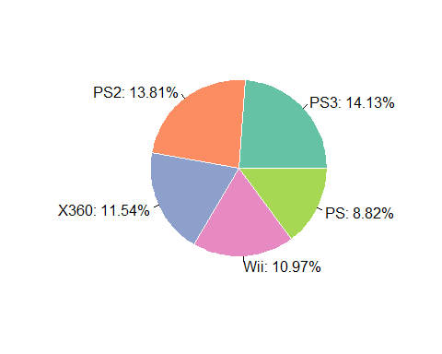
# 将四个饼状图合为一张图
# 设置图形布局为2行2列
par(mfrow = c(2, 2))
plot1 <- pie(region_platform_filtered$platform_sale,
labels = c("DS: 9.28%", "PS2: 13.98%", "PS3: 10.76%", "Wii: 10.31%",
"X360: 10.99%"),
radius = 1,
border="white", col=myPalette,
main = "popular platform in global")
plot2 <- pie(jp_platform_filtered$percentage,
labels = c("DS: 13.63%", "PS: 10.88%", "PS2: 10.71%", "SNES: 9.08%",
"NES: 7.68%"),
radius = 1,
border="white", col=myPalette,
main = "popular platform in Japan")
plot3 <- pie(na_platform_filtered$percentage,
labels = c("X360: 13.72%", "PS2: 13.22%", "Wii: 11.48%", "PS3: 8.97%",
"DS: 8.97%"),
radius = 1,
border="white", col=myPalette,
main = "popular platform in North America")
plot4 <- pie(EU_platform_filtered$percentage,
labels = c("PS3: 14.13%", "PS2: 13.81%", "X360: 11.54%", "Wii: 10.97%",
"PS: 8.82%"),
radius = 1,
border="white", col=myPalette,
main = "popular platform in Europe")
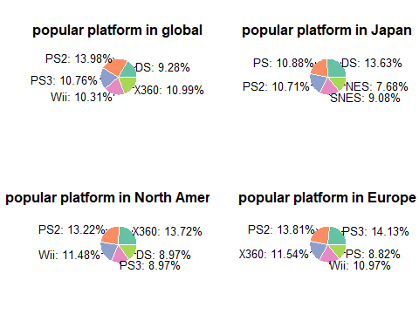
# 各地区游戏销量趋势
library(tidyverse)
## ── Attaching core tidyverse packages ──────────────────────── tidyverse 2.0.0 ──
## ✔ forcats 1.0.0 ✔ stringr 1.5.1
## ✔ lubridate 1.9.4 ✔ tibble 3.2.1
## ✔ purrr 1.0.4 ✔ tidyr 1.3.1
## ✔ readr 2.1.5
## ── Conflicts ────────────────────────────────────────── tidyverse_conflicts() ──
## ✖ dplyr::filter() masks stats::filter()
## ✖ dplyr::lag() masks stats::lag()
## ℹ Use the conflicted package (<http://conflicted.r-lib.org/>) to force all conflicts to become errors
# 将数据转为长数据
region_sales <- datas |>
pivot_longer(cols = `NA_Sales`:`Other_Sales`, names_to = "region",
values_to = "sales")
# 将地区销量按年分类
region_sales <- region_sales |>
select(Year, region, sales) |>
group_by(Year, region) |>
summarise(total_sales_region = sum(sales, na.rm = TRUE), .groups = "keep")
head(region_sales)
## # A tibble: 6 × 3
## # Groups: Year, region [6]
## Year region total_sales_region
## <int> <chr> <dbl>
## 1 1980 EU_Sales 0.67
## 2 1980 JP_Sales 0
## 3 1980 NA_Sales 10.6
## 4 1980 Other_Sales 0.12
## 5 1981 EU_Sales 1.96
## 6 1981 JP_Sales 0
ggplot(region_sales, aes(x = Year, y = total_sales_region, colour = region)) +
geom_point() +
geom_line()
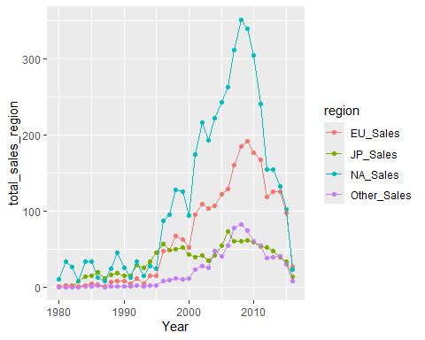
# 最受欢迎的游戏类型趋势
# 分析每年最受欢迎的五个游戏类别（由1995年开始分析，前些年游戏产业不成熟）
popular_genre <- datas |>
select(Year, Genre, Global_Sales) |>
group_by(Year, Genre) |>
summarise(total_global_sales = sum(Global_Sales, na.rm = TRUE)) |>
group_by(Year) |>
filter(Year %in% 1995:2030) |>
mutate(Genre = reorder(Genre, total_global_sales)) |>
top_n(3, total_global_sales)
## `summarise()` has grouped output by 'Year'. You can override using the
## `.groups` argument.
head(popular_genre, 20)
## # A tibble: 20 × 3
## # Groups: Year [7]
## Year Genre total_global_sales
## <int> <fct> <dbl>
## 1 1995 Fighting 14.8
## 2 1995 Platform 16.7
## 3 1995 Role-Playing 14.3
## 4 1996 Platform 28.2
## 5 1996 Racing 28.2
## 6 1996 Role-Playing 44.0
## 7 1997 Action 27.6
## 8 1997 Racing 31.9
## 9 1997 Sports 30.0
## 10 1998 Action 39.4
## 11 1998 Fighting 31.7
## 12 1998 Sports 41.8
## 13 1999 Racing 37.3
## 14 1999 Role-Playing 49.1
## 15 1999 Sports 30.3
## 16 2000 Action 34.0
## 17 2000 Role-Playing 29.0
## 18 2000 Sports 41.2
## 19 2001 Action 59.4
## 20 2001 Racing 55.8
ggplot(popular_genre, aes(x = Year, y = total_global_sales, colour = Genre)) +
geom_col() +
labs(title = "Trends of popular game genre",
x = "Year",
y = "Total global sale of video game")
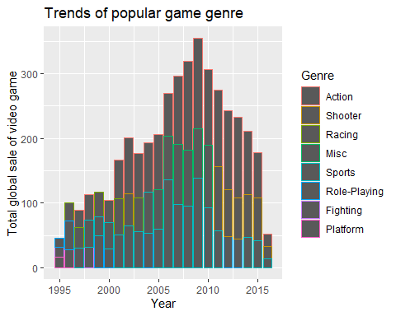
# 游戏类别的累计销售额
genre_sales <- datas |>
group_by(Genre) |>
summarise(total_genre_sales = sum(Global_Sales)) |>
mutate(Genre = reorder(Genre, -total_genre_sales))
head(genre_sales)
## # A tibble: 6 × 2
## Genre total_genre_sales
## <fct> <dbl>
## 1 Action 1723.
## 2 Adventure 235.
## 3 Fighting 444.
## 4 Misc 798.
## 5 Platform 829.
## 6 Puzzle 242.
ggplot(genre_sales, aes(x = Genre, y = total_genre_sales)) +
geom_col(fill = "skyblue") +
labs(title = "Total sales of each genre",
x = "Genre",
y = "Total sales of genre in global") +
theme(axis.text.x = element_text(angle = 30, hjust = 1))
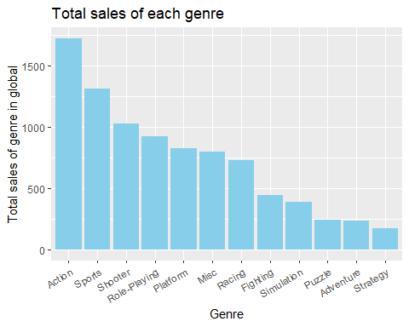
# 各个游戏类别的游戏数量
total_genre <- datas |>
filter(!is.na(Genre)) |>
group_by(Genre) |>
summarise(total = n()) |>
mutate(Genre = reorder(Genre, -total))
head(total_genre)
## # A tibble: 6 × 2
## Genre total
## <fct> <int>
## 1 Action 3252
## 2 Adventure 1276
## 3 Fighting 836
## 4 Misc 1710
## 5 Platform 876
## 6 Puzzle 571
ggplot(total_genre, aes(x = Genre, y = total)) +
geom_col(fill = "skyblue") +
labs(title = "Total game of each genre",
x = "Genre",
y = "Total game of genre") +
theme(axis.text.x = element_text(angle = 30, hjust = 1))
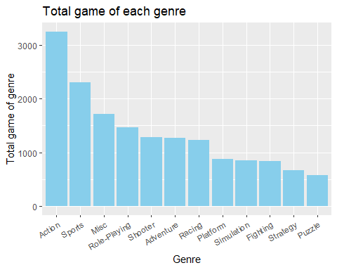
# 排名前500的游戏中，各个发行商发行游戏之市占比
publishers_sales <- datas |>
select(Publisher, Rank) |>
filter(Rank %in% 1:500) |>
group_by(Publisher) |>
summarise(total = n())
publishers_sales <- publishers_sales |>
mutate(percentage = total / sum(total) * 100) |>
arrange(desc(percentage)) |>
top_n(10, percentage) |>
mutate(Publisher = reorder(Publisher, -percentage))
head(publishers_sales)
## # A tibble: 6 × 3
## Publisher total percentage
## <fct> <int> <dbl>
## 1 Nintendo 141 28.4
## 2 Electronic Arts 64 12.9
## 3 Sony Computer Entertainment 52 10.5
## 4 Activision 45 9.07
## 5 Ubisoft 28 5.65
## 6 Take-Two Interactive 24 4.84
ggplot(publishers_sales, aes(x = Publisher, y = percentage)) +
geom_col(fill = "blue") +
labs(title = "Percentage of publisher in top 500 games",
x = "Game publisher",
y = "Percentafe of game publisher") +
theme(axis.text.x = element_text(angle = 30, hjust = 1))
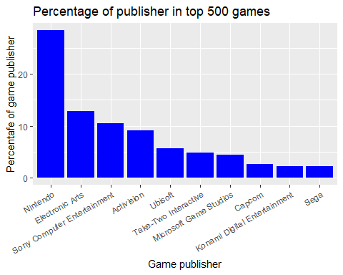
# 各个地区发行商游戏销售额
# 日本
jp_publisher_sales <- datas |>
filter(!is.na(Publisher)) |>
group_by(Publisher) |>
summarise(total_jp_sale = sum(JP_Sales)) |>
arrange(desc(total_jp_sale)) |>
mutate(percentage = total_jp_sale / sum(total_jp_sale) * 100)
head(jp_publisher_sales)
## # A tibble: 6 × 3
## Publisher total_jp_sale percentage
## <chr> <dbl> <dbl>
## 1 Nintendo 455. 35.4
## 2 Namco Bandai Games 127. 9.88
## 3 Konami Digital Entertainment 90.9 7.08
## 4 Sony Computer Entertainment 74.1 5.77
## 5 Capcom 67.4 5.25
## 6 Sega 56.2 4.37
# 北美
na_publisher_sales <- datas |>
filter(!is.na(Publisher)) |>
group_by(Publisher) |>
summarise(total_na_sale = sum(NA_Sales)) |>
arrange(desc(total_na_sale)) |>
mutate(percentage = total_na_sale / sum(total_na_sale) * 100)
head(na_publisher_sales)
## # A tibble: 6 × 3
## Publisher total_na_sale percentage
## <chr> <dbl> <dbl>
## 1 Nintendo 816. 18.8
## 2 Electronic Arts 584. 13.5
## 3 Activision 426. 9.83
## 4 Sony Computer Entertainment 265. 6.12
## 5 Ubisoft 253. 5.83
## 6 Take-Two Interactive 220. 5.09
# 欧盟
eu_publisher_sales <- datas |>
filter(!is.na(Publisher)) |>
group_by(Publisher) |>
summarise(total_eu_sale = sum(EU_Sales)) |>
arrange(desc(total_eu_sale)) |>
mutate(percentage = total_eu_sale / sum(total_eu_sale) * 100)
head(eu_publisher_sales)
## # A tibble: 6 × 3
## Publisher total_eu_sale percentage
## <chr> <dbl> <dbl>
## 1 Nintendo 418. 17.4
## 2 Electronic Arts 367. 15.2
## 3 Activision 214. 8.87
## 4 Sony Computer Entertainment 188. 7.79
## 5 Ubisoft 163. 6.77
## 6 Take-Two Interactive 118. 4.90
# 北美销量与欧洲销量的相关性
cor.test(datas$NA_Sales, datas$EU_Sales, method = "pearson")
##
## Pearson's product-moment correlation
##
## data: datas$NA_Sales and datas$EU_Sales
## t = 153.66, df = 16322, p-value < 2.2e-16
## alternative hypothesis: true correlation is not equal to 0
## 95 percent confidence interval:
## 0.7625872 0.7751296
## sample estimates:
## cor
## 0.7689324
cor.test(datas$NA_Sales, datas$JP_Sales, method = "pearson")
##
## Pearson's product-moment correlation
##
## data: datas$NA_Sales and datas$JP_Sales
## t = 64.607, df = 16322, p-value < 2.2e-16
## alternative hypothesis: true correlation is not equal to 0
## 95 percent confidence interval:
## 0.438978 0.463412
## sample estimates:
## cor
## 0.4512796
# 贝叶斯定理
# 假设先验概率：成功游戏的比例
prior_success <- sum(datas$Global_Sales > 1) / nrow(datas)
# 动作类成功概率（销量最高）
action_games <- datas[datas$Genre == "Action", ]
action_success_rate <- sum(action_games$Global_Sales > 1) / nrow(action_games)
# 后验概率计算（简单示例，假设独立事件）
posterior_success_action <- (action_success_rate * prior_success) /
((action_success_rate * prior_success) + ((1 - action_success_rate) * (1 - prior_success)))
posterior_success_action
## [1] 0.02037416
# 策略类游戏成功概率（销量最低）
strategy_games <- datas[datas$Genre == "Strategy", ]
strategy_sucess_rate <- sum(strategy_games$Global_Sales > 1) / nrow(strategy_games)
posterior_success_strategy <- (strategy_sucess_rate * prior_success) /
((strategy_sucess_rate * prior_success) + ((1 - strategy_sucess_rate) * (1 - prior_success)))
posterior_success_strategy
## [1] 0.006839617
differences <- posterior_success_action / posterior_success_strategy
differences
## [1] 2.978845

