Article
Coupled Acoustic-Elastic Finite Element Modeling of Underwater Sound Propagation

Abstract
Underwater sound propagation modeling is fundamental to sonar design and marine exploration. The parabolic equation (PE) method has been the dominant tool, but carries inherent limitations: the one-way approximation neglects backscattered energy, acoustic-only implementations ignore shear-wave conversion at the fluid-solid interface, and range-marching discretization approximates irregular bathymetry as a staircase boundary. These limitations become significant at low frequencies (below 200 Hz), where acoustic wavelengths reach 7.5-30 m and a substantial fraction of energy penetrates into the elastic seabed, exciting both compressional and shear waves. This study develops a two-dimensional frequency-domain finite element model that couples the Helmholtz equation in the water column with the Navier equation in the elastic seabed, enforcing pressure and normal displacement continuity at the fluid-solid interface as natural boundary conditions within a unified weak formulation. Irregular bathymetry is represented by a terrain-following curvilinear mesh generated via transfinite interpolation, eliminating staircase errors. A perfectly matched layer truncates open boundaries. Validation against RAMGEO for a Pekeris waveguide yields a smoothed mean absolute error of 1.8 dB (mean bias -0.17 dB). Comparison of acoustic-only and coupled models shows mean |ΔTL| of 0.8-5.1 dB across three seabed types, with local maxima exceeding 10 dB at interference nulls, confirming that acoustic-only models systematically underestimate transmission loss. Staircase mesh case studies show displacement differences of 53-116% and pressure differences of 23-24% relative to the curvilinear solution. The proposed model provides a rigorous forward engine for accurate transmission loss prediction in complex shallow-water environments.

Keywords: finite element method; acoustic-elastic coupling; transmission loss; underwater sound propagation; curvilinear mesh

1. Introduction
Underwater sound propagation modeling is fundamental to sonar system design, marine exploration, and underwater communications ^{[1-3]}. The dominant computational paradigm in this field has been the parabolic equation (PE) method, which approximates the full wave equation by factoring out the dominant horizontal phase and marching the resulting slowly varying envelope forward in range. The split-step Padé algorithm of Collins ^{[4]}, implemented in the Range-dependent Acoustic Model (RAM), provides an excellent balance of computational efficiency and accuracy for range-dependent environments and has become the de facto standard tool in operational underwater acoustics. For horizontally stratified environments, the normal-mode code KRAKEN ^{[5]} and the acousto-elastic normal-mode model of Westwood et al. ^{[6]} offer accurate solutions. Collins ^{[7]} and Collins and Westwood ^{[8]} further extended PE to elastic seabeds, establishing the energy-conserving higher-order formulations that underpin RAMGEO, which serves as the benchmark reference in the present study.
However, the PE-based approach carries inherent physical and numerical limitations that become increasingly significant in low-frequency, shallow-water environments. At frequencies below approximately 200 Hz, acoustic wavelengths in the water column reach 7.5–30 m, and a substantial fraction of the acoustic energy penetrates into the seabed rather than being reflected at the water-sediment interface ^{[1,9]}. In shallow-water waveguides where the water depth is comparable to or only a few times the acoustic wavelength, the seabed ceases to be a mere boundary condition; it becomes an active part of the propagation domain ^{[9,10]}. Acoustic energy that enters the elastic sediment propagates as both compressional (P) and shear (S) waves, interacts with sub-seabed layer interfaces, and can re-radiate back into the water column, modifying the interference pattern and transmission loss (TL) by several decibels ^{[9,10]}. These sub-seabed interactions are governed by the full elastic wave equation — the same Navier equation that underpins seismic wave modeling in exploration geophysics ^{[11-13]} — and cannot be captured by the one-way PE approximation, which by construction propagates energy only in the forward (range-increasing) direction and neglects backscattered contributions from the seabed interior.
Furthermore, at low frequencies where acoustic energy penetrates deeply into the seabed, the elastic properties of the seabed — particularly the shear-wave velocity $V_{S}$ — become decisive for accurate TL prediction. At the fluid-solid interface, incident compressional waves undergo P-to-S mode conversion, diverting a fraction of the incident energy into shear waves in the sediment ^{[9,10]}. The magnitude of this energy partition depends on the impedance contrast and the P-wave critical angle $θ_{cP}=\sin^{-1}(c_{f}/V_{P})$; for soft sediments with $V_{S}$ = 200–400 m/s, the mode-conversion effect can alter TL by 1–6 dB on average, with local maxima exceeding 10 dB at interference nulls ^{[9]}. Acoustic-only models, which treat the seabed as a fluid half-space with $V_{S}$ = 0, are structurally incapable of representing this shear-wave energy loss and the associated phase shift in the reflection coefficient that modifies the multipath interference pattern throughout the water column. Consequently, for rigorous underwater acoustic analysis in shallow-water environments with elastic seabeds, a fully coupled acoustic-elastic formulation is essential ^{[14,15]}.
A separate but equally important limitation of existing methods concerns the representation of irregular seabed topography. PE-based methods advance horizontally and discretize the water depth as a sequence of flat steps, resulting in a staircase approximation of the true bathymetric boundary. This staircase artifact introduces two sources of numerical error: artificial diffraction at step corners generates spurious scattered waves, and the distorted local normal direction at step faces produces incorrect reflection coefficients ^{[11,12]}. These errors are most severe at slope angles beyond approximately 5° and at higher frequencies, and can contribute several decibels of error in TL prediction. Regular-grid finite-difference methods (FDM) share this staircase limitation because the Cartesian grid does not conform to bathymetric boundaries ^{[11,12]}. In exploration seismology, terrain-following curvilinear meshes — generated via the transfinite interpolation (TFI) framework of Gordon and Hall ^{[16]} and the structured grid generation theory of Thompson et al. ^{[17]} — have long been the standard remedy for irregular topography. However, this approach has seldom been applied systematically to underwater acoustic propagation modeling.
The finite element method (FEM), a mature tool in exploration geophysics ^{[13,18,19]}, offers a natural solution to all three limitations described above. Frequency-domain FEM, established as the forward engine for seismic FWI by Pratt ^{[13]}, solves the complete Helmholtz equation for acoustic pressure without the one-way approximation inherent in PE. The elastic wave equation (Navier equation) is solved simultaneously, with acoustic-elastic coupling enforced at the fluid-solid interface through natural boundary conditions in the weak formulation ^{[19,20]}. Ihlenburg ^{[18]} systematically analyzed the Helmholtz FEM formulation and numerical dispersion, while Zienkiewicz and Taylor ^{[19]} and Atalla and Sgard ^{[20]} established the theoretical foundation for acoustic-elastic coupled FEM. The spectral element method (SEM) of Komatitsch and Tromp ^{[21]} demonstrated high-order accuracy for elastic wave propagation on unstructured meshes; Bottero et al. ^{[22]} applied time-domain SEM to full-wave ocean acoustic simulation with acoustic-elastic seabed coupling; and Cristini and Komatitsch ^{[23]} illustrated further SEM applications in ocean acoustics. Isakson and Chotiros ^{[24]} applied FEM to shallow-water waveguide reverberation and transmission loss, and Kim et al. ^{[25]} presented frequency-domain FEM for acoustic wave propagation. Absorbing boundaries are handled by the perfectly matched layer (PML), originally developed for electromagnetic wave simulation by Bérenger ^{[26]} and subsequently adopted as a standard tool in seismic wave modeling ^{[27,28]}. Despite these individual developments, to the best of our knowledge, no published study simultaneously combines frequency-domain FEM with quadrilateral elements, complete acoustic-elastic coupling, a terrain-following curvilinear mesh, and systematic quantitative verification against an established benchmark code such as RAMGEO.
The present study addresses this gap by developing a 2D frequency-domain FEM model that fully couples the Helmholtz equation in the water column with the Navier equation in the elastic seabed, enforcing pressure continuity and normal displacement continuity at the fluid-solid interface as natural boundary conditions within a unified weak formulation. Irregular bathymetry is represented by a terrain-following curvilinear mesh generated via the TFI of Gordon and Hall ^{[16]}, an established technique in structured grid generation ^{[17,29]}, eliminating staircase errors at the geometrical level. Outgoing waves are absorbed by a PML ^{[26,27,30]}. The resulting sparse linear system is solved with the PARDISO direct solver ^{[31]}. The FEM model is systematically validated against RAMGEO ^{[7,8]}, and the TL difference ($Δ$TL) between the fully coupled and acoustic-only models is quantified. Sensitivity analyses are conducted over frequency (50, 100, 200 Hz) and seabed shear-wave velocity (soft, medium, and hard seabed types), and a case study comparing staircase and curvilinear mesh representations across three irregular bathymetric profiles completes the numerical investigation. The developed model provides a benchmark-quality forward solution for underwater acoustic propagation over elastic seabeds with irregular bathymetry.
The remainder of this paper is organized as follows. Section 2 presents the governing equations, acoustic-elastic coupling conditions, FEM weak formulation, and curvilinear mesh generation. Section 3 presents five numerical experiments assessing model accuracy and parametric sensitivity. Section 4 discusses the physical interpretation of the results and limitations. Section 5 states the conclusions.

2. Theory and Methods
This section presents the mathematical foundation of the 2D frequency-domain finite element model for coupled acoustic-elastic underwater sound propagation. As discussed in the Introduction, at the low frequencies of interest (50-200 Hz) acoustic energy penetrates deeply into the seabed, where it propagates as both compressional and shear waves governed by the elastic wave equation. Accurate modeling of this sub-seabed response requires solving the full wave equations in both the water column and the elastic seabed simultaneously. Accordingly, the water column is treated as an inviscid ideal fluid governed by the Helmholtz equation, while the seabed is treated as an isotropic elastic solid governed by the frequency-domain Navier equation — the same equations that underpin seismic wave modeling in exploration geophysics ^{[13]}. The solutions in the two domains are linked through physically consistent coupling conditions at the fluid-solid interface that enforce pressure continuity and normal displacement continuity. Galerkin finite element discretization together with isoparametric curvilinear coordinate transformation leads to a coupled sparse linear system. Outgoing waves at artificial boundaries are absorbed by a perfectly matched layer (PML), and irregular bathymetry is represented by a terrain-following curvilinear mesh based on transfinite interpolation (TFI) ^{[16]}, eliminating the staircase errors inherent in PE and FDM methods.
2.1. Acoustic Governing Equation
2.1.1. Helmholtz Equation
The fundamental equation governing underwater sound propagation is the wave equation for acoustic pressure $p(x,t)$. In an inviscid, irrotational fluid, pressure perturbations satisfy
$\frac{1}{c_{f}^{2}(x)}\frac{∂^{2}p}{∂t^{2}}-∇^{2}p=s(x,t)$ (1)
where $c_{f}(x)$ is the spatially varying sound speed, $s(x,t)$ is the source function, and $∇^{2}=∂^{2}/∂x^{2}+∂^{2}/∂z^{2}$ is the 2D Laplacian. The spatial dependence of $c_{f}$ accommodates realistic ocean sound-speed profiles.
Assuming a time-harmonic source $e^{-iωt}$ and applying the Fourier transform, the time-domain wave Equation 1 reduces to the frequency-domain Helmholtz equation, widely used in frequency-domain seismic modeling ^{[13]}:
$∇^{2}p(x,ω)+k_{f}^{2}(x) p(x,ω)=-S(x,ω)$ (2)
where $p(x,ω)$ is the complex acoustic pressure amplitude, $k_{f}(x)=ω/c_{f}(x)$ is the wavenumber, $ω=2πf$ is the angular frequency, and $S(x,ω)$ is the source spectrum. For a point source, $S(x,ω)=δ(x-x_{s})$, whose 2D free-space Green’s function is the zero-order Hankel function of the first kind, $p_{inc}(r)=(i/4)H_{0}^{(1)}(k_{f}r)$.
In Equation 2, the term $∇^{2}p$ describes spatial diffusion of the pressure field, while $k_{f}^{2}p$ represents the restoring character of wave propagation; the balance between these two terms determines the wave propagation pattern. Transmission loss (TL) at a receiver location is defined relative to the pressure $p_{0}$ at a reference distance $r_{0}=1$ m:
$TL=-20\log_{10}\left|\frac{p(x)}{p_{0}}\right| [dB]$ (3)
2.1.2. Advantages of the Frequency-Domain Formulation
Three principal advantages motivate the use of the frequency-domain Helmholtz Equation 2 rather than a time-domain formulation. First, the problem reduces to solving a single linear system for each target frequency, eliminating the thousands of time-step iterations required to satisfy the CFL stability condition in the time domain. Second, frequency-domain discretization yields a sparse complex linear system that can be solved efficiently by high-performance sparse direct solvers such as PARDISO ^{[13]}. Third, when multiple source positions are considered, the LU factorization of the system matrix is computed only once and reused for each source via back-substitution, substantially reducing the total computational cost — the same strategy that underpins frequency-domain seismic FWI ^{[13]}. In the present study, the finite element solution of Equation 2 is obtained independently for each of the discrete frequencies in the range 50–200 Hz.
2.2. Elastic Governing Equation
2.2.1. Frequency-Domain Navier Equation
Elastic wave propagation in the seabed (sediment and basement rock) is governed by linear elasticity theory — the same physical foundation underlying seismic exploration modeling. The equation of motion for the displacement vector $u=(u_{x},u_{z})^{T}$, derived from Newton’s second law and the divergence of the Cauchy stress tensor, becomes under the time-harmonic assumption $e^{-iωt}$:
$-ω^{2}ρ_{s}(x) u(x,ω)=∇⋅σ(x,ω)$ (4)
where $ρ_{s}(x)$ is the spatially varying density and $σ$ is the Cauchy stress tensor. The left-hand side of Equation 4 represents the inertia force $-ω^{2}ρ_{s}u$, and the right-hand side $∇⋅σ$ is the elastic restoring force arising from spatial gradients in internal stress. The balance between these two forces determines elastic wave propagation. Expanding by component for an isotropic elastic medium, the $x$- and $z$-direction equations of motion are:
$(λ+2μ)\frac{∂^{2}u_{x}}{∂x^{2}}+μ\frac{∂^{2}u_{x}}{∂z^{2}}+(λ+μ)\frac{∂^{2}u_{z}}{∂x∂z}+ω^{2}ρ_{s}u_{x}=0$ (5)
$(λ+2μ)\frac{∂^{2}u_{z}}{∂z^{2}}+μ\frac{∂^{2}u_{z}}{∂x^{2}}+(λ+μ)\frac{∂^{2}u_{x}}{∂x∂z}+ω^{2}ρ_{s}u_{z}=0$ (6)
2.2.2. Stress-Strain Relationship (Hooke’s Law)
For an isotropic linearly elastic solid, the stress tensor $σ$ and strain tensor $ε$ are related by the generalized Hooke’s law:
$σ_{ij}=λ δ_{ij} ε_{kk}+2μ ε_{ij}$ (7)
where $λ$ and $μ$ are the Lamé constants and $δ_{ij}$ is the Kronecker delta. The strain tensor is defined as the symmetric gradient of the displacement:
$ε_{ij}=\frac{1}{2}\left(\frac{∂u_{i}}{∂x_{j}}+\frac{∂u_{j}}{∂x_{i}}\right)$ (8)
Under 2D plane-strain conditions, the stress components are explicitly:
$\begin{aligned}σ_{xx}&=(λ+2μ)\frac{∂u_{x}}{∂x}+λ\frac{∂u_{z}}{∂z} \\ σ_{zz}&=λ\frac{∂u_{x}}{∂x}+(λ+2μ)\frac{∂u_{z}}{∂z} \\ σ_{xz}&=μ\left(\frac{∂u_{x}}{∂z}+\frac{∂u_{z}}{∂x}\right)\end{aligned}$ (9)
2.2.3. Relationship Between Elastic Wave Velocities and Lamé Constants
Because the Lamé constants are not directly measurable, it is convenient to express them in terms of the compressional wave velocity $V_{P}$, shear wave velocity $V_{S}$, and density $ρ_{s}$:
$V_{P}=\sqrt{\frac{λ+2μ}{ρ_{s}}}, V_{S}=\sqrt{\frac{μ}{ρ_{s}}}$ (10)
$V_{P}$ is determined by the bulk modulus $λ+2μ$ and density, while $V_{S}$ depends solely on the shear modulus $μ$. The Lamé constants are recovered from the specified material properties as:
$μ=ρ_{s}V_{S}^{2}, λ=ρ_{s}(V_{P}^{2}-2V_{S}^{2})$ (11)
In the fluid (water column), shear stresses cannot be sustained, so $μ=0$ and shear waves do not exist. This is the fundamental physical distinction between the water column and the elastic seabed, and it necessitates separate governing equations for the two domains. Wave attenuation is incorporated by treating the Lamé constants as complex-valued quantities. Under the $e^{-iωt}$ time-harmonic convention, attenuation requires a negative imaginary part, so the complex velocities are defined as $V_{P}^{*}=V_{P}(1-i/(2Q_{P}))$ and $V_{S}^{*}=V_{S}(1-i/(2Q_{S}))$; substituting these into Equation 11 naturally introduces frequency-domain attenuation parameterized by the quality factors $Q_{P}$ and $Q_{S}$ ^{[1]}.
2.3. Acoustic-Elastic Coupling Conditions
At the interface $Γ_{fs}$ between the acoustic fluid domain $Ω_{f}$ and the elastic solid domain $Ω_{s}$, three physically required coupling conditions must be enforced ^{[1,9]}. We adopt the $e^{-iωt}$ time-harmonic convention throughout, with acoustic pressure defined as positive in compression (i.e., $p>0$ corresponds to a compressive state). The Cauchy stress $σ$ follows the standard solid-mechanics sign convention (tension positive). Let $\hat{n}$ denote the unit outward normal from the fluid domain directed into the solid domain. The fluid particle displacement is related to the pressure gradient through the linearized momentum equation $ρ_{f}ω^{2}u^{f}=∇p$, which gives the normal component $u_{n}^{f}=(1/ρ_{f}ω^{2}) ∂p/∂n$.
Condition 1: Normal stress continuity. The normal stress must be continuous across the fluid-solid interface. Since an ideal fluid sustains no tangential stress, the normal traction on the fluid side equals the acoustic pressure $p$. The force balance condition is:
$σ⋅\hat{n}|_{Ω_{s}}=-p\hat{n}|_{Ω_{f}} \text{on }Γ_{fs}$ (12)
That is, the acoustic pressure on the fluid side equals in magnitude, and is opposite in sign to, the normal compressive stress on the solid side.
Condition 2: Normal displacement continuity. The interface must remain in contact, so the normal displacement is continuous. In the frequency domain, the normal displacement of the fluid particle is obtained from the momentum equation $ρ_{f}ω^{2}u_{n}^{f}=∂p/∂n$, giving:
$u⋅\hat{n}|_{Ω_{s}}=-\frac{1}{ρ_{f}ω^{2}}\frac{∂p}{∂n}|_{Ω_{f}} \text{on }Γ_{fs}$ (13)
Condition 3: Zero shear traction. An ideal fluid cannot transmit shear stresses, so the tangential traction component on the solid side of the interface must vanish:
$\left[σ⋅\hat{n}-(σ⋅\hat{n}⋅\hat{n})\hat{n}\right]|_{Ω_{s}}=0 \text{on }Γ_{fs}$ (14)
Since condition (12) already prescribes the normal component only, condition (14) is automatically satisfied when (12) holds. All three conditions are incorporated as natural boundary conditions in the surface integral terms of the weak formulation and are imposed automatically during FEM matrix assembly, without explicit interfacial constraints.
2.4. Finite Element Formulation
2.4.1. Weak Formulation
The full computational domain consists of the fluid region $Ω_{f}$, the solid region $Ω_{s}$, their shared interface $Γ_{fs}$, and the absorbing PML layer $Ω_{PML}$ (Figure 1).
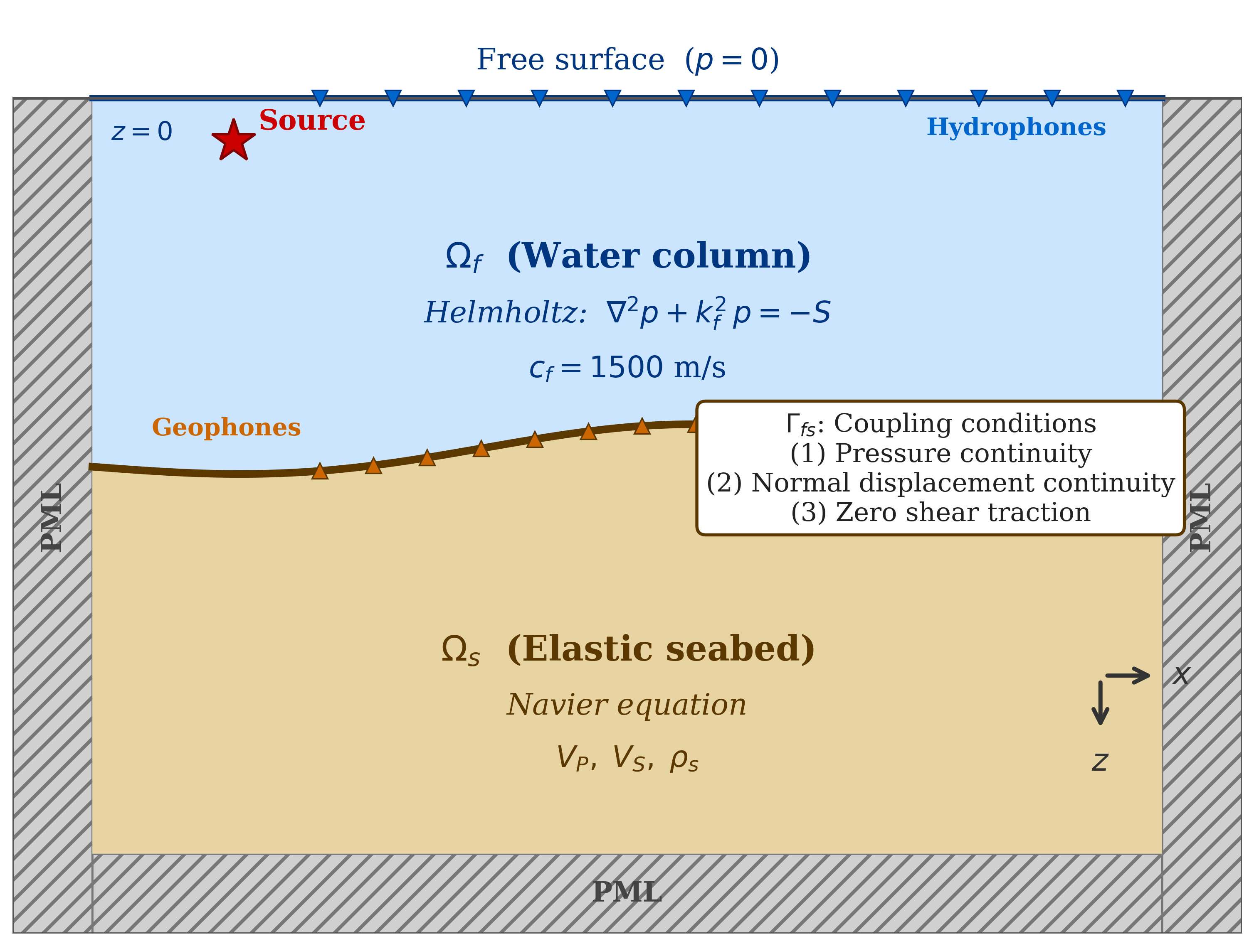
Figure 1. Schematic of the 2D computational domain showing the acoustic fluid domain ($Ω_{f}$), elastic solid domain ($Ω_{s}$), fluid-solid interface ($Γ_{fs}$), perfectly matched layer (PML), and boundary conditions. The point source is located at depth $z_{s}$ in the water column.
Acoustic domain weak form. Multiplying Equation 2 by a test function $q∈H^{1}(Ω_{f})$, integrating over $Ω_{f}$, and applying Green’s first identity (integration by parts) yields:
Ωf​∇q⋅∇p dΩ-kf2Ωf​q p dΩ-∂Ωf​q∂p∂n dΓ=Ωf​q S dΩ (15)
The first term on the left represents spatial diffusion via the pressure gradient inner product; the second term represents wave propagation via the wavenumber. The boundary integral ∂Ωf​q(∂p/∂n) dΓ is handled according to the boundary type. At the coupling interface $Γ_{fs}$, substituting condition (13) gives:
Γfs​q∂p∂n dΓ=-ρfω2Γfs​q (u⋅n) dΓ (16)
This term expresses the physical action of the solid normal displacement as a pressure source in the acoustic domain.
Elastic domain weak form. Taking the inner product of Equation 4 with a vector test function $v∈[H^{1}(Ω_{s})]^{2}$, integrating over $Ω_{s}$, and applying Green’s first identity yields:
Ωs​σ(u):ε(v) dΩ-ω2Ωs​ρsu⋅v dΩ=∂Ωs​(σ⋅n)⋅v dΓ (17)
The first term on the left is the internal elastic energy; the second is the inertia term. At the coupling interface $Γ_{fs}$, substituting condition (12) gives:
Γfs​(σ⋅n)⋅v dΓ=-Γfs​p (v⋅n) dΓ (18)
This term expresses the physical action of the acoustic pressure as a normal load on the elastic boundary. The coupled weak system is formed by combining Equations 15–18, with unknowns comprising the fluid pressure $p$ and solid displacements $(u_{x},u_{z})$.
2.4.2. Discretization and Matrix Assembly
The Galerkin method is adopted, so that the trial and test function spaces are identical. The computational domain is partitioned into isoparametric quadrilateral elements, within each of which the unknowns are approximated by nodal basis functions. Nine-node biquadratic Lagrange elements (Q9) are employed. In the reference coordinates $(ξ,η)∈[-1,1]^{2}$, the shape functions are tensor products of 1D quadratic Lagrange polynomials:
$N_{I}(ξ,η)=L_{i}(ξ) L_{j}(η), I=3(j-1)+i, i,j∈\{1,2,3\}$ (19)
where the 1D Lagrange basis functions are:
$L_{1}(ξ)=\frac{ξ(ξ-1)}{2}, L_{2}(ξ)=1-ξ^{2}, L_{3}(ξ)=\frac{ξ(ξ+1)}{2}$ (20)
Q9 elements are chosen because, for the same number of nodes per wavelength, the numerical dispersion error is substantially lower than for bilinear Q4 elements. Since numerical dispersion (the pollution error) worsens with increasing frequency in Helmholtz problems, higher-order elements are essential ^{[18]}. Approximating the pressure and displacements within each element by the shape functions:
$p^{h}(x)=\sum_{I=1}^{9}{N_{I}}(x) {\hat{p}}_{I}, u_{k}^{h}(x)=\sum_{I=1}^{9}{N_{I}}(x) {\hat{u}}_{k,I} (k=x,z)$ (21)
and substituting into the weak formulation and assembling over all elements yields the coupled block linear algebraic system:
$\left(\begin{matrix}K_{f}-ω^{2}M_{f} & ρ_{f}ω^{2}C_{fs}^{T} \\ -C_{fs} & K_{s}-ω^{2}M_{s}\end{matrix}\right)\left(\begin{matrix}\hat{p} \\ \hat{u}\end{matrix}\right)=\left(\begin{matrix}f_{p} \\ 0\end{matrix}\right)$ (22)
The individual block matrices are defined as:
[Kf]ij=Ωf​∇Ni⋅∇Nj dΩ, [Mf]ij=Ωf​1cf2(x)NiNj dΩ (23)
[Ks]IJ=Ωs​BITDBJ dΩ, [Ms]IJ=Ωs​ρsNITNJ dΩ (24)
[Cfs]iJ=Γfs​Ni NJ⋅n dΓ (25)
where $B$ is the strain-displacement matrix, $D$ is the elastic constitutive matrix assembled from the Lamé constants, $\hat{p}$ and $\hat{u}$ are the nodal degree-of-freedom vectors for pressure and displacement respectively, and $f_{p}$ is the acoustic source load vector. In $M_{f}$, the factor $1/c_{f}^{2}(x)$ is retained inside the integral to accommodate spatially varying sound speed. The coupling matrix $C_{fs}$ appears in the off-diagonal blocks of system (22) as $+ρ_{f}ω^{2}C_{fs}^{T}$ in the (1,2) position and $-C_{fs}$ in the (2,1) position, yielding an unsymmetric structure. This unsymmetry arises because the acoustic pressure and elastic displacement unknowns have different physical dimensions, and it correctly represents bidirectional energy transfer between the fluid and solid ^{[19,20]}. Numerical integration employs a $3×3$ Gauss-Legendre quadrature rule per element.
The global matrix in system (22) is a large sparse complex matrix, which is solved efficiently by the PARDISO direct sparse solver based on LU factorization ^{[31]}. For analyses at multiple frequencies, an independent matrix factorization is performed at each frequency; for multiple sources at a single frequency, the factorization is reused and only back-substitution is repeated for each source.
2.4.3. Absorbing Boundary Condition: PML
To suppress reflections of outgoing waves at the artificial boundaries of the computational domain, a perfectly matched layer (PML) ^{[26]} is applied, implemented via complex coordinate stretching ^{[27,28,30]}. PML was originally developed for electromagnetic wave simulation ^{[26]} and subsequently adopted as a standard absorbing boundary tool in seismic wave modeling ^{[28]}; the same formulation is applied here to the underwater acoustic and elastic domains. The stretching function in the direction $ξ$ ($x$ or $z$) is:
$\tilde{ξ}=ξ+\frac{1}{iω}\int_{0}^{ξ}{σ}(ξ^{'}) dξ^{'}, s_{ξ}(ξ)=1+\frac{σ(ξ)}{iω}$ (26)
where $σ(ξ)≥0$ is a damping function that increases gradually within the PML. A quadratic profile $σ(ξ)=σ_{max}(ξ/d_{PML})^{2}$ is adopted, where $d_{PML}$ is the PML thickness, set to $2λ_{f}$ ($λ_{f}=c_{f}/f$, the acoustic wavelength in water). The maximum damping coefficient is chosen to achieve a target theoretical reflection coefficient $R_{0}$ at normal incidence ^{[27]}:
$σ_{max}=\frac{3c_{f}}{2d_{PML}}ln​\left(\frac{1}{R_{0}}\right)$ (27)
with $R_{0}={10}^{-4}$ (i.e., 80 dB attenuation). For example, at 100 Hz ($λ_{f}=15$ m, $d_{PML}=30$ m), this yields $σ_{max}≈690$ s$​^{-1}$. The PML is applied to all four sides of the computational domain except the free surface ($z=0$), where the Dirichlet condition $p=0$ is imposed. In the elastic domain, the same complex coordinate stretching is applied to the Navier equation by replacing partial derivatives $∂/∂ξ$ with $(1/s_{ξ}) ∂/∂ξ$, ensuring consistent PML treatment across the fluid-solid interface ^{[28]}. Inside the PML, the spatial differential operators in both the Helmholtz and Navier equations are replaced by stretched-coordinate derivatives, and the PML element matrices are assembled within the same weak-form framework as the acoustic and elastic domains.
2.5. Curvilinear Mesh
2.5.1. TFI-Based Mesh Generation
To represent irregular seabed topography accurately, a terrain-following curvilinear mesh is employed. The mapping between physical coordinates $(x,z)$ and computational coordinates $(ξ,η)$ is defined by the transfinite interpolation (TFI) method of Gordon and Hall ^{[16]}. Here $ξ∈[0,1]$ is the horizontal computational coordinate and $η∈[0,1]$ is the vertical coordinate running from the sea surface to the seabed.
In the simplest case of a flat sea surface at $z=0$ and a bathymetric profile $z_{b}(x)$, the TFI mapping reduces to a unidirectional linear blending along the vertical coordinate:
$z(x,η)=(1-η)⋅0+η⋅z_{b}(x)=η z_{b}(x)$ (28)
This is a special case of the general TFI framework ^{[16]}, in which the top boundary is flat and the mapping simplifies to a single projector. Despite its simplicity, this mapping deforms the uniform computational grid $(ξ,η)$ to conform precisely to the seabed geometry ^{[17]}. The elastic solid region below the seabed is generated by an analogous vertical blending between the seabed and the bottom boundary of the computational domain.
2.5.2. Jacobian Coordinate Transformation
To evaluate FEM integrals on curvilinear elements, physical-domain integrals are transformed to computational-domain integrals. The Jacobian matrix is:
$J=\left(\begin{matrix}∂x/∂ξ & ∂x/∂η \\ ∂z/∂ξ & ∂z/∂η\end{matrix}\right)$ (29)
Physical-domain partial derivatives are obtained by the chain rule as:
$\left(\begin{matrix}∂/∂x \\ ∂/∂z\end{matrix}\right)=J^{-1}\left(\begin{matrix}∂/∂ξ \\ ∂/∂η\end{matrix}\right)$ (30)
and the area element transforms as $dΩ=|detJ| dξ dη$. A $3×3$ Gauss-Legendre quadrature rule is applied for numerical integration within each element.
2.5.3. Comparison with Staircase Mesh
In conventional PE-based methods and regular-grid FEM, irregular bathymetry is approximated by a staircase boundary. This approximation generates artificial diffraction at step corners and introduces errors in the local normal direction of the seabed, distorting the reflection coefficient. For a sloping seabed inclined at angle $θ$, the vertical positional error of the staircase approximation is proportional to the grid spacing $Δz$, manifesting as phase errors in reflected pressure. The terrain-following curvilinear mesh eliminates these geometric errors by aligning element edges with the physical boundary. The TFI approach adopted here ^{[16]} is an established mesh-generation technique; its effectiveness in reducing staircase-induced errors in the present context is quantified in Section 3.5.
3. Numerical Examples
The performance of the proposed FEM model for coupled acoustic-elastic underwater sound propagation is assessed through five numerical examples. Section 3.1 validates the FEM code against RAMGEO in a range-independent environment with a flat seabed. Section 3.2 quantifies the TL difference between the acoustic-only and acoustic-elastic coupled models. Sections 3.3 and 3.4 present systematic sensitivity analyses with respect to frequency and seabed shear-wave velocity, respectively. Section 3.5 provides a case study comparing staircase and curvilinear meshes across three irregular bathymetric profiles. In all examples, the PML thickness is set to twice the acoustic wavelength ($2λ_{f}$) at the analysis frequency, and the element size satisfies $h≤λ_{f}/8$ ^{[18]}. In the elastic domain, the shear wavelength $λ_{S}=V_{S}/f$ can be considerably shorter than the acoustic wavelength. For Q9 biquadratic elements, however, the effective number of points per wavelength is approximately twice that of linear elements due to the mid-side and center nodes. For example, at 200 Hz with $V_{S}=200$ m/s (the most demanding case), $λ_{S}=1.0$ m and $h=0.94$ m, yielding approximately 3 Q9 nodes per shear wavelength (equivalent to ~6 sampling points per $λ_{S}$), which satisfies the minimum resolution requirement for second-order elements ^{[18]}.
3.1. FEM Model Validation: Comparison with RAMGEO
3.1.1. Model Configuration
The accuracy of the proposed FEM code is validated by comparing transmission loss against RAMGEO (elastic PE) in a range-independent environment with a flat horizontal seabed. RAMGEO is based on the energy-conserving higher-order PE of Collins ^{[7]} and serves as an established benchmark for underwater sound propagation with elastic seabed representation ^{[1,8]}.
The test environment is configured as follows: water depth 200 m, point source at approximately 101 m depth (grid index 112 with grid spacing $h=0.9$ m; grid dimensions $n_{x}=11114$, $n_{z}=557$, corresponding to a total grid extent of 10 km including PML regions), frequency 100 Hz. TL is analyzed over the range 0–5 km. Water column properties are $c_{f}=1,500$ m/s and $ρ_{f}=1,000$ kg/m$​^{3}$. The elastic seabed half-space is assigned $V_{P}=1,800$ m/s, $V_{S}=400$ m/s, $ρ_{s}=1,800$ kg/m$​^{3}$, consistent with a medium-stiffness sandy sediment in the geoacoustic classification of Hamilton ^{[10]}. In Sections 3.1–3.3, no intrinsic attenuation is applied ($Q_{P}=Q_{S}=∞$, i.e., lossless), in order to isolate the effect of acoustic-elastic coupling from material absorption; attenuation is introduced in Section 3.4 (Table 2) to investigate its combined influence with shear-wave velocity. The receiver array is placed at the same depth as the source (approximately 101 m), and TL is computed from Equation 3.
3.1.2. Results and Analysis
Figure 2 shows the TL comparison at approximately 101 m receiver depth over the range 0–5 km. The FEM and RAMGEO TL curves reproduce the positions and amplitudes of the multipath interference peaks (TL minima) and troughs (TL maxima) throughout the entire range. The raw mean absolute error (MAE) of 5.0 dB is dominated by sub-wavelength phase shifts at narrow interference nulls, where even a slight difference in source representation or propagation algorithm produces large pointwise TL deviations. Such phase sensitivity is inherent to dense shallow-water waveguides and is well documented in PE-FEM comparisons ^{[1]}. A 100 m running-average smoothing (corresponding to approximately 6–7 acoustic wavelengths at 100 Hz) suppresses these narrow-null fluctuations while preserving the amplitude envelope, yielding MAE = 1.8 dB with a mean bias of $-0.17$ dB, confirming that the envelope structure is accurately reproduced. The small discrepancy observed at ranges below 500 m (up to 1.2 dB) is attributed to the difference between RAMGEO’s PE starting-field approximation and the Green’s function-based source representation used in the FEM ^{[1]}.
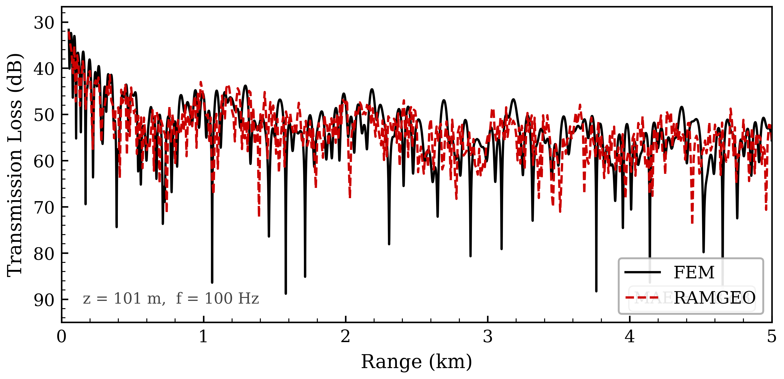
Figure 2. Transmission loss comparison between the FEM acoustic-elastic coupled model (solid black) and RAMGEO (dashed red) at approximately 101 m receiver depth over range 0–5 km in a range-independent Pekeris waveguide at 100 Hz.
The accurate reproduction of the interference envelope demonstrates that the FEM correctly captures the phase relationships among acoustic multipaths. These results confirm that the proposed FEM code provides reliable accuracy for underwater sound propagation problems involving elastic seabed representation.
3.2. Comparison of Acoustic-Only and Acoustic-Elastic Coupled Models
3.2.1. Model Configuration
To quantify the influence of seabed elastic properties on transmission loss, the acoustic-only and coupled models are compared in the same environment. The acoustic-only model treats the seabed as an ideal fluid half-space, ignoring shear-wave transmission ($V_{S}=0$), while the coupled model fully accounts for elastic seabed properties. The configuration is identical to Section 3.1. The TL difference $ΔTL={TL}_{coupled}-{TL}_{acoustic}$ is computed over the 2D range-depth space. Positive $ΔTL$ indicates greater attenuation in the coupled model, reflecting additional acoustic energy loss due to P-to-S mode conversion at the fluid-solid interface.
3.2.2. Results and Analysis
Figure 3 compares the TL curves of the acoustic-elastic coupled model (solid) and the acoustic-only model (dashed) at three receiver depths: 50 m, 101 m, and 150 m. The acoustic-only model consistently underestimates TL relative to the coupled model across all depths and ranges, confirming that neglecting shear-wave interactions in the seabed leads to a systematic bias. The mean absolute TL difference ($|ΔTL|$) is 5.89 dB at 50 m, 5.97 dB at 101 m, and 5.59 dB at 150 m. Note that these values are obtained under the lossless assumption ($Q_{P}=Q_{S}=∞$) to isolate the pure coupling effect; under realistic attenuation conditions (Section 3.4), the $|ΔTL|$ is reduced. Nevertheless, these results demonstrate that the coupling effect persists throughout the water column with relatively uniform magnitude.
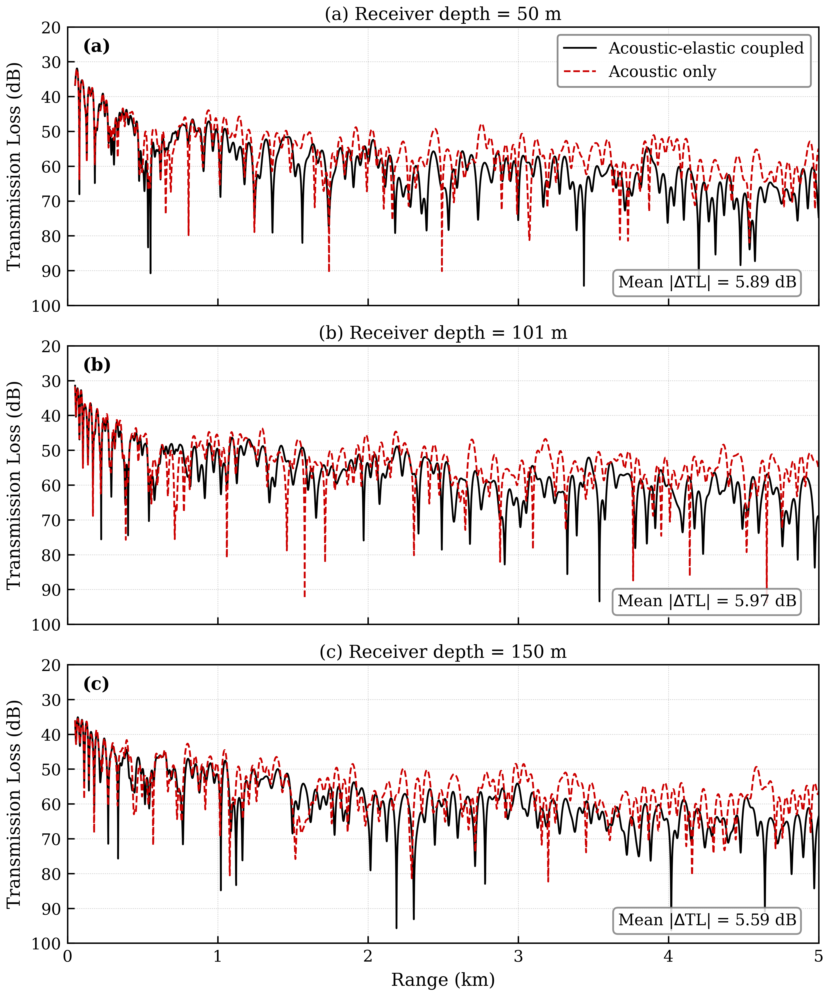
Figure 3. Transmission loss comparison between coupled (solid) and acoustic-only (dashed) models at three receiver depths: (a) 50 m, (b) 101 m, and (c) 150 m over range 0–5 km at 100 Hz.
At ranges below 1 km, direct-path energy dominates and the elastic seabed effect is comparatively small. At ranges of 1–5 km, the number of bottom reflections increases and the cumulative energy loss from P-to-S mode conversion grows progressively, so $ΔTL$ increases with range. At the mid-water depth (101 m), where the source is located, the $|ΔTL|$ is largest (5.97 dB), consistent with the stronger bottom interaction of ray paths near the source depth. Near the surface (50 m) and closer to the seabed (150 m), the slightly lower $|ΔTL|$ values reflect the different modal excitation patterns at each depth ^{[1]}. These results indicate that acoustic-only models may underestimate TL by approximately 5–6 dB on average under lossless conditions.
3.3. Frequency Sensitivity Analysis
3.3.1. Model Configuration
To investigate the influence of frequency on the acoustic-elastic coupling effect and the numerical properties of the FEM, the coupled FEM model is compared with the acoustic-only FEM model at three frequencies: 50, 100, and 200 Hz. All other settings follow Section 3.1. For each frequency, the element size and total number of degrees of freedom (DOF) are adjusted proportionally to the wavelength to maintain the consistent discretization condition $h≤λ/8$. Computational parameters are summarized in Table 1.
Table 1. Computational parameters of the FEM model at three analysis frequencies. DOF: degrees of freedom; $h_{max}$: maximum element size.
Frequency (Hz) | Wavelength $λ$ (m) | $h_{max}$ (m) | Approx. DOF | Computation time (s)
50 | 30.0 | 3.75 | ~28,000 | ~12
100 | 15.0 | 1.875 | ~110,000 | ~48
200 | 7.5 | 0.94 | ~440,000 | ~195
3.3.2. Results and Analysis
Figure 4 compares TL curves at approximately 101 m receiver depth for the three frequencies from the acoustic-elastic coupled FEM model (solid lines) and the acoustic-only FEM model (dashed lines). At 50 Hz, the long wavelength yields a wide spatial period of the interference pattern (approximately 200–300 m), and the greater penetration depth into the seabed distributes the elastic coupling effect over a broad range. At 100 Hz the interference pattern is distinct and $ΔTL$ is most clearly resolved. At 200 Hz the interference pattern becomes considerably more complex, with shorter spatial periods (50–80 m) and larger peak-to-trough amplitudes in the TL curves.
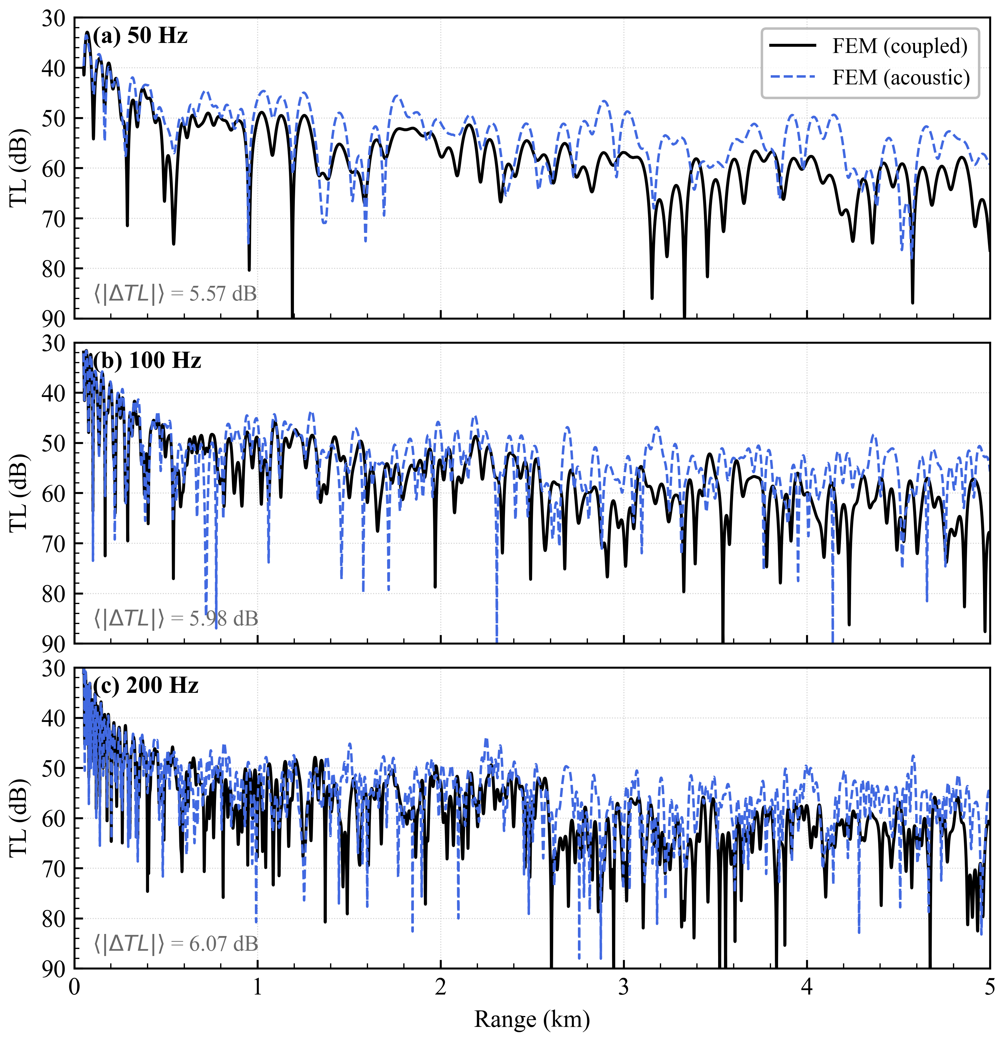
Figure 4. Frequency sensitivity analysis: coupled (solid) and acoustic-only (dashed) FEM models at (a) 50 Hz, (b) 100 Hz, and (c) 200 Hz at approximately 101 m receiver depth.
The mean $|ΔTL|$ between the coupled and acoustic-only FEM models is approximately 5.6 dB at 50 Hz, 6.0 dB at 100 Hz, and 6.0 dB at 200 Hz. These values reflect the consistent sensitivity of the 200 m water column to P-to-S mode conversion across the tested frequency range.
As expected for a 2D problem, the DOF scales as $N_{DOF}∝f^{2}$ (Table 1), with the DOF increasing approximately 16-fold from 50 to 200 Hz. The computation time increases by a factor of approximately 16 over this range, scaling approximately linearly with DOF at these problem sizes ($N≤4.4×{10}^{5}$). The trend in mean $|ΔTL|$ with frequency reflects the complex interplay between modal penetration depth and shear-wavelength scale in the sediment at each frequency. This frequency dependence has practical implications: the operating frequency of sonar detection or underwater communication systems should be selected with explicit consideration of the seabed shear properties, since both the magnitude and spatial structure of the elastic coupling effect depend sensitively on frequency.
3.4. Shear-Wave Velocity Sensitivity Analysis
3.4.1. Model Configuration
To quantify the effect of seabed shear-wave velocity ($V_{S}$) on transmission loss, three seabed types are defined following the geoacoustic classification of Hamilton ^{[10]}. Material properties for each type are listed in Table 2. The analysis frequency is 100 Hz; all other settings follow Section 3.1.
Table 2. Geoacoustic parameters for three seabed types used in the shear-wave velocity sensitivity analysis. Classification follows Hamilton ^{[10]}. $Q_{P}$ and $Q_{S}$: quality factors for compressional and shear waves.
Seabed Type | $V_{P}$ (m/s) | $V_{S}$ (m/s) | $ρ_{s}$ (kg/m$​^{3}$) | $$Q_{P}$$ | $$Q_{S}$$
Soft sediment | 1,550 | 200 | 1,400 | 50 | 30
Medium sediment | 1,800 | 400 | 1,800 | 100 | 60
Hard bottom | 3,000 | 800 | 2,500 | 300 | 150
3.4.2. Results and Analysis
Figure 5 compares the coupled and acoustic-only model TL at approximately 101 m receiver depth for the three seabed types.
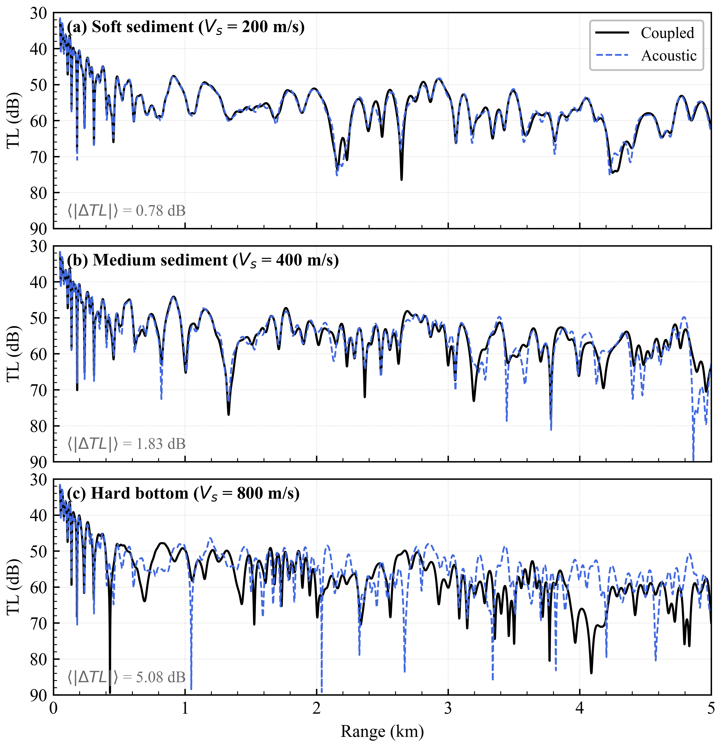
Figure 5. Shear-wave velocity sensitivity: coupled (solid) vs. acoustic-only (dashed) FEM models for (a) soft sediment ($V_{S}$ = 200 m/s), (b) medium sediment ($V_{S}$ = 400 m/s), and (c) hard bottom ($V_{S}$ = 800 m/s) at approximately 101 m receiver depth (100 Hz).
The spatial average of $|ΔTL|$ for the soft sediment ($V_{S}=200$ m/s) is approximately 0.8 dB, for the medium sediment ($V_{S}=400$ m/s) approximately 1.8 dB, and for the hard bottom ($V_{S}=800$ m/s) approximately 5.1 dB. Note that these $|ΔTL|$ values differ from the medium-sediment result in Section 3.2 (mean $|ΔTL|$ of approximately 5.97 dB at 101 m depth). This difference arises primarily because Sections 3.1–3.3 use a lossless seabed ($Q_{P}=Q_{S}=∞$) to isolate the coupling effect, whereas Section 3.4 introduces intrinsic attenuation ($Q_{P}=100$, $Q_{S}=60$ for medium sediment; Table 2), which damps the shear waves in the seabed and reduces the net $|ΔTL|$. Furthermore, all geoacoustic parameters ($V_{P}$, $ρ_{s}$, $Q_{P}$, $Q_{S}$) vary simultaneously across the three seabed types (Table 2), so the reported $|ΔTL|$ values reflect the combined influence of all material properties, not $V_{S}$ alone. The observed trend reflects the dependence of the reflection coefficient on the overall acoustic impedance contrast at the fluid-solid interface.
These results quantitatively confirm that geoacoustic seabed properties are decisive for accurate TL prediction. The increasing $|ΔTL|$ from soft to hard seabed is primarily driven by the growing acoustic impedance contrast at the fluid-solid interface, which modifies both the magnitude and phase of the plane-wave reflection coefficient. For the soft sediment ($Z_{s}/Z_{f}≈1.4$), the impedance contrast is small and the reflection coefficient differs only modestly between the elastic and fluid models. For the hard bottom ($Z_{s}/Z_{f}≈5.0$), the large impedance contrast introduces a pronounced phase shift in the reflection coefficient—particularly near the P-wave critical angle $θ_{cP}=\sin^{-1}(c_{f}/V_{P})≈{30}^{∘}$—which substantially alters the multipath interference pattern and produces the largest $|ΔTL|$ ^{[1,9]}. A more detailed physical interpretation is provided in Section 4.
The variation in $|ΔTL|$ across the three seabed types demonstrates the strong sensitivity of the coupled model to seabed properties, with practical implications for model selection discussed in Section 4.
3.5. Case Study: Staircase vs. Curvilinear Mesh
3.5.1. Model Configuration
Three representative irregular bathymetric profiles are considered to compare the numerical accuracy of staircase and curvilinear meshes:
- Downslope: water depth increases linearly from 790 m to approximately 980 m over 0–3.98 km (slope gradient 5%).
- Anticline: a Gaussian bathymetric high centered at approximately 2 km, with depth rising from a mean of 790 m to 690 m at the apex (amplitude 100 m).
- Syncline: a Gaussian bathymetric low centered at approximately 2 km, with depth dropping from a mean of 790 m to 890 m at the trough (amplitude 100 m).
The domain is discretized on a $399×399$ grid with spacing $h=10$ m. This spacing corresponds to approximately 3 elements per acoustic wavelength at the highest frequency (200 Hz, $λ_{f}=7.5$ m), which is coarser than the $h≤λ/8$ criterion used in the TL experiments of Sections 3.1–3.4. However, since the objective of this case study is to compare the relative difference between staircase and curvilinear mesh solutions — not to compute absolute TL — the identical discretization in both meshes ensures that any observed difference is attributable solely to the boundary representation, not to resolution effects. We note that the absolute wavefield amplitudes at 200 Hz may be affected by under-resolution, but this bias cancels in the differential comparison. The staircase mesh employs a regular orthogonal grid, representing the seabed as a staircase of horizontal steps. The curvilinear mesh is generated using the TFI approach described in Section 2, aligning element edges precisely with the seabed. The analysis is conducted over a bandwidth of 50–200 Hz; the seabed properties correspond to the medium sediment in Table 2.
3.5.2. Results and Analysis
Figure 6 presents the velocity model and broadband seismograms for each of the three bathymetric profiles. For each case, the left panel shows the velocity model with the true seabed boundary (solid black line) and the staircase approximation (dashed red line) overlaid. The remaining columns display three wavefield components—horizontal displacement $u_{x}$, vertical displacement $u_{z}$, and pressure $p$—obtained by inverse Fourier transform of the frequency-domain elastic solutions over 50–200 Hz. For each component, the staircase mesh result (top) is compared against the curvilinear mesh result (bottom).
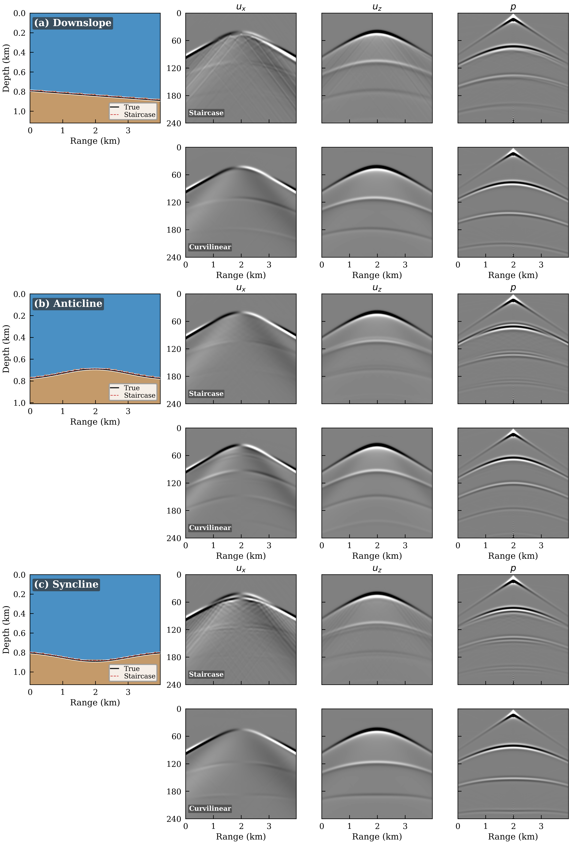
Figure 6. Staircase vs. curvilinear mesh comparison for three bathymetric profiles: (a) downslope, (b) anticline, and (c) syncline. Left column: velocity model with true seabed (solid black) and staircase approximation (dashed red). Remaining columns: broadband seismograms of $u_{x}$, $u_{z}$, and $p$ components (50–200 Hz), with staircase mesh (top) and curvilinear mesh (bottom) for each profile.
Table 3 summarizes the relative difference between the staircase and curvilinear solutions for all three wavefield components, measured by the $L_{2}$ norm $∥u_{stair}-u_{curv}∥_{2}/∥u_{curv}∥_{2}$. The displacement components ($u_{x}$, $u_{z}$) exhibit substantially larger relative differences (53–116%) than the pressure field (23–24%), demonstrating that the vector displacement field is far more sensitive to boundary discretization errors than the scalar pressure. This is physically expected: the staircase approximation misrepresents the local surface normal at each step face, introducing errors in the tangential traction components that directly govern the displacement field, while the pressure (being a scalar) is affected primarily through the integrated effect of reflection coefficient errors. Among the three profiles, the anticline and syncline exhibit the largest $u_{z}$ discrepancies (98% and 116%, respectively), consistent with their stronger seabed curvature. In the staircase seismograms, visible waveform distortions appear near the seabed boundary where the step-like approximation introduces artificial diffraction. The curvilinear seismograms exhibit smoother waveforms that conform naturally to the bathymetric interface.
Table 3. Relative $L_{2}$ difference (%) between staircase and curvilinear mesh solutions for three wavefield components across the three bathymetric profiles.
Profile | $u_{x}$ (%) | $u_{z}$ (%) | $p$ (%)
Downslope | 78.7 | 84.8 | 24.4
Anticline | 53.0 | 98.0 | 23.4
Syncline | 63.4 | 115.5 | 24.2
The physical origin of the staircase mesh error is twofold, as discussed in Section 2: artificial diffraction at step corners generates numerically spurious diffracted waves, and incorrect local normal directions at step faces introduce errors in the traction boundary conditions. Because the displacement field depends directly on the tangential traction continuity at the fluid-solid interface, the displacement components $u_{x}$ and $u_{z}$ are affected more severely than the scalar pressure. The 3–5$×$ greater sensitivity of the displacement field (Table 3) underscores the importance of accurate boundary representation in elastic wavefield modeling. The terrain-following curvilinear mesh eliminates both sources of error by aligning element boundaries precisely with the physical seabed, confirming the theoretical argument of Section 2. These results demonstrate that the staircase limitation common to PE and FDM methods can be systematically overcome by FEM with curvilinear mesh discretization.
4. Discussion
The numerical results presented in Section 3 demonstrate the practical consequences of the three physical limitations of conventional PE-based methods identified in the Introduction: the neglect of backscattered energy, the absence of shear-wave conversion at the fluid-solid interface, and the staircase approximation of irregular bathymetry. At the low frequencies considered here (50-200 Hz), acoustic wavelengths in the water column reach 7.5-30 m, and a substantial fraction of the acoustic energy penetrates into the elastic seabed rather than being reflected at the water-sediment interface. The following subsections interpret the numerical findings in terms of the underlying wave physics and assess the practical applicability of the proposed FEM model.
4.1. Physical Interpretation of Acoustic-Elastic Coupling Effects
The numerical examples demonstrate that the acoustic-elastic coupled model differs from the acoustic-only model by a spatially averaged $|ΔTL|$ that varies systematically with seabed type, reaching approximately 5.1 dB for the hard bottom ($V_{S}=800$ m/s), 1.8 dB for the medium sediment ($V_{S}=400$ m/s), and 0.8 dB for the soft sediment ($V_{S}=200$ m/s), with local maxima exceeding 10 dB at interference nulls. These differences originate from two distinct physical mechanisms at the water-seabed interface.
The first mechanism is direct energy loss via P-to-S mode conversion. When a compressional wave impinges on the elastic seabed, a fraction of the incident energy is converted into shear waves in the sediment, which is captured by the coupled model but entirely absent from the acoustic-only model. The second, and often dominant, mechanism is the modification of the plane-wave reflection coefficient phase by the presence of shear rigidity ($μ=ρ_{s}V_{S}^{2}$). Even when shear-wave energy conversion is modest, the phase of the reflected wave changes relative to the fluid-only case, shifting the positions and amplitudes of the multipath interference pattern in the water column and thereby producing large $|ΔTL|$ at interference nulls ^{[1,9]}.
The observed trend — $|ΔTL|$ increasing from soft to hard seabed — is explained by this phase-shift mechanism rather than by mode-conversion energy loss alone. It should be noted that $V_{P}$, $ρ_{s}$, and $Q$ also vary across the three seabed types (Table 2), so the reported $|ΔTL|$ values reflect the combined effect of all geoacoustic parameters, not $V_{S}$ in isolation. For the soft sediment ($V_{P}=1,550$ m/s, $V_{S}=200$ m/s), the compressional impedance contrast with water is small ($Z_{s}/Z_{f}≈1.4$), so the reflection coefficient differs only modestly between the elastic and fluid models, and $|ΔTL|$ remains below 1 dB. For the hard bottom ($V_{P}=3,000$ m/s, $V_{S}=800$ m/s), the large impedance contrast ($Z_{s}/Z_{f}≈5.0$) and the emergence of a P-wave critical angle at $θ_{cP}=\sin^{-1}(c_{f}/V_{P})≈{30}^{∘}$ cause a pronounced phase jump in the reflection coefficient near the critical angle. This phase jump shifts the positions of constructive and destructive interference, producing the largest $|ΔTL|$ of 5.1 dB. The systematic dependence of $|ΔTL|$ on seabed type observed in Figure 5 is thus primarily governed by the impedance contrast and the associated reflection-coefficient phase behavior, rather than by the absolute magnitude of shear-wave energy conversion.
The frequency sensitivity analysis (Section 3.3) reveals that the mean $|ΔTL|$ between coupled and acoustic-only FEM models is approximately 5.6 dB at 50 Hz and approximately 6.0 dB at both 100 Hz and 200 Hz. The relatively stable $|ΔTL|$ across frequencies reflects the consistent role of P-to-S mode conversion throughout the 200 m waveguide, while subtle frequency-dependent variations arise from the changing spatial structure of the interference pattern and the associated distribution of bottom-reflected ray paths. This frequency dependence has practical implications: the operating frequency of sonar detection or underwater communication systems should be selected with explicit consideration of the seabed shear properties, since both the magnitude and spatial structure of the elastic coupling effect depend sensitively on frequency.
Taken together, these results directly address the second limitation identified in the Introduction — the neglect of shear-wave effects in acoustic-only models. Acoustic-elastic coupled modeling is essential for accurate TL prediction, particularly in environments with stiff seabeds where $|ΔTL|$ reaches 5.1 dB. For soft sediments with $V_{S}≤200$ m/s, the mean $|ΔTL|$ of 0.8 dB may fall within acceptable tolerances for some operational applications, but for medium to hard seabeds the acoustic-only approximation introduces systematic biases that cannot be neglected.
4.2. Performance and Applicability of the Curvilinear Mesh
The case study in Section 3.5 shows that the staircase mesh introduces relative differences in the pressure field of 24.4% (downslope), 23.4% (anticline), and 24.2% (syncline) compared to the curvilinear mesh solution, while displacement errors reach 53–116%. These results quantitatively address the first limitation identified in the Introduction, namely the staircase bathymetric approximation inherent in PE and FDM methods, and demonstrate that a terrain-following curvilinear mesh systematically improves waveform prediction accuracy in irregular-bathymetry environments.
Two distinct mechanisms contribute to staircase mesh errors. First, artificial diffraction at step corners generates numerically spurious diffracted waves that are absent from the true solution at a smooth seabed; these spurious fields perturb the pressure waveform and shift the positions of peaks and troughs. Second, the normal direction to the seabed is forced to be vertical or horizontal at each step face, so the reflection coefficient is computed at the wrong incidence angle, yielding systematic errors in reflected pressure amplitude. The fact that displacement errors are largest for the anticline and syncline topographies (where the seabed curvature is greatest) is physically consistent: greater curvature implies larger local angular deviation of the true normal from the staircase-approximated normal ^{[17]}.
The TFI-based curvilinear mesh ^{[16]} eliminates both sources of error by aligning element boundaries with the physical seabed, but introduces its own limitations. The linear TFI mapping adopted here is effective for bathymetric slope angles up to approximately 10°; for very steep relief exceeding 30°, the Jacobian matrix of the mapping may become ill-conditioned, degrading numerical stability. In such cases, elliptic PDE-based mesh generation ^{[17]} or fully unstructured triangular meshes would provide more robust alternatives. Extension of the present approach to fully 3D irregular bathymetry will likely require unstructured tetrahedral or hexahedral meshes combined with more sophisticated mesh generation algorithms ^{[29,32]}, and this is identified as a priority for future work.
4.3. Comparison with RAMGEO and Methodological Differences
The FEM methodology adopted here draws on established techniques from seismic wave modeling. The frequency-domain approach, the use of sparse direct solvers via LU factorization, and the coupling of acoustic and elastic domains all derive from the computational seismology tradition ^{[13,19]}. The present work demonstrates that these tools transfer directly and effectively to the underwater acoustic problem.
The validation in Section 3.1 shows FEM-RAMGEO agreement with a running-average MAE of 1.8 dB (mean bias $-0.17$ dB) in a range-independent horizontally stratified environment. The residual discrepancy arises primarily from three methodological differences. First, PE is inherently a one-way propagation method that neglects backscattering, whereas FEM fully resolves two-way wave propagation — a capability well established in computational seismology, where backscattering from impedance contrasts is routinely handled ^{[13]}. In horizontal stratification, backscattering is weak and the effect of this difference is small; however, in range-dependent environments with strong impedance contrasts or irregular topography, backscattering contributions may become significant, and FEM’s two-way treatment would then provide a meaningful accuracy advantage. Second, RAMGEO solves the elastic wave equation within the one-way PE framework ^{[8]}, which inherently restricts backscattering and wide-angle propagation, while the present FEM solves the full Navier equation without directional constraints and therefore captures all elastic wave phenomena without approximation. Third, the finite-order Padé approximation underlying the PE formulation introduces phase errors at wide propagation angles, and these errors accumulate at higher frequencies.
In range-dependent environments with abrupt bathymetric changes, the accuracy advantage of FEM over PE is expected to be more pronounced. PE-based methods retain superior computational efficiency (Section 4.4), making them the preferred choice for long-range propagation (tens to hundreds of kilometers) and real-time operational applications. The present FEM model is particularly suited to short-to-medium range propagation (1–10 km) in complex irregular seabed environments, where the combination of two-way wave propagation, complete elastic seabed treatment, and bathymetric conformity provides the most decisive accuracy advantages.
4.4. Computational Efficiency and Practical Considerations
The FEM model developed in this study employs the actual grid dimensions of $n_{x}=11114$ and $n_{z}=557$ nodes at grid spacing $h=0.9$ m for the 200 m water depth configuration at 100 Hz. Using the PARDISO direct solver on an Intel Core i9-13900K workstation (8 threads, 64 GB RAM), the total computation time per frequency — including matrix assembly, LU factorization, and back-substitution — is approximately 48 seconds at 100 Hz (Table 1), which is roughly 20–30 times slower than RAMGEO under equivalent conditions. However, the frequency-domain FEM formulation offers important practical advantages in multi-source and multi-receiver scenarios: the LU factorization of the system matrix is computed only once per frequency and reused for all source positions via back-substitution, and the responses at all receiver locations are obtained simultaneously from a single matrix solve ^{[13]}. Multi-frequency analyses can be parallelized straightforwardly across frequency channels.
Memory usage is the primary practical constraint: storage of the sparse complex matrix and the PARDISO factorization requires approximately 2–4 GB. Extension to frequencies above 200 Hz or to 3D geometries would necessitate iterative sparse solvers with effective preconditioners to remain within practical memory limits. Future implementation of MPI parallelization and GPU acceleration would substantially reduce computation time for large-scale multi-frequency analyses.
4.5. Limitations and Future Work
The present study is restricted to 2D; real ocean environments include azimuth-dependent 3D effects. Horizontal refraction and 3D scattering by complex seabed topography can play significant roles in certain environments ^{[33]}, and 2D models cannot fully reproduce these phenomena. The present model also assumes a single seabed layer, whereas real seabeds typically consist of multiple sediment layers with distinct impedance contrasts, requiring additional interfacial coupling conditions. Sound-speed profile gradients in the water column, sea-surface roughness, and seabed roughness are additional physical effects that should be progressively incorporated in future model extensions.
The demonstrated sensitivity of the forward model to seabed parameters (Section 3.4) also suggests potential for future application as a forward engine in geoacoustic parameter estimation. Application of the model to field data from the seas surrounding the Korean Peninsula, including the East Sea and the Yellow Sea, where complex bathymetry and variable sediment cover coexist, will provide an important test of the method’s practical applicability ^{[34]}.
5. Conclusion
Applying the frequency-domain FEM framework with Helmholtz-Navier coupling and terrain-following curvilinear mesh to the underwater acoustic propagation problem, a two-dimensional fully coupled acoustic-elastic model has been developed and systematically validated through five numerical examples. The acoustic pressure in the water column is governed by the Helmholtz equation; elastic displacement in the seabed is governed by the Navier equation; pressure continuity and normal displacement continuity at the fluid-solid interface are enforced as natural boundary conditions within a unified weak formulation; and irregular bathymetry is represented by a terrain-following curvilinear mesh generated via the transfinite interpolation mapping of Gordon and Hall ^{[16]}. The main findings of the study are as follows.
First, in a range-independent 200 m deep Pekeris waveguide environment, the proposed FEM acoustic-elastic coupled model agrees with RAMGEO with a 100 m running-average MAE of 1.8 dB and a mean bias of $-0.17$ dB, confirming that the amplitude envelope of multipath interference is accurately reproduced. The approach of coupling the Helmholtz equation for the acoustic domain with the Navier equation for the elastic domain within a single weak-form framework, and imposing fluid-solid interface conditions as natural boundary conditions, is shown to be numerically effective and consistent.
Second, quantitative comparison of the coupled and acoustic-only models reveals that the mean $|ΔTL|$ at approximately 101 m receiver depth is approximately 0.8 dB for soft sediment ($V_{S}=200$ m/s), 1.8 dB for medium sediment ($V_{S}=400$ m/s), and 5.1 dB for hard bottom ($V_{S}=800$ m/s), with local maxima exceeding 10 dB at interference nulls. The strong dependence on seabed type confirms that acoustic-elastic coupled modeling is essential for accurate TL prediction in environments with variable seabed stiffness.
Third, frequency sensitivity analysis at 50, 100, and 200 Hz yields mean $|ΔTL|$ values of approximately 5.6 dB, 6.0 dB, and 6.0 dB respectively between the coupled and acoustic-only FEM models, confirming that the elastic coupling effect persists consistently across the tested frequency range for the 200 m waveguide configuration. This frequency-dependent behavior has direct implications for the design of sonar and underwater communication systems operating over elastic seabeds.
Fourth, across three irregular seabed profiles — downslope, anticline, and syncline — the staircase mesh introduces relative differences in the pressure field of 24.4%, 23.4%, and 24.2% respectively, and displacement differences of 53–116%, compared to the curvilinear mesh solution. The terrain-following curvilinear mesh, generated via transfinite interpolation ^{[16]}, fundamentally eliminates artificial diffraction and normal-direction errors at the seabed, substantially improving waveform prediction accuracy in irregular-bathymetry environments. Errors are largest for the anticline and syncline profiles, consistent with the greater seabed curvature and correspondingly larger angular deviation of the staircase-approximated normal.
The proposed 2D frequency-domain FEM acoustic-elastic coupled model simultaneously implements complete fluid-solid coupling conditions, a terrain-following curvilinear mesh, and frequency-domain sparse direct solution, thereby overcoming two fundamental limitations of existing PE and FDM methods — staircase bathymetric approximation and neglect of shear-wave effects — within a single unified framework. Future work will address 3D extension, multilayer seabed and sound-speed profile incorporation, and application to field data for validation in realistic ocean environments. # References
References
[1] Jensen FB, Kuperman WA, Porter MB, Schmidt H, 2011, Computational Ocean Acoustics, 2nd ed., Springer, New York. doi:10.1007/978-1-4419-8678-8
[2] Hovem JM, 2010, Marine Acoustics: The Physics of Sound in Underwater Environments, Peninsula Publishing, Los Altos.
[3] Etter PC, 2018, Underwater Acoustic Modeling and Simulation, 5th ed., CRC Press, Boca Raton. doi:10.1201/9780429465901
[4] Collins MD, 1993, A split-step Padé solution for the parabolic equation method. J. Acoust. Soc. Am., 93(4): 1736-1742. doi:10.1121/1.406739
[5] Porter MB, Reiss EL, 1984, A numerical method for ocean-acoustic normal modes. J. Acoust. Soc. Am., 76(1): 244-252. doi:10.1121/1.391101
[6] Westwood EK, Tindle CT, Chapman NR, 1996, A normal mode model for acousto-elastic ocean environments. J. Acoust. Soc. Am., 100(6): 3631-3645. doi:10.1121/1.417226
[7] Collins MD, 1989, A higher-order parabolic equation for wave propagation in an ocean overlying an elastic bottom. J. Acoust. Soc. Am., 86(4): 1459-1464. doi:10.1121/1.398706
[8] Collins MD, Westwood EK, 1991, A higher-order energy-conserving parabolic equation for range-independent ocean acoustics. J. Acoust. Soc. Am., 89(3): 1068-1075. doi:10.1121/1.400526
[9] Schmidt H, Jensen FB, 1985, A full wave solution for propagation in multilayered viscoelastic media with application to Gaussian beam reflection at fluid-solid interfaces. J. Acoust. Soc. Am., 77(3): 813-825. doi:10.1121/1.392038
[10] Hamilton EL, 1980, Geoacoustic modeling of the sea floor. J. Acoust. Soc. Am., 68(5): 1313-1340. doi:10.1121/1.385100
[11] Virieux J, 1986, P-SV wave propagation in heterogeneous media: Velocity-stress finite-difference method. Geophysics, 51(4): 889-901. doi:10.1190/1.1442147
[12] Levander AR, 1988, Fourth-order finite-difference P-SV seismograms. Geophysics, 53(11): 1425-1436. doi:10.1190/1.1442422
[13] Pratt RG, 1999, Seismic waveform inversion in the frequency domain, Part 1: Theory and verification. Geophysics, 64(3): 888-901. doi:10.1190/1.1444597
[14] Dosso SE, Dettmer J, 2011, Bayesian matched-field geoacoustic inversion. Inverse Probl., 27(5): 055009. doi:10.1088/0266-5611/27/5/055009
[15] Gerstoft P, 1994, Inversion of seismoacoustic data using genetic algorithms and a posteriori probability distributions. J. Acoust. Soc. Am., 95(2): 770-782. doi:10.1121/1.408387
[16] Gordon WJ, Hall CA, 1973, Construction of curvilinear co-ordinate systems and applications to mesh generation. Int. J. Numer. Methods Eng., 7(4): 461-477. doi:10.1002/nme.1620070405
[17] Thompson JF, Warsi ZUA, Mastin CW, 1985, Numerical Grid Generation: Foundations and Applications, North-Holland, New York.
[18] Ihlenburg F, 1998, Finite Element Analysis of Acoustic Scattering, Springer, New York. doi:10.1007/b98828
[19] Zienkiewicz OC, Taylor RL, 2000, The Finite Element Method, Vol. 1: The Basis, 5th ed., Butterworth-Heinemann, Oxford.
[20] Atalla N, Sgard F, 2015, Finite Element and Boundary Methods in Structural Acoustics and Vibration, CRC Press, Boca Raton. doi:10.1201/b18366
[21] Komatitsch D, Tromp J, 1999, Introduction to the spectral element method for three-dimensional seismic wave propagation. Geophys. J. Int., 139(3): 806-822. doi:10.1046/j.1365-246x.1999.00967.x
[22] Bottero A, Cristini P, Komatitsch D, Asch M, 2016, An axisymmetric time-domain spectral-element method for full-wave simulations: Application to ocean acoustics. J. Acoust. Soc. Am., 140(1): 696-708. doi:10.1121/1.4954937
[23] Cristini P, Komatitsch D, 2012, Some illustrative examples of the use of a spectral-element method in ocean acoustics. J. Acoust. Soc. Am., 131(3): EL229-EL235. doi:10.1121/1.3682459
[24] Isakson MJ, Chotiros NP, 2011, Finite element modeling of reverberation and transmission loss in shallow water waveguides with rough boundaries. J. Acoust. Soc. Am., 129(3): 1273-1279. doi:10.1121/1.3531999
[25] Kim S, Oh J, Shin C, 2021, Frequency-domain finite-element modeling for acoustic wave propagation. Geophys. Geophys. Explor., 24(3): 156-165. doi:10.7582/GGE.2021.24.3.156
[26] Bérenger JP, 1994, A perfectly matched layer for the absorption of electromagnetic waves. J. Comput. Phys., 114(2): 185-200. doi:10.1006/jcph.1994.1159
[27] Collino F, Tsogka C, 2001, Application of the perfectly matched absorbing layer model to the linear elastodynamic problem in anisotropic heterogeneous media. Geophysics, 66(1): 294-307. doi:10.1190/1.1444908
[28] Komatitsch D, Martin R, 2007, An unsplit convolutional perfectly matched layer improved at grazing incidence for the seismic wave equation. Geophysics, 72(5): SM155-SM167. doi:10.1190/1.2757586
[29] Liseikin VD, 2010, Grid Generation Methods, 2nd ed., Springer, Dordrecht. doi:10.1007/978-90-481-2912-6
[30] Chew WC, Weedon WH, 1994, A 3D perfectly matched medium from modified Maxwell’s equations with stretched coordinates. Microw. Opt. Technol. Lett., 7(13): 599-604. doi:10.1002/mop.4650071304
[31] Schenk O, Gärtner K, 2004, Solving unsymmetric sparse systems of linear equations with PARDISO. Future Gener. Comput. Syst., 20(3): 475-487. doi:10.1016/j.future.2003.07.011
[32] Käser M, Dumbser M, 2006, An arbitrary high-order discontinuous Galerkin method for elastic waves on unstructured meshes I: The two-dimensional isotropic case with external source terms. Geophys. J. Int., 166(2): 855-877. doi:10.1111/j.1365-246X.2006.03051.x
[33] Deane GB, Buckingham MJ, 1993, An analysis of the three-dimensional sound field in a penetrable wedge with a stratified fluid or elastic basement. J. Acoust. Soc. Am., 93(3): 1319-1328. doi:10.1121/1.405417
[34] Choi JW, Kim BN, Yoon SW, Park JS, 2019, Sound speed profiles and their effects on acoustic propagation in the East Sea. Ocean Polar Res., 41(2): 75-85. doi:10.4217/OPR.2019.41.2.075

