Read Biased Source Accurately or Read Unbiased Source Directionally:

Using Agent-Based Modeling to Explore Cognitive Processes Leading to the Political Polarization of Public Attitude on Climate Change

# Introduction

Environmental problems are currently one of the most contested policy area in United States. Political polarization of public attitude between Republicans and Democrats on climate change represents this contestation. This partisan gap on climate change has become vastly wide over time. In 1989, the gap was virtually non-existent between Republicans and Democrats (**cite**). In March 2017 Gallup poll, it had grown to a 48-percentage point difference (Democrats: 66% concerned vs. Republicans: 18% concerned). This is especially puzzling because the increased partisan gap has coexisted with the growing consensus in scientific community about anthropogenic climate change. (기존 연구의 한계가 빠져 있음). This paper focuses on modeling and exploring two different mechanisms that have been proposed to explain the political polarization of the public’s attitude on climate change using agent-based modeling.

# Media and Political Polarization in Climate Change

## Two Dimensions of Polarization

It has been widely accepted that opinion about climate change are extremely diversified in US. The attitude polarization could not be explained solely on single dimension since attitude toward climate change has polarized along two dimensions: “between the public and scientists” and “between Republicans and Democrats”. It has been reported that Democrats tend to follow scientific consensus while Republicans do not. Therefore, the actual polarization has been occurred between “Republican publics” and the others. Why such huge difference exists? This is especially puzzling since scientific information is more “objective” than subjective opinion of the public. How can subjective opinion persist for such a long-time despite of widespread objective information? Temporal difference could exist, but 30 years stability of this difference could not be easily understood. Scholars have dedicated their effort to explain this puzzle. One of the main explanatory variable suggested is the exposure to scientific consensus. (다른 변수들도 있나?) Interestingly, the effect of the exposure is on active scholarly debate. One group of scholars insist that the exposure to scientific consensus could yield depolarization; the other group insist that it could accelerate polarization.

### Scientists and the Public

### Republicans and Democrats

## The Relationship between Partisan Media and Attitude Polarization

## Causal Mechanisms of Attitude Polarization

“Selective exposure” suggests that partisan information source is a reason for issue polarization (Bennett & Iyengar, 2008; Iyengar & Hahn, 2009). To avoid cognitive dissonance, a person has tendency to favor consonant information produced by ideologically similar information sources. People tend to seek out such information sources. As the result, they selectively expose themselves to consonant political messages and reinforce their prior attitude on policy issues. Within the same framework, it is also possible that Republicans in red states tend to read conservatives newspapers not because they intentionally select but because conservative newspapers are more widely available in the state (Mutz, 2006). What these studies suggests is the correlation between individual’s partisanship and their biased assimilation of information as a causal mechanism of political polarization on climate change. Additionally, there can be a nonlinear growth of both selective exposure and political polarization of policy issues (Stroud, 2010).

“Partisan motivated reasoning” implies that a person can be motivated to arrive at a particular conclusion on policy issues consistent with her party identification (Bolsen, Druckman, & Cook, 2014; Taber & Lodge, 2006). In this explanation, people reads messages preferentially (directionally) regardless of information sources (Mutz, 2006). For instance, climate change skeptics’ attitude may be adjusted when they exposed to counterattitudinal messages. But, it is also possible that skeptical attitude can increase even after reading messages by a climate change believer. That is, there can be a “boomerang effect” since exposure to ideologically incongruent message could be used ironically to reinforce their partisanship and attitude on climate change. This partisan motivated reasoning is so strong that a recent research reported that motivated skepticism dominates framing effect which has been considered important in the climate change literature (Zhou, 2016). The strength of the motivated reasoning depends on the strength of one’s partisanship (Bolsen et al., 2014): The stronger the partisanship, the more likely to engage in motivated reasoning on information.

We build a prototype agent-based model to understand which of the mechanisms better explains the observed political polarization of the public’s attitude on climate change. Each mechanism represents the distinct process of the public attitude formation. Selective exposure assumes that partisans selectively search information sources produced by media organization with similar ideology as a causal driver. When they receive information, they update their attitude by combining information with their prior attitude. Therefore, attitude change could be explained by the political orientation of ideologically adjacent information sources and the sources’ policy attitude. On the other hand, if individuals process information according to partisan motivated reasoning, there is a chance that the direction of her attitude after reading a message would coincide with the affiliated party’s orientation regardless of partisan identity of the information source. In summary, the public’s attitude change on a policy issue by selective exposure is primarily related to adjacent media organizations, whereas the effect of partisan motivated reasoning is largely related to their strength of partisanship.

Figure 1: Political Polarization of the Public on Climate Change (Reference Pattern)

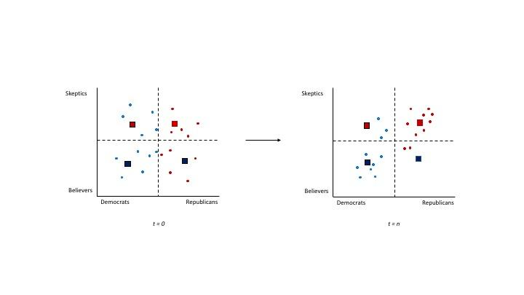

The causal mechanisms operate within a two-dimensional space in our prototype model (as seen from Figure 1). Horizontal axis represents ideological spectrum (left to Democrat, right to Republican). Vertical axis represents attitude about climate change (ceiling to skeptics, bottom to believers). Little dots are individuals and squares are information sources (e.g., media organizations). Information sources regularly produce messages that reflect the sources’ ideological preference and specific policy attitude on climate change. Individuals interact with information sources by selecting which news to read and how to interpret. Figure 2 illustrates this interaction process that can lead to political polarization. In both of models, individuals update their attitude on climate change by combining prior attitude (path a) with policy attitude embodied in received information (path b). Two models are different in the role of partisanship. In model 1 (selective exposure), the partisanship of individuals is used to select information; they select news produced by ideologically similar (horizontally close) sources (path c). In model 2 (motivated reasoning), individuals randomly select information. However, partisanship plays a role in the interpretation of information: it mediates the influence of information on policy attitude (path d). We experiments the mechanisms with a fixed number of individuals, a fixed number of information sources, and fixed partisanship during the simulation period. This helps isolate the result of each mechanisms without being confounded by other factors.

Figure 2: Two Competing Explanations Underlying the Observed Political Polarization

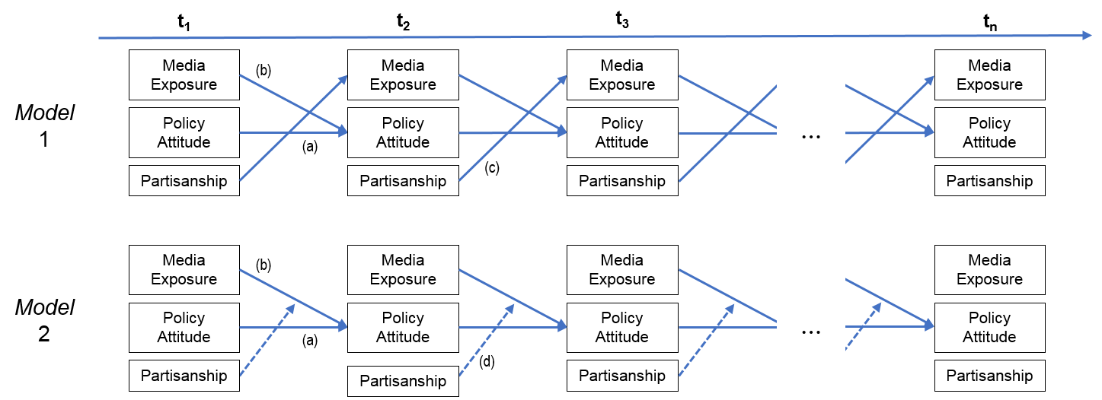

Note:Comparison of cognitive process models between selective exposure (*model 1*) and partisan motivated reasoning (*model 2*): (a) attitude stability. (b) media effect. (c) selective exposure. (d) partisan motivated reasoning

We expect that both mechanisms will lead to the political polarization of the public attitude, but the simulation results will get us a nuanced understanding of which explanation is more plausible and under what conditions it may so in climate change context. This thought experiments can shed further light on the role of and interactions between information sources and partisanship in explaining the political polarization of the public on climate change.

# Why Use ABM?

# Modeling Media Influence on Political Polarization

## Sources of Political Information

Change of opinion through social influence has been extensively studied in the field of “opinion dynamics”. According to opinion dynamics scholars, the answer is the communication between individuals. Through communication between individuals, opinions could be changed and consequently reaches convergence (n=1) or polarization(n=2) or fragmentation(n>2). What is the source of opinion change?

How can we model selective exposure? While both field of communication-political science and opinion dynamics have tried to illuminate the process of attitude change, major difference between these groups. Communication and political science research frequently report partisanship as the important criteria in choosing which source to read, opinion dynamics model focuses on similarity of opinion itself {Mutz, 2006 #347}. This difference is possibly because former group tends to study the selection of news source, while the latter group mainly focuses on interpersonal information exchange. Then the important question would be “where does American public get information, media or interpersonal communication?”. If the mass media is the primary source of information, partisanship would be the main factor in choosing which media outlet to read. If the interpersonal communication is the primary source, similarity in opinion would be the main factor. According to the Pew Research Center survey, in 2016 presidential election (http://www.journalism.org/2016/02/04/the-2016-presidential-campaign-a-news-event-thats-hard-to-miss/), majority of Americans get political information from cable TV news (24%), followed by social media (14%). Age turns out to be important factor in choosing primary information source. Social media is the primary source (35%) in young Americans (18-29) group. What is important is that the heuristic criterion employed by American public is different according to the information source. According to an experimental study, in social media, social endorsement (number of people recommend the news article) cues rather than partisan cues (source label) turn out to be more important {Messing, 2014 #407}. Furthermore, the presence of social endorsement cues even reduced the effect of partisan cues.



Therefore, we should distinguish specific mechanism of selective exposure based on which sources American public use. In case of traditional media (TV news or printed news), partisan cues are used. If social media is used, social endorsement cue is used to select source. Both of two primary sources of information, media outlet and interpersonal communication, are included in our model. Two layers

This idea has similarly implemented by

Among models developed in opinion dynamics, “bounded confidence” (BC) model captured the psychological mechanism of selective attention {Hegselmann, 2002 #401}. In this model, a group of agents repeat the process of opinion formation by exchanging their opinion with others. They do not adopt uncritically or disregard opinions of other agents; they update their opinion by combining those with the others. Degree of update is proportional to their opinion differences. The most important idea of BC model is that agents would only consider opinions of the others who have similar opinion with them. Agent *i* have a certain level of confidence ($ε_{i}$) about their opinion. Therefore, at round t, agent *i* (who has opinion $x_{i}(t)$) selectively exchange opinions with other agents who have their opinion within the confidence bound, [$x_{i}(t)-ε_{i}, x_{i}(t)+ε_{i}$]. The set of agents who can exchange opinion with agent *i* is represented as $I(i,x)$.

$$I(i,x)=\{1≤j≤n| |x_{i}-x_{j}|≤ε_{i}\}$$

Since the authors of BC model set equal weight for the opinions of others (for simplicity), the updated opinion of agent *i* at round t+1 is calculated as the average opinion of the agents whose opinion belong to the confidence bound of agent *i*.

$$x_{i}(t+1)={|I(i,x(t))|}^{-1}\sum_{j∈I(i,x(t))}{x_{j}(t)} for t∈T$$

Selection mechanism을 어떻게 설정할 것인가?: 정보 소스마다 다른 기준을 설정해야 하는가?

Mass media: ideological selectivity

Interpersonal communication: confirmation bias

그리고 filter hypothesis까지 합쳐서?

Selective exposure could be employed in two ways: selecting similar opinion or selecting opinions of ideologically congruent agents. It seems that BC model incorporate the former idea. However, if the meaning of selectivity is related to political ideology, then this model has major limitation. Since different types of selectivity operate regarding different information sources, BC model should be modified. We altered BC model to incorporate the idea of partisan selective exposure.

In BC model, agents pay attention selectively to who has similar opinions.

Confirmation bias vs. Ideological selectivity

Relative agreement (RC) model added more realistic updating rules to BC model. While BC model

$$x_{j}(t+1)=x_{j}(t)+μ[(h_{ij}/u_{i})-1][x_{i}(t)-x_{j}(t)]$$

$$u_{j}(t+1)=u_{j}(t)+μ[(h_{ij}/u_{i})-1][u_{i}(t)-u_{j}(t)]$$

Motivated reasoning을 어떻게 모델링 할 수 있는가?

How can we model motivated reasoning? {Abrica-Jacinto, 2017 #372@@author-year} Ideological affinity has been implemented in PA/C with opinion affinity model.

# Analysis

# Discussion

# Reference

Bennett, W. L., & Iyengar, S. (2008). A new era of minimal effects? The changing foundations of political communication. *Journal of Communication, 58*(4), 707-731.

Bolsen, T., Druckman, J. N., & Cook, F. L. (2014). The Influence of Partisan Motivated Reasoning on Public Opinion. *Political Behavior, 36*(2), 235-262. doi:10.1007/s11109-013-9238-0

Hart, P. S., & Nisbet, E. C. (2012). Boomerang Effects in Science Communication. *Communication Research, 39*(6), 701-723. doi:10.1177/0093650211416646

Iyengar, S., & Hahn, K. S. (2009). Red Media, Blue Media: Evidence of Ideological Selectivity in Media Use. *Journal of Communication, 59*(1), 19-39. doi:10.1111/j.1460-2466.2008.01402.x

Mutz, D. C. (2006). How the mass media divide us. In p. s. nivola & d. w. brady (Eds.), *Red and blue nation? Characteristics and causes of America’s polarized politics*. Washington, DC: Brookings Institution Press.

Stroud, N. J. (2010). Polarization and Partisan Selective Exposure. *Journal of Communication, 60*(3), 556-576.

Taber, C. S., & Lodge, M. (2006). Motivated Skepticism in the Evaluation of Political Beliefs. *American Journal of Political Science, 50*(3), 755-769. doi:10.1111/j.1540-5907.2006.00214.x

Zhou, J. (2016). Boomerangs versus Javelins: How Polarization Constrains Communication on Climate Change. *Environmental Politics, 25*(5), 788-811. doi:10.1080/09644016.2016.1166602