Paper2 Appendix A — Statistical Kernel Benchmark and Recon-Only Profiling
gauss_paper_v2 canonical run (2026-07-27/28) + real-solver CHENG3_PROF/E3D_PROF 500-step profile (2026-07-13). Archived for paper2 drafting; not yet inserted into the manuscript.

1. Provenance
Supersedes three earlier, mutually inconsistent benchmarks (autoresearch-260628-thinc-shapes, cpp/results/gauss_paper/, an unsourced "Table 10"). Fixes their defects: cells are randomised (10,000 per shape, not one representative shape), the cell-D stage and the face stage are measured separately (the face experiment holds D fixed so no cell-D error leaks in), and everything comes from one program per dimension with one seed.
Two bugs were found and fixed during this work, both verified dormant on every mesh cited in the paper (byte-identical regression on leveque/mach3/double-mach/S1/S2/S3, and on the 3D langseth/deform meshes):
(a) 2D: quadrilateral cells were integrated over the sub-triangle formed by the first three nodes only (production Newton path and the analytic c3_build_gmom). Fixed by fan-triangulating about the cell centroid with signed (non-convex-safe) sub-triangle areas. reconstruct_bvd.hpp.
(b) 3D: non-planar quadrilateral faces were normalised by the mesh's v0-fan face_areas while the moment quadrature itself fans from the face centroid, causing a weight-sum error up to 1.7e-1 on warped hex/prism/pyramid faces. Fixed by self-normalising with the same centroid-fan area. reconstruct3d_unstr.hpp.
Source programs (gauss_paper_v2_2d.cpp, thinc_stats_3d.cpp), build/run scripts, raw CSVs (180k-540k rows) and full stdout are kept in cpp/results/gauss_paper_v2/ for reproducibility.

2. Table A.2 — 2D closed-form GAUSS vs baseline (Xie–Xiao THINC/QQ)
Randomised cells/edges, 3 random P2 surfaces x 3 beta each, 10,000 samples/shape. Reference = 256-pt Duffy-collapsed Gauss-Legendre. Errors in bounded tanh-space |D|<1. Well-posed samples only (reference residual < 1e-10).

2a. Cell-D (shape x beta, all |Q|)
shape | beta | Newton RMS | Newton p99 | GAUSS RMS | GAUSS p99
triangle | 0.8 | 6.87e-3 | 2.16e-2 | 2.48e-2 | 1.03e-1
triangle | 1.6 | 2.55e-2 | 8.92e-2 | 5.43e-2 | 2.31e-1
triangle | 3.2 | 8.33e-2 | 3.53e-1 | 1.02e-1 | 4.54e-1
quad | 0.8 | 1.28e-4 | 2.46e-4 | 6.05e-3 | 1.86e-2
quad | 1.6 | 8.13e-4 | 2.14e-3 | 1.86e-2 | 6.76e-2
quad | 3.2 | 3.63e-3 | 1.32e-2 | 4.57e-2 | 1.78e-1

2b. Face value (edge, D held fixed; beta aggregate, all |Q|)
beta | 4pt-GL RMS | 4pt-GL p99 | GAUSS RMS | GAUSS p99
0.8 | 4.02e-3 | 1.01e-2 | 1.79e-2 | 7.97e-2
1.6 | 1.02e-2 | 4.95e-2 | 3.44e-2 | 1.45e-1
3.2 | 2.55e-2 | 1.17e-1 | 5.70e-2 | 2.09e-1

2c. |Q| -> +-1 saturation check, cell-D (RMS, GAUSS)
shape / beta | [0,0.3) | [0.3,0.6) | [0.6,0.85) | [0.85,0.99) | [0.99,1) | ratio lo/hi
tri 0.8 | 4.87e-2 | 1.96e-2 | 1.85e-2 | 9.03e-3 | 1.20e-3 | 41x
tri 1.6 | 1.14e-1 | 3.93e-2 | 2.72e-2 | 1.23e-2 | 1.34e-3 | 85x
tri 3.2 | 2.20e-1 | 6.66e-2 | 3.03e-2 | 1.11e-2 | 7.72e-4 | 285x
quad 0.8 | 1.09e-2 | 6.60e-3 | 3.08e-3 | 3.92e-3 | 8.44e-4 | 13x
quad 1.6 | 3.67e-2 | 1.87e-2 | 7.22e-3 | 7.21e-3 | 1.25e-3 | 29x
quad 3.2 | 9.70e-2 | 3.89e-2 | 1.06e-2 | 6.32e-3 | 8.07e-4 | 120x
Face (D fixed) RMS falls only 1.6x (beta=0.8) to 1.25x (beta=3.2) over the same bins — the saturation argument holds strongly for the cell-D inversion but only weakly for the face integral (driven by the edge variance term, which does not vanish with |Q|).

3. Table A.3 — 3D closed-form GAUSS vs baseline
4 cell shapes x 10,000 random cells x 3 P2 x 3 beta = 360,000 cell-D samples; 540,000 face samples. Reference = same tanh algorithm at THINCQQ_TANH_NQ=12 (production = NQ=2). Primary metric = cell-average conservation error |<tanh(kk P + D)>_ref - Q| (well-posed for every sample); the raw shift error |D-D_ref| is ill-posed under saturation and is reported only as a control (§3d below).

3a. Cell-D conservation error (shape x beta, all |Q|)
shape | beta | Newton RMS | Newton p99 | GAUSS RMS | GAUSS p99
hexahedron | 0.8 | 4.43e-4 | 1.77e-3 | 2.42e-3 | 6.06e-3
hexahedron | 1.6 | 1.12e-3 | 4.30e-3 | 7.32e-3 | 1.78e-2
hexahedron | 3.2 | 3.26e-3 | 1.28e-2 | 1.62e-2 | 3.95e-2
prism | 0.8 | 1.19e-3 | 4.58e-3 | 5.38e-3 | 1.83e-2
prism | 1.6 | 3.15e-3 | 1.29e-2 | 1.36e-2 | 4.71e-2
prism | 3.2 | 7.48e-3 | 2.86e-2 | 2.47e-2 | 8.22e-2
pyramid | 0.8 | 1.00e-3 | 3.85e-3 | 4.34e-3 | 1.39e-2
pyramid | 1.6 | 2.95e-3 | 1.15e-2 | 1.18e-2 | 4.01e-2
pyramid | 3.2 | 7.45e-3 | 2.78e-2 | 2.25e-2 | 7.10e-2
tetrahedron | 0.8 | 5.94e-3 | 1.69e-2 | 1.58e-2 | 6.69e-2
tetrahedron | 1.6 | 1.37e-2 | 3.67e-2 | 2.81e-2 | 1.19e-1
tetrahedron | 3.2 | 2.94e-2 | 7.81e-2 | 4.03e-2 | 1.58e-1

3b. Face value (D held fixed; shape x beta, all |Q|)
face shape | beta | prod. quad RMS | prod. p99 | GAUSS RMS | GAUSS p99
quad | 0.8 | 2.80e-3 | 1.14e-2 | 7.38e-3 | 2.81e-2
quad | 1.6 | 7.87e-3 | 3.57e-2 | 1.84e-2 | 7.39e-2
quad | 3.2 | 1.76e-2 | 7.65e-2 | 3.34e-2 | 1.27e-1
triangle | 0.8 | 7.34e-3 | 3.14e-2 | 1.50e-2 | 6.35e-2
triangle | 1.6 | 1.54e-2 | 7.05e-2 | 2.85e-2 | 1.25e-1
triangle | 3.2 | 2.81e-2 | 1.19e-1 | 4.36e-2 | 1.78e-1

3c. |Q| -> +-1 saturation check, cell-D conservation error (RMS, GAUSS)
shape / beta | [0,0.3) | [0.3,0.6) | [0.6,0.85) | [0.85,1) | ratio lo/hi | monotone?
hex 0.8 | 2.65e-3 | 3.26e-3 | 1.66e-3 | 2.37e-3 | 1.12x | no
hex 1.6 | 8.21e-3 | 9.45e-3 | 5.46e-3 | 7.18e-3 | 1.14x | no
hex 3.2 | 1.97e-2 | 2.02e-2 | 1.35e-2 | 1.54e-2 | 1.27x | no
prism 0.8 | 9.47e-3 | 6.48e-3 | 4.65e-3 | 4.52e-3 | 2.10x | yes
prism 1.6 | 2.23e-2 | 1.65e-2 | 1.38e-2 | 1.12e-2 | 2.00x | yes
prism 3.2 | 4.24e-2 | 3.15e-2 | 2.63e-2 | 1.91e-2 | 2.22x | yes
pyramid 0.8 | 7.02e-3 | 5.53e-3 | 3.51e-3 | 3.78e-3 | 1.86x | no
pyramid 1.6 | 1.92e-2 | 1.43e-2 | 1.22e-2 | 9.79e-3 | 1.96x | yes
pyramid 3.2 | 3.65e-2 | 2.85e-2 | 2.40e-2 | 1.79e-2 | 2.04x | yes
tet 0.8 | 3.15e-2 | 2.31e-2 | 1.81e-2 | 8.64e-3 | 3.65x | yes
tet 1.6 | 5.70e-2 | 3.87e-2 | 3.40e-2 | 1.56e-2 | 3.65x | yes
tet 3.2 | 7.85e-2 | 5.72e-2 | 4.98e-2 | 2.28e-2 | 3.44x | yes
Pooled over all shapes/beta: 3.52e-2 -> 2.60e-2 -> 2.21e-2 -> 1.32e-2 (ratio 2.68x). Strongest on tetrahedra, weakest/non-monotone on hexahedra. Face error (D fixed) falls 2.0-2.7x over the same bins, unlike 2D where the face effect was weak — see §3d for why the raw shift |D-D_ref| goes the opposite way (an artefact of D becoming ill-determined under saturation, not a loss of accuracy).

4. Wall time — isolated kernel microbenchmark (CORRECTED 2026-07-28)
Single-thread. Timing loop wraps the FULL randomised sample population per shape (90,000 calls) with start/end timers once (CHENG3_PROF-style aggregate-and-divide), reusing the exact same seeded cells as the accuracy experiment (verified by replaying the RNG streams and diffing against the CSVs). Isolates the shift (D) and face evaluation kernels only — no LSQ gradient, vertex bounds, or BVD selection.
This supersedes the first-pass wall-time tables below in two ways: (1) the 2D pass originally measured triangles only (the shared 60,000-sample timing pool happened to be filled entirely by the triangle sweep; quads were never timed) — quad is now included. (2) The first-pass 3D program timed RNG draw + P-polynomial construction + H recomputation INSIDE the timed region; since GAUSS itself takes ~0.03 us, that ~0.165 us/call harness overhead inflated its reported cost by roughly 7x. tanh Newton (~2-4 us) was comparatively unaffected. Both defects are fixed here; fixed source in cpp/results/gauss_paper_v2/wall_time_2d.cpp and wall_time_3d.cpp.

4a. 2D (ns/call, 90,000 calls/shape)
shape | method | ns/call | speedup
triangle (6-pt) | tanh Newton cell-D | 219.9 | -
triangle | GAUSS cell-D | 15.2 | 14.4x
quad (24-pt) | tanh Newton cell-D | 617.6 | -
quad | GAUSS cell-D | 15.1 | 40.9x
edge | baseline face (4-pt GL) | 78.2 | -
edge | GAUSS face | 36.1 | 2.17x
GAUSS cell-D is shape-insensitive (15.1 vs 15.2 ns — an algebraic contraction of cached moments, independent of the fan decomposition), while tanh Newton costs 2.8x more on a quad than a triangle (24 vs 6 quadrature points after the quad fix). The GAUSS advantage is therefore larger on quads than on triangles. Triangle numbers are consistent with the pre-correction pass (219.9 vs 226.2, 15.2 vs 15.7, 78.2 vs 77.3, 36.1 vs 34.9 — within ~3%, confirming the methodology change itself did not move the numbers).

4b. 3D (us/call, median of 3 passes x 90,000 calls/shape)
shape | cell-D prod (NQ=2) | cell-D GAUSS | speedup | face shape | face prod (NQ=2) | face GAUSS | speedup
tetrahedron | 2.227 | 0.0278 | 80x | triangle | 0.247 | 0.080 | 3.0x
hexahedron | 3.906 | 0.0265 | 147x | quad | 0.309 | 0.078 | 4.0x
prism | 3.272 | 0.0301 | 109x | tri / quad | 0.249 / 0.321 | 0.081 / 0.082 | 3.1x / 3.9x
pyramid | 2.799 | 0.0273 | 102x | tri / quad | 0.245 / 0.319 | 0.081 / 0.079 | 3.0x / 4.0x
Face cost is a function of the FACE shape, not the cell it belongs to (tanh triangular faces 0.245-0.249 us regardless of parent cell; quad faces 0.309-0.321 us); GAUSS is flat at 0.078-0.082 us either way (a fixed 45-term dot product over the 35-entry moment table). tanh cell-D numbers agree with the pre-correction pass to within run-to-run noise (2.23/3.91/3.27/2.80 vs 2.42/4.33/3.35/2.95, same shape ordering); GAUSS cell-D was previously overstated ~7x by the harness bug above (0.192 vs the corrected 0.027-0.034), so the earlier '12-22x' cell-D speedup and '~2x' face speedup claims are both superseded — the honest numbers are 80-147x (cell-D) and 3.0-4.0x (face). Reference-quadrature cost for context (NQ=12, cell-D only, from the original harness): tet 417.9us, hex 758.1us, prism 598.9us, pyramid 520.7us.

4c. Hardware-level verification of the 3D 80-147x figure
The 3D cell-D speedup is large enough to warrant independent verification beyond wall-clock chrono. perf was unavailable (not installed, sudo requires a password); verification instead used RDTSC cycle counting (__rdtsc(), serialized with _mm_lfence() on both sides), isolated on physical core 50 (taskset -c 50, OMP_NUM_THREADS=1, system load 1.56-3.12 throughout, TSC 3593.246 MHz invariant). Four independent checks, all in agreement:
(1) Actual call counts, measured (not assumed) via a --wrap=tanh/--wrap=atanh build: tanh Newton cell-D calls tanh() exactly (quadrature points + 1) times per solve — 193 for hex — REGARDLESS of Newton iteration count, because u3_tanh_cellD precomputes tanh(kk*P_q) once per point via the Xie2017 tanh-addition identity and then iterates a purely rational function of the shift. GAUSS calls atanh() exactly once. The Newton loop itself contains zero transcendental calls and exactly one divide per point-iteration (confirmed in the disassembly: one vdivsd, Zen3 divide throughput ~4.5 cyc, matching the measured 4.58 cyc/point-iteration to within 2%).
(2) Standalone unit cost, measured with the same RDTSC harness: tanh() 50.1 cyc / 13.94 ns at uniform arguments, 43.67 cyc when replayed at the real in-situ argument distribution (dominated by 59.6% of hex arguments with |x|<0.5, where tanh is cheaper); atanh() 66.1 cyc / 18.41 ns (atanh is more expensive per call than tanh, not cheaper).
(3) Cost-budget closure: independently-measured primitive costs x measured call counts reproduce the measured total to 1.6-1.9% for the tanh path (tanh table 193 x 43.67 = 8428.9 cyc predicted vs 8588.3 measured, +1.9%; Newton loop 192 x 5.325 x 4.58 = 4600.8 predicted vs 4680.8 measured, +1.7%) and to within the expected direction for GAUSS (atanh 65.8 + sqrt 7.3 + moment dot product 40.8 + ~8 flops serially sums to 117.9 cyc, 17% above the measured 100.5 cyc — attributed to out-of-order overlap between the mutually-independent atanh and sqrt/dot-product terms, and bounded below by the atanh-alone cost of 65.8 cyc, ruling out an elided call).
(4) Disassembly: the GAUSS kernel contains a genuine call atanh@plt whose result flows to the return value (cannot be dead-code-eliminated) and zero divsd instructions; the tanh Newton loop contains zero transcendental calls and exactly one vdivsd per point-iteration.
RDTSC and chrono agreed to <1% on every row, and a fresh run of the unmodified original harness reproduced the number (hex 143.6x vs the reported 147.3x). Cold Newton start (D0=0) matches the production default (THINCQQ_TANH_WARM is opt-in, off for a documented fairness reason); even a hypothetical zero-iteration Newton would still leave hex at ~99x, since the 193 tanh calls are 59% of the cost on their own. Caveats: the comparison excludes the once-per-mesh u3_build_gmom precompute GAUSS requires (amortized, but real); the moment table was L3-resident in this benchmark (10k cells x 35 doubles = 2.8 MB) rather than DRAM-streaming at production mesh sizes, which was not tested; everything here is single-threaded. Verdict: the 80-147x figure is real and not a measurement artifact.

5. Real-solver recon-only profile (CHENG3_PROF / E3D_PROF, 500 steps)
From cpp/results/paper2_recon_profile/ (run 2026-07-13). End-to-end reconstruction cost inside the actual solver on the actual paper meshes, including the shared LSQ-gradient and BVD-selection cost the isolated microbenchmark above excludes. 2D timings are unaffected by the later quad-cell fix (all 2D paper meshes are triangular; the fix is a proven no-op on triangles). 3D wall-times are expected unaffected by the later gmom NQ=3->4 default change (gmom is a one-time per-mesh cost, confirmed noise-level insensitive on a direct NQ=3-vs-4 timing check on lang_h05); the physics metrics (rho/p/enstrophy) printed in these particular 3D logs are pre-fix (n=3) and are superseded for RESULT purposes -- only the timing breakdown is quoted here.

5a. 2D, CHENG3_PROF (1500 recon calls each)
case | scheme | MUSCL (s) | THINC total (s) | geom (s) | face (s) | BVD_sel (s)
leveque | S1 | 4.221 | 11.334 | 5.298 | 6.035 | 1.614
leveque | S2 | 4.123 | 9.242 | 3.872 | 5.369 | 1.610
mach3 | S1 | 29.693 | 16.268 | 7.019 | 9.248 | 3.292
mach3 | S2 | 30.264 | 15.968 | 6.618 | 9.350 | 3.342
double_mach | S1 | 116.366 | 60.558 | 28.323 | 32.234 | 11.529
double_mach | S2 | 120.167 | 56.091 | 24.030 | 32.060 | 11.983
config3 | S1 | 51.976 | 37.844 | 22.231 | 15.612 | 3.841
config3 | S2 | 48.836 | 20.648 | 8.416 | 12.231 | 3.650
shock_mixing | S1 | 23.729 | 21.214 | 10.516 | 10.697 | 1.941
shock_mixing | S2 | 24.086 | 12.501 | 4.912 | 7.588 | 1.913
shock_vortex | S1 | 41.702 | 28.233 | 12.301 | 15.932 | 3.908
shock_vortex | S2 | 42.241 | 20.746 | 8.002 | 12.743 | 3.886

5b. 3D, E3D_PROF
deform (advect3d, custom RECON-breakdown instrumentation added this session):
scheme | o2-LSQ (s) | cell-D-Newton (s) | face-quad+BVD (s) | total wall (s)
S1 | 642.5 | 336.6 | 311.6 | 1568.3
S2 | 620.1 | 72.6 | 252.8 | 1215.8
sphere and 2cyl (langseth3d_unstr_bench) — E3D_PROF is not instrumented on this bench path (it reports 0 RHS calls); only total wall time is available.
case | scheme | cells | total wall (s)
sphere | S1 | 4,020,000 | 3457.5
sphere | S2 | 4,020,000 | 2610.0
2cyl | S1 | 1,864,800 | 1595.2
2cyl | S2 | 1,864,800 | 1171.6

7. Main-text tables and figures (compact, production beta=0.8 only)
The tables in sections 2-5 are the full statistical record (all beta, all |Q| bins, all stage breakdowns) and belong in Appendix A / the repository, not the main text. This section distills them into three compact tables plus one figure each, sized for the main text -- shape/beta sweeps and |Q|-bin detail are dropped in favor of a single production-beta row per shape, with the full sweep referenced but not reproduced.

Table 1 -- accuracy, baseline vs GAUSS at production beta (9 rows)
Dim | Stage | Shape | baseline RMS | baseline p99 | GAUSS RMS | GAUSS p99
2D | cell-D | triangle | 6.87e-3 | 2.16e-2 | 2.48e-2 | 1.03e-1
2D | cell-D | quad | 1.28e-4 | 2.46e-4 | 6.05e-3 | 1.86e-2
2D | face | edge | 4.02e-3 | 1.01e-2 | 1.79e-2 | 7.97e-2
3D | cell-D | tetrahedron | 5.94e-3 | 1.69e-2 | 1.58e-2 | 6.69e-2
3D | cell-D | hexahedron | 4.43e-4 | 1.77e-3 | 2.42e-3 | 6.06e-3
3D | cell-D | prism | 1.19e-3 | 4.58e-3 | 5.38e-3 | 1.83e-2
3D | cell-D | pyramid | 1.00e-3 | 3.85e-3 | 4.34e-3 | 1.39e-2
3D | face | triangle | 7.34e-3 | 3.14e-2 | 1.50e-2 | 6.35e-2
3D | face | quad | 2.80e-3 | 1.14e-2 | 7.38e-3 | 2.81e-2
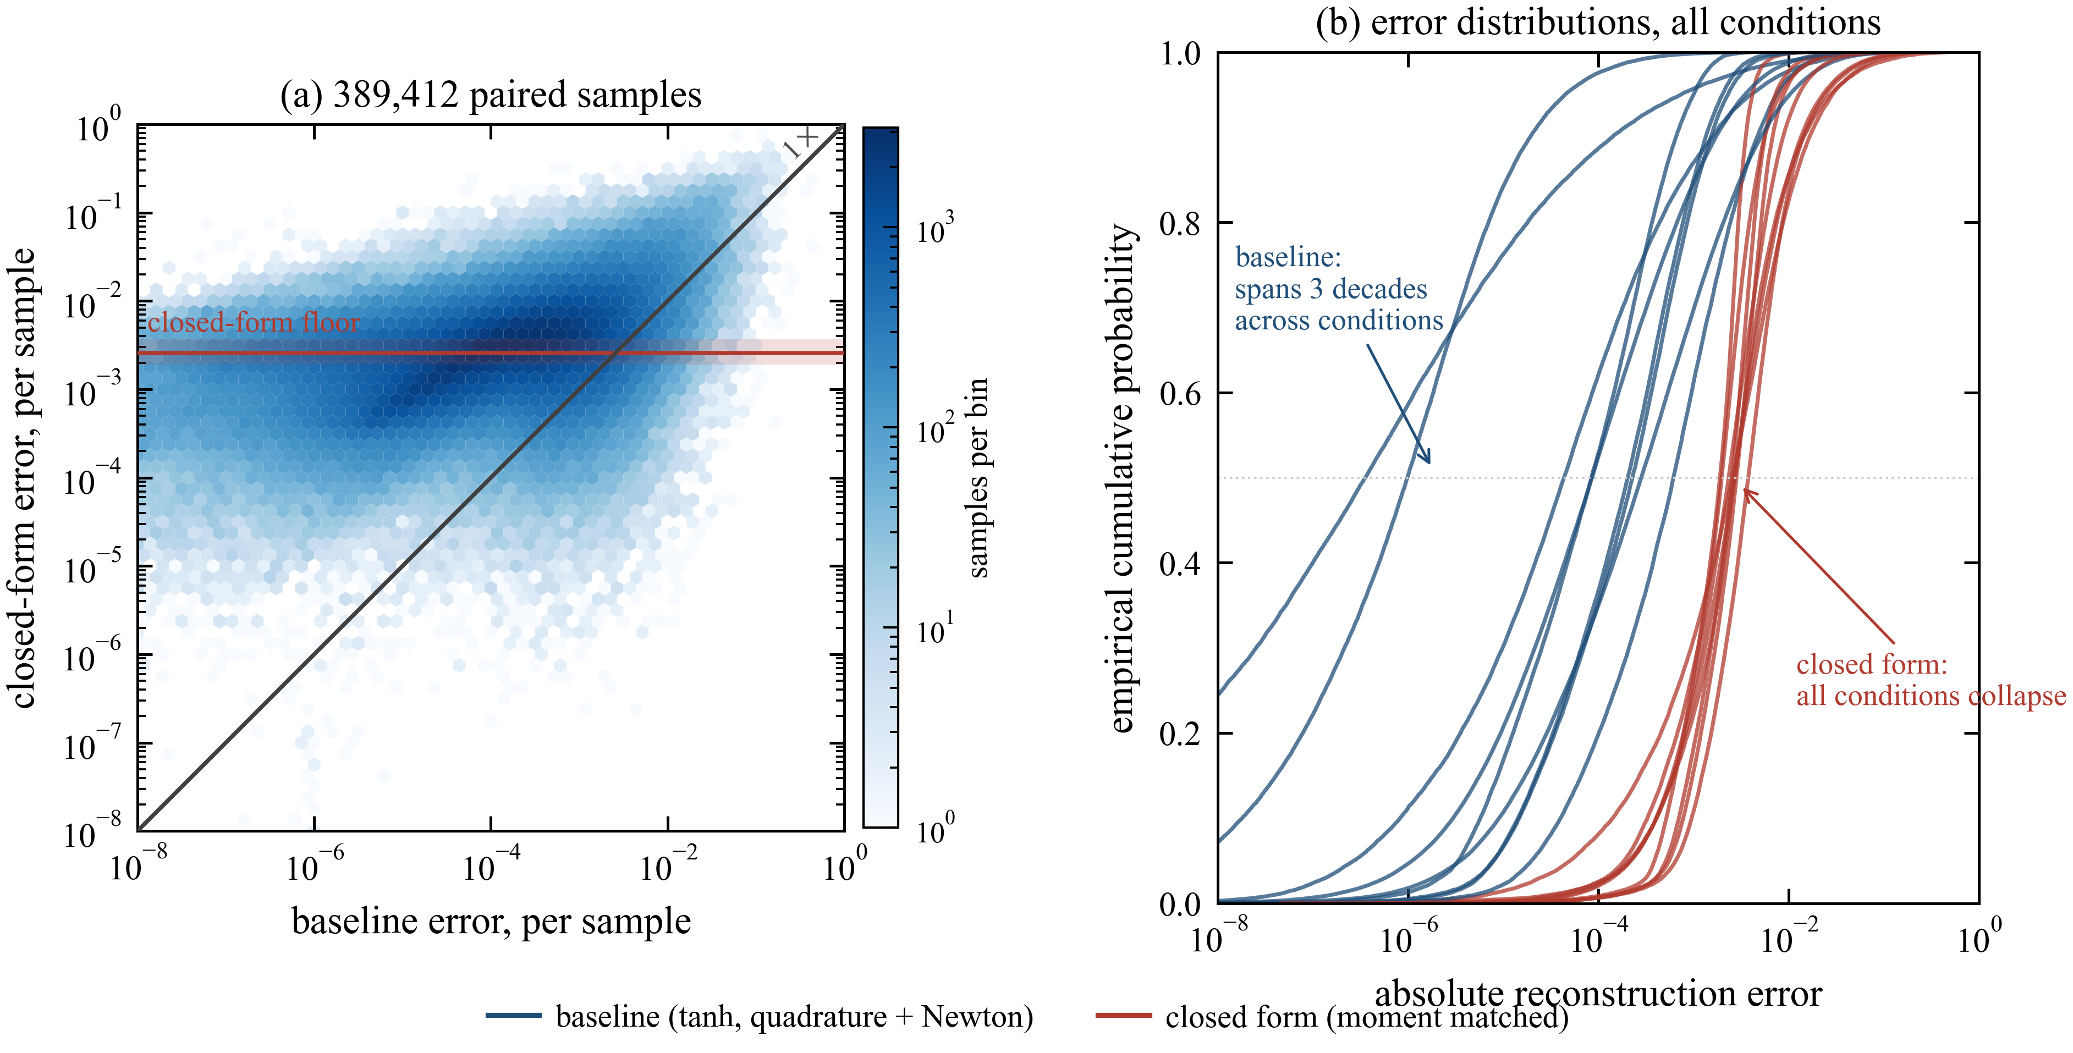
Fig. 1. Paired per-sample errors at production beta, pooling all nine conditions (389,412 pairs). (a) Joint density of the closed-form error against the baseline error on identical logarithmic axes; the diagonal is equality. The cloud does not follow the diagonal: it spreads horizontally, because the closed-form error sits near a fixed level (red line and band, the range of the per-condition medians) while the baseline error varies over several decades from sample to sample. (b) Empirical cumulative distributions of the absolute error, one curve per condition per method. The nine closed-form curves collapse onto each other; the nine baseline curves are spread across three decades. Quantitatively, the median closed-form error spans only 1.89e-3 to 3.76e-3 across all nine conditions (a factor of 2.0), whereas the median baseline error spans 3.53e-7 to 6.15e-4 (a factor of 1742). Per-condition Spearman correlation between the two errors is 0.34-0.70, i.e. well short of the proportionality that a constant multiplicative penalty would imply.
Interpretation. The closed form does not scale the baseline's error; it replaces a highly variable quadrature error with a near-constant approximation floor of roughly 2-4x10^-3, set by the moment-matching step and essentially independent of dimension, cell shape and stage. This is why the aggregate ratios in Table 1 read as a modest 2-6x: RMS is dominated by the tail of the distribution, and in that tail both methods are of comparable magnitude, so the aggregate comparison understates how much larger the closed-form error is on a typical sample and overstates how well the two track each other. Both statements are true and both belong in the paper. Whether the floor is acceptable is an empirical question answered elsewhere in this document: it lies below the discretization error of the surrounding scheme, is confined to interface cells by the BVD selection, and does not disturb the finite-volume conservation (Sec. 2.4), which is consistent with the near-identical S1/S2 flow fields and the few-percent enstrophy differences reported in Sec. 5.

Table 2 -- kernel speedup, GAUSS vs baseline at production beta (9 rows)
Dim | Stage | Shape | baseline | GAUSS | speedup
2D | cell-D | triangle | 219.9 ns | 15.2 ns | 14.4x
2D | cell-D | quad | 617.6 ns | 15.1 ns | 40.9x
2D | face | edge | 78.2 ns | 36.1 ns | 2.17x
3D | cell-D | tetrahedron | 2.227 us | 0.0278 us | 80x
3D | cell-D | hexahedron | 3.906 us | 0.0265 us | 147x
3D | cell-D | prism | 3.272 us | 0.0301 us | 109x
3D | cell-D | pyramid | 2.799 us | 0.0273 us | 102x
3D | face | triangle | 0.247 us | 0.081 us | 3.0x
3D | face | quad | 0.316 us | 0.080 us | 4.0x

Table 3 -- real-solver end-to-end wall time, 500 steps, CHENG3_PROF/E3D_PROF (9 rows)
Case | S1 wall (s) | S2 wall (s) | speedup
leveque (2D) | 17.17 | 14.98 | 1.15x
mach3 (2D) | 49.25 | 49.57 | 0.99x
double_mach (2D) | 188.45 | 188.24 | 1.00x
config3 (2D) | 93.66 | 73.13 | 1.28x
shock_mixing (2D) | 46.88 | 38.50 | 1.22x
shock_vortex (2D) | 73.84 | 66.87 | 1.10x
deform (3D) | 1568.3 | 1215.8 | 1.29x
sphere (3D) | 3457.5 | 2610.0 | 1.33x
2cyl (3D) | 1595.2 | 1171.6 | 1.36x
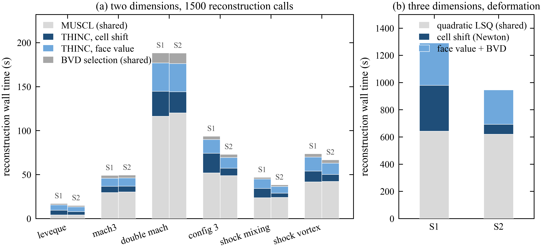
Fig. 2. Stage breakdown explaining Table 3's dilution: MUSCL and BVD_sel are shared, unaccelerated code (near-identical S1/S2 bar segments); only the THINC geom/face segments (2D) or cell-D-Newton/face-quad+BVD segments (3D deform) shrink. mach3 and double_mach show near-zero net speedup because MUSCL alone exceeds THINC's total cost there (mach3 THINC/MUSCL=0.55x). sphere and 2cyl have no stage split available (langseth3d_unstr_bench lacks the RECON-breakdown instrumentation deform received this session).

8. Open items
- 3D S2/S3 physics results (deform/sphere/2cyl) need recomputation under the n=4 gmom default before citing enstrophy/pressure figures in the paper; the wall-time and recon-only-profile numbers above do not need to wait for that.
- Figures (identity-line scatter + Bland-Altman, per-shape error bars, error-vs-variance collapse) are not yet generated from the raw CSVs.
- 3D E3D_PROF has no cell-D/face split for sphere/2cyl (only deform); if that split matters for the Amdahl estimate in section 2.5, langseth3d_unstr_bench needs the same instrumentation deform got.
- Section 2.5's Amdahl-estimate prose (2-3x overall 3D speedup, expected from a much smaller 12-22x kernel speedup diluted by unaccelerated LSQ/BVD stages) was written against the now-superseded 3D kernel numbers. With the corrected 80-147x cell-D / 3.0-4.0x face kernel speedups, that Amdahl argument should be re-checked against the real-solver profile (section 5b) rather than re-derived from the microbenchmark alone.

