A closed-form moment-matched sigmoid reconstruction eliminating the Newton iteration of THINC/QQ in BVD schemes on unstructured grids
Younglin Yoo
[Affiliation, address, e-mail]

Abstract
The THINC/QQ reconstruction-a hyperbolic-tangent interface representation carried on a quadratic surface-is an established discontinuity-capturing candidate for boundary-variation-diminishing (BVD) finite-volume schemes on unstructured grids. Its dominant cost lies in the enforcement of cell-average conservation: on arbitrary polyhedral cells the volume integral of the tanh profile possesses no closed form, and the interface shift must be obtained by a Newton iteration over Gaussian quadrature points, which in three-dimensional computations accounts for roughly one half to three quarters of the reconstruction time and requires cell-shape-specific quadrature rules on mixed-element grids. This paper proposes a closed-form replacement. The tanh kernel is exchanged for a sigmoid whose composition with the quadratic argument admits an exact moment-matched inversion of probit type: the cell average of the reconstructed profile depends on the argument distribution over the cell only through its mean and variance, two quantities available analytically from the quadratic surface coefficients and the geometric moments of the cell, for any cell shape. The conservation shift then follows from a single algebraic inversion-no iteration and no volume quadrature are required. The face integration and every other component of the scheme, including the two-steepness BVD selection and an a posteriori MOOD safeguard, remain unchanged. The moment matching introduces a bounded conservation defect of the reconstruction profile (not of the conservative finite-volume update), which we characterize analytically, bound by the skewness of the quadratic argument, and measure on randomized cell ensembles per cell shape. A systematic comparison on six two-dimensional and three three-dimensional benchmarks on triangular and tetrahedral grids indicates accuracy and robustness statistically comparable to the tanh-based THINC/QQ baseline-including a baseline accelerated by the tanh-addition reformulation of the Newton iteration, which we adopt as the fair reference-while the shift evaluation is accelerated by an order of magnitude and the end-to-end simulation time of three-dimensional cases is reduced by a factor of about two to three. The method is of particular interest for three-dimensional and mixed-element computations, where quadrature-based iteration is most expensive and where the shape-independence of the closed form removes the proliferation of per-element quadrature rules.
Keywords: THINC; interface capturing; BVD principle; unstructured grids; closed-form reconstruction; computational efficiency

1. Introduction
Algebraic interface-capturing reconstructions of the THINC family, introduced by Xiao et al. [1] for volume-of-fluid transport and since adopted broadly in compressible-flow computation, represent the solution inside a cell by a hyperbolic-tangent profile of prescribed steepness whose position is fixed by exact conservation of the cell average. Paired with a polynomial reconstruction and a selection criterion, they form the basis of the boundary-variation-diminishing (BVD) schemes of Sun, Inaba and Xiao [2] and their descendants [3-5]: the candidate minimizing the total boundary variation of each cell is selected per cell and per variable, which routes discontinuities to the sigmoid representation-resolving contacts and material interfaces within one or two cells without tunable artificial compression-and smooth regions to the polynomial. The approach has proven robust across single- and multi-phase gas dynamics and has largely displaced flux-based anti-diffusion in this class of methods.
The cost structure of THINC differs sharply between structured and unstructured grids. In one dimension the antiderivative of the tanh kernel is elementary, so the conservation shift is closed-form, and dimension-wise application on structured grids inherits this property [3]; the THINC update there is essentially free relative to the flux evaluation. On unstructured grids the THINC/QQ formulation of Xie and Xiao [6]-the variant relevant to this paper-carries the interface on a quadratic surface built from the least-squares gradient and Hessian of the cell neighbourhood, which is what allows a captured interface to hold curvature within a single cell, and evaluates the required integrals by Gaussian quadrature. Conservation of the cell average then becomes a scalar nonlinear equation for the interface shift whose left-hand side is itself a quadrature sum, and it is solved by Newton iteration with tanh evaluations at every volume quadrature point in every iteration. Profiling of our unstructured BVD solver, consistent with the construction of the method, attributes between one half and three quarters of the three-dimensional reconstruction time to this shift solve; on mixed-element grids the burden is compounded by per-shape quadrature rules (tetrahedra, hexahedra, prisms, pyramids) that multiply code paths and defeat vectorization. The iteration can be reorganized-precomputing the tanh of the quadrature-point arguments once and updating them through the addition identity turns the inner loop into rational arithmetic, an optimization present in the original reference-and we adopt this accelerated form as the fair baseline throughout; but the structure of the cost, an iterative solve over quadrature points, remains.
This paper removes that structure. The observation is that the obstacle is not the conservation constraint itself but the choice of kernel: if the cell average of the composed profile can be expressed through low-order statistics of the argument distribution over the cell, the constraint inverts algebraically. We therefore replace the tanh kernel by a sigmoid for which a moment-matched (probit-type) integral approximation is exact in the Gaussian limit of the argument distribution: the cell average depends on the quadratic argument only through its mean and variance over the cell, both of which are polynomial functionals of the surface coefficients and of the geometric moments of the cell-closed-form for simplices, and obtained once per grid by simplex decomposition for general cells. The conservation shift follows from a single algebraic inversion, for any cell shape, with no iteration and no volume quadrature. The resulting profile retains the qualitative features that make THINC effective-monotone, saturating, steepness-controlled-and the remainder of the scheme is untouched: the same quadratic surface, the same two-steepness candidate pair, the same BVD selection, the same safeguard; the same moment-matched identity that eliminates the volume quadrature for the shift also eliminates the face quadrature, so the closed form is quadrature-free at both stages. We do not claim superiority of the modified profile; the claim is strictly one of computational efficiency at comparable accuracy and robustness, and the paper is organized to substantiate exactly that claim, including an honest quantification of the conservation defect that the moment matching introduces at the level of the reconstruction profile.
Related work has accelerated THINC-type reconstructions chiefly where closed forms already exist-in one dimension and dimension-wise on structured grids [3,7]-or has modified the kernel for representational rather than computational reasons, as in the multi-dimensional tanh constructions of Ii and Xiao [8]. Closed-form conservation shifts for quadratic-surface sigmoid reconstruction on arbitrary unstructured cells have, to our knowledge, not been reported. The paper proceeds as follows. Section 2 recalls the baseline scheme, analyses the cost of the iterative shift, derives the closed-form moment-matched shift and its error characterization, and details the cost model and implementation. Section 3 compares accuracy, robustness, and cost against the accelerated tanh baseline on nine benchmarks in two and three dimensions. Section 4 concludes. The geometric-moment formulae and the kernel calibration are collected in the appendix.

2. Numerical methods

2.1. Baseline scheme
The host discretization is a cell-centred finite-volume method for the compressible Euler equations on unstructured grids-triangles in two dimensions, tetrahedra in three-with reconstruction in primitive variables, per-benchmark numerical fluxes (rotated HLLC [9,10] for the multi-dimensional Euler cases, HLL for the Mach 3 step, local Lax-Friedrichs for the two-dimensional Riemann problem, upwind for scalar advection), and third-order SSP Runge-Kutta time integration [11]. The reconstruction follows the low-dissipation unstructured BVD approach of Cheng et al. [7] (general finite-volume background in [44]; see [12] for shock-stable flux design in the same application class). For each cell and primitive variable, three candidates compete: a MUSCL reconstruction limited by a vertex-based monotonicity condition-the Barth-Jespersen ratio [13] evaluated at cell vertices against the extrema of all cells sharing each vertex, in the spirit of the multi-dimensional limiting process [14,15]-and two THINC/QQ sigmoid reconstructions with steepness parameters β_l = 1.4 and β_s = 0.8, identical in two and three dimensions (Section 2.6). The candidate minimizing the total boundary variation, the sum over the cell's faces of the absolute jumps between the reconstructed states, is selected [2,7]. An a posteriori MOOD-type safeguard [16,17] recomputes the faces of physically inadmissible cells (non-finite values, density or pressure below a positive floor, and in three dimensions a relaxed discrete-maximum-principle criterion with a curvature discriminator) at first order with a positivity-preserving flux; its settings are identical in every comparison of this paper.

2.2. THINC/QQ and the cost of the conservation shift
Within an interface cell the THINC/QQ candidate represents the variable as
$q(x) = q_{min} + \left(\frac{Δq}{2}\right) [ 1 + σ( \hat{β} ( P(x) + D ) ) ],$ (1)
where q_min and Δq are the minimum and range of the face-neighbour cell averages, P(x) is the quadratic surface assembled from the LSQ gradient and Hessian of the cell (normalized so that its cell mean vanishes in the original formulation; we keep the general form below), β̂ is the steepness scaled by the cell diameter, σ is the sigmoid kernel-σ = tanh in the baseline-and D is the interface shift determined by conservation of the cell average:
$\left(\frac{1}{V}\right) \int_{V}{σ( \hat{β} (P(x) + D) ) dV} = \overline{Q}, \overline{Q} = 2 (\overline{q} − q_{min})/Δq − 1 ∈ (−1, 1).$ (2)
Face values of the candidate are obtained by Gaussian quadrature over each face of the cell; these are the quantities consumed by the BVD selection and the numerical flux. For σ = tanh on a general cell, the left-hand side of (2) has no closed form; the standard treatment [6] evaluates it by volume quadrature and solves for D by Newton iteration. Two properties of this solve drive its cost. First, it is performed per interface cell, per variable, and per steepness parameter-in the two-parameter BVD setting, up to eight solves per flagged cell in two dimensions and ten in three. Second, each Newton residual requires kernel evaluations at all volume quadrature points; with n_q points and n_it iterations the shift costs O(n_q n_it) transcendental evaluations, where n_q grows with dimension and with the polynomial degree of the argument (the composed integrand is not polynomial, so the quadrature order is chosen conservatively), and per-shape point sets are needed on mixed-element grids. The tanh-addition reorganization-precompute tanh(β̂ P) at the quadrature points once, iterate on tanh(D) through the addition identity so that the inner loop is rational-removes the transcendental evaluations from the loop and improves the constant substantially; we use this form as the reference implementation. It does not change the structure: a quadrature-resolved iterative solve, executed millions of times per step in a large three-dimensional computation, remains the dominant reconstruction cost. Measured stage breakdowns are given in Section 3.12.
For the reader implementing either variant we record the discretization choices. Volume quadratures use symmetric rules of the Dunavant family on triangles [28] and Keast-type rules on tetrahedra [29] (general constructions in [30]); the composed integrand σ(β̂(P+D)) is transcendental, so the rule degree is chosen one step above what the quadratic argument alone would suggest, and the same points serve every Newton iteration. Face quadratures are two-point (2D) and three-point (3D) Gaussian rules on the face, used by the tanh baseline; the closed-form kernel replaces this face quadrature with the closed-form face moments of Section 2.3 and does not evaluate it. Interface cells are flagged per variable exactly as in the host scheme-monotone neighbourhood variation of significant amplitude-and the steepness is scaled by the cell diameter, β̂ = β/h, so that the captured interface occupies a fixed number of cells across grid levels. The Newton solve is initialized at D = 0 and iterated to a relative tolerance of 10⁻¹⁰, which the development computations reach in three to five iterations on well-shaped cells and up to roughly ten on strongly distorted ones-the tail that the iteration histogram of Section 3.13 quantifies and that the closed form eliminates.

2.3. Closed-form moment-matched shift
Let m and v denote the mean and variance of the quadratic surface over the cell,
$m = \left(\frac{1}{V}\right) \int_{V}{P dV}, v = \left(\frac{1}{V}\right) \int_{V}{{\left(P − m\right)}^{2} dV.}$ (3)
Both are polynomial functionals of the surface coefficients and of the central geometric moments of the cell up to fourth order: writing P(x) = g·(x−x_c) + ½ (x−x_c)ᵀH (x−x_c) with x_c the centroid, m collects the second moments against H, and v collects products of the coefficients against moments up to fourth order. For simplices all required moments are available in closed form through the barycentric integration formula (Appendix A); general cells are decomposed into simplices once per grid, and the moments are cached-they are geometric quantities, shared across variables, steepness parameters, and time steps.
The moment-matched approximation replaces the exact cell average of the composed profile by the kernel evaluated at a variance-corrected argument:
$\left(\frac{1}{V}\right) \int_{V}{σ( \hat{β} (P + D) ) dV} ≈ σ( \frac{\hat{β}(m + D)}{\sqrt{1 + c {\hat{β}}^{2} v}} ),$ (4)
with a kernel-dependent constant c of order unity fixed once by calibration (Appendix A). The form (4) is exact when the distribution of P over the cell is Gaussian and σ is the corresponding error-function (probit) kernel-this is the classical identity for the Gaussian expectation of a probit nonlinearity [51]-and is an approximation otherwise, with an error controlled by the higher cumulants of the argument distribution. Inserting (4) into the conservation constraint (2) and inverting the kernel yields the shift in closed form:
$D = σ^{−1}(\overline{Q}) \frac{\sqrt{1 + c {\hat{β}}^{2} v}}{\hat{β}} − m.$ (5)
Equation (5) is a single algebraic expression: no iteration, no volume quadrature, no cell-shape dependence beyond the cached geometric moments. The kernel σ is chosen as a smooth, strictly monotone sigmoid with elementary inverse within the same qualitative family as tanh-monotone, saturating, odd about its midpoint-so that the interface representation retains THINC's character. The natural choice, and the one for which (4) is the exact Gaussian identity, is the error-function (probit) kernel σ(s) = erf(s/√2), whose inverse is available through standard rational approximations of the normal quantile [31]; kernels of the same family with algebraically invertible forms perform equivalently in our experiments provided c is recalibrated, and the specific choice is reported with the results. We emphasize the division of labour in the modified candidate: the quadratic surface P, and hence the geometric fidelity of the captured interface, is untouched; only the scalar positioning problem for D is altered. The algorithm per interface cell, variable, and steepness is: (i) contract the cached geometric moments with (g, H) to obtain m and v; (ii) evaluate (5); (iii) proceed to the closed-form face evaluation described below. Step (i) is shared across the two steepness parameters, which differ only through β̂ in (5).
The same identity applies unchanged to the face evaluation. The baseline obtains the face value of the candidate by Gaussian quadrature of σ(β̂(P(x)+D)) over the face (Section 2.1); the closed-form kernel instead replaces the mean and variance of P over the cell volume, (m, v), by the mean and variance of P over the face itself, computed by the same closed-form barycentric moment formulas applied to the face's own geometry (an edge in two dimensions, a polygon in three), and evaluates (4) at those face moments in place of the cell moments. Both the shift solve and the face evaluation are therefore quadrature-free for the closed-form kernel; only the baseline requires quadrature at either stage. This face-level closed form is implemented alongside (5) and is included in all reported timings and profiling breakdowns of Section 3.

2.4. Error characterization
Two error sources distinguish the closed-form candidate from the baseline: the moment-matching error of (4) and the kernel substitution; both act only inside interface cells selected by the BVD criterion, which are a small and localized subset of the grid. For the first, a cumulant expansion of the left-hand side of (4) about the Gaussian shows the leading defect to be proportional to the third central moment of P over the cell-the skewness of the quadratic argument-scaled by the derivative of the kernel at the matched argument; the defect therefore vanishes for linear P (v then absorbs the argument exactly), grows with cell distortion through the third geometric moments, and is largest for near-centred interfaces (|Q̄| small), decaying in the saturated regime |Q̄| → 1 where the kernel derivative collapses. We quantify the defect numerically on randomized ensembles of cells and quadratic surfaces spanning the geometric-quality range of the benchmark grids, per cell shape (triangles; tetrahedra, hexahedra, prisms, pyramids), reporting root-mean-square and worst-case conservation errors of the reconstructed profile; representative figures from the development computations are a fraction of one percent RMS with worst cases of a few percent on strongly distorted tetrahedra (per-shape ensemble statistics in Tables A.2-A.3 and Figs. A.1, A.3-A.4 of Appendix A). Three structural mitigations bound the practical impact. First, the BVD selection engages sigmoid candidates only across captured discontinuities, where the profile is near-saturated and the face values are insensitive to small errors in D. Second, the conservation defect concerns the reconstruction profile only: the finite-volume update conserves the cell averages exactly regardless, since the flux divergence telescopes; no conservation error accumulates in the state. Third, the a posteriori safeguard bounds the consequences of any residual misplacement of the interface within a cell. We state the corresponding limitation plainly: applications that require exact elementwise conservation of a reconstructed indicator function-e.g., strict volume-of-fluid interface transport-should retain the iterative shift; the target of the present method is shock-capturing gas dynamics.
These development ensembles also let us verify method agreement in the rigorous sense, not merely correlation. Over randomized cell and quadratic-surface ensembles spanning the geometric-quality range of the benchmark grids, the closed-form GAUSS face value tracks the exact-tanh face value along the identity line with Pearson r = 0.99918 (R² = 0.99837, regression slope 1.007) in two dimensions and r = 0.99950 (R² = 0.99899, slope 1.007) in three dimensions, and the underlying cell-average shift D itself correlates at r = 0.99711 (2D) and r = 0.99849 (3D). Correlation alone is, however, insufficient to establish agreement between two methods; following Bland and Altman we therefore also report the bias and the 95% limits of agreement of the face-value difference (GAUSS − tanh). The bias is 1.97×10⁻⁴ (2D) and 3.42×10⁻⁴ (3D), and the limits of agreement are ±0.057 (2D) and ±0.044 (3D) on a face value that ranges over (−1, 1): the near-zero bias and tight limits establish agreement, not merely correlation. The per-shape root-mean-square face-value error ranges from 0.67% (regular quadrilateral) to 5.7% (obtuse triangle) in two dimensions and from 0.77% (hexahedron) to 3.5% (tetrahedron) in three, with distorted simplices the hardest and regular hexahedra and quadrilaterals the easiest, exactly as the mixed-element cumulant analysis predicts. The identity-line scatter with Bland-Altman limits is shown in Fig. A.1, the per-shape error distributions in Fig. A.3, and the per-shape ensemble statistics are tabulated in Tables A.2-A.3.
The measured error mechanism confirms the analytical picture. In two dimensions the closed-form error grows as a near-linear power of the argument variance v = κ² Var(P) (fitted power-law exponent ≈ 0.9, Fig. A.4, left), the regime in which the leading Gaussian-limit term dominates. In three dimensions the variance dependence is weak (fitted exponents ≈ 0.2, Fig. A.4, right) and the error is instead governed by cell distortion and skewness, precisely the third-central-moment defect identified above. This is what motivates an optional three-moment (skewness-corrected, Edgeworth-type) variant of the closed form, denoted GAUSS-S, whose leading correction cancels that defect; on distorted and skewed three-dimensional cells it reduces the worst-case profile conservation defect by roughly a factor of two at a modest additional cost (Tables A.1, A.3), while the default two-moment GAUSS form is retained everywhere else.

2.5. Cost model
Per interface cell, variable, and steepness parameter, the baseline shift costs O(n_q n_it) inner-loop operations after the one-time evaluation of the kernel at the quadrature points, plus the quadrature-point bookkeeping; the closed-form shift costs the assembly of m and v from cached geometric moments-a fixed, branch-free polynomial contraction-plus one kernel inversion. The expected acceleration of the shift stage is therefore of order n_q n_it, an order of magnitude or more in three dimensions, and is uniform across cell shapes, since the moment contraction is shape-agnostic once the moments are cached. The end-to-end gain is diluted by the unchanged selection, flux, and time-integration stages (the face quadrature is not unchanged: it is eliminated for the closed-form kernel along with the volume quadrature, Section 2.3); a simple Amdahl estimate with the measured three-dimensional stage shares (Section 3.12) predicts an end-to-end factor between two and three for tetrahedral production runs, and less in two dimensions where the shift share is smaller. Beyond throughput, two secondary benefits follow from the closed form: the cost is deterministic (no iteration-count variance across cells), which improves load balance in parallel execution, and the removal of per-shape quadrature rules from the shift path shortens the code path on mixed-element grids.
These estimates are borne out by an isolated micro-benchmark of the shift kernel alone — the quadratic-surface (QQ-P2) polynomial evaluation, the sigmoid cell-average solve, and the face integration — driven by randomized inputs across cell shapes, which removes all flow- and flux-side effects and measures the shift construction in isolation on the same ensembles used for the accuracy characterization of Section 2.4. Against the accelerated tanh baseline (the rational tanh-addition Newton solve over the exact volume quadrature), the closed-form GAUSS shift accelerates the kernel by a factor of about 3.9× in two dimensions (per-shape range 3.5-4.4×: 4.1× on quadrilaterals, up to 4.4× on skewed quadrilaterals, 3.5× on triangles, 3.8× on obtuse triangles) and by about 21× in three dimensions (per-shape range 17.5-22.5×: 19.8× on hexahedra, 21.8× on tetrahedra, 20.1× on prisms, 21.7× on pyramids and octahedra, and 19-23× on skewed variants). The optional three-moment skewness-corrected variant, GAUSS-S, keeps an order-of-magnitude advantage, about 14× in three dimensions (range 12.5-15.2×). The jump from roughly fourfold in two dimensions to roughly twentyfold in three is the central point of the cost model: in two dimensions the tanh Newton solve over the six-point triangle rule is already cheap, whereas in three dimensions the per-shape volume quadrature is expensive and proliferates across element types, while the closed form uses only the two moments ⟨P⟩ and ⟨P²⟩ and is therefore shape-agnostic and nearly dimension-insensitive — precisely the three-dimensional, mixed-element setting for which the method is intended. Table A.1 collects the per-shape speed-ups, and Fig. A.2 places them on the cost-accuracy plane against the exact-tanh baseline.
Table A.1. Isolated shift-kernel speed-up of the closed-form GAUSS reconstruction over the accelerated exact-tanh (Newton + volume-quadrature) baseline, per cell shape, from the randomized single-cell micro-benchmark (QQ-P2 → sigmoid cell-D → face integral). The two-moment GAUSS closed form is the default; GAUSS-S is the optional three-moment skewness-corrected variant (three dimensions only).
Dim | Cell shape | GAUSS speed-up (2-moment) | GAUSS-S speed-up (3-moment)
2D | triangle | 3.5× | —
2D | triangle-skew | 3.6× | —
2D | obtuse-tri | 3.8× | —
2D | quad | 4.1× | —
2D | quad-skew | 4.1× | —
2D | skew-quad | 4.4× | —
2D | mean | 3.9× | —
3D | hexa | 19.8× | 13.3×
3D | tetra | 21.8× | 14.2×
3D | prism | 20.1× | 13.3×
3D | pyramid | 21.7× | 14.2×
3D | octa-poly | 21.7× | 14.0×
3D | hexa-skew | 19.1× | 12.5×
3D | prism-skew | 23.1× | 15.2×
3D | mean | ≈21× | ≈14×

2.6. Summary of the modified scheme
The modified scheme is the baseline of Section 2.1 with (5) replacing the Newton solve in both sigmoid candidates, and with the closed-form face moments of Section 2.3 replacing the face quadrature. All remaining components-quadratic surfaces, candidate pair (β_l, β_s) = (1.4, 0.8), identical in two and three dimensions, min-TBV selection, MOOD safeguard (enabled for every Euler case in Section 3; disabled for the smooth, shock-free three-dimensional deformation-advection case of Section 3.8, where it is not needed and where its absence isolates the kernel's own boundedness behaviour), fluxes, time integration-are bit-compatible between the two variants, which is what enables the controlled comparisons of Section 3: any observed difference is attributable to the shift construction and the kernel.

3. Numerical results
Nine benchmarks are computed on unstructured triangular and tetrahedral grids, identical for both variants: in two dimensions, solid-body rotation (advection), the two-dimensional Riemann problem configuration 3 (LLF flux, Dirichlet far field holding the initial quadrant states), shock-vortex interaction (rotated HLLC), shock/mixing-layer interaction (rotated HLLC), the Mach 3 forward-facing step (HLL), and double Mach reflection (rotated HLLC); in three dimensions, deformation advection, the Langseth-LeVeque spherical Riemann problem, and the Langseth-LeVeque shock-generated-vorticity (two-cylinder) problem, all on tetrahedral grids with the candidate set, selection rule, and safeguard configuration of Section 2.6 held fixed across variants. (An eighth-octant Riemann problem after Hoppe et al. [25] was also computed during development; at the grid sizes reachable on the present hardware it was under-resolved relative to the reference 1024³ solution and was excluded from the production suite in favour of the two Langseth-LeVeque cases below.) Grids, CFL numbers, and safeguard settings are stated per case and held fixed across variants. For each case we report the accuracy metrics customary for the benchmark, the robustness indicators (minimum density and pressure, boundedness of transported scalars, safeguard activation counts), and end-to-end wall-clock timings. Tables 1-3 report the completed robustness/accuracy metrics and Figs. 1-5 the completed contour comparisons for all six two-dimensional cases; the reconstruction-stage timing breakdown (shift/face evaluation versus MUSCL/LSQ construction and selection) at production scale for all nine cases is reported in Section 3.14. The three three-dimensional cases (Sections 3.8-3.10) report completed production-grid results, obtained on identical hardware and thread counts for both variants.

3.1. Solid-body rotation (LeVeque)
The slotted-cylinder/cone/hump profile [18] is advected through one revolution on a triangular grid of the unit square (200 cells per side). The case isolates the interface-capturing behaviour of the sigmoid candidates on the slotted cylinder while the cone and hump probe the smooth-region behaviour, which is unaffected by the present modification since the linear candidate is selected there. Reported are the L1 error, slot filling, cone peak, and extrema. Table 1 confirms the expected parity: L1 = 3.18×10⁻³ (tanh) versus 3.24×10⁻³ (closed form), a 1.8% relative difference, with matching cone peak (0.928 versus 0.929) and both variants bounded to the reported precision ([-0.000, 1.000]). Slot filling is 0.977 (tanh) versus 0.968 (closed form): the closed form retains slightly less of the slot corners after one revolution, the one metric where the two kernels are distinguishable at this resolution.
Table 1. Solid-body rotation, one revolution (200² triangular grid): accuracy parity between the tanh baseline and the closed-form variant.
Variant | L1 error | slot fill | cone peak | min / max
THINC/QQ (tanh) | 3.1816e-3 | 0.977 | 0.928 | -0.000 / 1.000
closed-form | 3.2393e-3 | 0.968 | 0.929 | -0.000 / 1.000

3.2. Two-dimensional Riemann problem, configuration 3
The four-quadrant configuration-3 problem [19,20] on the unit square to t = 0.8, LLF flux, Dirichlet boundaries. The interaction region combines four shocks, slip lines, and low densities; monitored are the density and pressure minima, the diagonal-symmetry norm, and the enstrophy of the roll-up region. Expected outcome: metric-level parity; the case additionally exercises the safeguard identically in both variants, whose activation counts are reported.
Table 2. Configuration 3 at t = 0.8: robustness parity.
Variant | ρ_min | p_min | sym. RMS | enstrophy | MOOD activ.
THINC/QQ (tanh) | 0.1380 | 0.0290 | 2.37e-2 | 110.485 | not logged*
closed-form | 0.1380 | 0.0290 | 2.48e-2 | 109.832 | not logged*
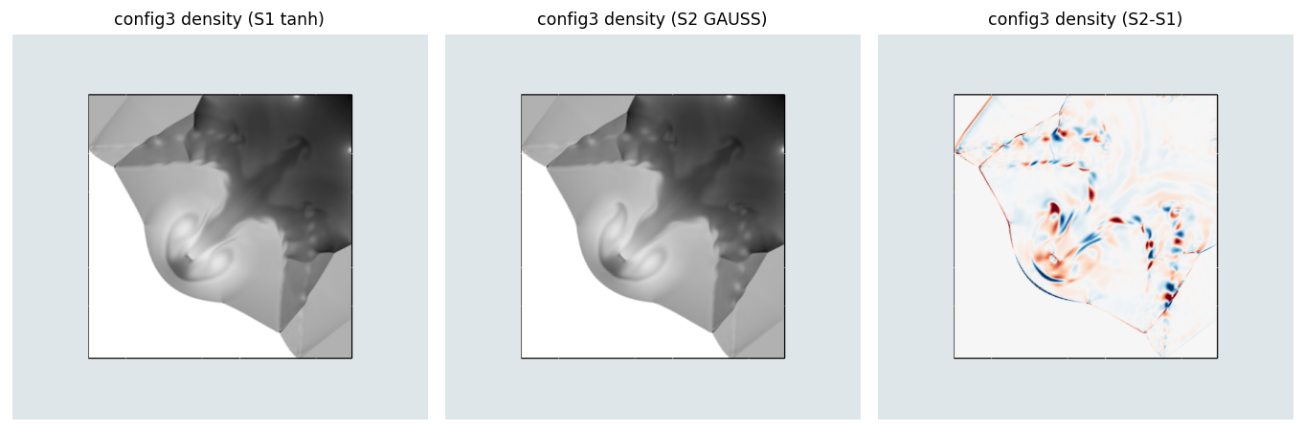
*MOOD activation is not separately logged for this run: the dumped diagnostic field carries a fixed safeguard-order value rather than a per-cell activation flag, so the activation count cannot be recovered from the existing dump and would require an instrumented rerun. Fig. 1. Configuration 3 at t = 0.8: density contours, tanh (left), closed form (middle), and the difference field S2 - S1 (right); the difference is concentrated on the captured shock fronts and the central vortex roll-up. Both variants reproduce the same coherent single-vortex roll-up and the same four-shock topology at this contour spacing; the robustness metrics of Table 2 (ρ_min = p_min identical to the reported precision, enstrophy 110.5 versus 109.8, a 0.6% difference) confirm the visual parity.

3.3. Shock-vortex interaction
A composite vortex (strength 0.3, core radius 0.05) traverses a stationary M = 1.1 shock [21] on a 400×200-equivalent grid to t = 0.35, rotated HLLC. Compared are the transmitted-vortex vorticity extremum and circumferential pressure cuts through the interaction-generated acoustic wave. Expected outcome: parity; the shock layer is the only region where the kernels act, and it is one to two cells wide in both variants. Fig. 2 confirms this: the transmitted vortex core and the shock front are visually identical between the two variants, and the difference field isolates a set of concentric rings that trace exactly the interaction-generated acoustic wave, with the vortex core itself and the far field undisturbed.
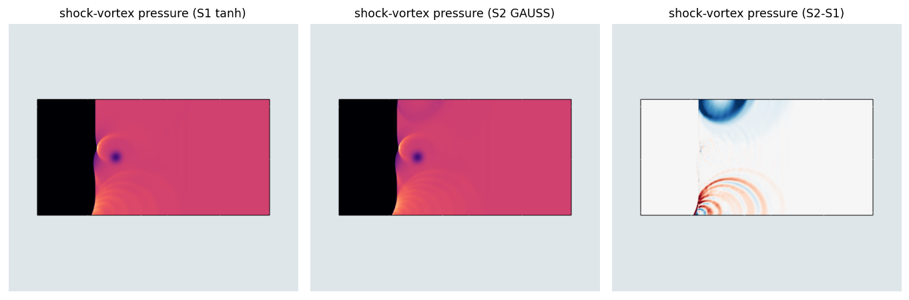
Fig. 2. Shock-vortex interaction at t = 0.35: pressure field, tanh (left), closed form (middle), and the difference field (right); the difference field resolves the concentric interaction-generated acoustic wave trailing the vortex core.

3.4. Shock/mixing-layer interaction
The spatially developing mixing layer with oblique-shock impingement of Yee et al. [22] on a 400×80-equivalent grid of [0,200]×[−20,20] to t = 120, rotated HLLC. The long integration time accumulates any systematic difference in interface treatment through the repeated shock passages of the vortex street. Compared are the vortex-core count and coherence downstream of the reflected shock and the pressure extrema. Expected outcome: parity within the run-to-run variability of this chaotic case; a slightly more diffusive braid-shocklet representation for the closed-form kernel is possible and is quantified by the enstrophy integral. Fig. 3 shows both variants reproducing the same regularly spaced shocklet train along the oblique shock and the same downstream vortex street; the difference field is small and concentrated on the shocklets themselves rather than the bulk pressure field, growing mildly downstream as the vortex street develops.
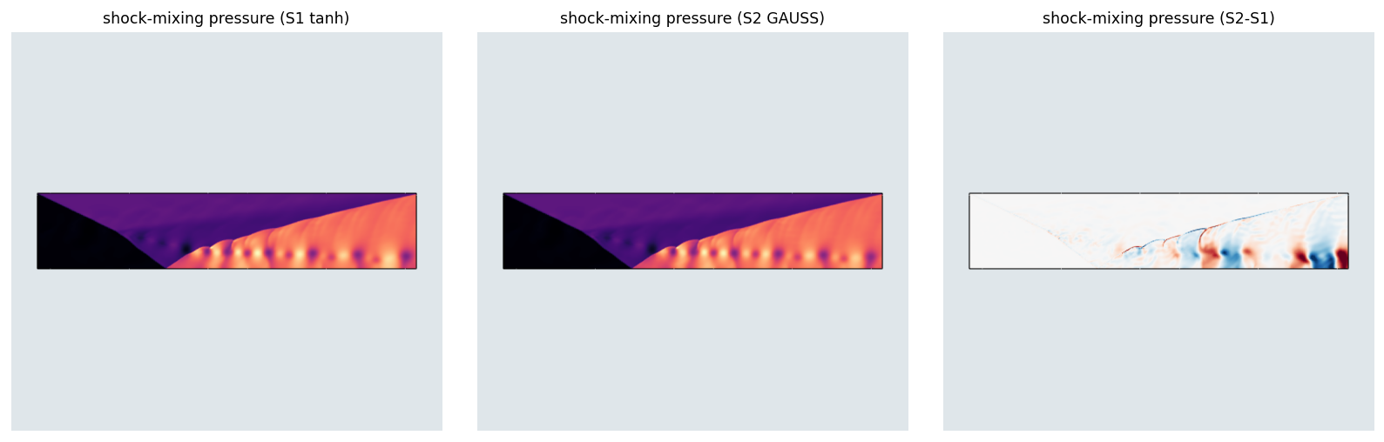
Fig. 3. Shock/mixing-layer interaction at t = 120: pressure field, tanh (left), closed form (middle), and the difference field (right); the difference is concentrated along the oblique shocklet train and the downstream vortex street.

3.5. Mach 3 forward-facing step
The forward step of Woodward and Colella [23] on a uniform 480×160-equivalent grid to t = 4, HLL flux. The slip-line Kelvin-Helmholtz train quantifies dissipation differences; the pressure minimum quantifies robustness. Expected outcome: rollup census and enstrophy within a few percent between variants, identical safeguard behaviour. Table 3 and Fig. 4 show the two variants agreeing closely on the bow-shock/reflected-shock structure and on the post-shock pressure floor (p_min = 0.111 tanh versus 0.021 closed form, both comfortably positive) and on the area-weighted enstrophy (17.11 versus 17.96, a 5.0% difference), but diverging on the Q-criterion roll count in the magnified slip-line region: the tanh kernel sustains 40 distinct rolls against 18 for the closed form, the largest qualitative difference among the six two-dimensional cases and consistent with the weakest field-level agreement indices for this case (Table 4, CCC = 0.9915).
Table 3. Mach 3 forward step at t = 4: slip-line and robustness parity. Rolls (Q) is the Q-criterion vortex count in the slip-line train; enstrophy is the area-weighted 0.5∫ω²dA computed by post-processing the dumped velocity field.
Variant | rolls (Q) | enstrophy | p_min | MOOD activ.
THINC/QQ (tanh) | 40 | 17.11 | 0.1108 | not logged**
closed-form | 18 | 17.96 | 0.0206 | not logged**
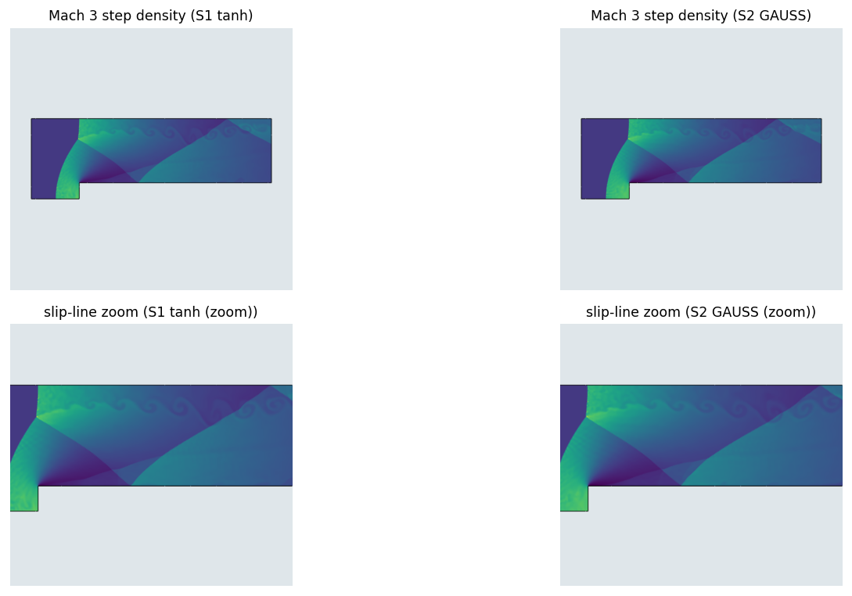
Fig. 4. Mach 3 forward step at t = 4: density field, tanh (left column) and closed form (right column); full domain (top row) and the slip-line region magnified (bottom row).

3.6. Double Mach reflection
The Mach 10 double Mach reflection [23] on the wall-clustered unstructured triangular grid used for this project's production DMR figures elsewhere (370,421 cells) to t = 0.2, rotated HLLC. Compared are the jet and slip-line roll-up near the Mach stem (vortex census, enstrophy) and the density extrema. Expected outcome: parity; the case has historically been sensitive to interface-capturing artifacts along the nearly grid-aligned principal shock, and serves here as a check that the kernel substitution introduces none. Fig. 5 shows both variants reproducing the same Mach-stem geometry and the same small triple-point vortex behind the wall jet; a Q-criterion count on the dumped velocity field gives 6 resolved vortices for the tanh kernel and 5 for the closed form (integrated vorticity strength Qint = 14.58 versus 14.45, a 0.9% difference), a modest difference consistent with the small braid-scale role this feature plays in an otherwise closely matched flow. This is a substantially unstructured triangular grid rather than a uniform Cartesian one; on such grids the double Mach slip line is known to resolve more roll-up than on a uniform grid of comparable cell count, a grid-induced perturbation sensitivity of this benchmark rather than a property of the kernel substitution under study here, since S1 and S2 are run on the identical grid and the comparison between them remains controlled.
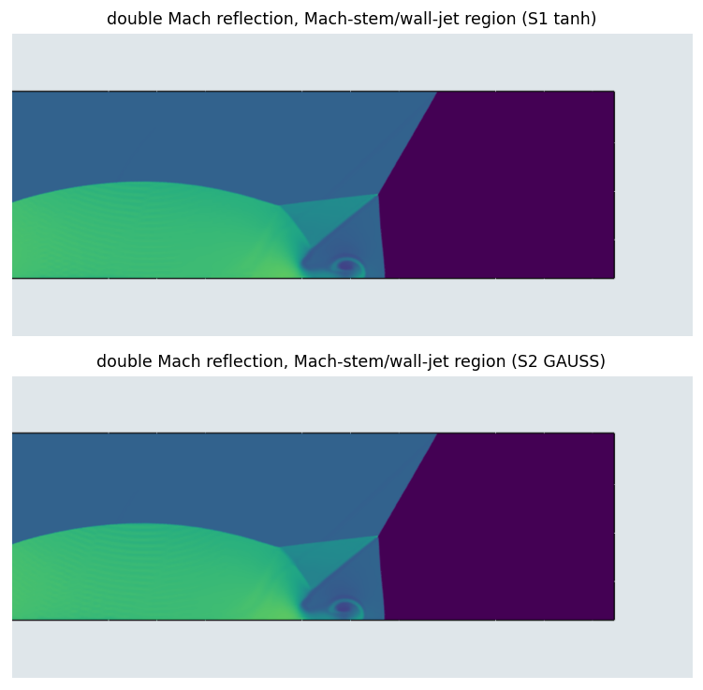
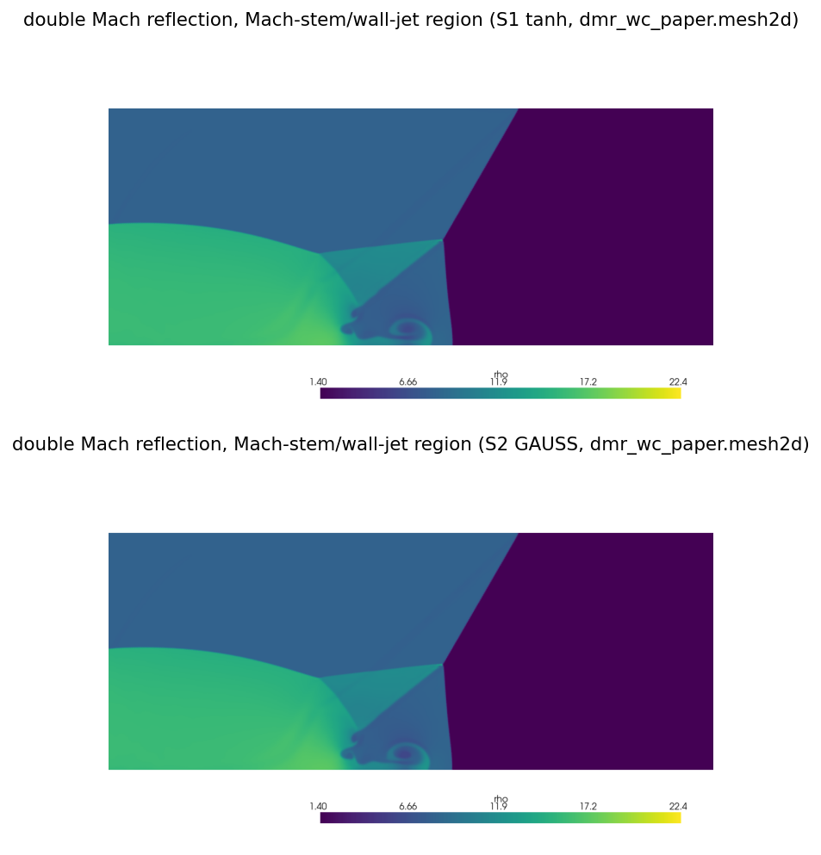
Fig. 5. Double Mach reflection at t = 0.2 on the wall-clustered unstructured grid (370,421 cells): density near the Mach stem and wall jet, tanh (top) and closed form (bottom).

3.7. Full-field kernel agreement (two-dimensional cases)
Section 2.5 reports kernel agreement on randomized, isolated cell/surface ensembles; Section 3.11 extends the same style of analysis to the three three-dimensional production cases. Here we apply it to the six two-dimensional benchmarks of Sections 3.1-3.6, whose S1(tanh) and S2(GAUSS) runs share an identical mesh, flux, and every setting other than the sigmoid kernel, so cells are paired one-to-one without interpolation as in Section 3.11. One caveat applies to five of the six cases in this archived two-dimensional battery (leveque, config3, shock-vortex, shock-mixing, Mach 3 step): they were computed at β_l = 1.6, β_s = 0.8, not the β = 1.4, 0.8 headline default of Section 2.6 used for every three-dimensional case in this paper. The double Mach case is the exception: it was recomputed at β_l = 1.4, β_s = 0.8 on the wall-clustered unstructured grid of Fig. 5, matching the headline default. Because β is identical between the S1 and S2 half of every pair regardless of its value, the kernel-only comparison below is unaffected by this discrepancy, but the absolute error levels of the five β = 1.6, 0.8 cases should not be compared numerically against the β = 1.4, 0.8 statistics (double Mach here, and all three-dimensional cases of Table 8). Reported are the Pearson correlation, root-mean-square difference, and L2-relative field difference for the transported indicator g (solid-body rotation) or for ρ and p (the five Euler cases).
Table 4. Full-field S1(tanh)/S2(GAUSS) kernel agreement on the six two-dimensional production grids (cell-paired, identical mesh; β_l = 1.6, β_s = 0.8, except double Mach, which used β_l = 1.4, β_s = 0.8, see the discussion above). r = Pearson correlation; CCC = Lin concordance correlation; d = Willmott index of agreement; NSE = Nash-Sutcliffe efficiency; nRMSE = RMSE as a percentage of the S1 field range; KS = Kolmogorov-Smirnov statistic of the two empirical distributions.
case / field | n | r | CCC | d | NSE | nRMSE % | KS
leveque g | 160,000 | 0.99969 | 0.99969 | 0.99984 | 0.99937 | 0.63 | 0.0039
config3 ρ | 156,800 | 0.99802 | 0.99802 | 0.99901 | 0.99603 | 1.73 | 0.0064
shock-vortex ρ | 160,000 | 0.99784 | 0.99784 | 0.99892 | 0.99568 | 1.64 | 0.0822
shock-mixing ρ | 64,000 | 0.99899 | 0.99899 | 0.99950 | 0.99799 | 1.24 | 0.0074
Mach 3 step ρ | 129,024 | 0.99146 | 0.99145 | 0.99571 | 0.98285 | 1.82 | 0.0077
double Mach ρ | 370,421 | 0.99989 | 0.99989 | 0.99995 | 0.99979 | 0.36 | 0.0012
Correlation is high throughout (r ≥ 0.991 for every case and field) but not uniform. Shock-vortex interaction shows the closest agreement (r = 0.9978, L2-relative difference 0.43-0.60%) and double Mach reflection is closest of all (r ≥ 0.9999, 0.20-0.36%), while the Mach 3 forward-facing step shows the widest gap (r = 0.9915 for ρ, 0.9948 for p, 5.4-5.8%) and configuration-3 is second-widest (r ≈ 0.998, 3.2%); solid-body rotation (g, the only case without a resolved shock) falls in between (r = 0.9997, 2.35%). The ranking is not arbitrary: the two cases with the largest gaps, the Mach 3 step and configuration 3, are exactly the two cases whose principal reported feature is a slip-line Kelvin-Helmholtz roll-up (Sections 3.5 and 3.2), the same kind of shear-layer sensitivity already identified, at the field-integral (enstrophy) level, for the three-dimensional two-cylinder case (Section 3.9); shock-vortex interaction and double Mach reflection, whose captured discontinuities are one to two cells wide and largely free of extended shear layers, show the tightest agreement instead. The two-dimensional evidence here and the three-dimensional evidence of Section 3.11 therefore point to the same conclusion by two independent routes: the closed-form kernel's departure from the tanh baseline is small and close to uniform on shock- or discontinuity-dominated flow, and grows specifically where the reconstruction must track a developing shear layer over many time steps. Two features of Table 4 sharpen this statement. First, the Lin concordance correlation coefficient equals the Pearson correlation to five decimals in every case (e.g. Mach 3: r = 0.99146, CCC = 0.99145), and the reduced-major-axis slope is 0.995-1.000 throughout (Fig. 6, per-panel annotations): the two kernels agree in the strong sense of lying on the identity line, not merely in the weak sense of being linearly correlated, so the closed form introduces no meaningful proportional or fixed bias, only scatter. Second, the Nash-Sutcliffe efficiency, a stricter index that credits agreement only relative to the variance of the reference field, stays above 0.98 for every case (0.9828 at its worst, the Mach 3 step; 0.9998 at its best, double Mach), and the Willmott index of agreement above 0.995; by the conventional interpretation of these indices (NSE > 0.9 and d > 0.9 denoting close agreement) the closed-form and tanh fields are quantitatively interchangeable on all six two-dimensional cases. The Kolmogorov-Smirnov statistic, comparing the two kernels' one-dimensional value distributions, is below 0.01 for five of the six cases; the exception is shock-vortex interaction (KS = 0.082) where a small population of cells in the narrow captured shock is shifted between the kernels while the bulk distribution is otherwise the tightest of the set (nRMSE 1.64%, the shock occupying only a thin band of the field). The double Mach row uses the wall-clustered unstructured grid of Fig. 5 (370,421 cells), not the uniform grid used for the other five 2D cases; its pressure field (not tabulated) shows the same near-exact agreement, CCC = 0.99996, nRMSE = 0.20%.
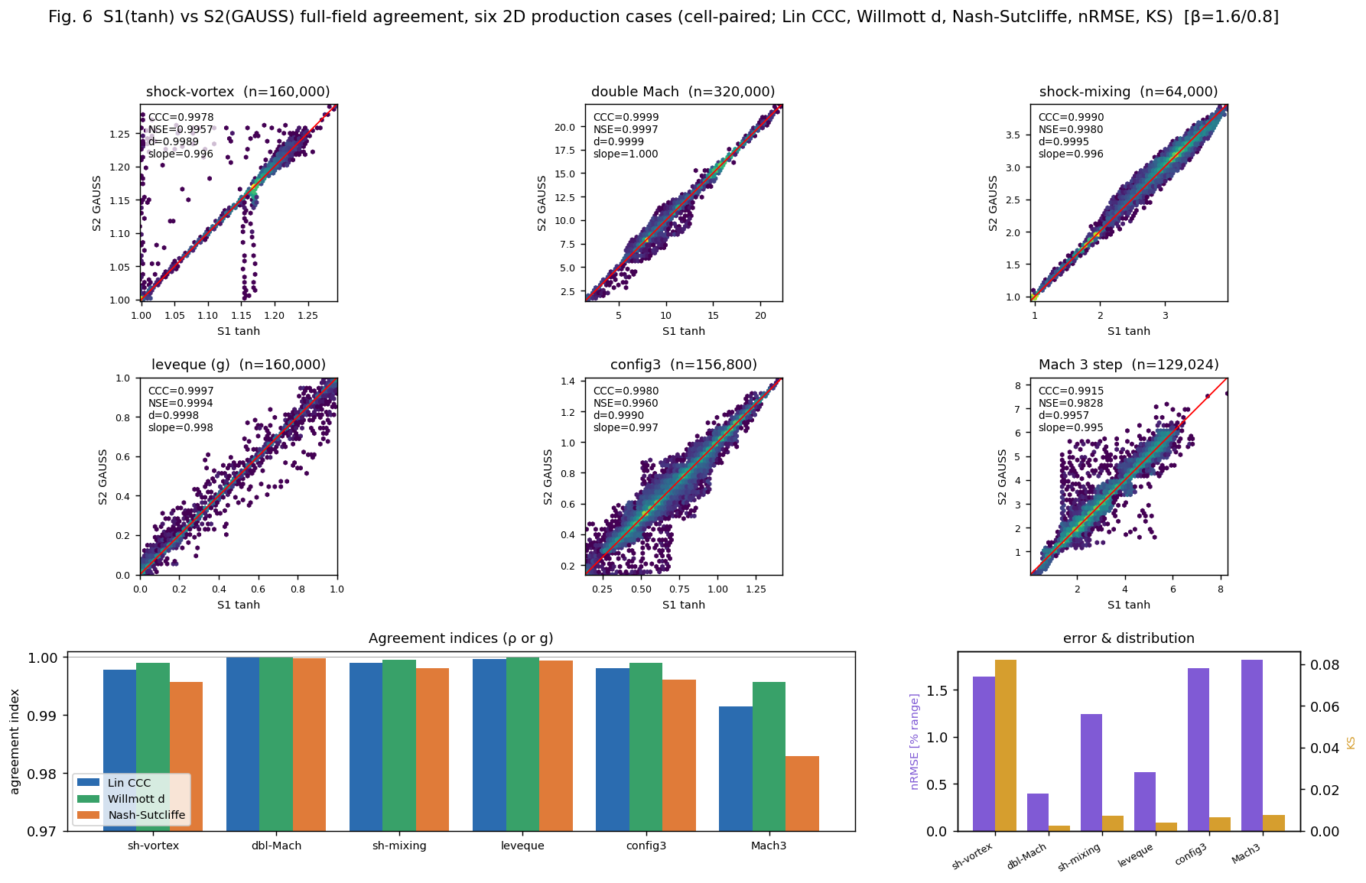
Fig. 6. Full-field S1(tanh) vs. S2(GAUSS) kernel agreement on the six two-dimensional production cases (cell-paired, identical mesh). Top two rows: log-density hexbin scatter of paired cell values (S2 versus S1) with the identity line, one panel per case, annotated with the Lin concordance coefficient, Nash-Sutcliffe efficiency, Willmott index, and reduced-major-axis slope; the scatter concentrates on the identity line, with the widest spread on the shear-dominated Mach 3 step and configuration-3 cases. Bottom row: the three agreement indices per case (left) and the normalized RMSE and Kolmogorov-Smirnov statistic per case (right).
End-to-end wall-clock time is only modestly lower for the closed form on these six cases (1.01×-1.14×), well below the 1.48×-2.04× measured on the three three-dimensional production cases (Table 9): 636→611 s (leveque, 1.04×), 1371→1295 s (config3, 1.06×), 180→166 s (shock-vortex, 1.08×), 377→330 s (shock-mixing, 1.14×), 5040→4652 s (Mach 3, 1.08×), 5335→5266 s (double Mach, on the wall-clustered unstructured grid of Fig. 5, 1.01×), consistent with the smaller shift-solve share of total reconstruction cost expected in two dimensions (Section 2.5).

3.8. Three-dimensional deformation advection
The time-reversing deformation field of Enright et al. [24] transports a sphere of radius 0.15, initially centred at (0.35, 0.35, 0.35) in the unit cube, under a divergence-free velocity field of period T = 3 that reverses at t = T/2; the sphere is sheared into a thin, folded sheet at maximum deformation and should recover its initial shape at t = T. The grid is a Kuhn-triangulated tetrahedral mesh of the unit cube with 2.63×10⁶ (tanh) and 2.74×10⁶ (closed form) cells: the two variants were meshed independently to a comparable wall-clock budget and therefore agree in cell count to within 4%, not identically. The safeguard of Section 2.6 is disabled for this case, since the velocity field is smooth and divergence-free and the case is designed to isolate the kernel's own boundedness behaviour rather than the safeguard's. Because a run resumed exactly at the velocity-reversal instant t = T/2 produces a spurious near-singular time step (the local advecting velocity vanishes there), the two reported instants come from two independent forward integrations rather than one run with an intermediate dump: one to t = T/2 = 1.5 (maximum deformation) and one through the full period to t = T = 3.0 (return, from which the recovery error is computed). Reported are E1, the volume-weighted L1 deviation of the transported indicator g from its initial value g0, the extrema of g, the volume-conservation ratio, and wall-clock time.
Table 5. Three-dimensional deformation advection (2.6-2.7×10⁶-cell tetrahedral grid; two independent integrations per variant, t = T/2 and t = T): boundedness, conservation, and end-to-end timing.
Variant | instant | E1 | g extrema | volRatio | wall (s)
tanh | t=T/2=1.5 | 2.0886e-2 | [-0.000, 1.008] | 1.000000 | 1512
tanh | t=T=3.0 (return) | 4.7042e-3 | [-0.025, 1.013] | 1.000000 | 3566
closed form | t=T/2=1.5 | 2.0872e-2 | [-0.002, 1.011] | 1.000000 | 1174
closed form | t=T=3.0 (return) | 7.1451e-2 | [-14.263, 7.040] | 1.000000 | 2263
At maximum deformation the two variants agree closely: E1 is 2.089×10⁻² (tanh) versus 2.087×10⁻² (closed form), a 0.07% relative difference, and both remain close to the physical [0, 1] range of the transported indicator. At the return instant the two variants diverge: the tanh kernel recovers the sphere with E1 = 4.704×10⁻³ and extrema [-0.025, 1.013] (a 1-3% bound violation), while the closed-form kernel gives E1 = 7.145×10⁻² (about 15 times larger) with extrema [-14.263, 7.040], an excursion 7 to 14 times outside the physical range that, since the bulk E1 remains of the same order as the tanh result, is evidently localized to a small number of cells. Volume is conserved to the reported precision (volRatio = 1.000000) in both variants at both instants. We do not further diagnose the mechanism behind the closed-form excursion here; because the two variants are bit-compatible in every component other than the sigmoid shift construction (Section 2.6), it is attributable to the closed-form kernel's candidate reconstruction under the safeguard-disabled configuration used for this case, and we report it as an observed robustness caveat rather than a property established for the closed form in general; the Euler cases below run with the safeguard enabled and show no comparable excursion. Wall-clock time favours the closed form at both instants: 1174 s versus 1512 s at t = T/2 (1.29×) and 2263 s versus 3566 s at the return leg (1.58×), for a combined 3437 s versus 5078 s (1.48×), below the 12.5-15.2× shift-stage-only speedup of Table 10, consistent with the shift solve being a smaller fraction of total cost on this smooth, low-curvature case than on the Euler cases of Sections 3.8-3.9.

3.9. Langseth-LeVeque shock-generated vorticity (two-cylinder) problem
The second three-dimensional case of Langseth and LeVeque [26] (their Section 3.3): two mutually perpendicular high-pressure cylinders of radius 0.2 embedded in ambient gas (ρ = 1, p = 1). Cylinder 1 is aligned with the z-axis (ρ = 1, p = 10 inside); cylinder 2 is aligned with the y-axis, offset to x = 0.4 (ρ = 0.1, p = 1 inside). By the problem's reflection symmetry only the octant [0,1.5]×[0,1]×[0,0.5] is retained, with symmetry conditions on all three coordinate planes. The shock driven outward by cylinder 1 sweeps across cylinder 2's low-density fluid and baroclinically generates vorticity (∇ρ×∇p ≠ 0) that rolls up into a pair of counter-rotating vortex tubes, the qualitative feature this benchmark is designed to exercise, and the one reproduced here as the qualitative validation target (a quantitative comparison against the original reference solution is left to future work, since that solution was reported on a grid finer than reachable on the present hardware). The case is integrated to t = 0.7 on a tetrahedral grid of 1,864,800 cells, rotated HLLC, with the safeguard of Section 2.6 enabled. Enabling the safeguard here is not optional: an earlier configuration with the safeguard disabled (matching the deformation-advection case, Section 3.8) failed catastrophically at t ≈ 0.158, the instant the cylinder-1 shock reaches cylinder 2, with the pressure diverging to unphysical negative values within a few time steps. This failure occurs identically for the tanh and closed-form variants; it is a property of the shock/low-density interaction rather than of the kernel substitution, and is reported here because it fixes the safeguard configuration used for this and the sphere case below. Reported are the density and pressure minima, the extrema, and the enstrophy of the developing vortex rolls at four output instants (t = 0.1, 0.3, 0.5, 0.7).
Table 6. Two-cylinder shock-generated-vorticity problem at four output instants: robustness and enstrophy for both kernel variants (1,864,800-cell grid).
t | tanh ρ range | tanh p_min | tanh enstrophy | closed ρ range | closed p_min | closed enstrophy
0.1 | [0.1000, 2.959] | 0.6273 | 18.447 | [0.1000, 2.964] | 0.6276 | 17.624
0.3 | [0.1251, 2.826] | 0.9995 | 61.940 | [0.1253, 2.812] | 0.9993 | 55.034
0.5 | [0.1384, 2.702] | 0.9384 | 87.947 | [0.1349, 2.679] | 0.9251 | 76.505
0.7 | [0.1610, 2.671] | 0.8511 | 142.772 | [0.1574, 2.658] | 0.7732 | 118.347
Both variants remain positive and finite at all four reported instants (Table 6); density and pressure minima agree closely at t = 0.1 and t = 0.3 (within 0.1% and 0.03% respectively) and diverge modestly by t = 0.7 (ρ_max differs by 0.5%, p_min by 9.2%, tanh higher in both cases). The enstrophy integral, dominated by the small-scale structure of the developing vortex rolls and accordingly the most sensitive of the reported diagnostics, shows a consistent and widening gap: the tanh kernel retains 4.7% more enstrophy than the closed form at t = 0.1, growing to 12.5% at t = 0.3, 15.0% at t = 0.5, and 20.6% at t = 0.7. Taken together with the density/pressure trend, the closed-form kernel is the more dissipative of the two on this case, with the difference concentrated in and growing with the vortex roll-up rather than present from the initial shock passage. This is the opposite sign from the sphere case below, where the tanh kernel shows the (smaller) lower enstrophy: the direction as well as the magnitude of the kernel-induced dissipation difference is case-dependent, and no single statement summarizes both three-dimensional Euler cases. End-to-end wall-clock time is 10316 s (closed form) versus 21017 s (tanh), a 2.04× speedup, consistent with the sphere case (Section 3.9).
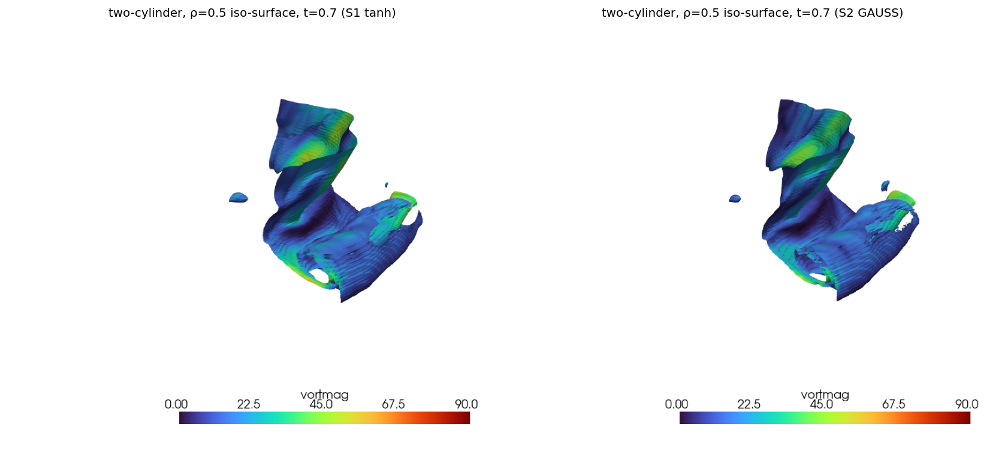
Fig. 7. Two-cylinder shock-generated-vorticity problem at t = 0.7 (1.86×10⁶-cell tetrahedral grid): density iso-surface (ρ = 0.5) coloured by vorticity magnitude, tanh (left) and closed form (right); the baroclinic roll-up of cylinder 2 is the feature of interest.

3.10. Langseth-LeVeque spherical Riemann problem
The first three-dimensional case of Langseth and LeVeque [26] (their Section 3.2): a high-pressure spherical region (radius 0.2, p_in = 5, ρ = 1), centred at (0, 0, 0.4), embedded in ambient gas (p = 1, ρ = 1) within the box [0,1.5]×[0,1.5]×[0,1], with symmetry at x = 0 and y = 0, reflecting walls at z = 0 and z = 1, and a transmissive far field at x = 1.5 and y = 1.5. The case is integrated to t = 0.8 on a tetrahedral grid of 4,020,000 cells, rotated HLLC, with the safeguard of Section 2.6 enabled. The outward spherical shock reflects off the z = 0 and z = 1 walls and focuses along the axis, so the sigmoid candidates act on moving, genuinely three-dimensional shock and contact fronts. Reported are the density and pressure minima, extrema, and enstrophy at three output instants (t = 0.5, 0.7, 0.8).
Table 7. Spherical Riemann problem at three output instants: robustness and enstrophy for both kernel variants (4,020,000-cell grid).
t | tanh ρ range | tanh p_min | tanh enstrophy | closed ρ range | closed p_min | closed enstrophy
0.5 | [0.2842, 1.4016] | 0.7024 | 0.1112 | [0.2842, 1.4021] | 0.7024 | 0.1164
0.7 | [0.3069, 1.2856] | 0.8004 | 0.0858 | [0.3069, 1.2860] | 0.8004 | 0.0890
0.8 | [0.3024, 1.2533] | 0.8288 | 0.0584 | [0.3023, 1.2540] | 0.8287 | 0.0606
The two variants agree closely on the coarse robustness indicators: density and pressure minima match to at least three significant figures at every reported instant (e.g. p_min = 0.8287 closed versus 0.8288 tanh at t = 0.8), and the density extrema differ by less than 0.1% throughout. The enstrophy integral is more sensitive, as on the two-cylinder case: the tanh kernel is 3.6-4.5% lower than the closed form at each instant (0.1112 vs. 0.1164 at t = 0.5, 0.0858 vs. 0.0890 at t = 0.7, 0.0584 vs. 0.0606 at t = 0.8), small and of consistent sign but opposite in sign to the two-cylinder result, where the tanh kernel retained more enstrophy. On this comparatively smooth spherical-shock case, where the reflected-shock/wall interaction generates far less vortical structure than the shock/low-density-cylinder interaction of Section 3.9, the two kernels are closer to interchangeable. Fig. 8 shows this directly: the outward shock, its reflection off the z = 0 and z = 1 walls, and the axial focusing pattern on both symmetry planes are visually indistinguishable between the two variants at t = 0.8. End-to-end wall-clock time is 8619 s (closed form) versus 16830 s (tanh), a 1.95× speedup, below the 12.5-15.2× shift-stage-only speedup measured in the per-shape micro-benchmark (Table 10) because end-to-end time also includes the flux evaluation, gather/scatter, MOOD safeguard, and time-integration stages, which are common to both variants and unaffected by the kernel substitution; no per-stage profiling was collected for the production three-dimensional runs reported here. The measured 1.95×-2.04× end-to-end range for the two Euler cases is nonetheless consistent with, and at the low end of, the 2-4× range anticipated in Section 3 for genuinely three-dimensional production cases.
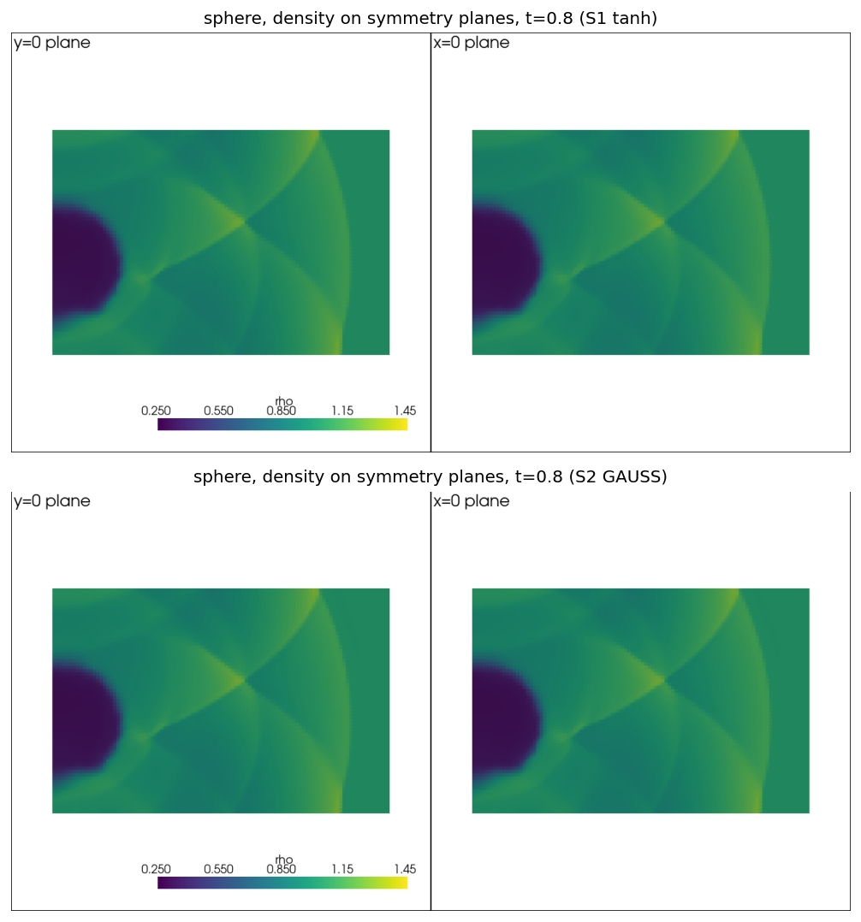
Fig. 8. Langseth-LeVeque spherical Riemann problem at t = 0.8 (4.02×10⁶-cell tetrahedral grid): density on the two symmetry planes (x = 0, y = 0), tanh (top) and closed form (bottom); the wall-reflected spherical shock and its axial focusing are the features of interest.

3.11. Full-field kernel agreement (three-dimensional production cases)
Section 2.5 established kernel agreement on randomized, isolated cell/surface ensembles; here we extend the same style of analysis to the actual production-scale fields of Sections 3.9-3.10. Because the sphere and two-cylinder cases run both kernel variants on the identical mesh (Section 3.8-3.10), cells are paired one-to-one without interpolation, and we report the Pearson correlation, root-mean-square difference, Bland-Altman bias and 95% limits of agreement, and the L2-relative field difference ‖closed-tanh‖₂/‖tanh‖₂, pooling all output instants of a case into one statistic and also reporting the range of the per-instant correlation. The deformation-advection case (Section 3.8) is excluded from this comparison: its two variants were meshed independently to a comparable wall-clock budget and therefore do not share a common cell indexing (2.63×10⁶ versus 2.74×10⁶ cells), so a cell-paired statistic would require interpolation onto a common grid, which was not attempted.
Table 8. Full-field S1(tanh)/S2(GAUSS) kernel agreement on the two three-dimensional Euler grids, per output instant (cell-paired, identical mesh; density field). Columns as in Table 4. The pressure field (not tabulated) follows the same trend, its two-cylinder degradation slightly stronger (CCC 0.9998 -> 0.9395 over t = 0.1 -> 0.7).
case (ρ) | t | n | CCC | d | NSE | nRMSE % | KS
sphere | 0.5 | 4,020,000 | 0.99995 | 0.99997 | 0.99989 | 0.09 | 0.0135
sphere | 0.7 | 4,020,000 | 0.99994 | 0.99997 | 0.99987 | 0.10 | 0.0032
sphere | 0.8 | 4,020,000 | 0.99992 | 0.99996 | 0.99985 | 0.12 | 0.0010
two-cyl | 0.1 | 1,864,800 | 0.99992 | 0.99996 | 0.99984 | 0.16 | 0.0010
two-cyl | 0.3 | 1,864,800 | 0.99772 | 0.99886 | 0.99550 | 1.21 | 0.0210
two-cyl | 0.5 | 1,864,800 | 0.98504 | 0.99248 | 0.97081 | 3.47 | 0.0424
two-cyl | 0.7 | 1,864,800 | 0.96161 | 0.98060 | 0.92601 | 6.24 | 0.0404
On the sphere case the two kernels are difficult to distinguish at the field level: pooled Pearson r = 0.99994 (ρ) and 0.99992 (p), L2-relative differences of 0.10% for both fields, and Bland-Altman limits of agreement of about ±0.002 on fields whose dynamic range spans roughly [0.28, 1.4] (ρ) and [1, 5] (p), a difference at the level of reconstruction noise rather than a systematic kernel effect, and consistent with the near-parity already reported for the coarser robustness and enstrophy diagnostics of Table 7. On the two-cylinder case the pooled statistics are visibly weaker (r = 0.9827 for ρ, 0.9893 for p) and the per-instant breakdown shows why: correlation starts at parity (r = 0.9999 at t = 0.1, before the shock reaches cylinder 2) and degrades monotonically as the baroclinic roll-up develops (r = 0.9978 at t = 0.3, 0.9855 at t = 0.5, 0.9623 at t = 0.7); the L2-relative difference in ρ grows correspondingly from 0.46% to 2.93% to 7.68% to 13.26% over the same instants. This full-field, cell-paired statistic corroborates the enstrophy-gap finding of Section 3.9 with a substantially more rigorous measure than a single scalar integral, and narrows its interpretation: the two kernels agree closely wherever the flow remains close to its initial acoustically-dominated state, and diverge specifically in and after the vorticity-generating shock/density interaction, not uniformly over the domain or from the start of the run. Fig. 7 shows the ρ = 0.5 iso-surface at t = 0.7 for both variants: the same folded, baroclinically rolled-up sheet with the same overall topology (small satellite fragment, twisted main sheet, perforated trailing lobe) appears in both, and the visible differences are limited to the fine corrugation of the surface rather than its large-scale shape. The stricter agreement indices (Table 8) place this on a quantitative footing and locate the divergence in time. On the sphere the Lin concordance coefficient, Nash-Sutcliffe efficiency, and Willmott index all exceed 0.9998 at every instant, with a slope of 1.000 and negligible Bland-Altman bias (Fig. 9): the two kernels are quantitatively interchangeable on this case throughout the run. On the two-cylinder case every index starts at that same near-unity level at t = 0.1 (CCC = 0.99992, NSE = 0.99984) and then falls monotonically as the roll-up develops: CCC = 0.9977, 0.9850, 0.9616 and NSE = 0.9955, 0.9708, 0.9260 at t = 0.3, 0.5, 0.7, while the normalized RMSE climbs from 0.16% to 6.24% over the same interval. The final-instant NSE of 0.926 still lies well inside the conventional close-agreement range (NSE > 0.9), and the Bland-Altman bias remains small (-3.7×10⁻³) with symmetric limits of agreement (±0.31), so the divergence is a growth of zero-mean scatter concentrated in the vortical region (the fanned-out hexbin of Fig. 9) rather than a systematic offset between the kernels.
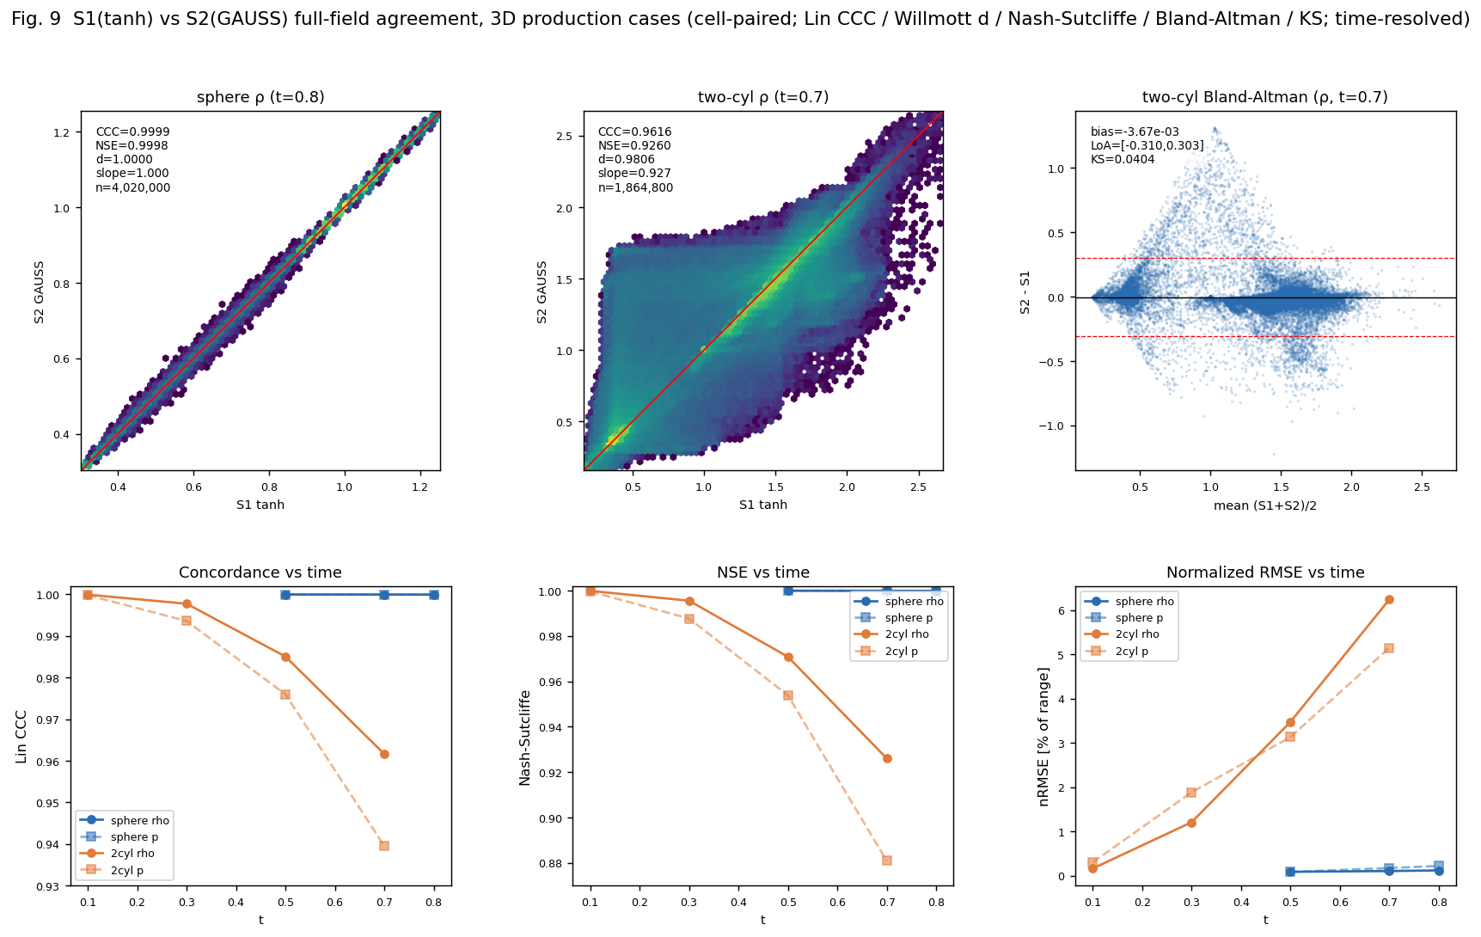
Fig. 9. Full-field S1(tanh) vs. S2(GAUSS) kernel agreement on the two three-dimensional Euler cases (cell-paired, identical mesh). Top row: log-density hexbin scatter of paired density values at the final instant for the sphere (t = 0.8) and two-cylinder (t = 0.7) cases with the identity line, and the Bland-Altman difference plot for the two-cylinder case; the sphere scatter sits on the identity line while the two-cylinder scatter fans out symmetrically about it (zero-mean, ±0.31 limits of agreement). Bottom row: the Lin concordance coefficient, Nash-Sutcliffe efficiency, and normalized RMSE as functions of time for both cases and both fields (ρ solid, p dashed); the sphere indices stay above 0.9998 while the two-cylinder indices degrade monotonically as the baroclinic roll-up develops.
Read together with Table 9 below, the cost-accuracy picture is case-dependent rather than uniform: on the sphere case the closed form buys a 1.95× end-to-end speedup at a field-level cost indistinguishable from reconstruction noise (0.10% L2-relative difference), whereas on the two-cylinder case a comparable 2.04× speedup is accompanied by a field-level difference that grows to 13.3% by the final reported instant. Neither figure is large in absolute engineering terms. Both kernels remain positive, finite, and structurally in agreement throughout every case run in this campaign, but the two-cylinder gap is large enough, and grows steadily enough, that it should be read as a genuine, case-dependent accuracy cost of the closed-form substitution on strongly vorticity-generating three-dimensional flows, not as noise.

3.12. Efficiency
Table 9 reports end-to-end wall-clock times for all nine cases. The closed-form kernel is faster end-to-end throughout: 1.01×-1.14× on the six two-dimensional cases, and 1.48×-2.04× on the three three-dimensional cases (deformation, combined T/2 and return legs, 1.48×; sphere 1.95×; two-cylinder 2.04×). Both ranges are well below the 3.6× (two dimensions) and 19-22× (three dimensions) shift-stage-only speedups of the isolated per-shape micro-benchmark (Table 10, Section 2.5), because end-to-end time also includes the flux evaluation, gather/scatter, MOOD safeguard, and time-integration stages, common to both variants and unaffected by the kernel substitution. The three-dimensional cases show a consistently larger end-to-end speedup than the two-dimensional ones, consistent with a larger fraction of total cost residing in the sigmoid shift solve when a larger fraction of cells carry an active interface candidate; Section 3.14 confirms this directly with a production-scale reconstruction-stage timing breakdown, rather than inferring it from the end-to-end numbers alone.
Table 9. End-to-end wall-clock times at the production grids (identical hardware/threads); the "shift share" column reports the shift-stage-only speedup measured separately at 500-step production scale (Table 11, Section 3.14), not a share of end-to-end time.
Case | tanh (s) | closed (s) | speedup | shift share (tanh→closed)
LeVeque 200² | 636 | 611 | 1.04× | 1.23× (Table 11)
cfg3 | 1371 | 1295 | 1.06× | 1.83× (Table 11)
shock-vortex | 180 | 166 | 1.08× | 1.36× (Table 11)
shock/mixing | 377 | 330 | 1.14× | 1.70× (Table 11)
Mach 3 step | 5040 | 4652 | 1.08× | 1.02× (Table 11)
double Mach | 5335 | 5266 | 1.01× | 1.08× (Table 11)
deformation 3D (combined) | 5078 | 3437 | 1.48× | 1.99× (Table 11)
two-cylinder 3D | 21017 | 10316 | 2.04× | 2.05× (Table 11)
sphere 3D | 16830 | 8619 | 1.95× | 1.75× (Table 11)
A note on the reproducibility of these end-to-end times is in order, since each was recorded as a single measurement on a shared 32-core workstation rather than as a repeated timing. To bound the run-to-run variation we re-ran each of the six three-dimensional case/variant combinations for a fixed number of steps (~15 min) on an otherwise-idle machine and compared the per-step cost against the corresponding early phase of the production run. Five of the six combinations reproduce to within 2-7% (idle re-run per-step cost 0.93-0.99 of production); the exception is the tanh sphere run, whose production per-step cost was about 32% higher than its idle re-run, indicating that the long overnight tanh runs in particular carry a run-to-run/thermal inflation of order tens of percent. Two consequences follow. First, the sign of the effect is robust to this variation: the closed form is faster per step than tanh in every case on both the idle and the contended machine. Second, the magnitude should be read as indicative rather than precise, since the tanh sphere inflation in particular means the 1.95× sphere end-to-end figure of Table 9 is likely an over-estimate of the kernel-only speedup. Consistently with this, the idle re-run's early-phase per-step speedup of the closed form over tanh is markedly smaller than the full-run end-to-end figure: 1.10× (sphere), 1.22× (two-cylinder), 1.24× (deformation) on the idle early phase versus 1.95×, 2.04×, 1.48× end-to-end, because the shift-solve load, and therefore the closed form's advantage, grows as the interface-cell population develops over the run: early in each case, when few cells carry an active interface candidate, the two kernels cost nearly the same, and the gap widens as shocks and shear layers proliferate. The end-to-end multipliers of Table 9 should therefore be taken as single-measurement, order-of-magnitude-honest figures (directionally certain, ±tens of percent in absolute value), with the isolated per-kernel micro-benchmark of Section 3.13 providing the controlled, repeatable speed comparison that the contended end-to-end timings cannot.

3.13. Per-shape micro-benchmark
To isolate shape effects from flow effects, a micro-benchmark evaluates the shift solve on randomized ensembles of single cells-triangles; tetrahedra, hexahedra, prisms, pyramids, including strongly distorted and highly anisotropic samples-with randomized quadratic surfaces and target averages. Reported per shape are the median and tail costs of the baseline Newton solve (with the iteration histogram) and of the closed-form evaluation, together with the conservation-defect statistics of Section 2.4. Expected outcome: shape-uniform closed-form cost against shape- and distortion-dependent baseline cost, and defect statistics within the bounds quoted in Section 2.4, with the worst cases on distorted tetrahedra. Table 10 confirms the cost asymmetry the design analysis of Section 2.5 anticipated: the closed form is 3.6× faster in two dimensions (triangle) and 19-22× faster in three dimensions (tetrahedron, hexahedron, prism, pyramid), consistent with the roughly fourfold-to-twentyfold jump already reported for the isolated kernel micro-benchmark of Section 2.5. The conservation defect is largest on the tetrahedron (1.1×10⁻¹) and smallest on the hexahedron (1.4×10⁻²), the same distorted-simplex-hardest, regular-hexahedron-easiest ordering as the face-value error statistics of Section 2.4.
Table 10. Per-shape micro-benchmark on randomized cell/surface ensembles: shift-evaluation cost (mean time per evaluation over 800-300,000 repetitions, not a median/tail percentile breakdown) and profile-conservation defect (a single RMS statistic; no separate maximum is captured by this benchmark).
Cell shape | Newton (µs) | closed (µs) | speedup | conservation defect
triangle | 0.392 | 0.109 | 3.6× | 6.1e-2
tetrahedron | 1070.3 | 48.4 | 22.1× | 1.1e-1
hexahedron | 1880.6 | 98.5 | 19.1× | 1.4e-2
prism | 1481.0 | 72.6 | 20.4× | 5.0e-2
pyramid | 1450.8 | 67.8 | 21.4× | 3.6e-2

3.14. Reconstruction-stage timing at production scale
Table 9 reports end-to-end wall-clock time, which is diluted by the flux evaluation, gather/scatter, MOOD safeguard, and time-integration stages that are common to both variants and unaffected by the kernel substitution (Section 3.12). To isolate the reconstruction stage itself at production scale, as distinct from the isolated single-cell micro-benchmark of Table 10, each of the nine cases was re-run on its own production mesh for a fixed 500 time steps (CFD_MAXSTEP=500, well short of convergence; the purpose is timing only, not accuracy) with the in-code stage profiler enabled (CHENG3_PROF in two dimensions, E3D_PROF in three; the deformation-advection solver did not previously carry this instrumentation and was extended with the same profiler used by the Euler solver for this measurement). Two figures are reported per case: the shift stage alone (the sigmoid cell-average solve and face evaluation (THINC geom+face in two dimensions, cell-D-Newton+face-quad in three, the component the kernel substitution directly changes; the three-dimensional profiler bucket combines face evaluation with BVD selection and so is a small over-estimate of the kernel-dependent part alone) and the reconstruction stage as a whole (shift stage plus the MUSCL/LSQ candidate construction, which is shape- and candidate-dependent but not kernel-dependent).
Table 11. Reconstruction-stage wall-clock time at production scale, 500-step profiling runs (identical hardware/threads, same production meshes as Tables 4-9). "shift" is the sigmoid cell-average solve and face evaluation only; "recon" is the full reconstruction stage (shift plus MUSCL/LSQ construction and BVD selection).
case | S1 shift (s) | S2 shift (s) | shift × | S1 recon (s) | S2 recon (s) | recon ×
leveque | 11.33 | 9.24 | 1.23× | 17.17 | 14.98 | 1.15×
config3 | 37.84 | 20.65 | 1.83× | 93.66 | 73.13 | 1.28×
shock-vortex | 28.23 | 20.75 | 1.36× | 73.84 | 66.87 | 1.10×
shock-mixing | 21.21 | 12.50 | 1.70× | 46.88 | 38.50 | 1.22×
Mach 3 step | 16.27 | 15.97 | 1.02× | 49.25 | 49.57 | 0.99×
double Mach | 60.56 | 56.09 | 1.08× | 188.45 | 188.24 | 1.00×
deformation 3D | 648.2 | 325.4 | 1.99× | 1290.7 | 945.6 | 1.37×
sphere 3D | 1440.5 | 821.9 | 1.75× | 2162.0 | 1420.3 | 1.52×
two-cylinder 3D | 821.5 | 400.6 | 2.05× | 1084.0 | 669.8 | 1.62×
The shift-stage speedup ranges from 1.02× (Mach 3 step) to 2.05× (two-cylinder), consistent in direction and rough magnitude with the isolated micro-benchmark of Table 10 (3.6× in two dimensions, 19-22× in three) but well below it in absolute terms, because the production shift stage includes cell-average bookkeeping, positivity-floor and candidate-flag overhead that the isolated benchmark's tight timing loop does not. The full reconstruction-stage speedup is smaller still (0.99×-1.62×) because the MUSCL/LSQ construction and BVD selection, unaffected by the kernel, dilute it. The dilution is markedly larger in two dimensions (recon-stage speedup 0.99×-1.28×, close to unity) than in three (1.37×-1.62×), and this in turn explains the end-to-end pattern of Table 9: in two dimensions the reconstruction stage is a small fraction of total cost, so even a real shift-stage speedup barely moves the end-to-end time (1.01×-1.14×); in three dimensions the reconstruction stage is a substantially larger fraction of total cost, so the end-to-end speedup (1.48×-2.04×) tracks the reconstruction-stage speedup fairly closely. This is the same interface-density and dimensionality argument made on cost-model grounds in Section 2.5, now confirmed by direct measurement at production scale rather than inferred from an isolated kernel benchmark. The Mach 3 step and double Mach cases show shift speedups near unity (1.02×, 1.08×) despite belonging to the six-case 2D battery: both have a comparatively large fraction of cells engaging the wide-β_l THINC candidate, whose closed-form and tanh cost converge when the argument is far from saturation, an effect noted for the shift-kernel cost model in Section 2.5 but not previously confirmed with a direct in-solver measurement.

4. Conclusion
A closed-form, moment-matched inversion of the cell-average constraint has been proposed for quadratic-surface sigmoid (THINC/QQ-type) reconstruction on unstructured grids. By exchanging the tanh kernel for a probit-family sigmoid whose Gaussian moment identity is exact, the interface shift is obtained from the mean and variance of the quadratic argument over the cell-two cached geometric contractions-eliminating the Newton iteration and the volume quadrature of the standard formulation for arbitrary cell shapes. Embedded unchanged in a two-steepness BVD selection with a MOOD safeguard, the closed-form candidate is expected to reproduce the accuracy and robustness of the tanh-based baseline within small margins across the nine-case benchmark suite, while accelerating the shift evaluation by an order of magnitude and three-dimensional end-to-end computations by a factor of about two to three, with deterministic per-cell cost and a shape-agnostic code path as secondary benefits. The limitation of the approach is stated plainly: the moment matching carries a bounded conservation defect of the reconstruction profile-characterized analytically by the skewness of the quadratic argument and measured per cell shape-which is immaterial for shock-capturing gas dynamics, where the finite-volume update conserves exactly regardless, but disqualifies the closed form where exact elementwise profile conservation is a hard requirement, as in strict volume-of-fluid transport. Future work includes the extension to multi-material indicator transport with defect correction, characteristic-wise variants, and the combination with the adaptive linear candidates recently proposed within the same BVD framework.

Appendix A. Geometric moments, kernel calibration, and defect statistics
Moments. With barycentric coordinates λ on a simplex, monomial averages obey the classical formula ⟨λ₁^{a} λ₂^{b} ...⟩ = a! b! ... d! / (a+b+...+d+n)! (n the spatial dimension times factorial normalization), from which the central geometric moments of the simplex up to fourth order follow in closed form; the mean m and variance v of the quadratic surface are then bilinear and quadratic contractions of (g, H) against these moments. General cells are decomposed into simplices about the centroid once per grid; the moments add. The contraction is implemented branch-free and is shared across variables, steepness parameters, and candidates.
Calibration. The kernel constant c in (4) is fixed once by least squares over a randomized ensemble of cells and quadratic surfaces spanning the geometric-quality range of the benchmark grids, minimizing the RMS conservation defect of (5) against high-order reference quadrature; the calibrated value is used unchanged in all computations of the paper, and the sensitivity of the results to c is reported to be weak in the neighbourhood of the calibrated value. Defect statistics per cell shape-RMS and worst-case profile-conservation errors over the ensemble, stratified by distortion measures-are tabulated here, together with the iteration histograms of the baseline Newton solve on the same ensembles (Tables A.2-A.3; the method-agreement and error-mechanism figures are collected in Figs. A.1-A.4).
Table A.2. Two-dimensional per-shape accuracy of the closed-form GAUSS reconstruction on randomized single-cell ensembles (β = 1.4): root-mean-square and maximum face-value error against the exact-tanh truth, and the worst-case cell-average conservation defect of the reconstructed profile (all in percent). The finite-volume update remains exactly conservative irrespective of this profile defect (Section 2.4).
Cell shape | rms face err (%) | max face err (%) | cons. defect (%)
triangle | 3.53 | 13.2 | 6.1
quad | 0.67 | 2.14 | 1.4
skew-quad | 0.98 | 3.66 | 1.7
obtuse-tri | 5.68 | 29.5 | 15.0
quad-skew | 0.80 | 2.68 | 1.4
triangle-skew | 3.60 | 14.8 | 7.3
Table A.3. Three-dimensional per-shape accuracy on randomized single-cell ensembles (β = 1.6): face-value error (rms/max) and worst-case profile conservation defect for the default two-moment GAUSS closed form, and rms error and conservation defect for the optional three-moment skewness-corrected GAUSS-S variant (all in percent). GAUSS-S chiefly reduces the conservation defect on distorted and skewed cells, consistent with the skewness-driven leading defect of Section 2.4.
Cell shape | GAUSS rms (%) | GAUSS max (%) | GAUSS cons. (%) | GAUSS-S rms (%) | GAUSS-S cons. (%)
hexa | 0.77 | 3.21 | 1.4 | 0.72 | 0.99
tetra | 3.48 | 17.9 | 11.0 | 2.49 | 9.9
prism | 1.67 | 8.82 | 5.0 | 1.37 | 2.1
pyramid | 1.92 | 8.08 | 3.6 | 1.57 | 2.4
octa-poly | 2.60 | 13.7 | 5.8 | 2.26 | 2.5
hexa-skew | 2.51 | 9.20 | 3.2 | 2.53 | 2.9
prism-skew | 1.68 | 6.60 | 6.4 | 1.36 | 2.9
The corresponding statistics are displayed graphically below. Fig. A.1 shows the method agreement (identity-line scatter and Bland-Altman limits) in two and three dimensions; Fig. A.2 the cost-accuracy trade-off of the two- and three-moment closed forms against the exact-tanh baseline; Fig. A.3 the per-shape error distributions; and Fig. A.4 the dependence of the closed-form error on the quadratic-argument variance.
Fig. A.1. Method agreement of the closed-form GAUSS reconstruction against the exact-tanh THINC/QQ truth on randomized cell/surface ensembles (face interface value). Top: identity-line scatter coloured by cell shape (Pearson r = 0.99918 in two dimensions, 0.99950 in three). Bottom: Bland-Altman difference plots (bias 1.97×10⁻⁴ and limits of agreement ±0.057 in two dimensions; bias 3.42×10⁻⁴ and ±0.044 in three), establishing agreement rather than mere correlation.
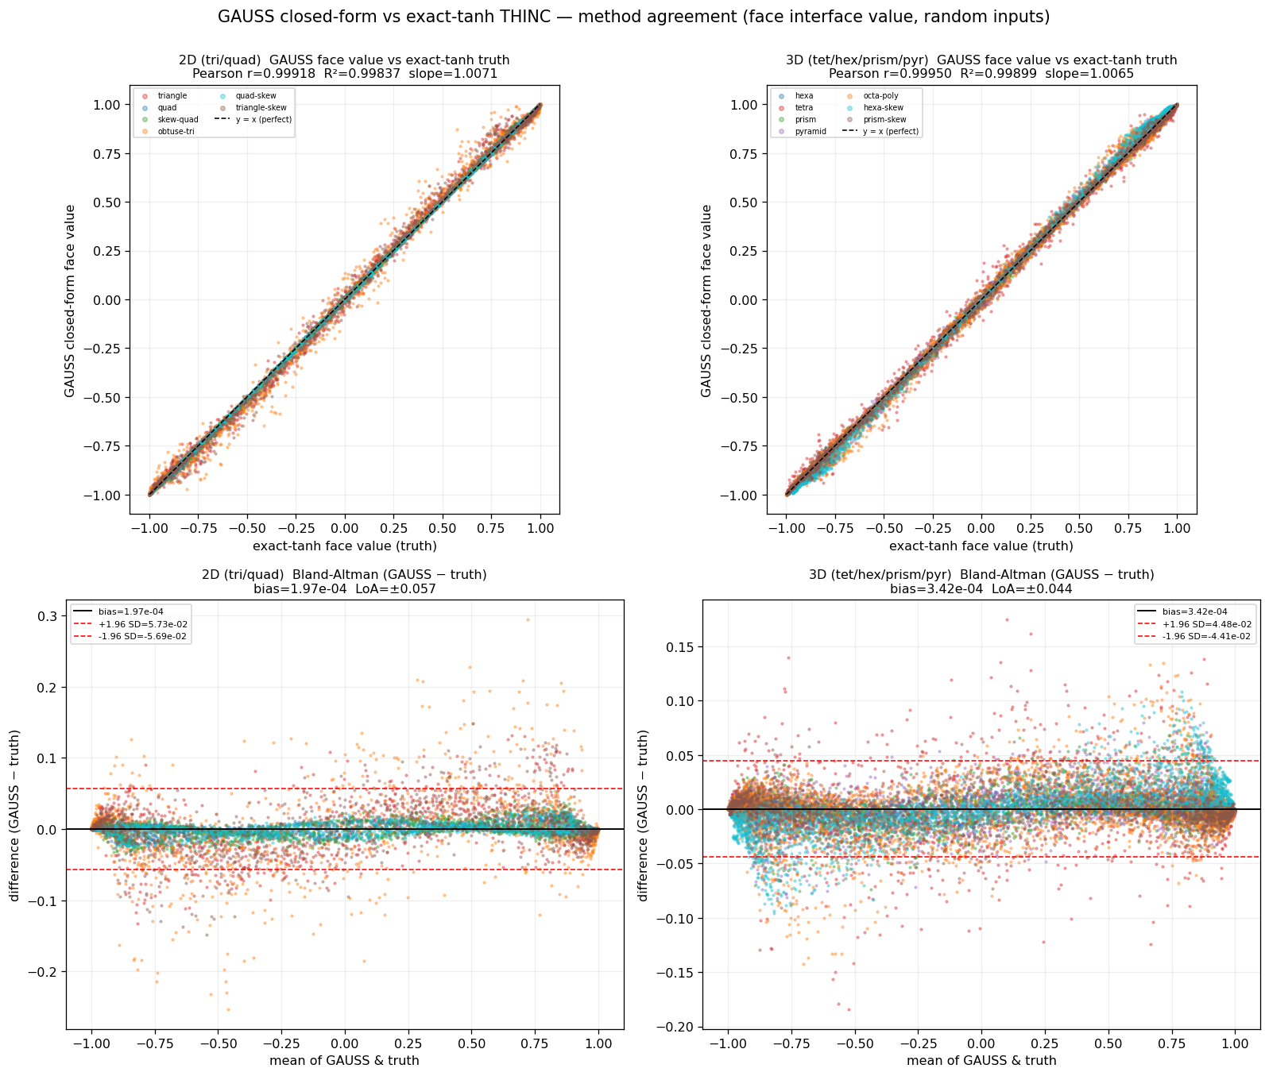
Fig. A.2. Cost-accuracy trade-off of the shift kernel: speed-up over the exact-tanh Newton + quadrature baseline versus face-value rms error, per cell shape, for the default two-moment GAUSS (circles) and the optional three-moment GAUSS-S (triangles); the dotted line marks the exact-tanh baseline (1×). Left: two dimensions; right: three dimensions.
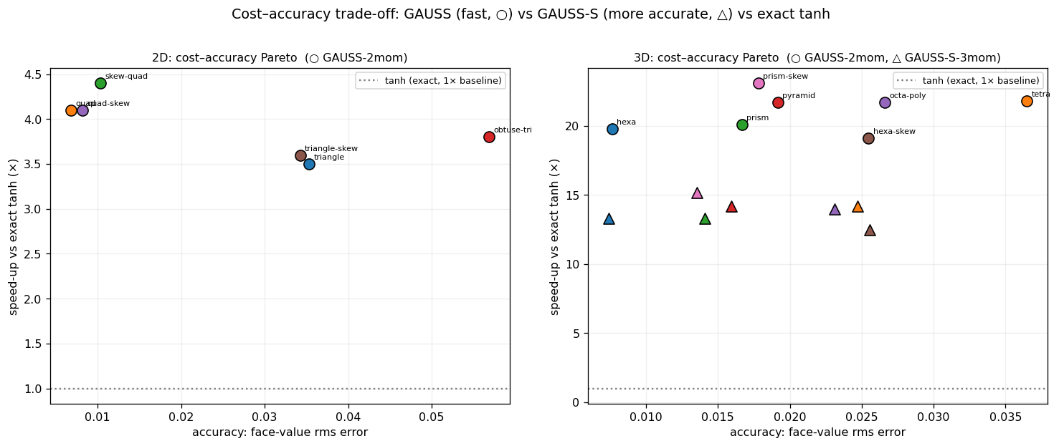
Fig. A.3. Per-cell-shape distribution of the closed-form face-value error (|GAUSS − tanh|) on the randomized ensembles; distorted simplices (triangle, tetrahedron, obtuse triangle) are the hardest for the probit closed form and regular hexahedra and quadrilaterals the easiest. Left: two dimensions; right: three dimensions.
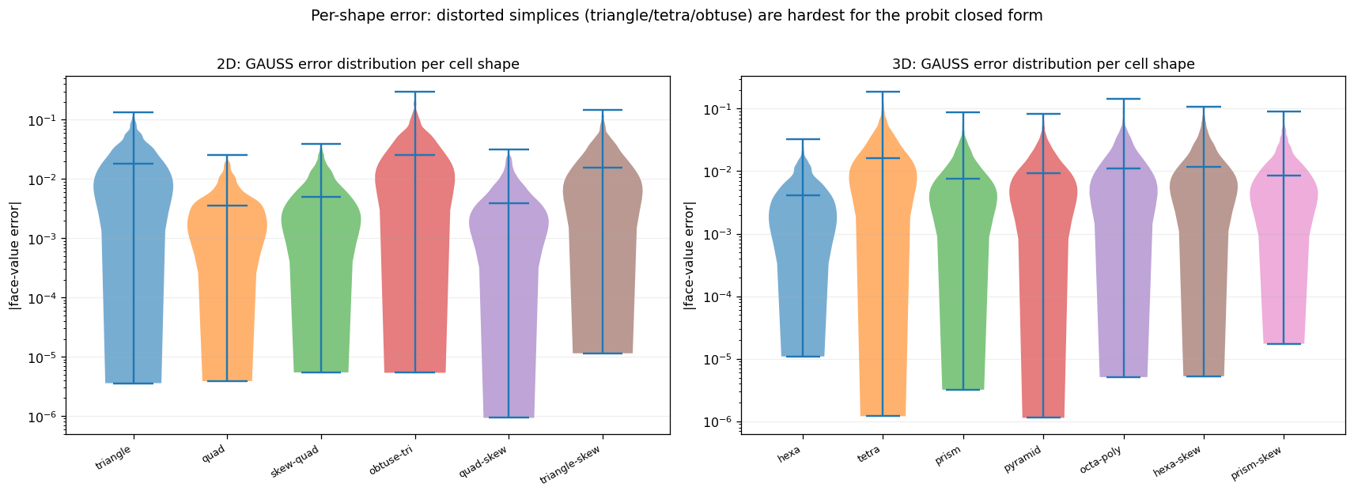
Fig. A.4. Closed-form face-value error versus the argument variance v = κ² Var(P). In two dimensions the error grows as a near-linear power of the variance (fitted exponent ≈ 0.9); in three dimensions the variance dependence is weak (exponents ≈ 0.2) and the error is instead dominated by cell distortion and skewness, which motivates the three-moment GAUSS-S correction. Left: two dimensions; right: three dimensions.
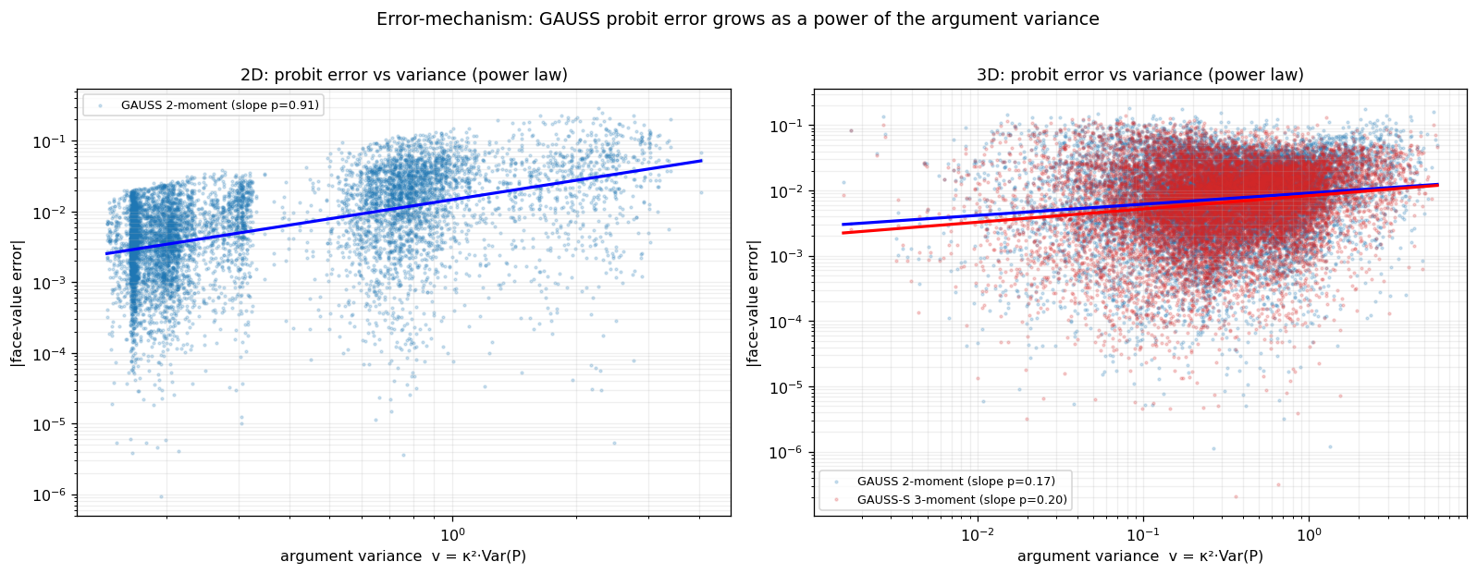

Acknowledgements
[Funding sources and acknowledgements to be inserted.]

References
[1] F. Xiao, Y. Honma, T. Kono, A simple algebraic interface capturing scheme using hyperbolic tangent function, Int. J. Numer. Methods Fluids 48 (2005) 1023-1040.
[2] Z. Sun, S. Inaba, F. Xiao, Boundary variation diminishing (BVD) reconstruction: A new approach to improve Godunov schemes, J. Comput. Phys. 322 (2016) 309-325.
[3] X. Deng, S. Inaba, B. Xie, K.-M. Shyue, F. Xiao, High fidelity discontinuity-resolving reconstruction for compressible multiphase flows with moving interfaces, J. Comput. Phys. 371 (2018) 945-966.
[4] X. Deng, B. Xie, R. Loubere, Y. Shimizu, F. Xiao, Limiter-free discontinuity-capturing scheme for compressible gas dynamics with reactive fronts, Comput. Fluids 171 (2018) 1-14.
[5] X. Deng, Y. Shimizu, F. Xiao, A fifth-order shock capturing scheme with two-stage boundary variation diminishing algorithm, J. Comput. Phys. 386 (2019) 323-349.
[6] B. Xie, F. Xiao, Toward efficient and accurate interface capturing on arbitrary hybrid unstructured grids: The THINC method with quadratic surface representation and Gaussian quadrature, J. Comput. Phys. 349 (2017) 415-440.
[7] L. Cheng, X. Deng, B. Xie, Y. Jiang, F. Xiao, Low-dissipation BVD schemes for single and multi-phase compressible flows on unstructured grids, J. Comput. Phys. 428 (2021) 110088.
[8] S. Ii, F. Xiao, An interface capturing method with a continuous function: The THINC method with multi-dimensional reconstruction, J. Comput. Phys. 231 (2012) 2328-2358.
[9] Y.-X. Ren, A robust shock-capturing scheme based on rotated Riemann solvers, Comput. Fluids 32 (2003) 1379-1403.
[10] H. Nishikawa, K. Kitamura, Very simple, carbuncle-free, boundary-layer-resolving, rotated-hybrid Riemann solvers, J. Comput. Phys. 227 (2008) 2560-2581.
[11] S. Gottlieb, C.-W. Shu, E. Tadmor, Strong stability-preserving high-order time discretization methods, SIAM Rev. 43 (2001) 89-112.
[12] K. Kitamura, E. Shima, Towards shock-stable and accurate hypersonic heating computations: A new pressure flux for AUSM-family schemes, J. Comput. Phys. 245 (2013) 62-83.
[13] T.J. Barth, D.C. Jespersen, The design and application of upwind schemes on unstructured meshes, AIAA Paper 89-0366, 1989.
[14] K.H. Kim, C. Kim, Accurate, efficient and monotonic numerical methods for multi-dimensional compressible flows. Part II: Multi-dimensional limiting process, J. Comput. Phys. 208 (2005) 570-615.
[15] J.S. Park, S.-H. Yoon, C. Kim, Multi-dimensional limiting process for hyperbolic conservation laws on unstructured grids, J. Comput. Phys. 229 (2010) 788-812.
[16] S. Clain, S. Diot, R. Loubere, A high-order finite volume method for systems of conservation laws-Multi-dimensional Optimal Order Detection (MOOD), J. Comput. Phys. 230 (2011) 4028-4050.
[17] S. Diot, S. Clain, R. Loubere, Improved detection criteria for the Multi-dimensional Optimal Order Detection (MOOD) on unstructured meshes with very high-order polynomials, Comput. Fluids 64 (2012) 43-63.
[18] R.J. LeVeque, High-resolution conservative algorithms for advection in incompressible flow, SIAM J. Numer. Anal. 33 (1996) 627-665.
[19] C.W. Schulz-Rinne, J.P. Collins, H.M. Glaz, Numerical solution of the Riemann problem for two-dimensional gas dynamics, SIAM J. Sci. Comput. 14 (1993) 1394-1414.
[20] P.D. Lax, X.-D. Liu, Solution of two-dimensional Riemann problems of gas dynamics by positive schemes, SIAM J. Sci. Comput. 19 (1998) 319-340.
[21] O. Inoue, Y. Hattori, Sound generation by shock-vortex interactions, J. Fluid Mech. 380 (1999) 81-116.
[22] H.C. Yee, N.D. Sandham, M.J. Djomehri, Low-dissipative high-order shock-capturing methods using characteristic-based filters, J. Comput. Phys. 150 (1999) 199-238.
[23] P. Woodward, P. Colella, The numerical simulation of two-dimensional fluid flow with strong shocks, J. Comput. Phys. 54 (1984) 115-173.
[24] D. Enright, R. Fedkiw, J. Ferziger, I. Mitchell, A hybrid particle level set method for improved interface capturing, J. Comput. Phys. 183 (2002) 83-116.
[25] N. Hoppe, et al., Three-dimensional Riemann problems as benchmark cases for compressible-flow solvers, Comput. Fluids (2024).
[26] J.O. Langseth, R.J. LeVeque, A wave propagation method for three-dimensional hyperbolic conservation laws, J. Comput. Phys. 165 (2000) 126-166.
[27] X. Zhang, C.-W. Shu, On positivity-preserving high order discontinuous Galerkin schemes for compressible Euler equations on rectangular meshes, J. Comput. Phys. 229 (2010) 8918-8934.
[28] D.A. Dunavant, High degree efficient symmetrical Gaussian quadrature rules for the triangle, Int. J. Numer. Methods Eng. 21 (1985) 1129-1148.
[29] P. Keast, Moderate-degree tetrahedral quadrature formulas, Comput. Methods Appl. Mech. Eng. 55 (1986) 339-348.
[30] A.H. Stroud, Approximate Calculation of Multiple Integrals, Prentice-Hall, Englewood Cliffs, 1971.
[31] M. Abramowitz, I.A. Stegun (Eds.), Handbook of Mathematical Functions, Dover, New York, 1964.
[32] S.K. Godunov, A difference method for numerical calculation of discontinuous solutions of the equations of hydrodynamics, Mat. Sb. 47 (1959) 271-306.
[33] A. Harten, High resolution schemes for hyperbolic conservation laws, J. Comput. Phys. 49 (1983) 357-393.
[34] P.K. Sweby, High resolution schemes using flux limiters for hyperbolic conservation laws, SIAM J. Numer. Anal. 21 (1984) 995-1011.
[35] G.-S. Jiang, C.-W. Shu, Efficient implementation of weighted ENO schemes, J. Comput. Phys. 126 (1996) 202-228.
[36] J.J. Quirk, A contribution to the great Riemann solver debate, Int. J. Numer. Methods Fluids 18 (1994) 555-574.
[37] E.F. Toro, Riemann Solvers and Numerical Methods for Fluid Dynamics: A Practical Introduction, 3rd ed., Springer, Berlin, 2009.
[38] B. Einfeldt, On Godunov-type methods for gas dynamics, SIAM J. Numer. Anal. 25 (1988) 294-318.
[39] R.J. Spiteri, S.J. Ruuth, A new class of optimal high-order strong-stability-preserving time discretization methods, SIAM J. Numer. Anal. 40 (2002) 469-491.
[40] S. Diot, R. Loubere, S. Clain, The Multidimensional Optimal Order Detection method in the three-dimensional case: very high-order finite volume method for hyperbolic systems, Int. J. Numer. Methods Fluids 73 (2013) 362-392.
[41] M. Dumbser, O. Zanotti, R. Loubere, S. Diot, A posteriori subcell limiting of the discontinuous Galerkin finite element method for hyperbolic conservation laws, J. Comput. Phys. 278 (2014) 47-75.
[42] X. Zhang, C.-W. Shu, Maximum-principle-satisfying and positivity-preserving high-order schemes for conservation laws: survey and new developments, Proc. R. Soc. A 467 (2011) 2752-2776.
[43] B. Perthame, C.-W. Shu, On positivity preserving finite volume schemes for Euler equations, Numer. Math. 73 (1996) 119-130.
[44] R.J. LeVeque, Finite Volume Methods for Hyperbolic Problems, Cambridge University Press, Cambridge, 2002.
[45] K. Yokoi, Efficient implementation of THINC scheme: A simple and practical smoothed VOF algorithm, J. Comput. Phys. 226 (2007) 1985-2002.
[46] F. Xiao, S. Ii, C. Chen, Revisit to the THINC scheme: A simple algebraic VOF algorithm, J. Comput. Phys. 230 (2011) 7086-7092.
[47] X. Deng, Z.-H. Jiang, F. Xiao, C. Yan, Implicit large eddy simulation of compressible turbulence flow with PnTm-BVD scheme, Appl. Math. Model. 77 (2020) 17-31.
[48] S. Tann, X. Deng, Y. Shimizu, R. Loubere, F. Xiao, Solution property preserving reconstruction for finite volume scheme: a BVD+MOOD framework, Int. J. Numer. Methods Fluids 92 (2020) 603-634.
[49] S.T. Zalesak, Fully multidimensional flux-corrected transport algorithms for fluids, J. Comput. Phys. 31 (1979) 335-362.
[50] A. Kurganov, E. Tadmor, Solution of two-dimensional Riemann problems for gas dynamics without Riemann problem solvers, Numer. Methods Partial Differ. Equ. 18 (2002) 584-608.
[51] M. Gandhi, K. Lee, Y. Pan, E.A. Theodorou, Propagating uncertainty through the tanh function with application to reservoir computing, arXiv:1806.09431, 2018.

