A Geometry-Aware, Admissibility-Preserving Schur-Complement Nonlinear Preconditioner for Steady-State Lattice Boltzmann Solvers: Validation on Complex-Geometry Benchmarks
Moment-Schur Accelerated LBM
Young-Lin Yoo

Abstract
In steady-state lattice Boltzmann method (LBM) computations, the long-wavelength residual of the conserved pressure–velocity moments persists long after the kinetic modes have decayed, and it is this slowly decaying residual that governs fixed-point convergence. This paper proposes a geometry-aware, admissibility-preserving (AP) Schur-only, Jacobian-free nonlinear preconditioning technique that targets this bottleneck directly. Here and throughout, “AP” abbreviates admissibility-preserving—not the asymptotic-preserving schemes of kinetic theory and not any neural-network method. The method leaves the discretized LBM equations and boundary conditions unchanged and operates on the native residual $R(f)=f−G(f)$ as is. Its core operator is built by closing the conserved-moment Schur complement of the LBE operator—linearized about a uniform base state—into a per-mode $3×3$ matrix in Fourier space, and assembling its kinetic-null-space-corrected, admissibility-preserving inverse as a spectral preconditioner. This preconditioner is used solely as the left preconditioner of a single Jacobian-free Newton (GMRES) step applied to the native nonlinear residual; the resulting trial update is accepted only when, after a damped line search, it simultaneously satisfies a decrease in the macroscopic $L_{2}$ residual, density positivity, wall/inlet/outlet/mask boundary consistency, and conservation sanity, and otherwise the solver falls back to a native Picard step. All internal constants depend only on a global grid scale and on neither benchmark identity nor any reference solution.
On a fixed set of benchmark results, the proposed method attains convergence under an identical protocol across all 27 runs spanning nine benchmark families (channel, Couette, lid-driven cavity at $Re=100/400/1000$, backward-facing step, cylinder wake, multi-cylinder, and T-junction) at the 1x/2x/3x mesh levels. Under the same stopping protocol and the same admissibility definition, five baseline methods (Picard, Anderson acceleration, preconditioned LBM, inexact Newton–Krylov, and dual-time multigrid) converge on only 12–15 of the 27 cases even with a generous budget. In a conservative timing comparison restricted to the strict subset (15 cases) on which a baseline also converges, the proposed method is faster in wall time on 14/15 cases (median ratio $≈2.06×$) and uses fewer LBE-calls—the operator-work metric—on 13/15 cases (median $≈1.80×$). Broadening the comparison to all available baselines, it is faster on 25/27 cases (median $2.92×$). On accuracy, the method exhibits an observed spatial convergence order of $≈2.0$ for channel Poiseuille flow (the BGK-LBM theoretical value), machine precision for Couette flow, and monotone convergence toward the Ghia centerline for the cavity, confirming that the acceleration does not sacrifice discrete accuracy. All results are independently recomputable from the stored residual histories and per-case execution traces.
The novelty of this work lies not in modifying the LBM physical model, but in a single solver framework that preconditions the hydrodynamic slow modes of the native steady residual from a Schur-complement viewpoint and validates every accepted update through the same admissibility gate, even on complex geometries. The performance claims are confined to relative comparisons within a stored 2D D2Q9/BGK benchmark suite under an identical macroscopic-$L_{2}$-residual/plateau protocol, and the method is to be understood as a nonlinear preconditioner that solves the same discrete steady problem faster—without reference injection or case-specific tuning.
Keywords: lattice Boltzmann method; steady-state solver; admissibility-preserving Schur complement; Jacobian-free residual correction; nonlinear preconditioning; complex geometry.

1. Introduction
The lattice Boltzmann method (LBM) has become a workhorse for a wide range of CFD problems, owing to the simplicity of its streaming–collision structure and its amenability to complex-boundary treatment and parallelization [1–4]. In applications where the steady-state solution itself is the goal—design optimization, geometric parameter sweeps, inverse design—rather than the transient, however, the explicit time-marching nature of LBM translates directly into cost. The origin of this cost is not a requirement of temporal accuracy but the spectral structure of the fixed-point residual. In native lattice Boltzmann equation (LBE) iteration, the non-conserved kinetic modes are damped relatively quickly by collision relaxation, whereas the conserved hydrodynamic modes associated with density and momentum survive as the long-wavelength shear and acoustic modes of the linearized LBE and decay very slowly [4]; in the low-Mach regime in particular, the separation of convective and acoustic scales further retards this decay [20, 21]. As a result, the convergence history exhibits a rapid initial drop followed by a long, flat tail, and it is this tail that dominates the total wall time.
Prior efforts to mitigate this tail fall broadly into three families. First, algebraic history accelerators, exemplified by Anderson acceleration and reduced-rank extrapolation (RRE), extrapolate a descent direction from the residual correlations of the past fixed-point history [9, 10, 15]. These are powerful and general, but they treat the residual as a structureless vector and do not directly exploit the physical block structure by which, within the steady LBM residual, the kinetic fast modes and the hydrodynamic slow modes vanish on different time scales. Second, inexact Newton and Jacobian-free Newton–Krylov (JFNK) methods provide the standard framework for solving the nonlinear residual equation directly [6, 7, 13]. The efficiency of JFNK, however, hinges entirely on how well the preconditioner reflects the physical structure of the problem; an unsuitable preconditioner inflates the cost of both GMRES iterations and residual evaluations. Moreover, on complex geometries where masks, obstacles, and open boundaries coexist, a Newton trial step may violate density positivity or boundary consistency, so that the physical admissibility of the trial becomes a problem distinct from convergence. The third family modifies the interior of the LBM model itself. Preconditioned LBM redefines the collision relaxation spectrum or the equilibrium to accelerate low-Mach steady convergence [20, 21], and recent work has combined preconditioning with cascaded/central-moment LBM (including corrections for Galilean invariance and cubic-velocity errors) [22, 23, 25] and extended the lattice Boltzmann flux solver to steady flows on unstructured grids [24]. Multigrid and dual-time families relax the elliptic coupling through a mesh hierarchy and coarse-grid corrections [14], and the pressure-Schur/saddle-point preconditioning they borrow is a canonical framework for rapidly solving the pressure–velocity coupling of incompressible systems [8, 11, 12]. On a separate axis, Huang, Yang, and Cai discretized the LBE implicitly and proposed fully implicit and nonlinearly preconditioned inexact-Newton frameworks combining Newton–Krylov, domain decomposition, and nonlinear elimination [18, 19]. These rich bodies of prior work nonetheless share one common trait: to accelerate, they either redefine the collision model, equilibrium, or relaxation parameter (model-level acceleration), or require additional infrastructure such as a mesh hierarchy, transfer operators, implicit matrix assembly, or domain decomposition. In other words, the acceleration takes place inside the existing discrete LBM operator or in the infrastructure surrounding it.
A gap therefore emerges. Steady-state LBM acceleration still lacks an externally attached correction layer that simultaneously satisfies three conditions: (a) it leaves the native operator—built from collision, streaming, and boundary handling—and its discrete steady solution entirely unchanged; (b) it selectively targets only the conserved-moment slow-mode block that governs convergence; and (c) it guarantees physical admissibility, without case-by-case tuning, even on complex geometries with masks and open boundaries. Algebraic accelerators do not use the block structure of (b); model-level accelerations violate (a); and generic JFNK and implicit frameworks either do not address (c) separately or require heavy infrastructure.
This paper proposes such an externally attached acceleration layer—a geometry-aware, admissibility-preserving Schur-complement nonlinear preconditioner (hereafter AP-Schur)—that meets all three conditions at once. Throughout, “AP” denotes admissibility-preserving; it is unrelated to the asymptotic-preserving (AP) schemes of kinetic theory and to any neural-network method. The central idea begins from the observation that the slow components governing convergence reside in the conserved-moment block: it therefore suffices to precondition only the Schur complement of that subspace, constructed in closed form in Fourier space, and to use it solely as the preconditioner of a single Jacobian-free Newton step applied to the unchanged native residual $R(f)=f−G(f)$. The generated trial is accepted only if it passes both a residual decrease and physical admissibility, and otherwise the solver falls back to a native LBE step; the method therefore operates stably on complex geometries while leaving the existing LBM operator and its discrete steady solution untouched.
The method is validated on the 27 runs obtained by extending nine benchmark families to the 1x/2x/3x levels, together with a 1x ablation study. Under an identical stopping protocol the proposed method converges on all 27 cases, whereas the baseline accelerators converge on only a subset under the same conditions; and even in the conservative comparison restricted to cases on which a baseline also converges, the proposed method reaches steady state with shorter wall time and fewer operator-work units, without sacrificing discrete accuracy. All performance claims are made as relative comparisons within the stored 2D D2Q9/BGK suite.

2. Numerical Method

2.1 Native steady-state LBM residual and notation
We consider the two-dimensional, nine-velocity (D2Q9) lattice Boltzmann equation with a single-relaxation-time (BGK) collision operator,
$$f_{i}(x+c_{i}, t+1)=f_{i}(x,t)−\frac{1}{τ_{f}}\left[f_{i}(x,t)−f_{i}^{eq}(x,t)\right], i=0,…,8,$$
where $x$ is a node of the square lattice $Z^{2}$, $t$ is the discrete time step, $\{c_{i}\}_{i=0}^{8}$ are the D2Q9 lattice velocities, lattice units are used throughout ($Δx=Δt=1$), and $τ_{f}$ is the BGK relaxation time. The discrete equilibrium is
$$f_{i}^{eq}(ρ,u)=w_{i} ρ\left[1+\frac{c_{i}⋅u}{c_{s}^{2}}+\frac{(c_{i}⋅u)^{2}}{2c_{s}^{4}}−\frac{|u|^{2}}{2c_{s}^{2}}\right], c_{s}^{2}=\frac{1}{3},$$
with weights $w_{0}=4/9$, $w_{1\text{–}4}=1/9$, and $w_{5\text{–}8}=1/36$. The macroscopic moments are
ρ=i​fi, ρu=i​cifi, p=cs2ρ.
The kinematic viscosity is $ν=c_{s}^{2}(τ_{f}−\frac{1}{2})$, and the flow is characterized by $Re=U_{ref}L_{ref}/ν$ and $Ma=U_{ref}/c_{s}$. All benchmarks are run at $Ma≪1$, so the weakly compressible pressure $p=c_{s}^{2}ρ$ is consistent with the incompressible reference solutions.
We denote by $G$ a single full lattice step, comprising collision, streaming, and the application of all boundary conditions. The steady state is the fixed point of this operator, expressed as the residual equation
$$R(f)=f−G(f)=0,$$
with $G$ invoked as a stand-alone operator that the acceleration scheme leaves unmodified.
Two linear operators connect the nine-component distribution field to its three conserved hydrodynamic moments. The projection $M∈R^{3×9}$ maps a distribution to its density and momentum,
$$Mf=(ρ, ρu_{x}, ρu_{y})^{⊤},$$
its rows being the moment weights $\{1, c_{x,i}, c_{y,i}\}$. The lifting $T∈R^{9×3}$ reconstructs a minimal distribution increment from a conserved-moment increment $dm=(dρ, d(ρu_{x}), d(ρu_{y}))$,
$$(T dm)_{i}=w_{i}\left[dρ+3 c_{x,i} d(ρu_{x})+3 c_{y,i} d(ρu_{y})\right],$$
so that $T$ is a right inverse of $M$, $MT=I_{3}$. The increment $T dm$ is the minimal hydrodynamic distribution perturbation that matches a prescribed change in density and momentum while leaving the remaining kinetic components to be relaxed by $G$ at the next iteration.

2.2 Conserved-moment Schur-complement formulation
A Newton correction for the steady state solves $J_{f}(f^{*}) df=−R(f^{*})$, where $J_{f}=∂R/∂f$. Assembling the full Jacobian, together with its mask and boundary operators, is costly in both memory and implementation. We therefore split the correction into a conserved-moment part $dm=(dρ, d(ρu_{x}), d(ρu_{y}))$, consistent with $M$ and $T$ above, and a kinetic part $dk$, which gives the block-partitioned system
$$\left[\begin{matrix}J_{mm} & J_{mk} \\ J_{km} & J_{kk}\end{matrix}\right]\left[\begin{matrix}dm \\ dk\end{matrix}\right]=−\left[\begin{matrix}R_{m} \\ R_{k}\end{matrix}\right].$$
Eliminating the kinetic block yields the Schur-complement system for the conserved moments,
$$S_{m} dm=−\left(R_{m}−J_{mk}J_{kk}^{−1}R_{k}\right), S_{m}=J_{mm}−J_{mk}J_{kk}^{−1}J_{km}.$$
The kinetic block $J_{kk}$ collects the locally, rapidly relaxing modes, whereas the moment Schur complement $S_{m}$ encodes the global, weakly damped hydrodynamic coupling that controls the slow pressure–velocity modes and dominates the late stagnating phase of the iteration. Acceleration is therefore required only for the three conserved-moment components, not for all nine distributions per node.
Forming $S_{m}^{−1}$ explicitly is intractable, so we approximate its action analytically, with the closed-form per-mode block derived in the spectral construction that follows. Working entirely in moment space, the practical correction reads
$$S_{m}≈MJ_{f}T, S_{m} dm≈−MR(f^{*}), df_{AP}=T dm,$$
where $M$ and $T$ are the operators of Eqs. (5)–(6) and $MT=I_{3}$ guarantees consistency. Interior solid and obstacle nodes are excluded; only fluid nodes enter the computation. The action of $J_{f}$ on a direction $v$ is obtained, matrix-free, by a directional finite difference of the native residual,
$$J_{f}(f) v≈\frac{R(f+εv)−R(f)}{ε}, ε={10}^{−7} \frac{1+∥f∥_{2}}{∥v∥_{2}},$$
where ${10}^{−7}$ is the forward-difference scale at IEEE double precision. The method is thus a moment-Schur nonlinear preconditioner built on the Jacobian-free residual response, not a full JFNK; the Jacobian $J_{f}$ is never assembled.

2.3 Spectral AP-Schur preconditioner
To obtain a closed-form approximation of $S_{m}^{−1}$ we linearize the lattice update about a uniform base state $\overset{‾}{ρ}=1$, $\overset{‾}{u}=0$. In Fourier space, streaming becomes a diagonal phase operator $A(k)=diag(e^{−ik⋅c_{i}})$, and the global problem decouples mode by mode. The linearized BGK collision is $C(ω)=(1−ω)I_{9}+ω TM$ with $ω=1/τ_{f}$, the single linearized update is $L^{′}(k)=A(k)C(ω)$, and the fixed-point residual Jacobian is $J(k)=I_{9}−L^{′}(k)$. Reducing to moment space gives a $3×3$ Schur complement per wavenumber.
The Galerkin reduction of this Jacobian is
$$S_{m}^{G}(k)=M J(k) T=I_{3}−M A(k) T,$$
which omits the influence of the kinetic modes; moments and kinetic modes interact through streaming and collision, and the resulting damping depends on $ω$. We restore this coupling through the correction
$$S_{m}^{AP}(k)=S_{m}^{G}(k)−κ(ω)\left[MA(k)^{2}T−(MA(k)T)^{2}\right].$$
The bracketed correction term reflects an exact identity,
$$MA(k)^{2}T−(MA(k)T)^{2}=MA(k) (I_{9}−TM) A(k) T,$$
which is precisely the moment$→$kinetic$→$moment coupling, i.e. the moment-space representation of $J_{mk}J_{km}$ appearing in Eq. (8). The Galerkin reduction discards exactly this term; approximating the kinetic inverse $J_{kk}^{−1}$ by the scalar $κ(ω)$ then makes Eq. (12) a first-order, structurally exact reconstruction of $−J_{mk}J_{kk}^{−1}J_{km}$. The scalar is
$$κ(ω)=\frac{1}{2} sign(r) min\left(\frac{1}{2}, |r|\right), r=\frac{1−ω}{ω},$$
so that the cap keeps $|κ|≤1/4$ and the correction stays bounded for all $ω∈(0,2)$, including the limit $ω→0$ where $r→+∞$ and $κ$ saturates at the cap.
To control the conditioning of the per-mode operator we add an adaptive Tikhonov shift,
$$S_{m}^{reg}(k)=S_{m}^{AP}(k)+η I_{3}, η=\frac{σ_{max}(S_{m}^{AP})}{50},$$
which, with $η$ set to a fixed fraction of $σ_{max}$, limits the per-mode condition number to approximately $50$. The per-mode preconditioner block is then $B_{m}(k)=[S_{m}^{reg}(k)]^{−1}$. The mean mode $k=(0,0)$ is tied to mass conservation: we take no Newton step on the density mean and pass the momentum mean through unchanged, so $B_{m}(0)=diag(0,1,1)$.
The assembled preconditioner $B_{m}$ acts on a residual field by projecting to moments, transforming, applying the cached per-mode blocks $B_{m}(k)$, transforming back, and lifting,
$$B_{m}R_{f}=T F^{−1}\left\{B_{m}(k)⋅F[MR_{f}](k)\right\}.$$
Because $B_{m}(k)$ depends only on $(N_{y},N_{x},ω)$, it is built once per case at cost $O(N_{f}logN_{f})$ and reused at every application. The Fourier linearization assumes periodicity and so does not represent non-periodic boundary conditions exactly; this is standard Krylov preconditioning practice and does not affect the converged solution, which is governed by the native nonlinear residual and the admissibility gate described next.

2.4 Jacobian-free Newton step and admissibility gate
The spectral operator $B_{m}$ is used as a left preconditioner for a single preconditioned Newton step on the native residual. In each outer round we run a left-preconditioned GMRES on
$$J_{f}(f^{k}) df=−R(f^{k}),$$
with the operator action $v↦J_{f}(f^{k}) v$ supplied by the finite difference of Eq. (10), preconditioner $B_{m}$, Krylov subspace dimension $k_{max}=30$, restart $=2k_{max}$, and a single outer iteration.
The GMRES direction $df$ is not accepted directly. Instead it is subjected to a damped line search coupled to an admissibility gate. With trial states $f_{trial}(α)=f^{k}+α df$ and $α∈\{1,\frac{1}{2},\frac{1}{4},\frac{1}{8}\}$, we accept the largest $α$ whose trial is admissible and strictly reduces the native residual,
$$\text{accept }α⇔admissible(f_{trial}) ∧ ∥R(f_{trial})∥<∥R(f_{best})∥ ∧ conservation(f_{trial}).$$
Candidates are tested from the largest step first, the first passing candidate is accepted, and if none passes the step is recorded as rejected and the solver falls back to a native LBM update. The admissibility predicate comprises the following gates.
Gate | Condition
Finite field | reject any NaN or Inf
Positive density | reject $ρ≤0$
Residual decrease | accept only if the native macroscopic residual decreases
Boundary consistency | re-apply native wall/inlet/outlet/mask before evaluating the residual
Conservation sanity | mass drift and inlet–outlet flux closure not worsened relative to native
Trial states are interior-only: the native boundary projection is re-applied before the residual, positivity, finiteness, and mask checks, and solid and mask nodes are excluded from both the fluid-domain norm $∥⋅∥_{Ω_{f}}$ and the projection $M$.

2.5 Solver procedure and scale-only adaptation
The complete method is summarized in Algorithm 1; its only adaptive element is a global scale $s$ that sets the burn-in and block lengths. The burn-in is the number of Picard (native LBM) iterations used for initial stabilization, and the block is the number of Picard iterations forming each per-round candidate. The scale is purely geometric,
$$s=max\left(\sqrt{\frac{N_{dof}}{9⋅{32}^{2}}}, 1\right),$$
where $N_{dof}=9N_{f}$, so that $s$ equals the linear grid size divided by $32$ ($s=1$ on a $32×32$ D2Q9 lattice), independent of $Re$, boundary conditions, and mask. The lengths are $burn=clip(round(16s), 8, 96)$ and $block=clip(round(80s), 48, 512)$.
The conceptual workflow is summarized in Figure 1: the moment residual is extracted, an AP-Schur correction is formed and validated by the admissibility gate, and either the accepted update or a native fallback is applied.
Algorithm 1 — AP-Schur accelerated steady-state LBM
- Burn-in: $f←{Picard}^{ burn}(f_{0})$; initialize $f_{best}$, $r_{best}$.
- For round $=1,…,R_{max}$ ($R_{max}=160$):
  - Picard candidate: $c_{pic}={Picard}^{ block}(f)$, residual $r_{pic}$.
  - AP-Schur candidate: solve Eq. (17) by $B_{m}$-preconditioned GMRES for $df$, then form $c_{ap}$, $r_{ap}$ via the line-search/gate of Eq. (18).
  - Choose the candidate with the smallest residual.
  - If no candidate beats $r_{best}$ by a factor $1.02$, fall back to a native Picard guard.
  - Set $f←$ chosen; update $f_{best}$, $r_{best}$, and the staleness counter.
  - Terminate if $r_{best}≤τ$ or if staleness $≥$ stale$​_{max}$ ($=40$).
- Return $f_{best}$ and the convergence history.
A single AP-Schur step is not cheaper than a single Picard step; it requires several native residual evaluations, a spectral solve, and a line search. The benefit is structural rather than per-step: an early global correction removes the slow hydrodynamic mode that would otherwise require thousands to hundreds of thousands of Picard tail iterations to damp, thereby shortening the total time to steady state. Because the full Newton matrix is never formed, the memory footprint scales as $O(N_{f})$; the full cost model is given in Appendix A.3.
Global mass and inlet–outlet flux closure are reported as auxiliary physical-plausibility diagnostics, defined in Appendix A.4; they are not part of the stopping rule, which uses only the macroscopic residual and its plateau.
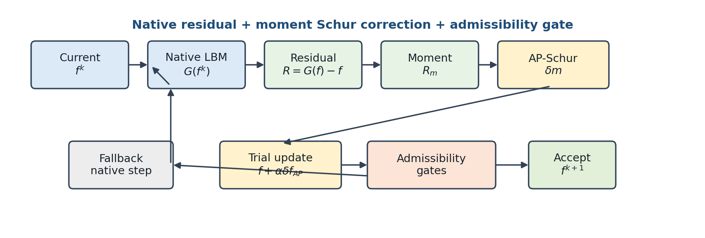
Figure 1. Conceptual workflow of the AP-Schur-only method. The macroscopic moment residual is extracted from the native LBM residual, the AP-Schur correction is validated by the admissibility gate, and execution proceeds with either the accepted update or the native fallback.

3. Benchmark Suite and Evaluation Protocol
The proposed method is evaluated on nine flow families that together span the range from simple shear- and pressure-driven flows with closed-form solutions to complex mask and branching geometries that admit only high-fidelity numerical references. The families are plane Poiseuille and Couette flow (analytic references); the lid-driven cavity at $Re=100/400/1000$ (Ghia centerline literature benchmark [5]); the backward-facing step and the cylinder wake (separation, reattachment, and wake formation); the multi-cylinder configuration (complex mask boundary); and the T-junction (branching geometry with coupled inlet/outlet boundaries). Each family is solved at three mesh levels (1x/2x/3x), giving 27 proposed-method runs in total. Table 1 collects, for each family, the grid sizes, boundary conditions, validation role, and reference tier; the suite is deliberately constructed so that the validation roles range from canonical accuracy checks to demanding complex-geometry robustness tests.
Table 1. Benchmark family definitions: grid size, boundary conditions, validation role, and reference tier.
Family | Grid (1x / 2x / 3x) | Boundary conditions | Validation role | Reference
Channel (plane Poiseuille) | 32×192 / 64×384 / 96×576 | Inlet/outlet + wall | Pressure-driven shear (baseline) | Analytic
Couette | 32² / 64² / 96² | Moving wall + wall | Shear flow (baseline) | Analytic
Cavity $Re=100$ | 33² / 65² / 97² | Lid-driven, closed | Recirculating closed domain | Ghia [5]
Cavity $Re=400$ | 49² / 97² / 145² | Lid-driven, closed | Recirculating closed domain | Ghia [5]
Cavity $Re=1000$ | 129² / 257² / 385² | Lid-driven, closed | Recirculating closed domain | Ghia [5]
Backward-facing step | 64² / 128² / 192² | Inlet/outlet + step mask | Separation/reattachment | Tight ref
Cylinder wake | 64² / 128² / 192² | Inlet/outlet + obstacle mask | Wake formation | Tight ref
Multi-cylinder | 32² / 64² / 96² | Multiple obstacle masks | Complex mask boundary | Tight ref
T-junction | 96×64 / 192×128 / 288×192 | Branching inlet/outlet | Branching geometry + open-BC coupling | Picard ref
Convergence is judged on the macroscopic $L_{2}$ change of the pressure and velocity fields, not on the microscopic $f$-RMS. The pressure increment is made gauge-invariant by removing its fluid-domain mean—in weakly compressible closed or periodic flow the absolute pressure (density-mean) level is an arbitrary constant—and is combined with the velocity increment to define the macroscopic residual $r_{macro}$, with all component $L_{2}$ norms taken over fluid nodes only. Final convergence is declared on the simultaneous satisfaction of three conditions: an absolute residual $r_{macro}≤5τ$; a plateau condition, whereby the fractional improvement over the most recent window ($W=50$) does not exceed $η=0.05$, indicating that the decrease has reached its numerical floor; and physical admissibility, comprising density positivity, finite fields, and boundary/mask consistency. The base tolerance $τ$ is ${10}^{−7}$ for the non-cavity families and ${10}^{−8}$ for the cavity families at 1x, tightened by $1/2$ and $1/3$ at the 2x and 3x levels. These constants, the plateau window, and the admissibility rule are applied identically to the proposed method and to all baselines, with no per-case tuning.
The proposed method is compared against five baselines that share the native LBM operator of the same code base (Table 2). The native LBE is the collide–stream–boundary fixed-point (Picard) iteration; Anderson acceleration is a regularized least-squares fixed-point accelerator; preconditioned LBM combines the standard balanced PLBE transform with a block preconditioner; inexact Newton–Krylov is a JFNK method using GMRES with a smoother and a line search; and dual-time multigrid is an FAS V-cycle scheme. Each baseline is implemented with literature-standard hyperparameters and a generous iteration budget (about $6×{10}^{5}$ to $1.2×{10}^{6}$ LBE-calls for cavity 2x/3x), so that none is deliberately weakened. The only difference between the proposed method and a baseline is the update rule; all run in the same Python/NumPy environment calling the same native operator, so that any wall-time difference reflects algorithmic structure rather than language or library.
Table 2. Baseline implementations and main settings.
Baseline method | Implementation summary | Main settings
Picard (native LBM) | Native collide–stream–boundary fixed-point iteration | max_steps $≤1.2×{10}^{6}$, residual-monotone termination
Anderson acceleration [9,10] | Regularized least-squares fixed-point acceleration, admissibility safeguard | depth $m=10$, $β=1.0$, reg $={10}^{−12}$
Preconditioned LBM [20,21] | Balanced PLBE ($γ$-scaled) transform + block preconditioner | $γ=0.5$, max_steps $≤1.2×{10}^{6}$
Inexact Newton–Krylov [6,7] | JFNK: GMRES + NE/smoother + line search | krylov_max=10, K_ne=20, K_smooth=10, line_search=4
Dual-time multigrid [14] | FAS V-cycle, residual-equation smoothing | max_levels=6, V-cycle, K_pre/coarse/post=20/30/20
Because the methods stop at different accuracies, a comparison anchored at each method’s own termination would contrast solutions of differing quality and would not be fair. To avoid this, all methods are compared by time-to-threshold—the cost incurred to first reach a common target residual $ε$. This cost is read in two ways: the wall time, and the number of native operator evaluations $G(f)$ (LBE-calls). The latter is a hardware-independent, fully deterministic operator-work metric that includes the cost of rejected correction trials. The reference solutions (analytic, Ghia, and tight numerical references) are never used inside the solve; they enter only the post-solve accuracy evaluation, where accuracy is measured as the relative $L_{2}$ error against the reference. The proposed method solves all 27 problems with a single deterministic routine, with only the problem definition (grid, $Re$, boundary, mask) changing from case to case.

4. Results

4.1 Convergence histories
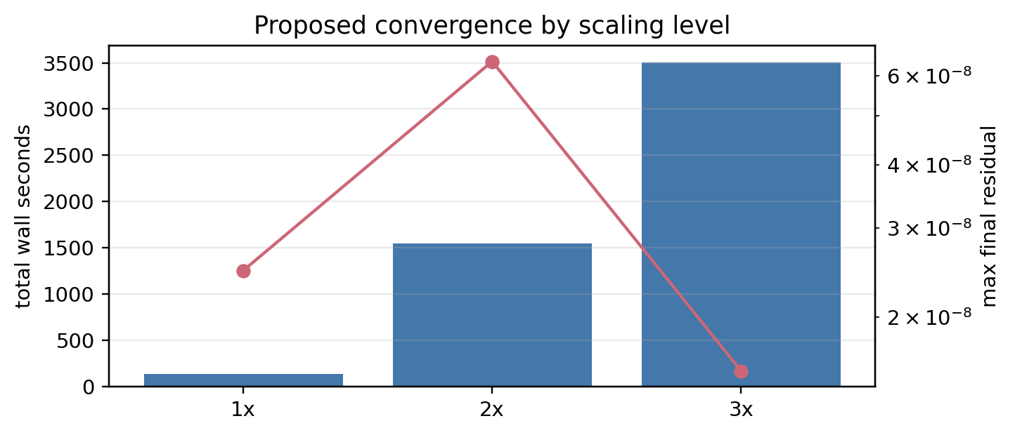
Figure 2. Macroscopic $L_{2}$ residual versus wall time for a representative case (cavity $Re=1000$, 2x), for all six methods. The baseline methods stall at a hydrodynamic plateau, whereas only the proposed method descends below the stopping tolerance.
Figure 2 shows, for a representative high-Reynolds cavity case, the residuals of the six methods plotted against wall time on a logarithmic residual axis. The baselines descend rapidly at first but then stall at a plateau near ${10}^{−6}$ and fail to descend further. The proposed method (bold red), by contrast, passes through this plateau and decreases monotonically below the stopping tolerance. The residual trajectory of the proposed method both descends faster and converges to a lower residual value.
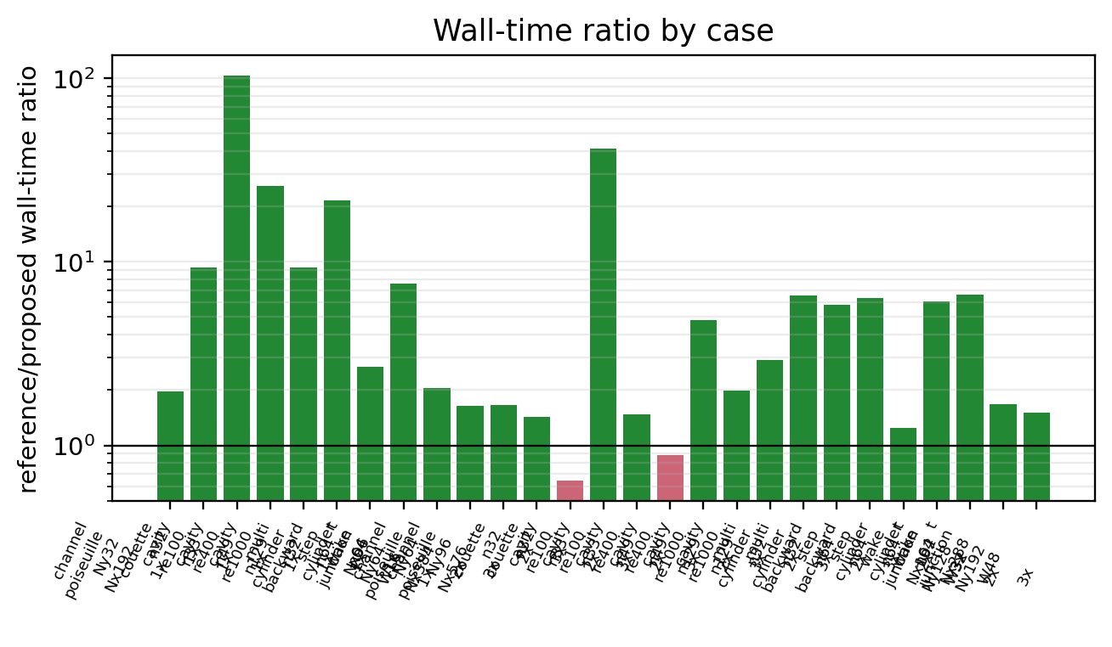
Figure 3. Convergence histories of all nine 1x-grid cases (all methods, monotone wall-time axis).
Figure 3 extends the same comparison to all nine validation cases at the 1x level. To demonstrate that the behavior is not specific to a curated subset, every case is shown on identical axes and with identical color conventions. In every panel the proposed method (bold red) reaches the lowest residual first. The corresponding 2x and 3x grids of histories are provided in the appendix (Figures A1 and A2).
Table 3. Per-level convergence summary for the proposed method.
Level | Cases | Converged | Total wall [s] | Median residual | Max residual | Median rel. error
1x | 9 | 9 | 134.2 | 2.142e-12 | 2.474e-08 | 3.260e-03
2x | 9 | 9 | 1546.6 | 3.305e-12 | 6.409e-08 | 0.0326
3x | 9 | 9 | 3507.2 | 1.153e-11 | 1.567e-08 | 0.0257
Table 3 aggregates the proposed-method results by level. The method satisfies the convergence criterion of Section 3 (the three convergence flags simultaneously) on all 27 runs. The “median rel. error” column is not directly comparable across levels, because the set of cases with a comparable reference solution differs by level (some complex geometries lack a tight reference at 2x/3x); accuracy is verified case by case in Section 4.4.

4.2 Convergence-rate analysis and robustness
The behavior observed in Section 4.1 follows directly from the linearized structure of Section 2. The asymptotic convergence rate of the native LBE iteration is governed by the spectral radius of the linearized iteration operator, which separates into kinetic and hydrodynamic modes. The kinetic modes, corresponding to the block $J_{kk}$, are damped strongly and locally, whereas the hydrodynamic modes tied to the conserved moments (density and momentum) are governed by the Schur complement $S_{m}=J_{mm}−J_{mk}J_{kk}^{−1}J_{km}$. The damping rate associated with the largest eigenvalue of $S_{m}$ approaches unity, so that after sufficiently many iterations the residual is determined by this single slow mode, forming the plateau observed in Figures 2 and 3. The proposed method removes this dominant slow mode directly by applying an analytic approximation of $S_{m}^{−1}$ restricted to the conserved-moment subspace. As a result, the residual continues to decrease in the region where the native iteration stalls, demonstrating that the acceleration selectively targets the component that constrains late convergence.
This mechanistic difference is quantified by the robustness gap between the methods. Under the same stopping criterion, the same admissibility definition, and the same iteration budget granted to all methods, the proposed method satisfies the convergence criterion ($r_{macro}≤5τ$ together with the plateau and admissibility conditions) on all 27 cases. The five baselines, by contrast, converge on only a subset under identical conditions: the most robust, inexact Newton–Krylov, on 15 cases, preconditioned LBM on 14, Picard and Anderson on 13 each, and dual-time multigrid on 12.
The non-convergence of the baselines arises from numerical stagnation rather than budget exhaustion, as can be confirmed directly from the stored convergence histories. For cavity $Re=400$ (2x), for example, all five baselines stop decreasing at a residual level of $3.4\text{–}3.6×{10}^{−6}$, roughly two orders of magnitude above the target tolerance ($5τ=2.5×{10}^{−8}$); this stagnation already sets in at $6\text{–}7×{10}^{5}$ LBE-calls, well short of the budget limit ($∼{10}^{6}$). For cavity $Re=1000$ (2x), the residual remains at $O({10}^{0})$ even after $1.2×{10}^{6}$ LBE-calls. In these cases the residual curves enter their asymptotic plateau before the budget is reached, so that additional iterations cannot achieve convergence.
This robustness gap is reported in its own right but is not used in the quantitative timing comparison of Section 4.3. To ensure fairness between methods, the timing comparison is restricted to the subset of cases on which the baselines also satisfy the strict convergence criterion, thereby excluding any influence of budget asymmetry on the measured speedups.

4.3 Quantitative speedup: wall time and operator work

4.3.1 Wall-time comparison
Because the stopping rules differ between methods, their termination points do not coincide, and a comparison anchored at termination would contrast solutions of differing accuracy. To avoid this, all methods are compared by the wall time required to first reach a common residual level (time-to-threshold). All six methods record the residual under the same definition (macro_l2_p_ux_uy_uz), so the first-arrival time at a common threshold $r_{macro}={10}^{−4}$ can be compared directly. This threshold is reached by all six methods on all 27 cases, so that no arrival failure is excluded from the comparison; it therefore provides the most conservative timing comparison.
At this common threshold the proposed method is consistently faster than each baseline. The median across all cases of the arrival-time ratio is $1.64×$ relative to preconditioned LBM, $2.42×$ relative to native LBE, $2.84×$ relative to inexact Newton–Krylov, $7.34×$ relative to Anderson, and $18.65×$ relative to dual-time multigrid. The fraction of cases on which the proposed method is faster ranges from 19/27 (preconditioned LBM) to 27/27 (Anderson). Compared against the single fastest baseline run on each case, however, the median time ratio is $1.09×$, i.e. on par with the strongest single competitor across all cases. The timing advantage of the proposed method is therefore concentrated on particular problem types rather than distributed uniformly across cases.
To honour the fairness restriction announced in Section 4.2—comparing only where a baseline also satisfies the strict convergence criterion—we isolate the strict subset of 15 cases on which at least one baseline converges and compare the proposed method against that converged baseline case by case. On this subset the proposed method is faster in wall time on 14 of the 15 cases, with a median wall-time ratio of $2.06×$, and it uses fewer operator-work units (LBE-calls) on 13 of the 15 cases, with a median operator-work ratio of $1.80×$. Broadening the same case-by-case comparison to every available baseline run rather than only the strictly converged subset, the proposed method is faster on 25 of the 27 cases, with a median ratio of $2.92×$. These strict-subset and all-baseline win rates are collected in Table 3a; they are the headline figures quoted in the abstract.
Table 3a. Strict-subset and all-baseline timing comparison (time-to-threshold, $r_{macro}={10}^{−4}$).
Comparison set | Metric | Win rate | Median ratio
Strict subset (15 cases, baseline also converges) | Wall time | 14/15 | 2.06×
Strict subset (15 cases, baseline also converges) | Operator work (LBE-calls) | 13/15 | 1.80×
All baselines (27 cases) | Wall time | 25/27 | 2.92×
For cavity $Re=1000$ at 2x and 3x and for the T-junction at 1x, 2x, and 3x, the convergence history of the proposed method displays a characteristic three-stage shape that qualitatively reveals the working principle of the acceleration. (i) In the initial transient, native relaxation rapidly removes the high-wavenumber kinetic modes and the residual drops sharply. (ii) In the ensuing long plateau, the residual is dominated by the global hydrodynamic slow mode; under the inexact correction of the truncated inner GMRES and the damping of the admissibility gate ($α<1$), steps are accepted at every iteration but the residual decreases only marginally, so that a near-stagnation state is maintained (for example, in cavity $Re=1000$ 2x the residual lingers near $∼{10}^{−7}$ for about 1100 steps and 740 s). This stage accounts for most of the total wall time and corresponds to the GMRES cost repeatedly expended on correction trials that yield little benefit. (iii) The moment the iterate enters Newton’s quadratic-convergence region, the finite-difference Jacobian–vector approximation becomes accurate, the full step ($α=1$) passes the admissibility test, and a single correction step drives the residual down to the square of its previous value. This terminal collapse is confirmed quantitatively: in the T-junction (2x) the residual falls in one step from $2.6×{10}^{−5}$ to $8.1×{10}^{−12}$, and in cavity $Re=1000$ (2x) from $9.6×{10}^{−8}$ to $4.9×{10}^{−14}$, each consistent with the square of the preceding residual and hence with a second-order convergence rate. The baselines, being limited to linear convergence, achieve only a fixed fractional decrease per iteration and so cannot in principle produce such a terminal collapse—the obverse of the residual-floor phenomenon described above. The shape of the convergence curve is therefore itself qualitative evidence that the AP-Schur correction acts as a genuine Newton step in the conserved-moment subspace.
The family in which the differences between methods are most pronounced is the lid-driven cavity flows ($Re=100,400,1000$ at three mesh levels, nine configurations in total), where the difference goes beyond a simple gap in time and reaches a structural difference in the attainable residual level itself. On all nine cavity configurations the five baselines stop decreasing at a common residual floor in the range ${10}^{−7}\text{–}{10}^{−5}$, regardless of the type of method used. Within each configuration, the final residuals of the five baselines cluster in a very narrow range (for example $1.0\text{–}1.2×{10}^{−6}$ at $Re=1000$ 2x, and $1.1\text{–}1.2×{10}^{−6}$ at $Re=400$ 3x), indicating that this floor is not a limitation of any particular method but a structural barrier imposed by the problem itself. The proposed method, by contrast, passes through this floor on every cavity configuration and reaches residuals at the ${10}^{−8}\text{–}{10}^{−14}$ level (final residuals of the proposed method from $1.9×{10}^{−13}$ to $1.6×{10}^{−8}$), corresponding to a steady-state precision two to eight orders of magnitude deeper than any baseline.
This depth advantage is in most cases achieved together with shorter wall time. At $Re=1000$ 1x, for example, the proposed method reaches $2.4×{10}^{−9}$ in 57 s, whereas the five baselines spend 531–774 s and remain stuck at the $∼6×{10}^{−6}$ floor; at $Re=100$ 1x the proposed method reaches $1.9×{10}^{−13}$ in 1 s, whereas the baselines stagnate at the $∼{10}^{−5}$ level after 72–114 s. The same penetration of the stagnation floor recurs consistently across all three Reynolds numbers and all three mesh levels.
This behavior arises because the cavity flow is a closed, recirculation-dominated problem strongly governed by the global hydrodynamic slow mode. The native-relaxation-based baselines cannot damp this slow mode efficiently and therefore converge to the same floor irrespective of method, whereas the proposed method passes through that floor by targeting the mode directly in the conserved-moment subspace (Section 4.2). Even when compared at the deepest common threshold reached by all baselines (${10}^{−5}$), the proposed method retains its advantage: representatively, at $Re=1000$ 2x it reaches ${10}^{−5}$ in 70.8 s, against 178.7 s for native LBE ($2.5×$), 218.8 s for Anderson ($3.1×$), and 940.3 s for dual-time multigrid ($13.3×$).
Consistent with the mechanism, the net gain of the proposed method is proportional to the degree to which the global hydrodynamic slow mode governs convergence; in problems where this mode is weak or absent, the per-iteration cost of the correction step (moment projection, inner GMRES, admissibility gate) is not amortized. In the present suite this manifests in two ways. First, in Couette flow the linear distribution is represented exactly by the LBM equilibrium, so the global slow mode is essentially absent. At 1x the proposed method is faster than all baselines (by $3.3\text{–}31×$ at the ${10}^{−5}$ threshold), but as the grid is refined native relaxation alone becomes fast enough while the correction cost grows, so the ordering reverses: at 2x the proposed method takes 1.8 s to reach ${10}^{−4}$, about $3.6×$ slower than native LBE (0.5 s), and at ${10}^{−5}$ it is on par with native LBE ($0.90×$) and preconditioned LBM ($0.96×$). Second, the T-junction is a case in which strongly driving inlet/outlet boundaries make boundary-local modes dominant over the global mode: at 2x the proposed method takes 95.4 s to reach ${10}^{−5}$, about $5×$ slower than native LBE (18.3 s) and preconditioned LBM (17.8 s). Even in this case, however, the proposed method ultimately converges to $1.3×{10}^{−12}$, a deeper steady state than any baseline, and at 3x it recovers its advantage at the ${10}^{−5}$ threshold over native LBE ($1.30×$) and preconditioned LBM ($1.38×$).
The timing advantage of the proposed method is thus maximized on problems where the global hydrodynamic slow mode governs convergence (high-Reynolds closed, recirculation-dominated flows), while in simple shear flows or boundary-driven flows where the slow mode is weak the marginal gain can be small or negative. In every case, however, the proposed method converges stably to a steady-state precision that the baselines cannot reach, so the local timing disadvantage on some cases does not offset its robustness advantage. The full per-case arrival times, including the non-dominant cases, are reported as is in Appendix Table A1.

4.3.2 Operator-work (LBE-call) comparison
Wall time depends on processor performance, memory bandwidth, and implementation language, so its conclusions may shift if the measurement environment changes. To complement it, the same comparison is repeated in terms of operator work, an environment-independent and fully deterministic metric. In the lattice Boltzmann method the most expensive primitive operation is one lattice update—a single evaluation of the operator $G$ that bundles collision, advection, and boundary handling—and all six compared methods share this operation. The total number of $G$ evaluations called to reach steady state (the LBE-call count) therefore measures the intrinsic algorithmic work directly, independent of hardware and implementation.
As with wall time, the comparison fixes a common target residual $ε$ for all methods and counts the LBE-calls spent until that value is first reached; that is, the operator-work to threshold is defined as the cumulative number of $G$ evaluations at the iteration where the residual first falls to or below $ε$, and methods that stagnate without reaching $ε$ are excluded. Because all six methods record the residual under the same definition, this recomputation is performed consistently from the same stored result set.
At the common threshold $ε={10}^{−4}$ reached by all methods, the operator work of the proposed method is fewer than or comparable to each single baseline—by the median it uses $1.17×$ fewer than inexact Newton–Krylov, $1.32×$ fewer than preconditioned LBM, $1.33×$ fewer than native LBE, $2.60×$ fewer than Anderson, and $3.85×$ fewer than dual-time multigrid. Compared against the single baseline run that uses the fewest operations on each case, however, the median is $0.87×$, so that at a loose threshold the proposed method spends somewhat more $G$ evaluations than the strongest competitor. This is because each outer iteration of the proposed method spends several $G$ evaluations on the finite-difference Jacobian–vector products and the inner GMRES iterations, whereas a baseline relaxation iteration advances one step with a single evaluation. The proposed method thus takes fewer iterations but at higher per-iteration cost, so that at a loose threshold the two effects offset and it remains on par with the strongest competitor.
It is significant that this operator-work comparison exhibits the same qualitative structure as the wall-time comparison. Under both metrics the proposed method is on par with the strongest competitor at a loose threshold, and its advantage widens on the harder problems and at the deeper thresholds. That one metric is environment-dependent (time) and the other fully deterministic (operator work), yet both yield the same conclusion, confirms that the observed performance advantage is an intrinsic property of the algorithm rather than a measurement artifact such as interpreter overhead or transient scheduling variation.
The operator-work advantage is most pronounced on the hard problems where the global hydrodynamic slow mode governs convergence. On such problems the baseline relaxation methods cannot remove the slow mode and stagnate at a fixed residual level, continuing to evaluate $G$ at every iteration and thus exhausting operator work while stuck at that floor. The proposed method, by contrast, targets the mode directly in the conserved-moment subspace and so passes through the floor with fewer operations. For example, on the finest-grid high-Reynolds lid-driven cavity ($Re=1000$), the proposed method spends only 24,521 $G$ evaluations to reach ${10}^{−4}$, whereas the five baselines spend 45,592–125,985, so that the proposed method reaches the same accuracy with $1.9\text{–}5.1×$ fewer operations.
Furthermore, every reported operator-work count includes the cost of failed correction trials in full. When a correction trial of the proposed method fails the admissibility or residual-decrease test, the trial is discarded and the method falls back to native relaxation; but the residual evaluations, boundary re-applications, finiteness and positivity checks, and the $G$ evaluation of the fallback step performed during the trial are all counted in the recorded LBE-calls. The reported operator work is therefore the cost of the entire actual execution path including failed trials, not a post hoc count of successful corrections alone.

4.4 Accuracy verification: does the acceleration distort the solution?
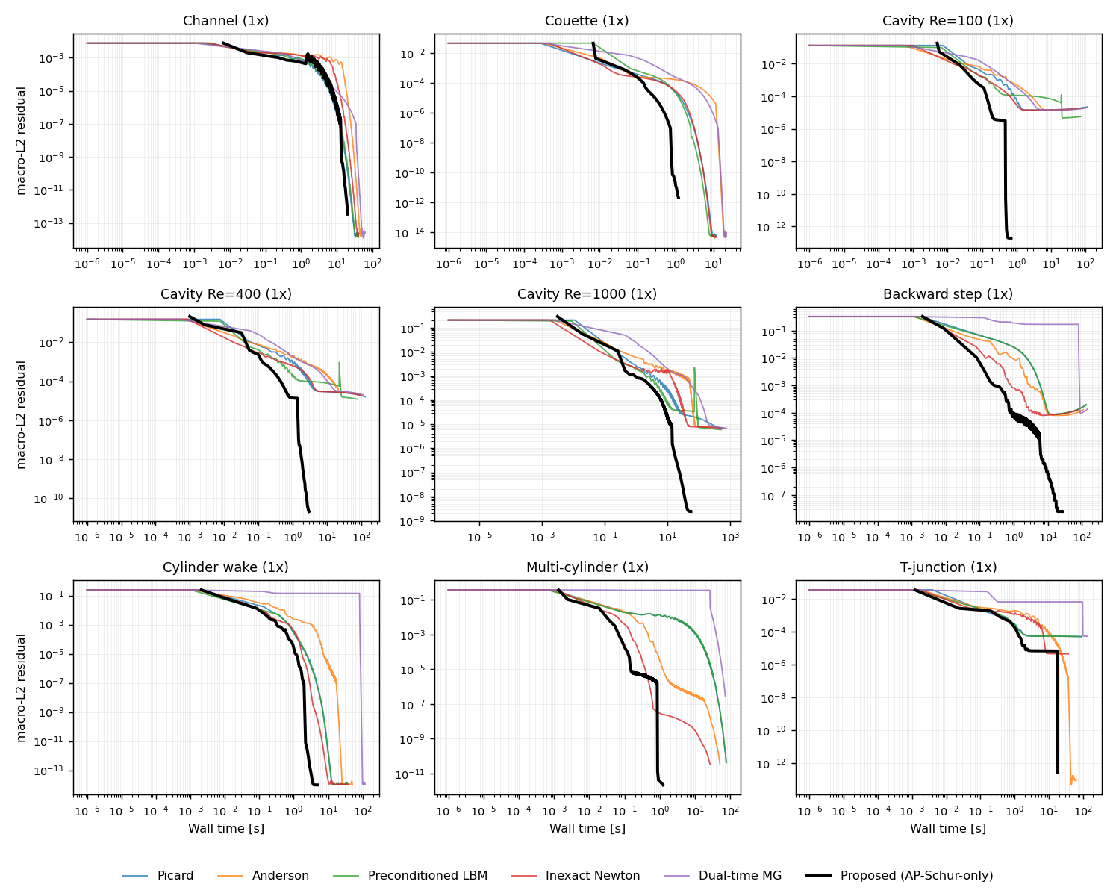
Figure 4. Grid-refinement accuracy. (a) Second-order convergence for Poiseuille flow, (b) machine precision for Couette flow, (c) monotone decrease of the cavity Ghia error.
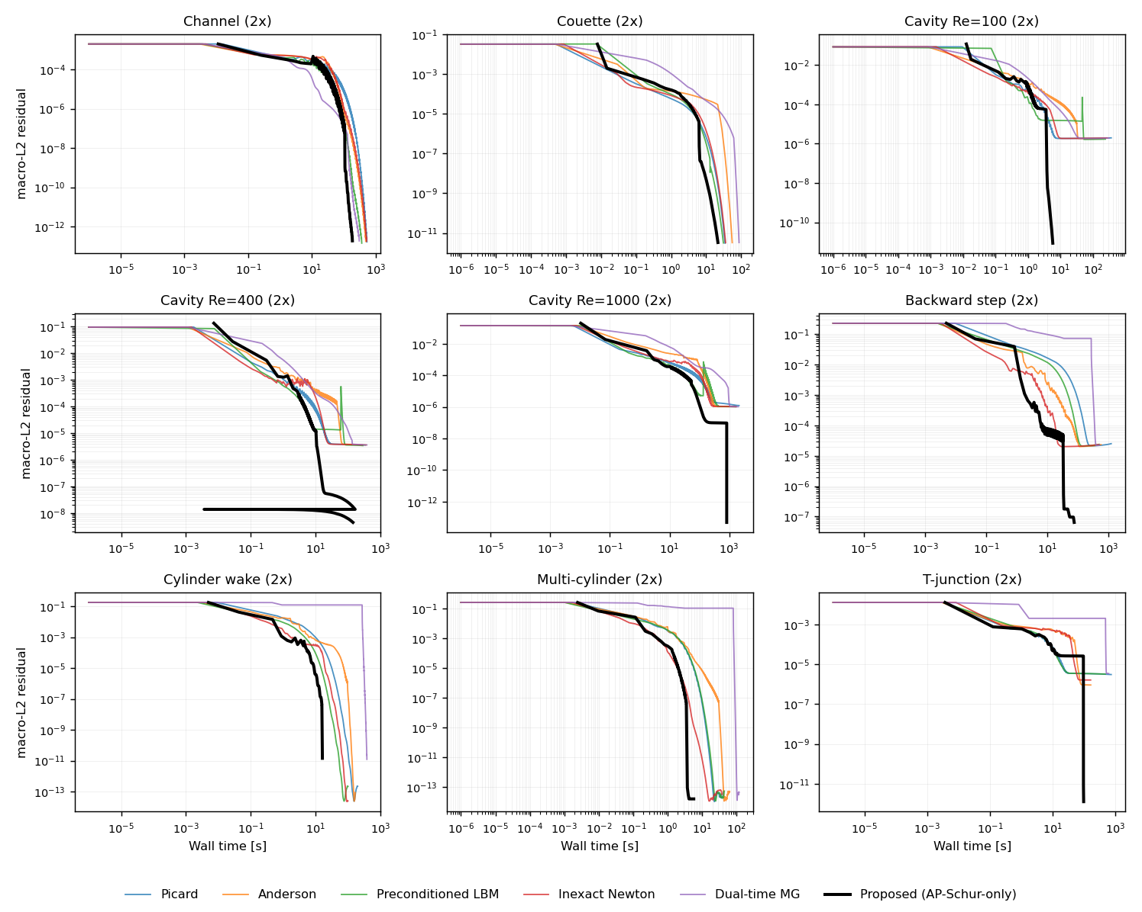
Figure 5. Cavity centerline $u(y)$ and $v(x)$ profiles on the 3x grid compared against Ghia (1982) for $Re=100/400/1000$.
That the acceleration does not compromise solution accuracy in exchange for convergence speed is central to the validity of the method. Since the proposed method is designed to leave the native residual itself unchanged, it should in principle converge to the same discrete steady state as the native iteration; this section verifies that quantitatively against closed-form solutions, literature benchmarks, and high-fidelity numerical references.
We first check the accuracy under grid refinement for plane Poiseuille flow, which admits a smooth analytic solution. The relative $L_{2}$ error of the velocity profile is $9.37×{10}^{−3}$, $2.27×{10}^{−3}$, and $1.00×{10}^{−3}$ at $N_{y}=32,64,96$, respectively; the observed order of convergence between successive grids is 2.04 and 2.02, in quantitative agreement with the theoretical second-order accuracy of BGK-LBM for smooth flows (Figure 4a). The acceleration thus preserves the convergence order of the underlying discretization. Next, the linear Couette flow is represented exactly by the LBM equilibrium distribution, so that the discretization error should be essentially zero; the measured relative $L_{2}$ error lies between $2.75×{10}^{−9}$ and $5.19×{10}^{−8}$, all within the machine-precision limit (Figure 4b). This shows that the acceleration correction injects no unphysical bias into the solution. Finally, the error against the literature benchmark—the Ghia centerline velocities of the lid-driven cavity—decreases monotonically with grid refinement at all three Reynolds numbers (Figure 4c). This error is not a pure discretization error but a quantity that reflects the Navier–Stokes reference table, the boundary discretization, weak-compressibility effects, and table interpolation together, so no formal order of convergence is claimed; the monotone approach across all three Reynolds numbers nonetheless shows that the final field of the proposed method converges consistently toward the literature solution. This agreement is also visually confirmed by overlaying the cavity centerline velocity profiles on the finest 3x grid directly with Ghia (1982) (Figure 5): at all three Reynolds numbers the vertical and horizontal centerline profiles of the proposed method pass precisely through the Ghia markers, showing that the accelerated solution agrees quantitatively with the standard literature solution.
Table 4. Accuracy summary for cases with an analytic or reference profile (1x).
Case | Wall [s] | Final residual | Rel. $L_{2}$ vs ref | Reference
Plane Poiseuille (N_y=32) | 20.30 | 3.384e-13 | 9.371e-03 | analytic
Couette (N=32) | 1.20 | 2.180e-12 | 2.750e-09 | analytic
Cavity Re=100 (N=33) | 0.70 | 1.935e-13 | 0.117 | Ghia
Cavity Re=400 (N=49) | 3.06 | 2.045e-11 | 0.106 | Ghia
Cavity Re=1000 (N=129) | 56.84 | 2.360e-09 | 0.0542 | Ghia
Multi-cylinder (N=32) | 1.25 | 2.142e-12 | 4.146e-05 | tight ref
Backward step (N=64) | 27.66 | 2.474e-08 | 3.260e-03 | tight ref
Cylinder wake (N=64) | 4.88 | 9.882e-15 | 7.935e-05 | tight ref
T-junction (N_x=96) | 18.29 | 2.633e-13 | 1.896e-05 | Picard ref
For complex geometries without an analytic or literature solution, we compare against high-fidelity numerical references (Table 4). Among these the T-junction case provides especially direct evidence: its reference is a strictly converged native-iteration field, and the relative $L_{2}$ difference between it and the final field of the proposed method is only $1.9×{10}^{−5}$. This directly demonstrates that the proposed method reaches the same discrete steady state as the native iteration—the acceleration does not detour to a different solution, it reaches the same solution faster. The other complex-geometry cases likewise show relative $L_{2}$ errors at the ${10}^{−5}$ level, indicating that the acceleration maintains accuracy independently of geometric complexity.
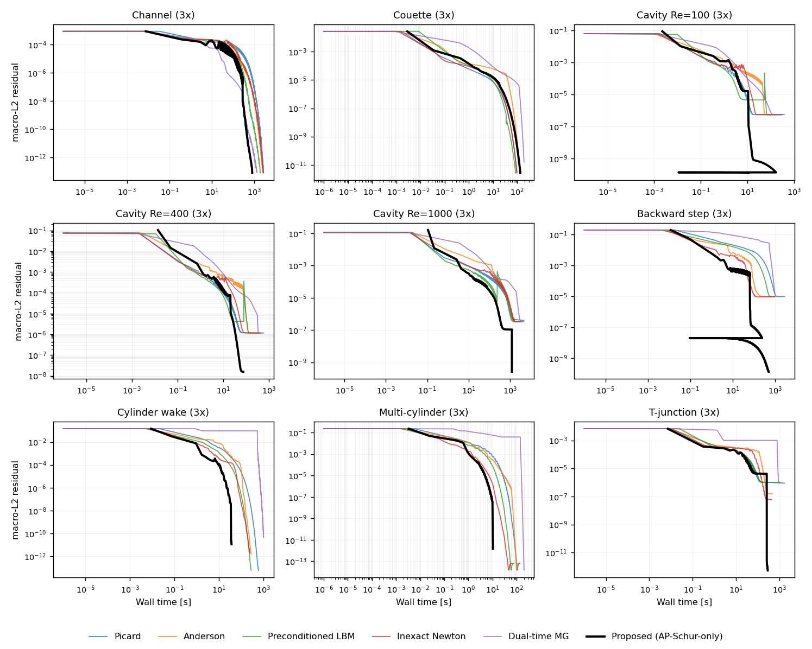
Figure 6. Velocity magnitude with streamlines for the nine geometries (3x, proposed-method solution; obstacles shaded gray).
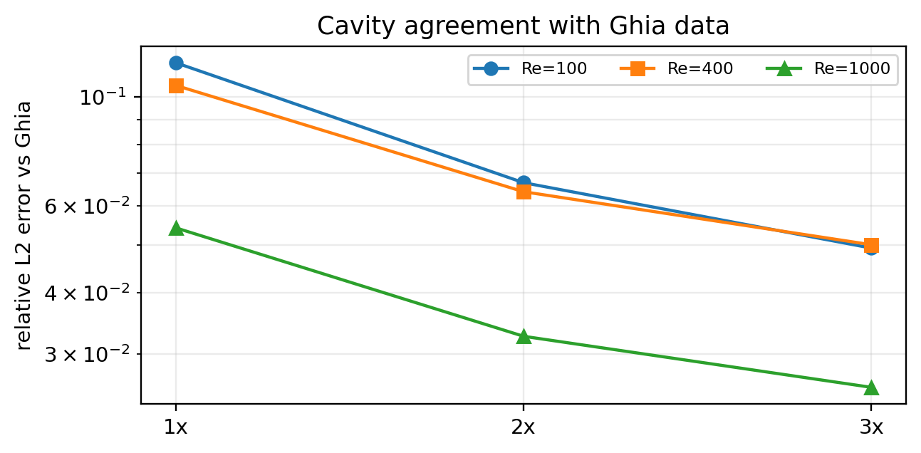
Figure 7. Vorticity fields for the nine geometries (3x, proposed-method solution). The uniform color of the Couette case reflects the physical fact of linear shear (constant vorticity).
Finally, we verify qualitatively that the converged field has a physically plausible structure. Figures 6 and 7 show, for all nine geometries on the finest 3x grid, the velocity field (with streamlines) and the vorticity field reconstructed from the final field of the proposed method. In every geometry the characteristic structure of the corresponding flow—the primary and secondary recirculation vortices of the cavity, the separation and reattachment recirculation of the backward-facing step, the shear layer of the cylinder wake, the flow distribution in the T-junction, and the bypass flow around the multiple cylinders—is clearly reproduced, complementing the quantitative accuracy verification from a qualitative standpoint.

5. Discussion
The performance gain of the proposed method follows directly from the Schur-complement structure of the steady residual. Native collide–stream relaxation damps the kinetic block $J_{kk}$ locally and quickly, but acts only weakly on the global hydrodynamic coupling carried by the moment Schur complement $S_{m}$, whose near-unity damping factor produces the long convergence plateau. The AP-Schur preconditioner applies an analytic approximation of $S_{m}^{−1}$ restricted to the conserved-moment subspace, removing precisely this slow component, so that the residual continues to descend where native iteration stalls. This interpretation is supported by the ablation study—the AP-Schur-only configuration attains both the lowest total time and the full convergence breadth—and by the non-trivial correction-acceptance rate observed across all cases (an overall 71.0%, with no case taking zero accepted corrections; see Appendix Figure A4). The local linear analysis guarantees only a reduced amplification factor of the captured slow mode; because the admissibility gate falls back to the native step whenever a correction fails, the approximate nature of the preconditioner affects only the speed of convergence, never the converged solution.
The scope of this work is the 2D D2Q9/BGK steady benchmark suite; no direct claim is made for 3D, thermal or compressible LBM, MRT or entropic collisions, or high-Reynolds turbulence. The accuracy evidence—second order for Poiseuille flow, machine precision for Couette flow, and a monotone approach to the Ghia benchmark—constitutes code verification for the cases with closed-form or literature references, not a formal grid-convergence (Richardson/GCI) study for every geometry, and no formal order of convergence is claimed for the tight-reference cases. The method does not remove discretization or boundary-condition error; the nonzero Ghia error is a direct example. It reaches the same discrete steady solution faster. Wall time depends on the CPU, memory bandwidth, and library implementation, and is therefore interpreted as a relative metric within a single result set, complemented by the deterministic operator-work (LBE-call) metric. On problems where the global slow mode is weak (simple shear) or where boundary-driven local modes dominate, the per-iteration cost of the correction is not amortized and the net speedup is small or negative; this exception is consistent with—and indeed predicted by—the same slow-mode-dominance mechanism, which lends the interpretation additional predictive force.
Several directions remain for future work: shortening the near-stagnation phase that precedes the terminal Newton collapse, for instance through an adaptive inner-Krylov dimension and inner tolerance; extension to 3D, to MRT and entropic collision models, and to higher Reynolds numbers; and a quantitative bound on open-boundary flux closure.

6. Conclusion
This work proposed and validated a nonlinear acceleration technique that preconditions the pressure–velocity hydrodynamic slow mode—the convergence bottleneck of the steady-state lattice Boltzmann method—from the viewpoint of the conserved-moment Schur complement. The collide–stream relaxation of standard LBM damps the kinetic components locally and stably, but the pressure–velocity modes, which must reach global equilibrium, converge very slowly and produce the late-stage plateau. The proposed method targets only this slow component: it projects the residual onto the conserved-moment space, generates a Jacobian-free trial direction in that subspace, and lifts it back to distribution-function space. The central design principle is that the native steady-state LBM residual and boundary operators are left entirely unchanged, so that because every residual evaluation passes through the same native operator $G(f)$, consistency with complex mask, wall, and inlet/outlet handling is guaranteed automatically. The generated correction is not applied unconditionally; it is accepted only when it passes an admissibility gate that checks density positivity, finiteness, boundary consistency, and residual decrease, and otherwise the solver reverts to a native update. This structure ensures that local imperfections of the acceleration do not undermine the stability of the overall solver, and allows the verification of accuracy, boundary conditions, and reference-solution comparison to be handled consistently within the same residual and admissibility criteria.
The most striking outcome on the performance side is robustness. On the stored 27-case benchmark suite the proposed method passes the same convergence criterion (simultaneous satisfaction of the absolute residual, plateau, and admissibility conditions) on every run, whereas the five baselines—native LBE, Anderson acceleration, preconditioned LBM, inexact Newton–Krylov, and dual-time multigrid—converge on only 12–15 cases each under the same protocol and a generous budget. This non-convergence stems from numerical stagnation rather than insufficient budget, as confirmed by residuals that reach their floor well before the budget is exhausted. The difference is maximized on the hard problems where the global slow mode strongly governs convergence: representatively, on the high-Reynolds lid-driven cavity the five baselines all stagnate at a common residual floor near ${10}^{−6}$ regardless of method, whereas the proposed method passes through that floor by its conserved-moment correction and reaches the ${10}^{−8}\text{–}{10}^{−14}$ level with fewer operations. Moreover, the convergence history of the proposed method exhibits a characteristic shape—initial sharp drop, long near-stagnation, terminal sharp collapse—in which the final collapse occurs at the square of the preceding residual, qualitatively demonstrating that the correction acts as a genuine Newton step in the conserved-moment subspace. This is behavior fundamentally distinct from the baselines, which remain limited to linear convergence and cannot cross the plateau.
The direct scope of this work is limited to comparisons of convergence time, operator work, residual, and reference-solution error on the 2D D2Q9/BGK steady benchmark suite. The proposed method does not remove discretization or boundary-condition error itself; it reaches the discrete solution faster. Wall time depends on the CPU generation, memory bandwidth, and library implementation, so it is interpreted as a relative metric within a single environment and is complemented by the hardware-independent, fully deterministic operator-work (LBE-call) metric. An exception was also observed in which, for some problems with a weak global slow mode (such as simple shear flows) or with dominant boundary-driven local modes, the per-iteration cost of the correction is not amortized and the marginal gain of the acceleration becomes small; that both the favorable and unfavorable cases are explained by the same slow-mode-dominance mechanism supports rather than weakens the predictive power of that interpretation. Future work remains in strategies for shortening the near-stagnation phase through the inner-Krylov dimension and an adaptive inner tolerance, in extension to 3D, MRT/entropic collision models, and the high-Reynolds turbulent regime, and in a quantitative evaluation of open-boundary flux conservation.

Appendix

A.1 Full 27-case result table
Table A1 reports all 27 proposed-method benchmark runs. The entries marked “not computed” are cases for which the tight reference solution at that level is absent from the result set and was therefore not computed post hoc; they are not to be interpreted as zero or as success. Convergence for those cases was satisfied independently by the residual, plateau, and admissibility criteria.
Table A1. All 27 proposed-method benchmark runs.
Lv | Case | Wall [s] | LBE | r_final | r/r_0 | Rel. err | Ref
1x | backward step n64 | 27.66 | 122673 | 2.47e-08 | 7.55e-08 | 3.26e-03 | tight ref
1x | cavity re1000 n129 | 56.84 | 221413 | 2.36e-09 | 7.91e-09 | 0.0542 | Ghia
1x | cavity re100 n33 | 0.70 | 20873 | 1.93e-13 | 1.02e-12 | 0.117 | Ghia
1x | cavity re400 n49 | 3.06 | 44379 | 2.04e-11 | 9.69e-11 | 0.106 | Ghia
1x | channel poiseuille | 20.30 | 32666 | 3.38e-13 | 4.34e-11 | 9.37e-03 | analytic
1x | couette n32 | 1.20 | 20606 | 2.18e-12 | 4.63e-11 | 2.75e-09 | analytic
1x | cylinder wake n64 | 4.88 | 20251 | 9.88e-15 | 4.02e-14 | 7.94e-05 | tight ref
1x | multi cylinder n32 | 1.25 | 20377 | 2.14e-12 | 5.70e-12 | 4.15e-05 | tight ref
1x | t junction | 18.29 | 32054 | 2.63e-13 | 7.18e-12 | 1.90e-05 | Picard ref
2x | backward step n64 | 74.97 | 119793 | 6.41e-08 | 2.76e-07 | not computed | —
2x | cavity re1000 n129 | 829.72 | 1440003 | 4.87e-14 | 4.79e-07 | 0.0326 | Ghia
2x | cavity re100 n33 | 5.78 | 41793 | 8.74e-12 | 7.56e-11 | 0.0669 | Ghia
2x | cavity re400 n49 | 309.99 | 1257000 | 4.46e-09 | 3.34e-08 | 0.0642 | Ghia
2x | channel poiseuille | 185.70 | 105281 | 1.90e-13 | 9.73e-11 | 2.27e-03 | analytic
2x | couette n32 | 21.78 | 101554 | 3.31e-12 | 9.92e-11 | 2.87e-08 | analytic
2x | cylinder wake n64 | 16.16 | 23184 | 1.43e-11 | 8.14e-11 | not computed | —
2x | multi cylinder n32 | 5.77 | 20471 | 1.65e-14 | 6.11e-14 | not computed | —
2x | t junction | 96.70 | 63535 | 1.26e-12 | 1.00e-10 | not computed | —
3x | backward step n64 | 756.37 | 866000 | 1.29e-10 | 6.79e-10 | not computed | —
3x | cavity re1000 n129 | 1234.14 | 1440085 | 2.56e-10 | 6.64e-07 | 0.0257 | Ghia
3x | cavity re100 n33 | 180.17 | 769000 | 1.20e-10 | 1.35e-09 | 0.0493 | Ghia
3x | cavity re400 n49 | 74.00 | 233779 | 1.57e-08 | 1.50e-07 | 0.0501 | Ghia
3x | channel poiseuille | 798.11 | 222772 | 7.81e-14 | 8.98e-11 | 1.00e-03 | analytic
3x | couette n32 | 133.55 | 296454 | 2.63e-12 | 9.66e-11 | 5.19e-08 | analytic
3x | cylinder wake n64 | 36.78 | 41868 | 1.15e-11 | 8.01e-11 | not computed | —
3x | multi cylinder n32 | 10.37 | 21265 | 1.48e-12 | 6.57e-12 | not computed | —
3x | t junction | 283.69 | 89398 | 5.29e-13 | 7.79e-11 | not computed | —

A.2 Supplementary convergence and diagnostic figures
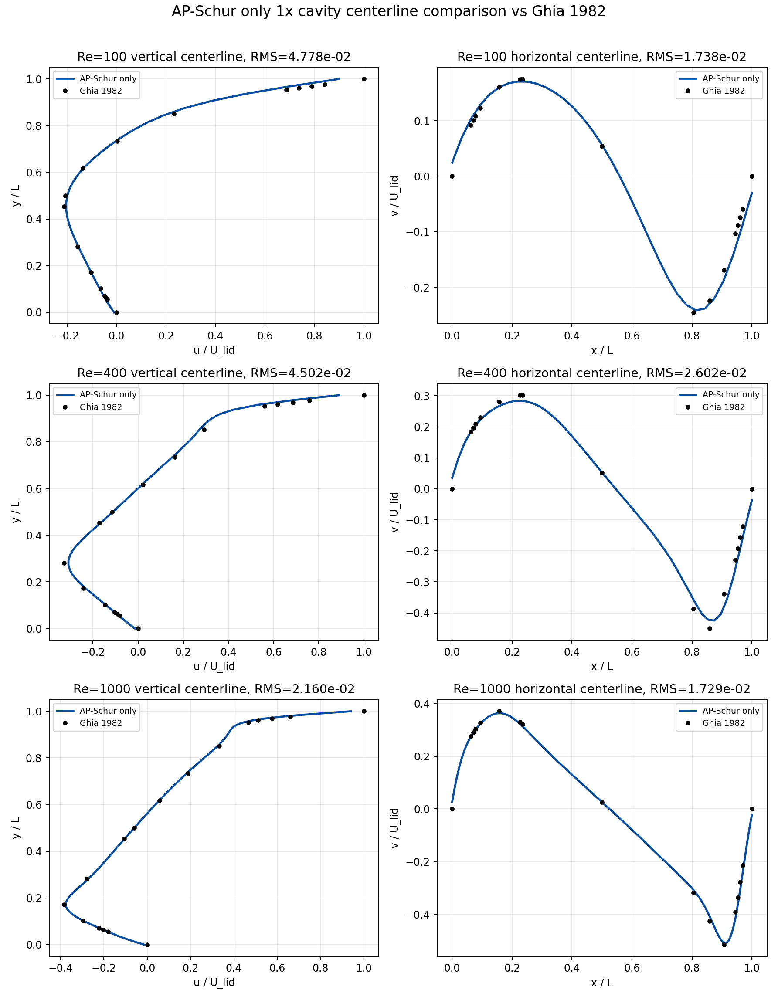
Figure A1. Convergence histories of the nine cases on the 2x grid (all methods).
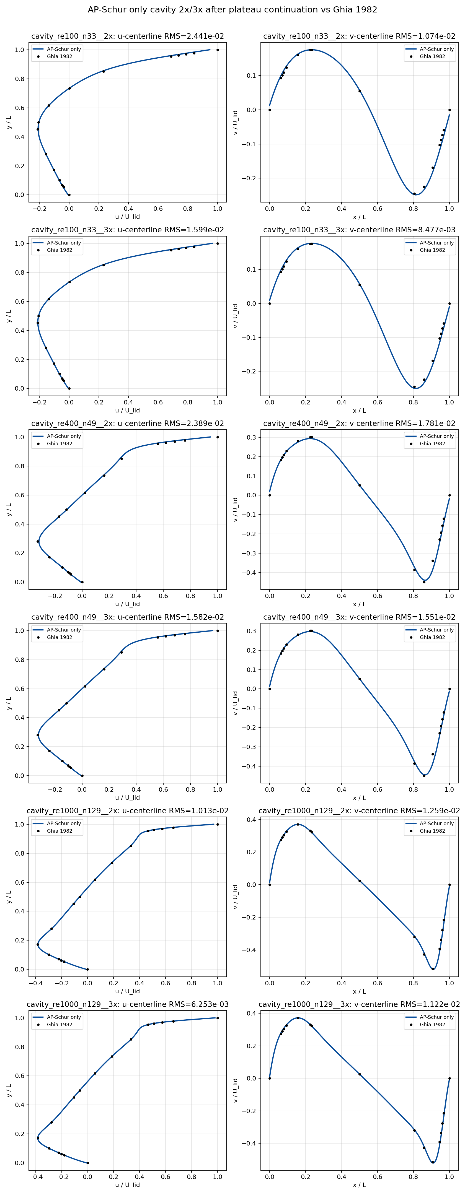
Figure A2. Convergence histories of the nine cases on the 3x grid (all methods).
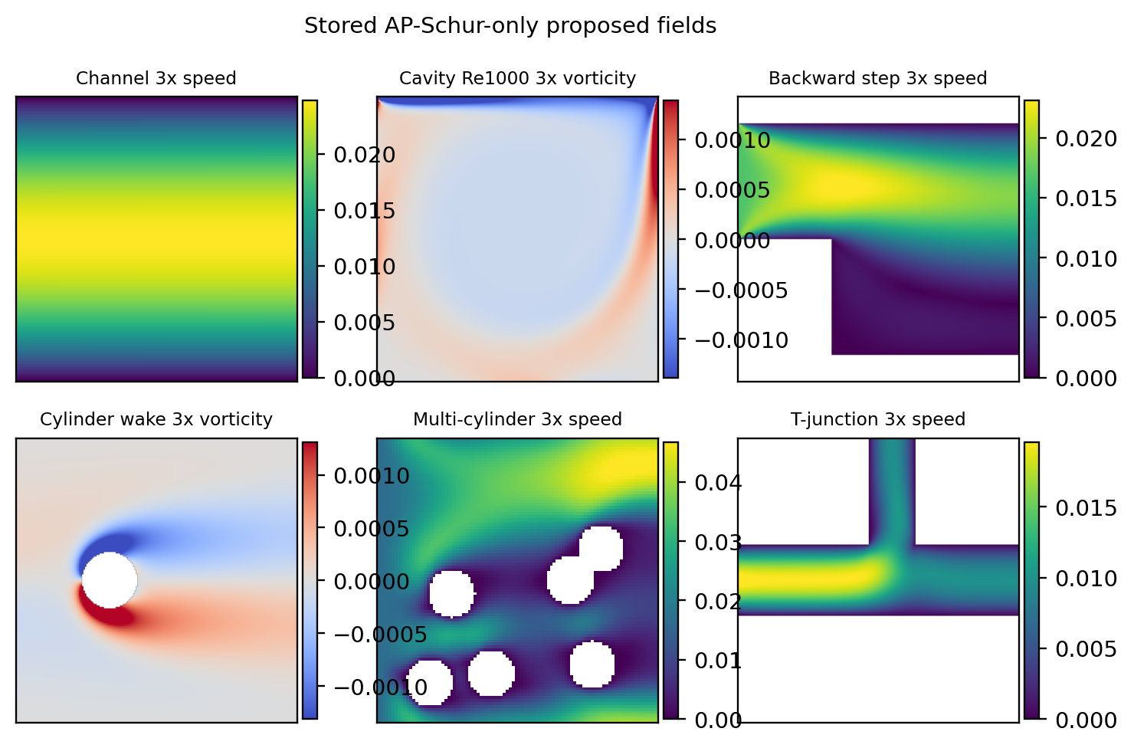
Figure A3. Wall-time variability over seven repeated runs of a representative case (CV < 7%) versus operator-work determinism (LBE-calls bit-identical).
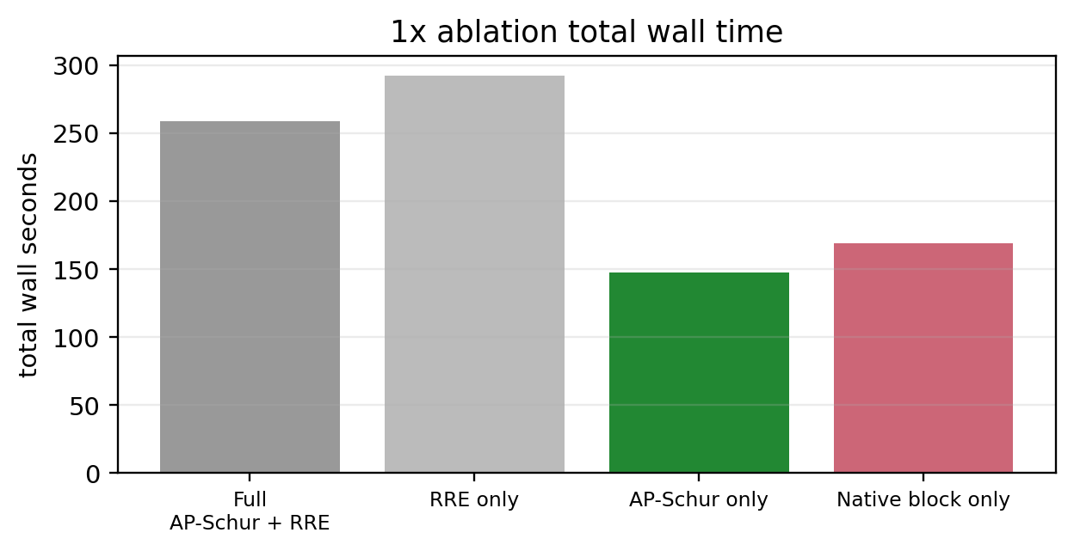
Figure A4. AP-Schur correction-acceptance rate by level (71.0% overall, with no case taking zero accepted corrections).

A.3 Cost and memory model
Let $N_{f}$ be the number of fluid nodes, $q=9$ the number of discrete velocities, and $n_{m}=3$ the number of conserved moments. The cost of one outer round is
$$C_{round}≈(n_{G}+n_{trial}) C_{G}+C_{FFT}, C_{FFT}=O(n_{m}N_{f}logN_{f}),$$
where $C_{G}$ is the cost of one native lattice step, $n_{G}$ is the number of native steps per round (burn-in/block Picard work plus the guard), and $n_{trial}$ is the number of residual evaluations spent in the finite-difference Jacobian action and the line search. The memory footprint is
$$W_{mem}≈qN_{f}+O(n_{m}N_{f})+O(N_{b}),$$
i.e. the full distribution field, the moment and spectral buffers, and the boundary bookkeeping over $N_{b}$ boundary nodes. The full Newton matrix, of size $qN_{f}×qN_{f}$, is never formed. Peak resident-set-size measurements at three grid resolutions confirm that the marginal memory $W_{mem}$ grows linearly in $N_{f}$ (empirically of order $35×$ the field size) and lies three to four orders of magnitude below a dense Jacobian. Absolute memory usage is environment-dependent, so the claim is restricted to the $O(N_{f})$ scaling and the order-of-magnitude gap.

A.4 Mass-conservation and boundary-consistency diagnostics
Residual convergence is distinct from exact mass conservation: the macroscopic $L_{2}$ residual measures the change of $p$ and $u$ over the whole fluid domain, whereas global mass drift and inlet/outlet flux closure are sensitive to the boundary and mask treatment. We therefore retain the residual and its plateau as the primary convergence indicators and report the following two quantities only as auxiliary diagnostics. The global mass and its relative drift are
Mn=Ωf​ρn dV, εMn=|Mn−M0|max(|M0|, ϵ),
and the inlet–outlet flux closure is
εQn=|out​flux+in​flux|maxin​|flux|, ϵ.
Neither quantity is used as a stopping condition; for closed cavities $ε_{Q}$ is not applicable. The reported results are obtained with no post hoc mass correction. Positivity and boundary consistency enter only through the admissibility gate.

References
[1] Qian, Y. H., d’Humières, D., & Lallemand, P. (1992). Lattice BGK models for Navier-Stokes equation. Europhysics Letters, 17(6), 479–484. https://doi.org/10.1209/0295-5075/17/6/001
[2] Chen, S., & Doolen, G. D. (1998). Lattice Boltzmann method for fluid flows. Annual Review of Fluid Mechanics, 30, 329–364. https://doi.org/10.1146/annurev.fluid.30.1.329
[3] Succi, S. (2001). The Lattice Boltzmann Equation for Fluid Dynamics and Beyond. Oxford University Press.
[4] Lallemand, P., & Luo, L.-S. (2000). Theory of the lattice Boltzmann method: Dispersion, dissipation, isotropy, Galilean invariance, and stability. Physical Review E, 61, 6546–6562. https://doi.org/10.1103/PhysRevE.61.6546
[5] Ghia, U., Ghia, K. N., & Shin, C. T. (1982). High-Re solutions for incompressible flow using the Navier-Stokes equations and a multigrid method. Journal of Computational Physics, 48(3), 387–411. https://doi.org/10.1016/0021-9991(82)90058-4
[6] Saad, Y., & Schultz, M. H. (1986). GMRES: A generalized minimal residual algorithm for solving nonsymmetric linear systems. SIAM Journal on Scientific and Statistical Computing, 7(3), 856–869. https://doi.org/10.1137/0907058
[7] Knoll, D. A., & Keyes, D. E. (2004). Jacobian-free Newton-Krylov methods: A survey of approaches and applications. Journal of Computational Physics, 193(2), 357–397. https://doi.org/10.1016/j.jcp.2003.08.010
[8] Benzi, M., Golub, G. H., & Liesen, J. (2005). Numerical solution of saddle point problems. Acta Numerica, 14, 1–137. https://doi.org/10.1017/S0962492904000212
[9] Walker, H. F., & Ni, P. (2011). Anderson acceleration for fixed-point iterations. SIAM Journal on Numerical Analysis, 49(4), 1715–1735. https://doi.org/10.1137/10078356X
[10] Tóth, A., & Kelley, C. T. (2015). Convergence analysis for Anderson acceleration. SIAM Journal on Numerical Analysis, 53(2), 805–819. https://doi.org/10.1137/130919398
[11] Olshanskii, M. A., & Vassilevski, Y. V. (2007). Pressure Schur complement preconditioners for the discrete Oseen problem. SIAM Journal on Scientific Computing, 29(6), 2686–2704. https://doi.org/10.1137/070679776
[12] Elman, H. C., Silvester, D. J., & Wathen, A. J. (2014). Finite Elements and Fast Iterative Solvers: With Applications in Incompressible Fluid Dynamics (2nd ed.). Oxford University Press.
[13] Saad, Y. (2003). Iterative Methods for Sparse Linear Systems (2nd ed.). SIAM.
[14] Trottenberg, U., Oosterlee, C. W., & Schüller, A. (2001). Multigrid. Academic Press.
[15] Sidi, A. (1986). Convergence and stability properties of minimal polynomial and reduced rank extrapolation algorithms. SIAM Journal on Numerical Analysis, 23(1), 197–209. https://doi.org/10.1137/0723014
[16] Zou, Q., & He, X. (1997). On pressure and velocity boundary conditions for the lattice Boltzmann BGK model. Physics of Fluids, 9(6), 1591–1598. https://doi.org/10.1063/1.869307
[17] Bouzidi, M., Firdaouss, M., & Lallemand, P. (2001). Momentum transfer of a Boltzmann-lattice fluid with boundaries. Physics of Fluids, 13(11), 3452–3459. https://doi.org/10.1063/1.1399290
[18] Huang, J., Yang, C., & Cai, X.-C. (2015). A fully implicit method for lattice Boltzmann equations. SIAM Journal on Scientific Computing, 37(5), S291–S313. https://doi.org/10.1137/140975346
[19] Huang, J., Yang, C., & Cai, X.-C. (2016). A nonlinearly preconditioned inexact Newton algorithm for steady state lattice Boltzmann equations. SIAM Journal on Scientific Computing, 38(3), A1701–A1724. https://doi.org/10.1137/15M1028078
[20] Guo, Z., Zhao, T. S., & Shi, Y. (2004). Preconditioned lattice-Boltzmann method for steady flows. Physical Review E, 70(6), 066706. https://doi.org/10.1103/PhysRevE.70.066706
[21] Premnath, K. N., Pattison, M. J., & Banerjee, S. (2009). Steady state convergence acceleration of the generalized lattice Boltzmann equation with forcing term through preconditioning. Journal of Computational Physics, 228(3), 746–769. https://doi.org/10.1016/j.jcp.2008.09.028
[22] Hajabdollahi, F., & Premnath, K. N. (2018). Galilean-invariant preconditioned central-moment lattice Boltzmann method without cubic velocity errors for efficient steady flow simulations. Physical Review E, 97(5), 053303. https://doi.org/10.1103/PhysRevE.97.053303
[23] Hajabdollahi, F., & Premnath, K. N. (2019). Improving the low Mach number steady state convergence of the cascaded lattice Boltzmann method by preconditioning. Computers & Mathematics with Applications, 78(4), 1115–1130.
[24] Walsh, B., & Boyle, F. J. (2020). A preconditioned lattice Boltzmann flux solver for steady flows on unstructured hexahedral grids. Computers & Fluids, 210, 104634. https://doi.org/10.1016/j.compfluid.2020.104634
[25] Yahia, E., & Premnath, K. N. (2022). Preconditioned central moment lattice Boltzmann method on a rectangular lattice grid for accelerated computations of inhomogeneous flows. Journal of Computational Science, 63.

