3. Results
Section 3.1 summarizes the benchmark suite and evaluation protocol; Section 3.2 reports the convergence behaviour, covering both the convergence histories and the convergence-rate analysis and robustness; Section 3.3 quantifies the performance of the proposed method relative to the baseline methods through wall-time and operator-work comparisons; Section 3.4 verifies solution accuracy against the available references.

3.1 Benchmark suite and evaluation protocol
The method is evaluated on nine flow configurations spanning canonical shear flows, separated and reattaching flows, and complex geometries described by a mask, an indicator field marking each lattice node as fluid or solid, together with branching geometries, each with a closed-form or high-fidelity reference solution: plane Poiseuille and Couette flow with analytic references, the lid-driven cavity at $Re=100/400/1000$ against the Ghia centerline benchmark [5], the backward-facing step and cylinder wake, whose physical role is to exhibit separation, reattachment, and wake formation, the multi-cylinder configuration with its complex mask boundary, and the T-junction, a branching geometry with coupled inlet/outlet boundaries. For the backward-facing step and cylinder wake, the accuracy assessment is limited to the relative $L_{2}$ difference of the converged field against a high-fidelity numerical reference and to qualitative reproduction of the expected flow structures; no separation, reattachment, or wake metric is measured. Each test case is solved at three mesh levels, denoted 1x/2x/3x, yielding 27 runs in total; Table 1 lists the grid sizes, boundary conditions, validation role, and reference tier. For cases lacking a closed-form or literature solution, the comparison uses a high-fidelity numerical reference, hereafter the reference solution, obtained by running the native iteration to a residual far below the stopping tolerance used for the comparisons on the same discretization; it is labeled as the tight reference in Table 1. Where no independent literature or analytic reference exists, as for the T-junction, a strictly converged native LBE fixed-point solution on the same grid serves the same purpose and is labeled as the native LBE reference.
Table 1. Benchmark case definitions: grid size, boundary conditions, validation role, and reference tier.
Family | Grid (1x / 2x / 3x) | Boundary conditions | Validation role | Reference
Channel (plane Poiseuille) | 32×192 / 64×384 / 96×576 | Inlet/outlet + wall | Pressure-driven shear (baseline) | Analytic
Couette | 32² / 64² / 96² | Moving wall + wall | Shear flow (baseline) | Analytic
Cavity $Re=100$ | 33² / 65² / 97² | Lid-driven, closed | Recirculating closed domain | Ghia [5]
Cavity $Re=400$ | 49² / 97² / 145² | Lid-driven, closed | Recirculating closed domain | Ghia [5]
Cavity $Re=1000$ | 129² / 257² / 385² | Lid-driven, closed | Recirculating closed domain | Ghia [5]
Backward-facing step | 64² / 128² / 192² | Inlet/outlet + step mask | Separation/reattachment | Tight reference
Cylinder wake | 64² / 128² / 192² | Inlet/outlet + obstacle mask | Wake formation | Tight reference
Multi-cylinder | 32² / 64² / 96² | Multiple obstacle masks | Complex mask boundary | Tight reference
T-junction | 96×64 / 192×128 / 288×192 | Branching inlet/outlet | Branching geometry + open-BC coupling | native LBE reference
Reference tier: the tight reference and the native LBE reference are the reference solutions defined in the running text of Section 3.1.
Convergence is judged on the macroscopic $L_{2}$ change of the pressure and velocity fields, not the microscopic $f$-RMS, the root-mean-square change of the particle distribution function $f$. The pressure increment is made gauge-invariant by removing its fluid-domain mean, since the absolute pressure level is arbitrary in a weakly compressible closed or periodic flow, and is combined with the velocity increment into a residual $r_{macro}$ over fluid nodes only. Convergence requires three conditions simultaneously: an absolute residual $r_{macro}≤5τ$; a plateau condition, namely a fractional improvement over the last $W=50$ checks of at most $η=0.05$; and physical admissibility, comprising density positivity, finite fields, and boundary/mask consistency. The base tolerance is $τ={10}^{−7}$ for the non-cavity cases and ${10}^{−8}$ for the cavity cases at 1x, multiplied by $1/2$ at 2x and by $1/3$ of the 1x value at 3x. All constants and the admissibility rule apply identically to every method, with no per-case tuning.
The proposed method, the moment-Schur accelerated LBM (MSA-LBM), is compared against five baselines that share the native LBM operator of the same code base, as listed in Table 2: the native LBE collide–stream–boundary fixed-point iteration; Anderson acceleration, a regularized least-squares fixed-point accelerator; preconditioned LBM, the standard balanced PLBE (preconditioned lattice Boltzmann equation) transform with a block preconditioner; inexact Newton–Krylov, a JFNK method using GMRES (generalized minimal residual, a Krylov-subspace linear solver) with two smoothing stages and a line search; and dual-time multigrid, an FAS V-cycle scheme, with the remaining abbreviations expanded in Table 2. Each baseline uses literature-standard hyperparameters and a generous iteration budget of about $6×{10}^{5}$ to $1.2×{10}^{6}$ LBE-calls, that is, evaluations of the native collide–stream–boundary operator, for cavity 2x/3x, so the comparison does not disadvantage any baseline. The only difference from the proposed method is the update rule, all calling the same native operator, so any wall-time difference reflects algorithmic structure.
Table 2. Baseline implementations and main settings.
Baseline method | Implementation summary | Main settings
native LBE | Native collide–stream–boundary fixed-point iteration | max_steps $≤1.2×{10}^{6}$, residual-monotone termination
Anderson acceleration [9,10] | Regularized least-squares fixed-point acceleration, admissibility safeguard | depth $m=10$, $β=1.0$, reg $={10}^{−12}$
Preconditioned LBM [20,21] | Balanced PLBE transform ($γ$-scaled) + block preconditioner $= 0. | 5$, max_steps $≤1.2×{10}^{6}$
Inexact Newton–Krylov [6,7] | JFNK (Jacobian-free Newton–Krylov): GMRES + NE (nonlinear-equation) smoother | (K_ne) + relaxation smoother (K_smooth) + line search krylov_max=10, K_ne=20, K_smooth=10, line_search=4
Dual-time multigrid [14] | FAS (full approximation scheme) V-cycle, residual-equation smoothing | max_levels=6, V-cycle, K_pre/coarse/post=20/30/20
Because the methods stop at different accuracies, all are compared by the cost required to first reach a common target residual $ε$, a time-to-threshold measure defined as the cost to first attain $r_{macro}≤ε$, read both as wall time and as the LBE-call count. The latter is a hardware-independent, deterministic operator-work metric giving the number of native collide–stream–boundary operator evaluations, denoted $G$ and defined formally in Section 3.3.2. Reference solutions, whether analytic, Ghia, or tight numerical, are never used inside the solve, entering only the post-solve accuracy evaluation through the relative $L_{2}$ error. The proposed method solves all 27 problems with a single deterministic routine, only the problem definition of grid, $Re$, boundary, and mask changing per case.

3.2 Convergence behaviour

3.2.1 Convergence histories
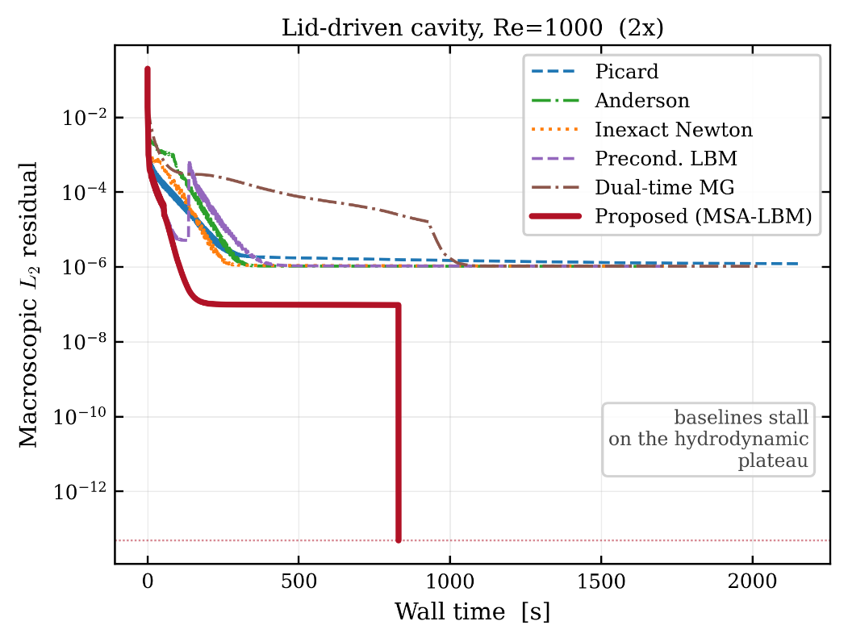
Figure 2. Macroscopic $L_{2}$ residual versus wall time for a representative case (cavity $Re=1000$, 2x), for all six methods. The baseline methods stall at a hydrodynamic plateau, whereas only the proposed method descends below the stopping tolerance.
Figure 2 plots the six methods’ residuals against wall time for a representative high-Reynolds cavity case on a logarithmic residual axis. The baselines descend rapidly but stall at a plateau near ${10}^{−6}$, whereas the proposed method, shown in bold red, penetrates it and decreases monotonically below the stopping tolerance.
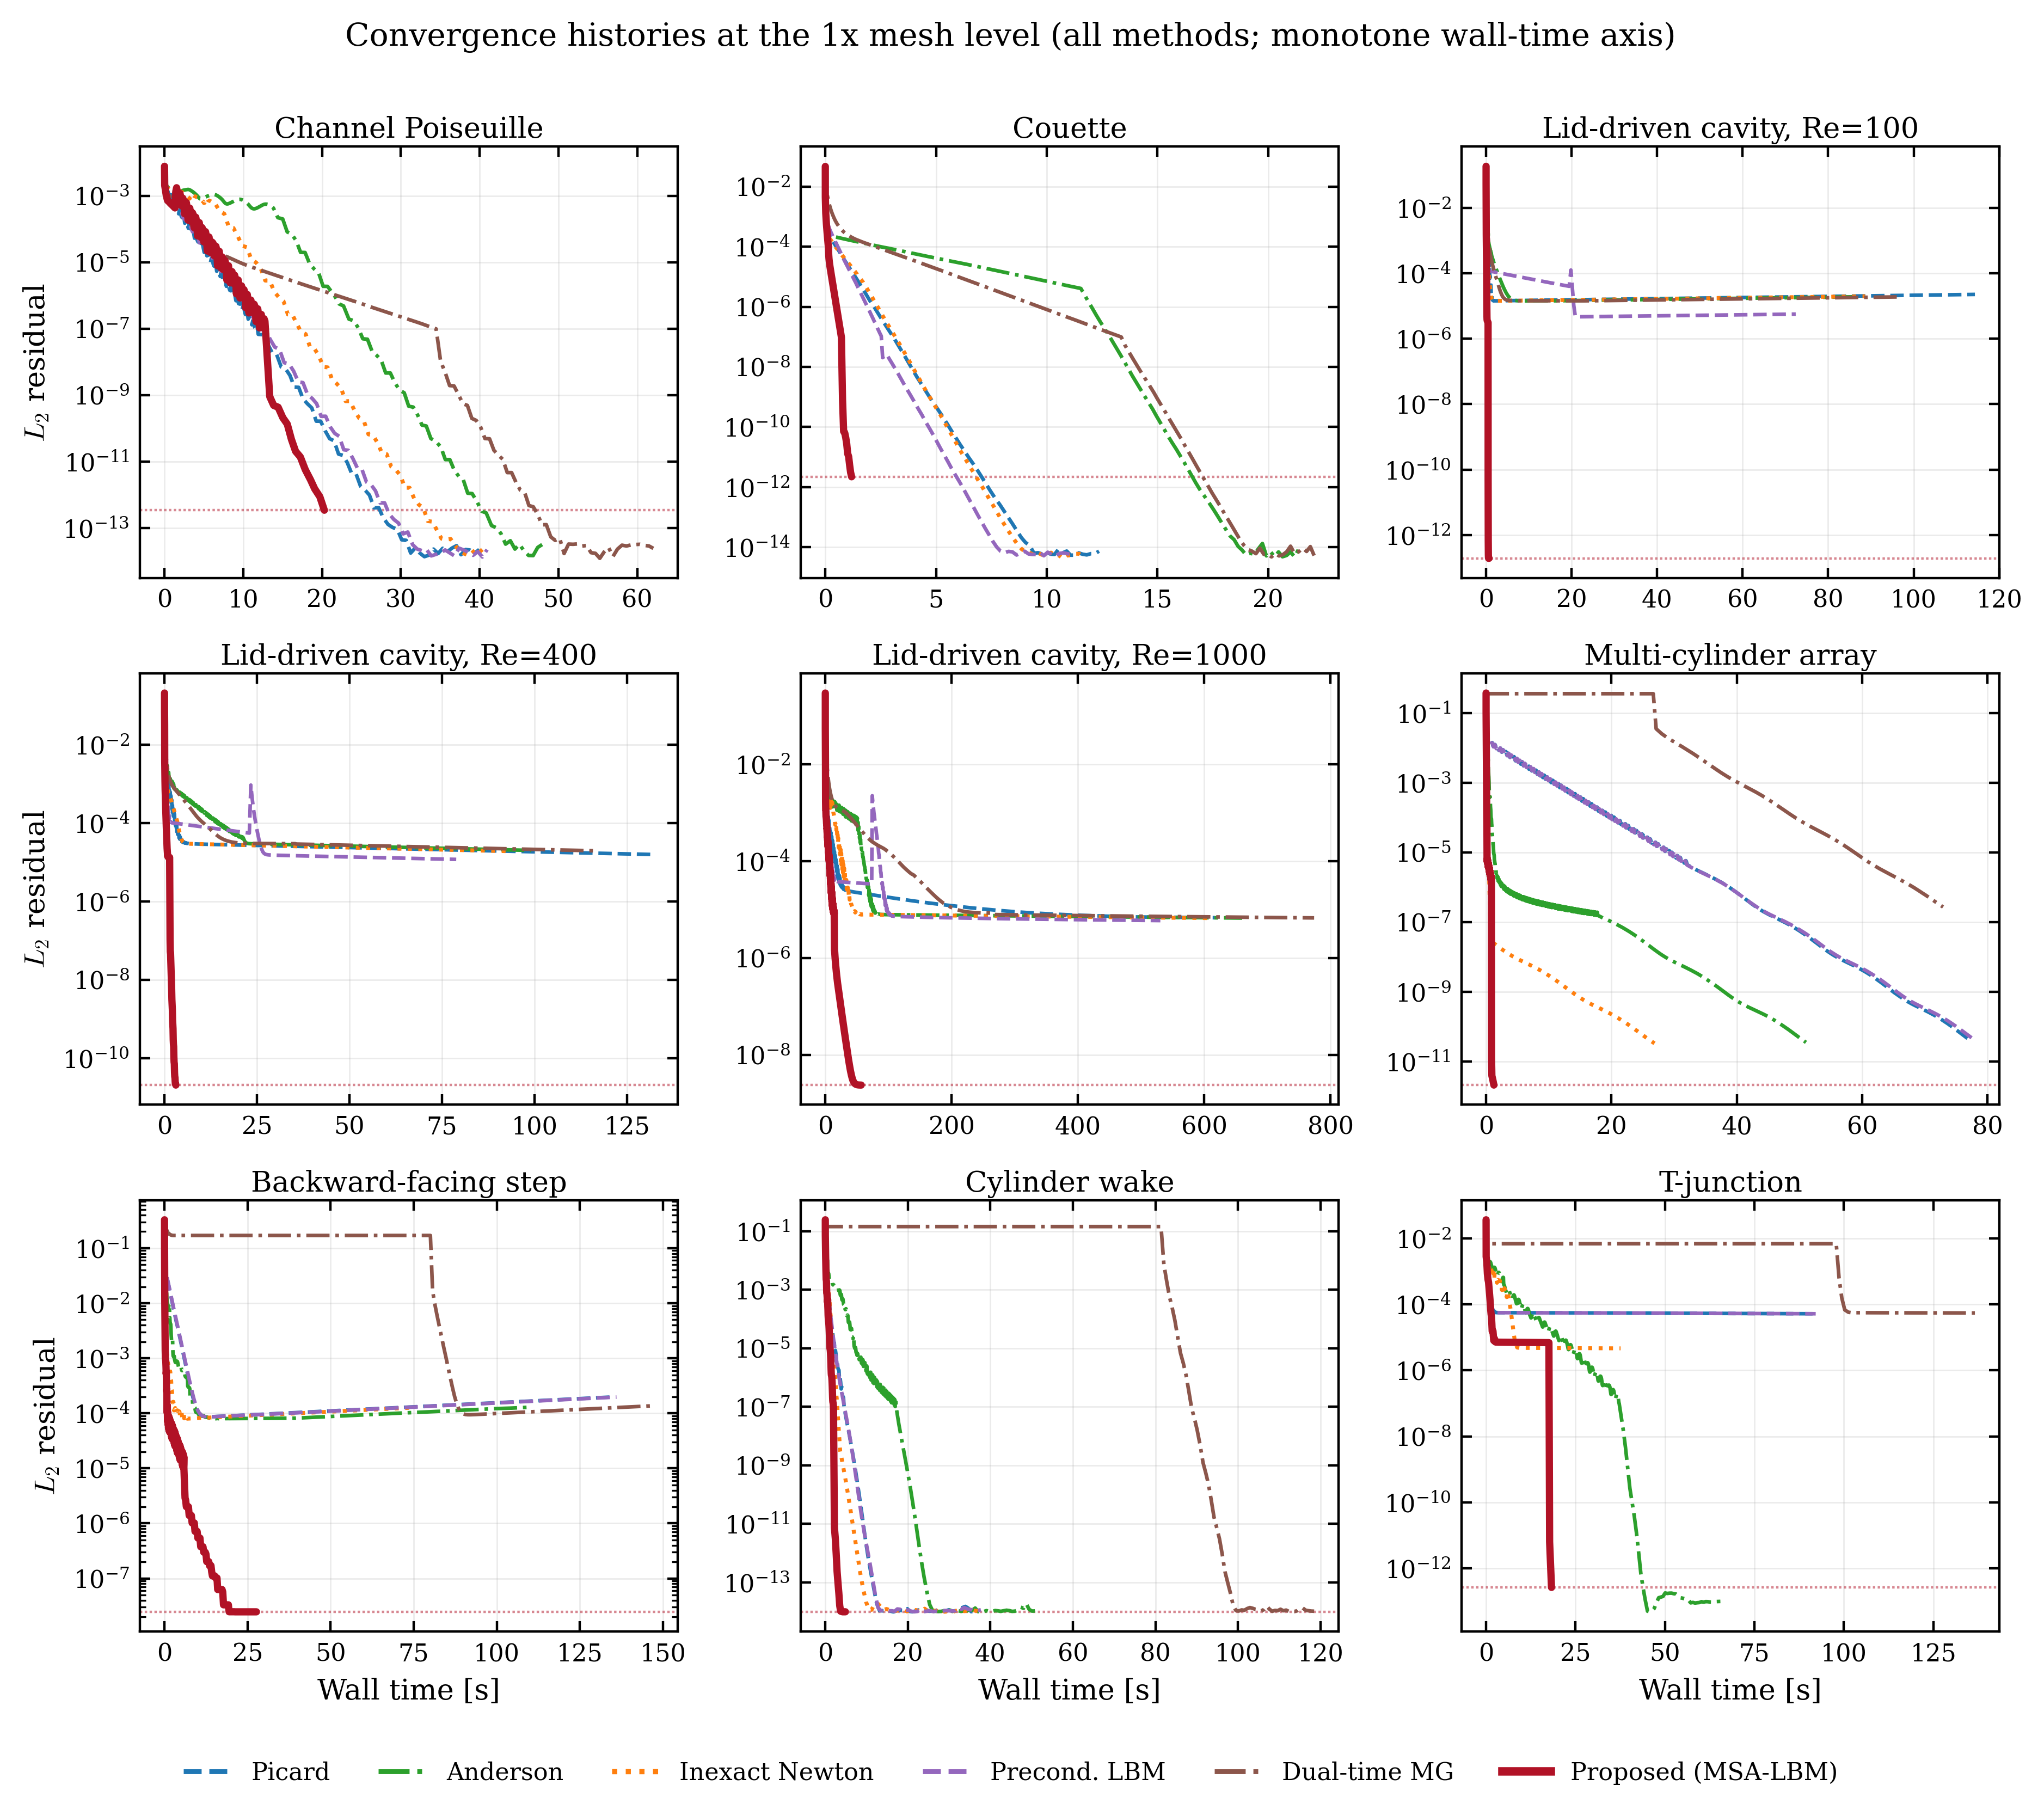
Figure 3. Convergence histories of all nine 1x-grid cases (all methods, monotone wall-time axis).
Figure 3 extends the comparison to all nine 1x cases on identical axes and color conventions, showing that the behavior is not specific to a curated subset: in every panel the proposed method, again in bold red, reaches the lowest residual first. The 2x and 3x histories are in the appendix, in Figures A1 and A2.
Table 3. Per-level convergence summary for the proposed method.
Level | Cases | Converged | Total wall [s] | Median residual | Max residual | Median rel. error
1x | 9 | 9 | 134.2 | 2.142e-12 | 2.474e-08 | 3.260e-03
2x | 9 | 9 | 1546.6 | 3.305e-12 | 6.409e-08 | 3.260e-02
3x | 9 | 9 | 3507.2 | 1.153e-11 | 1.567e-08 | 2.570e-02
Table 3 aggregates the proposed-method results by level; the method satisfies the three simultaneous convergence conditions of Section 3.1 on all 27 runs. The column reporting the median relative error is not comparable across levels, because the set of cases with a comparable reference differs by level, as some complex geometries lack a tight reference at 2x/3x.

3.2.2 Convergence rate and robustness
The behavior of Section 3.2.1 follows from the linearized structure of Section 2. The asymptotic convergence rate of the native LBE iteration is set by the spectral radius of the linearized operator, which separates into kinetic and hydrodynamic modes. The kinetic modes, associated with the block $J_{kk}$ of the Jacobian of the linearized collide-stream operator introduced in Section 2, are damped strongly and locally, whereas the hydrodynamic modes tied to the conserved moments are governed by the Schur complement $S_{m}=J_{mm}−J_{mk}J_{kk}^{−1}J_{km}$ formed from the remaining three blocks of that same Jacobian, where subscript $m$ denotes the conserved-moment (macroscopic) degrees of freedom and $k$ the remaining kinetic degrees of freedom. The damping rate of the largest eigenvalue of $S_{m}$ approaches unity, so after enough iterations the residual is determined by this single slow mode, forming the plateau in Figures 2 and 3. The proposed method removes this dominant slow mode by applying an analytic approximation of $S_{m}^{−1}$ restricted to the conserved-moment subspace, so the residual continues to decrease where the native iteration stalls, consistent with the acceleration targeting the component that constrains late convergence.
This difference is quantified by the robustness gap, the difference in the fraction of cases each method drives to the full convergence criterion. Under the same stopping criterion, admissibility definition, and iteration budget, the proposed method satisfies the convergence criterion of $r_{macro}≤5τ$ with the plateau and admissibility conditions on all 27 cases, whereas the five baselines converge on only a subset: inexact Newton–Krylov on 15, preconditioned LBM on 14, native LBE and Anderson on 13 each, and dual-time multigrid on 12.
The non-convergence arises from numerical stagnation, not budget exhaustion, as the stored histories indicate. This is clearest for the lid-driven cavity, where the baselines stall at a common residual floor regardless of method: across all nine cavity configurations at $Re=100/400/1000$ and three levels they stop decreasing in the range ${10}^{−7}\text{–}{10}^{−5}$, with final residuals clustered narrowly within each configuration, at $1.0\text{–}1.2×{10}^{−6}$ for $Re=1000$ 2x and $1.1\text{–}1.2×{10}^{−6}$ for $Re=400$ 3x, indicating a structural barrier rather than a method-specific limit. For cavity $Re=400$ 2x the floor is $3.4\text{–}3.6×{10}^{−6}$, two orders above the target $5τ=2.5×{10}^{−8}$, reached at $6\text{–}7×{10}^{5}$ LBE-calls, well short of the $1.2×{10}^{6}$-call budget of Table 2; for cavity $Re=1000$ 2x the floor of $1.0\text{–}1.2×{10}^{−6}$ is about $1.6\text{–}1.7$ orders of magnitude above the same target and is reached well before the level’s $1.2×{10}^{6}$-call budget is exhausted. The curves enter their asymptotic plateau before the budget is reached, indicating that the plateau, not the budget, is the limiting factor; the resulting robustness gap is reported here in its own right.

3.3 Performance comparison with the baseline methods

3.3.1 Wall-time comparison
The wall time to first reach the common threshold $ε={10}^{−4}$, that is $r_{macro}≤ε$, is compared across all six methods; because this threshold is attained by every method on all 27 cases, the comparison is the most conservative. Three comparators are applied to this same 27-case, same-threshold data, each answering a different question, so their medians are not expected to agree.
The first comparator holds the baseline fixed: against each baseline method individually, over all 27 cases, the median time-to-threshold ratio of the proposed method is $1.64×$ relative to preconditioned LBM, $2.42×$ to native LBE, $2.84×$ to inexact Newton–Krylov, $7.34×$ to Anderson, and $18.65×$ to dual-time multigrid; the fraction of cases on which it is faster ranges from 19/27 for preconditioned LBM to 27/27 for Anderson.
The second comparator lets the baseline vary case by case: against only the single fastest baseline on each case, the median ratio is $1.09×$. This is the most stringent comparator, since the reference is always whichever competitor is quickest for the given case, and its near-parity value shows the advantage is concentrated on particular problem types rather than uniform across all 27 cases.
The third comparator pools every individual baseline run rather than reducing each case to a single reference value: over all 27 cases and all five baselines, giving 135 case-baseline ratios in total, the pooled distribution favors the proposed method, with the median reported in Table 4. Summarized instead at the case level, the proposed method’s time-to-threshold is below the mean of its five baselines on the large majority of the 27 cases, as also reported in Table 4; this case-level win rate counts cases rather than ratios, so it is a coarser criterion than the per-baseline fractions of the first comparator and than the pooled-ratio median. Because most baselines are markedly slower than the fastest one on a given case, pooling all of them yields a larger median ratio than the fastest-baseline-only comparator.
A fourth, smaller-population comparison restricts to the strict subset of 15 cases in which at least one baseline also satisfies the full convergence criterion of Section 3.2.2, not merely the $ε={10}^{−4}$ threshold; this excludes the 12 cases in which no baseline converges under that stricter criterion, so its ratio is not directly comparable to the 27-case comparisons. The strict-subset and all-baseline comparisons summarized in Table 4 both show the proposed method faster on the large majority of cases, under both the wall-time and operator-work metrics, the latter being the native operator-evaluation count introduced in Section 3.1.
Table 4. Strict-subset and all-baseline timing comparison (time-to-threshold, $ε={10}^{−4}$).
Comparison set | Metric | Win rate | Median ratio
Strict subset (15 cases, baseline also converges) | Wall time | 14/15 | 2.06×
Strict subset (15 cases, baseline also converges) | Operator work (LBE-calls) | 13/15 | 1.80×
All baselines (27 cases) | Wall time | 25/27 | 2.92×
For cavity $Re=1000$ at 2x/3x and the T-junction at all three levels, the convergence history displays a characteristic three-stage shape that illustrates the underlying mechanism of the acceleration. First, in the initial transient, native relaxation removes the high-wavenumber kinetic modes and the residual drops sharply. Second, in the ensuing plateau the residual is dominated by the global slow mode; under the inexact truncated-GMRES correction and the admissibility-based step-acceptance gate, a line-search-like check that damps the step to $α<1$ when the full correction would violate admissibility, steps are accepted every iteration but the residual barely decreases, so that in cavity $Re=1000$ 2x it lingers near $∼{10}^{−7}$ for about 1100 steps and 740 s, and most of the wall time is spent on correction trials of little benefit. Third, once the iterate enters Newton’s quadratic-convergence region, the finite-difference Jacobian–vector approximation becomes accurate, the full step $α=1$ passes the gate, and a single correction produces a sharp residual drop, consistent with quadratic convergence rather than a fixed per-step reduction factor. Two cases illustrate this terminal collapse: in the T-junction 2x the single terminal correction step drops the residual from $2.6×{10}^{−5}$ to $8.1×{10}^{−12}$, about 6.5 orders of magnitude, after which a few further steps refine it toward its converged value, and in cavity $Re=1000$ 2x from $9.6×{10}^{−8}$ to $4.9×{10}^{−14}$, about 6.3 orders of magnitude, this being the case’s final converged residual. Both single-step drops are far larger than the roughly one order of magnitude per step characteristic of the baselines’ linear convergence, and both are broadly consistent with, though not numerically identical to, the residual squaring expected under exact quadratic convergence. The linearly convergent baselines cannot produce such a collapse, so the curve shape is itself evidence that the MSA-LBM correction acts as a Newton step in the conserved-moment subspace.
The cavity flows show the largest differences between methods, reflecting a structural gap in attainable residual. Where the baselines stall at the common floor of ${10}^{−7}\text{–}{10}^{−5}$ of Section 3.2.2, the proposed method breaks through it on every configuration to the ${10}^{−8}\text{–}{10}^{−13}$ level, with final residuals from $1.6×{10}^{−8}$ to $1.9×{10}^{−13}$, two to eight orders deeper on a per-case matched basis of each configuration’s own floor against its own final residual rather than the global extremes of the two ranges, with full per-case values in Appendix Table A1, and with shorter wall time: at $Re=1000$ 1x it reaches $2.4×{10}^{−9}$ in 57 s while the baselines spend 531–774 s stalled at the floor, and at $Re=100$ 1x it reaches $1.9×{10}^{−13}$ in 0.7 s versus 72–114 s of baseline stagnation. The penetration recurs across all Reynolds numbers and levels because the cavity is a closed, recirculation-dominated flow governed by the global slow mode native relaxation cannot damp efficiently. The advantage persists even at the deepest common threshold all baselines reach, ${10}^{−5}$: at $Re=1000$ 2x it reaches ${10}^{−5}$ in 70.8 s, against 178.7 s for native LBE at $2.5×$, 218.8 s for Anderson at $3.1×$, and 940.3 s for dual-time multigrid at $13.3×$.
Consistent with the mechanism, the net gain scales with how strongly the global slow mode governs convergence; where it is weak the per-iteration correction cost of restriction to the conserved-moment subspace, inner GMRES, and admissibility gate is not amortized, as two cases illustrate. In Couette flow the linear distribution is exact in the LBM equilibrium, so the slow mode is essentially absent: at 1x the proposed method beats all baselines by $3.3\text{–}31×$ at ${10}^{−5}$, but on refinement native relaxation alone suffices while the correction cost grows, reversing the order—at 2x it takes 1.8 s to reach ${10}^{−4}$, about $3.6×$ slower than native LBE at 0.5 s, and at ${10}^{−5}$ is comparable to native LBE at $0.90×$ and preconditioned LBM at $0.96×$. In the T-junction, strong inlet/outlet driving makes boundary-local modes dominant: at 2x it takes 95.4 s to reach ${10}^{−5}$, about $5×$ slower than native LBE at 18.3 s and preconditioned LBM at 17.8 s, yet still reaches a final converged residual of $1.3×{10}^{−12}$, deeper than any baseline, and at 3x recovers its advantage at ${10}^{−5}$ over native LBE at $1.30×$ and preconditioned LBM at $1.38×$. The advantage is thus maximized on slow-mode-dominated flows such as high-Reynolds closed recirculation and can be small or negative in simple shear or boundary-driven flows; even there it reaches the ${10}^{−12}$ final residual level for the T-junction 2x, a precision none of the five baselines attain on these cases within the plateau of Section 3.2.2. Full per-case arrival times are in Appendix Table A1.

3.3.2 Operator-work (LBE-call) comparison
Because wall time depends on processor performance, memory bandwidth, and implementation language, it is complemented here by the operator-work metric introduced in Section 3.1, which is environment-independent and fully deterministic. The most expensive LBM primitive is one lattice update, a single evaluation of $G$ bundling collision, advection, and boundary handling, shared by all six methods, so the total number of $G$ evaluations to reach steady state, the LBE-call count, measures the intrinsic algorithmic work. At the common threshold $ε={10}^{−4}$ the proposed method’s median operator work is smaller by a factor of $1.17$ relative to inexact Newton–Krylov, $1.32$ relative to preconditioned LBM, $1.33$ relative to native LBE, $2.60$ relative to Anderson, and $3.85$ relative to dual-time multigrid. Against the single fewest-operation baseline, the proposed method’s operator work is instead slightly larger, at $1/0.87≈1.15×$ that of the fewest-operation baseline: each outer iteration spends several $G$ evaluations on finite-difference Jacobian–vector products and inner GMRES, against one per baseline relaxation step, so fewer iterations at higher per-iteration cost balance out to near parity at a loose threshold. Because one metric is environment-dependent and the other fully deterministic, their matching structure of parity at a loose threshold and widening advantage on harder problems and deeper thresholds is consistent with the advantage being intrinsic rather than a measurement artifact.
The operator-work advantage is most pronounced on the hard, slow-mode-dominated problems, where the baselines cannot remove the slow mode and keep evaluating $G$ while stalled at the floor, whereas the proposed method descends below it in the conserved-moment subspace with fewer operations. On the finest-grid high-Reynolds cavity at $Re=1000$, for example, it spends only 24,521 $G$ evaluations to reach ${10}^{−4}$, against 45,592–125,985 for the five baselines, smaller by a factor of $1.9$–$5.1$ for the same accuracy.

3.4 Solution accuracy
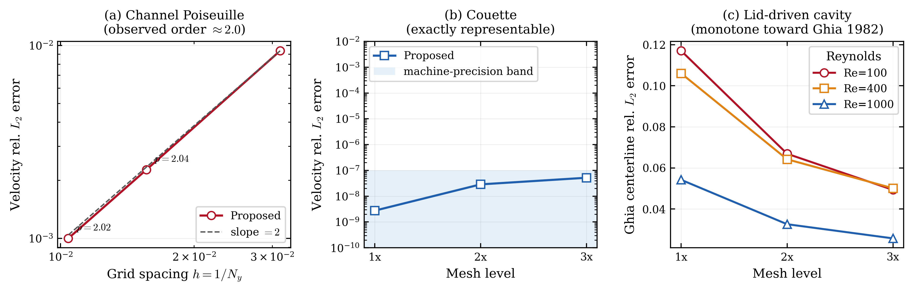
Figure 4. Grid-refinement accuracy. (a) Second-order convergence for Poiseuille flow, (b) near-zero error (at the level of the solver’s stopping tolerance) for Couette flow, (c) monotone decrease of the cavity Ghia error.
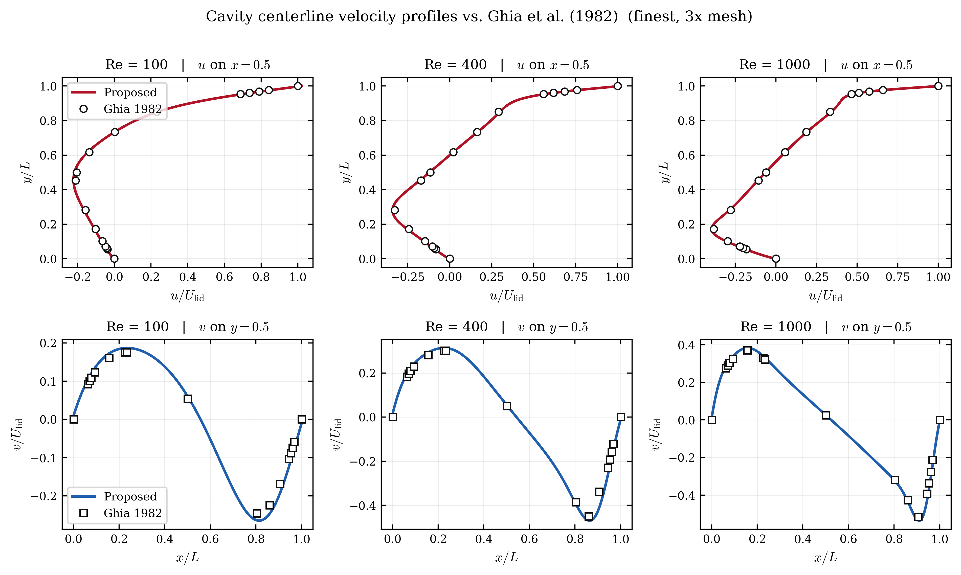
Figure 5. Cavity centerline $u(y)$ and $v(x)$ profiles on the 3x grid compared against Ghia (1982) for $Re=100/400/1000$.
Whether the acceleration achieves its speed advantage at the cost of accuracy is central to the validity of the method. Since it leaves the native residual unchanged, it should converge to the same discrete steady state as the native iteration; this section checks that expectation against closed-form solutions, literature benchmarks, and high-fidelity numerical references.
For plane Poiseuille flow, which admits a smooth analytic solution, the relative $L_{2}$ error of the velocity profile is $9.37×{10}^{−3}$, $2.27×{10}^{−3}$, and $1.00×{10}^{−3}$ at $N_{y}=32,64,96$, giving observed convergence orders of 2.04 and 2.02, matching the theoretical second-order accuracy of BGK-LBM, the Bhatnagar–Gross–Krook lattice Boltzmann method, for smooth flows, as shown in Figure 4a; the acceleration thus preserves the discretization order. Linear Couette flow is represented exactly by the LBM equilibrium, so its error should be essentially zero; the measured relative $L_{2}$ error lies between $2.75×{10}^{−9}$ and $5.19×{10}^{−8}$, near the level of the solver’s own convergence tolerance rather than reflecting a discretization error, as seen in Figure 4b, consistent with the correction injecting no unphysical bias. The error against the Ghia cavity centerline velocities decreases monotonically with refinement at all three Reynolds numbers, shown in Figure 4c; since it combines the Navier–Stokes reference table, boundary discretization, weak-compressibility effects, and table interpolation rather than a pure discretization error, no formal order is claimed, but the monotone approach shows consistent convergence toward the literature solution. Overlaying the 3x cavity centerline profiles on Ghia (1982) is consistent with this trend: at all three Reynolds numbers the vertical and horizontal profiles lie close to the Ghia markers, as seen in Figure 5.
Table 5. Accuracy summary for cases with an analytic or reference profile (1x).
Case | Wall [s] | Final residual | Rel. $L_{2}$ vs ref | Reference
Plane Poiseuille (N_y=32) | 20.30 | 3.384e-13 | 9.371e-03 | analytic
Couette (N=32) | 1.20 | 2.180e-12 | 2.750e-09 | analytic
Cavity Re=100 (N=33) | 0.70 | 1.935e-13 | 0.117 | Ghia
Cavity Re=400 (N=49) | 3.06 | 2.045e-11 | 0.106 | Ghia
Cavity Re=1000 (N=129) | 56.84 | 2.360e-09 | 0.0542 | Ghia
Multi-cylinder (N=32) | 1.25 | 2.142e-12 | 4.146e-05 | Tight reference
Backward step (N=64) | 27.66 | 2.474e-08 | 3.260e-03 | Tight reference
Cylinder wake (N=64) | 4.88 | 9.882e-15 | 7.935e-05 | Tight reference
T-junction (N_x=96) | 18.29 | 2.633e-13 | 1.896e-05 | native LBE reference
For complex geometries without an analytic or literature solution, the proposed-method field is compared against high-fidelity numerical references, as summarized in Table 5. The T-junction is especially direct: its reference is a strictly converged native-iteration field, and the relative $L_{2}$ difference from the proposed-method field is only $1.9×{10}^{−5}$, so the acceleration reaches the same discrete steady state faster rather than detouring to a different solution. Of the remaining complex-geometry cases, multi-cylinder and cylinder wake likewise show relative $L_{2}$ errors at the ${10}^{−5}$ level, at $4.146×{10}^{−5}$ and $7.935×{10}^{−5}$ in Table 5, whereas the backward-facing step shows a larger difference from its tight reference solution of $3.260×{10}^{−3}$, about two orders of magnitude higher, likely reflecting the sharp corner singularity at the step edge together with the finite resolution of the tight reference solution itself in that region. For the backward-facing step and cylinder wake, this relative-$L_{2}$ field agreement and the qualitative field reproduction discussed below are the only accuracy measures applied; a quantitative validation of separation-point, reattachment-length, or wake metrics is not performed here. Accuracy relative to the corresponding reference is therefore case-dependent rather than uniformly at the ${10}^{−5}$ level, and is best read case by case from Table 5 rather than as a single geometry-independent figure.
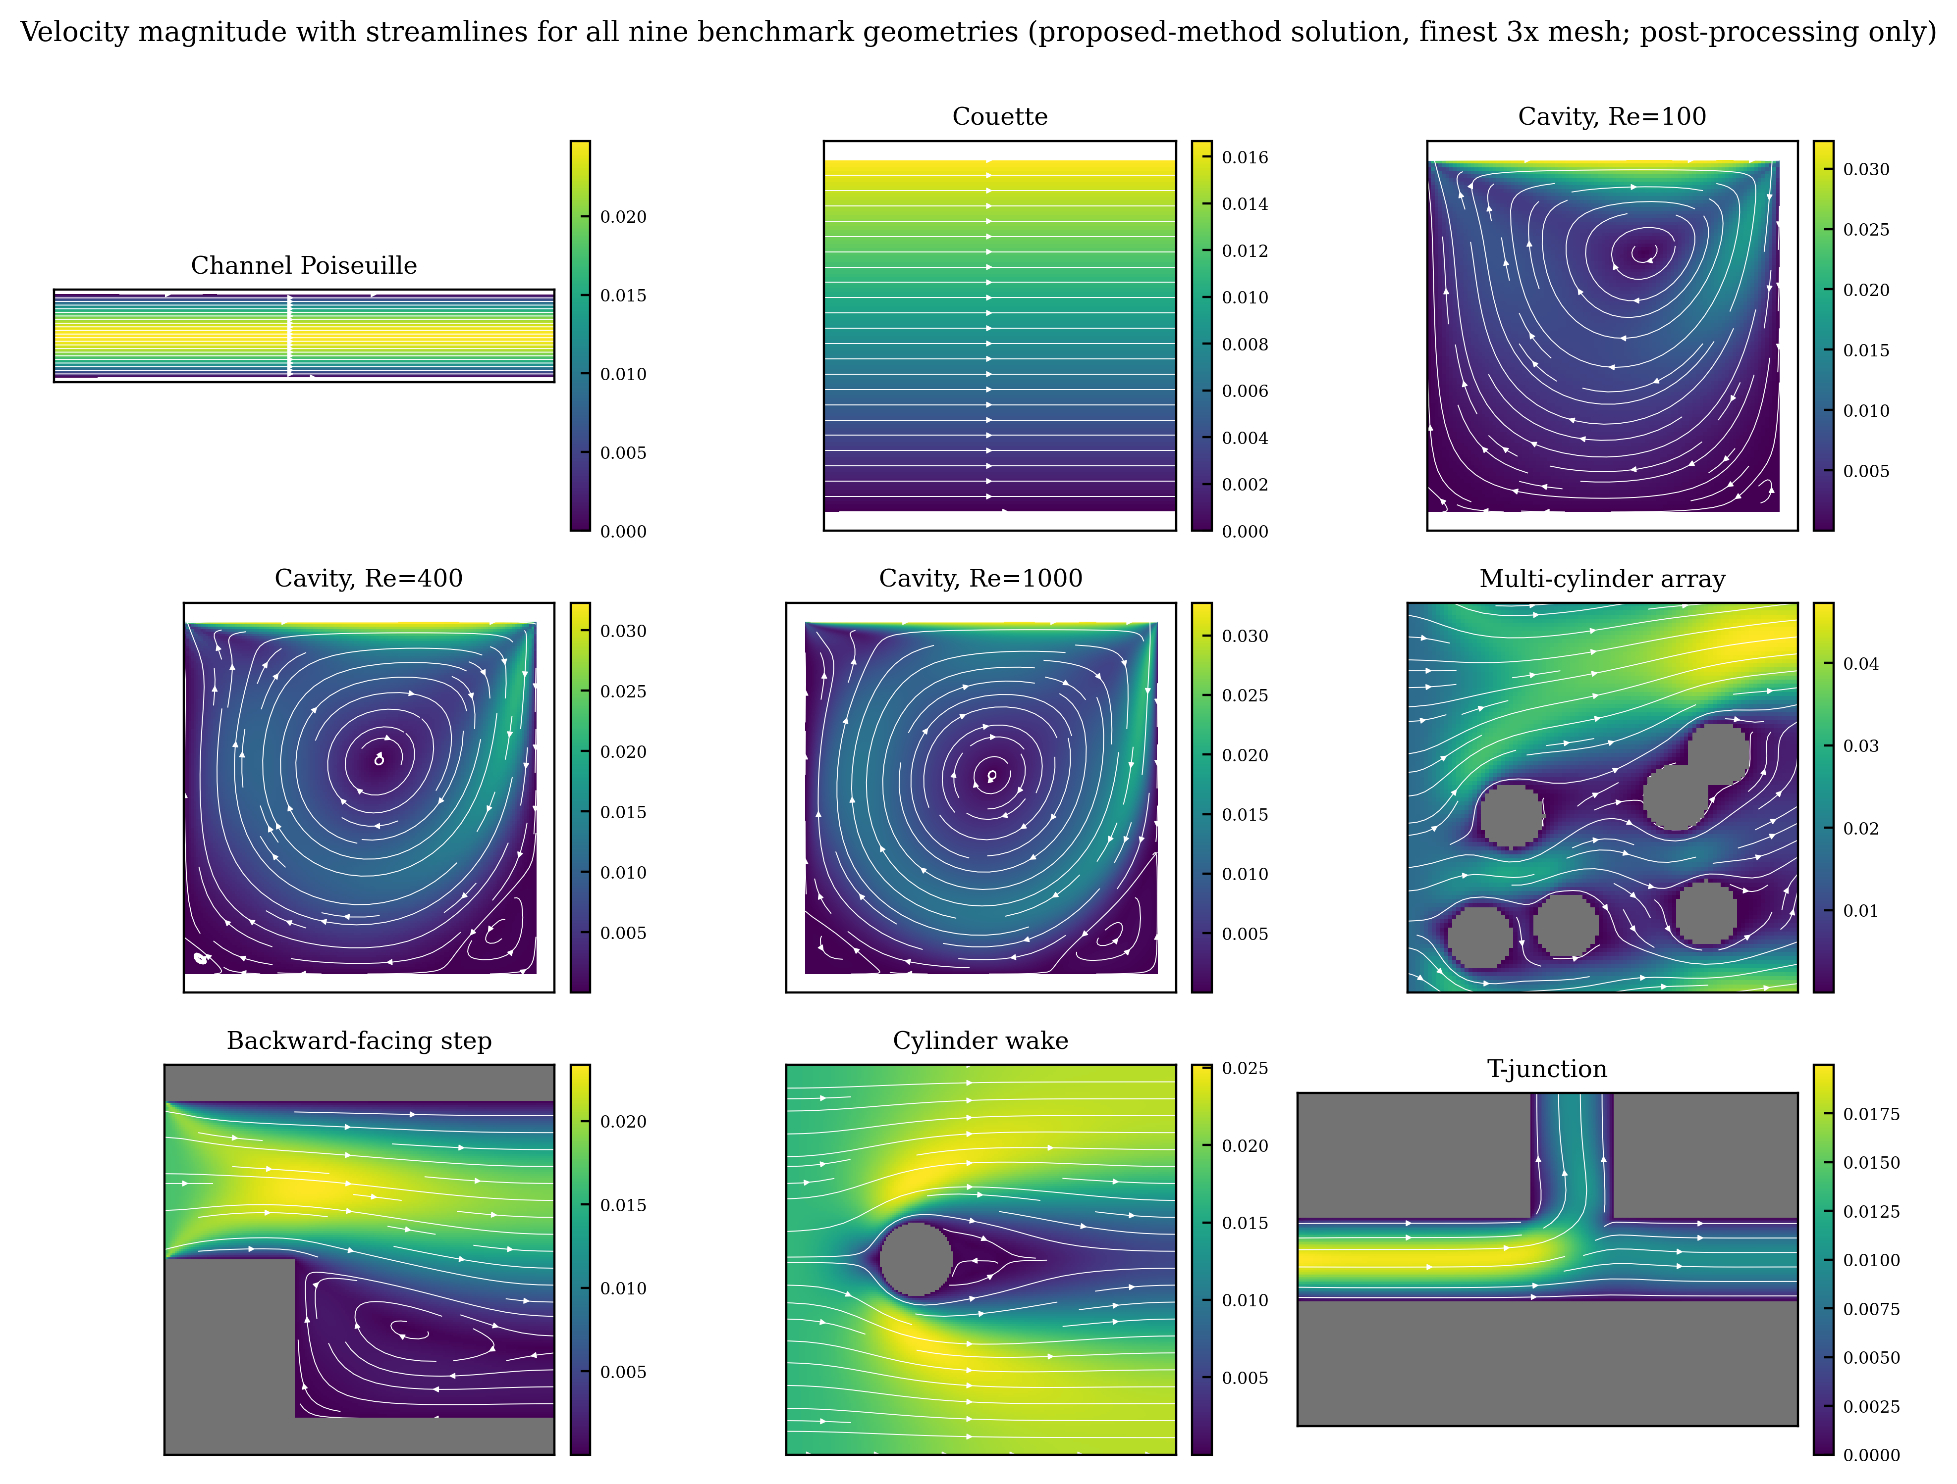
Figure 6. Velocity magnitude with streamlines for the nine geometries (3x, proposed-method solution; obstacles shaded gray).
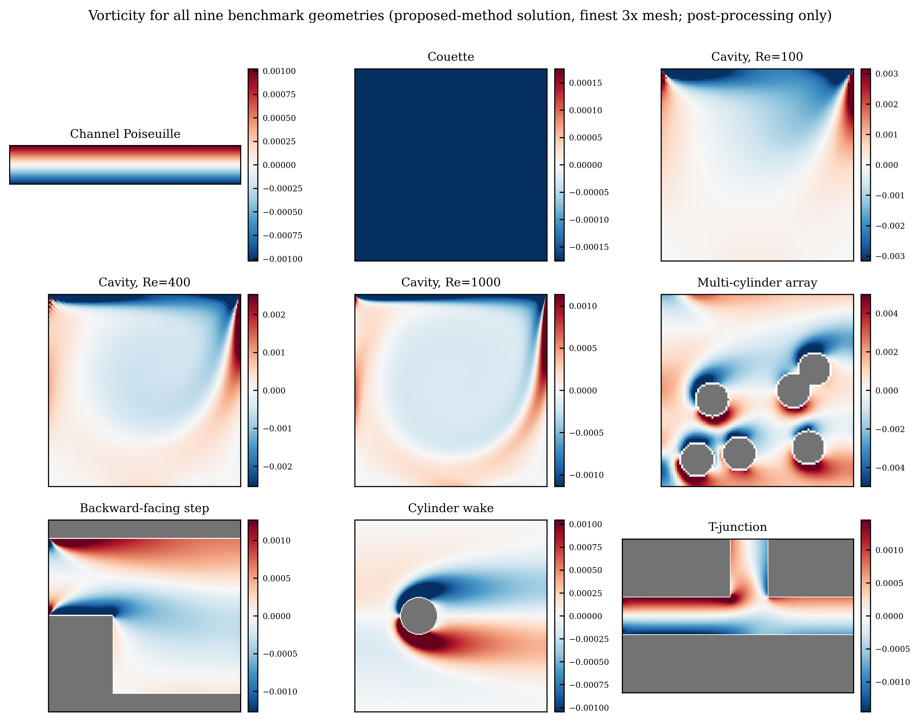
Figure 7. Vorticity fields for the nine geometries (3x, proposed-method solution). The uniform color of the Couette case reflects the physical fact of linear shear (constant vorticity).
Finally, Figures 6 and 7 show, for all nine geometries on the 3x grid, the velocity field with streamlines and the vorticity from the proposed-method solution. Every geometry qualitatively reproduces the characteristic flow structure—the cavity’s primary and secondary recirculation vortices, the backward-facing step’s separation and reattachment, the cylinder wake’s shear layer, the T-junction flow distribution, and the bypass flow around the multiple cylinders—complementing the quantitative relative-$L_{2}$ verification of Table 5, without implying a quantitative measurement of these structures.

