A Moment-Schur Nonlinear Preconditioner for Robust Steady-State Lattice Boltzmann Computation on Complex Geometries
Moment-Schur Accelerated LBM (MSA-LBM)
Young-Lin Yoo

Abstract
In steady-state lattice Boltzmann method (LBM) computations, the long-wavelength residual of the conserved pressure–velocity moments persists long after the kinetic modes decay and governs fixed-point convergence. We propose a geometry-aware, Jacobian-free nonlinear preconditioner, termed Moment-Schur Accelerated LBM (MSA-LBM), that targets this bottleneck while leaving the discretized LBM equations and boundary conditions unchanged, operating on the native residual $R(f)=f-G(f)$. The core operator closes the conserved-moment Schur complement of the LBE operator, linearized about a uniform base state, into a per-mode $3×3$ matrix in Fourier space and assembles its kinetic-null-space-corrected inverse as a spectral preconditioner, used solely as the left preconditioner of a single Jacobian-free Newton (GMRES) step on the native residual. After a damped line search, the trial update is accepted only when it simultaneously satisfies a decrease in the macroscopic $L_{2}$ residual, density positivity, wall/inlet/outlet/mask boundary consistency, and conservation sanity; otherwise the solver falls back to a native Picard step. All internal constants depend only on a global grid scale, on neither benchmark identity nor any reference solution.
On a fixed benchmark suite, the proposed method converges under an identical protocol across all 27 runs spanning nine benchmark problems (channel Poiseuille, Couette, lid-driven cavity at $Re=100/400/1000$, backward-facing step, cylinder wake, multi-cylinder, and T-junction) at the 1x/2x/3x mesh levels. Under the same stopping protocol and admissibility definition, five baseline methods (the native LBE (Picard) iteration, Anderson acceleration, preconditioned LBM, inexact Newton–Krylov, and dual-time multigrid) converge on only 12–15 of the 27 cases even with a generous budget. In a conservative timing comparison restricted to the strict subset of 15 cases on which a baseline also converges, the proposed method is faster in wall time on 14/15 cases (median ratio $≈2.06×$) and uses fewer LBE-calls, the operator-work metric, on 13/15 cases (median $≈1.80×$). Against each baseline individually, it is faster in the median by factors of 1.64–18.65× in wall time at a common threshold. On accuracy, the method exhibits an observed spatial convergence order of $≈2.0$ for channel Poiseuille flow (the BGK-LBM theoretical value), tolerance-level error for Couette flow, and monotone convergence toward the Ghia centerline for the cavity, confirming that the acceleration does not sacrifice discrete accuracy. All reported comparisons are recomputable from the stored residual histories and per-run execution traces.
The novelty lies not in modifying the LBM physical model but in a single solver framework that preconditions the hydrodynamic slow modes of the native steady residual from a Schur-complement viewpoint and validates every accepted update through the same admissibility gate, even on complex geometries. The performance claims are relative comparisons within a stored 2D D2Q9/BGK benchmark suite under an identical macroscopic-$L_{2}$-residual/plateau protocol; the method solves the same discrete steady problem faster, without reference injection or case-specific tuning.
Keywords: lattice Boltzmann method; steady-state solver; admissibility-preserving Schur complement; Jacobian-free residual correction; nonlinear preconditioning; complex geometry.

1. Introduction
The lattice Boltzmann method (LBM) is widely used in CFD, owing to its simple streaming–collision structure, its suitability for complex-geometry applications, and its inherent parallelizability [1–5]. In steady-state applications such as design optimization, geometric parametric studies, and inverse design, LBM can be computationally expensive because its explicit time marching requires many iterations to reach convergence [6,7]. This cost is caused by slowly decaying errors that delay convergence to the steady state. In native lattice Boltzmann equation (LBE) iteration, collision relaxation damps the non-conserved kinetic modes quickly, whereas the conserved hydrodynamic modes of density and momentum survive as the long-wavelength shear and acoustic modes of the linearized LBE and decay slowly [4]; in the low-Mach regime, the separation between convective and acoustic time scales further slows error decay [8–11]. The convergence history therefore shows a rapid initial drop followed by a long, flat tail that dominates the total wall time.
Existing approaches to reducing this long convergence tail fall into three classes. The first is history-based extrapolation: Anderson acceleration [12–14] and reduced-rank extrapolation [15] construct accelerated iterates from stored iterates and residuals, but these general-purpose methods do not explicitly target the slow hydrodynamic errors that limit steady-state LBM convergence. The second is Newton-type solution of the residual equation: inexact Newton and Jacobian-free Newton–Krylov (JFNK) methods [16–20] solve the nonlinear residual equation directly, and fully implicit inexact-Newton frameworks combining Newton–Krylov with domain decomposition and nonlinear elimination have been developed specifically for the LBE [21–24]. Their efficiency hinges on a preconditioner that reflects the underlying physical structure—here the saddle-point, Schur-complement structure of pressure–velocity coupling [25–27]. Moreover, in complex geometries, where solid regions are represented by a mask (an indicator field tagging each lattice node as fluid or solid), a Newton update at masked or open-boundary nodes can produce negative densities or violate boundary conditions, so the validity of each trial update must be enforced separately from convergence. The third class modifies the LBM model or adds solver infrastructure: preconditioned LBM rescales the collision spectrum or equilibrium to accelerate low-Mach steady convergence [8,9,28]; recent variants combine preconditioning with cascaded/central-moment collision [29–31] or extend the lattice Boltzmann flux solver to unstructured grids [32]; and multigrid/dual-time methods resolve the elliptic coupling through mesh hierarchies and coarse-grid corrections [6,33,34].
What is missing is a correction strategy that simultaneously (a) leaves the native operator—collision, streaming, and boundary handling—and its discrete steady solution unchanged; (b) targets only the conserved-moment slow-mode block that governs convergence; and (c) preserves physically valid states without case-by-case tuning, even on complex geometries with masked nodes and open boundaries. History-based extrapolation does not address (b); model-level acceleration violates (a); and generic JFNK or fully implicit frameworks require additional solver infrastructure and do not treat the admissibility of trial updates separately from convergence. The nonlinearly preconditioned inexact Newton method of Huang et al. [22] is the closest prior work: it also solves the steady LBE residual by Newton–Krylov iteration, but its preconditioning is algebraic, built from domain decomposition and nonlinear elimination, whereas the present method derives its preconditioner analytically from the conserved-moment Schur complement of the linearized LBE and enforces per-step physical admissibility.
We propose such a correction strategy—a geometry-aware moment-Schur nonlinear preconditioner with an admissibility-preserving acceptance gate, hereafter Moment-Schur Accelerated LBM (MSA-LBM)—that meets all three conditions at once. MSA-LBM accelerates the slow conserved-moment errors using a Fourier-space Schur preconditioner applied within a single Jacobian-free Newton correction to the original LBM residual $R(f)=f-G(f)$. The trial is accepted only if it passes both a residual decrease and physical admissibility; otherwise the solver falls back to a native LBE step. The method can therefore be applied to complex geometries while preserving the existing LBM operator and the corresponding discrete steady solution.
The method is validated on a set of benchmark cases. Under the same stopping criterion, MSA-LBM converges in all tested cases, whereas the baseline accelerators converge only in some. Among the cases where a baseline also converges, MSA-LBM reaches steady state with lower wall-clock time and fewer equivalent LBM steps, without loss of discrete accuracy. All reported comparisons are restricted to the stored two-dimensional D2Q9/BGK test suite.

2. Numerical Methods

2.1 Steady-state LBM residual
The two-dimensional, nine-velocity (D2Q9) lattice Boltzmann equation with a single-relaxation-time (BGK) collision operator is considered,
 | $$f_{i}(x+c_{i}, t+1)=f_{i}(x,t)-\frac{1}{τ_{f}}\left[f_{i}(x,t)-f_{i}^{eq}(x,t)\right], i=0,…,8,$$ | (1)
where $x$ is a node of the square lattice $Z^{2}$, $t$ the discrete time step, $\{c_{i}\}_{i=0}^{8}$ the D2Q9 lattice velocities, $τ_{f}$ the BGK relaxation time, and lattice units are used throughout ($Δx=Δt=1$). The discrete equilibrium distribution is
 | $$f_{i}^{eq}(ρ,u)=w_{i} ρ\left[1+\frac{c_{i}⋅u}{c_{s}^{2}}+\frac{(c_{i}⋅u)^{2}}{2c_{s}^{4}}-\frac{|u|^{2}}{2c_{s}^{2}}\right], c_{s}^{2}=\frac{1}{3},$$ | (2)
with weights $w_{0}=4/9$, $w_{1\text{–}4}=1/9$, and $w_{5\text{–}8}=1/36$, where $c_{s}$ denotes the lattice speed of sound. The macroscopic moments are
 | ρ=i​fi, ρu=i​cifi, p=cs2ρ. | (3)
The kinematic viscosity is $ν=c_{s}^{2}(τ_{f}-\frac{1}{2})$, and the flow is characterized by $Re=U_{ref}L_{ref}/ν$ and $Ma=U_{ref}/c_{s}$. All benchmarks run at $Ma≪1$, so the weakly compressible pressure $p=c_{s}^{2}ρ$ is consistent with the incompressible references [35,36].
Operator G denotes a single full lattice step comprising collision, streaming, and the application of all boundary conditions. The steady state is the fixed point of this operator, expressed as the residual equation
 | $ρR(f)=f-G(f)=0,$ | (4)
with $G$ invoked as a stand-alone operator that the acceleration scheme leaves unmodified. The native fixed-point iteration, in which f is repeatedly updated by the map $f=G(f)$, is referred to as the native LBE.
Two linear operators connect the nine-component distribution field to its three conserved hydrodynamic moments. The projection $M∈R^{3×9}$ maps a distribution to density and momentum,
 | $$Mf=(ρ, ρu_{x}, ρu_{y})^{⊤},$$ | (5)
Its rows being the moment weights $\{1, c_{x,i}, c_{y,i}\}$. The lifting $T∈R^{9×3}$ reconstructs a minimal distribution increment from a conserved-moment increment $dm=(dρ, d(ρu_{x}), d(ρu_{y}))$,
 | $$(T dm)_{i}=w_{i}\left[dρ+3 c_{x,i} d(ρu_{x})+3 c_{y,i} d(ρu_{y})\right],$$ | (6)
so that $T$ is the right inverse of $M$, $MT=I_{3}$. The increment $T dm$ is the minimal hydrodynamic perturbation matching a prescribed density-momentum change while leaving the remaining kinetic components for $G$ to relax at the next iteration.

2.2 Conserved-moment Schur-complement formulation
A Newton correction for the steady state solves , where . Assembling the full Jacobian with its mask and boundary operators is costly [17]. The correction is therefore split into a conserved-moment part , consistent with and , and a kinetic part , yielding the block-partitioned system$J_{f}(f^{*}) df=-R(f^{*})J_{f}=∂R/∂fdm=(dρ, d(ρu_{x}), d(ρu_{y}))MTdk$
 | $$\left[\begin{matrix}J_{mm} & J_{mk} \\ J_{km} & J_{kk}\end{matrix}\right]\left[\begin{matrix}dm \\ dk\end{matrix}\right]=-\left[\begin{matrix}R_{m} \\ R_{k}\end{matrix}\right]$$ | (7)
Eliminating the kinetic block yields the conserved-moment Schur-complement system,
 | $$S_{m} dm=-\left(R_{m}-J_{mk}J_{kk}^{-1}R_{k}\right), S_{m}=J_{mm}-J_{mk}J_{kk}^{-1}J_{km}.$$ | (8)
The kinetic block $J_{kk}$ collects the locally, rapidly relaxing modes, whereas the moment Schur complement $S_{m}$ encodes the global, weakly damped hydrodynamic coupling that governs the slow pressure–velocity modes and dominates the late stagnating phase. Acceleration is therefore required only for the three conserved-moment components, not for all nine distributions per node.
Forming $S_{m}^{-1}$ explicitly is intractable, so we approximate its action analytically; the closed-form per-mode block is derived in the spectral construction below. Working in moment space, the practical correction reads
 | $$S_{m}≈MJ_{f}T, S_{m} dm≈-MR\left(f^{*}\right), df_{AP}=T dm,$$ | (9)
where and are the operators of Eqs. (5)–(6). Only fluid nodes enter the computation; interior solid and obstacle nodes are excluded. The action of on a direction is obtained matrix-free by a directional finite difference of the native residual [17,37],$MTJ_{f}v$
 | $$J_{f}\left(f\right) v≈\frac{R\left(f+εv\right)-R\left(f\right)}{ε}, ε=ε_{0} \frac{1+∥f∥_{2}}{∥v∥_{2}}, ε_{0}​={10}^{-7}$$ | (10)
where $ε_{0}={10}^{-7}$is chosen a few times larger than $\sqrt{ε_{mach}}≈1.49×{10}^{-8}$to keep the difference above round-off noise while remaining in the linear regime. Although the directional derivative (10) is the same Jacobian–vector product used in JFNK, the present method is not a JFNK solver: the finite difference is used only to build the moment-Schur preconditioner $B_{m}$and to apply a single, gated Newton step per round (Section 2.4), rather than to drive an inner Newton–Krylov iteration to convergence. The full Jacobian $J_{f}$is therefore never assembled, and global convergence is governed by the native residual and the admissibility gate, not by the Newton iteration itself.

2.3 Spectral moment-Schur preconditioner
The goal of this section is a closed-form, per-wavenumber approximation of the Schur complement $S_{m}$of Section 2.2, whose exact inverse (8) is intractable. The construction proceeds in three stages, tracked by superscripts: a Galerkin reduction $S_{m}^{G}$that discards the kinetic coupling, a physically corrected form $S_{m}^{AP}$that restores it, and a regularized form $S_{m}^{reg}$used for the actual inverse. To obtain this approximation, the lattice update is linearized about a uniform base state $\overset{‾}{ρ}=1$, $\overset{‾}{u}=0$, which makes the linearized operator spatially invariant and therefore diagonalizable by the Fourier transform; the uniform state is adequate because the preconditioner need only capture the damping structure of the low-wavenumber slow modes, while the exact steady solution is fixed by the native residual. In Fourier space streaming becomes a diagonal phase operator $A(k)=diag(e^{-ik⋅c_{i}})$ and the global problem decouples mode by mode, as in the von Neumann analysis of the LBE [4]. The linearized BGK collision is $C(ω)=(1-ω)I_{9}+ω TM$ with $ω=1/τ_{f}$, the linearized update is $L^{'}(k)=A(k)C(ω)$, and the fixed-point residual Jacobian is $J(k)=I_{9}-L^{'}(k)$, reducing to a $3×3$ Schur complement per wavenumber in moment space.
The (Petrov–Galerkin, since $M≠T^{⊤}$) reduction of this Jacobian is
 | $$S_{m}^{G}(k)=M J(k) T=I_{3}-M A(k) T,$$ | (11)
which projects the $9×9$ Jacobian onto the three-dimensional moment subspace but discards the moment→kinetic→moment coupling; moments and kinetic modes interact through streaming and collision, with the resulting damping depending on $ω$. We restore this coupling through the correction
 | $$S_{m}^{AP}(k)=S_{m}^{G}(k)-κ(ω)\left[MA(k)^{2}T-(MA(k)T)^{2}\right].$$ | (12)
The bracketed term is an exact identity,
 | $$MA(k)^{2}T-(MA(k)T)^{2}=MA(k) (I_{9}-TM) A(k) T,$$ | (13)
which is the moment$→$kinetic$→$moment coupling, i.e. the moment-space representation of $J_{mk}J_{km}$ in Eq. (8) that the Galerkin reduction discards. The exact reconstruction of the discarded coupling would require the kinetic inverse $J_{kk}^{-1}$. Since the kinetic block relaxes at rate $ω$, its inverse is dominated by a single scale. Writing the linearized collision as a relaxation toward equilibrium, the kinetic modes carry the factor $\left(1-ω\right)$per streaming step against the moment modes' unit factor, so their relative response scales as $r=\left(1-ω\right)/ω$; we therefore represent $J_{kk}^{-1}$by the scalar proxy $κ\left(ω\right)∝r$. To keep the correction bounded across the full stability range $ω∈\left(0 , 2\right)$—in particular as $ω→0$, where $r→+∞$—the proxy is capped:
 | $$κ(ω)=\frac{1}{2} sign(r) min\left(\frac{1}{2}, |r|\right), r=\frac{1-ω}{ω},$$ | (14)
so that $∣κ∣≤1/4$. The cap value $1/2$and the prefactor $1/2$are the tightest bounds that keep the corrected operator $S_{m}^{AP}$positive-definite across all wavenumbers in the base-state analysis; their effect on convergence is quantified by the sensitivity study in Appendix C. To prevent the per-mode inverse $B_{m}\left(k\right)={\left[S_{m}^{reg}\left(k\right)\right]}^{-1}$from amplifying near-singular modes, an adaptive Tikhonov shift is added:
 | $$S_{m}^{reg}\left(k\right)=S_{m}^{AP}\left(k\right)+η I_{3}, η=\frac{σ_{max}\left(S_{m}^{AP}\right)}{C_{η}}$$ | (15)
By tying to rather than to a fixed absolute value, the shift scales automatically with the local operator norm and caps the per-mode condition number at . Because enters only the preconditioner and not the native residual, the choice of affects the convergence rate but not the converged solution; its effect is quantified in Appendix C, where varying it over C_{η} ∈ {20, 50, 100} is shown to leave the converged solution unchanged to within the stopping tolerance while altering only the convergence rate. The per-mode block is then . The mean mode is tied to mass conservation: we take no Newton step on the density mean and pass the momentum mean through unchanged, so .
The assembled $B_{m}$ acts on a residual field by projecting to moments, transforming, applying the cached per-mode blocks $B_{m}(k)$, transforming back, and lifting,
 | $$B_{m}R_{f}=T F^{-1}\left\{B_{m}(k)⋅F[MR_{f}](k)\right\}.$$ | (16)
Because $B_{m}(k)$ depends only on $(N_{y},N_{x},ω)$, it is built once per case at cost $O(N_{f}logN_{f})$ and reused at every application. The Fourier linearization assumes periodicity and so does not represent non-periodic boundary conditions exactly; this is standard Krylov preconditioning practice and does not affect the converged solution, which is governed by the native nonlinear residual and the admissibility gate described next.

2.4 Jacobian-free Newton step and admissibility gate
The spectral operator $B_{m}$ is the left preconditioner for a single Newton step on the native residual. In each outer round, a single left-preconditioned GMRES solve is applied to the native Newton system
 | $$J_{f}\left(f^{k}\right) df=-R\left(f^{k}\right),$$ | (17)
that is, GMRES solves the preconditioned system $B_{m}J_{f}\left(f^{k}\right) df=-B_{m}R\left(f^{k}\right)$, where the operator action $v↦J_{f}\left(f^{k}\right)v$is supplied matrix-free by the finite difference (10) and $B_{m}$is applied via the spectral sequence (16). Krylov dimension $k_{max}=30$, restart $=2k_{max}$, and a single outer iteration.
The GMRES direction is not accepted directly but subjected to a damped line search coupled to an admissibility gate, in the spirit of globalized inexact Newton methods [19,37]. With trial states and , we accept the largest whose trial is admissible and strictly reduces the native residual:$dff_{trial}(α)=f^{k}+α dfα∈\{1,\frac{1}{2},\frac{1}{4},\frac{1}{8}\}α$
 | $$\text{accept }α⇔admissible(f_{trial}) ∧ ∥R(f_{trial})∥<∥R(f_{best})∥ ∧ conservation(f_{trial}).$$ | (18)
Candidates are tested from the largest step first, and the first to pass is accepted; if none passes, the step is rejected and the solver falls back to a native LBM update. Each outer round forms two competing candidates from the same current state: a native LBE candidate obtained by a fixed number of native LBM steps, and the MSA-LBM candidate obtained from the gated Newton step above. The candidate with the smaller native residual is retained (Algorithm 1); the accelerated step is thus never trusted blindly but must outperform plain native iteration at every round. This dual-candidate structure is what the admissibility gate and the native fallback jointly guarantee. The admissibility predicate comprises the following gates.

Gate | Condition
Finite field | reject any NaN or Inf
Positive density | reject $ρ≤0$
Residual decrease | accept only if the native macroscopic residual decreases
Boundary consistency | re-apply native wall/inlet/outlet/mask before evaluating the residual
Conservation sanity | mass drift and inlet–outlet flux closure not worsened relative to native

Trial states are interior-only: the native boundary projection is re-applied before the residual, positivity, finiteness, and mask checks, and solid and mask nodes are excluded from both the fluid-domain norm $∥⋅∥_{Ω_{f}}$ and $M$.

2.5 Solver procedure and scale-only adaptation
The complete method is summarized in Algorithm 1; its only adaptive element is a global scale $s$ setting the burn-in and block lengths. The burn-in is the number of native LBM iterations for initial stabilization, and the block is the number forming each per-round candidate. The scale is geometric,
 | $$s=max\left(\sqrt{\frac{N_{dof}}{9⋅{32}^{2}}}, 1\right),$$ | (19)
where $N_{dof}=9N_{f}$, so $s$ equals the linear grid size divided by $32$ ($s=1$ on a $32×32$ D2Q9 lattice), independent of $Re$, boundary conditions, and mask. The lengths are $burn=clip(round(16s), 8, 96)$ and $block=clip(round(80s), 48, 512)$.
Figure 1 summarizes the workflow: the moment residual is extracted, an MSA-LBM correction is formed and validated by the admissibility gate, and either the accepted update or a native fallback is applied.

Algorithm 1 — MSA-LBM accelerated steady-state LBM
- Burn-in: $f←{Picard}^{ burn}(f_{0})$; initialize $f_{best}$, $r_{best}$.
- For round $=1,…,R_{max}$ ($R_{max}=160$):
  - Picard candidate: $c_{pic}={Picard}^{ block}(f)$, residual $r_{pic}$.
  - MSA-LBM candidate: solve Eq. (17) by $B_{m}$-preconditioned GMRES for $df$, then form $c_{ap}$, $r_{ap}$ via the line-search/gate of Eq. (18).
  - Choose the candidate with the smallest residual.
  - If no candidate beats $r_{best}$ by a factor $1.02$, fall back to a native LBE guard.
  - Set $f←$ chosen; update $f_{best}$, $r_{best}$, and the staleness counter.
  - Terminate if $r_{best}≤τ$ or if staleness $≥$ stale$​_{max}$ ($=40$).
- Return $f_{best}$ and the convergence history.

A single MSA-LBM step is not cheaper than a single native LBE step: it requires several native residual evaluations, a spectral solve, and a line search. The benefit is structural: an early global correction removes the slow hydrodynamic mode that would otherwise require thousands to hundreds of thousands of native LBE tail iterations to damp, shortening the total time to steady state. Because the full Newton matrix is never formed, the memory footprint scales as $O(N_{f})$.
Global mass and inlet–outlet flux closure are reported as auxiliary physical-plausibility diagnostics; they are not part of the stopping rule, which uses only the macroscopic residual and its plateau.

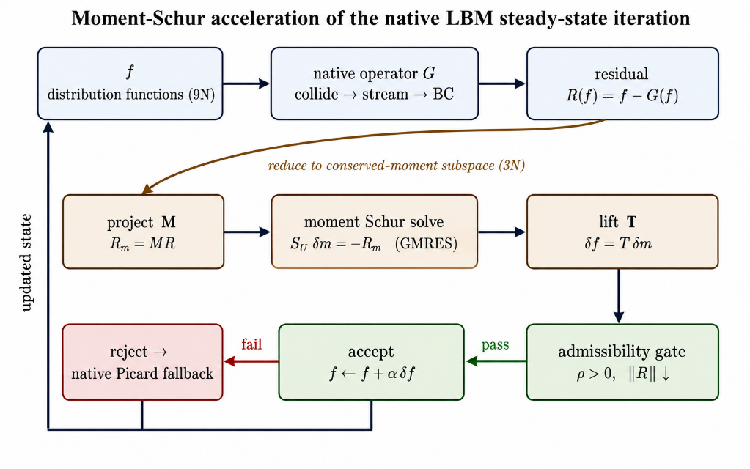
Figure 1. Conceptual workflow of the MSA-LBM method: moment-residual extraction, gated correction, and accepted-update-or-native-fallback execution.

3. Results
This section evaluates the proposed method against the five baselines in terms of robustness, computational cost, and solution accuracy. Section 3.1 defines the benchmark problems, the convergence criteria, and the baseline methods. Section 3.2 examines the convergence behavior and robustness, Section 3.3 compares the computational cost in wall time and operator work, and Section 3.4 verifies the solution accuracy against the references.

3.1 Benchmark problems and convergence criteria
The method is evaluated on nine benchmark problems, each with an analytic or high-fidelity numerical reference solution. The benchmark problems cover three classes of flows: canonical wall-bounded flows, separated and reattaching flows, and flows in complex geometries. Complex geometries are described by a mask, i.e., an indicator field marking each lattice node as fluid or solid. The canonical wall-bounded flows are plane Poiseuille and Couette flow, both with analytic solutions, and the lid-driven cavity at Re = 100/400/1000, compared against the Ghia benchmark [38]. The separated flows are the backward-facing step and the cylinder wake, which exhibit separation, reattachment, and wake formation [39]. The complex-geometry problems are the multi-cylinder configuration, with multiple mask boundaries, and the T-junction, a branching geometry with coupled inlet/outlet boundaries. Each problem is solved at three mesh levels, denoted 1x/2x/3x, yielding 27 runs in total; Table 1 lists the grid size, Reynolds number, boundary conditions, physical role, and reference type of every problem. Full specifications of the domains, initial conditions, and boundary-condition schemes are given in Appendix B.

Table 1. Definitions of the nine benchmark problems: grid sizes at the three mesh levels, Reynolds number, boundary conditions, physical role, and reference type.
Problem | Grid (1x / 2x / 3x) | Re | Boundary conditions | Physical role | Reference
Channel (plane Poiseuille) | 32×192 / 64×384 / 96×576 | 32 | Inlet/outlet + wall | Pressure-driven shear | Analytic
Couette | 32² / 64² / 96² | 32 | Moving wall + wall | Wall-driven shear | Analytic
Cavity | 33² / 65² / 97² | 100 | Lid-driven, closed | Recirculating closed domain | Ghia [38]
Cavity | 49² / 97² / 145² | 400 | Lid-driven, closed | Recirculating closed domain | Ghia [38]
Cavity | 129² / 257² / 385² | 1000 | Lid-driven, closed | Recirculating closed domain | Ghia [38]
Backward-facing step | 64² / 128² / 192² | 26 | Inlet/outlet + step mask | Separation/reattachment | Native LBE
Cylinder wake | 64² / 128² / 192² | 15 | Inlet/outlet + obstacle mask | Steady wake formation | Native LBE
Multi-cylinder | 32² / 64² / 96² | ≈5 | Multiple obstacle masks | Complex mask boundary | Native LBE
T-junction | 96×64 / 192×128 / 288×192 | 13 | Branching inlet/outlet | Branching geometry + open-BC coupling | Native LBE

The Reynolds numbers of the complex-geometry problems are chosen within the range in which a steady fixed point exists—below the onset of vortex shedding for the cylinder wake, and at the low-Re laminar regime for the backward-facing step and multi-cylinder array—so that a well-defined steady reference solution is available. The purpose of these problems is to stress the steady-state solver on masked and open-boundary geometries, not to reproduce high-Reynolds wake or separation physics; the physical role in Table 1 therefore refers to the qualitative flow structure rather than to a turbulent regime.
For the four problems without an analytic or literature reference—the backward-facing step, cylinder wake, multi-cylinder, and T-junction—the reference solution is obtained by running the native LBE iteration on the same discretization to a residual far below the stopping tolerance used in the comparisons; it is labeled the native LBE reference in Table 1. For these problems the accuracy assessment is limited to the relative L₂ difference of the converged field from this reference and to qualitative reproduction of the expected flow structures (Section 3.4).
Convergence is judged on the macroscopic fields rather than on the microscopic distribution function: the residual monitors the change of pressure and velocity between successive checks, not the root-mean-square change of f. Because the absolute pressure level is arbitrary in a weakly compressible closed or periodic flow, the pressure increment is first made gauge-invariant by subtracting its mean over the fluid domain. The macroscopic residual is then defined over the fluid nodes Ω_{f} as
 | $$r_{macro}=\sqrt{ {\left\|Δu\right\|}_{L_{2}\left(Ω_{f}\right)}^{2}+ {\left\|Δp - {\left\langle Δp\right\rangle }_{Ω_{f}}\right\|}_{L_{2}\left(Ω_{f}\right)}^{2}},$$ | (20)
where Δ(·) denotes the change between consecutive convergence checks and ⟨·⟩_{Ω_f} the fluid-domain mean. Convergence is declared only when three conditions hold simultaneously: (i) the residual satisfies r_{macro} ≤ 5τ, where the factor 5 provides a safety margin over the base tolerance τ; (ii) the residual has stagnated, i.e., the fractional improvement of r_{macro} over a moving window of the W most recent convergence checks (W = 50, the window length), the fractional improvement of $r_{macro}$does not exceed η (η = 0.05, the maximum admissible relative decrease within the window), ensuring that the reported value is the converged level rather than a transient undershoot; and (iii) the iterate is physically admissible, requiring density positivity, finite fields, and boundary/mask consistency. The base tolerance is τ = 10⁻⁷ for the non-cavity problems and τ = 10⁻⁸ for the cavity problems on the 1x grids, and is tightened to τ/2 and τ/3 on the 2x and 3x grids, respectively. All constants and the admissibility rule are identical for every method and every problem, with no per-case tuning.
The proposed MSA-LBM is compared against five baseline methods, all built on the identical native LBM operator and summarized in Table 2: (i) the native LBE fixed-point iteration of the collide–stream–boundary operator; (ii) Anderson acceleration [12,13]; (iii) preconditioned LBM using the standard balanced transform with a block preconditioner [8,9]; (iv) inexact Newton–Krylov, a JFNK method combining GMRES with two smoothing stages and a line search [16,17]; and (v) dual-time multigrid using a full-approximation-scheme (FAS) V-cycle [33]. Each baseline uses literature-standard hyperparameters and a generous iteration budget—up to 1.2×10⁶ evaluations of the native operator per run, of which the hardest problems (cavity 2x/3x) consume 6×10⁵ to 1.2×10⁶—large enough that any failure of a baseline to converge reflects stagnation of the iteration itself rather than exhaustion of the budget (Section 3.2.2). The proposed method is subject to no such cap and iterates until its convergence criterion is met (Appendix A.1). All six methods differ only in the update rule and call the identical native operator; any performance difference therefore reflects algorithmic structure alone.
Because the methods stop at different final accuracies, they are compared by the cost to first reach a common target residual ε, i.e., the time-to-threshold: the cost to first attain r_{macro} ≤ ε. This cost is measured in two ways: as wall time, and as the LBE-call count—the number of evaluations of the native collide–stream–boundary operator G, a hardware-independent and fully deterministic measure of operator work (Section 3.3.2). Reference solutions, whether analytic, Ghia, or native LBE, are never used inside the solve; they enter only the post-solve accuracy assessment through the relative L₂ error. Finally, the proposed method solves all 27 runs with a single deterministic routine; only the problem definition—grid, Reynolds number, boundary conditions, and mask—changes between cases. All runs were executed in serial on a single core of an AMD Ryzen Threadripper PRO processor (256 GB system memory); all six methods share the same implementation, so wall times are directly comparable within this study.

Table 2. Implementation summary and main parameter settings of the five baseline methods.
Baseline | Implementation | Main settings
Native LBE | Collide–stream–boundary fixed-point iteration | max_steps ≤ 1.2×10⁶; residual-monotone termination
Anderson acceleration [12,13] | Regularized least-squares fixed-point acceleration with admissibility safeguard | depth m = 10; β = 1.0; regularization 10⁻¹²
Preconditioned LBM [8,9] | Balanced PLBE transform (γ-scaled) with block preconditioner | γ = 0.5; max_steps ≤ 1.2×10⁶
Inexact Newton–Krylov [16,17] | JFNK: GMRES with nonlinear-equation (NE) and relaxation smoothers, line search | krylov_max = 10; K_ne = 20; K_smooth = 10; line_search = 4
Dual-time multigrid [33] | FAS V-cycle with residual-equation smoothing | max_levels = 6; K_pre/coarse/post = 20/30/20

3.2 Convergence behavior

3.2.1 Convergence histories

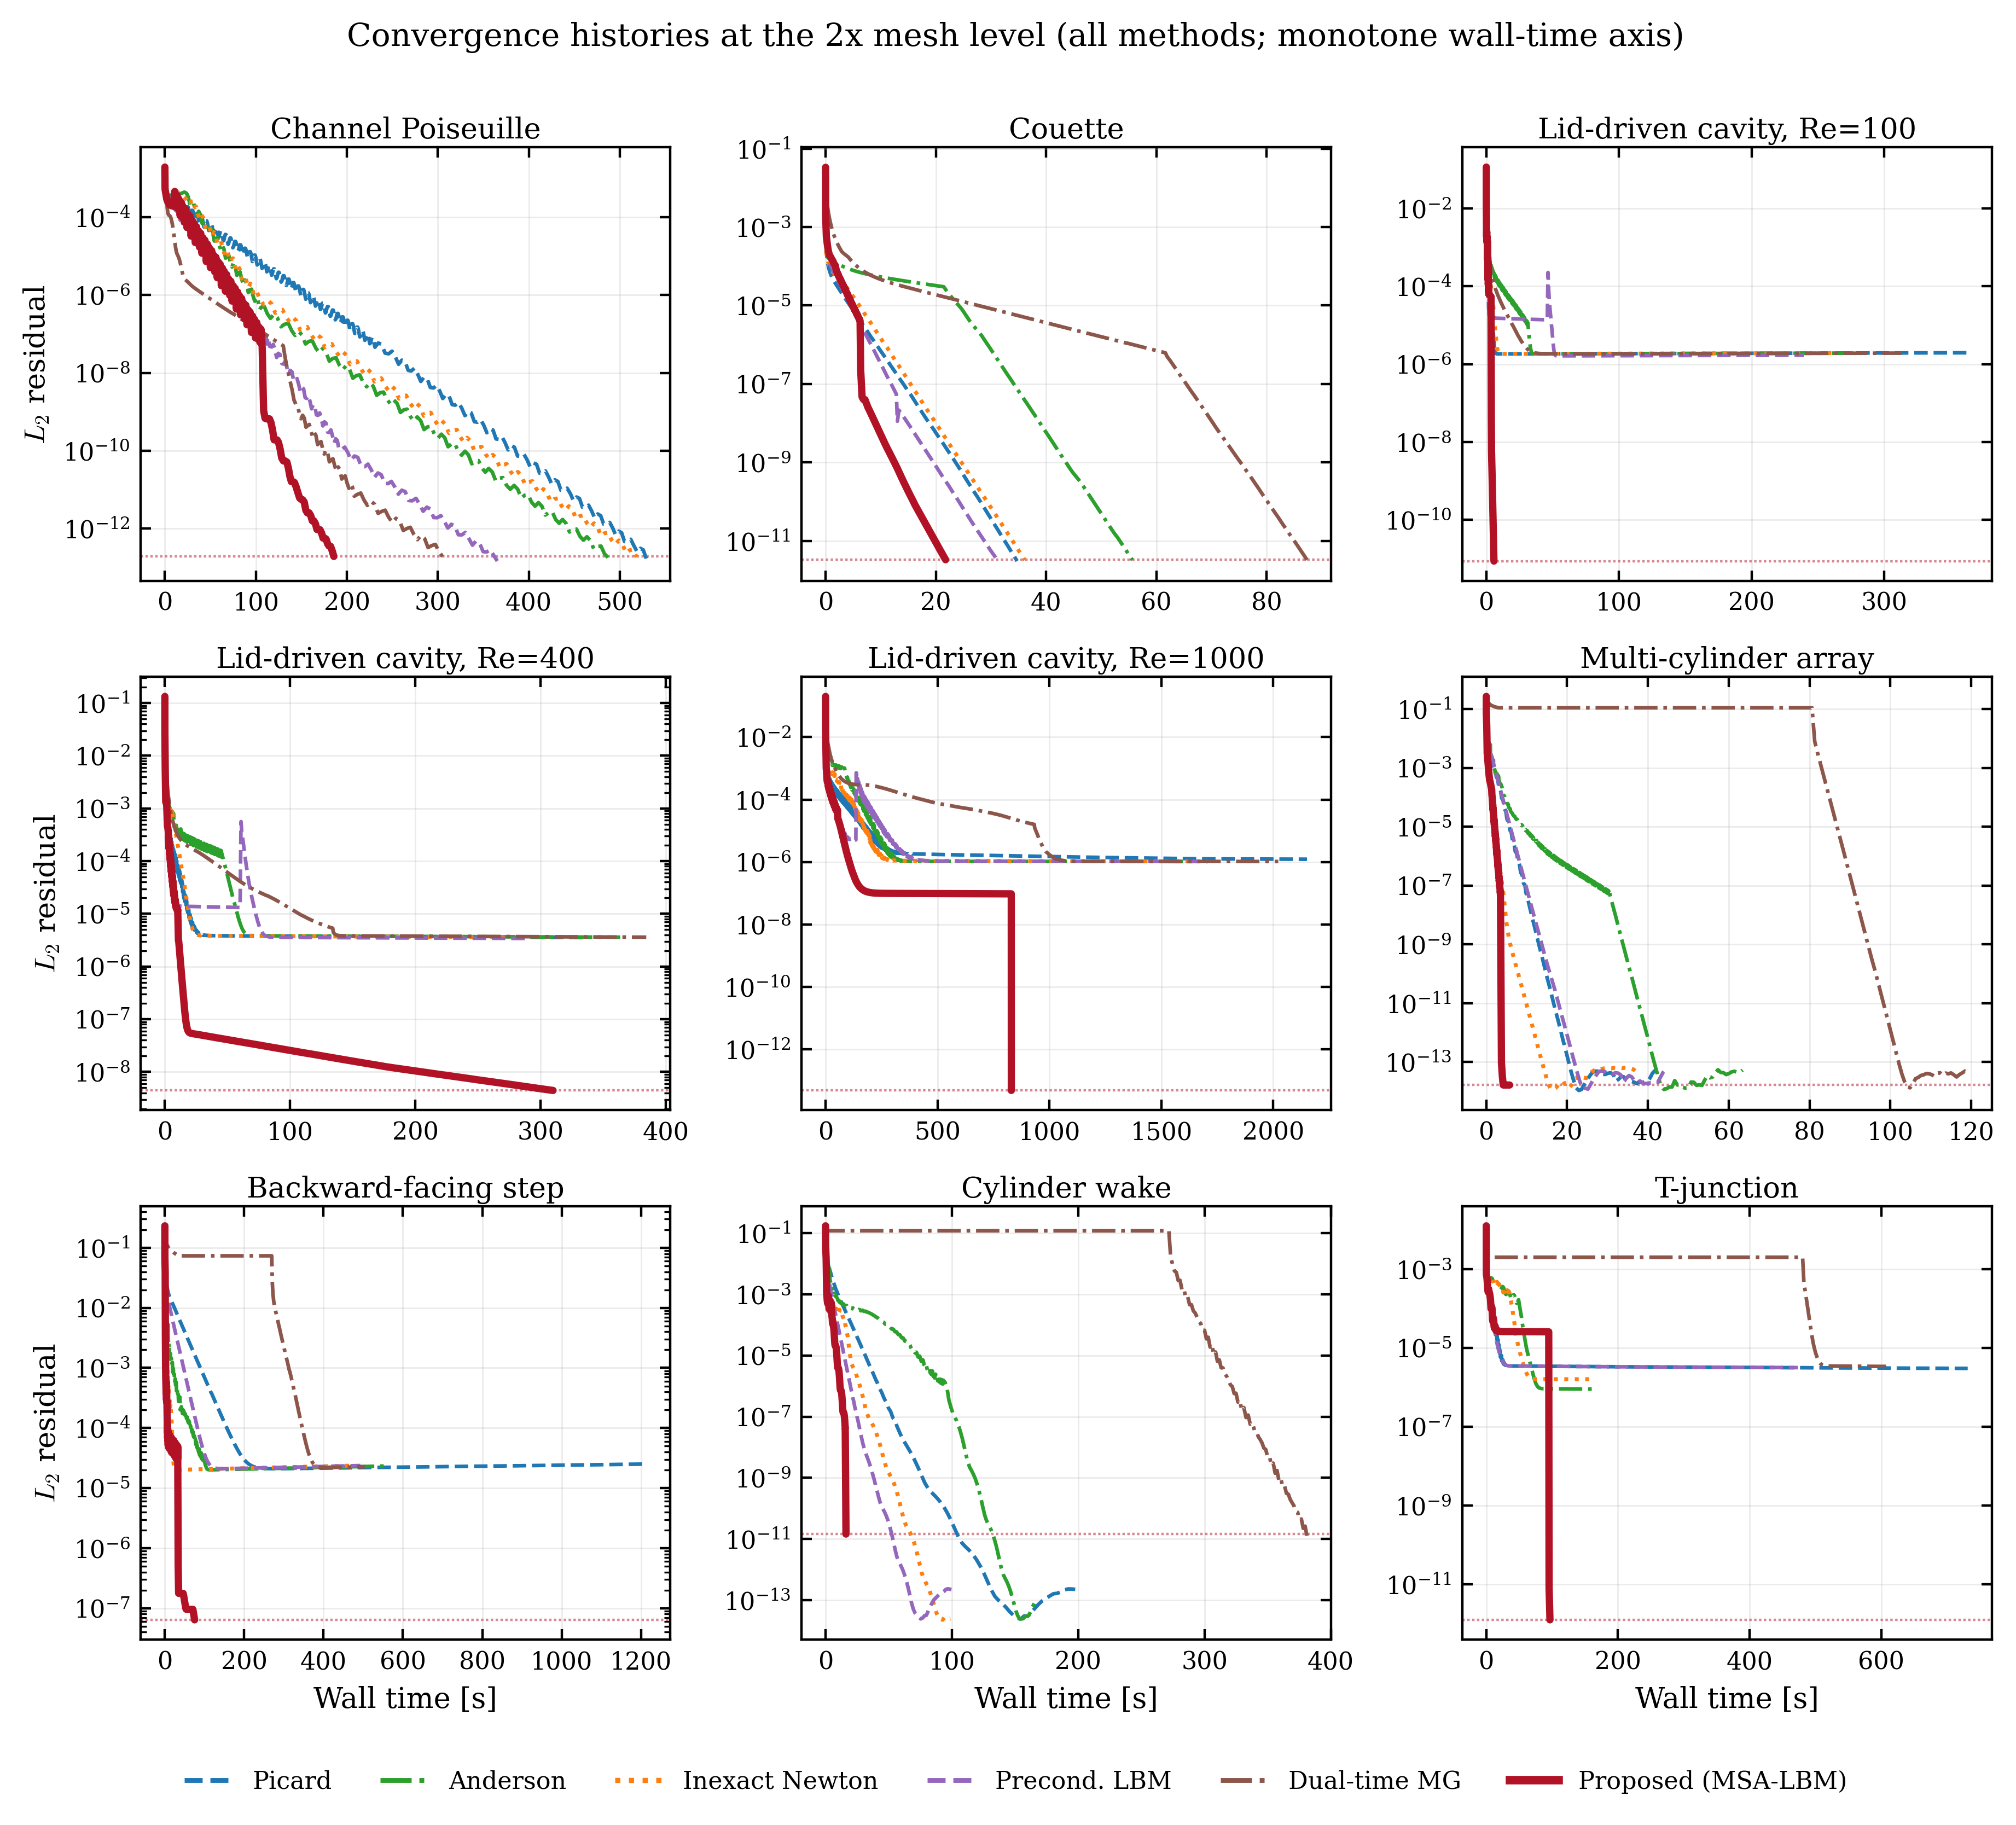
Figure 2. Residual histories (running-minimum $r_{macro}$versus wall time) of the six methods for the nine benchmark problems at the 2x mesh level.

Figure 2 shows the residual histories of all six methods at the 2x mesh level. Two regimes are visible, and they partition the benchmark set exactly. On the five problems where the global slow mode is weak or absent—plane Poiseuille, Couette, cylinder wake, multi-cylinder, and the T-junction—the baselines also converge (all five baselines at 2x, and at least two at every level), and the methods differ mainly in the wall time to reach a common threshold (quantified in Section 3.3). On the four slow-mode-dominated problems—the three cavities and the backward-facing step—no baseline converges at any level: the baselines flatten at a residual plateau, whereas the proposed method penetrates it and continues to its stopping tolerance. The same partition holds at 1x and 3x (Appendix Figures A1–A2), and the separation widens with refinement.

Table 3. Per-level convergence summary of the proposed method over the nine benchmark problems, reported as median (min–max), where a residual margin r_{macro}/(5τ) below unity indicates convergence with margin. The LBE-call maxima at 2x/3x exceed the baseline cap of Table 2 because the proposed method iterates uncapped to its convergence criterion (Appendix A.1).
Level | Converged | Wall time [s], median (range) | LBE-calls, median (range) | Final r_{macro}, median (range) | Margin r_{macro}/(5τ), median (worst)
1x | 9/9 | 4.9 (0.7–56.8) | 32,054 (20,251–221,413) | 2.14e-12 (9.88e-15–2.47e-08) | 4.3e-06 (0.049)
2x | 9/9 | 75.0 (5.8–829.7) | 101,554 (20,471–1,440,003) | 3.31e-12 (1.65e-14–6.41e-08) | 1.3e-05 (0.256)
3x | 9/9 | 180.2 (10.4–1,234.1) | 233,779 (21,265–1,440,085) | 1.15e-11 (7.81e-14–1.57e-08) | 6.9e-05 (0.940)

Table 3 summarizes the proposed method by level: all 27 runs satisfy the three convergence conditions of Section 3.1, with median residual margins of four to five orders of magnitude below the threshold. The tightest case (cavity Re = 400, 3x) converges at 94% of its threshold while still satisfying the plateau and admissibility conditions.
The shape of the proposed-method curves reveals the mechanism of the acceleration. In the cavity Re = 1000 and T-junction panels of Figure 2, the history has a characteristic three-stage form: a sharp initial descent, as native relaxation removes the high-wavenumber kinetic modes; an extended stall, during which the iterate is still outside Newton’s quadratic-convergence region, the finite-difference Jacobian–vector approximation is inaccurate, and the accepted correction steps—often damped to a step factor α < 1 by the admissibility gate, where α ∈ {1, 1/2, 1/4, 1/8} is the line-search damping factor of Section 2.4 (α = 1 being the full Newton step)—yield little benefit; and a sudden terminal drop—the vertical segments in Figure 2—once the iterate enters Newton's quadratic-convergence region and the full step α = 1 is accepted. This terminal step spans 6.5 orders of magnitude in the T-junction (2.6×10⁻⁵ → 8.1×10⁻¹²) and 6.3 orders in cavity Re = 1000 (9.6×10⁻⁸ → 4.9×10⁻¹⁴), far exceeding the roughly one order per step of the linearly convergent baselines and broadly consistent with the residual squaring of quadratic convergence. The curve shape is thus direct evidence that the correction acts as a Newton step in the conserved-moment subspace. Across all 27 runs, the moment-Schur candidate is accepted in 71.0% of the outer rounds, with no run in which it is never accepted, confirming that the correction—rather than the native fallback—drives the observed convergence.
The size of the net gain follows the same mechanism: it is largest where the slow mode governs convergence, and shrinks where it does not, since the per-iteration cost of the correction (moment-subspace restriction, inner GMRES, admissibility gate) is then not amortized. On the cavity flows the proposed method reaches residuals two to eight orders of magnitude below each configuration's baseline floor, and in less time—at Re = 1000, 1x, it attains 2.4×10⁻⁹ in 57 s while the baselines remain stalled after 531–774 s. Conversely, in Couette flow the slow mode is essentially absent and the method is merely comparable to the fastest baselines upon refinement, and in the T-junction it reaches the loose threshold 10⁻⁵ more slowly than the two fastest baselines—yet is the only method to reach 1.3×10⁻¹². The full per-case cost comparison is given in Section 3.3 and Appendix Table A1.

3.2.2 Slow-mode analysis and robustness
The behavior observed in Section 3.2.1 follows from the linearized structure derived in Section 2. The asymptotic convergence rate of the native LBE iteration is set by the spectral radius of the linearized collide–stream operator [4], whose modes separate into kinetic and hydrodynamic families. The kinetic modes, associated with the Jacobian block J_{kk}, are damped strongly and locally. The hydrodynamic modes, tied to the conserved moments, are governed instead by the Schur complement $S_{m}=J_{mm}-J_{mk}J_{kk}^{-1}J_{km}$, where the subscripts m and k denote the conserved-moment (macroscopic) and remaining kinetic degrees of freedom, respectively. The largest eigenvalue of S_{m} has a damping rate approaching unity, so after sufficiently many iterations the residual is controlled by this single slow mode—this is the plateau of Figure 2. The proposed method removes precisely this mode by applying an analytic approximation of S_{m}⁻¹ restricted to the conserved-moment subspace; the residual therefore continues to decrease where the native iteration stalls.
The practical consequence is a robustness gap: the difference in the fraction of problems each method drives to the full convergence criterion of Section 3.1. Under identical stopping criteria, admissibility rules, and iteration budgets, the proposed method converges on all 27 runs, whereas the baselines converge only on a subset: inexact Newton–Krylov on 15, preconditioned LBM on 14, native LBE and Anderson on 13, and dual-time multigrid on 12. This partition is exact: the 15 runs on which at least one baseline converges are precisely the five problems outside the cavity/backward-step group at all three levels, and the 12 runs on which no baseline converges are the three cavities and the backward-facing step at all three levels.
The stored histories show that this non-convergence arises from numerical stagnation, not budget exhaustion. The evidence is clearest for the lid-driven cavity, where the baselines stall at a residual floor that is common to all five methods. Across the nine cavity configurations, the baselines stop decreasing in the range 10⁻⁷–10⁻⁵, and the final residuals cluster narrowly within each configuration—1.0–1.2×10⁻⁶ for Re = 1000 2x, 1.1–1.2×10⁻⁶ for Re = 400 3x—indicating a structural barrier rather than a method-specific limit. For cavity Re = 400 2x, the floor of 3.4–3.6×10⁻⁶ lies two orders of magnitude above the target 5τ = 2.5×10⁻⁸ and is reached at 6–7×10⁵ LBE-calls, well short of the 1.2×10⁶-call budget of Table 2; for Re = 1000 2x, the floor is reached similarly early. In every case the curves enter their asymptotic plateau long before the budget is exhausted: the plateau, not the budget, is the limiting factor. This substantiates the claim of Section 3.1 that baseline non-convergence is a property of the methods themselves.

3.3 Performance comparison with the baseline methods

3.3.1 Wall-time comparison
All six methods are compared by the wall time to first reach the common threshold ε = 10⁻⁴, i.e., r_{macro} ≤ ε. This threshold is attained by every method on all 27 runs, making it the most conservative basis for comparison. For each problem, the time-to-threshold ratio is defined as t_{baseline}/t_{proposed}, so values above unity favor the proposed method; ratios are summarized by their median over the relevant set of runs. Because the following comparisons summarize the same data against different reference populations, their median values differ by construction.
Table 4 reports the comparison at three levels of stringency. First, against each baseline individually over all 27 problems, the proposed method is faster in the median against every baseline, with median ratios from 1.64× (preconditioned LBM) to 18.65× (dual-time multigrid) and per-baseline win rates from 19/27 to 27/27. The lower win rate against preconditioned LBM (19/27) is consistent with the mechanism of Section 3.2.1: the cases in which a baseline is faster are precisely the slow-mode-weak problems (Couette, T-junction upon refinement), where the correction cost is not amortized, whereas the large median ratios against Anderson and dual-time multigrid reflect their stalling on the slow-mode-dominated problems. Second, against the per-problem best baseline—for each problem, whichever of the five baselines is fastest on that problem, generally a different method from problem to problem—the median ratio is 1.09×. This is the most stringent reference, an oracle that no single fixed method realizes in practice: near-parity here, combined with the clear per-baseline advantages above, shows that the gain is concentrated on the slow-mode-dominated problems identified in Section 3.2, while on the remaining problems the proposed method is competitive with the best available alternative. Third, on the strict subset of 15 runs on which at least one baseline also satisfies the full convergence criterion of Section 3.2.2, the comparison is made at that criterion itself rather than at the loose threshold: the proposed method reaches full convergence faster than the fastest fully converged baseline on 14 of 15 runs, with a median ratio of 2.06×.

Table 4. Wall-time ratios t_{baseline}/t_{proposed} (values above unity favor the proposed method), evaluated at the common threshold ε = 10⁻⁴ for the first six rows and at the full convergence criterion of Section 3.2.2 for the strict-subset row.
Comparison | Reference population | Win rate | Median ratio
Per baseline (ε = 10⁻⁴) | Native LBE (27 problems) | 21/27 | 2.42×
 | Anderson (27 problems) | 27/27 | 7.34×
 | Preconditioned LBM (27 problems) | 19/27 | 1.64×
 | Inexact Newton–Krylov (27 problems) | 23/27 | 2.84×
 | Dual-time multigrid (27 problems) | 25/27 | 18.65×
Per-problem best baseline (ε = 10⁻⁴) | Fastest baseline on each problem (27) | 16/27 | 1.09×
Strict subset (full criterion) | Baseline also fully converged (15) | 14/15 | 2.06×

3.3.2 Operator-work (LBE-call) comparison
Wall time depends on hardware and implementation; the LBE-call count introduced in Section 3.1—the number of evaluations of the native collide–stream–boundary operator G, the dominant computational primitive shared by all six methods—is deterministic and environment-independent, and therefore measures the intrinsic algorithmic work. At the common threshold ε = 10⁻⁴, the proposed method requires less operator work than every baseline in the median, by factors of 1.17 (inexact Newton–Krylov), 1.32 (preconditioned LBM), 1.33 (native LBE), 2.60 (Anderson), and 3.85 (dual-time multigrid). Against the per-problem fewest-operation baseline, the proposed method instead requires about 15% more operator work in the median. This near-parity at a loose threshold is expected: each outer iteration of the proposed method spends several G evaluations on finite-difference Jacobian–vector products and inner GMRES, against one G evaluation per baseline relaxation step, so fewer iterations at a higher per-iteration cost roughly balance. On the same strict subset, compared at the full convergence criterion, the proposed method requires less operator work than the fastest fully converged baseline on 13 of 15 runs, with a median factor of 1.80.
The advantage grows with problem difficulty. On the slow-mode-dominated problems the baselines keep evaluating G while stalled at the residual floor, whereas the proposed method descends below it with fewer operations: on the finest-grid cavity at Re = 1000, it reaches ε = 10⁻⁴ in 24,521 G evaluations, against 45,592–125,985 for the five baselines—a factor of 1.9–5.1 for the same accuracy. That the wall-time and operator-work comparisons exhibit the same structure—near parity at a loose threshold against the best per-problem competitor, and a widening advantage on harder problems and deeper thresholds—confirms that the measured speedup is algorithmic in origin rather than an artifact of the timing environment.

3.4 Solution accuracy
Whether the accelerated iteration converges to the correct solution—that is, whether the speed gain is obtained at the expense of accuracy—is central to the validity of the method. The acceleration modifies only the update rule and leaves the fixed-point residual of the native operator unchanged; the accelerated iteration therefore shares the fixed points of the native iteration and is expected to converge to the identical discrete steady state. This section verifies that expectation against analytic solutions, the Ghia benchmark, and the native LBE references of Section 3.1.

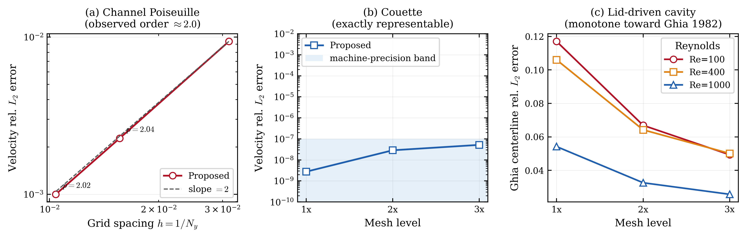
Figure 3. Accuracy under grid refinement: (a) observed second-order convergence for plane Poiseuille flow, (b) tolerance-level error for Couette flow, and (c) monotone decrease of the cavity error against the Ghia benchmark.

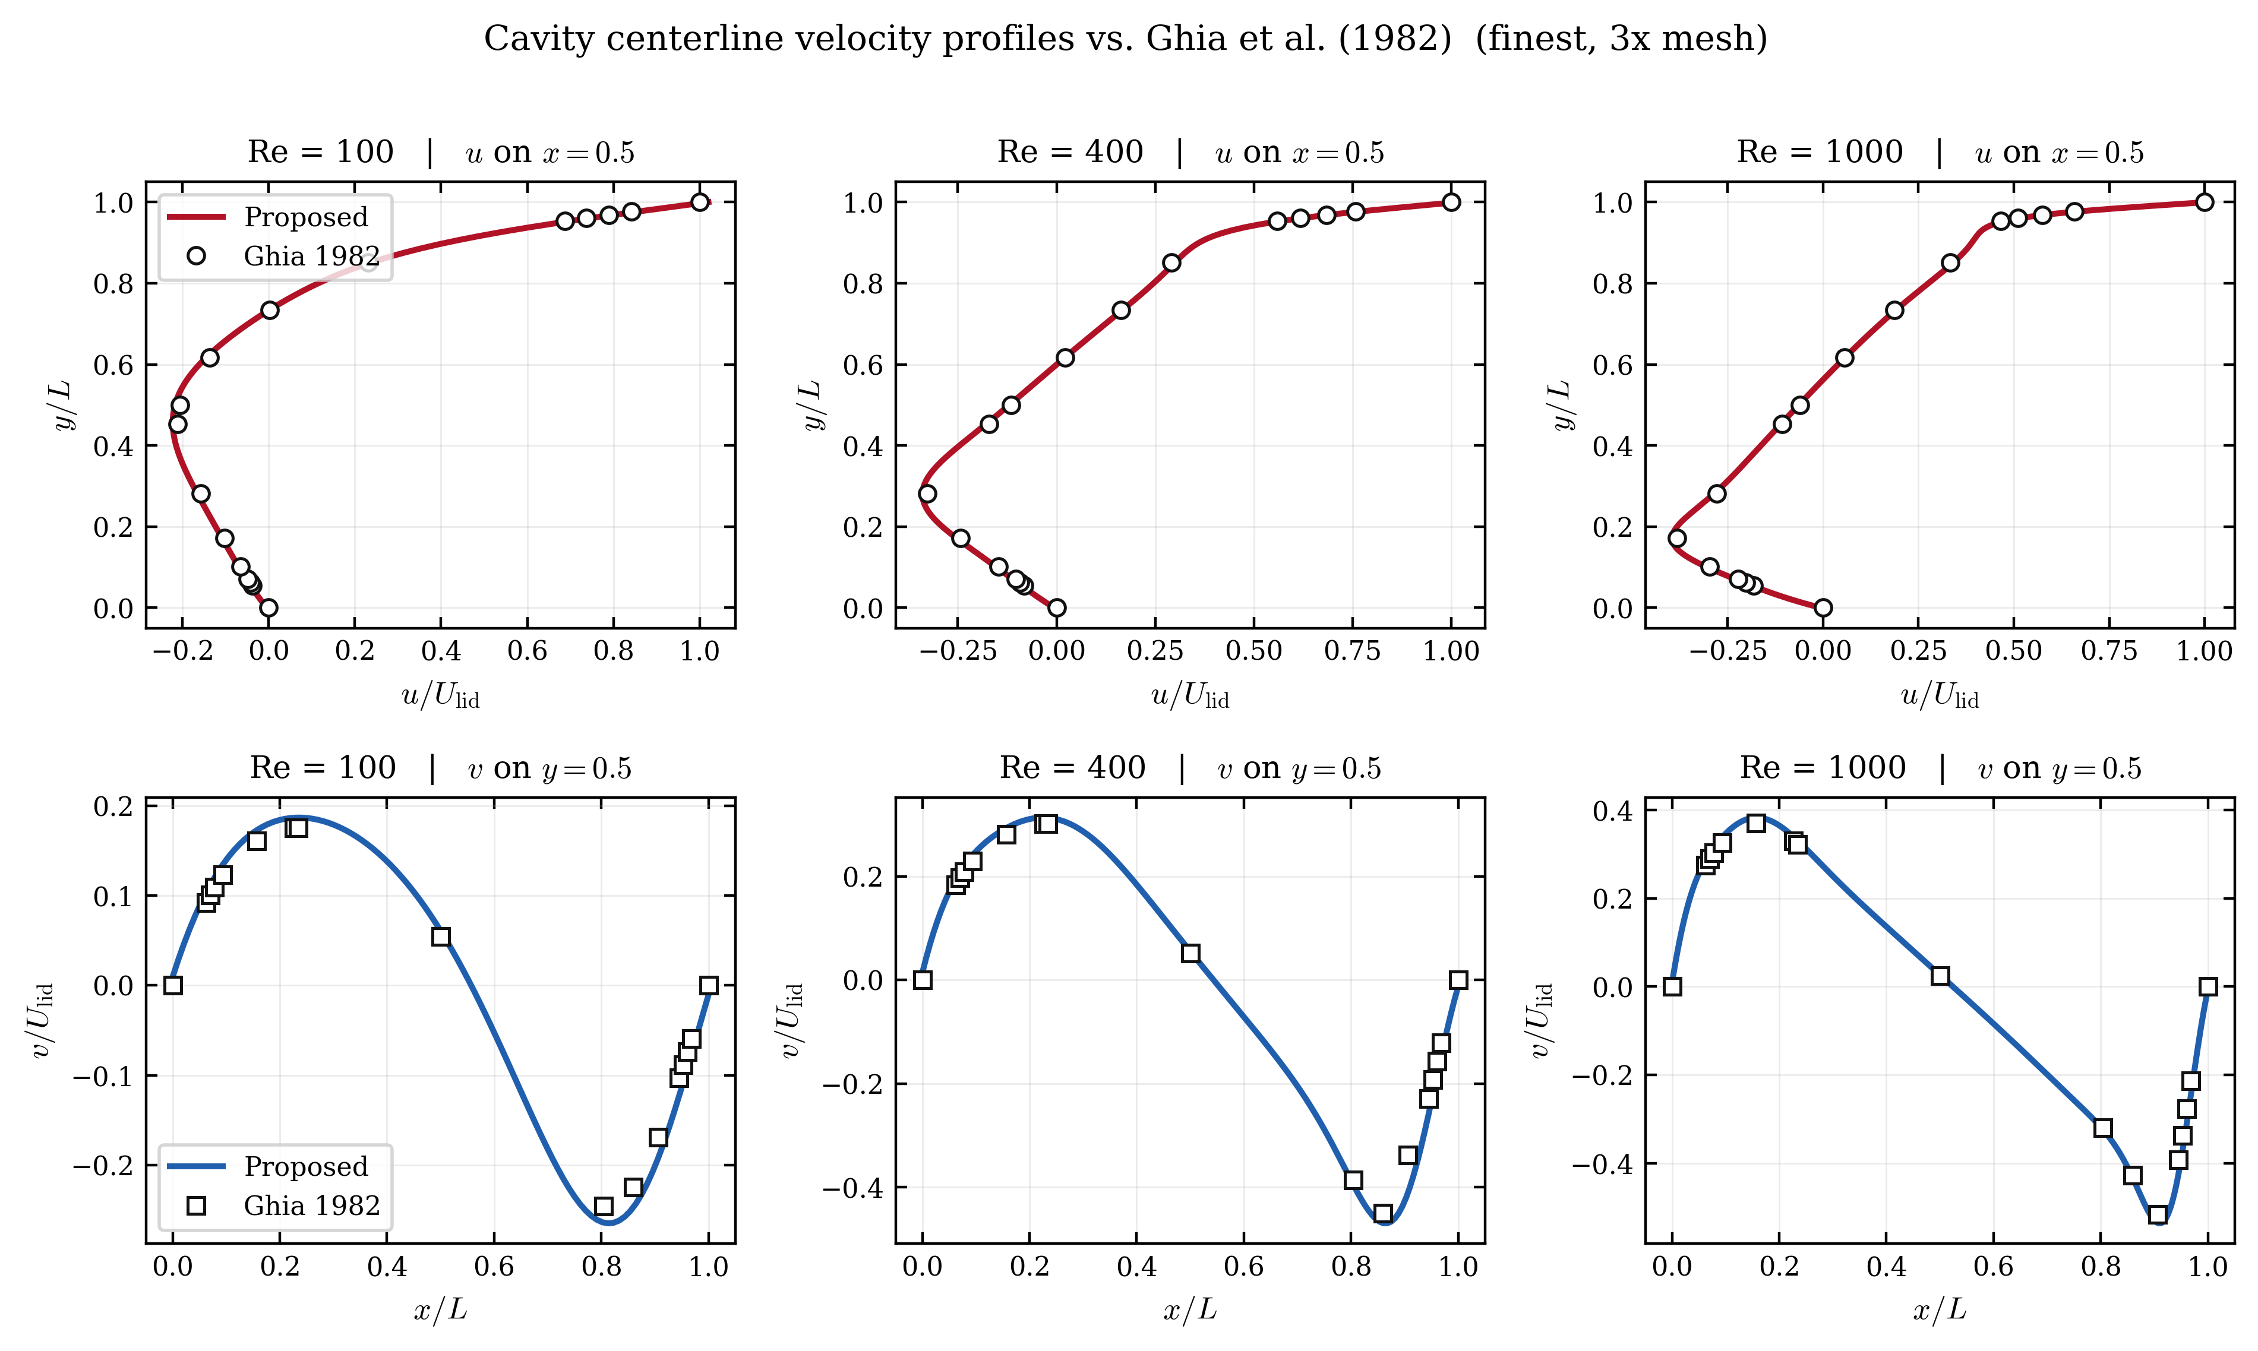
Figure 4. Centerline velocity profiles u(y) and v(x) of the cavity at the 3x level, compared with the Ghia benchmark [38] at Re = 100, 400, and 1000.

The analytic cases confirm that the acceleration preserves the accuracy of the underlying discretization. For plane Poiseuille flow, the relative L₂ error of the velocity profile is 9.37×10⁻³, 2.27×10⁻³, and 1.00×10⁻³ at N_{y} = 32, 64, 96, giving observed convergence orders of 2.04 and 2.02—matching the theoretical second-order accuracy of BGK-LBM (Figure 3a). For Couette flow, which the LBM equilibrium represents exactly, the measured relative L₂ error of 2.75×10⁻⁹–5.19×10⁻⁸ lies at the level of the convergence tolerance rather than of a discretization error (Figure 3b), confirming that the correction introduces no spurious bias. For the lid-driven cavity, the error against the Ghia centerline velocities decreases monotonically with refinement at all three Reynolds numbers (Figure 3c); because this error mixes discretization, boundary treatment, weak compressibility, and interpolation of the reference table, no formal order is claimed, but the solution converges consistently toward the literature benchmark, and the 3x centerline profiles closely follow the Ghia markers at all three Reynolds numbers (Figure 4).

Table 5. Accuracy of the proposed method at the 1x level, measured as the relative L₂ error of the converged field against the analytic, Ghia, or native LBE reference of each problem.
Problem | Rel. $L_{2}$ vs reference | Reference
Plane Poiseuille (N_y=32) | 9.371e-03 | Analytic
Couette (N=32) | 2.750e-09 | Analytic
Cavity Re=100 (N=33) | 0.117 | Ghia [38]
Cavity Re=400 (N=49) | 0.106 | Ghia [38]
Cavity Re=1000 (N=129) | 0.0542 | Ghia [38]
Multi-cylinder (N=32) | 4.146e-05 | Native LBE
Backward step (N=64) | 3.260e-03 | Native LBE
Cylinder wake (N=64) | 7.935e-05 | Native LBE
T-junction (N_x=96) | 1.896e-05 | Native LBE

The cavity Ghia errors in Table 5 (0.05–0.12) are larger than the ${10}^{-5}$-level differences of the other problems because they are evaluated at the coarsest (1x) level and combine the weak-compressibility model gap against the incompressible Ghia reference with reference-table interpolation; as shown in Figure 3c, this error decreases monotonically under refinement and is not a property of the acceleration.
For the four problems compared against the native LBE reference, the relative L2 difference measures directly whether the acceleration reaches the same discrete steady state. For the T-junction, multi-cylinder, and cylinder wake, the difference is at the 10⁻⁵ level (1.9×10⁻⁵, 4.1×10⁻⁵, and 7.9×10⁻⁵), confirming that the accelerated iteration arrives at the same fixed point rather than detouring to a different solution. The backward-facing step shows a larger difference of 3.26×10⁻³. This is likely dominated by the neighborhood of the step corner, where the geometry induces a locally singular velocity gradient at the continuous level [40]; both the accelerated solution and the reference resolve this region only to finite accuracy, so the two fields are expected to differ most there rather than globally. As stated in Section 3.1, no quantitative separation, reattachment, or wake metrics are evaluated for these problems.
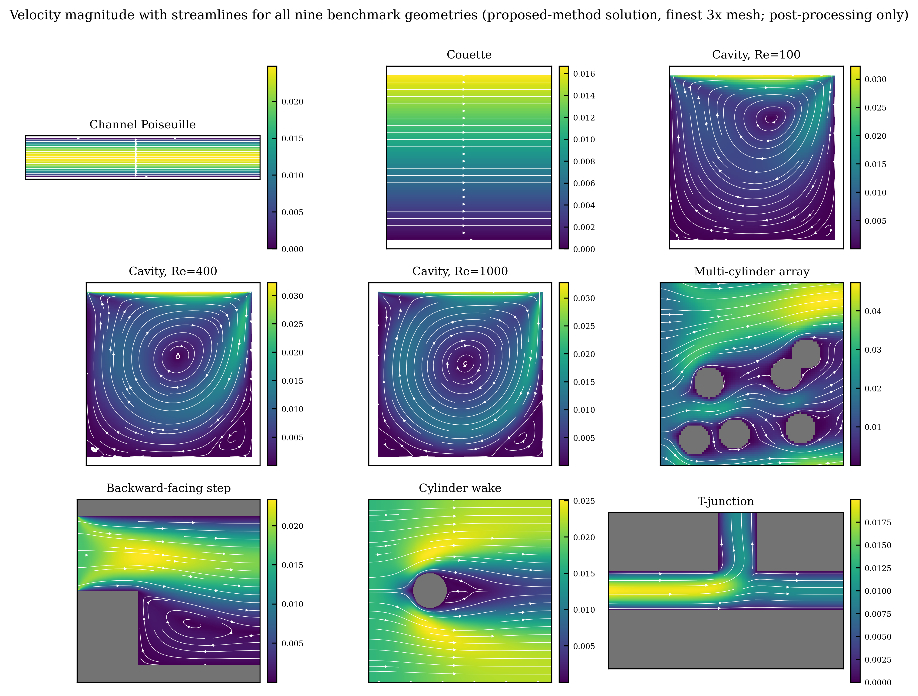
Figure 5. Velocity magnitude and streamlines of the proposed-method solutions for the nine problems at the 3x level, with solid obstacles shaded gray.
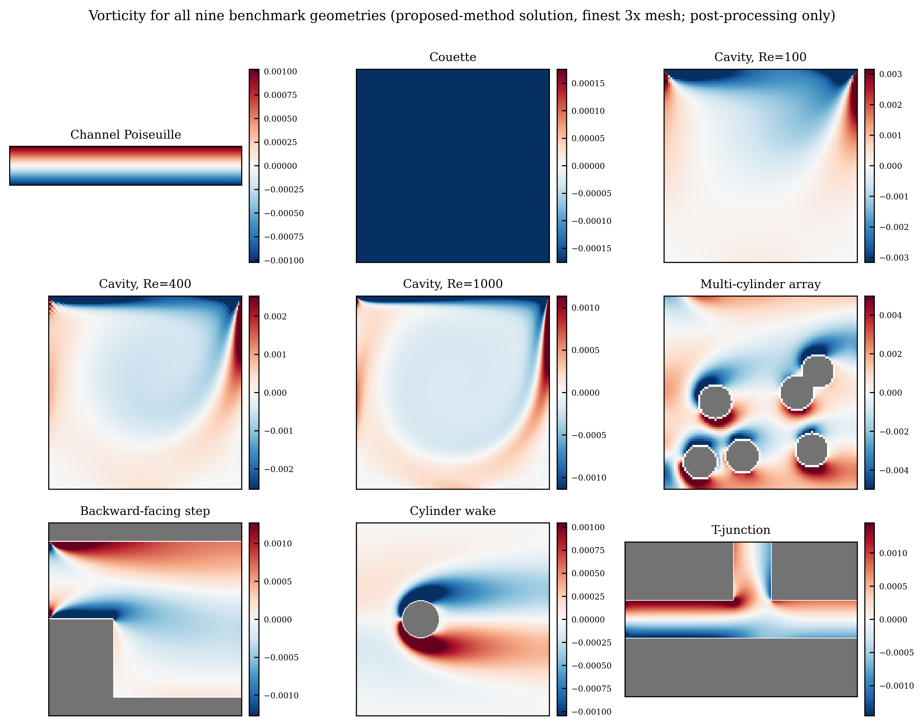
Figure 6. Vorticity fields of the proposed-method solutions for the nine problems at the 3x level.

Finally, Figures 5 and 6 show the velocity magnitude with streamlines and the vorticity fields of the proposed-method solutions for all nine problems on the 3x grids. Every problem reproduces its characteristic flow structure—the primary and secondary recirculation vortices of the cavity, the separation and reattachment of the backward-facing step, the shear layers of the cylinder wake, the flow division of the T-junction, and the bypass flow around the multiple cylinders—complementing the quantitative verification of Table 5.

3.5 Aggregate performance across the benchmark suite
Sections 3.3 and 3.4 compared the methods case by case. This section summarizes the twenty-seven cases collectively, first through performance profiles that rank the methods over the whole suite, then through the distribution of the per-case speed-up, and finally through the agreement of the accelerated solution with reference data.

3.5.1 Performance profiles
The per-case metrics of Section 3.3 are aggregated over the whole test suite by the performance profile of Dolan and Moré [43]. For a solver $s$ and a problem $p$ in the set $P$ of the twenty-seven benchmark cases, let $c_{p,s}$ denote the cost required by $s$ to satisfy the convergence criterion of Section 3.1 on problem $p$, with $c_{p,s}=∞$ when $s$ fails to converge. The performance ratio is
$$r_{p,s}=\frac{c_{p,s}}{\min_{s^{′}}c_{p,s^{′}}},$$
and the performance profile of $s$ is the cumulative distribution
$$ρ_{s}(τ)=\frac{|\{ p∈P:r_{p,s}≤τ \}|}{|P|}, τ≥1.$$
Here $ρ_{s}(1)$ is the fraction of cases on which $s$ is the fastest solver, the right-hand asymptote $\lim_{τ→∞}ρ_{s}(τ)$ is the fraction it solves at all, and a profile lying above all others indicates the preferred method. Figure 7 reports $ρ_{s}$ for two cost measures: wall-clock time, which reflects a specific implementation and machine, and native-operator (LBE) calls, which is hardware-independent and counts only evaluations of the collide–stream–boundary operator.
Under both measures the MSA-LBM profile lies above every baseline for all $τ$. Two features are quantitative. First, at $τ=1$ the MSA-LBM profile attains $0.963$ in wall-clock time and $0.926$ in operator calls: the proposed method is the fastest, or tied for fastest, on 26 and 25 of the 27 cases, respectively, whereas no baseline is fastest on more than one case. Second, the MSA-LBM profile reaches unity at $τ=1.56$ (wall-clock time) and $τ=1.28$ (operator calls), so on every case its cost is within a factor of $1.6$ of the best solver for that case. The baseline profiles instead saturate well below unity, at $0.44$ to $0.56$, because each baseline converges on only 12 to 15 of the 27 cases (Section 3.2); their right-hand asymptotes are exactly these solved fractions. The vertical gap between the MSA-LBM profile and the baselines at large $τ$ therefore measures robustness, and the horizontal gap at fixed $ρ$ measures efficiency. The proposed method dominates in both.
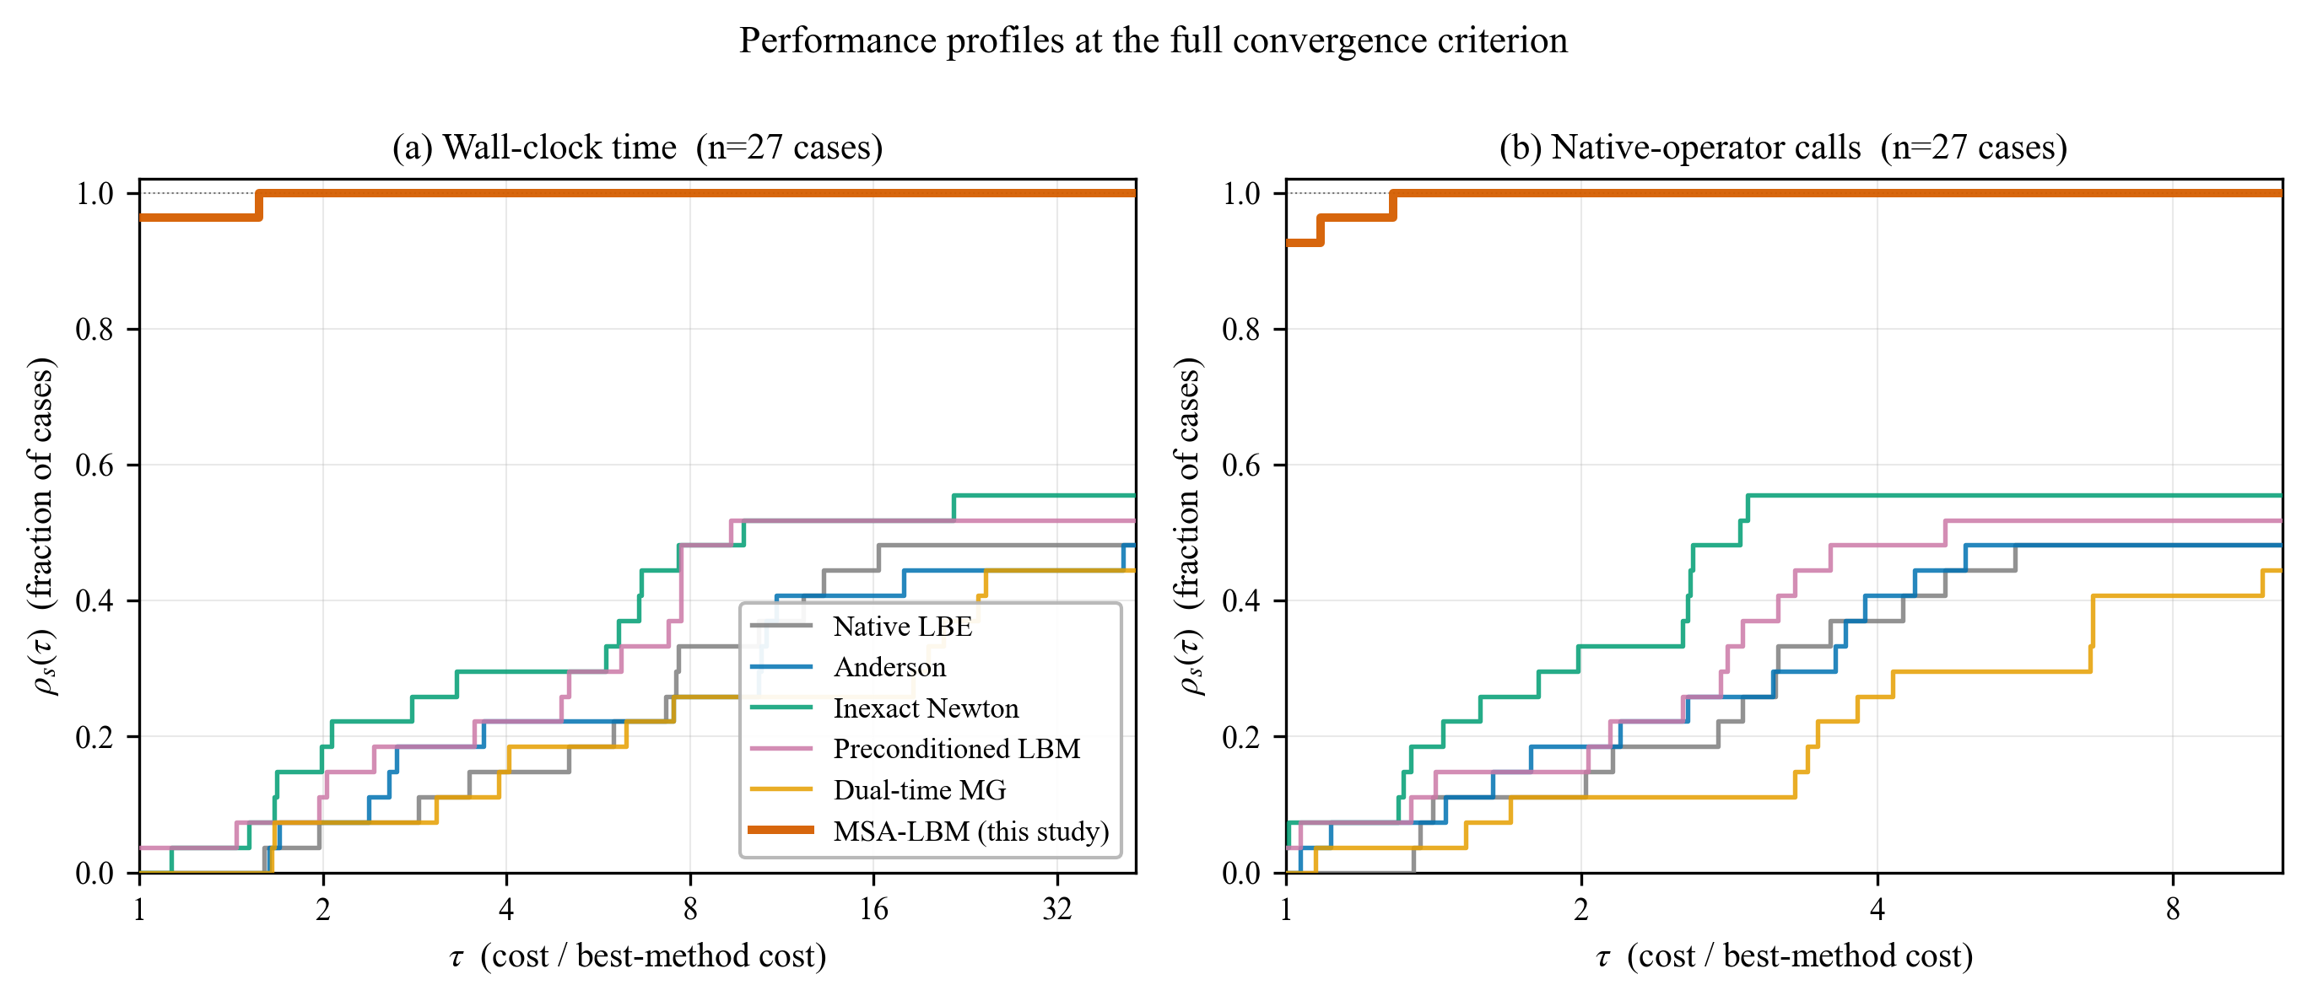
Figure 7. Performance profiles over the 27-case suite at the full convergence criterion, in (a) wall-clock time and (b) native-operator calls. $ρ_{s}(τ)$ is the fraction of cases solved by method $s$ within a factor $τ$ of the fastest method. MSA-LBM lies above all baselines for every $τ$, is fastest on 26/27 (wall) and 25/27 (calls) cases at $τ=1$, and reaches all cases by $τ≤1.56$; each baseline saturates at its solved fraction, 0.44–0.56.

3.5.2 Distribution of the per-case speed-up
The median speed-ups of Table 4 are point summaries of the distributions in Figure 8, which plots, for each baseline, the ratio of that baseline’s cost to the MSA-LBM cost to reach the common threshold $ε={10}^{−4}$ on each of the 27 cases. In wall-clock time the median speed-up ranges from $1.6×$ against the preconditioned LBM to $18.6×$ against dual-time multigrid, with the interquartile range spanning roughly a decade for the slowest baselines; in operator calls the medians are lower, from $1.2×$ to $3.8×$. The difference between the two measures is informative: the operator-call speed-up isolates the purely algorithmic gain, whereas the additional wall-clock advantage reflects the per-iteration overhead that Anderson mixing, the Krylov solve of the preconditioned method, and the dual-time sub-iterations incur beyond the native operator itself. The operator-call figure is thus the more conservative statement of the improvement.
A minority of cases fall below parity, and these are identified rather than omitted. They are confined to the analytically simple Couette and coarse channel flows, where native iteration already reaches the loose threshold $ε={10}^{−4}$ within a few tens of sweeps, before the dense per-mode factorization of the moment-Schur operator is amortized; the deepest instance is Couette flow at $0.28×$. This behaviour is a property of the loose threshold and the trivial cases: at the full convergence criterion (Figure 7) the proposed method is the fastest or tied on 26 of 27 cases, and the sub-parity instances disappear. The advantage widens as the tolerance is tightened and as the Reynolds number increases, which is the regime of practical interest.
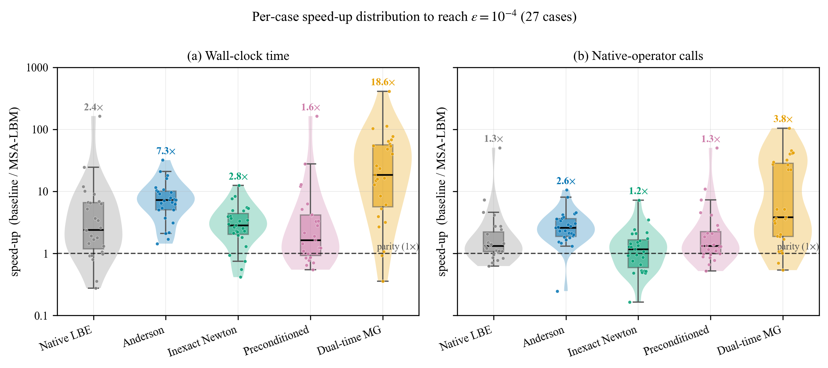
Figure 8. Distribution of the per-case speed-up of MSA-LBM over each baseline to reach $ε={10}^{−4}$, across the 27 cases (violin: kernel density; box: quartiles; points: individual cases; dashed line: parity). Bold labels give the medians of Table 4. (a) wall-clock time; (b) native-operator calls.

3.5.3 Agreement with reference data
Acceleration is useful only if it does not change the solution. Two distinct notions of agreement are examined in Figure 9. Panel (a) tests agreement with an independent benchmark: the MSA-LBM velocity along the vertical centreline of the lid-driven cavity is plotted against the tabulated data of Ghia et al. [38] for $Re=100$, $400$, and $1000$. The points collapse onto the line of perfect agreement with a root-mean-square deviation of $8.8×{10}^{−3}$ in units of the lid speed, consistent with the second-order spatial accuracy of Section 3.4 on these grids; the accelerated method reproduces the benchmark to discretization accuracy.
Panel (b) tests a stronger property: that the accelerated iteration converges to the same numerical fixed point as the unaccelerated native LBE, rather than to a nearby spurious state. The MSA-LBM velocity magnitude is plotted against the reference solution node by node, pooled over $149 385$ fluid nodes from six cases spanning channel, Couette, cylinder-wake, backward-step, multi-cylinder, and T-junction geometries. The maximum nodewise deviation is $4.3×{10}^{−5}$, four orders of magnitude below the panel-(a) discretization error and of the order of the convergence tolerance itself. The admissibility gate therefore alters only the path to the fixed point, not its location: the proposed method solves the same discrete system as native LBE, and does so on the full suite, including the twelve cases on which every baseline fails to converge.
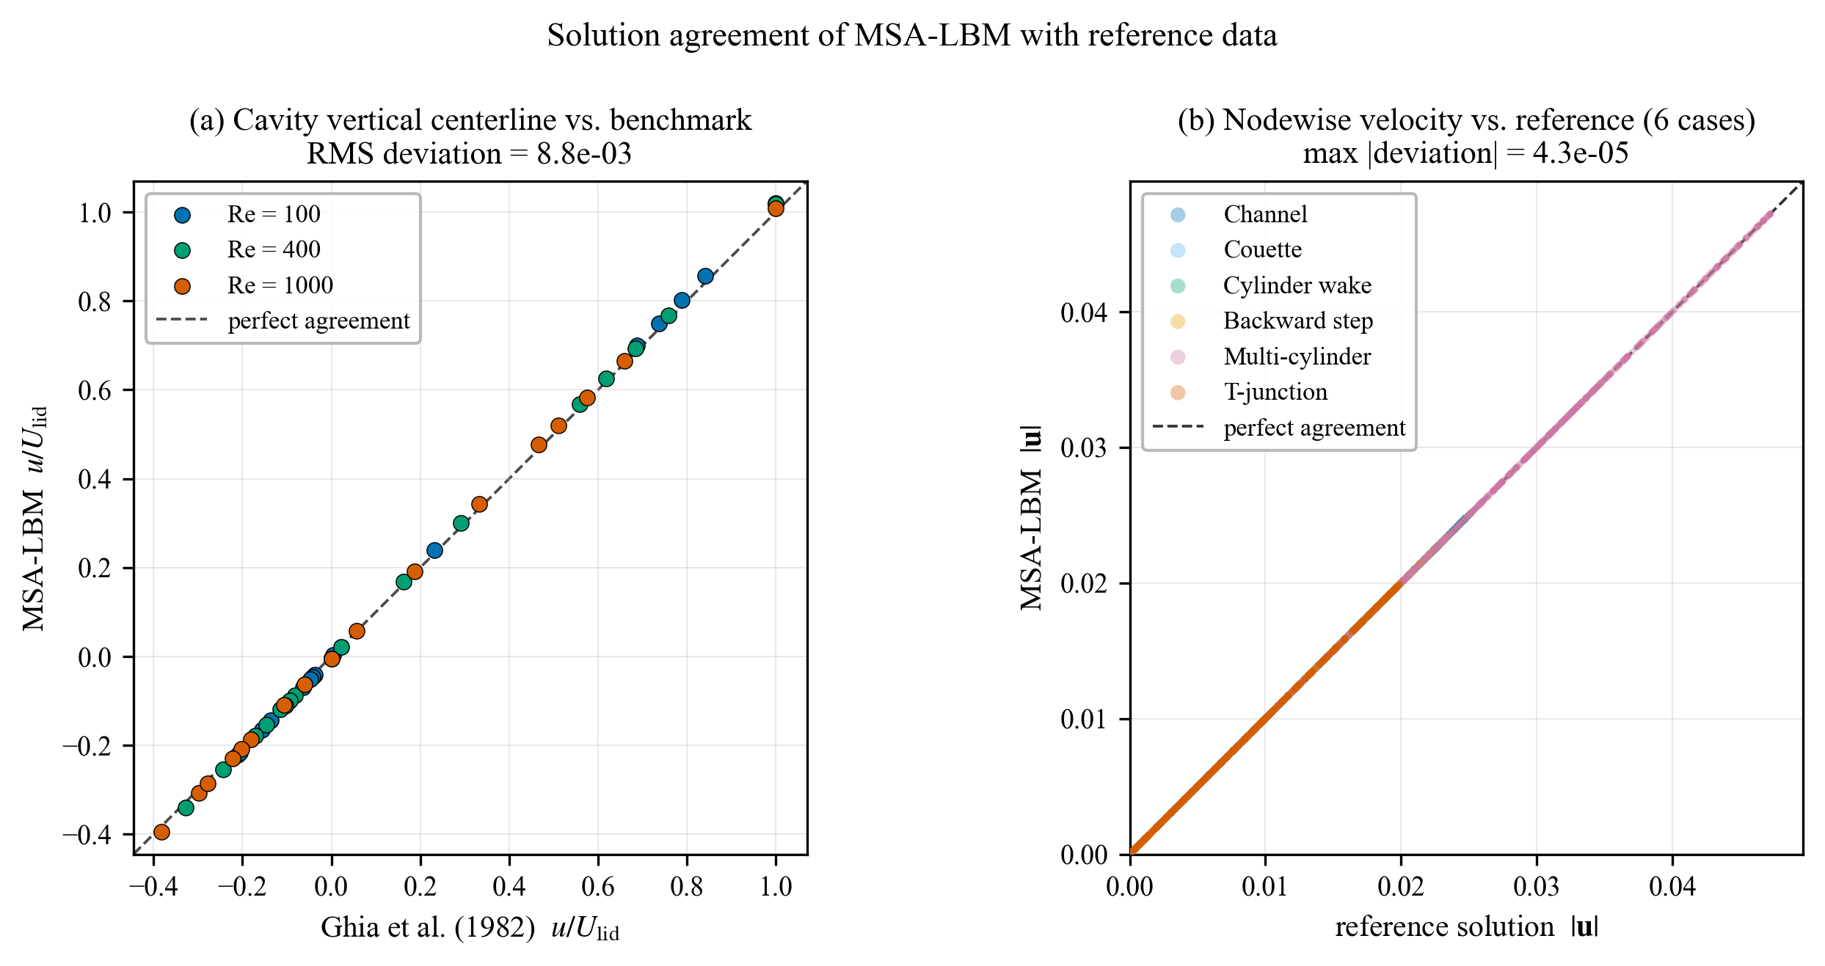
Figure 9. Agreement of the MSA-LBM solution with reference data. (a) Cavity vertical-centreline velocity against Ghia et al. [38] for three Reynolds numbers (RMS deviation $8.8×{10}^{−3}$). (b) Nodewise velocity magnitude against the reference fixed point, pooled over $149 385$ fluid nodes from six geometries (maximum deviation $4.3×{10}^{−5}$). Dashed line: perfect agreement.

4. Conclusion
This work proposed and validated MSA-LBM, a nonlinear acceleration technique that preconditions the pressure–velocity hydrodynamic slow mode—the convergence bottleneck of the steady-state lattice Boltzmann method—from the conserved-moment Schur-complement viewpoint. It leaves the native residual and boundary operators unchanged: it projects the residual onto the conserved-moment subspace, forms a Jacobian-free trial direction there, and accepts it only through an admissibility gate (density positivity, finiteness, boundary consistency, residual decrease), reverting to a native update otherwise. Because every residual evaluation passes through the same native operator $G(f)$, consistency with complex masks and boundaries is automatic and the approximate correction cannot compromise the converged solution. The moment-Schur candidate is accepted in 71.0% of outer rounds overall, with no zero-acceptance run (Section 3.2.1), isolating the correction—rather than the native fallback—as the source of the gain.
The principal outcome is robustness: under an identical protocol and a generous budget the proposed method converges on all 27 cases, whereas the five baselines converge on only 12–15 each, their non-convergence arising from numerical stagnation rather than budget exhaustion. The gap is largest on slow-mode-dominated problems such as the high-Reynolds cavity, where the proposed method penetrates the common baseline residual floor with fewer operations. Its convergence history—a sharp drop, a long near-stagnation, then a terminal collapse consistent with the residual squaring of a Newton step—establishes that the correction acts as a genuine Newton step the linearly convergent baselines cannot reproduce.
The scope is limited to comparisons of convergence time, operator work, residual, and reference-solution error on the 2D D2Q9/BGK steady benchmark suite. The method does not remove discretization or boundary-condition error; it reaches the discrete solution faster. Wall time depends on CPU generation, memory bandwidth, and library, so it is read as a relative metric within one environment and complemented by the deterministic operator-work (LBE-call) metric. For problems with a weak global slow mode (simple shear) or dominant boundary-driven local modes, the per-iteration correction cost is not amortized and the marginal gain becomes small; that both favorable and unfavorable cases follow from the same slow-mode-dominance mechanism supports its predictive power. Future work includes shortening the near-stagnation phase through the inner-Krylov dimension and an adaptive inner tolerance, extension to 3D, MRT/entropic collision models, and the high-Reynolds turbulent regime, and a quantitative evaluation of open-boundary flux conservation.

Appendix
Appendix A. Complete per-run results and supplementary convergence histories
A.1 Complete results of the 27 runs. Table A1 lists every proposed-method run individually: the wall time and LBE-call count to full convergence, the final residual r_{macro}, the residual reduction relative to the initial value r/r₀, and, where a reference is available, the relative L₂ error of the converged field. Entries marked "—" denote runs for which no reference field is available at that level; they indicate the absence of a post-solve accuracy evaluation, not a failure or a zero error, and the convergence of those runs was established independently by the three criteria of Section 3.1. The LBE-call counts of cavity Re = 400 at 2x, cavity Re = 100 at 3x, and cavity Re = 1000 at 2x and 3x exceed the nominal per-run step budget because these runs were continued under the identical stopping rule; the cost of the continued segments is fully included in the reported wall times and LBE-calls.

Table A1. Complete results of the 27 proposed-method runs: wall time and LBE-calls to full convergence, final residual, residual reduction r/r₀, and relative L₂ error against the reference where available.
Level | Problem | Wall [s] | LBE-calls | Final r_{macro} | r/r₀ | Rel. L₂ vs ref. | Reference
1x | Plane Poiseuille | 20.30 | 32,666 | 3.38e-13 | 4.34e-11 | 9.37e-03 | Analytic
1x | Couette | 1.20 | 20,606 | 2.18e-12 | 4.63e-11 | 2.75e-09 | Analytic
1x | Cavity Re = 100 | 0.70 | 20,873 | 1.93e-13 | 1.02e-12 | 0.117 | Ghia [38]
1x | Cavity Re = 400 | 3.06 | 44,379 | 2.04e-11 | 9.69e-11 | 0.106 | Ghia [38]
1x | Cavity Re = 1000 | 56.84 | 221,413 | 2.36e-09 | 7.91e-09 | 0.0542 | Ghia [38]
1x | Backward-facing step | 27.66 | 122,673 | 2.47e-08 | 7.55e-08 | 3.26e-03 | Native LBE
1x | Cylinder wake | 4.88 | 20,251 | 9.88e-15 | 4.02e-14 | 7.94e-05 | Native LBE
1x | Multi-cylinder | 1.25 | 20,377 | 2.14e-12 | 5.70e-12 | 4.15e-05 | Native LBE
1x | T-junction | 18.29 | 32,054 | 2.63e-13 | 7.18e-12 | 1.90e-05 | Native LBE
2x | Plane Poiseuille | 185.70 | 105,281 | 1.90e-13 | 9.73e-11 | 2.27e-03 | Analytic
2x | Couette | 21.78 | 101,554 | 3.31e-12 | 9.92e-11 | 2.87e-08 | Analytic
2x | Cavity Re = 100 | 5.78 | 41,793 | 8.74e-12 | 7.56e-11 | 0.0669 | Ghia [38]
2x | Cavity Re = 400 | 309.99 | 1,257,000 | 4.46e-09 | 3.34e-08 | 0.0642 | Ghia [38]
2x | Cavity Re = 1000 | 829.72 | 1,440,003 | 4.87e-14 | 4.79e-07 | 0.0326 | Ghia [38]
2x | Backward-facing step | 74.97 | 119,793 | 6.41e-08 | 2.76e-07 | — | —
2x | Cylinder wake | 16.16 | 23,184 | 1.43e-11 | 8.14e-11 | — | —
2x | Multi-cylinder | 5.77 | 20,471 | 1.65e-14 | 6.11e-14 | — | —
2x | T-junction | 96.70 | 63,535 | 1.26e-12 | 1.00e-10 | — | —
3x | Plane Poiseuille | 798.11 | 222,772 | 7.81e-14 | 8.98e-11 | 1.00e-03 | Analytic
3x | Couette | 133.55 | 296,454 | 2.63e-12 | 9.66e-11 | 5.19e-08 | Analytic
3x | Cavity Re = 100 | 180.17 | 769,000 | 1.20e-10 | 1.35e-09 | 0.0493 | Ghia [38]
3x | Cavity Re = 400 | 74.00 | 233,779 | 1.57e-08 | 1.50e-07 | 0.0501 | Ghia [38]
3x | Cavity Re = 1000 | 1,234.14 | 1,440,085 | 2.56e-10 | 6.64e-07 | 0.0257 | Ghia [38]
3x | Backward-facing step | 756.37 | 866,000 | 1.29e-10 | 6.79e-10 | — | —
3x | Cylinder wake | 36.78 | 41,868 | 1.15e-11 | 8.01e-11 | — | —
3x | Multi-cylinder | 10.37 | 21,265 | 1.48e-12 | 6.57e-12 | — | —
3x | T-junction | 283.69 | 89,398 | 5.29e-13 | 7.79e-11 | — | —

Wall time is not monotone in the mesh level for every problem (for example, cavity Re = 400 converges faster at 3x than at 2x): the total cost depends on when the terminal Newton step of Section 3.2.1 is accepted, which varies between levels.
A.2 Supplementary convergence histories. Figures A1 and A2 show the residual histories of all six methods at the 1x and 3x mesh levels, complementing the 2x histories of Figure 2. The partition of Section 3.2.1 is unchanged at both levels: no baseline converges on the three cavities or the backward-facing step, while the proposed method converges on all nine problems.
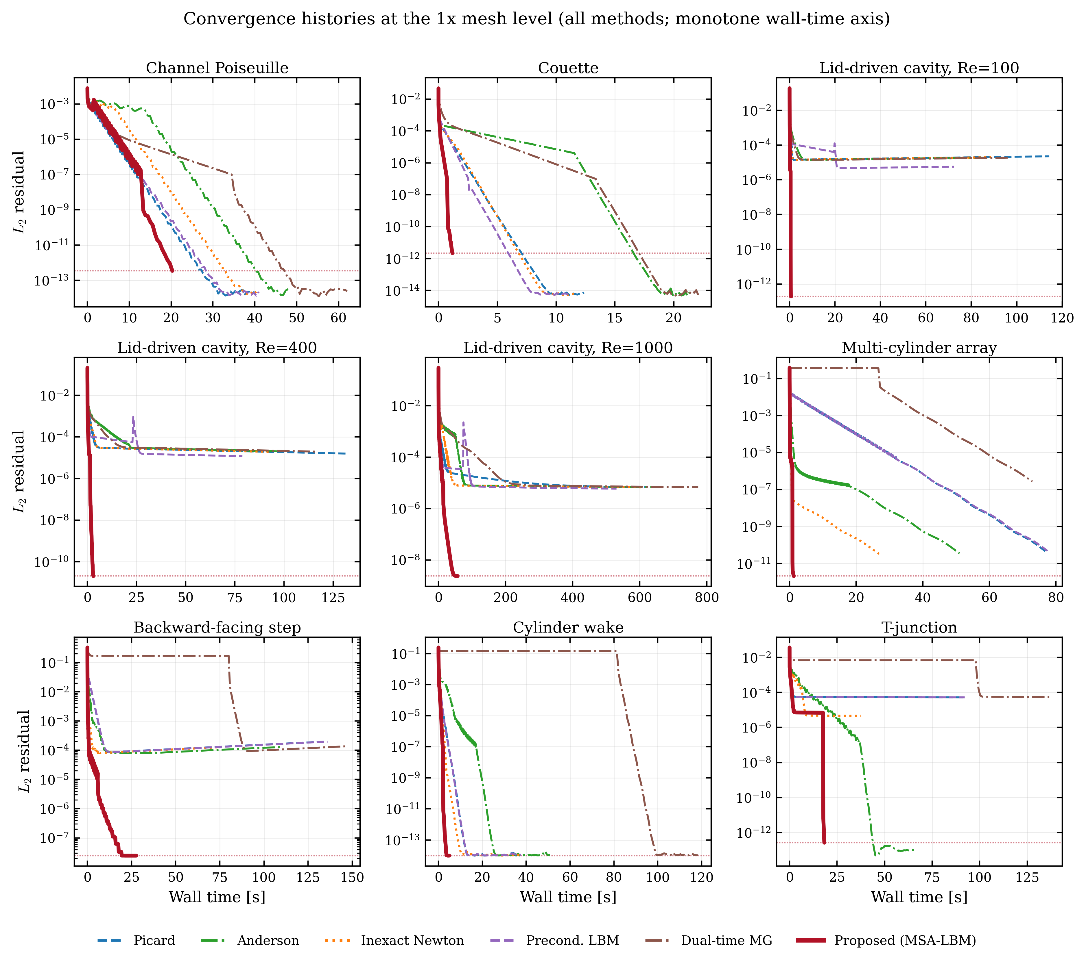
Figure A1. Residual histories (r_{macro}versus wall time) of the six methods for the nine benchmark problems at the 1x mesh level.
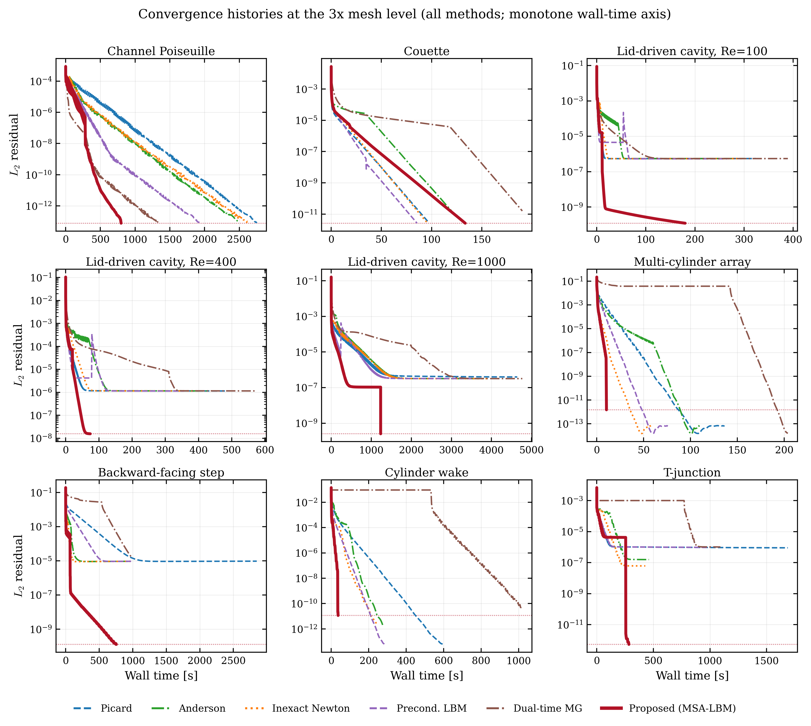
Figure A2. Residual histories (r_{macro}versus wall time) of the six methods for the nine benchmark problems at the 3x mesh level.

Appendix B. Benchmark problem specifications
B.1 Common settings. All problems use the D2Q9 lattice with the BGK collision operator in lattice units (Δ x = Δ t = 1), initial density ρ = 1, and relaxation time τf = 3ν + 1/2. Refinement from level 1x to level L (L = 2, 3) multiplies every linear dimension by L and every prescribed velocity by 1/L, so that the Reynolds number of each problem is the same at all three levels while the Mach number decreases with refinement. The boundary conditions follow the Zou–He velocity/pressure formulation [41] and the (momentum-corrected) bounce-back rules [42]. The convergence tolerances are given in Section 3.1. Table B1 lists the domain, physical parameters, initial condition, and boundary conditions of every problem; all velocities and viscosities are quoted at the 1x level in lattice units.

Table B1. Specifications of the nine benchmark problems at the 1x level, with all velocities scaled by 1/L and all dimensions by L at mesh level L.
Problem | Domain (1x) | ν | Velocity | Re | Initial condition | Boundary conditions
Plane Poiseuille | 32 × 192 | 0.05 | ū_{in} = 0.05 | ≈32 | Parabolic profile 6ū,η(1-η) | Zou–He velocity inlet (left); Zou–He pressure outlet (right); full-way bounce-back walls (top/bottom)
Couette | 32² | 0.05 | U_{wall} = 0.05 | ≈32 | Rest | Periodic in x; full-way bounce-back bottom wall; momentum-corrected bounce-back moving top wall
Cavity (Re = 100/400/1000) | 33²/49²/129² | from Re | U_{lid} = 0.1 | 100/400/1000 | Rest | Link-wise bounce-back on three stationary walls; momentum-corrected bounce-back at the moving lid
Backward-facing step | 64² | 0.05 | U_{in} = 0.05 | 26 | Uniform u_{x} = U_{in} (equilibrium) | Zou–He velocity inlet (left); extrapolation outlet (right); bounce-back at all wall and mask surfaces
Cylinder wake | 64² | 0.04 | U_{in} = 0.05 | 15 | Uniform u_{x} = U_{in} (equilibrium) | Same as backward-facing step
Multi-cylinder | 32² | 0.05 | U_{in} = 0.05 | ≈5 | Uniform u_{x} = U_{in} (equilibrium) | Same as backward-facing step
T-junction | 96 × 64 | 0.05 | U_{in} = 0.04 | 13 | Uniform inlet-velocity equilibrium in the fluid region | Zou–He velocity inlet (left); Zou–He pressure outlets (right and top branches); bounce-back at all mask surfaces

The Reynolds numbers are based on the channel height (Poiseuille), the wall gap (Couette), the cavity side length, the step height (backward-facing step), the cylinder diameter (cylinder wake and multi-cylinder), and the branch width (T-junction).
B.2 Mask geometries. The masked problems are defined on the unit square [0,1]² in physical coordinates and rasterized at lattice cell centers, so that all three mesh levels represent the same geometry at different resolutions. The backward-facing step has solid walls of thickness 6/64 along the top and bottom boundaries and a solid block occupying x < 1/3, y < 1/2, giving a step height of 0.40625 (26 cells at 1x) and an expansion ratio of 2.0. The cylinder wake contains a single cylinder of radius 6/64 centered at (1/3, 1/2), giving a diameter of 12 cells at 1x. The multi-cylinder problem contains six cylinders of radius 1/12 centered at (0.1875, 0.1406), (0.4063, 0.1719), (0.2656, 0.4531), (0.6875, 0.5), (0.7656, 0.2031), and (0.7969, 0.6094). The T-junction consists of a horizontal channel and a vertical branch of common width W (W = 16 cells at 1x), with the inlet on the left and outlets at the right and top ends.

Appendix C. Sensitivity to the preconditioner parameters
The spectral preconditioner of Section 2.3 contains two internal constants: the kinetic-null-space correction coefficient κ(ω) of Eq. (14), clipped to |κ|≤ 1/4, and the Tikhonov factor C_{η} that sets the per-mode regularization η = σ_{max}/C_{η} in Eq. (15), fixed to C_{η} = 50 in all runs. This appendix establishes that neither constant affects the converged solution and that the reported value of C_{η} is a robust choice rather than a tuned one.
C.1 Invariance of the converged solution. The preconditioner enters the algorithm only as the left preconditioner of the Jacobian-free Newton step, and every trial update is accepted only if it decreases the native residual R(f)=f-G(f) and passes the admissibility gate. The constants κ and C_{η} therefore influence only the search direction and the rate of convergence, never the set of admissible fixed points, which is defined entirely by R(f)=0. For the steady laminar problems considered here the fixed point is unique, so two runs differing only in the preconditioner constants converge to the same R(f)=0. This invariance is not merely qualitative. By the stopping criterion of Section 3.1, any converged state satisfies r_{macro}≤ 5τ; two such runs therefore report states lying within an r_{macro}≤ 5τ neighborhood of the same native fixed point, and so agree in their macroscopic pressure and velocity fields to O(5τ)—that is, to the common stopping tolerance, 2.5×10⁻⁸ to 5×10⁻⁷ depending on the problem. The constants thus set how quickly the tail of Section 3.2.1 is traversed, not where it terminates.
C.2 Choice of C_{η}. The Tikhonov factor controls a trade-off between the conditioning of the per-mode 3× 3 operator and the fidelity of the preconditioner. Because the preconditioner is built from a linearization about the uniform base state, its per-mode operator depends only on the collision rate ω=1/τ_{f} and not on the Reynolds number directly. Table C1 therefore reports, for four values of ω that span the viscosities of the benchmark suite, the worst-mode condition number of the regularized operator S_{m}^{reg}—the largest condition number over all wavenumbers k—as a function of C_{η}. The condition number grows monotonically with C_{η}, from about 5 at C_{η} = 20 to about 37 at C_{η} = 1000. A larger C_{η} improves the linear approximation of S_{m}⁻¹ but worsens the conditioning, which amplifies the noise of the finite-difference Jacobian–vector products evaluated inside GMRES; a smaller C_{η} is better conditioned but a weaker preconditioner. The value C_{η} = 50 keeps the operator well conditioned, with a worst-mode condition number of about 8 across the suite, while still yielding a per-mode preconditioned amplification below unity at every wavenumber. Because the correction is validated by the native residual (Section C.1), moderate departures from this value change only the convergence rate, not the solution; C_{η} was fixed at 50 for every problem.

Table C1. Worst-mode condition number—the maximum over all wavenumbers k—of the regularized per-mode Schur operator S_{m}^{reg} as a function of the Tikhonov factor C_{η}, at four collision rates ω spanning the benchmark viscosities. The linearized preconditioner depends on ω alone, not on the Reynolds number.
C_{η} | ω = 1.54 | ω = 1.61 | ω = 1.67 | ω = 1.86
20 | 4.8 | 4.9 | 5.0 | 5.2
50 | 7.6 | 7.7 | 7.8 | 8.2
100 | 10.7 | 11.0 | 11.1 | 11.7
1000 | 34.0 | 34.8 | 35.4 | 37.3

C.3 The correction coefficient κ. The coefficient κ(ω) is not a free parameter. As shown in Section 2.3, the bracketed term it multiplies in Eq. (14) is exactly the moment-to-kinetic-to-moment coupling MA(k)(I₉-TM)A(k)T, and approximating the kinetic-block inverse J_{kk}⁻¹ by the scalar κ(ω)=1/2 sign(r)min(1/2,|r|), with r=(1-ω)/ω, reconstructs the term -J_{mk}J_{kk}⁻¹J_{km} omitted by the Galerkin reduction to first order. The clip |κ|≤ 1/4 bounds the correction as ω→ 0, where r→∞, and prevents the regularized operator from becoming indefinite. Disabling the correction reduces the preconditioner to its Galerkin form; by the invariance of Section C.1 this leaves the converged solution unchanged and affects only the convergence rate.

Acknowledgements
The author thanks colleagues for helpful discussions on lattice Boltzmann steady-state solvers and Krylov preconditioning. (Funding sources and institutional support to be added.)

References
[1] Qian, Y. H., d’Humières, D., & Lallemand, P. (1992). Lattice BGK models for Navier-Stokes equation. Europhysics Letters, 17(6), 479–484. https://doi.org/10.1209/0295-5075/17/6/001
[2] Chen, S., & Doolen, G. D. (1998). Lattice Boltzmann method for fluid flows. Annual Review of Fluid Mechanics, 30, 329–364. https://doi.org/10.1146/annurev.fluid.30.1.329
[3] Succi, S. (2001). The Lattice Boltzmann Equation for Fluid Dynamics and Beyond. Oxford University Press.
[4] Lallemand, P., & Luo, L.-S. (2000). Theory of the lattice Boltzmann method: Dispersion, dissipation, isotropy, Galilean invariance, and stability. Physical Review E, 61, 6546–6562. https://doi.org/10.1103/PhysRevE.61.6546
[5] Krüger, T., Kusumaatmaja, H., Kuzmin, A., Shardt, O., Silva, G., & Viggen, E. M. (2017). The Lattice Boltzmann Method: Principles and Practice. Springer. https://doi.org/10.1007/978-3-319-44649-3
[6] Mavriplis, D. J. (2006). Multigrid solution of the steady-state lattice Boltzmann equation. Computers & Fluids, 35(8–9), 793–804. https://doi.org/10.1016/j.compfluid.2005.07.020
[7] Verberg, R., & Ladd, A. J. C. (1999). Simulation of low-Reynolds-number flow via a time-independent lattice-Boltzmann method. Physical Review E, 60(3), 3366–3373. https://doi.org/10.1103/PhysRevE.60.3366
[8] Guo, Z., Zhao, T. S., & Shi, Y. (2004). Preconditioned lattice-Boltzmann method for steady flows. Physical Review E, 70(6), 066706. https://doi.org/10.1103/PhysRevE.70.066706
[9] Premnath, K. N., Pattison, M. J., & Banerjee, S. (2009). Steady state convergence acceleration of the generalized lattice Boltzmann equation with forcing term through preconditioning. Journal of Computational Physics, 228(3), 746–769. https://doi.org/10.1016/j.jcp.2008.09.028
[10] Turkel, E. (1987). Preconditioned methods for solving the incompressible and low speed compressible equations. Journal of Computational Physics, 72(2), 277–298. https://doi.org/10.1016/0021-9991(87)90084-2
[11] Turkel, E. (1999). Preconditioning techniques in computational fluid dynamics. Annual Review of Fluid Mechanics, 31, 385–416. https://doi.org/10.1146/annurev.fluid.31.1.385
[12] Walker, H. F., & Ni, P. (2011). Anderson acceleration for fixed-point iterations. SIAM Journal on Numerical Analysis, 49(4), 1715–1735. https://doi.org/10.1137/10078356X
[13] Tóth, A., & Kelley, C. T. (2015). Convergence analysis for Anderson acceleration. SIAM Journal on Numerical Analysis, 53(2), 805–819. https://doi.org/10.1137/130919398
[14] Anderson, D. G. (1965). Iterative procedures for nonlinear integral equations. Journal of the ACM, 12(4), 547–560. https://doi.org/10.1145/321296.321305
[15] Sidi, A. (1986). Convergence and stability properties of minimal polynomial and reduced rank extrapolation algorithms. SIAM Journal on Numerical Analysis, 23(1), 197–209. https://doi.org/10.1137/0723014
[16] Saad, Y., & Schultz, M. H. (1986). GMRES: A generalized minimal residual algorithm for solving nonsymmetric linear systems. SIAM Journal on Scientific and Statistical Computing, 7(3), 856–869. https://doi.org/10.1137/0907058
[17] Knoll, D. A., & Keyes, D. E. (2004). Jacobian-free Newton-Krylov methods: A survey of approaches and applications. Journal of Computational Physics, 193(2), 357–397. https://doi.org/10.1016/j.jcp.2003.08.010
[18] Saad, Y. (2003). Iterative Methods for Sparse Linear Systems (2nd ed.). SIAM.
[19] Dembo, R. S., Eisenstat, S. C., & Steihaug, T. (1982). Inexact Newton methods. SIAM Journal on Numerical Analysis, 19(2), 400–408. https://doi.org/10.1137/0719025
[20] Eisenstat, S. C., & Walker, H. F. (1996). Choosing the forcing terms in an inexact Newton method. SIAM Journal on Scientific Computing, 17(1), 16–32. https://doi.org/10.1137/0917003
[21] Huang, J., Yang, C., & Cai, X.-C. (2015). A fully implicit method for lattice Boltzmann equations. SIAM Journal on Scientific Computing, 37(5), S291–S313. https://doi.org/10.1137/140975346
[22] Huang, J., Yang, C., & Cai, X.-C. (2016). A nonlinearly preconditioned inexact Newton algorithm for steady state lattice Boltzmann equations. SIAM Journal on Scientific Computing, 38(3), A1701–A1724. https://doi.org/10.1137/15M1028078
[23] Noble, D. R., & Holdych, D. J. (2007). Full Newton lattice Boltzmann method for time-steady flows using a direct linear solver. International Journal of Modern Physics C, 18(4), 652–660.
[24] Hübner, T., & Turek, S. (2010). Efficient monolithic simulation techniques for the stationary lattice Boltzmann equation on general meshes. Computing and Visualization in Science, 13, 129–143. https://doi.org/10.1007/s00791-009-0132-6
[25] Benzi, M., Golub, G. H., & Liesen, J. (2005). Numerical solution of saddle point problems. Acta Numerica, 14, 1–137. https://doi.org/10.1017/S0962492904000212
[26] Olshanskii, M. A., & Vassilevski, Y. V. (2007). Pressure Schur complement preconditioners for the discrete Oseen problem. SIAM Journal on Scientific Computing, 29(6), 2686–2704. https://doi.org/10.1137/070679776
[27] Elman, H. C., Silvester, D. J., & Wathen, A. J. (2014). Finite Elements and Fast Iterative Solvers: With Applications in Incompressible Fluid Dynamics (2nd ed.). Oxford University Press.
[28] Izquierdo, S., & Fueyo, N. (2009). Optimal preconditioning of lattice Boltzmann methods. Journal of Computational Physics, 228(17), 6479–6495. https://doi.org/10.1016/j.jcp.2009.05.040
[29] Hajabdollahi, F., & Premnath, K. N. (2018). Galilean-invariant preconditioned central-moment lattice Boltzmann method without cubic velocity errors for efficient steady flow simulations. Physical Review E, 97(5), 053303. https://doi.org/10.1103/PhysRevE.97.053303
[30] Hajabdollahi, F., & Premnath, K. N. (2019). Improving the low Mach number steady state convergence of the cascaded lattice Boltzmann method by preconditioning. Computers & Mathematics with Applications, 78(4), 1115–1130.
[31] Yahia, E., & Premnath, K. N. (2022). Preconditioned central moment lattice Boltzmann method on a rectangular lattice grid for accelerated computations of inhomogeneous flows. Journal of Computational Science, 63 (2022). https://doi.org/10.1016/j.jocs.2022.101821
[32] Walsh, B., & Boyle, F. J. (2020). A preconditioned lattice Boltzmann flux solver for steady flows on unstructured hexahedral grids. Computers & Fluids, 210, 104634. https://doi.org/10.1016/j.compfluid.2020.104634
[33] Trottenberg, U., Oosterlee, C. W., & Schüller, A. (2001). Multigrid. Academic Press.
[34] Jameson, A. (1991). Time dependent calculations using multigrid, with applications to unsteady flows past airfoils and wings. AIAA Paper 91-1596. https://doi.org/10.2514/6.1991-1596
[35] He, X., & Luo, L.-S. (1997). Lattice Boltzmann model for the incompressible Navier–Stokes equation. Journal of Statistical Physics, 88(3–4), 927–944.
[36] Guo, Z., Shi, B., & Wang, N. (2000). Lattice BGK model for incompressible Navier–Stokes equation. Journal of Computational Physics, 165(1), 288–306. https://doi.org/10.1006/jcph.2000.6616
[37] Kelley, C. T. (1995). Iterative Methods for Linear and Nonlinear Equations. SIAM. https://doi.org/10.1137/1.9781611970944
[38] Ghia, U., Ghia, K. N., & Shin, C. T. (1982). High-Re solutions for incompressible flow using the Navier-Stokes equations and a multigrid method. Journal of Computational Physics, 48(3), 387–411. https://doi.org/10.1016/0021-9991(82)90058-4
[39] B. F. Armaly, F. Durst, J. C. F. Pereira, and B. Schönung, Experimental and theoretical investigation of backward-facing step flow, Journal of Fluid Mechanics, 127 (1983), 473–496. https://doi.org/10.1017/S0022112083002839
[40] Moffatt, H. K. (1964). Viscous and resistive eddies near a sharp corner. Journal of Fluid Mechanics, 18(1), 1–18. https://doi.org/10.1017/S0022112064000015
[41] Zou, Q., & He, X. (1997). On pressure and velocity boundary conditions for the lattice Boltzmann BGK model. Physics of Fluids, 9(6), 1591–1598. https://doi.org/10.1063/1.869307
[42] Bouzidi, M., Firdaouss, M., & Lallemand, P. (2001). Momentum transfer of a Boltzmann-lattice fluid with boundaries. Physics of Fluids, 13(11), 3452–3459. https://doi.org/10.1063/1.1399290
[43] Dolan, E. D., & Moré, J. J. (2002). Benchmarking optimization software with performance profiles. Mathematical Programming, 91(2), 201–213. https://doi.org/10.1007/s101070100263

