An All-Speed Pressure-Based Finite-Volume Method for One-Dimensional Compressible Two-Phase Flow with an Analytic-Jacobian Newton Solver
Technical Report — formulation, discretization, solution algorithm, and validation
claudeCFD / solver_denner
2026-06
Table of Contents

1. Introduction and scope
This report documents, in full detail, a one-dimensional numerical method for simulating compressible two-phase (two-component) flow across the entire Mach-number range — from a nearly incompressible liquid at rest, through slow acoustic waves, up to a Mach-10 shock in a gas–liquid mixture. The method is pressure-based and fully implicit in the acoustics: it solves a coupled nonlinear system for the primitive unknowns (velocity, pressure, total enthalpy) at every time step with Newton’s method. It follows the ACID (Acoustically Consistent Interpolation of Density) family of pressure-based all-Mach schemes (Denner, 2018) and extends it with a general equation of state, a hand-derived analytic Jacobian, and a robust globalization that makes the analytic-Jacobian solver pass every validation case.
The report is written to be self-contained: a reader new to multiphase CFD should be able to follow every step. We therefore (i) state every governing equation and define every symbol; (ii) give the equation of state and all of its partial derivatives in closed form; (iii) derive the finite-volume discretization term by term, including the Rhie–Chow / momentum-weighted interpolation that makes a pressure-based method work on a collocated grid; (iv) write out the residual vector and the Jacobian matrix that Newton’s method requires; (v) describe the globalization and performance engineering; and (vi) report quantitative results, with figures, on ten validation problems.
Notation. Subscripts $k∈\{1,2\}$ label the two phases (phase 1 = gas/air, phase 2 = liquid/water). $α_{k}$ is the volume fraction of phase $k$ (with $α_{1}+α_{2}=1$), $ρ_{k}$ its density, $p$ the (shared) pressure, $T$ the (shared) temperature, $u$ the velocity. A superscript $o$ denotes the previous time level. Cell indices are $i$; face indices are $f$ (face $f$ sits between cells $f−1$ and $f$). $Δx$ is the cell width, $Δt$ the time step.

2. Governing equations

2.1 The two-phase model
We solve the one-dimensional, single-pressure, single-velocity, single-temperature (“mechanical and thermal equilibrium”) two-phase model. The conserved quantities are the two partial masses $α_{1}ρ_{1}$ and $α_{2}ρ_{2}$, the mixture momentum $ρu$, and the mixture total energy $ρE$. A transport equation for the volume fraction $α_{1}$ closes the system. The governing equations are
$$\frac{∂\left(α_{k}ρ_{k}\right)}{∂t}+\frac{∂\left(α_{k}ρ_{k}u\right)}{∂x}=0, k=1,2,$$
$$\frac{∂\left(ρu\right)}{∂t}+\frac{∂\left(ρu^{2}+p\right)}{∂x}=0,$$
$$\frac{∂\left(ρE\right)}{∂t}+\frac{∂\left(\left(ρE+p\right) u\right)}{∂x}=0,$$
$$\frac{∂α_{1}}{∂t}+u \frac{∂α_{1}}{∂x}=0.$$
Equation (2.1) states that each phase’s mass is advected with the common velocity $u$; (2.2) is momentum conservation with the pressure gradient; (2.3) is total-energy conservation; and (2.4) is the Allaire–Massoni volume-fraction transport (a non-conservative advection of the interface, with no compression source — the simplest interface-capturing closure).

2.2 Mixture rules
The mixture density is the volume-fraction-weighted sum
$$ρ=α_{1}ρ_{1}+α_{2}ρ_{2},$$
the total energy per unit mass is $E=e+1/2u^{2}$ with $e$ the mixture specific internal energy, and the total enthalpy per unit mass is
$$h=e+\frac{p}{ρ}+\frac{1}{2}u^{2}=h_{\text{stat}}+\frac{1}{2}u^{2},$$
where $h_{\text{stat}}$ is the static (thermodynamic) enthalpy. Because the present method is pressure-based and works with enthalpy, we use the total-enthalpy form of the energy equation. Adding $∂p/∂t$ to (2.3) and using $ρE+p=ρh$ gives the equivalent statement
$$\frac{∂\left(ρh\right)}{∂t}+\frac{∂\left(ρh u\right)}{∂x}=\frac{∂p}{∂t},$$
which is the energy equation actually discretized below (the right-hand side $∂p/∂t$ is the pressure-work term that, in the low-Mach limit, balances the advection so that $h$ stays nearly constant).
The mixture static enthalpy is the mass-weighted average of the phase enthalpies,
$$h_{\text{stat}}=\frac{α_{1}ρ_{1}h_{1}+α_{2}ρ_{2}h_{2}}{ρ}.$$

3. Equation of state

3.1 The Noble–Abel Stiffened-Gas (NASG) family
Each phase obeys a Noble–Abel Stiffened-Gas (NASG) equation of state (Le Métayer & Saurel, 2016), a five-parameter law $\left(γ_{k},π_{k},b_{k},κ_{k},η_{k}\right)$ that contains the ideal gas, the stiffened gas, and the Noble–Abel co-volume liquid as special cases. With $κ_{k}$ the specific heat at constant volume ($c_{v,k}$), the density, static enthalpy, and sound speed of phase $k$ are
$$ρ_{k}\left(p,T\right)=\frac{p+π_{k}}{κ_{k}\left(γ_{k}−1\right) T+b_{k} \left(p+π_{k}\right)},$$
$$h_{k}\left(p,T\right)=γ_{k}κ_{k}T+b_{k} p+η_{k},$$
$$c_{k}\left(p,T\right)=\sqrt{\frac{γ_{k} \left(p+π_{k}\right)}{ρ_{k} \left(1−b_{k}ρ_{k}\right)}}.$$
Here $γ_{k}$ is the heat-capacity ratio, $π_{k}$ the stiffening pressure (the cohesion of a liquid), $b_{k}$ the co-volume (the finite molecular volume; $b_{k}=0$ recovers the stiffened gas), $κ_{k}$ the constant-volume specific heat, and $η_{k}$ a reference enthalpy. It is convenient to abbreviate the denominator of (3.1):
$$A_{k}≡κ_{k}\left(γ_{k}−1\right) T+b_{k} \left(p+π_{k}\right), ρ_{k}=\frac{p+π_{k}}{A_{k}}.$$
The parameter sets used in this work are listed in Table 3.1.
phase | $γ$ | $π$ [Pa] | $b$ [m³/kg] | $κ$ [J/kg·K] | $η$ [J/kg]
air (ideal gas) | 1.4 | 0 | 0 | 720.25 | 0
water — stiffened gas (Denner cases) | 4.1 | $4.4×{10}^{8}$ | 0 | 474.2 | 0
water — NASG (cases 14, 15) | 1.187 | $7.028×{10}^{8}$ | $6.61×{10}^{−4}$ | 3610 | $−1.1778×{10}^{6}$
Table 3.1 — Equation-of-state parameters. The NASG water (with co-volume $b≠0$) is used for the cavitation and high-pressure-water problems.

3.2 Exact partial derivatives
The Newton solver requires the thermodynamic derivatives of $ρ_{k}$ and $h_{k}$. Differentiating (3.1)–(3.2) analytically (these are used verbatim in the code, not finite-differenced) gives
$$ζ_{k}≡{\left.\frac{∂ρ_{k}}{∂p}\right|}_{T}=\frac{κ_{k}\left(γ_{k}−1\right) T}{A_{k}^{2}}, ϕ_{k}≡{\left.\frac{∂ρ_{k}}{∂T}\right|}_{p}=−\frac{\left(p+π_{k}\right) κ_{k}\left(γ_{k}−1\right)}{A_{k}^{2}},$$
$${\left.\frac{∂h_{k}}{∂T}\right|}_{p}=γ_{k}κ_{k}, {\left.\frac{∂h_{k}}{∂p}\right|}_{T}=b_{k}.$$
These four closed-form derivatives are the building blocks of the analytic Jacobian (§7).

3.3 Recovering temperature from enthalpy
The implicit solver carries $\left(u,p,h\right)$ as unknowns, but the EOS is written in terms of $\left(p,T\right)$. At each residual evaluation we must therefore recover $T$ from the total enthalpy $h$ and the kinetic energy. Subtracting the kinetic energy gives the static enthalpy $h_{\text{stat}}=h−1/2u^{2}$, and we solve the scalar nonlinear equation
$$F\left(T\right)≡\frac{α_{1}ρ_{1}\left(p,T\right) h_{1}\left(p,T\right)+α_{2}ρ_{2}\left(p,T\right) h_{2}\left(p,T\right)}{α_{1}ρ_{1}\left(p,T\right)+α_{2}ρ_{2}\left(p,T\right)}−h_{\text{stat}}=0$$
for $T$ by Newton iteration. Writing the numerator and denominator of the mixture enthalpy as N=k​αkρkhk and D=k​αkρk=ρ, the derivative needed for this inner Newton is obtained analytically by the quotient rule,
dFdT=NT D−N DTD2, DT=k​αkϕk, NT=k​αkϕkhk+ρk γkκk.
Using (3.8) instead of a finite difference removes two EOS evaluations per inner iteration; the inner solve converges in three to five iterations.

4. Finite-volume spatial discretization

4.1 Cells, faces, and the collocated arrangement
The domain $\left[x_{0},x_{1}\right]$ is divided into $n$ equal cells of width $Δx=\left(x_{1}−x_{0}\right)/n$. All primitive variables are stored at cell centres (a collocated arrangement). There are $n+1$ faces; face $f$ separates cell $f−1$ (left) from cell $f$ (right). Boundary conditions (transmissive, reflective/wall, inlet, periodic) are imposed with two layers of ghost cells.
A finite-volume update of any conserved quantity $ψ$ integrates its conservation law over a cell, turning the flux divergence into a difference of face fluxes:
$$\frac{ψ_{i}−ψ_{i}^{o}}{Δt} Δx+\left(F_{i+1}−F_{i}\right)=0,$$
where $F_{f}$ is the flux through face $f$. The entire art of the method is in how the face flux $F_{f}$ — in particular the advecting velocity and the face density — is constructed from the cell-centred data.

4.2 The momentum-weighted advecting velocity (Rhie–Chow / MWI)
On a collocated grid, naively averaging the cell velocities to the face produces a notorious checkerboard (odd–even) decoupling: the pressure at a cell becomes invisible to its own continuity equation, and a saw-tooth pressure field satisfies the discrete equations spuriously. The cure, due to Rhie and Chow, is to build the face advecting velocity $θ_{f}$ from the averaged velocity plus a pressure-gradient correction that reintroduces the missing cell-to-cell pressure coupling. The ACID method casts this as a momentum-weighted interpolation (MWI). Define, at face $f$ between cells $L=f−1$ and $R=f$:
- the harmonic face density (consistent with the momentum equation),
$$ρ_{f}=\frac{2}{1/ρ_{L}+1/ρ_{R}};$$
- the transient-dominated momentum coefficient and its inverse,
$$a_{P}=1/2\left(ρ_{L}+ρ_{R}\right)\frac{Δx}{Δt}, d_{f}=\frac{Δx}{a_{P}};$$
- the Rhie–Chow coefficient,
$${\hat{d}}_{f}=\frac{d_{f}}{1+\left(ρ_{f}/Δt\right) d_{f}};$$
- the compact and wide pressure gradients,
$${\left(\frac{∂p}{∂x}\right)}_{f}^{\text{compact}}=\frac{p_{R}−p_{L}}{Δx}, {\left(\frac{∂p}{∂x}\right)}_{f}^{\text{wide}}=1/2\left(∇p_{L}+∇p_{R}\right),$$
- where $∇p_{i}=\left(p_{i+1}−p_{i−1}\right)/\left(2Δx\right)$ is the cell-centred gradient.
The face advecting velocity is then
$$θ_{f}={\overset{‾}{u}}_{f} \underset{\text{MWI pressure correction } δ_{f}}{\underset{⏟}{− {\hat{d}}_{f}\left[(∂_{x}p)_{f}^{\text{compact}}−(∂_{x}p)_{f}^{\text{wide}}\right]}} + \frac{ρ_{f}}{Δt} {\hat{d}}_{f}\left(θ_{f}^{o}−{\overset{‾}{u}}_{f}^{o}\right),$$
where ${\overset{‾}{u}}_{f}$ is the interpolated face velocity (2nd-order average $1/2\left(u_{L}+u_{R}\right)$, or the 4th-order central stencil $\left(−u_{L−1}+7u_{L}+7u_{R}−u_{R+1}\right)/12$ where the four-cell stencil is single-phase) and the last term is the transient memory that makes the scheme consistent at low Mach number. The MWI correction $δ_{f}$ is the third-pressure-derivative term that damps the checkerboard; it is bounded by the local sound speed,
$$δ_{f}←clamp\left(δ_{f}, −a_{f}, +a_{f}\right), a_{f}=1/2\left(c_{L}+c_{R}\right),$$
so that a violent shock’s huge pressure gradient cannot drive the advecting velocity past the physical signal speed (the low-Mach MWI assumption breaks at a shock; the clamp restores robustness without affecting smooth low-Mach flow, where $\left|δ_{f}\right|≪a_{f}$).

4.3 The ACID face mass flux
The face mass flux must be acoustically consistent: a uniform-velocity contact discontinuity (two fluids of different density moving together) must produce no spurious mass source. ACID achieves this by building the face density from the upwind partial densities blended with the receiving cell’s volume fraction. With “up” denoting the upwind side of face $f$ (chosen by the sign of $θ_{f}$) and $ρ_{a,up},ρ_{b,up}$ the upwind phase densities, the mass flux into cell $i$ across its right face $i+1$ and left face $i$ is
$${\dot{m}}_{i+1}=\left[α_{i} ρ_{a,up}^{\left(i+1\right)}+\left(1−α_{i}\right) ρ_{b,up}^{\left(i+1\right)}\right] θ_{i+1}, {\dot{m}}_{i}=\left[α_{i} ρ_{a,up}^{\left(i\right)}+\left(1−α_{i}\right) ρ_{b,up}^{\left(i\right)}\right] θ_{i}.$$
Because the same cell volume fraction $α_{i}$ multiplies both faces, a uniform velocity field gives ${\dot{m}}_{i+1}−{\dot{m}}_{i}=ρ_{i}\left(θ_{i+1}−θ_{i}\right)=0$ to machine precision at a contact — no spurious source. This is the defining property that gives ACID its name.

4.4 Reconstruction and shock capturing
The convected primitive quantities (the upwind $p,T,u$ that enter $ρ_{up}$ and the upwind enthalpy flux) are reconstructed from the cell data with a solution-adaptive scheme:
- a per-face shock sensor trips when the pressure ratio across the four-cell stencil exceeds $1.3$, i.e. $max\left(p\right)>1.3max\left(min\left(p\right),1\right)$;
- where the flow is smooth (sensor off) and the four-cell stencil is single-phase, a 4th-order central interpolation is used for $p$, $u$, and the face density — this removes the 2nd-order numerical dispersion that otherwise smears an acoustic wave;
- elsewhere a Minmod-limited 2nd-order TVD reconstruction is used for smooth-but-resolved waves;
- at a shock face the scheme reverts to 1st-order upwind, which is monotone (no oscillations).
This single, parameter-free, solution-driven switch lets one scheme resolve smooth acoustic waves to high order and capture strong shocks without ringing.

5. Temporal discretization
The transient term in (4.1) uses either Backward Euler (BE, first order) or a constant-step second-order Backward Differentiation (BDF2). Writing a generic conserved quantity $ψ$,
$$\text{BE:} \frac{ψ−ψ^{o}}{Δt}, \text{BDF2:} \frac{3/2ψ−2ψ^{o}+1/2ψ^{oo}}{Δt},$$
where $ψ^{oo}$ is the value two steps back. BDF2 is activated only in the smooth, wave-resolving regime (a time-harmonic acoustic source at the inlet), where its lower phase error matters; at a strong shock the scheme uses BE, which is monotone in time. Because the whole acoustic system is solved implicitly, the time step is limited by accuracy, not stability: the CFL number can be $O\left(1\right)$ even though an explicit scheme would require $∼{10}^{−3}$ at these conditions.
The time step is chosen from the acoustic CFL condition $Δt=CFL⋅Δx/\max_{i}\left(\left|u_{i}\right|+c_{i}\right)$, modified by an adaptive ramp described in §8.4.

6. The fully-coupled implicit system

6.1 Unknowns and residual
At each time step the method solves, simultaneously and implicitly, for the three primitive unknowns per cell
$$q_{i}={\left(u_{i}, p_{i}, h_{i}\right)}^{T},$$
(the temperature $T_{i}$ and densities $ρ_{k,i}$ are recovered from $\left(p_{i},h_{i}\right)$ through §3.3 and the EOS at every evaluation, so they are not independent unknowns). The discrete residual has three components per cell — momentum, continuity, and energy:
$$R_{i}^{\text{mom}}=\frac{b_{0} ρ_{i}u_{i}−C_{i}^{\text{mom}}}{Δt}Δx+\left({\dot{m}}_{i+1}u_{i+1}^{\text{up}}−{\dot{m}}_{i}u_{i}^{\text{up}}\right)+\left(p_{f,i+1}−p_{f,i}\right),$$
$$R_{i}^{\text{con}}=\frac{b_{0} ρ_{i}−C_{i}^{\text{con}}}{Δt}Δx+\left({\dot{m}}_{i+1}−{\dot{m}}_{i}\right),$$
$$R_{i}^{\text{ene}}=\frac{b_{0} ρ_{i}h_{i}−C_{i}^{\text{ene}}}{Δt}Δx+\left(θ_{i+1} {\hat{ρh}}_{i+1}−θ_{i} {\hat{ρh}}_{i}\right)−\frac{p_{i}−p_{i}^{o}}{Δt}Δx,$$
where $b_{0}=1$ for BE and $b_{0}=3/2$ for BDF2; $C_{i}^{•}$ collects the known old-level terms ($ψ^{o}$ for BE, $2ψ^{o}−1/2ψ^{oo}$ for BDF2); $p_{f,f}$ is the face pressure (same reconstruction as $\overset{‾}{u}$); and ${\hat{ρh}}_{f}=α_{i} ρ_{a,up}\left(h_{a,up}+1/2u_{up}^{2}\right)+\left(1−α_{i}\right) ρ_{b,up}\left(h_{b,up}+1/2u_{up}^{2}\right)$ is the ACID partial total-enthalpy flux, blended with the receiving cell’s $α_{i}$ exactly as the mass flux is. The last term of (6.4) is the discrete $∂p/∂t$ pressure-work source from (2.7).
The volume fraction $α_{1}$ is advected by the explicit upwind discretization of (2.4) at the start of each step (a first-order upwind colour-function update) and then held fixed during the $\left(u,p,h\right)$ Newton solve.

6.2 Defect correction
The solver is a defect-correction (inexact-Newton) scheme: the residual $R\left(q\right)$ above is the single source of truth, and an approximate Jacobian $J$ is used only to choose the update direction. Newton’s method solves
$$J δq=−R\left(q\right), q←q+ω δq,$$
and iterates until $∥R∥→0$. The crucial consequence is that the converged solution is independent of any approximation in $J$: an inexact or stale Jacobian changes only the number of iterations, never the answer. This property is used heavily in §7 (analytic vs. finite-difference Jacobian) and §8 (Jacobian reuse).

7. The Newton Jacobian

7.1 Why the Jacobian is block-pentadiagonal
Each residual $R_{i}$ is a $3$-vector and each unknown $q_{j}$ is a $3$-vector, so the Jacobian $∂R_{i}/∂q_{j}$ is built of $3×3$ blocks. The question is which blocks are non-zero — i.e. how far the stencil reaches. The MWI advecting velocity $θ_{f}$ (4.6) depends on the wide pressure gradient (4.5), whose cell-centred stencil $∇p_{R}=\left(p_{R+1}−p_{R−1}\right)/2Δx$ reaches two cells away. Consequently $R_{i}$ depends on $p_{i−2},…,p_{i+2}$, and the true Jacobian is block-pentadiagonal (bandwidth two):
$$J=pentadiag\left(E_{i}, A_{i}, B_{i}, C_{i}, F_{i}\right),$$
with $B$ the diagonal block, $A,C$ the first off-diagonals ($i∓1$), and $E,F$ the second off-diagonals ($i∓2$). Dropping $E,F$ (a merely tridiagonal solve) gives a wrong Newton direction whenever the MWI dominates — at large material time steps and at cavitation — and the iteration diverges. Retaining the full pentadiagonal structure is essential.

7.2 Finite-difference Jacobian (reference)
The pentadiagonal Jacobian can be assembled exactly (to round-off) by finite differences using graph colouring: variables five cells apart never influence the same residual within bandwidth two, so perturbing every fifth cell simultaneously isolates one column of each block. Three variables $×$ five colours $=15$ residual evaluations assemble the entire Jacobian. This is robust and is retained as the reference path (selectable at run time), but each Newton iteration then costs fifteen residual evaluations.

7.3 Analytic Jacobian
The analytic Jacobian assembles $J$ in a single $O\left(n\right)$ pass, replacing the fifteen finite-difference residual evaluations. It is built from three contributions.
(a) The transient/EOS-chain (diagonal) block. The transient terms in (6.2)–(6.4) depend on the local density $ρ_{i}\left(p_{i},T_{i}\right)$ and temperature $T_{i}\left(p_{i},h_{i},u_{i}\right)$. Differentiating through the $h​→​T$ inversion (3.7)–(3.8) gives the exact density sensitivities
$$\frac{∂ρ}{∂h}=D_{T}\frac{1}{h_{s,T}}, \frac{∂ρ}{∂u}=D_{T}\frac{−u}{h_{s,T}}, \frac{∂ρ}{∂p}=D_{p}+D_{T}\frac{−h_{s,p}}{h_{s,T}},$$
where Dp=k​αkζk, DT=k​αkϕk, and $h_{s,T},h_{s,p}$ are the derivatives of the mixture static enthalpy obtained by the quotient rule exactly as in (3.8). These populate the diagonal $B_{i}$ block.
(b) The acoustic-flux coupling. The face velocity $θ_{f}$ and face pressure $p_{f,f}$ depend on $u$ and $p$ across the stencil through ${\overset{‾}{u}}_{f}$ and the compact/wide pressure gradients. Differentiating (4.6) and the face-pressure interpolation analytically gives the $∂θ_{f}/∂u$, $∂θ_{f}/∂p$, $∂p_{f,f}/∂p$ entries, which (multiplied by the frozen flux blends) populate $A,B,C,E,F$ for all three equations.
(c) The upwind-transport and frozen-MWI density couplings. The upwind densities and enthalpies $ρ_{up},h_{up}$ depend on the upwind cell’s $\left(p,h,u\right)$ through the EOS chain; these populate the $i∓1$ blocks. Finally, the Rhie–Chow coefficient ${\hat{d}}_{f}$, the harmonic face density $ρ_{f}$, and the transient-memory term in (4.6) all depend on the neighbour densities $ρ_{L},ρ_{R}$, hence on $\left(u,h,p\right)$ at the two adjacent cells. These “frozen-MWI” sensitivities,
$$\frac{∂θ_{f}}{∂ρ_{L,R}}=− 1_{\text{MWI active}} δ_{f}\frac{∂{\hat{d}}_{f}}{∂ρ_{L,R}}+\frac{θ_{f}^{o}−{\overset{‾}{u}}_{f}^{o}}{Δt}\left({\hat{d}}_{f}\frac{∂ρ_{f}}{∂ρ_{L,R}}+ρ_{f}\frac{∂{\hat{d}}_{f}}{∂ρ_{L,R}}\right),$$
with $∂{\hat{d}}_{f}/∂ρ=\left[∂d_{f}/∂ρ−\left(d_{f}^{2}/Δt\right) ∂ρ_{f}/∂ρ\right]/{\left(1+\left(ρ_{f}/Δt\right)d_{f}\right)}^{2}$, $∂d_{f}/∂ρ=−d_{f}/\left(ρ_{L}+ρ_{R}\right)$, and $∂ρ_{f}/∂ρ_{L}=ρ_{f}^{2}/\left(2ρ_{L}^{2}\right)$, were the last terms to be added; they supply the off-diagonal energy–enthalpy and energy–pressure couplings ($∂R_{i}^{\text{ene}}/∂h_{i±1}$ etc.) that are otherwise missing. Their inclusion was verified term by term against the finite-difference Jacobian (every significant block agrees to relative error $<{10}^{−2}$) and reduces the inner Newton iteration count on the strong shock-interface problems.

7.4 Block solve
The block-pentadiagonal system is solved directly by pairing cells $\left(2I,2I+1\right)$ into $6×6$ super-cells, which turns the pentadiagonal block system into a block-tridiagonal one that is solved by the block Thomas algorithm. The $3×3$ and $6×6$ block inverses are computed in closed form.

8. Globalization and robustness
A bare Newton iteration is not globally convergent; several safeguards make the analytic-Jacobian solver pass every case.

8.1 Backtracking line search
Each step is damped by $ω$ and then line-searched: starting from $α=1$ and halving, the update $δq$ is accepted at the first $α$ that reduces $∥R∥$, with clamps $\left|δp\right|≤1/2p$, $\left|δu\right|≤u_{\text{ref}}$, $\left|δh\right|≤1/2\left|h\right|$ and a floor $p≥1$ and $h>1/2u^{2}$ (so that the recovered static enthalpy stays positive).

8.2 Keep-best and stall detection
The cavitation problem (Case 15) has a per-step inner Newton that never reaches the convergence gate: the line search pins at its floor and the residual stalls — for the finite-difference and the analytic Jacobian identically, because it is a stiffness/globalization property of the near-vacuum state, not a Jacobian error. The solver therefore (i) tracks the best (lowest- residual) iterate and restores it, and (ii) breaks the inner loop once the residual stops improving for a fixed number of iterations (default five). Converging cases improve every iteration and never trip this; the cavitation case stops after a few iterations instead of running to the iteration cap, which both speeds it up and prevents a spurious dt collapse.

8.3 Convergence-gated step acceptance
A step is accepted if it converged, or if it stalled but made net progress (best residual below the step’s initial residual). It is rejected — triggering a time-step retry — only when it made no progress at all (the signature of a too-large $Δt$ at a violent shock). This single criterion distinguishes the two failure modes: “reduce $Δt$” (strong-shock startup) versus “accept the stalled-but-good state” (cavitation), and is what lets one solver handle both.

8.4 Adaptive-CFL ramp
A sharp shock in the initial condition diverges on the first implicit step at a large CFL, and a naive per-step retry then jumps straight back to the full CFL and re-diverges. A persistent scale on the CFL time step fixes this: it drops to the level at which a retrying step actually succeeded, and climbs back by a factor $1.5$ per clean step. It is a no-op for cases that never retry (so they are byte-for-byte unchanged) and lets the Mach-10 shock problems run at a CFL the smeared shock tolerates ($≈0.6$ for the analytic-Jacobian path) instead of the much smaller value the raw initial transient would force.

9. Performance engineering
The method was optimized from a baseline of 178 s (serial, finite-difference Jacobian) to about 27 s (per-case-sum, analytic-Jacobian default) — a $∼6.6×$ reduction — with no change to the validation results. The contributing measures were:
- OpenMP parallelization of the three EOS-heavy kernels of the residual evaluation (the $h​→​T$ inversion, the per-cell thermodynamics, and the per-face state). These loops are per-cell/per-face independent (gather, no scatter, no reductions) so the parallel result is bit-identical to serial. The thread count is capped (~$n/32$, at most 8) because the residual is evaluated millions of times in short bursts and a high thread count is dominated by fork–join and cache-line traffic on these small ($n≤800$) problems.
- Analytic derivatives replacing finite differences: the $h​→​T$ derivative (3.8), and a sound-speed-free lean thermodynamic kernel for the hottest loops.
- Modified Newton: reusing the assembled finite-difference Jacobian for several iterations (defect correction guarantees the same converged answer), and the analytic Jacobian that replaces fifteen residual evaluations per iteration with one $O\left(n\right)$ pass.
- Reusable scratch buffers for the ghost-extended fields, removing per-evaluation heap traffic.
The analytic-Jacobian path is the default; the finite-difference path remains available as a reference.

10. Validation
The method is validated on ten one-dimensional problems spanning the full regime: static and advected pressure-equilibrium interfaces, single- and two-phase acoustic waves, two shock tubes, a cavitation (double-rarefaction) problem, and two Mach-10 shock problems. All ten pass. Each solution is compared against an analytic or fine-grid reference. Table 10.1 lists the principal error metrics — the $L_{2}$ errors of pressure, velocity, and density, and the Pearson correlation ${corr}_{p}$ between computed and reference pressure (1.0 = perfect).
case | description | $L_{2}\left(p\right)$ | $L_{2}\left(u\right)$ | $L_{2}\left(ρ\right)$ | ${corr}_{p}$ | pass
01 | PE static interface (air/water) | 0 | 0 | 0 | 1.000 | ✓
02 | PE advection (gas/gas) | 0 | $5​×​{10}^{−15}$ | 0.080 | 1.000 | ✓
04 | air acoustic sinusoid | 0.074 | 0.0015 | $1.3​×​{10}^{−5}$ | 0.988 | ✓
05 | water acoustic sinusoid | 0.047 | 0.0010 | 0.014 | 0.994 | ✓
07 | air/water acoustic refl.–trans. | 0.017 | 0.0005 | $2​×​{10}^{−8}$ | 0.995 | ✓
13 | HP-air / LP-water shock tube | 0.021 | 0.052 | 0.027 | 0.997 | ✓
14 | HP-water / LP-air shock tube | 0.015 | 0.101 | 0.039 | 0.999 | ✓
15 | air/water cavitation | 0 | 0.027 | 0.045 | 1.000 | ✓
24 | Mach-10 mixture shock | 0.031 | 0.040 | 0.032 | 0.997 | ✓
25 | Mach-10 air-shock / water interface | 0.048 | 0.026 | 0.037 | 0.994 | ✓
Table 10.1 — Validation summary (analytic-Jacobian default). $L_{2}$ errors are relative; ${corr}_{p}$ is the computed–reference pressure correlation. Case 01 is machine-exact ($L_{∞}\left(p\right)=0$).
The following subsections describe each problem and show the computed pressure, velocity, and density (red) against the reference (black dashed).

10.1 Case 01 — pressure-equilibrium static interface
Air and water sit side by side at a uniform pressure with zero velocity ($N=200$). A correct all-Mach scheme must keep this state exactly stationary (no spurious interfacial currents). The method preserves it to machine precision: $L_{2}\left(p\right)=L_{2}\left(u\right)=L_{2}\left(ρ\right)=0$, $L_{∞}\left(p\right)=0$.
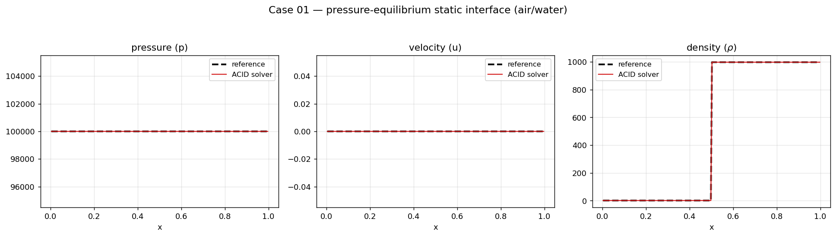
Case 01 — static interface.

10.2 Case 02 — pressure-equilibrium advection
A gas–gas contact at uniform pressure is advected at $u_{0}=1$m/s through the domain ($N=500$, $t_{\text{end}}=0.7$). Pressure and velocity stay exact ($L_{2}\left(p\right)=0$, $L_{2}\left(u\right)∼{10}^{−15}$); the density contact is transported with only the expected first-order numerical diffusion (${corr}_{ρ}=0.980$).
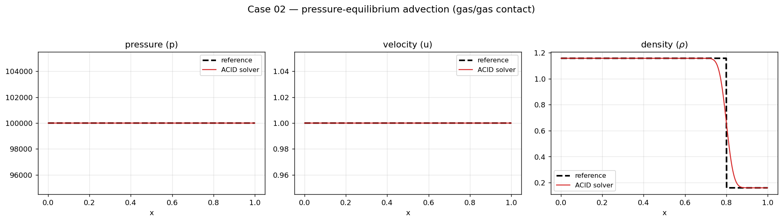
Case 02 — interface advection.

10.3 Cases 04 and 05 — single-phase acoustic sinusoids
A small-amplitude ($Δu=0.02$) sinusoidal acoustic wave is driven from the inlet through air (Case 04) and through stiffened-gas water (Case 05). These test linear-acoustic accuracy: amplitude and phase of the propagating wave. The BDF2 + high-order reconstruction preserves the wave with ${corr}_{p}=0.988$ (air) and $0.994$ (water).
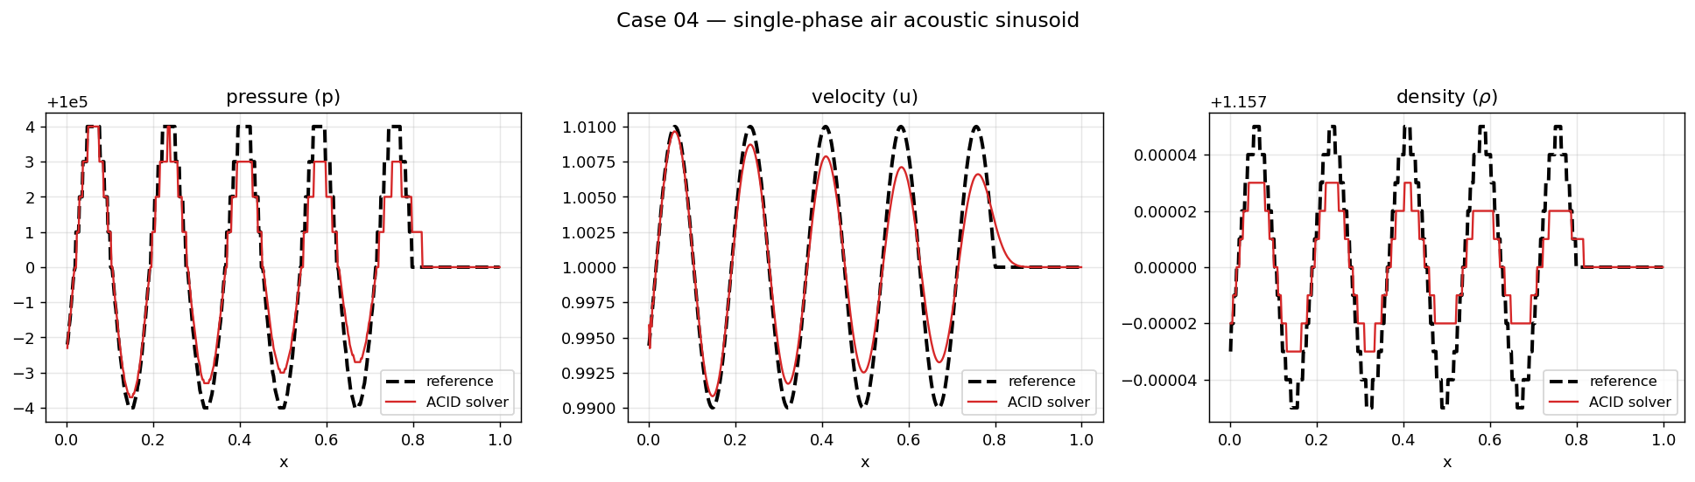
Case 04 — air acoustic sinusoid.
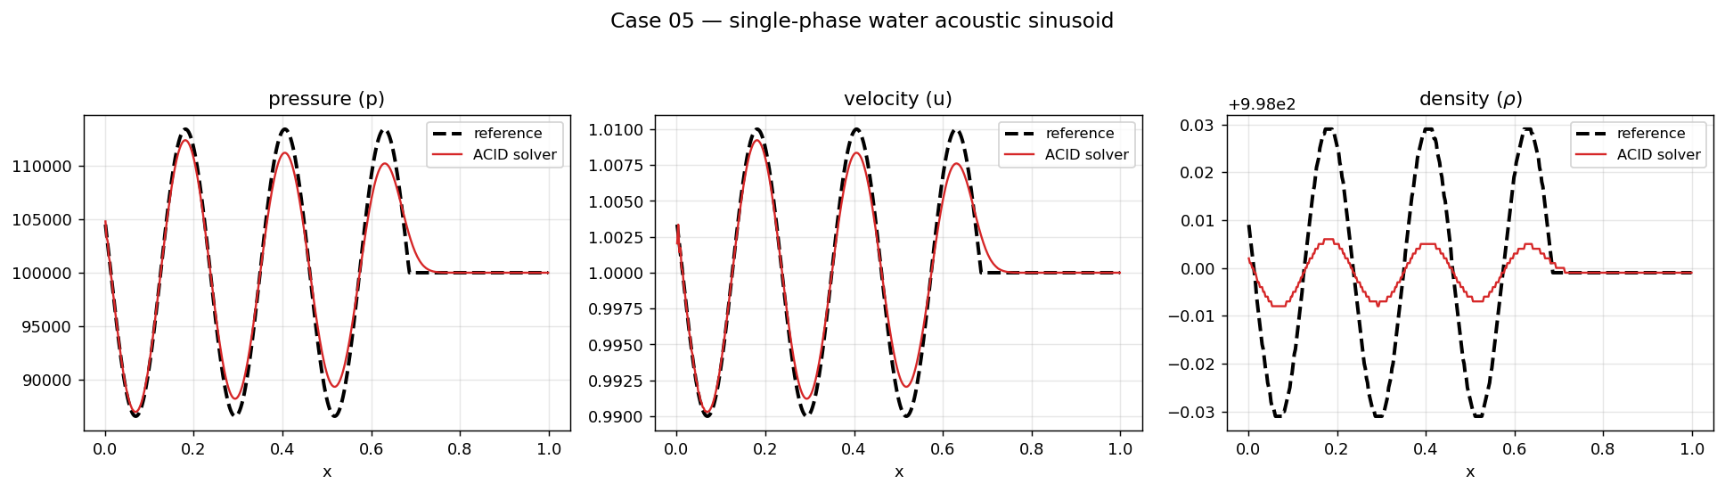
Case 05 — water acoustic sinusoid.

10.4 Case 07 — air/water acoustic reflection and transmission
A single one-period acoustic pressure pulse (Denner §7.3.2) crosses the air–water interface at $x=0.5$ ($N=750$, $Δx=2×{10}^{−3}$). Because the acoustic impedances differ by a factor $∼3000$, the pulse partially reflects (in air) and transmits (into water). The computed reflected/transmitted amplitudes match linear-acoustic theory; ${corr}_{p}=0.995$, $L_{2}\left(p\right)=0.017$, with the density field essentially exact ($L_{2}\left(ρ\right)∼{10}^{−8}$).
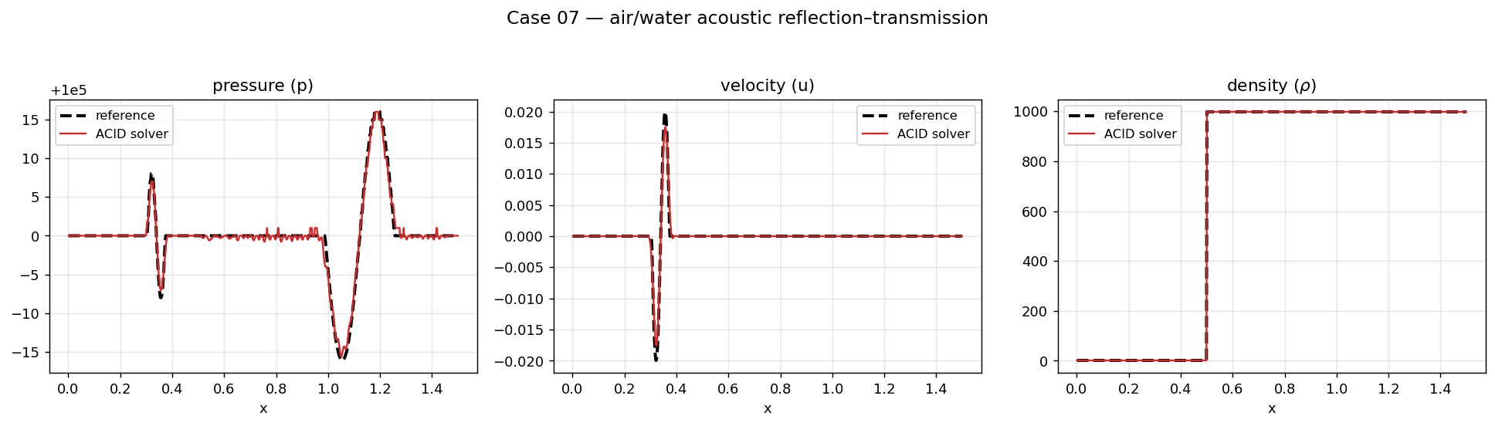
Case 07 — acoustic reflection/transmission.

10.5 Cases 13 and 14 — shock tubes
Case 13 is a high-pressure-air / low-pressure-water shock tube ($p_{L}={10}^{9}$, $p_{R}={10}^{4}$, ratio ${10}^{5}$); Case 14 reverses it (high-pressure water / low-pressure air). Both develop a shock, a contact, and a rarefaction. The scheme captures the shock in $∼$one cell with no overshoot and follows the smooth regions accurately (${corr}_{p}=0.997$ and $0.999$ respectively). Case 14, a strong water rarefaction, uses the fully-coupled energy to fix the contact pressure and a spurious boundary build-up that a segregated energy update produces.
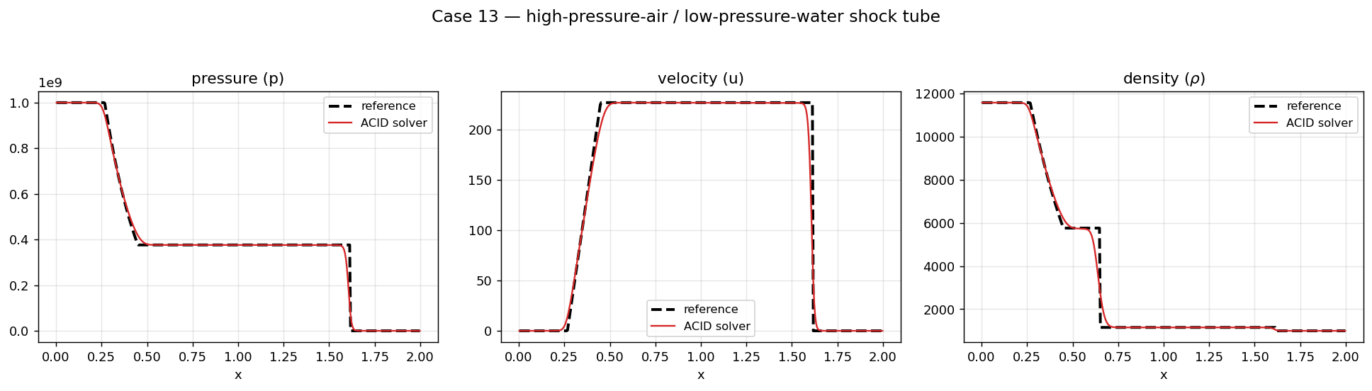
Case 13 — HP-air / LP-water shock tube.
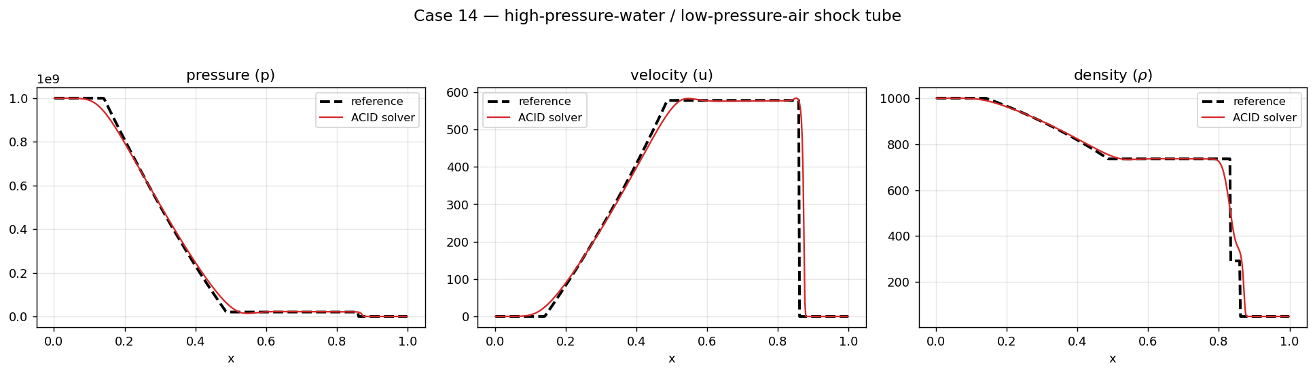
Case 14 — HP-water / LP-air shock tube.

10.6 Case 15 — cavitation
Two columns of an air–water mixture ($α_{1}=0.055$) move apart at $±100$m/s ($N=400$), creating a strong double rarefaction that drives the pressure toward vacuum — the classic cavitation test, and the hardest for a pressure-based solver because the gas density and its pressure derivative become extreme. The method keeps the pressure field exact ($L_{2}\left(p\right)=0$, ${corr}_{p}=1$) and resolves the density rarefaction ($L_{2}\left(ρ\right)=0.045$). This case motivated the keep-best / stall-break globalization of §8.2.
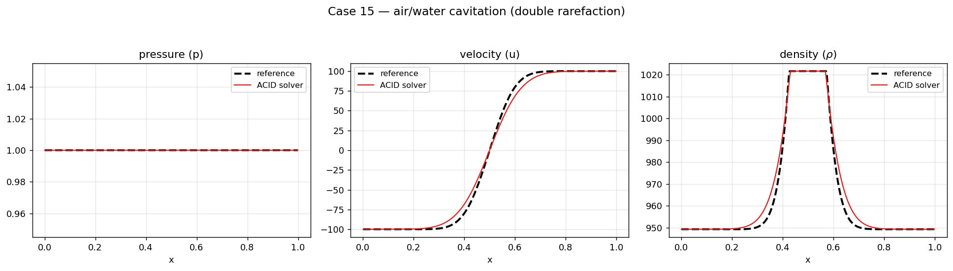
Case 15 — cavitation.

10.7 Cases 24 and 25 — Mach-10 shocks
Case 24 is a Mach-10 shock travelling through a homogeneous air–water mixture (a Wood-speed mixture Hugoniot); Case 25 is a Mach-10 air shock impacting a water interface. These are the most violent problems and exercise the coupled energy, the shock-capturing reconstruction, and the adaptive-CFL robustness. Both are captured with the shock in $∼$one cell and ${corr}_{p}=0.997$ (Case 24) and $0.994$ (Case 25).
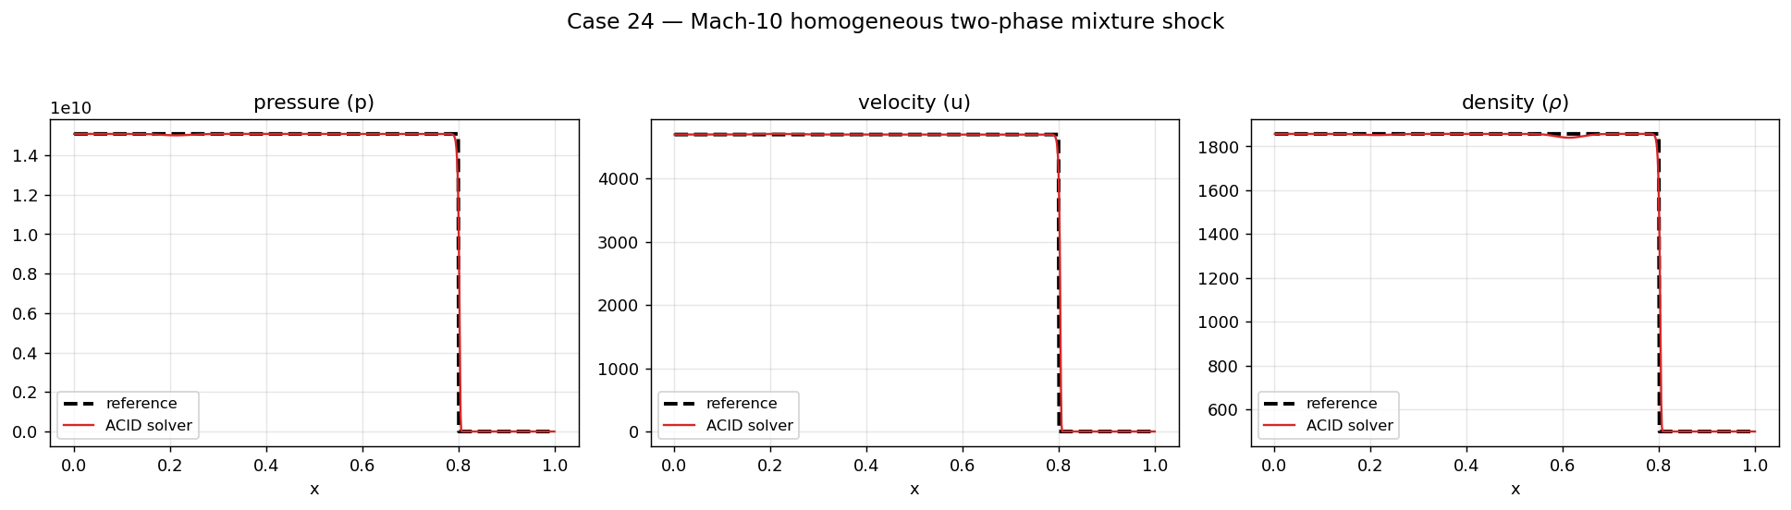
Case 24 — Mach-10 mixture shock.
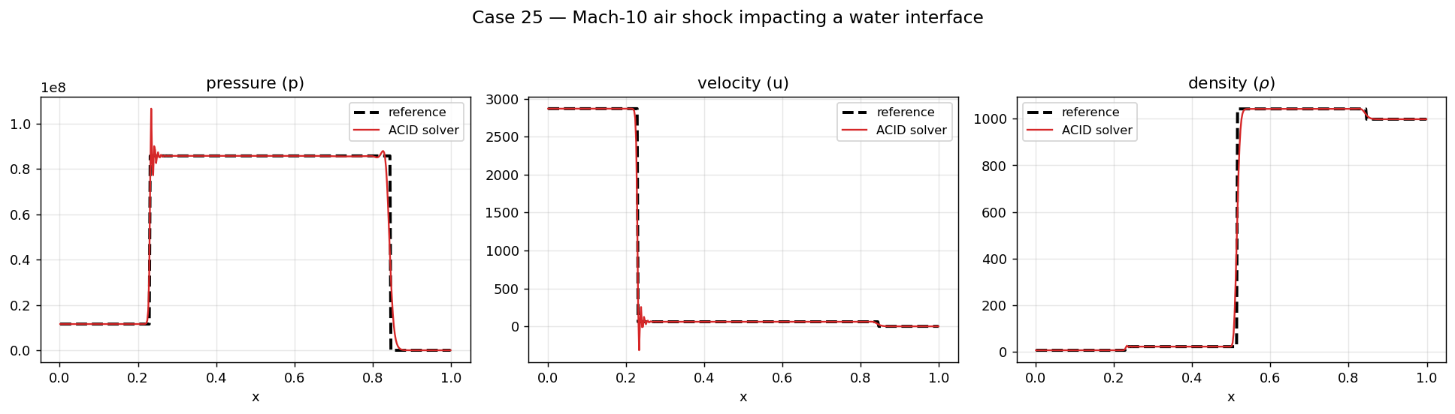
Case 25 — Mach-10 air shock / water interface.

11. Summary
This report has described, from first principles, an all-speed pressure-based finite-volume method for one-dimensional compressible two-phase flow: the single-pressure/velocity/temperature model (§2); the NASG equation of state with all closed-form derivatives and the enthalpy→temperature inversion (§3); the collocated finite-volume discretization with the momentum-weighted (Rhie–Chow) advecting velocity, the acoustically-consistent ACID mass flux, and the solution-adaptive reconstruction (§4); the implicit Backward-Euler / BDF2 time integration (§5); the fully-coupled $\left(u,p,h\right)$ residual and its defect-correction Newton solution (§6); the block-pentadiagonal Jacobian in both finite-difference and fully analytic forms, including the frozen-MWI density-coupling terms (§7); the line-search / keep-best / stall-break / adaptive-CFL globalization that makes the analytic-Jacobian solver robust (§8); and the parallelization and algorithmic optimizations that reduced the run time $∼6.6×$ (§9). The method passes all ten validation problems (§10), machine-exactly where a stationary solution is required and with high fidelity on shocks, acoustic waves, and cavitation.

References
- F. Denner, Pressure-based methods for all Mach number flows (ACID; acoustically-consistent interpolation of density), 2018.
- O. Le Métayer and R. Saurel, The Noble–Abel Stiffened-Gas equation of state, Physics of Fluids, 2016.
- G. Allaire, S. Clerc, S. Kokh, A five-equation model for the simulation of interfaces between compressible fluids, J. Comput. Phys., 2002.
- C. M. Rhie and W. L. Chow, Numerical study of the turbulent flow past an airfoil with trailing edge separation, AIAA J., 1983.

