NS Surface water modelling - Navier-Stokes equations in 2D-case

In this Chapter the purpose is to present the Navier-Stokes equations in 2D-case. These equations are used to compute water surface elevations and horizontal velocity components for subcritical, free-surface flow in two dimensional flow fields. Both steady and unsteady state (dynamic) problems can be analyzed. Sometimes these equations are also called also “shallow water equations”.

Equations describing the flow of water in floodplains, estuaries, and other surfacewater
bodies are based on the classical concepts of conservation of mass and momentum. For many practical surface-water flow applications, knowledge of the full three-dimensional
flow structure is not needed. Often it is sufficient to know about depth-averaged flow quantities acting in two perpendicular horizontal directions only, or about cross-section-averaged flow quantities acting in the longitudinal channel direction only. Equations that describe depth-averaged two-dimensional flow are presented in this chapter. Initial and boundary conditions needed to solve the set of governing water flow equations are described as well.

Derivation of the partial differential equations

The partial differential equations (PDEs) describing flow in 2D-cases like lakes, estuaries, rivers and floodplains will be first introduced in Section NS.1. The numerical solution of these equations will here be carried out using the so called finite volume method (FVM) and the discretization used in FVM provides an excellent way to derive the Navier-Stokes PDEs in 2D-case. The procedure will be as follows: 1) introduce the Navier-Stokes equations without deriving them, 2) formulate the numerical solution using the finite volume method, 3) show that the discretized equations can be presented as partial differential equations given in 1).

Comparison of 1D- and 2D-solutions
Saint Venant equations are commonly used to calculate unsteady flow in open channels. The Saint Venant equations can be used to solve the flow in 1D-case assuming that velocity is constant in the cross-sectional area of the river. Comparison of 2D Navier-Stokes equations with the 1D Saint Venant equations is given to help those readers who are more familiar with river flows.
NS.1 Navier-Stokes equations in 2D-case
NS.1.1 Mass balance or equation of continuity
Equation of continuity in 2D-case
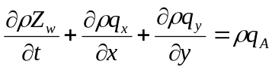 (NS-1)

where ρ is density of water (kg m⁻³), Z_{w} is elevation of water level (m above a reference datum), Z_{w}=h + Z_{b}, h is water depth (m) , Z_{b} is bottom elevation above a reference datum (m), q_{x}=v_{x}h and q_{y}=v_{y}h are unit flow rates in x- and y-direction, respectively (m² s⁻¹), v_{x}, and v_{y} are velocities in x- and y-direction and q_{A} is mass inflow or outflow rate per unit area (m³ m⁻² s⁻¹).

It is useful to write the 1D St Venant equation for continuity as a comparison (see web-material of the Yhd-12.121 Open channel hydraulics course). Solution of the Saint Venant equation is used to calculate flow in open channel in 1D-case assuming that velocity is constant in the river cross-section. Solution gives water level elevation Z_{w}, water depth h, cross-sectional area of flow A, discharge Q and velocity v =Q/A along the river.

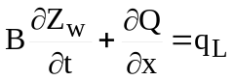 (SV-1)

where B is channel top width (m), Q is discharge (m³ s⁻¹) and q_{L} is additional discharge per unit length of the channel (m³ m⁻¹ s⁻¹).

By comparing Eqs. (NS-1) and (SV-1) we see that they are essentially very similar. In 1D-river models cross section varies in longitudinal section of the river and therefore channel top width must be included in (SV-1). If B would be constant, then (SV-1) could be written for rectangular channel as follows:

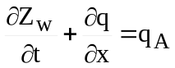 (SV-1b)

where q =Q/B and q_{A}=q_{L}/B. Equation (SV-1b) is the same than (NS-1) if y-direction is omitted.

NS.1.2 Momentum equations

By definition momentum (“liikemäärä”) is the product of the mass times the velocity of an object. If an object has a high momentum, it is more difficult to change its velocity. In surface water models equation of momentum must be written separately for x- and y-direction. Velocity differences create momentum transfer both in longitudinal and transverse directions and this phenomenon has several implications in surface water modelling, which will be discussed later on in this Chapter.

Momentum equations in x- and y-direction can be written as follows:

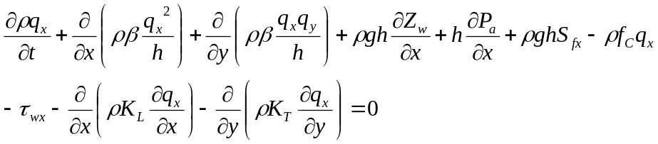 (NS-2)

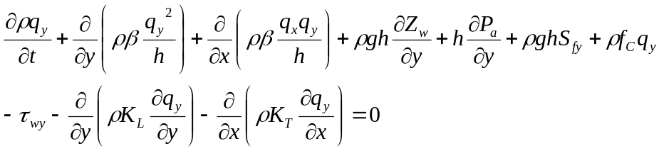 (NS-3)

where β is isotropic momentum flux correction coefficient that accounts for the variation of
velocity in the vertical direction (1.0-1.1), g = gravitational acceleration (m s⁻²), ρ is density of water (kg m⁻³), P_{a} is atmospheric pressure at the water surface (N m⁻²), f_{C} is Coriolis parameter (-), S_{fx} and S_{fy} (m m⁻¹) are friction slope terms that take into account then bed shear stresses acting in the x and y directions, respectively , τ_{wx} and τ_{wx} are surface shear stresses caused by wind acting in the x and y directions , respectively (N m⁻²). The last two terms in Eqs. (NS-2) and (NS-3) are the eddy viscosity terms where K_{L} and K_{T} are longitudinal and transverse eddy viscosity (m² s⁻¹) or depth-averaged kinematic eddy viscosity or turbulent exchange coefficient (in Finnish:”pitkittäinen ja poikittainen liikemäärän sekoittumiskerroin”).

The interpretation of the terms of the momentum equation (NS-2) in the x-direction are as follows:
- the first term is momentum change over time
- the second term is change of momentum in x-direction
- the third term is change of momentum in y-direction
- the fourth term is the influence of the slope of the water surface in x-direction
- the fifth term is influence of atmospheric pressure in x-direction
- the sixth term is the bottom friction term in x-direction
- the seventh term is the influence of Coriolis force
- the eight term is the influence of wind caused shear stress in x-direction
- the ninth term is the longitudinal momentum transfer term
- the tenth term is the transverse momentum transfer term

Comparison to 1D-equation

The equivalent form of the momentum balance in 1D-case is

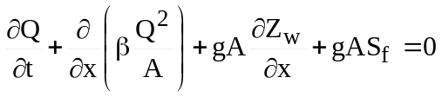 (SV-2)

which is the momentum equation of the Saint Venant equations. If cross-sectional area of the river would be constant, then (SV-2) could be divided by B and we would get 1D-equation for a rectangular channel.

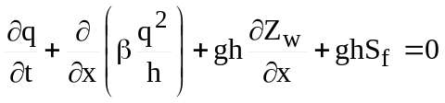 (SV-2b)

The terms in (SV-2b) are the same than the corresponding terms in 2D Navier-Stokes equations indicating that Saint Venant equations are a simplification of the 2D Navier-Stokes equations. The missing terms related to wind and atmospheric pressure could be easily added to 1D Saint Venant equations. The turbulence does not have the same type of interpretation in 1D case since we have to assume constant velocity in a cross-section. Therefore, in 1D-models the effect of turbulence is usually included in the friction term.

Calculation of friction terms

The friction slope in the momentum equations are calculated using the Manning equation.

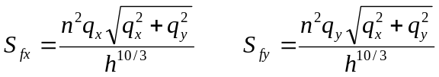 (NS-4)

This does not imply that Manning coefficient n should also be given as input data to the model. This is one option but another choice is to use Darcy-Weissbach equations to calculate f_{DW} from roughness height k_{s} and water depth h and then use conversion formula to relate f_{DW} and Manning n. There exist two equations (NS-5a) and (NS-5b) that can be used to relate roughness height and Darcy-Weissbach friction factor f_{DW}. The first one, (NS-5a) has been developed by Liu (2001) and the second one, (NS-5b) is based on Darcy-Weissbach equation that was originally developed for pipe flows. Manning coefficient can then be calculated using Eq. (NS-6).

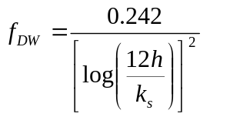 (NS-5a)
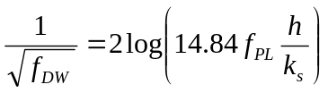 (NS-5b)
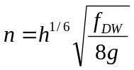 (NS-6)

where constand f_{PL} is usually assumed to be 0.827.

Calculation of surface shear stress caused by wind

Directional components of surface shear stress, τ_{wx} and τ_{wy} caused by wind are calculated as follows:

(NS-7)

where c_{s} is a dimensionless surface stress coefficient, ρ_{a} mass density of air (kg m⁻³), W is
characteristic wind velocity near the water surface (m s⁻¹) and ψ is angle between the wind direction and the positive x-axis. Surface stress coefficients have been found to depend on wind speeds and can be calculated by the general relation (FESWMS-model):

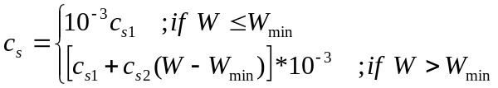 (NS-8)

where c_{s1}, c_{s2}, and W_{min} are coefficients. For wind speed in meters per second, measured 10 meters above the water surface, Garratt (1977) finds that c_{s1} = 1.0, c_{s2} = 0.067, and Wmin = 4 m/s. Wang and Connor (1975) compare several relations for c_{s} and conclude that c_{s1} = 1.1, c_{s2} = 0.0536, and W_{min} = 0 m/s. Hicks (1972) suggests the coefficients c_{s1} = 1.0, c_{s2} = 0.05, and W_{min} = 5.0 m/s. However, factors other than wind velocity can influence the value of the surface stress coefficient c_{s}. For example, Hicks et al. (1974) show that as water becomes shallow (less than 2.5 m deep) long period waves are not able to develop fully. As a result, water surfaces will be smoother and the value of c_{s} remains close to 0.001 for all wind speeds. In the FESWMS-model the default values of wind shear stress coefficients in are as follows: c_{s1} = 1.0, c_{s2} = 0.0 and W_{min} = 0.0 m/s.

Calculation of Coriolis effect

Effect of the Earth’s rotation on water movement is taken into account by terms in the momentum equations that contain the Coriolis parameter f_{C} = 2ωsinφ, where ω is angular velocity of the rotating Earth (=7.27 x 10-5 radians per second), and φ is angle of latitude. The sign of φ is positive in the northern hemisphere and negative in the southern hemisphere. For most shallow flows where the horizontal extent to depth ratio is large (for
example, flows in nearly all rivers and flood plains), the Coriolis effect will be small and
can be safely ignored.

Modeling Turbulence

All forms of numerical models require some form of stabilization. In 2D Navier-Stokes equations the eddy viscosity terms provide a way to stabilize the numerical solution. The numerical solution of the NS-equations requires a certain amount of turbulence to achieve stability. However, one may get useful solutions by specifying a higher turbulence value than is physically justified. This technique will produce a stable model without the need to add too much resolution.

What Is Turbulence?

The fluid momentum transfer due to exchanges of fluid masses moving at different speeds is called turbulence exchange. It is approximated in the governing equations by multiplying the turbulent exchange coefficients, K_{L} and K_{T}, by the second derivative of the velocity with respect to the x and y directions. Although it is difficult to establish the value for turbulent exchange coefficients, analogy with physical conditions suggests that turbulence exchanges depend on the momentum of the fluid and the distance over which that momentum is applied, divided by the fluid velocity and the surface area of the cell or element. Therefore, as the element size increases, K_{L} and K_{T} should increase, or as the velocity increases, K_{L} and K_{T} should increase, in order for the rate of turbulent exchange to remain constant.

Specifying turbulence exchange coefficients

Turbulent exchanges are sensitive to changes in the direction of the velocity vector. Conversely, small values of the turbulent exchange coefficients allow the velocity vectors too much freedom to change directions in the iterative solution. The result is a numerically unstable problem for which the program will diverge rather than converge at a solution. The recourse is to continue increasing the turbulent exchange coefficients, K_{L} and K_{T}, until a stable solution is achieved.

An automatic way to assign the longitudinal turbulent exchange coefficient is to allow the model to automatically adjust K_{L} after each iteration, based upon a provided Peclet number, which is based upon the unique size and calculated velocity within each element. The Peclet number defines the relationship between the velocity, elemental length, fluid density, and K_{L}. Recall the formula for Peclet number, Pe (unitless), where Pe is recommended to be between 15 and 40.

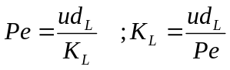 (NS-9)

where u is average grid velocity (m s⁻¹), d_{L} is grid length in streamwise direction (m) and KL is longitudinal momentum exchange coefficient (m² s⁻¹). In automatic eddy viscosity calculation a Peclet number around 20 is suggested, which enables to calculate K_{L} for each grid when u and d_{L} are known. Transverse momentum exchange coefficient can be assumed to be some fraction of the longitudinal coefficient, e.g. K_{T}=(0.3-0.7)K_{L}.

Eddy viscosity problems

Generally, larger elements, and elements with higher velocities will have larger eddy viscosity values. Turbulence issues can create problems during a simulation. Since viscosity is involved in the equations of motion, it effects the velocity distribution, which will influence the depth, which will determine the effects of roughness, which may in turn effect the phase and amplitude of the tidal signal, etc. If the eddy viscosity is too high, velocity magnitudes will appear uniform across the channel. Eddies will not form in the waterway if the eddy viscosities are too high. Picture a high viscosity value having the effect of turning the water to “syrup”. If the eddy viscosity is too low, the velocity contour patterns will appear erratic or the solution will collapse.

NS.2 Numerical solution of the 2D Navier-Stokes equations
NS.2.1 Introduction
The three most commonly used numerical methods to solve the 2D or 3D Navier-Stokes equations are finite difference method (FDM), finite volume method (FVM) and finite element method (FEM).

Consider that a 2D-model has to be developed for the area bounded by the black line in Fig. NS-1. In finite difference method the grid has to be composed of rectangles. In numerical solution it is possible that Δx_{i,j} and Δy_{i,j} can be different in various parts of the domain. The whole computational area must be covered by the grid system and those cells which fall outside the bounded line must be somehow eliminated from the computation (e.g. put velocity equal to zero in all those cells).

Finite volume (FVM) and finite element (FEM) methods could in this case utilize the same elements or cells. In FVM method the idea is to calculate water level at the midpoint of each cell and fluxes or velocities are calculated at the boundaries of the cells (see also Fig. NS-2). The control volume needed in FVM is the volume of each cell. Mass and momentum balances are calculated for every cell. In cases when the shape of the lake or estuary is very complicated, the application of FEM will be much more flexible.

In finite element method it is possible to use several nodes inside each element. Very often the number of nodes in each quadrilateral is 8 (corners and midpoints of each side) or 9 (additionally the midpoint of each cell). An example of 9-point quadrilateral is given in Fig. NS-1c. In finite element method water level, and velocities are calculated at the
same points whereas in FVM water level is calculated in the midpoint and velocities at the boundaries of each cell (see also Fig. NS-2).

NS.2.2 Finite volume method

NS.2.2.1 Introduction
The benefit of the finite volume method is its simplicity: mass balances are calculated assuming that mass change over time in the control volume equals the difference between inflowing mass and outflowing mass. Consider that terms of continuity equation – mass balance - are denoted by M and terms in momentum balance by MX and MY. Mass flow M (kg s⁻¹) is density multiplied by discharge M=ρQ (kg m⁻³ m³ s⁻¹). It needs to be pointed out that velocities and water levels are not caqlculated at the same points, which means that in the calculation of momentum balance terms it is necessary to evaluate h at discharge points and q_{x} and q_{y} at water level point.
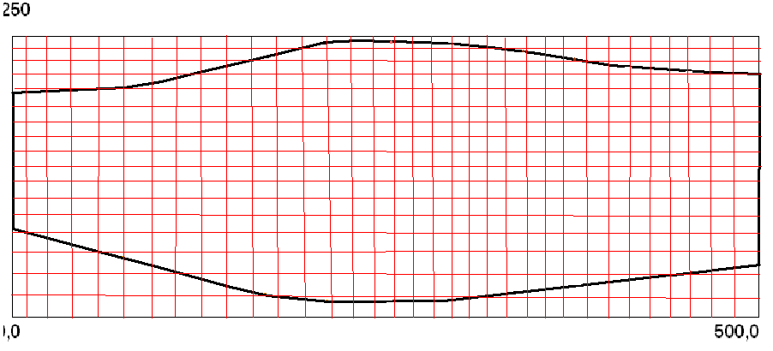
a) Finite difference grid
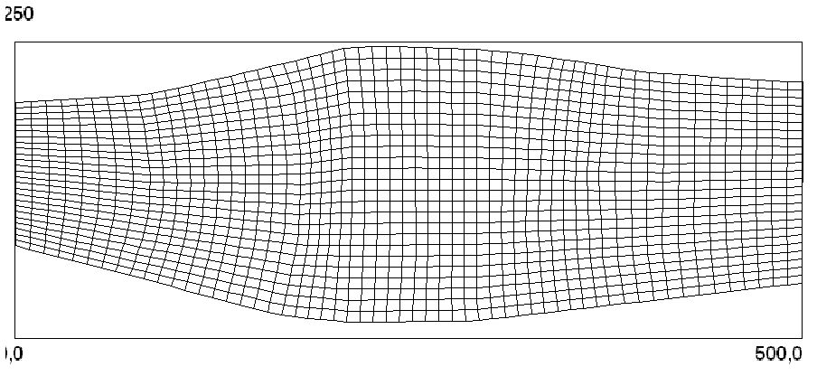
b) Finite volume grid
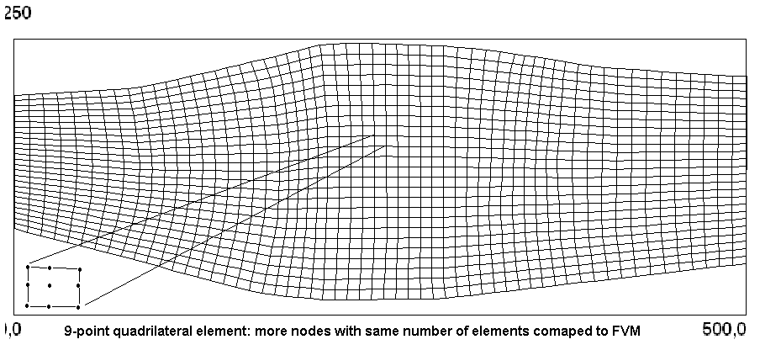
c) Finite element grid
Fig. NS-1. a) grid used in finite difference method (structured, orthogonal grid), b) grid in finite volume method (structured, non-orthogonal grid) and c) finite element grid (9-point quadrilateral element as an example).

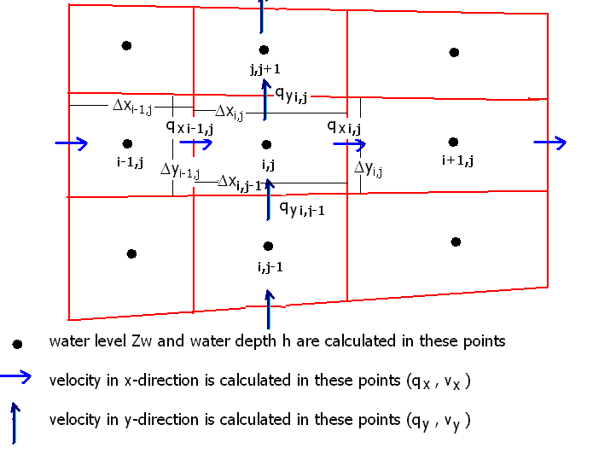
Fig. NS-2. The basic principle of the computational grid of the finite volume method.

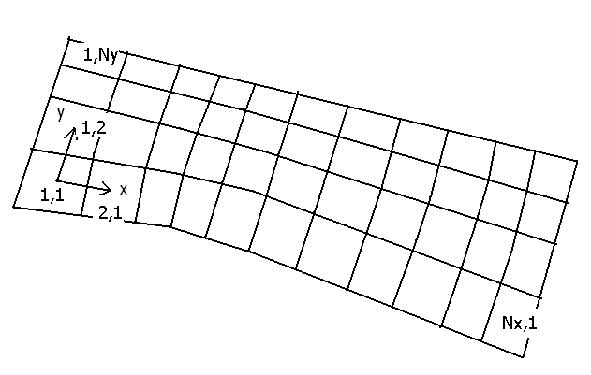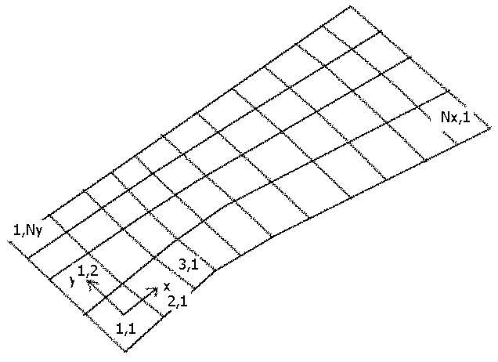

Fig. NS-3. In finite volume method the grid is usually not orthogonal. Direction of local x- and y-axis do not usually coincide with global coordinates.

NS.2.2.2 Calculation of mass balance for FVM

Consider now the numerical solution of (NS-1) using the finite volume method. The idea is to calculate mass balance of cell (i,j) in Fig. NS-2. Let’s use the following symbols: M_{x,in} is inflowing mass in x-direction (kg s⁻¹), M_{x,out} is outflowing mass in x-direction (kg s⁻¹), M_{y,in} is inflowing mass in y-direction (kg s⁻¹), M_{y,out} is outflowing mass in y-direction (kg s⁻¹), M_{A} is additional mass inflow to the cell (external sink or source), M^{t} is mass at control volume at time t and M^{t+Δt} is mass at control volume at time t+ Δt. The mass balance of cell (i,j) is then (for simplicity of notations index i,j is omitted from all symbols)
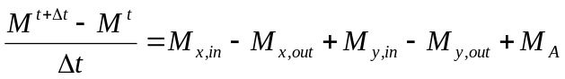 (NS-10)

The components of the mass balance are calculated as follows:

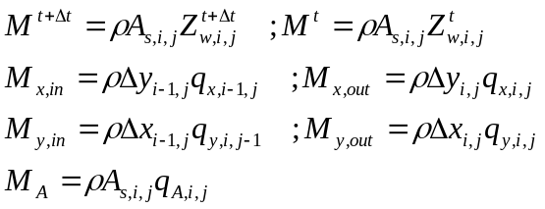 (NS-11)

Now we substitute the mass balance terms given in Eqs. (NS-11) to (NS-10) and move all terms to the left hand side and denote the function by F_{C,i,j}:

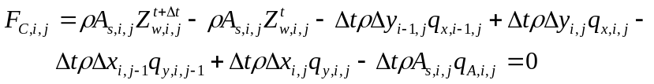 (NS-12)

At this stage no time indication is defined the q_{x}- and q_{y}-values. This will be done later on when this equation (NS-12) is used in the numerical solution of the 2D Navier-Sokes equations. The general principles of the numerical solution are given in in Section NS.2.3 and the details of the solution in Appendix A.

NS.2.2.3 Calculation of momentum balance in x-direction

Momentum is the product of the mass and velocity and its unit is thus kg m s⁻¹. The momentum balance can be given in the form that the rate of change of momentum is equal to the forces acting on it. The x-direction momentum balance components of the control volume of the cell (i,j) in Fig. (NS-2) are given in Eq. (NS-13) (for simplicity of notations index i,j is omitted from all symbols).
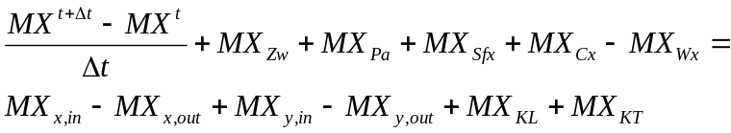 (NS-13)

where MX^{t+Δt} - MX^{t} is momentum change (kg m s⁻¹) at control volume during one time step Δt (s), MX_{x,in} is the momentum inflow in x-direction (kg m s⁻²), MX_{x,out} is the momentum outflow in x-direction, MX_{y,in} is the inflow of the x-direction momentum in y-direction and MX_{y,out} is the outflow of the x-direction momentum in y-direction, respectively. MX_{Zw}, MX_{Pa}, MX_{Sfx}, MX_{Cx}, MX_{Wx} are the forces acting, i.e. water surface slope (gravity term), atmospheric pressure, friction, Coriolis force and wind stress, respectively. The last two terms refer to momentum exchange due to turbulent shear stresses.

Now the aim is to develop equations for calculating the the momentum balance terms given in Eq. (NS-13). The water volume of the cell is A_{s,i,j} x h_{i,j}. In the control volume denoted by cell (i,j) in Fig. (NS-2) the change of momentum over time in x-direction can be calculated as follows (density x volume x velocity):

(NS-14)
This indicates that the unit of the momentum balance terms must be kg m s⁻². The momentum inflow/outflow terms can be calculated as the product of mass inflow and velocity (density x discharge x velocity). E.g. inflow in x-direction is ρβΔy_{i-1,j}q_{x,i-1,j}v_{x,i-1,j}
= ρβΔy_{i-1,j}q²_{x,i-1,j}/h_{i-1/2,j}. All four momentum inflow and outflow terms are given in Eq. (NS-15).

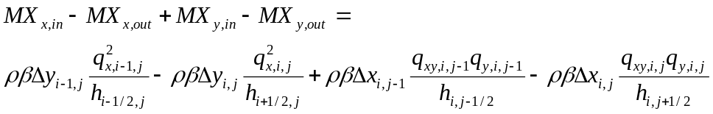 (NS-15)

where h_{i-1/2,j} is water depth at velocity point between cells (i-1,j) and (i,j) and h_{i+1/2,j} is water depth at velocity point between cells (i,j) and (i+1,j), respectively. Correspondingly,
h_{i,j-1/2} is water depth at velocity (discharge) point between cells (i,j-1) and (i,j) and h_{i,j+1/2} is water depth at velocity point between cells (i,j) and (i,j+1). q_{xy,i,j-1} and q_{xy,i,j} are x-direction discharges at q_{y}-points : q_{xy,i,j-1}=0.25*(q_{x,i-1,j-1} + q_{x,i,j-1} + q_{x,i-1,j} + q_{x,i,j}), and
q_{xy,i,j}=0.25*(q_{x,i-1,j} + q_{x,i,j} + q_{x,i-1,j+1} + q_{x,i,j+1}).

The force terms can be calculated with Eqs, (NS-16).

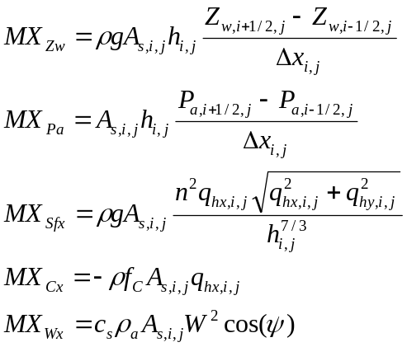 (NS-16)

where the subindices i-1/2,j and i+1/2,j in Z_{w}- and P_{a}-terms refer to values at the
velocity (discharge) points between cells (i-1,j), (i,j) and (i+1,j), respectively. q_{hx,i,j} and and q_{hy,i,j} denote x-discharge and y-discharge, respectively at the midpoint of the cell:
q_{hx,i,j} = 0.5*(q_{x,i-1,j} + q_{x,i,j}) and q_{hy,i,j} = 0.5*(q_{y,i,j-1} + q_{y,i,j}).

The turbulence exchange terms can be given using Eqs. (NS-17):

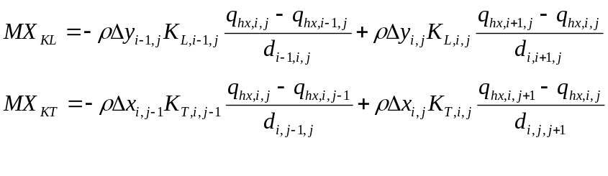 (NS-17)
where d_{i-1,i,j} is the distance between midpoints of cells (i-1,j) and (i,j), and d_{i,i+1,j} is the distance between midpoints of cells (i,j) and (i+1,j), respectively. Correspondingly, d_{i,j-1,j} is the distance between midpoints of cells (i,j-1) and (i,j), and d_{i,j,j+1} is the distance between midpoints of cells (i,j) and (i,j+1), respectively. q_{hx,i,j}, q_{hx,i-1,j}, q_{hx,i+1,j}, q_{hx,i,j-1}, and q_{hx,i,j+1}, are the x-discharges at the midpoints of cells (i,j) and (i-1,j), (i+1,j), (i,j-1) and (i,j+1), respectively. The five discharge terms are calculated as averages from the surrounding q_{x}-values.

NS.2.2.4 Calculation of momentum balance in y-direction

The y-direction momentum balance components of the control volume of the cell (i,j) in Fig. (NS-2) are given in Eq. (NS-18) (for simplicity of notations index i,j is omitted from all symbols).
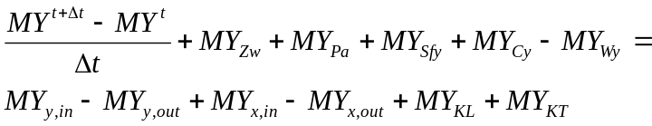 (NS-18)

where MY^{t+Δt} - MY^{t} is momentum change (kg m s⁻¹) at control volume during one time step Δt (s), MY_{y,in} is the momentum inflow in y-direction (kg m s⁻²), MY_{y,out} is the momentum outflow in y-direction, MY_{x,in} is the inflow of the y-direction momentum in x-direction and MY_{y,out} is the outflow of the y-direction momentum in x-direction, respectively. MY_{Zw}, MY_{Pa}, MY_{Sfy}, MY_{Cy}, MY_{Wy} are the work done by water surface slope, atmospheric pressure, friction, Coriolis force and wind stress, respectively. The last two terms refer to momentum exchange due to turbulent shear stresses.

In the control volume denoted by cell (i,j) in Fig. (NS-2) the change of momentum over time in y-direction can be calculated as follows (density x volume x velocity):

(NS-19)

The y-direction momentum inflow/outflow terms can be calculated using Eqs. (NS-20).

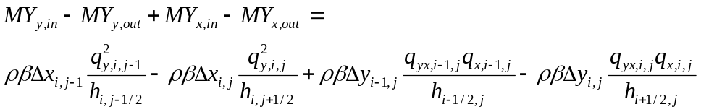 (NS-20)

where the water depth terms are the same than in Eq. (NS-15). q_{yx,i-1,j} and q_{yx,i,j} are y-direction discharges at q_{x}-points: q_{yx,i-1,j}=0.25*(q_{y,i-1,j-1} + q_{y,i-1,j} + q_{y,i,j-1} + q_{y,i,j}), and
q_{yx,i,j}=0.25*(q_{y,i,j-1} + q_{y,i,j} + q_{y,i+1,j-1} + q_{y,i+1,j}).

The force terms can be calculated with Eqs, (NS-21).

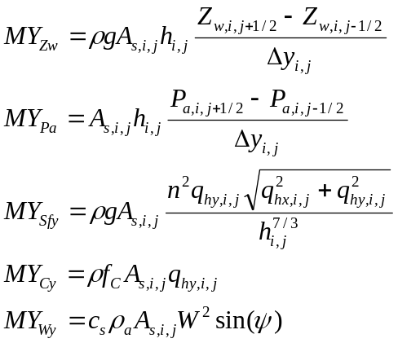 (NS-21)
where the subindices i,j-1/2 and i,j+1/2 in Z_{w}- and P_{a}-terms refer to values at the
velocity (discharge) points between cells (i,j-1), (i,j) and (i,j+1), respectively. q_{hx,i,j} and and q_{hy,i,j} denote x-discharge and y-discharge, respectively at the midpoint of the cell:
q_{hx,i,j} = 0.5*(q_{x,i-1,j} + q_{x,i,j}) and q_{hy,i,j} = 0.5*(q_{y,i,j-1} + q_{y,i,j}).

The turbulence exchange terms can be given using Eqs. (NS-22):
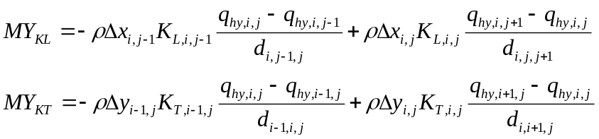 (NS-22)
where the distances between midpoints of cells are the same than in Eq. (NS-17). q_{hy,i,j}, q_{hy,i-1,j}, q_{hy,i+1,j}, q_{hy,i,j-1}, and q_{hy,i,j+1} are the y-discharges at the midpoints of cells (i,j) and (i-1,j), (i+1,j), (i,j-1) and (i,j+1), respectively. The five discharge terms are calculated as averages from the surrounding q_{y}-values.

The FVM-equations for momentum in x- and y-direction

The finite volume equation for momentum balance in x-direction can be given by combining Eqs. (NS-13) .. (NS-17). For y-direction the corresponding equation can be obtained by combining Eqs. (NS-18)-(NS-22).
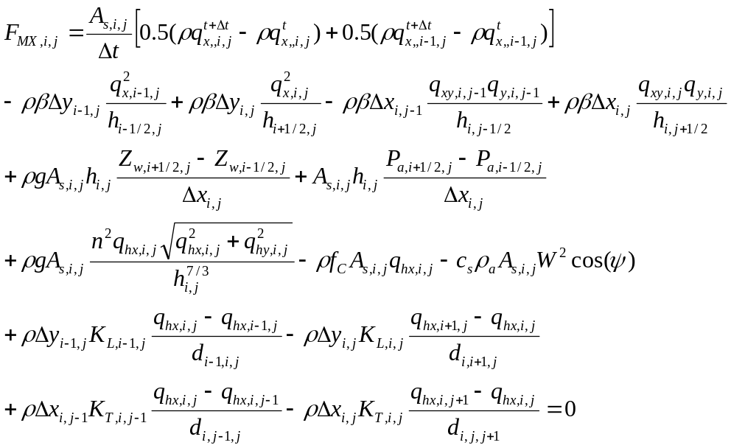 (NS-23)

The finite volume equation for momentum balance in y-direction can be given by Eq. (NS-24).

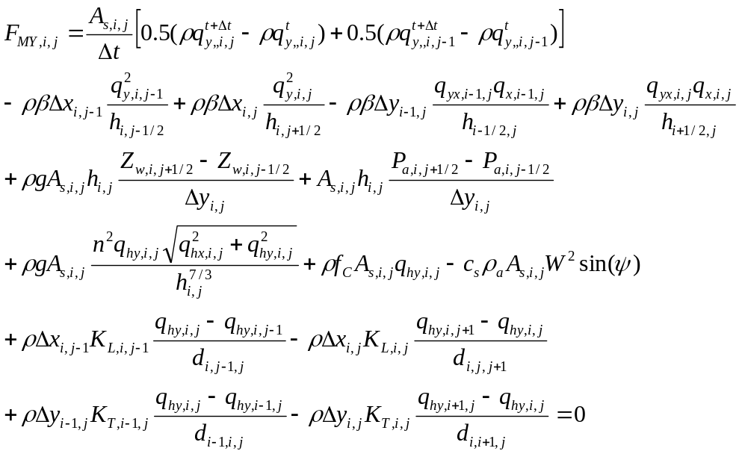 (NS-24)

NS.2.2.5 Derivation of the PDE’s from FVM balance equations
Now the purpose is to show that the discretization of the finite volume method can be used to derive the mass balance equation (NS-1) of the 2D Navier-Stokes equations. Eq. (NS-11) can be substituted to Eq. (NS-10) and we get

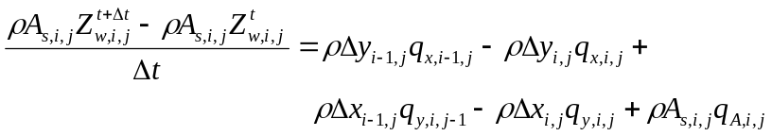 (NS-25)

A simplification of the FVM discretization can be obtained by making the assumption that all cells are rectangulars with A_{s,i,j}=Δx_{i,j}Δy_{i,j} =ΔxΔy. We divide Eq. (NS-25) by A_{s,i,j} and we get and equation

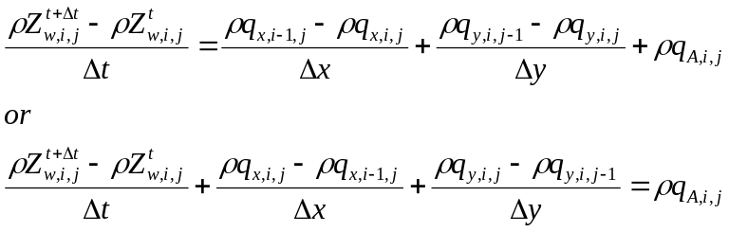 (NS-26)

The definition of the partial differential equation is given below:

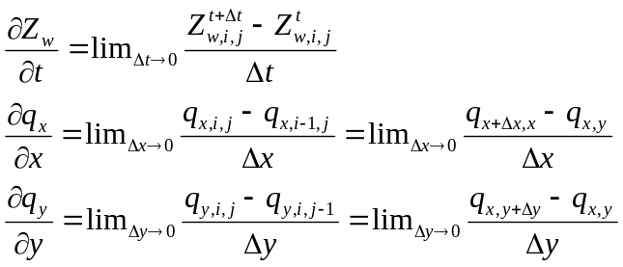 (NS-27)

If we compare the terms in (NS-27) with the terms of Eq. (NS-1) it can be seen that
the mass balance PDE can be derived from (NS-26) and (NS-27).

(NS-1)

The x-direction momentum PDE can be derived by substituting Eqs. (NS-14)… (NS-18) to Eq. (NS-13). Eq. (NS-14) has been here slightly simplified and the force terms due to friction, Coriolis and wind have been left away at this stage.

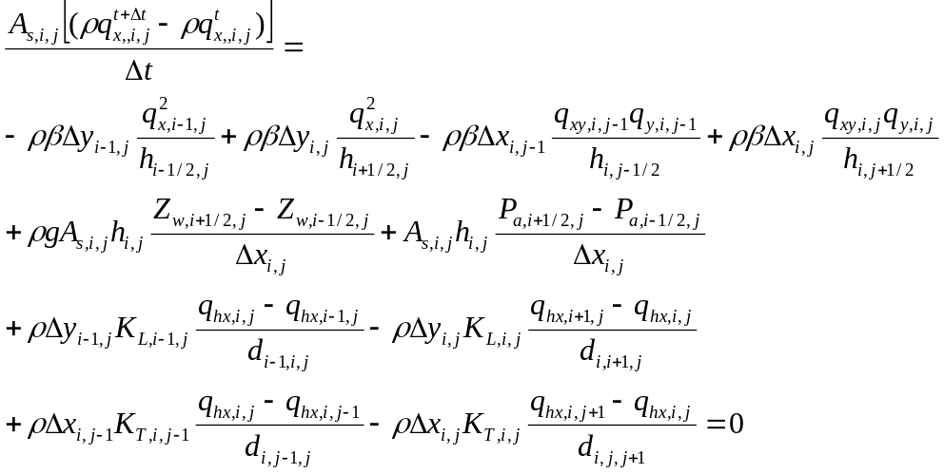 (NS-28)

Now we make the assumption that all cells are rectangulars with A_{s,i,j}=Δx_{i,j}Δy_{i,j} =ΔxΔy. We divide Eq. (NS-28) by A_{s,i,j} and we get and equation

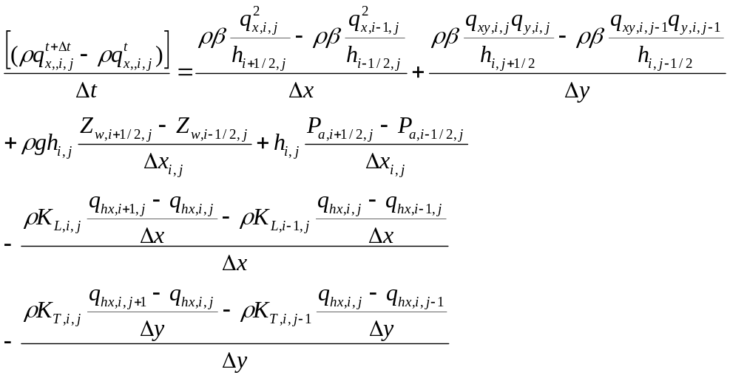 (NS-29)

The partial differential equation can now be obtained without friction, Coriolis and wind term by utilizing the definition of the PDE given in Eq. (NS-27).

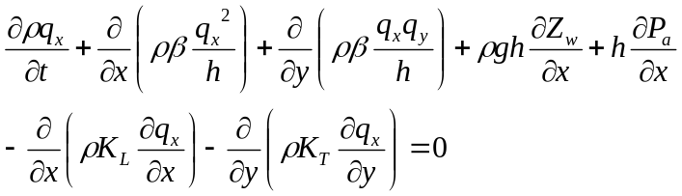 (NS-30)

The PDE of the 2D Navier-Stokes equations can be obtained by adding the force terms to Eq. (NS-30).

