ARCH A4988·Coding for Spatial Practices

Assignment 03: Style Lina Bo Bardi

OVERVIEW

Using your new knowledge of CSS styling properties, style *Houses or Museums?* by Lina Bo Bardi. You’ve already marked up the content in a previous exercise. For this assignment, we will be intentional about the color and typeface choice. In addition, keep in mind the *Seven Tools for Visually Conveying Importance* and *Gestalt Principles of Design* establish hierarchy between the elements on the page and ease readability.

INSTRUCTIONS

**Define the container**

We begin by defining a container, in which we place three elements. A header, a main, and a footer. Here’s the page structure:

<div class="container">

<header>Header</header>

<main>Main</main>

<footer>Footer</footer>

</div>

**Start adding basic CSS properties**

The Universal Selector is the * in CSS. Literally the asterisk character. A common use of this selector is as a reset. We’ve talked about how HTML elements have their own CSS styles...so we use this to reset all the margins and padding.

* {

margin: 0;

padding: 0;

box-sizing: border-box;

}

Next, let’s discuss how to get our website to fill the entire viewport

html,

body {

height: 100%;

}

body {

min-height: 100vh;

background-color: papayawhip;

}

Let’s give some blanket styles to all the sections for now to make it easier for us to see what we’re doing as we build:

main, header, footer {

padding: 20px;

border: 1px solid #000000;

color: #141414;

}

Next, apply CSS properties to move the semantic elements into place:

header,

footer {

height: 20vh;

}

main {

height: 60vh;

}

You should see something similar to the following:

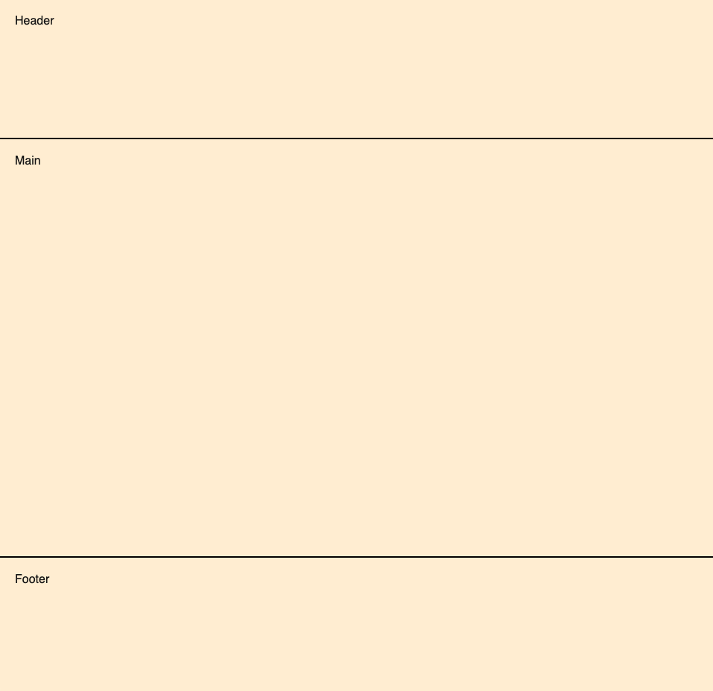

**Determine color**

* Define a list of attributes.
* Select a color to reflect those attributes.
* Determine a more specific version (tone, shade, tint) of the chosen color.

Remember, limit yourself to two or three colors at the most.

Think about the contrast between the background color and typeface.

Try to stay away from pure white or pure black. For example, use #141414 for black or #F2F2F2 for white, or similar.

**Determine Typeface**

1. Decide on a serif or sans-serif font
2. Select a typeface to complement your list of attributes
3. Choose a typeface pairing (if you decide to use more than one)
   * Select header or display typeface (Heading 1)
   * Select body typeface, default: 16px or 1em
   * Select functional typeface (captions, nav), default: 12px to 14px or 0.75em to 0.875em
4. Establish a font ramp
   * Determine size and weight, e.g. Helvetica Medium, 16px
   * Determine leading (aka line-height), e.g. 1.68em

Set the base **font-famil**y, **line-height** and **font-size** on the <body> element; then apply relative font sizing to the other elements.

**Image Indicates Importance (from The Seven Tools)**

Wrap the image in a <figure> element, similar to the following:

<figure>

<img src="assets/catburrito.jpg">

<figcaption>Cat Burrito</figcaption>

</figure>

Read the article, [How to fill a box with an image without distorting it?](https://developer.mozilla.org/en-US/docs/Learn/CSS/Howto/Fill_a_box_with_an_image) on the MDN Documentation site. Determine the size of the image in relation to the viewport window and size accordingly.

Place the <figcaption> in one of two locations:

|  |  |
| --- | --- |

Use **position: absolute** to place the text in the appropriate location.

**Apply Whitespace, Size or Contrast**

Use whitespace to create conceptual groupings. Use size with the heading to indicate its importance. Use contrast:

* between background color and text using **color** and **background-color**
* between the article title (heading 1) and the author name (byline) using **font-size**