SensoSpoon Design
  - Conceptual Design and Detailed Design
  - MECHENG736/730 | September 2026
SensoSpoon is an actively stabilised eating utensil designed to reduce unwanted spoon motion while preserving the user’s intended movement. The selected design combines a two-axis flexure gimbal, two handle-mounted voice-coil actuators, dual inertial sensors and optional surface electromyography (sEMG) assistance. This document explains the design choices, their implementation and the evidence needed before a physical prototype can be considered reliable.

1 Conceptual Design

Design objective and scope
The user should be able to lift and orient the spoon naturally without the controller treating every movement as a disturbance. The main engineering challenge is to separate intended movement from tremor, then produce corrective torque with limited actuator force and travel. Pitch raises or lowers the spoon tip; roll tilts the bowl from side to side.
The selected scope is active pitch and roll compensation over a defined operating envelope. Two controlled rotations cannot cancel arbitrary three-dimensional translation and rotation simultaneously. Near-zero spillage is a useful task outcome, but it does not imply zero motion or universal tremor cancellation.
Design criterion | Working specification or evaluation
Disturbance rejection | Assess 4–12 Hz rotational inputs; target at least 90% attitude RMS reduction in nominal 1° per-axis tests.
User control | Preserve voluntary movement; report tracking error separately from tremor-only performance.
Mechanical authority | Command within ±14° per axis; model compliant stops at ±15° and actuator stroke of ±6.35 mm.
Practical use | Detachable spoon, rounded grip and protected electronics; cleaning and comfort require physical testing.

Concept selection
Candidate | Assessment against the project objectives
Passive weighted utensil | Simple implementation, but cannot actively regulate spoon attitude or explicitly preserve a measured motion intention.
Rotary motor gimbal | Direct rotational actuation is possible; gear backlash and motor placement would require separate packaging and dynamic assessment.
Grounded voice coils with flexures | Selected for reversible force control, direct rods and low-backlash pivots; limited travel and coupled force transmission remain design constraints.

This is a qualitative engineering selection, not a measured competitor ranking. The proposed contribution is the integration of the mechanism, sensor feedback and optional intention assistance; novelty against published systems requires a separate literature comparison.

2 Detailed Design

Mechanical architecture
The handle contains the fixed actuator housings, battery and main electronics. A custom moving carrier supports the detachable spoon at the front. Its spherical exterior follows two constrained flexure axes; it is not a free ball-and-socket joint. Two C-Flex B-10 pivots support pitch and one D-10 pivot supports roll [2, 3].
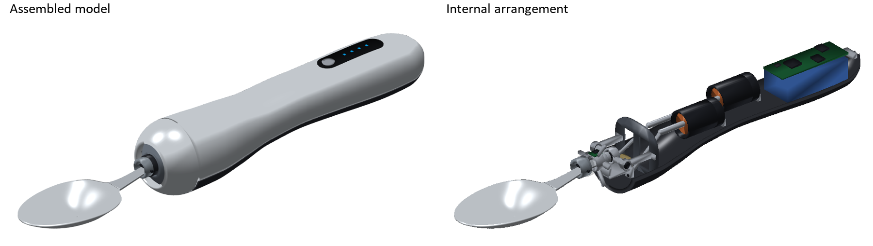
Figure 1. Current MATLAB geometry, shown assembled and in cutaway. These are model renders, not prototype photographs.

How the pushrods create pitch and roll
Each guided voice coil moves a rod forward or backward. The rods attach away from the gimbal axes and remain inclined as the mechanism moves. Their forces therefore create both pitch and roll moments. The controller coordinates both actuators; one coil is not assigned exclusively to pitch and the other to roll.
For roll, the useful moment comes from the transverse force components acting at offset attachment points. An offset alone is insufficient: a force exactly parallel to the spoon’s lengthwise axis produces no torque about that axis. Straight rods can provide roll authority when their installation angle and connection geometry are appropriate; a right-angle bend or bellcrank is not required.
The fixed-length rod constraints define actuator displacement as a function of the two joint angles. The transmission Jacobian converts joint velocity into rod velocity and rod force into joint torque. This configuration-dependent mapping is used in both the plant and controller, rather than assuming two independent ideal rotary actuators.

Packaging and dimensions
Feature | Current nominal geometry
Overall length | 271 mm
Spoon bowl and neck | 62 × 40 × 12 mm bowl; 31 mm curved neck; 1.2 mm rim and 1.8 mm bottom thickness
Grip sections | Approximately 33 × 28 mm near the forward grip and 34.4 × 30 mm toward the rear
Front assembly | 42 mm maximum fixed-bezel diameter; 34 mm moving-carrier diameter
Actuator arrangement | Staggered longitudinally; rear actuator uses a 32 mm long, 3 mm diameter coaxial extension

Staggering the actuators trades additional length for a narrower grip. The bowl and neck use smooth transitions to retain a familiar spoon profile. The current dimensions are design values, not an ergonomic validation. The rotation centre is an equivalent local flexure centre; a remote centre of motion has not been established.

Actuators and component selection
The voice coils are linear motors: current produces bidirectional force, and reversing current reverses the force. Their housings remain fixed to the handle, while the coil movers, rods and spoon mechanism contribute to moving inertia. Catalogue components provide the hardware basis; the assembled gimbal and its connecting parts remain custom [1–6].
Component | Qty | Selection and relevant specification
Guided voice coil | 2 | Moticont GVCM-016-019-01M; 15.9 mm diameter, 12.7 mm total stroke, 1.5 N continuous force; 4.6 N intermittent at 10% duty [1].
Flexure pivots | 3 | C-Flex B-10 ×2 for pitch and D-10 ×1 for roll. Model torsional stiffness: 0.00518 and 0.01165 N m/rad respectively [2, 3].
H-bridge driver | 2 | TI DRV8876PWPR; bidirectional current control. The project uses a 1.5 A current limit, below the device’s 3.5 A peak rating [4].
IMU | 2 | Bosch BMI270, one on the handle and one on the moving spoon carrier. Selected sampling: 800 Hz, ±500°/s and ±8 g [5].
Microcontroller | 1 | STM32G431CBT6; 170 MHz Cortex-M4 with floating-point support. Firmware timing is not yet validated [6].
Battery and PCB | 1 set | Model supply: 2S, 7.4 V, 400 mAh; battery envelope 41 × 20 × 13 mm. Main PCB target: 45 × 16 mm; routing remains unfinished.
Custom mechanics | 1 set | Carrier, frames, rods, rod ends, shaft extension, quick release and enclosure. Final tolerances and manufacturing drawings are still required.

Physical model and electrical limits
The analytical plant has eight continuous states: two joint angles, two angular velocities, two coil currents and two temperature rises. Coil current follows an RL model with driver resistance and back electromotive force. Electromagnetic force acts through the rod geometry to drive coupled rigid-body dynamics, including gravity, base acceleration, springs, damping, friction and compliant stops.
The nominal coil parameters are 4.6 Ω resistance, 0.8 mH inductance and a 1.5 N/A force constant. Stroke-dependent force variation, friction and thermal properties include uncalibrated assumptions. The peak catalogue force is not treated as continuous authority. Current allocation accounts for the model’s current, average copper-loss and shaft side-load limits.

Mechanical detail still requiring verification
The model includes the mass of both 11 g movers and the rear extension. Its approximately 0.55 mm nominal extension clearance is not a tolerance analysis. Custom rod ends must accommodate angular motion without binding, and the manufacturer’s 2.2 N shaft side-load rating does not certify the extension’s bending moment. Flexure life depends on load and angle; the catalogue ±15° indefinite-life statement applies at zero load [2, 3].

Sensing and motion control
Two IMUs measure handle and spoon motion so that the controller can estimate their orientations and relative rotation. Gyroscope integration is corrected slowly using accelerometer information. The simulated measurements include bias, noise, quantisation, filtering and one-sample delay. Accelerometers measure specific force, so rapid translation can disturb the gravity-based attitude correction.
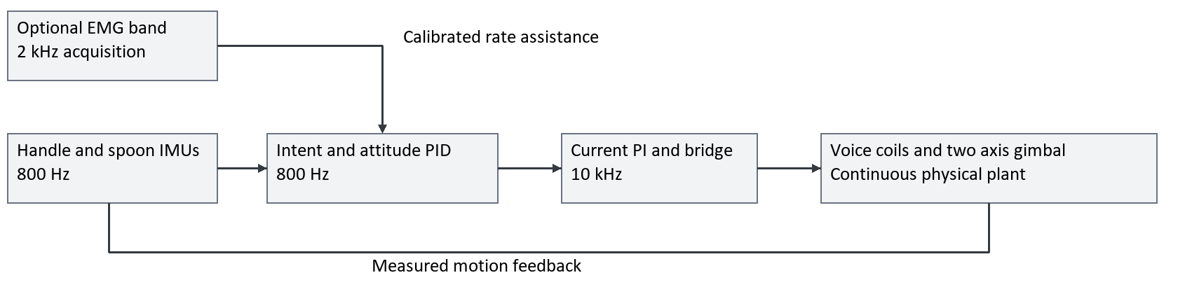
Figure 2. Control architecture. Only measured or causally decoded sensor signals enter the controller; true motion intent is reserved for evaluation.

Baseline control sequence
The handle attitude passes through fixed notch filters centred at 4, 6, 8, 10 and 12 Hz, followed by bounded phase-lead compensation and a 10 Hz low-pass filter. This produces an estimate of the slower intended movement. Frequency overlap between voluntary motion and tremor remains a fundamental ambiguity.
An 800 Hz attitude PID loop compares the measured spoon orientation with this reference. Nominal dynamics, gravity and flexure compensation reduce the feedback effort. A bounded two-actuator allocator converts the requested torque into coil-current references using the current transmission geometry. A separate 10 kHz current PI loop commands bridge voltage, with resistance and back-EMF feedforward and anti-windup.
Joint references are limited to ±14°, with a reference-rate limit of 180°/s. The plant still computes actual motion and possible overshoot. The 35 Hz attitude setting is a controller tuning parameter, not a measured hardware bandwidth. Startup assumes two seconds of stationary, level-fixture IMU calibration.

Optional EMG wristband
The proposed forearm band supplies four differential surface-EMG channels to assist intention estimation. It senses muscle activity; it neither generates stabilising force nor stimulates the user. The current acquisition interface assumes 2 kHz sampling, causal 20–450 Hz filtering, rectification, a 4 Hz envelope and 20 ms transport delay. Filtering choices are informed by established EMG signal-quality concerns [7].
A separate labelled calibration maps opposing channel envelopes to estimated pitch and roll rates. A limited rate-dependent correction is then added to the IMU reference. Its default weight is 0.3, lead coefficient 0.12 s and angular cap ±2°. Invalid contact or clipped data cancels assistance; reconnection includes a 150 ms recovery period. EMG is disabled by default.
Current demonstrations use synthetic EMG with noise, cross-talk and tremor contamination. Electrode placement, especially for forearm roll, requires individual testing. The actual wearable electronics and electrode arrangement have not been selected, and the synthetic rate mapping does not establish physiological accuracy.

Verification and design implications
Analytical feasibility is evaluated with the same electrical and mechanical plant used for animation. Native closed-loop runs use Simulink ode23t. A faster multirate integrator supports broader testing; it is checked against a native nominal case and identified separately in reports. Twelve verification groups cover geometry, physical consistency, sensors, control, liquid behaviour and EMG interfaces [8].
Attitude suppression is the reduction in three-dimensional attitude-error RMS relative to a spoon rigidly attached to the same handle input. Steady scoring starts at 1.5 s; startup and peak errors are also reported. The baseline is a locked joint, not an unpowered freely moving gimbal. Different trial durations, payloads and noise seeds must not be treated as identical experiments.
Test | Computed outcome | Design implication
Native tremor-only  8 Hz, 1°/axis, 5 g, 2 s | 96.61% attitude reduction; 0.0339° RMS. | Supports nominal angular compensation; does not establish all-frequency performance.
Native strong tremor  4 Hz, 5°/axis, 8 mL, 4 s | 92.58% attitude reduction. Estimated spill: 2.728 mL without control and 0 mL with control. | Shows reduced spill risk in this case; spoon-position RMS remains 4.06 mm.
Native voluntary motion plus tremor  8 Hz, 1°/axis, 4 s | EMG reduces RMS from 0.498° to 0.418°; peak current rises from 0.80 A to 1.33 A. | Intention assistance can help, but requires more current and real-signal calibration.
Fast boundary tests  20 Hz or large stepped amplitude | Constraints fail and motion can be amplified. | The operating envelope must be limited; universal 100% suppression is not supported.

Meaning of the liquid demonstration
Liquid is represented by two damped free-surface modes, volume conservation and a rim-overflow law. The solved spoon motion drives the liquid model, but changing liquid distribution, reaction forces and spilled mass do not feed back into the mechanical solution. It is a one-way reduced model, not CFD. For the strong-tremor case, halving grid spacing and time step changes estimated uncontrolled spill from 2.728 to 2.682 mL; controlled spill remains zero.
Numerical agreement does not validate unmeasured damping, wetting or splash physics. A no-spill animation therefore supports a testable design hypothesis rather than a guarantee that a physical spoon will remain spill-free.

Interaction and product details
The proposed user sequence is to attach the clean spoon, power on, calibrate while stationary and begin normal eating movements. The optional band is calibrated separately. A rounded enclosure, detachable food-contact part and simple status controls support this interaction. Final materials, cleaning seals, pinch protection, fault shutdown and low-battery behaviour require explicit prototype design and testing; the current shell does not establish waterproofing or comfort.

Prototype priorities and references

Next design decisions
The next prototype should test the most uncertain force-transmission and sensing assumptions before increasing controller complexity. First, measure the coil force–stroke relation, rod friction and extension bending under representative spoon loads. Verify the transmission geometry, flexure stress and loaded fatigue life across the required angles. These results should replace nominal assumptions in the model.
Next, build a routed control board and identify the current loops, IMU alignment, processing delays and thermal behaviour. Use a motion fixture to compare predicted and measured spoon attitude before progressing to liquid tests. Assess EMG with separate calibration and evaluation recordings, including electrode movement, co-contraction and loss of contact. Finally, evaluate grip comfort, cleaning and unintended motion with a physical prototype under an appropriate test protocol.
Candidate construction routes are a formed stainless-steel spoon, accurately machined gimbal seats and a polymer enclosure with a compliant grip surface. These are proposed manufacturing choices, not released specifications. Material compatibility, finish, fastening and tolerance drawings must be settled before fabrication.

References and traceability
[1] Moticont. GVCM-016-019-01M guided voice-coil motor, product specification and metric drawing. https://www.moticont.com/GVCM-016-019-01.htm
[2] C-Flex Bearing Co. B-10 Specification Sheet. https://c-flex.com/wp-content/uploads/2025/02/B-10-SERIES-Specification-Sheet.pdf
[3] C-Flex Bearing Co. D-10 Specification Sheet. https://c-flex.com/wp-content/uploads/2025/02/D-10-SERIES-Specification-Sheet.pdf
[4] Texas Instruments. DRV8876 H-bridge motor driver. https://www.ti.com/product/DRV8876
[5] Bosch Sensortec. BMI270 inertial measurement unit. https://www.bosch-sensortec.com/en/products/motion-sensors/imus/bmi270
[6] STMicroelectronics. STM32G431CB microcontroller. https://www.st.com/en/microcontrollers-microprocessors/stm32g431cb.html
[7] Delsys. Signal Quality Monitor guidance on movement artifacts and cross-talk. https://delsys.com/support/emgworks/signal-quality-monitor/
[8] SensoSpoon MATLAB project. Current design parameters, hardware basis, control results, liquid model and EMG comparison; local project revision reviewed 14 September 2026. Key records: docs/DESIGN.md, docs/HARDWARE_BOM.md, output/results/CONTROL_RESULTS.md, docs/LIQUID_MODEL.md and output/results/emg_comparison.csv.
[9] A. McDaid. Biomechatronics Project MECHENG736/730, course presentation dated 28 July 2026, pp. 5–10. Supplied file: Project Presentation- MECHENG736-730 - 2025.pdf.
Manufacturer specifications [1–7] accessed 14 September 2026. The document addresses the conceptual and detailed design elements of the R&D-focused brief [9]; literature review, end-user research and the separate go-to-market plan remain separate report components.

