* **DFROBOT RelayShield V2.1**

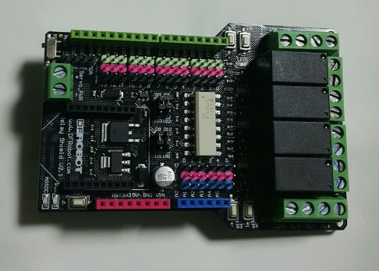

**1). Spec**

Specification

* Compatible with Arduino Rev3
* 4 buttons to test module
* LED status indicator of relay
* Support Xbee IO directly control
* Xbee socket for wireless communication
* Selectable digital IO pin for control(Default digital 2,7,8,10)
* 6 channels Analog IO & 13 channels Digital IO
* Up to 4 Relay with photo-coupled circuit
* Relay information:
  + Contact Rating 3A AC 120V / DC 24V
  + Max Switching Voltage AC 240V / DC 60V
  + Max Switching Current 5A
  + Max Switching Power AC 360VA / DC 90W
  + Electrical Life (Min) 100,000 Operations
  + Mechanical Life (Min) 10,000,000 Operations
  + Safety Standard(relay) UL cUL TUV CQC
  + Coil Working Voltage 9VDC
  + Working temperature -30℃ to +85℃
  + Working temperature 40% - 85%
* Size:95x65mm

**2). PINOUT**

[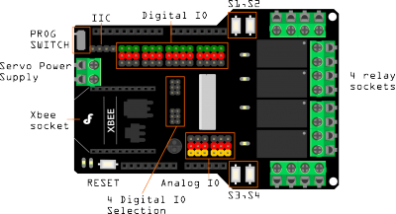](https://www.dfrobot.com/wiki/index.php/File:DFR0144_pin_out.png)

|  |  |  |
| --- | --- | --- |
| **Pin** | **Pin State:HIGH** | **Pin State:LOW** |
| Digital 2 | NC1 is disconnected with COM1 | NC1 is connected with COM1 |
|  | NO1 is connected with COM1 | NO1 is disconnected with COM1 |
| Digital 7 | NC2 is disconnected with COM2 | NC2 is connected with COM2 |
|  | NO2 is connected with COM2 | NO2 is disconnected with COM2 |
| Digital 8 | NC3 is disconnected with COM3 | NC3 is connected with COM3 |
|  | NO3 is connected with COM3 | NO3 is disconnected with COM3 |
| Digital 10 | NC4 is disconnected with COM4 | NC4 is connected with COM4 |
|  | NO4 is connected with COM4 | NO4 is disconnected with COM4 |
| Note: NC: Normally Closed; NO: Normally Open.  : D2, D7, D8, D10: 기본값, 아두이노 디지털 핀 2, 7, 8, 10번에 연결되어 릴레이 제어  각 릴레이마다 제어 스위치.  **3). Plugging in an appliance**  [https://www.dfrobot.com/wiki/images/thumb/c/c8/Lamp_demo.png/500px-Lamp_demo.png](https://www.dfrobot.com/wiki/index.php/File:Lamp_demo.png)  : 릴레이의 “COM” 과 “NO” 소켓에는 Positive 선이 연결되어야 함. HIGH의 디지털 신호 또는 “1”을 보내면 릴레이가 trigger됨. LOW의 디지털 신호 또는 “0”을 보내게 되면 릴레이의 작동이 중지됨.  **4). Sample Code**  byte relayPin[4] = {  2,7,8,10};  *//D2 -> RELAY1*  *//D7 -> RELAY2*  *//D8 -> RELAY3*  *//D10 -> RELAY*  char input=0;  int val;  void setup() {  **for**(int i = 0; i < 4; i++) pinMode(relayPin[i],OUTPUT);  Serial.begin(57600);  delay(100);  Serial.println("Press 1-4 to control the state of the relay");  Serial.println("waiting for input:");  **for**(int j = 0; j < 4; j++) digitalWrite(relayPin[j],LOW);  }  void loop() {  **if** (Serial.available())  {  char input= Serial.read();  **if**(input != -1)  {  **switch**(input)  {    **case** '1':  Serial.println("Relay1");  val=digitalRead(relayPin[0]);  val=!val;  digitalWrite(relayPin[0],val);  **break**;  **case** '2':  Serial.println("Relay2");  val=digitalRead(relayPin[1]);  val=!val;  digitalWrite(relayPin[1],val);  **break**;  **case** '3':  Serial.println("Relay3");  val=digitalRead(relayPin[2]);  val=!val;  digitalWrite(relayPin[2],val);  **break**;  **case** '4':  Serial.println("Relay4");  val=digitalRead(relayPin[3]);  val=!val;  digitalWrite(relayPin[3],val);  **break**;    **default**:  **if**(input != '\r' && input != '\n')  Serial.println("invalid entry");  **break**;  }  }  *// else unablerelay();*  }  } | | |