Application of crystal plasticity on sheet metal forming constitutive modeling

* Introduction

# Crystal plasticity

## Classic models

Taylor & Sachs (static) bounds

## Visco-Plastic Self-Consistent model

[Deal details on the development of VPSC with introducing important papers]

## Elasto-Visco-Plastic Self-Consistent

[Inform briefly how the elasticity is incorporated]

May need to mention the issues associated with elasticity (Bauschinger, TRIP, internal lattice strain…)

# Constitutive modeling for sheet metal forming

## Current issues

- [AHSS; multiphase; complex microstructures; TRIP; Bauschinger effect]

- Mentioning the virtual experiment in conjunction with sub-scale modeling that will be useful when characterizing continuum model & suggest some more physically based interpretation of various phenomena

## Meso-scale modeling using crystal plasticity

CP is on 1) a lower level than continuum models. And it may provide some physically meaningful information on both development and characterization of continuum models.

# Structure of the following sections

[The thesis consists of three topics: 1) Works at NIST, 2) RGVB, and 3) EVPSC-TRIP]

# Reference

* Part I: Measurement of yield locus based on the internal lattice strain and digital image correlation

# Marciniak tooling topped with X-ray goniometer

## System configuration

X-ray goniometer configuration, sample geometry, DIC

## Stress calculation and correction

The linear regression method. This linearity assumption breaks down according to the observation as plasticity comes into play (texture/grain shape).

# Experimental results

Balanced biaxial + two plane strain states for a) mild steel and b) dual phase steel

Its analysis…

# Stress factor

Stress correction based on some analytical models & EVPSC’s prediction

# Reference

* Part II: Dislocation density-based hardening model incorporation to Elasto-Visco Plastic Self-Consistent framework (Bauschinger effect, too?)

# Introduction

Summary & Review of RGVB (2007) and its recent implementation to VPSC framework

# Incorporation of Bauschinger effect into EVPSC

Implement back stress,, which is sensitive to the loosely tangled dislocations. These dislocations possess relatively low critical resolved shear stress so that it dissolves (or annihilate) very quickly upon loading.

# Verification of the model

Flow stress behavior (follow the benchmark problems…) 1) forward shear and reverse shear. With an increasing amount of pre-tension strain, observe the more pronounced Bauschinger effect and the plateau.

# Reference

Rauch, E. F., Gracio, J. J., & Barlat, F. (2007). Work-hardening model for polycrystalline metals under strain reversal at large strains. *Acta Materialia, 55*(9), 2939 - 2948.

* Part III: Incorporation of transformation-induced plasticity to the Elasto-Visco-Plastic Self-Consistent model

# Martensitic transformation of the selected material

Martensitic transformation refers to a diffusionless and displacive thermo-mechanical solid phase transformation that occurs for various metallic materials. It has some distinctive characteristics such as the habit phenomenon (Machlin & Cohen, 1951), inhomogeneous strain in martensite domain, and shear and dilatation attributed to the displacive nature. Quenching, the sudden drop of temperature, triggers the martensitic transformation. It is well known that mechanical stimuli, either plastic deformation (Olson & Cohen, 1975) or assistive stress (Olson & Cohen, 1982), also prompts the transformation. Current study mainly focuses on the latter.

## Transformation induced plasticity

Transformation induced-plasticity (TRIP) is the term referring to the additional plastic accommodation due to micro stress and strain fields that originate from phase transformation. There are two well-known sources of TRIP: 1) Greenwood and Johnson (1965) claimed that the specific volume differential between the two co-existing phases induces the softer phase to accommodate the internal micro stresses; 2) Magee (1966) studied that the stress-dependency on the variant selection results in preferred orientation of the martensitic inclusion, which leads to the macroscopic shape change. Details on the phase transformation strain and its implementation strategy are discussed in section 2.3.2.

## Meta-stable austenitic stainless steel

The chosen material for the current study is a 304 austenitic stainless steel. The 304 austenitic stainless steel (304-STS) is consisted of fully austenitic grains and designed to phase-transform in the room temperature when plastically deformed. In principle current framework is applicable to materials with more complex phase patterns. TRIP steels that are widely used for automotive components is not single austenitic. It is usually consisted of ferrite, bainite and some residual metastable austenite. Such case may complicate the modeling. For this reason, the chosen 304-STS sample is more suitable for verification of the model. The texture is represented as below: …

# How the implementation is done

## Variants and the selection criterion

Existence of crystallographically equivalent variants is an important feature to look at. Stress state-dependent variant selection results in the macroscopic deviatoric shape change (1966). Therefore, the precise crystal orientation relation between martensite and austenite together with the appropriate variant selection rule is of prime importance.

Among others, the Kurdjumov-Sach (KS) and Nishiyama-Wasserman (NW) relations have been used in many works. [citation needed]. The work of Wechsler, Lieberman and Read (WLR) [citation needed] also provides orientation relationship which is determined by the lattice parameters. Bhadeshia claimed that WLR is more appropriate than KS, since it can explain some other characteristics such as … , albeit phenomenological.

Often, the crystal relation is expressed by providing plane normal (PN) and invariant line (IL) directions given in the crystal axes of austenite and martensite. For example, KS and NW provide crystal orientations as in Table 1. This way of representation

Table The Kurdjumov-Sachs and Nishiyama-Wasserman orientation relations are given. and b are a habit plane normal and an invariant line direction, respectively. The superscripts and refer to the parent austenite and child martensite.

|  |  |  |
| --- | --- | --- |
|  | Kurdjumov-Sachs | Nishiyama-Wasserman |
| Habit plane normal | //: // | //: // |
| Invariant direction | //: // | //: // |

Figure The schematic two-dimensional view on crystal orientation relation and its associated axes is given. The black solid axes represent the crystal orientations of the two phases. The two gray coincident axes are composed of habit plane normal and invariant line direction . Based on the directions of the bases vectors referred in their crystal axes, and , the orientation between the two solid axes can be determined.

In order to facilitate the orientation relationship determination, an auxiliary vector, **t**, is introduced as the cross product of and . The crystal orientation relationship is determined based on the fact that // , // and //. Figure 1 schematically depicts the current problem. Details are given in what follows.

: Crystal axes of austenite and martensite, respectively.

where () indicates the single-row matrix.

The transformation matrix that rotates the austenite’s crystal axes, , to the one for martensite, , is as below:

Based on above lines the crystal relation for KS and NW are found and denoted as and , respectively.

Wechsler-Lieberman-Read (WLR) model provides a profound, albeit phenomenological, theory on the crystallographic characteristics of martensitic transformation. WLR model provides the orientation relation in the form of the orthogonal rotation matrix. Their calculation is based on the lattice parameters of austenite and martensite. The lattice parameters being used in this study is given in the table.

Table Lattice parameters of austenite and martensite

|  |  |  |
| --- | --- | --- |
|  | Austenite | Martensite |
| Lattice paremters [nm] | 0.3589 | 0.2873 |

Following Bhadeshia (Bhadeshia, 2001), the crystal orientation relation and transformation strain are calculated based on the lattice parameters for a particular variant and denoted here as:

and .

The Multiplication using the cubic crystal symmetry operation, , is performed as below:

Variant selection was determined based on the interaction energy defined as below:

.

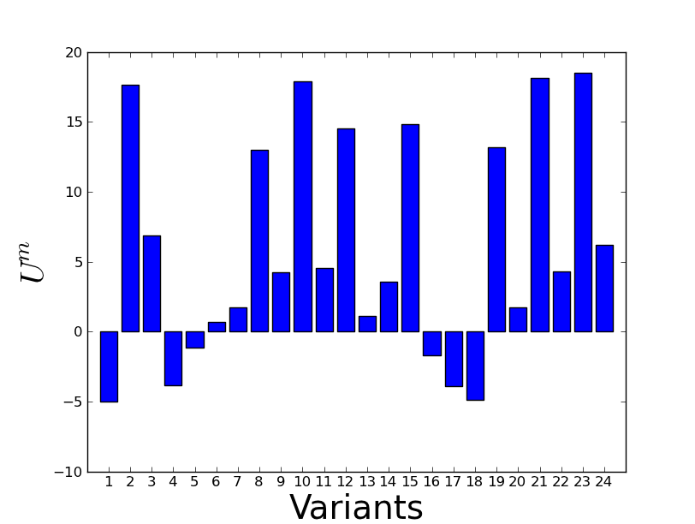

Figure . Exemplary interaction energy distribution for each of twenty-four variants of an austenitic parent grain

In Figure 2, about four variants show fairly close level of interaction energy within 10% of difference. Figure 3 depicts several clusters of poles indicating the small misorientation between certain variants. In the current framework, for each of elasto-plastic computational step, one variant is chosen when the criterion is met. Therefore, according to the interaction energy distribution in Figure 2, the variant 23 will be selected for the current parent austenitic grain. In reality, the previously created martensitic inclusion may have relaxed the surrounding matrix, so the variant selection will be a bit perturbed. In order to statistically mimic this, a small window of selection pool is introduced for those variants whose interaction energy is within:

, where is an empirical parameter.

The variant is randomly picked among those within this statistical range. When is unity, the most strict variant selection criterion is applied while with a lower more relaxed selection is rendered. Determination of is …

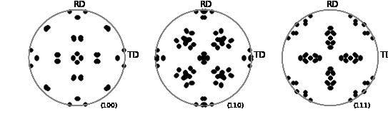

Figure Pole figures of 24 variants of a cube-oriented grain based on WLR orientation relation

## Creation of new martensitic grain and its associated volume transition

In the current framework, the polycrystalline aggregate firstly deforms only with austenitic grains, and martensitic grains are generated on the fly. For each computational increment, each and every austenitic grain is checked if transformation-starting criterion is met. Currently, when the accumulative total slip shear, , reaches austenitic grain is eligible to transit a part of its volume to a new martensitic grain. The volume of martensite is determined following Olson and Cohen (Olson & Cohen, 1975). Olson and Cohen (OC) model is in a form of double exponential equation. The volume fraction of martensite, , is expressed as a function of macroscopic strain as shown in , originally designed to reproduce the macroscopic volume evolution of martensite:

|  |  |
| --- | --- |
|  | eq. |

, where and are fitting parameters and is an exponent associated with shear band formation.

OC model is adapted onto the grain level. Instead of the macroscopic strain, total sum of accumulative slip shear, , is used to account for the inhomogeneous activity of each austenitic grain:

For each computational step time, , the volume of newly created martensite should be:

.

In the current framework, only one martensitic grain for each incremental step is inherited from a parent grain. The boundary condition, as of mixed boundary condition of macroscopic velocity gradient and stress, is given incrementally. The computation incremental step is set as axial strain. Therefore, in order to achieve 0.3 macroscopic axial strain, total incremental steps will be: steps. If we generate new martensitic grains for each of steps, the computation will be too much costly.

## Characteristics of newly formed martensitic grain

### Crystal orientation relationship

Crystal orientation of the martensite is dependent on the habit plane and invariant line direction for the case of KS and NW. On the other hand, WLR model, as explained in Bhadeshia, provides a full tensorial rotation matrix.

### Transformation strain

There are many different suggestions available in the literature when determining the transformation strain associated with the martensite formation. Among others, Wechsler-Lieberman-Read (1953) model’s transformation strain as suggested in Bhadeshia (2001) is used for all considered orientation relationships. Following Bhadeshia (2001), the transformation strain[1] is calculated based on the lattice parameters in Table 2.

### Morphology of martensitic inclusion

### Hardening and critical resolved shear stress

# Benchmark studies

## Determination of

## Cube texture benchmark

Humbert et al. (2007) showed that there is a evident variant selection mechanism in martensitic transformation using the Kurdjumov-Sachs type variant mechanisms. The same was proved by Kundu and Bhadeshia (2006) with WLR model. For this reason, EVPSC-TRIP is tested for a cube-textured polycrystal. The cube texture was created by rotation of the ideal cube component with respect to randomly generated reference axis. The created texture is shown in Figure 4.

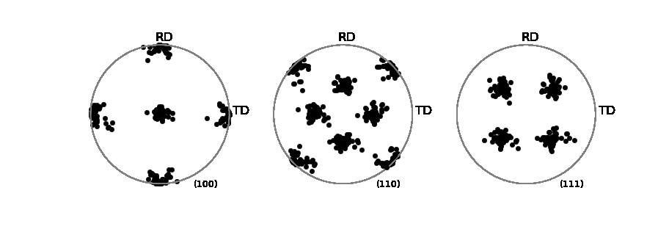

Figure (100), (110) and (111) pole figures of the cube texture based on the Gaussian distribution

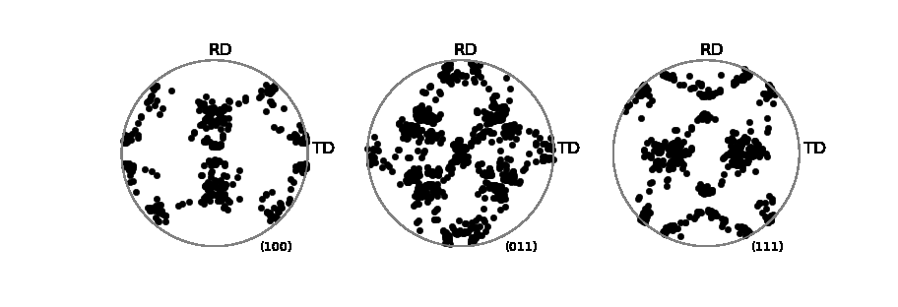

Figure Pole figures of the formed martensite from the cube texture by WLR theory.

## Transformation strain accommodation

## Internal strain measure (missing experimental data)

# Reference

1. In the original book of Bhadeshia used the term, *macroscopic* shape strain. In it, the *shape* strain of martensitic grain is referred as the macroscopic strain in comparison to the invariant *lattice* strain. In the current manuscript, the macroscopic scale refers to a bigger scale, i.e., the aggregative one spanning constituting grains collectively.