Nerst-Plank Equation

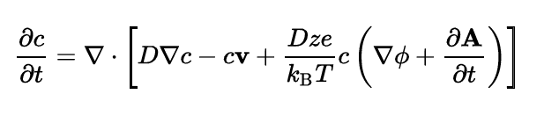
v = 0
φ = constant
A = constant

D = constant

In 1D:

https://www.dam.brown.edu/people/alcyew/handouts/numdiff.pdf
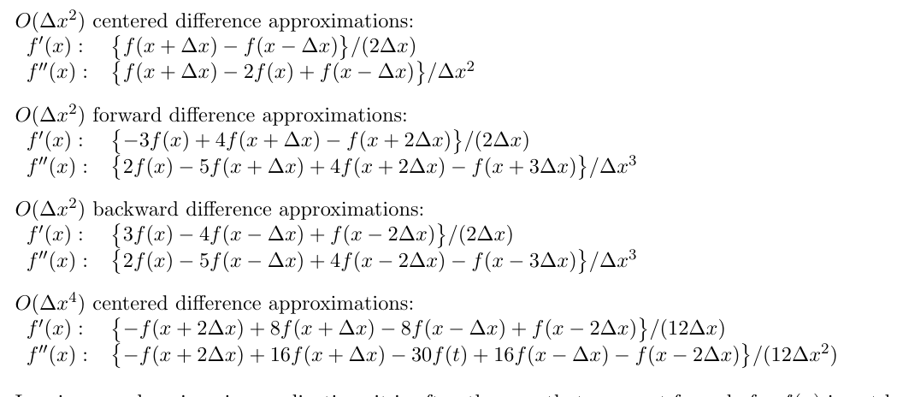

In interior:
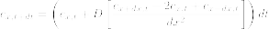

On left boundary:

NOT NEEDED
NOT NEEDED

On right boundary:

Boundary conditions:

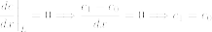

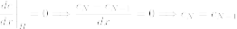

D = constant, v = 0, dA/dt = 0

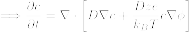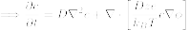

Vector identity:

In 1D:

Finite difference expansion:

For interior points (i.e. not c_{t,x=0} or c_{t,x=N})

Finite Difference expansion for exterior (boundary) points:
NOT NEEDED

Boundary conditions:

On left/right boundary:
0

