Project Report

On

# Advance HealthCare System

*Submitted in partial fulfillment of the requirements for the final year of*

**Bachelor of Technology**

In

**Computer Science & Engineering**

Submitted By:

**1. Ashhar Rahman (2001660100014)**

**2. Younus Siddique (2001660100067)**

*Under the guidance of*

**Mr. Shiv K Dubey**

## Mr. Sarvesh Kumar



**Dr. Ambedkar Institute of Technology for Divyangjan**

**(2020-2024)**

**AKTU LUCKNOW, UTTAR PRADESH**

Project Report

On

# Advance HealthCare System

*Submitted in partial fulfillment of the requirements for the final year of*

**Bachelor of Technology**

In

**Computer Science & Engineering**

Submitted By:

**1. Ashhar Rahman (2001660100014)**

**2. Younus Siddique (2001660100067)**

*Under the guidance of*

**Mr. Shiv K Dubey**

## Mr. Sarvesh Kumar



**Dr. Ambedkar Institute of Technology for Divyangjan**

**(2020-2024)**

**AKTU LUCKNOW, UTTAR PRADESH**

# CERTIFICATE OF APPROVAL

This is to certify that *Ashhar Rahman (2001660100014) and Younus Siddique (2001660100067)* have successfully completed the mini project entitled: *"Advance HealthCare System"*

Under the able guidance of***Mr. Shiv K Dubey and Mr. Sarvesh Kumar*** toward the fulfillment of the final year course in Computer Science & Engineering.

Internal Examiner

External Examiner

Project Head (HoD)

Prof. Sri Nath Dwivedi

# CANDIDATE DECLARATION

I hereby certify that the work, which is being presented in the report, entitled "*Advance HealthCare System*", in the partial fulfillment of the requirement for the final year of Bachelor in Technology and submitted to the institution is an authentic record of my own work carried out during the period January, 2024 to June, 2024 under the supervision of *Mr. Shiv K Dubey and Mr. Sarvesh Kumar*.

The matter presented in this report has not been submitted elsewhere for the final year from

any Institutions.

Date: Signature of candidate

1. Ashhar Rahman
2. Younus Siddique

This is to certify that the above statement made by the candidate is correct to the best of our knowledge.

Date: Signature of Project Guide

# ACKNOWLEDGEMENTS

I am fortunate enough to have worked under the very guidance of **Mr. Shiv K Dubey and Mr. Sarvesh Kumar***,* Computer Science and Engineering, Dr. Ambedkar Institute of Technology for Divyangjan Kanpur. I wish to express my sincere sense of gratitude to his/her. His/ Her pain staking guidance despite very busy schedule, his/her in- sparing supervision and keen interest, invaluable and tireless devotion, scientific approach, and brilliant technological acumen have been a source of tremendous help throughout my project.

I also express my deep and immense gratitude to *Prof. Sri Nath Dwivedi*, Head of Department. Their scholarly guidance, encouragement, and constructive criticisms have contributed immensely to the successful completion of this work.

I would like to thank my parents for their love and support. They always believed in me whatever decision I have made in my life. I would also like to thank my friends for their love and encouragement over the years. Finally, I am thankful to all the members of the CSE Department, AITD Kanpur, for their help and valuable support.

# ABSTRACT

Our project *Advance HealthCare System* includes registration of patients, storing their details into the system, and booking their appointments with doctors.

Our software has the facility to give a unique id for every patient and stores the details of every patient and the staff automatically. Users can search the availability of a doctor and the details of a patient using the id. The Advance HealthCare System can be entered using a username and password. It is accessible either by an administrator or receptionist. Only they can add data into the database. The data can be retrieved easily. The interface is very user-friendly. The data is well protected for personal use and makes the data processing very fast.

It has mainly two modules. One is at Administration Level and the other one is of user i.e. of patients and doctors. The Application maintains authentication to access the application. Administrator tasks include managing doctors’ information, patient’s information. To achieve this aim, a database was designed one for the patient and other for the doctors which the admin can access. The complaints which are given by the user will be referred by authorities. The Patient modules include checking appointments.

# TABLE OF CONTENTS

1. Introduction……………………………………………………………………………1

1.1. Objective………………………………………………………………………...1

1.2. Project Overview………………………………………………………………...1

1.3. Benefits of AHCS…………………………………………………………….….2

1.4. Scope of Project………………………………………………….………………3

1.5. Development Methodology / Development Theory……………..……………….3

2. Requirement Analysis…………...…………………………………….……………….5

2.1. Feasibility Study…………………………………………………………………5

2.2. Technical Specification………………………………………….……………….5

2.2.1. System Interfaces………...………………………………………………6

2.2.2. H/W Requirement……………………………………….……………….6

2.2.3. S/W Requirement……………………………………….………………..6

2.3. Summary………………………………………………………………………...7

3. Project Design Methodology……………………….……………….…………………8

3.1. Data Design……………………………………………………………………...8

3.2. ER Diagram…………………………………………………….………………10

3.3. DFDs……………………………………………………………………………11

3.3.1. Level 0 DFD………...……………………………………………….…12

3.3.2. Level 1 DFD……………………………………….…………………...13

3.4. Use Case Diagram……………………………………………………………...13

3.5. Website User Characteristics….…………..……………………………………15

3.6. Summary…………………...………………………………...………………...16

4. Website Screenshots………………...………………………………….…………….17

5. Conclusion……………….………………………………………………………...…24

6. References..…………………………………………………………………………..25

**LIST OF FIGURES**

Figure 3.1 ER Diagram…………………………………………………………………11

Figure 3.2 Level 0 DFD………………………….……………………………………..12

Figure 3.3 Level 1 DFD………………………………………………...........................13

Figure 3.4 Use Case Diagram…………………………………………………………...15

Figure 4.1 User Login Page………………………………………………….………….17

Figure 4.2 User Home Page………………………………………...…………………..17

Figure 4.3 User Registration Page…………….….…………………………………….18

Figure 4.4 Appointment Page Part 1………………………………………………….....18

Figure 4.5 Appointment Page Part 2…………………………………………………….19

Figure 4.6 Send Message Page………………………………………………………….19

Figure 4.7 Admin Dashboard Login……………………..……………………………..20

Figure 4.8 Admin Dashboard Home…………………………………………….……...20

Figure 4.9 Add New Admin……………………………………….................................21

Figure 4.10 Add New Doctor………………………………………………….………..21

Figure 4.11 All Registered Doctors…………………….…………………….…………22

Figure 4.12 All User Messages ………………………………………….……………...22

Figure 4.13 Hospital Database………………………….………………………………23

Figure 4.14 Disease Prediction Page……………………..……………………………..23

**LIST OF TABLES**

Table 3.1 Various Doctor Departments …………………………………….……….…...8

Table 3.2 Message Scheme………………………………………….…………………..8

Table 3.3 User(Admin, Doctor, Patient) Schema ………………………………….........9

Table 3.4 Appointment Scheme………………………………………………….............9

# CHAPTER 1: INTRODUCTION

In this busy world we don’t have the time to wait in infamously long hospital queues. The problem is, queuing at hospital is often managed manually by administrative staff, then take a token there and then wait for our turn then ask for the doctor and the most frustrating thing - we went there by traveling a long distance and then we come to know the doctor is on leave or the doctor can’t take appointments.

HMS will help us overcome all these problems because now patients can book their appointments at home, they can check whether the doctor they want to meet is available or not. Doctors can also confirm or decline appointments, this help both patient and the doctor because if the doctor declines’ appointment, then patient will know this in advance and patient will visit hospital only when the doctor confirms’ the appointment this will save time and money of the patient.

Patients can also pay the doctor’s consultant fee online to save their time.

HMS is essential for all healthcare establishments, be it hospitals, nursing homes, health clinics, rehabilitation centers, dispensaries, or clinics. The main goal is to computerize all the details regarding the patient and the hospital. The installation of this healthcare software results in improvement in administrative functions and hence better patient care, which is the prime focus of any healthcare unit.

# 1.1 Objective

AHCS will help us overcome all these problems because now patients can book their appointments at home, they can check whether the doctor they want to meet is available or not. Doctors can also confirm or decline appointments, this help both patient and the doctor because if the doctor declines’ appointment, then patient will know this in advance and patient will visit hospital only when the doctor confirms’ the appointment this will save time and money of the patient. Patients can also pay the doctor’s consultant fee online to save their time.

# 1.2 Project Overview

AHCS is essential for all healthcare establishments, be it hospitals, nursing homes, health clinics, rehabilitation centers, dispensaries, or clinics. The main goal is to computerize all the details regarding the patient and the hospital. The installation of this healthcare software results in improvement in administrative functions and hence better patient care, which is the prime focus of any healthcare unit.

Our application contains two modules – the admin module and the user module. Our application will not only help the admin to preview the monthly and/or yearly data but it will also allow them to edit, add or update records. The software will also help the admin to monitor the transactions made by the patients and generate confirmations for the same. The admin will be able to manage and update information about doctors.

The user module can be accessed by both the doctors and the patients. The doctor can confirm and/or cancel appointments. The doctors can even add prescriptions for their patients using our application. The patients will be able to apply for the appointment and make transaction for the same, and can even cancel appointments with the doctors. They can track details about the previous transactions made by them

# 1.3 Benefits of AHCS

There are various benefits of this Advance HealthCare System which we can see in the below points.

* *Appointment booking*

1. Helps patients cut the long queue and saves their time.

2. Is equipped with features like automated email and text message reminders.

* *Role-Based Access Control*

1. Allows employees to access only the necessary information to effectively perform their job duties.

2. Increases data security and integrity.

* *Overall cost reduction*

1. Cuts down paper costs as all the data are computerized.

2. No separate costs for setting up physical servers.

* *Data accuracy*

1. Removes human errors

2. Alerts when there’s a shortage of stock

* *Data security*

1. Helps to keep patients records private

2. Restricts access through role-based access control

* *Revenue management*

1. Makes daily auditing simple

2. Helps with statistics and other financial aspects

# 1.4 Scope of Project

The AHCS system will be used as an application that serves hospitals, clinics, dispensaries, or other health institutions. The intention of the system is to increase the number of patients that can be treated and managed properly. If the hospital management system is file based, the management of the hospital must put much effort into securing the files. They can be easily damaged by fire, insects, and natural disasters. Also, could be misplaced by losing data and information.

# 1.5 Development Methodology / Development Theory

Systems are designed to keep in mind an issue that is to be solved. Every system is designed in its unique keeping in mind the requirement of the problem or the issue. Our system solves the problem of searching for the goods that the customer needs. System design involves the design of overall architecture, based on which we design components, modules, and interfaces.

The beginning of any system architecture is by decomposing it into smaller fragments. Decomposition and binding of components makes the architecture easy to understand and makes it easier to understand.

Our system uses algorithms for collecting data which will collect the data of user and we have data analyzing algorithm which will analyze and highlight the needs of user.

**Language used: JavaScript**

JavaScript is a lightweight, cross-platform, single-threaded, and interpreted compiled programming language. It is also known as the scripting language for webpages. It is well-known for the development of web pages, and many non-browser environments also use it. JavaScript is a weakly typed language (dynamically typed). JavaScript can be for Client-side developments as well as Server-side developments. JavaScript is both an imperative and declarative type of language. JavaScript contains a standard library of objects, like Array, Date, and Math, and a core set of language elements like operators, control structures, and statements.

Client-side: It supplies objects to control a browser and its Document Object Model (DOM). Like if client-side extensions allow an application to place elements on an HTML form and respond to user events such as mouse clicks, form input, and page navigation. Useful libraries fro the client side are AngilarJS, ReactJS, VueJS, and so many others.

Server-side: It supplies objects relevant to running JavaScript on a server. For if the server-side extensions allow an application to communicate with a database and provide continuity of information from one invocation to another of the application or perform file manipulations on a server. The useful framework which is the most famous these days is Node.js.

**GUI used: Visual Studio Code**

Visual Studio Code (famously known as **VS Code**) is a free open-source text editor by Microsoft. VS Code is available for Windows, Linux, and macOS. Although the editor is relatively lightweight, it includes some powerful features that have made VS Code one of the most popular development environment tools in recent times.

VS Code supports a wide array of programming languages from Java, C++, and Python to CSS, Go, and Docker file. Moreover, VS Code allows you to add on and even create new extensions including code linters, debuggers, and cloud and web development support. The VS Code user interface allows for a lot of interaction compared to other text editors. To simplify user experience, VS Code is divided into five main regions:

1. The Activity Bar

2. The Side Bar

3. Editor Groups

4. The Panel

5. The Status Bar

**CHAPTER 2: REQUIREMENT ANALYSIS**

# 2.1 Feasibility Study

The Advance HealthCare System is a feasible product that follows the following types of feasibility.

* *Operational feasibility*
  1. This system can be used effectively to nurse a covid or elderly patient.
  2. It is easy to use due to the simplicity in hardware and working interface.
  3. It can be very beneficial for patient’s closed ones as it is impossible to be there for patient 24*7.
* *Economic feasibility*
  1. The total expenditure of the project is efficient.
  2. This system is economical to manufacture and implement when looked at its various usefulness.
* *Technical feasibility*
  1. The components can be assembled and replaced easily if necessary for proper functioning.
  2. Real time data can be easily monitored and viewed through the website.
* *Schedule feasibility*
  1. The project has been completed successfully within the specified time with the given resources and knowledge.

# 2.2 Technical Specification

This Advance HealthCare System is a self-contained system that manages activities of the hospital. The fully functional automated hospital management system which will be developed through this project will eliminate the disadvantages caused by the manual system by improving the reliability, efficiency, and performance.

The usage of a database to store patient, doctor, admin details etc. will accommodate easy access, retrieval, and search and manipulation of data. The access limitations provided through access privilege levels will enhance the security of the system. The system will facilitate concurrent access and convenient management of activities of the medical center.

**2.2.1 System Interfaces**

❖ *User Interfaces*

* This section provides a detailed description of all inputs into and outputs from the system. It also gives a description of the hardware, software and communication interfaces and provides basic prototypes of the user interface.
* The protocol used shall be HTTP.
* The Port number used will be 80.
* There shall be logical address of the system in IPv4 format.

❖ *Hardware Interfaces*

* Laptop/Desktop PC:- Purpose of this is to make appointments when Patients want to consult a doctor or when the doctors need to check on their patients. To perform such an action, it needs very efficient computers otherwise due to that reason patients must wait for a long time to get what they ask for.
* Laser Printer (B/W):- This device is for printing patients’ info etc.
* Wi-Fi router:- Wi-Fi router is used for internetwork operations inside of a hospital and simply data transmission from pc’s to server.

❖ *Software Interfaces*

* JDK 1.8 - Java is fast, secure, and reliable. From laptops to data centers, game consoles to scientific supercomputers, cell phones to the Internet,
* Mysql server - Database connectivity and management
* OS Windows 7/8/8.1- Very user friendly and common OS

**2.2.2 H/W Requirement**

* **Processor:** Intel i5 2.5 Ghz upto 3.5Ghz (or AMD equivalent)
* **GPU (preferred):** dedicated GPU from NVIDIA or AMD with 4GB VRAM
* **Memory:** minimum 8GB RAM
* **Secondary Storage:** minimum 128GB SSD or HDD
* **Network Connectivity:** bandwidth ~ 10 Mbps 3 75 Mbps

**2.2.3 S/W Requirement**

* **Visual Studio Code (VS Code):** Visual Studio Code (famously known as **VS Code**) is a free open-source text editor by Microsoft. VS Code is available for Windows, Linux, and macOS. Although the editor is relatively lightweight, it includes some powerful features that have made VS Code one of the most popular development environment tools in recent times.
* **MongoDB Atlas:** MongoDB Atlas is an integrated suite of data services centered around a cloud database designed to accelerate and simplify how you build data. Build faster and build smarter with a developer data platform that helps solve your data challenges.
* **MERN Stack:** MERN Stack is a JavaScript Stack that is used for easier and faster deployment of full-stack web applications. MERN Stack comprises of 4 technologies namely: MongoDB, Express, React and Node.js. It is designed to make the development process smoother and easier.
* **Operating System:** Operating system acts as the interface between the user programs and the kernel. Windows 8 and above (64 bit) operating system is required.
* **Jupyter Notebook:** The Jupyter Notebook is an open-source web application that allows you to create and share documents that contain live code, equations, visualizations, and narrative text. Uses include data cleaning and transformation, numerical simulation, statistical modelling, data visualization, machine learning, and much more.

**2.3 Summary**

Requirement analysis is an essential part of product development. It plays an important role in determining the feasibility of an application. By analyzing the different requirements for a system, a concrete plan of action can be designed. The software and hardware requirements can limit the system if not carefully listed down. They must be compatible with each other to complete integration of the system to deliver the final product. These requirements are a quantitative measure of the system. The user demand is met by breaking down the high-level tasks to requirements, which helps in the task of system design providing clear goals. The functional and non-functional requirements help measure the system operations. The functional requirements describe the operations that a system must perform. These can include tasks such as pre-processing, data extraction and evaluation. The non-functional requirements perform the task of measuring how well the system executes these operations. It assesses the system based on how reliable, accurate and user friendly it is. Requirement analysis is hence an important task before the start of any project.

**CHAPTER 3: PROJECT DESIGN METHODOLOGY**

# 3.1 Data Design

Data Design gives the design of the database maintained for the website. It tells us about the various data used on the website and makes us aware of the terms which we might struggle to understand. AHCS uses various complex words, short forms, and unknown data so the tables below will help us understand all that peacefully.

|  |  |  |
| --- | --- | --- |
| **Sr. No.** | **Doctor Department** | **Description** |
| 1. | Paediatrics | Treating infants, toddlers, children |
| 2. | Orthopedics | Treatment of musculoskeletal system |
| 3. | Cardiology | Treatment of heart disease |
| 4. | Neurology | Treats disorder affecting brain, nerves |
| 5. | Oncology | Treatment of cancer |
| 6. | Radiology | Deals with radiant energy to diagnose diseases |
| 7. | Physical Therapy | Exercises, massages, and treatment based on physical stimuli |
| 8. | Dermatology | Treatment of affected skin, hair, nails |
| 9. | ENT | Ear, Nose, Throat treatment |

Table 3.1 Various Doctor Departments

|  |  |  |  |  |
| --- | --- | --- | --- | --- |
| **Sr. No.** | **Name** | **DataType** | **Constraint** | **Description** |
| 1. | _id | ObejectId | Primary Key | Unique ID |
| 2. | firstName | String | minLength = 3 | First name |
| 3. | lastName | String | minLength = 3 | Last name |
| 4. | email | String | - | Email Id |
| 5. | phone | String | minLength = 10 | Mobile Number |
| 6. | message | String | minLength = 10 | Message of user |

Table 3.2 Message Schema

|  |  |  |  |  |
| --- | --- | --- | --- | --- |
| **Sr. No.** | **Name** | **DataType** | **Constraint** | **Description** |
| 1. | _id | ObejectId | Primary Key | Unique ID |
| 2. | firstName | String | minLength = 3 | First name |
| 3. | lastName | String | minLength = 3 | Last name |
| 4. | email | String | - | Email Id |
| 5. | phone | String | minLength = 10 | Mobile Number |
| 6. | aadhaar | String | minLength = 10 | Message of user |
| 7. | dob | Date | - | Date Of Birth |
| 8. | gender | String | - | Gender |
| 9. | role | String | - | Admin, Doctor, Patien |
| 10. | doctorDepartment | String | - | Department of Doctor |
| 11. | docAvatar | String | - | Doctor Photo |
| 12. | notification | Boolean | - | Notification update |

Table 3.3 User (Admin, Doctor, Patient) Schema

|  |  |  |  |  |
| --- | --- | --- | --- | --- |
| **Sr. No.** | **Name** | **DataType** | **Constraint** | **Description** |
| 1. | _id | ObejectId | Primary Key | Unique ID |
| 2. | firstName | String | minLength = 3 | First name |
| 3. | lastName | String | minLength = 3 | Last name |
| 4. | email | String | - | Email Id |
| 5. | phone | String | minLength = 10 | Mobile Number |
| 6. | aadhaar | String | minLength = 10 | Message of user |
| 7. | dob | Date | - | Date Of Birth |
| 8. | gender | String | - | Gender |
| 9. | appointment_date | String | - | Date of appointment |
| 10. | department | String | - | Department |
| 11. | doctor.firstName | String | - | Doctor first name |
| 12. | doctor.lastName | String | - | Doctor last name |
| 13. | hasVisited | Boolean | - | Has visited doctor before |
| 14. | address | String | - | Address |
| 15. | doctorId | ObjectId | Reference User | Unique ID |
| 16. | patientId | ObjectId | Reference User | Equal to User ID |
| 17. | status | String | - | Pending, Accepted, Rejected |
| 18. | statusUpdated | Boolean | - | Status changed or not |

Table 3.4 Appointment Schema

# 3.2 ER Diagram

ER diagrams are used to represent the E-R model in a database, which makes them easy to convert into relations (tables). ER diagrams provide the purpose of real-world modeling of objects which makes them intently useful. ER diagrams require no technical knowledge and no hardware support. These diagrams are very easy to understand and easy to create even for a naive user. It gives a standard solution for visualizing the data logically.

***Symbols Used in ER Model***

ER Model is used to model the logical view of the system from a data perspective which consists of these symbols:

* **Rectangles:**Rectangles represent Entities in the ER Model.
* **Ellipses:**Ellipses represent Attributes in the ER Model.
* **Diamond:**Diamonds represent Relationships among Entities.
* **Lines:**Lines represent attributes to entities and entity sets with other relationship types.
* **Double Ellipse:**Double Ellipses represent [Multi-Valued Attributes](https://iotap.geeksforgeeks.org/problems/what-is-the-difference-between-single-valued-and-multi-valued-attributes).
* **Double Rectangle:**Double Rectangle represents a Weak Entity.

***How to Draw ER Diagram?***

Here are few steps through which we can me ER Diagram which are fun to make and give us a deep understanding of the topic.

* The very first step is Identifying all the Entities, and place them in a Rectangle, and labeling them accordingly.
* The next step is to identify the relationship between them and place them accordingly using the Diamond, and make sure that, Relationships are not connected to each other.
* Attach attributes to the entities properly.
* Remove redundant entities and relationships.
* Add proper colors to highlight the data present in the database.

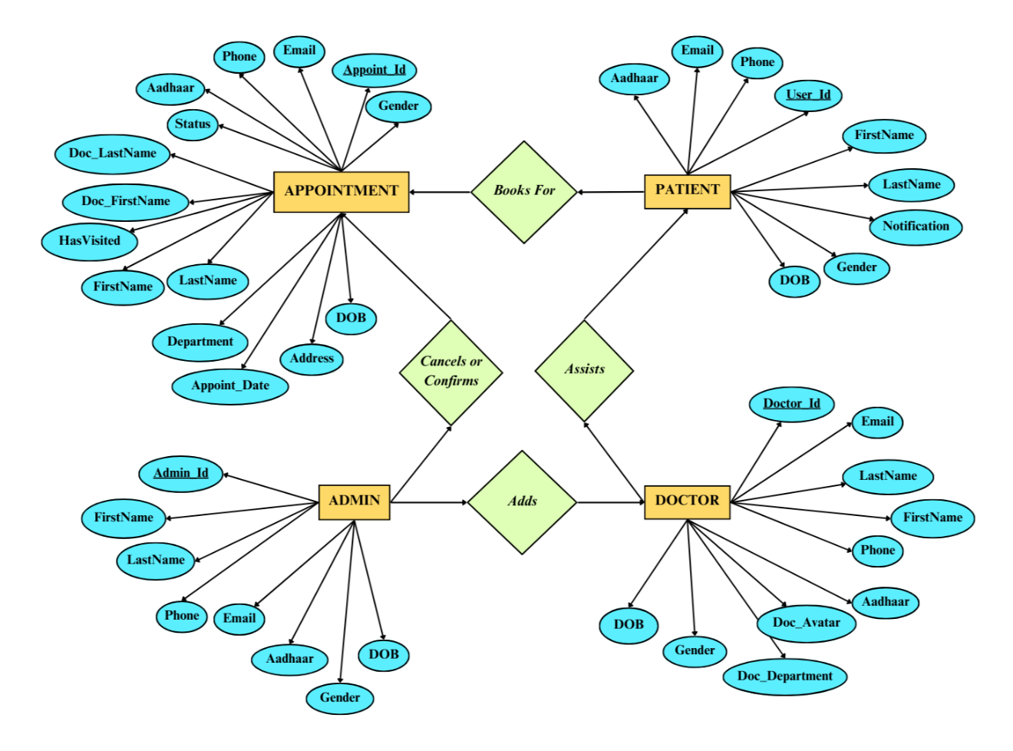

Figure 3.1 ER Diagram

# 3.3 DFDs

A data flow diagram (DFD) is a graphical representation of the “flow” of data through information through information system, modeling its prospects. DFDs are also used for the visualization of data processing. A DFD shows what kind of information will be input to the system and output from the system, where the data will come from and go to, and where the data will be stored. It does not show the timing of the processors, or information about whether processes will operate in sequence or in parallel. Data flow diagrams are used to graphically represent the flow of data in a business information system. DFD describes the processes that are involved in a system to transfer data from the input to the file storage and reports generation. Data flow diagrams can be divided into logical and physical. The logical data flow diagram describes the flow of data through a system to perform certain functionality of a business. The physical data flow diagram describes the implementation of the logical data flow.

**3.3.1 Level 0 DFD**

Level 0 is also called a Context Diagram. It is a basic overview of the whole system or process being analyzed or modeled. It is designed to be an at-a-glance view showing the system as a single high-level process with its relationship to external entities. It should be easily understood by a wide audience, including stakeholders, business analysts, data analysts and developers.

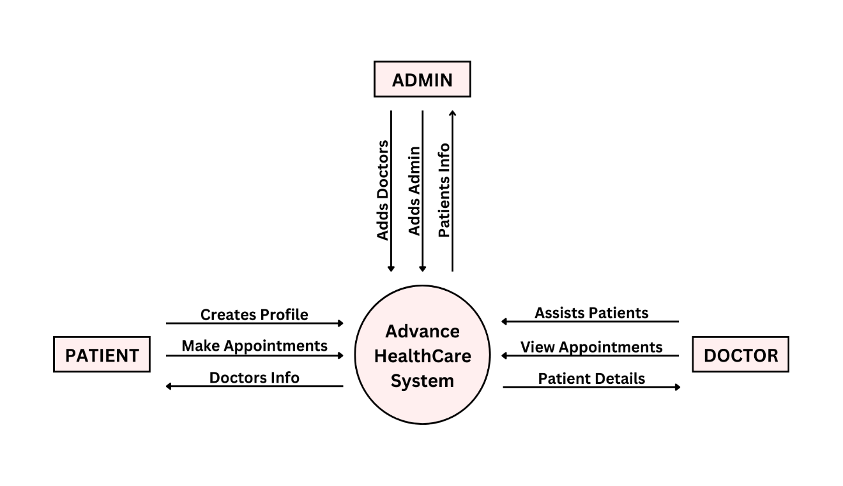

Figure 3.2 Level 0 DFD

**3.3.2 Level 1 DFD**

The level 1 data flow diagram (DFD) shows how the system is divided into sub-systems (processes), each of which deals with one or more of the data flows to or from an external agent, and which together provides all functionality of the system. It also identifies the internal data stores that must be presenting order for the system to do its job, and flow of data between the various inputs of the system.

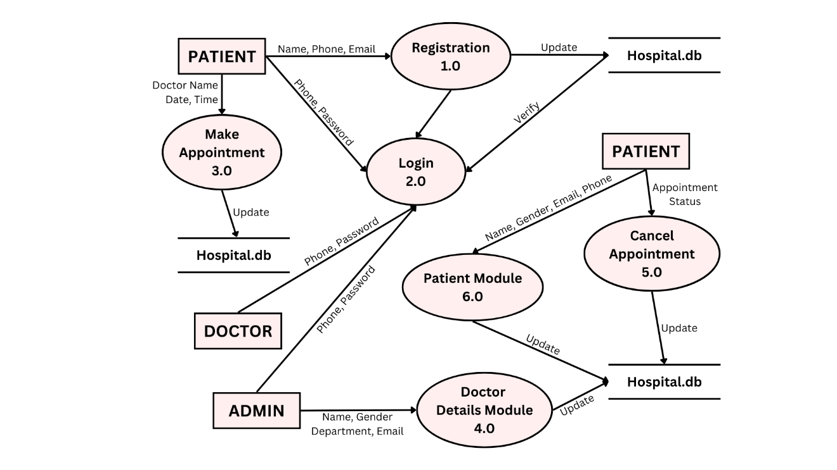

Figure 3.3 Level 1 DFD

# 3.4 Use Case Diagram

**PATIENT DETAILS:-**

*• Registration Part*

**1.** **Description** - The new patient can register themselves and add their details like name,

dob, gender, email, etc. The patient entry will be made in the AHCS database.

**2.** **Pre-Condition** - The patient must be a new patient, if necessary, fields left by user,

then prompt users to fill the necessary fields.

**3.** **Main Flow of Events** -

a. Patient selects sign up and login module.

b. A registration form get displayed.

c. Patient fills in the required details.

**4. Post Conditions** - Patient records are added to the AHCS database.

*•* *Appointment Part*

**1. Description** - It shows users a list of available doctors, dates and enables

patients to select the most suitable appointment date and doctor.

**2. Pre-Condition** - The patient must be a registered patient; Patient can fix any number

appointment for a particular department.

**3. Main Flow of Events** -

a. Patient first logs into system.

b. View his/her record.

c. Create a new appointment.

**4. Post Conditions** - Patient details are displayed, and a new appointment is fix and the

AHCS database is updated.

**DOCTOR DETAILS:-**

**1. Description** - The doctor view patient record/update his details and add description of

the treatment given to the patient.

**2. Pre-Condition** - The doctor must be a registered doctor, System does not allow the

doctor to modify the qualification, hospital managed details.

**3. Main Flow of Events** -

a. Doctor logs in to the system.

b. Doctor may select view patient.

c. Doctor add description of patient treatment.

d. Doctor may select appointment details.

e. Doctor confirm or cancel appointment.

**4. Post Condition** - The patient and doctor‘s database are updated.

**ADMIN DETAILS:-**

**1. Description** - The admin add doctor, update doctor details, and new admin.

**2. Main Flow of Events** -

1. Admin logs into the system.

2. Admin may add a new doctor.

2.1. Admin fills in the doctor’s details.

3. Admin view Doctor record.

4. Admin may add a new doctor.

5. Admin can view all messages of users.

**3. Pre-Condition** - Admin must first log in with his/her credentials.

**4. Post Condition** - The AHCS database is updated.

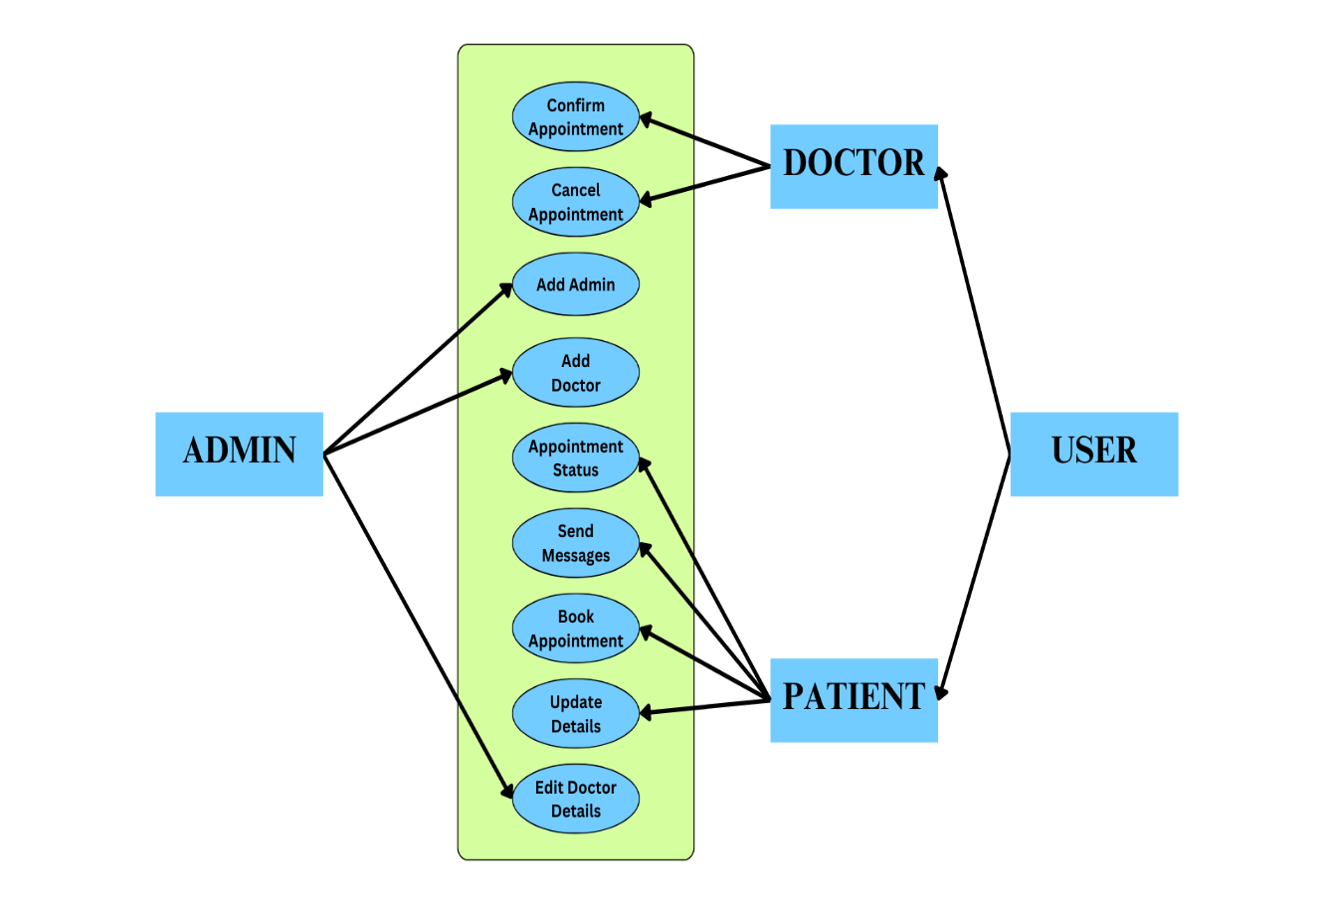

Figure 3.4 Use Case Diagram

**3.5 Website User Characteristics**

**ADMIN**

Admin has full access to the system which means he can manage any activity regarding the system. He is the most privileged user who can access the system.

*Key functions:*

• Access patient record, doctor record.

• Add new doctor entry in system database.

• Add new admin entry in system database.

• View Records. (Total no of patients treated, doctor added).

**PATIENT**

Patients can choose the best preferred appointments from the options provided. After the appointment is confirmed by the respective doctor they can visit the doctor for a check-up. Patients have access to only their records.

*Key functions:*

• Make appointment.

• Cancel appointment.

• Update Details.

**DOCTOR**

Doctors can view the patient appointment list and provide confirmation or make changes in the appointment list if required. Doctors have access to only records of those patients whom they are treating.

*Key functions:*

• Confirmation of appointment.

• Cancellation of appointment.

• Modification of appointment list.

• Add Prescription.

# 3.6 Summary

# This chapter gives a brief introduction to the system design process, and its methodologies required for developing a system. It deals with different types of design processes used in the real world and system architectures. The proposed model mainly describes how exactly the system works. Data flow diagram for the proposed model is designed in three different levels of abstraction. Dataflow diagram (DFDs) offers a graphical representation for summarizing the movement of data flows in the different levels of processes. It is mainly discussed about what is the proposed system that is implementing with that of the existing system. It describes how the complexity is reduced, reduced in the cost and about the performance of the system.

6.1

Introduction

SYSTEM TESTING

System testing of software or hardware is testing conducted on a complete, integrated system

to evaluate the system's compliance with its specified requirements. A primary purpose of

testing is to detect software failures so that defects may be discovered and corrected. Testing

cannot establish that a product functions properly under all conditions, but only that it does not

function properly under specific conditions. The scope of software testing often includes the

examination of code as well as the execution of that code in various environments and

conditions as well as examining the aspects of code: does it do what it is supposed to do and do

what it needs to do. In the current culture of software development, a testing organization may

be separate from the development team. There are various roles for testing team members.

Information derived from software testing may be used to correct the process by which software

i

# CHAPTER 4: WEBSITE SCREENSHOTS

Figure 4.1 User Login Page

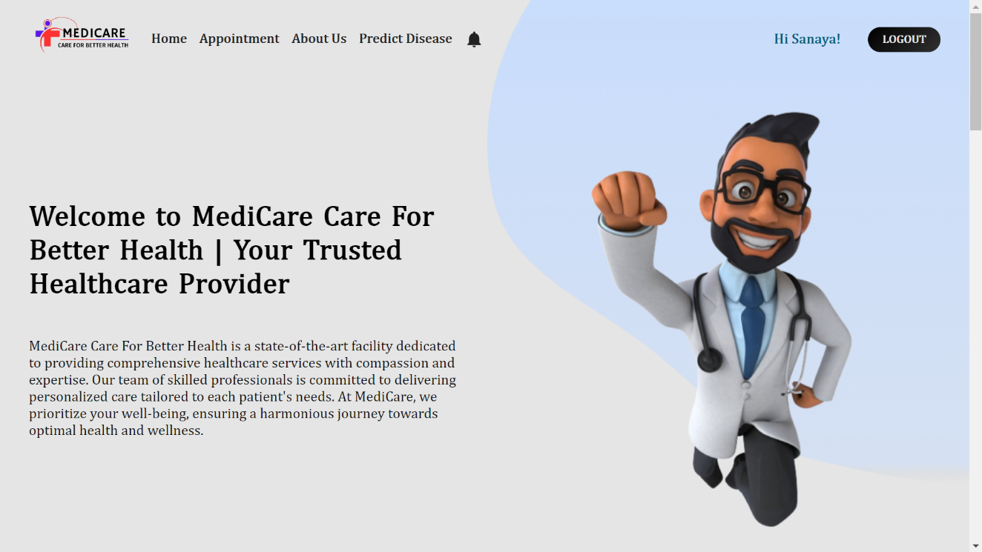

Figure 4.2 User Home Page

# 

Figure 4.4 Appointment Page Part 1

Figure 4.3 User Registration Page

# 

Figure 4.6 Send Message Page

Figure 4.5 Appointment Page Part 2

# 

Figure 4.8 Admin Dashboard Home

Figure 4.7 Admin Dashboard Login

# 

Figure 4.10 Add New Doctor

Figure 4.9 Add New Admin

# 

Figure 4.12 All User Messages

Figure 4.11 All Registered Doctors

# 

Figure 4.14 Disease Prediction Page

Figure 4. 1

Figure 4.13 Hospital Database

# CHAPTER 5: CONCLUSION

Healthcare is a field where information must be maintained properly. This field needs to create a user-friendly system, which guides users at all steps they need to perform in it. The information provided by the users must be kept secure, as the healthcare information is very confidential. The prescriptions for a certain patient are forwarded electronically to the pharmacy. This avoids the unnecessary time taken by the patient to carry the prescription to the pharmacy.

Thus, our healthcare is much secure providing authentication to the user. Our project guides the user to the action they need to perform. Our project is userfriendlier than all other e-healthcare systems with voice messages and blue tooth enhancement. Our healthcare system currently focuses on the relationships between patients and doctors. We plan to extend the system to other healthcare facilities and professionals, such as laboratory technicians who perform and report tests and analyses requested by physicians.

Working on the project was an excellent experience. It helped us to understand the importance of planning, designing and implementation so far, we have learnt in our theory books. It helped us unleash our creativity while working in a team. It also realized the importance of team working, communication as a part of this project. The project was successfully completed after a lot of effort and work hours. This project underwent a number of compiling, debugging, removing errors, making it bug free, adding more facilities in Advance HealthCare System and interactivity making it more reliable and useful. This project focused that scheduling a project and adhering to that schedule creates a hard sense of time- management. It has also let us know that co-operative teamwork always produces effective results. The entire project has been developed and deployed as per the requirements stated by the user. There are also a few features which can be integrated with this system to make it more flexible. Below list shows the future points to be consider:

• Getting the status of patient.

• Including a different module for pharmacy, LAB, Bed Allotment and many more.

• Including a Frequently Asked Questions Section.

Finally, we like to conclude that we put all our efforts throughout the development of

our project and tried to fulfill most of the requirements of the user.

**CHAPTER 6: REFERENCES**

1. American Hospital Association. "Hospital Statistics 2023." *AHA Annual Survey Database*. 2023.

2. World Health Organization. "Digital Health Interventions for Health System Strengthening." *WHO Guideline*. 2023.

3. Brown, L. "The Impact of E-Health Technologies on Patient Outcomes." *Journal of Medical Systems*, vol. 29, no. 5, 2023, pp. 340-354

4. National Institute of Health. "Health Information Technology." *NIH Fact Sheets*.2023.

5. Kumar, Arjun. "Design and Implementation of a Healthcare Management System." *Computer Science Research Papers, vol. 13, no. 1, 2022, pp. 45-60.

**Websites Refences**

1. **React** - A JavaScript library for building user interfaces.

https://reactjs.org

2. **Node.js** - JavaScript runtime built on Chrome's V8 JavaScript engine.

https://nodejs.org

3. **MongoDB** - The most popular database for modern apps.

https://www.mongodb.com

4. **Postman** - An API platform for building and using APIs.

https://www.postman.com