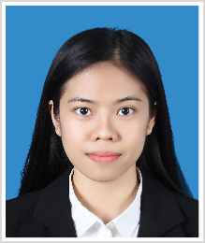Chavisa Singkeepong

**Date of Birth: 16/02/1995 (25 years old)**

**Mobile： 0639245153**

**Email： Chavisa.singkeepong@gmail.com**

# Education

**2018.09 - 2019.09 Master, University of Glasgow,** GPA: B1 with Merit

Major : International Corporate Finance and Banking

# 2013.05 - 2017.05 Bachelor, Thammasat University, GPA: 3.64 First class Honours

Major : Faculty of economics Minor : Finance

# Working Experience

**2019.12 - Present Toyota Daihatsu Engineering & Manufacturing CO., LTD.**

Position : Accounting (Specialist), Cost Maintenance & Kaizen Department

**Main responsibility**

-To support cost of vehicle part and import part for tax privilege

-To analyze cost alteration such as spec change, or tentative supplier

-To calculate and announce monthly FX

-To arrange operation schedule between TMC, TDEM and TMT

# Project Experiences

* **June-September 2017 Work and travel in USA**

# January-May 2017 Teaching Assistant (TA) at Thammasat University

# August-November 2016 Internship at Thailand Development Research Institute Foundation

# Training

**2017.10 - 2018.05 English skill**

Training Institution : Nelson English Centre, New Zealand

# Certificates

2019 Award of Master of Science, with Merit

2018 General English Certificate (Intermediate)

2017 Derivative License

Excellent Seminar Paper

The Bachelor of Economics with First class Honours

Single License

**Research Experiences**

2019 Dissertation “Dividend Policy and Profitability”

2017 Seminar paper “Market Structure of the Coffin”

2015 Research leader “Pricing Strategies of Low-cost Airlines”

**Language Skills**

Thai (Native speaker)

English (TOEIC 725)