Microsoft Entra ID Bulk Group Automation
App Registration & Microsoft Graph Permissions Setup Guide
Project: Entra-ID-Bulk-Group-Automation
Purpose: Configure a Microsoft Entra application registration for GitHub Actions app-only authentication and bulk group membership automation.

1. Create the App Registration
Open the Microsoft Entra admin center and navigate to: Entra ID → App registrations → New registration.
- Name: Entra-ID-Bulk-Group-Automation
- Supported account types: Accounts in this organizational directory only (Single tenant)
- Redirect URI: Leave blank
Click Register.
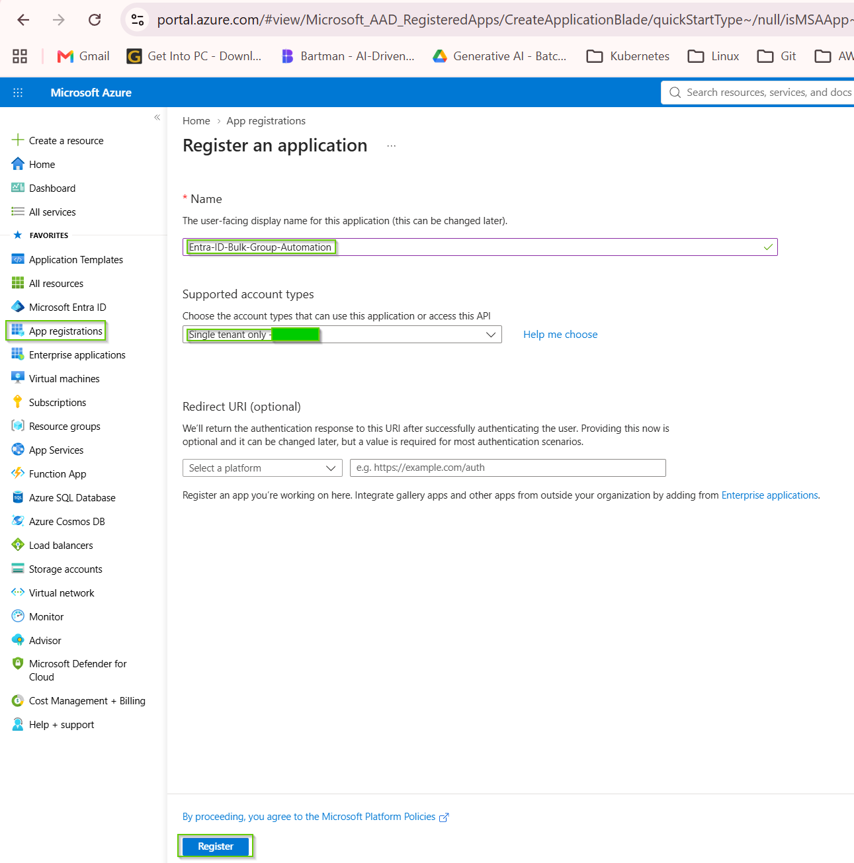

2. Record Application and Tenant IDs
From the App Registration → Overview page, record:
- Application (client) ID
- Directory (tenant) ID
These become AZURE_CLIENT_ID and AZURE_TENANT_ID in GitHub Environment Secrets.
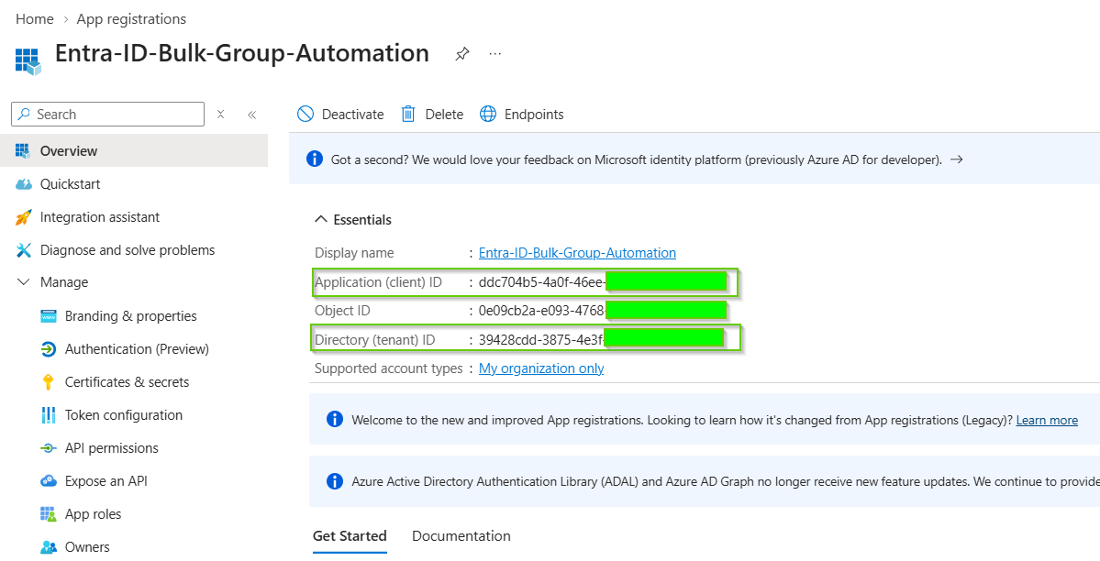

3. Create a Client Secret
- Open Certificates & secrets.
- Under Client secrets, select New client secret.
- Description: GitHub Actions Automation.
- Choose an expiration according to your organization's policy.
- Click Add.
- Copy the Secret Value immediately. Do not use the Secret ID.
The secret value becomes AZURE_CLIENT_SECRET in GitHub. Never hard-code it in YAML or PowerShell.
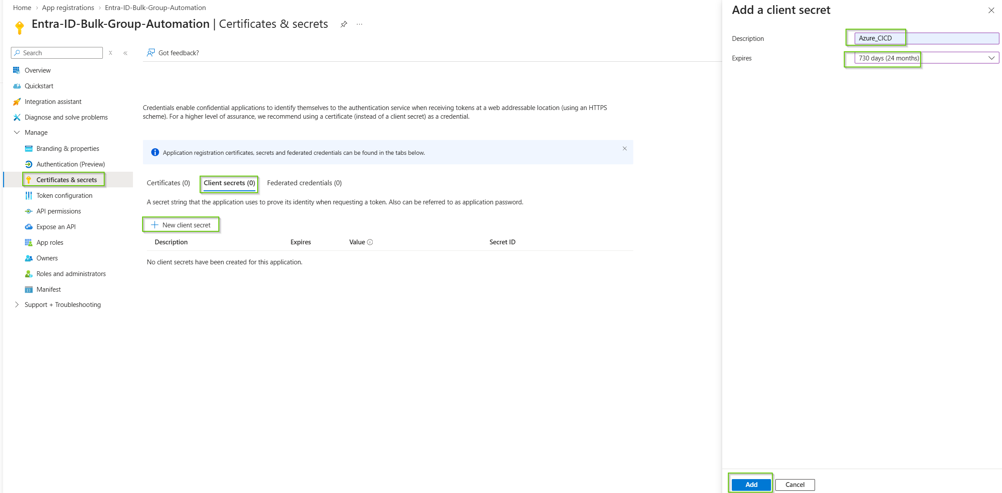
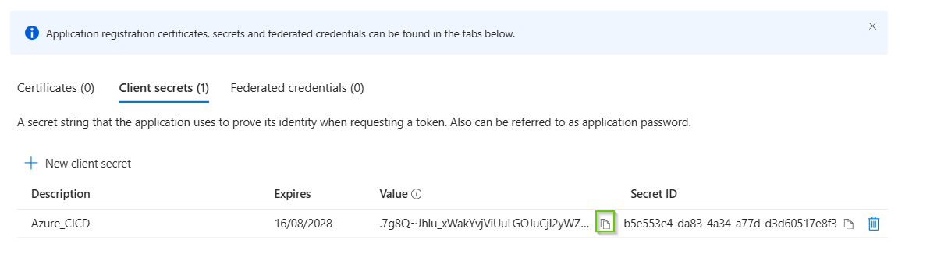

4. Add Microsoft Graph API Permissions
Navigate to API permissions → Add a permission → Microsoft Graph → Application permissions.
Use Application permissions, not Delegated permissions, because GitHub Actions authenticates as the application.
Permission | Type | Purpose
User.Read.All | Application | Find and read users
Group.Read.All | Application | Read groups
GroupMember.ReadWrite.All | Application | Read and modify group membership
Device.Read.All | Application | Find/read devices
Only add Device.ReadWrite.All if the implemented Graph operations actually require it. Follow least privilege.
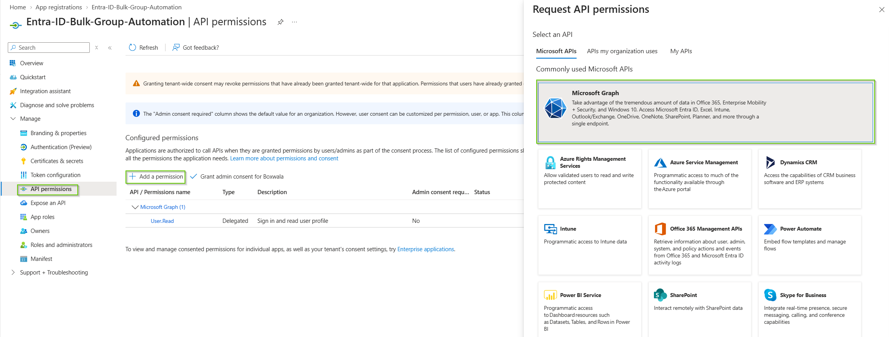
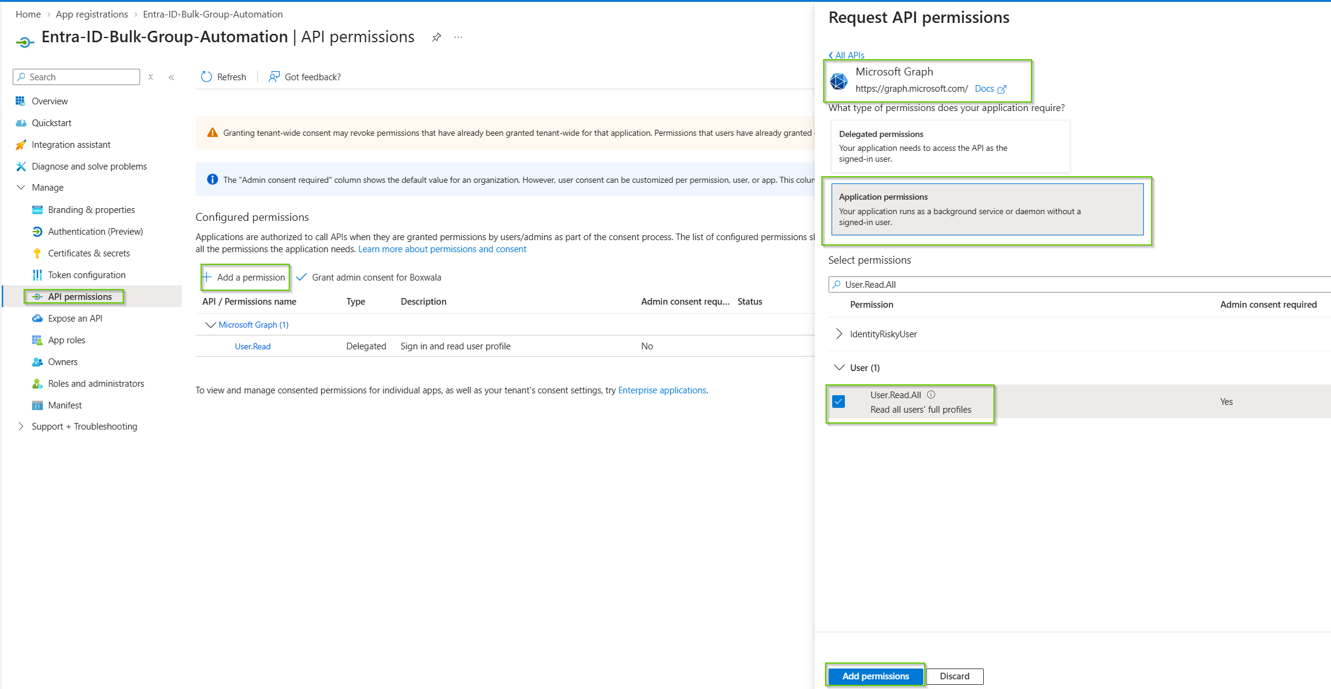

5. Grant Administrator Consent
- Return to API permissions.
- Select Grant admin consent for <Tenant Name>.
- Confirm with Yes.
- Verify the permissions show a status similar to Granted for <Tenant Name>.
Application permissions require administrator consent.
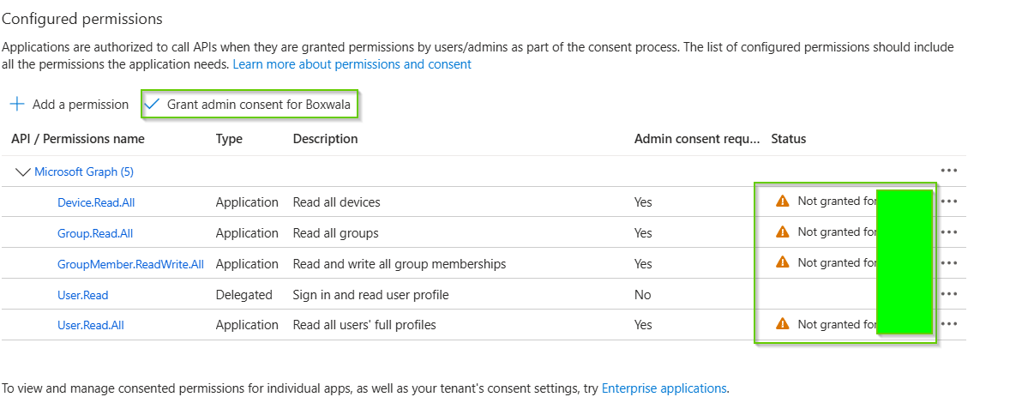
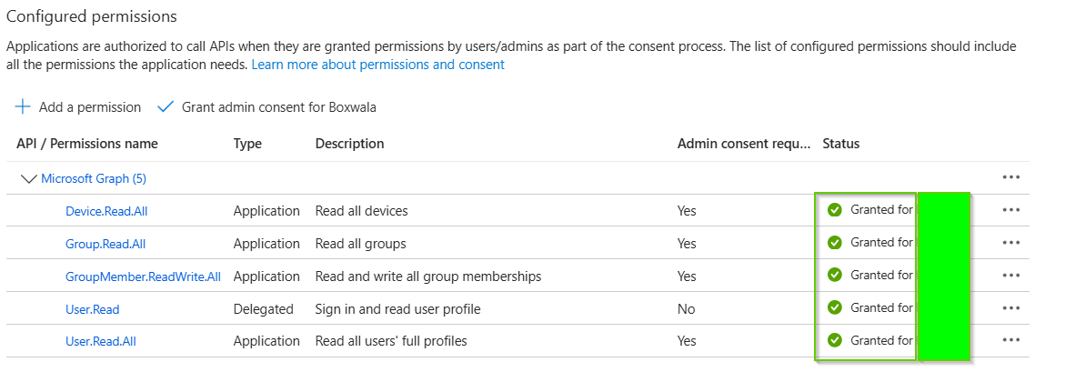

6. Configure GitHub Environments
In the repository go to Settings → Secrets and variables → Actions → Environments.
- DEV
- UAT
- PRD
Add these secrets to each environment:
- AZURE_CLIENT_ID
- AZURE_TENANT_ID
- AZURE_CLIENT_SECRET

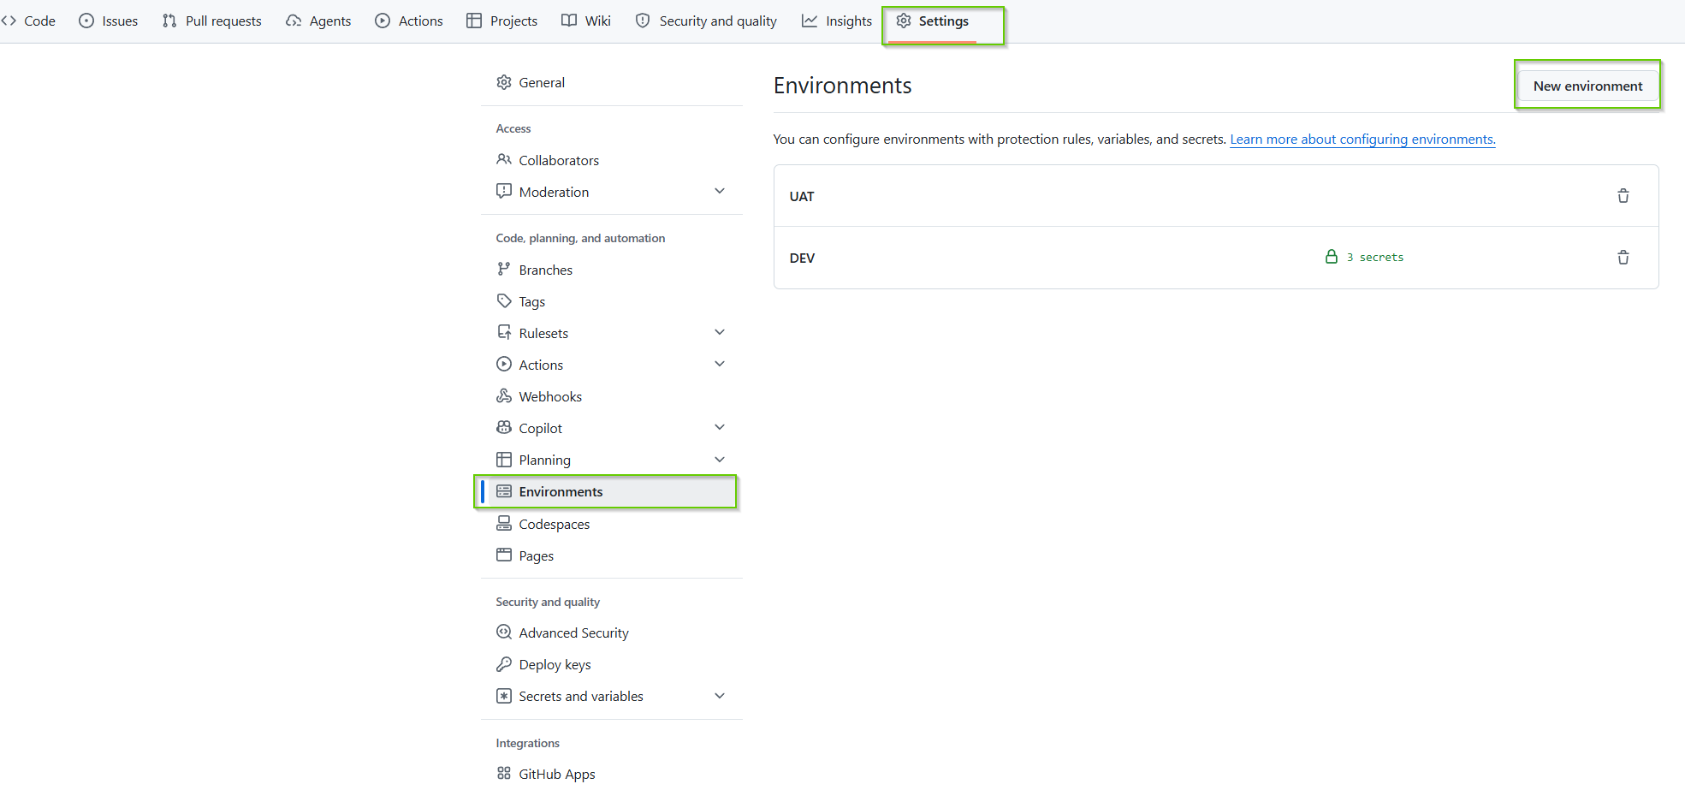
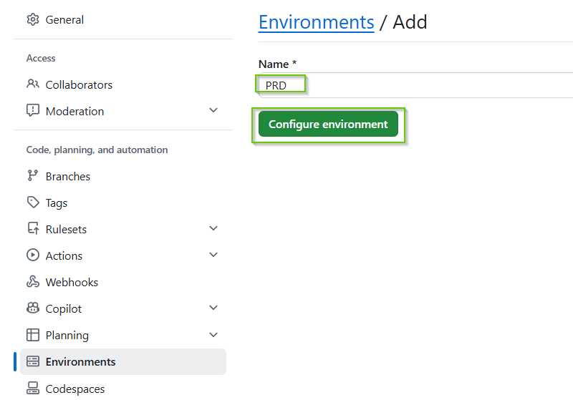
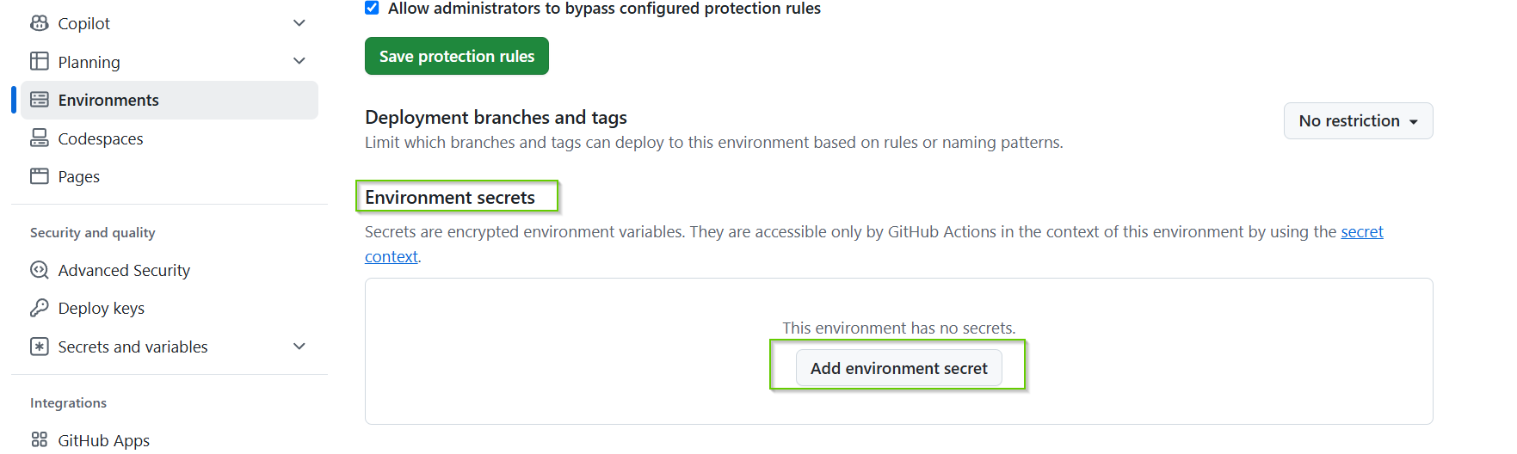
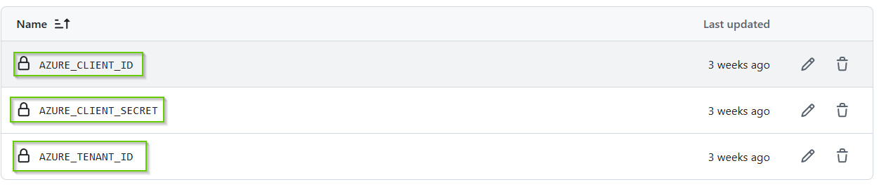

7. Recommended Environment Design
For a professional deployment, use separate App Registrations / service principals:
- Entra-ID-Bulk-Automation-DEV
- Entra-ID-Bulk-Automation-UAT
- Entra-ID-Bulk-Automation-PRD
This allows environment credentials and permissions to be independently controlled, rotated, audited and disabled.

8. GitHub Actions Authentication Flow
The workflow selects an environment, obtains the corresponding GitHub Environment Secrets, and passes them to the PowerShell authentication module.
Connect-MgGraph `
-ClientId $env:CLIENT_ID `
-TenantId $env:TENANT_ID `
-ClientSecretCredential $Credential

9. End-to-End Architecture
Operator → GitHub Actions → DEV/UAT/PRD → GitHub Environment → Application credentials → Microsoft Entra ID → Service Principal → Microsoft Graph → Users / Groups / Devices → Group Membership

10. Security Recommendations
- Never hard-code client secrets.
- Use GitHub Environment Secrets.
- Use separate application registrations for DEV/UAT/PRD where practical.
- Apply only required Microsoft Graph permissions.
- Use GitHub Environment protection and approvals for PRD.
- Rotate client secrets according to policy.
- For production, prefer GitHub Actions OIDC / workload identity federation to eliminate long-lived client secrets.

11. Validation Checklist
☐ App Registration created
☐ Single-tenant configuration selected
☐ Client ID recorded
☐ Tenant ID recorded
☐ Client Secret created securely
☐ User.Read.All added as Application permission
☐ Group.Read.All added as Application permission
☐ GroupMember.ReadWrite.All added as Application permission
☐ Device.Read.All added as Application permission
☐ Admin consent granted
☐ DEV GitHub Environment configured
☐ UAT GitHub Environment configured
☐ PRD GitHub Environment configured

12. Authentication Test
Run Module 01 authentication workflow after configuring the application and GitHub secrets.
Expected output includes:
- Environment variables validated.
- Microsoft Graph Authentication module loaded.
- Connected successfully.
- Auth Type: AppOnly
- TokenCredentialType: ClientSecret
After authentication succeeds, test Get User and Get Group before executing bulk membership changes.

13. Documentation Reference
Microsoft Learn: Microsoft Entra app registrations, Microsoft Graph application permissions, and app-only authentication.

