Entra ID Bulk Group Automation
GitHub Actions Setup Guide
Purpose: Configure GitHub Actions for the current Entra ID bulk user/device group automation project.

1. Current Repository Structure
The following automation files:
Entra-ID-Bulk-Group-Automation/
│
├── .github/
│ └── workflows/
│ └── bulk-group-membership-management.yml
│
├── scripts/
│ ├── add-devices-to-group.ps1
│ ├── add-users-to-group.ps1
│ ├── common.ps1
│ ├── connect-entra.ps1
│ ├── main.ps1
│ ├── remove-devices-from-group.ps1
│ └── remove-users-from-group.ps1
│
├── Entra-ID-App-Registration-Setup-Guide.docx
├── Setting-up-GitHub-Actions.docx
└── README.md

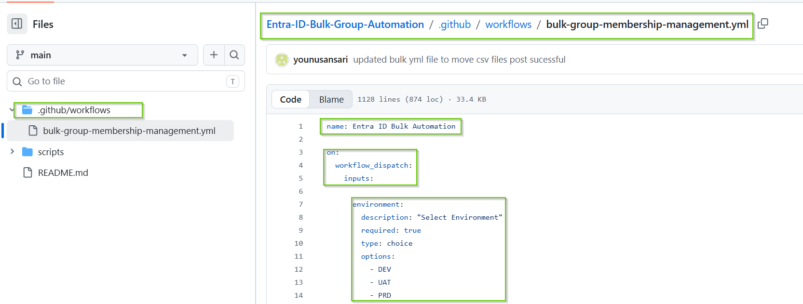

2. CSV Branch Structure
The updated Git repository also contains a csv-upload branch. Its current CSV structure is:
csv-upload/
└── csv/
├── dev/
│ ├── pending/
│ ├── processing/
│ ├── completed/
│ └── failed/
│
├── uat/
│ ├── pending/
│ ├── processing/
│ ├── completed/
│ └── failed/
│
└── prd/
├── pending/
├── processing/
├── completed/
└── failed/
The current csv-upload branch contains the environment folders and .gitkeep files; request CSVs are uploaded into the appropriate pending folder.

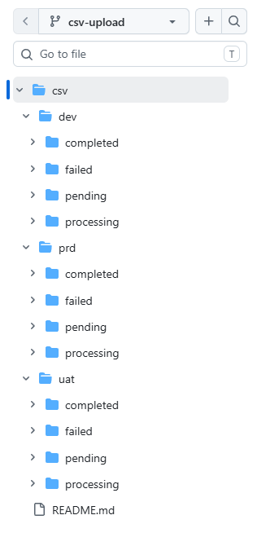

3. Create GitHub Environments
In the GitHub repository:
- Open Settings.
- Open Environments.
- Create DEV.
- Create UAT.
- Create PRD.
The workflow uses environment: ${{ inputs.environment }}, so selecting DEV/UAT/PRD automatically selects the corresponding GitHub Environment.

4. Add GitHub Environment Secrets
Add these secrets separately to DEV, UAT and PRD:
- AZURE_CLIENT_ID
- AZURE_TENANT_ID
- AZURE_CLIENT_SECRET
The PowerShell authentication script reads them through CLIENT_ID, TENANT_ID and CLIENT_SECRET environment variables.

5. Workflow File
Current workflow filename:
.github/workflows/bulk-group-membership-management.yml
The workflow is manually triggered with workflow_dispatch.

6. Workflow Inputs
Input | Options | Purpose
environment | DEV / UAT / PRD | Select target Entra environment
operation | Add Users to Group / Remove Users from Group / Add Devices to Group / Remove Devices from Group | Select bulk operation
dry_run | Yes / No | Preview changes or execute actual changes

7. Required Workflow Permissions
The workflow currently uses:
permissions:
contents: write
This is required because the workflow moves successfully processed CSV files on the csv-upload branch and pushes the resulting commit.

8. Workflow Execution - Step by Step
01 - Checkout Automation Repository — actions/checkout@v4 checks out the automation repository.
02 - Checkout CSV Data — Fetches origin/csv-upload and checks out only the csv directory into the main workspace.
03 - Display Workflow Inputs — Displays environment, operation and Dry Run.
04 - Validate Environment — Validates DEV, UAT or PRD.
05 - Validate Operation — Validates one of the four supported operations.
06 - Validate Dry Run — Validates Yes or No.
07 - Determine Input Type — Maps user operations to Users and device operations to Devices.
08 - Validate Environment Folder — Converts DEV/UAT/PRD to lowercase and validates ./csv/dev, ./csv/uat or ./csv/prd and the pending folder.
09 - Determine Request File — Builds the request filename from environment and operation.
10 - Validate Request File — Checks that the expected CSV exists in the environment pending folder.
11 - Validate CSV Structure — Checks that the CSV has records and the correct columns.
12 - Install Microsoft Graph Modules — Installs Microsoft.Graph.Authentication, Microsoft.Graph.Users, Microsoft.Graph.Groups and Microsoft.Graph.Identity.DirectoryManagement.
13 - Display Graph SDK Information — Displays installed Graph module and SDK information.
14 - Verify Required Cmdlets — Checks Connect-MgGraph, Get-MgUser, Get-MgGroup, Get-MgDevice and Get-MgGroupMember.
15 - Display Request Preview — Displays the first five CSV records before execution.
16 - Execute Automation — Runs scripts/main.ps1 with Operation, CsvPath and DryRun.
17 - Move Request File to Completed — After successful non-Dry-Run execution, moves the request from pending to completed on csv-upload, adds UTC timestamp and GitHub run number, commits and pushes.
18 - Generate Job Summary — Writes execution metadata to the GitHub Actions job summary.
19 - Upload Logs — Uploads logs as a GitHub Actions artifact with 30-day retention.

9. Request File Naming
The workflow automatically creates filenames based on the selected environment and operation.
- DEV + Add Users → csv/dev/pending/dev-add-users-to-groups.csv
- DEV + Remove Users → csv/dev/pending/dev-remove-users-from-groups.csv
- DEV + Add Devices → csv/dev/pending/dev-add-devices-to-groups.csv
- DEV + Remove Devices → csv/dev/pending/dev-remove-devices-from-groups.csv
- UAT and PRD use the same naming pattern with uat/prd.

10. CSV Formats
User operations:
UserEmail,GroupName
john.doe@company.com,Dev-Team
jane.doe@company.com,Dev-Team
Device operations:
DeviceName,GroupName
LAPTOP001,Dev-Team
LAPTOP002,Dev-Team

11. PowerShell Script Responsibilities
File | Responsibility
scripts/main.ps1 | Central orchestrator; loads common/authentication scripts and routes all four operations.
scripts/connect-entra.ps1 | App-only Microsoft Graph authentication and disconnect.
scripts/common.ps1 | CSV validation, Graph lookup helpers, membership checking, logging and execution summary.
scripts/add-users-to-group.ps1 | Bulk user addition.
scripts/remove-users-from-group.ps1 | Bulk user removal.
scripts/add-devices-to-group.ps1 | Bulk device addition.
scripts/remove-devices-from-group.ps1 | Bulk device removal.

12. Microsoft Graph Modules
- Microsoft.Graph.Authentication
- Microsoft.Graph.Users
- Microsoft.Graph.Groups
- Microsoft.Graph.Identity.DirectoryManagement

13. Microsoft Graph Application Permissions
For the current operations, configure the App Registration with the required Application permissions, subject to your exact Graph calls and least-privilege review:
- User.Read.All
- Group.Read.All
- GroupMember.ReadWrite.All
- Device.Read.All
Grant administrator consent after adding the required permissions.

14. Authentication Flow
GitHub Actions
|
v
GitHub Environment
|
+-- AZURE_CLIENT_ID
+-- AZURE_TENANT_ID
+-- AZURE_CLIENT_SECRET
|
v
CLIENT_ID / TENANT_ID / CLIENT_SECRET
|
v
scripts/connect-entra.ps1
|
v
Microsoft Graph
|
v
Microsoft Entra ID

15. Dry Run Behavior
Dry Run = Yes:
- Validates the request.
- Looks up users/devices and groups.
- Checks membership.
- Does not modify group membership.
- Leaves the CSV in pending.
Dry Run = No:
- Performs the requested membership changes.
- If successful, Step 17 moves the request to completed.
- The completed filename includes UTC timestamp and GitHub run number.

16. Completed File Naming
Successful actual execution changes:
csv/dev/pending/dev-add-users-to-groups.csv
to a timestamped completed file such as:
csv/dev/completed/dev-add-users-to-groups_20260813-013045_run-152.csv
This preserves the original request name while providing traceability through UTC timestamp and GitHub run number.

17. Recommended Test Sequence
- Run Module 01 / authentication and confirm AppOnly authentication succeeds.
- Run Get User and Get Group validation.
- Upload a small user CSV to csv/dev/pending on csv-upload.
- Run Add Users to Group with Dry Run = Yes.
- Run Add Users to Group with Dry Run = No.
- Confirm the file moves to csv/dev/completed with timestamp/run number.
- Test Remove Users.
- Test Add Devices.
- Test Remove Devices.
- Repeat testing in UAT before considering PRD.

18. Final Architecture
Operator
|
v
GitHub Actions
|
+-- Environment
+-- Operation
+-- Dry Run
|
v
main branch automation
|
+-- scripts/main.ps1
+-- scripts/connect-entra.ps1
+-- scripts/common.ps1
+-- user/device operation scripts
|
v
CSV from csv-upload branch
|
v
Microsoft Graph
|
v
Microsoft Entra ID
|
v
Execution Summary
|
+-- Dry Run -> pending
|
+-- Success -> completed + timestamp + run number

