1. Jenkins CI CD pipeline for flask application
Objective:
Set up a Jenkins pipeline that automates the testing and deployment of a simple Python web application.
Requirements:
1. Setup:
- Install Jenkins on a virtual machine or use a cloud-based Jenkins service.
- Configure Jenkins with Python and any necessary libraries.
2. Source Code:
- Fork the provided Python web application repository on GitHub (provide a link to a sample Python web application repository).
- Clone the forked repository into your Jenkins server.
3. Jenkins Pipeline:
- Create a Jenkinsfile in the root of your Python application repository.
- Define a pipeline with the following stages:
- Build: Install dependencies using pip.
- Test: Run unit tests using a testing framework like pytest.
- Deploy: If tests pass, deploy the application to a staging environment.
4. Triggers:
- Configure the pipeline to trigger a new build whenever changes are pushed to the main branch of the repository.
5. Notifications:
- Set up a notification system to alert via email when the build process fails or succeeds.
6. Documentation:
- Document the pipeline process and any prerequisites needed for the setup in a README.md file in the repository.
7. Submission:
- Provide the URL to the GitHub repository with the Jenkinsfile and updated README.md.
- Include screenshots of the Jenkins pipeline showing the build, test, and deployment stages.
Deliverables:
- Forked GitHub repository with Jenkinsfile.
- Documentation in README.md.
- Screenshots of the Jenkins pipeline execution.

Lunch EC2 instance
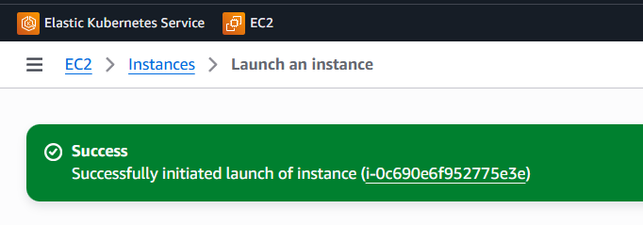

sudo apt update
sudo apt upgrade

sudo apt install python3
check if you have
python3 --version
pip3 --version
sudo apt install python3-pip
pytest --version
sudo apt install python3-pytest
sudo apt install python3-flask
sudo apt update
sudo apt install python3.12-venv

sudo apt install fontconfig openjdk-21-jre
java -version
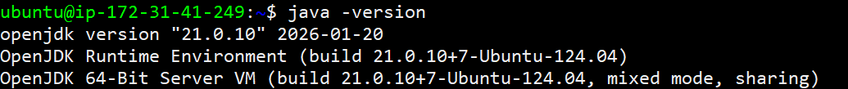

sudo wget -O /etc/apt/keyrings/jenkins-keyring.asc https://pkg.jenkins.io/debian-stable/jenkins.io-2026.key
echo "deb [signed-by=/etc/apt/keyrings/jenkins-keyring.asc]" https://pkg.jenkins.io/debian-stable binary/ | sudo tee /etc/apt/sources.list.d/jenkins.list > /dev/null
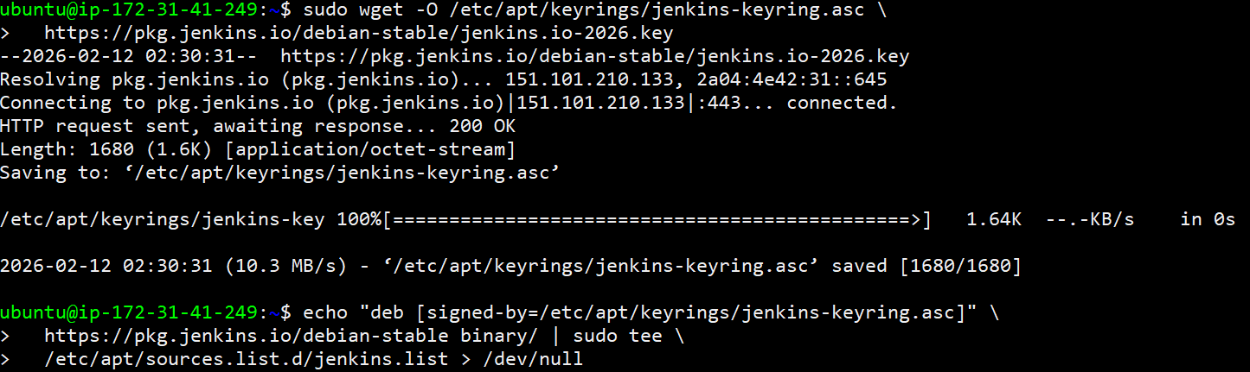

sudo apt update
sudo apt install jenkins

Post installation setup your Security Group to allow port 8080
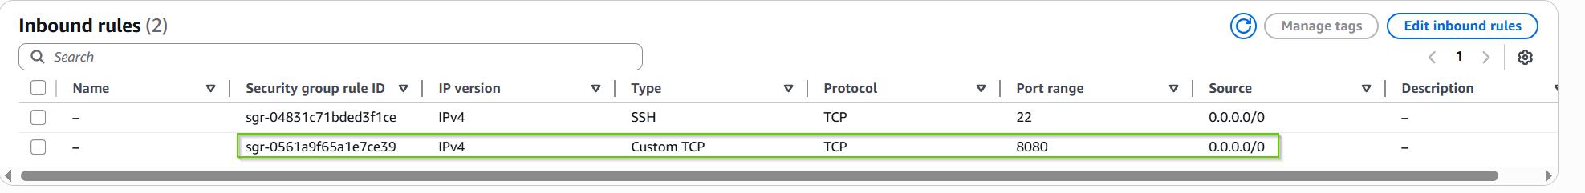

Open browser and hit http://ec2instancepublicIP:8080
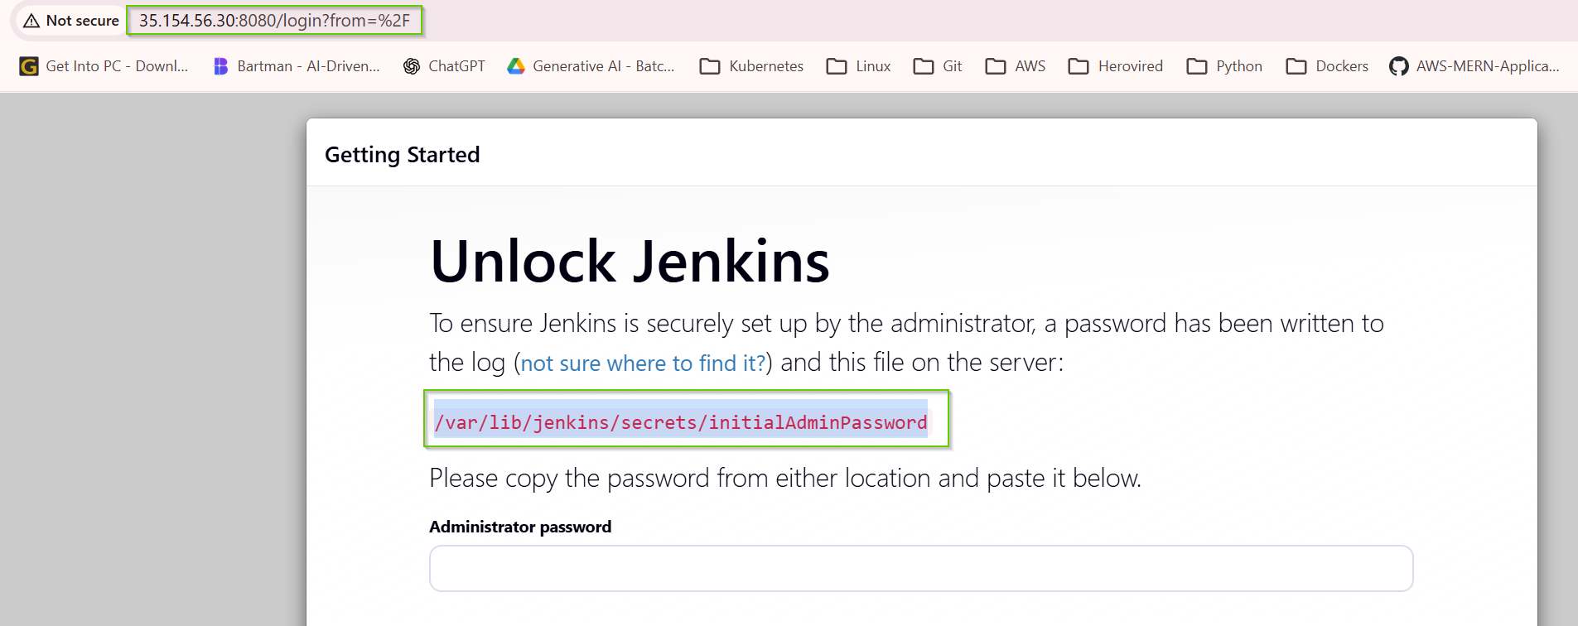
Get the password for first login
sudo cat /var/lib/jenkins/secrets/initialAdminPassword

Once login click on Install suggested plugins

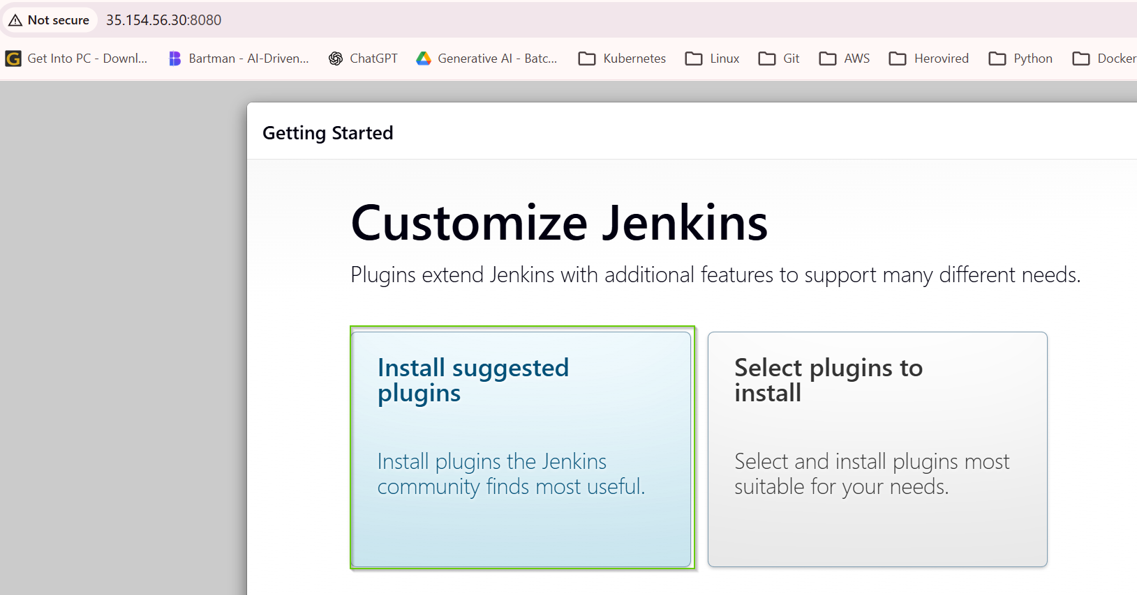

Create User / Admin
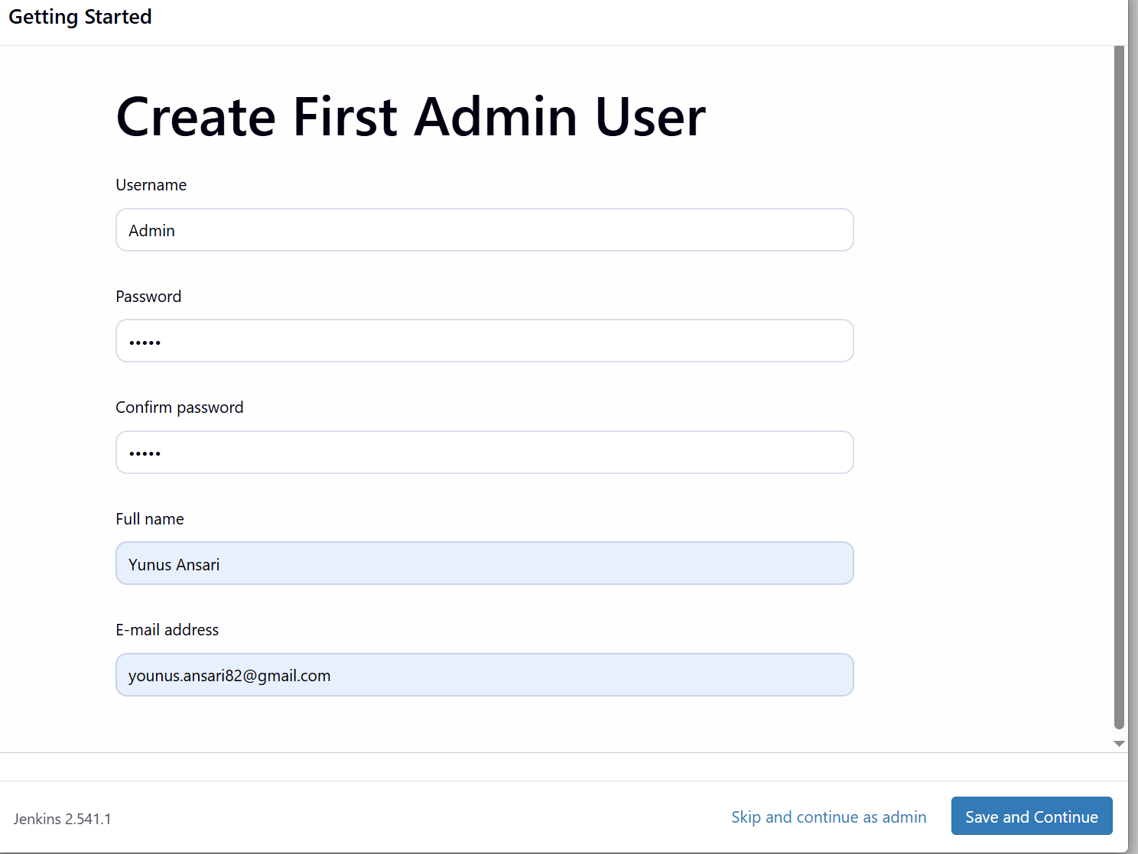

Create Simple Python flask application and push it to git and create branch as jenkins
https://github.com/younusansari/Jenkins-CI-CD-flask-app.git
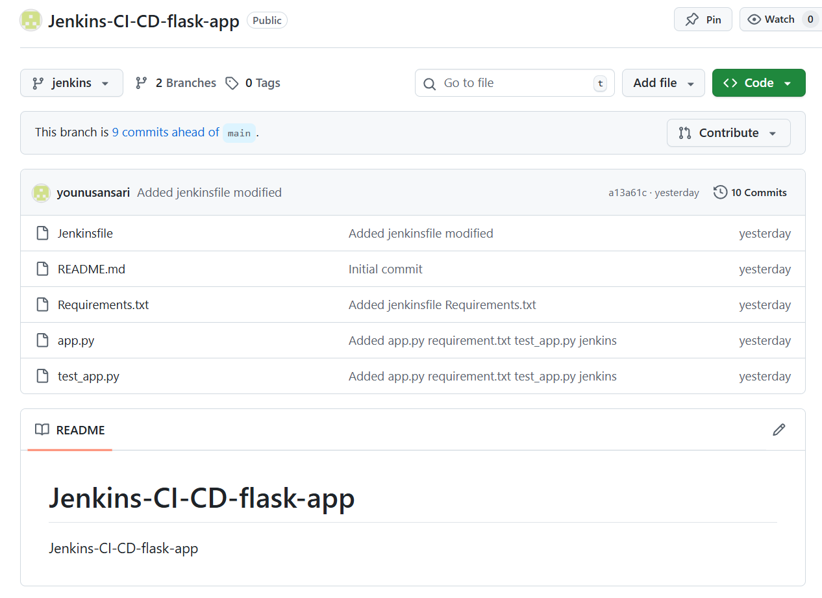
App.py
from flask import Flask, jsonify

def create_app():
app = Flask(__name__)

@app.route('/')
def home():
return jsonify({"message": "Hello, Jenkins CI/CD!"})

@app.route('/health')
def health():
return jsonify({"status": "healthy"}), 200

return app

if __name__ == '__main__':
app = create_app()
app.run(host='0.0.0.0', port=5000)

test_app.py
import pytest
from app import create_app

@pytest.fixture
def client():
app = create_app()
app.config['TESTING'] = True
with app.test_client() as client:
yield client

def test_home(client):
response = client.get('/')
assert response.status_code == 200
assert b"Hello, Jenkins CI/CD!" in response.data

def test_health(client):
response = client.get('/health')
assert response.status_code == 200
assert b"healthy" in response.data

requirements.txt
Flask
pytest
pytest-flask

Jenkinsfile

Now create a Job
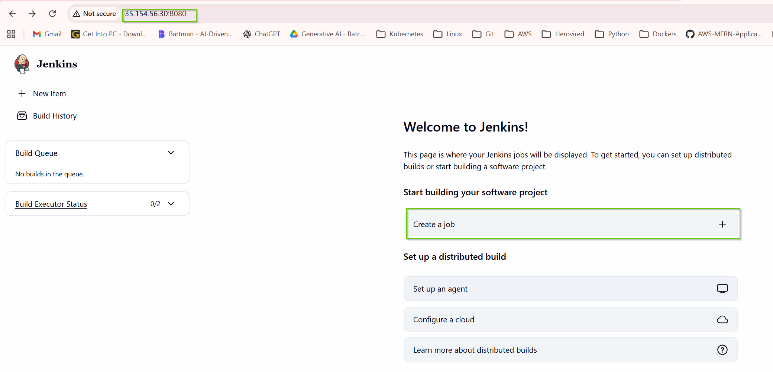
Name: Flask Application
Select : Pipeline
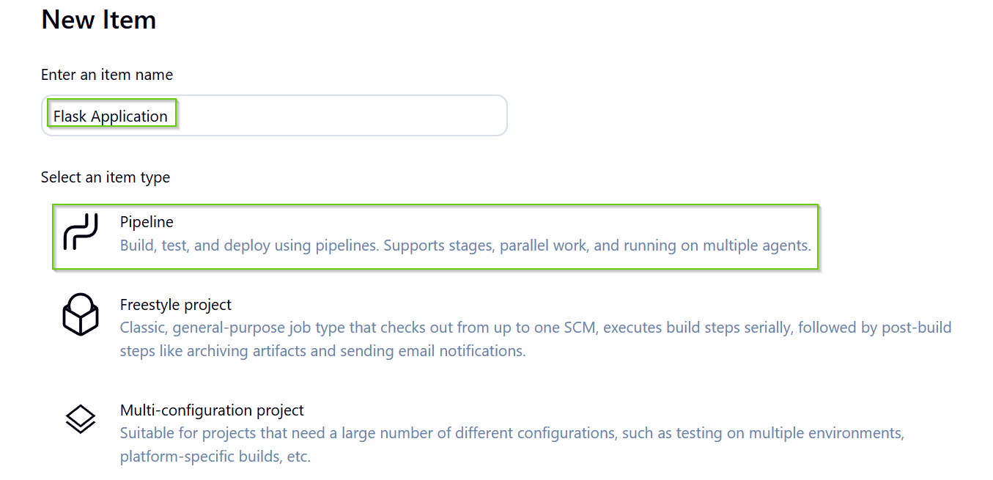
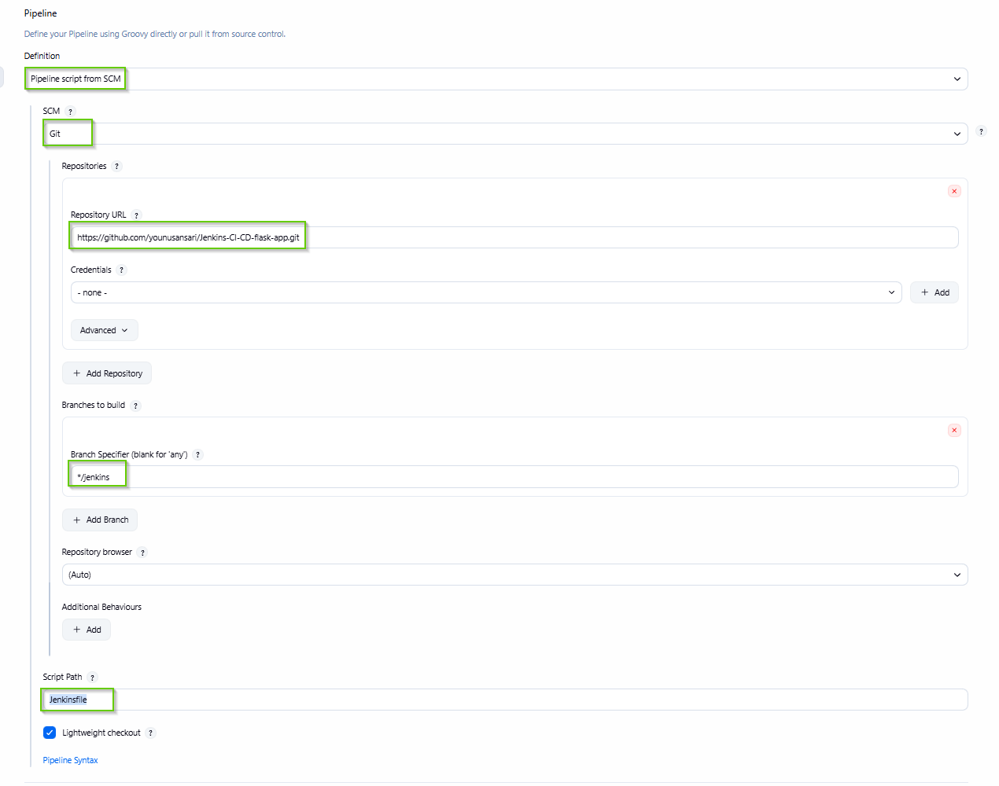
Save it

Once you save it click on Build Now
Under the builds click on recent build

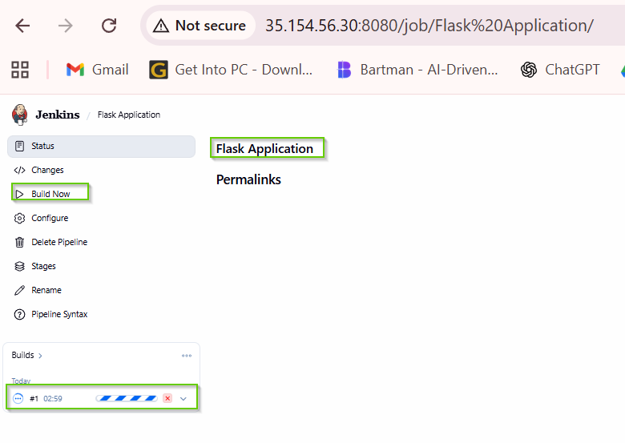

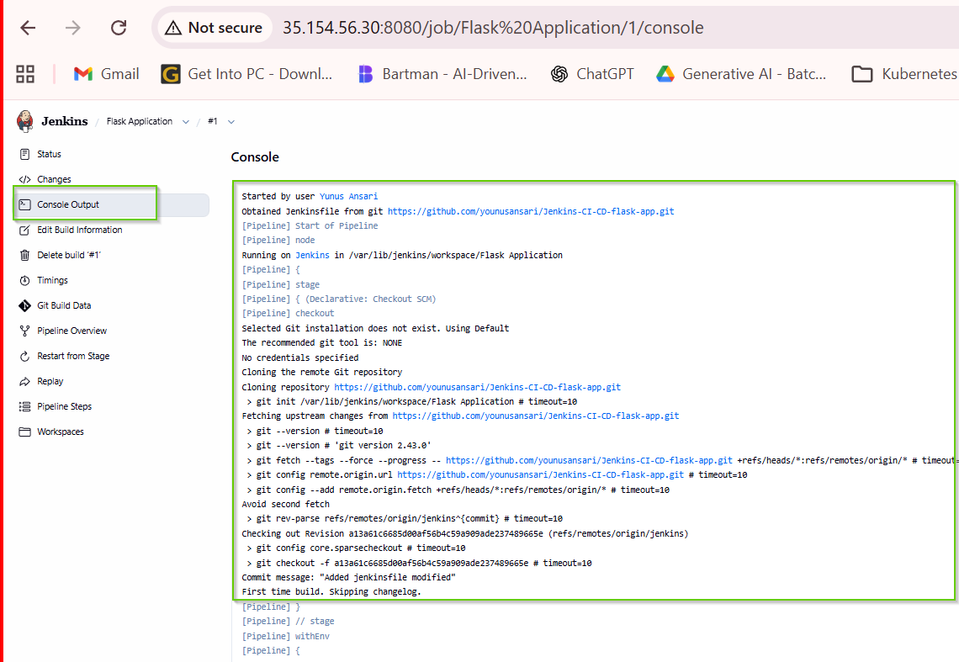

python3 --version
pip3 --version
pytest --version

