Assignment 1: Automated Instance Management Using AWS Lambda and Boto3
Objective: In this assignment, you will gain hands-on experience with AWS Lambda and Boto3, Amazon's SDK for Python. You will create a Lambda function that will automatically manage EC2 instances based on their tags.
Task: You're tasked to automate the stopping and starting of EC2 instances based on tags. Specifically:
1. Setup:
- Create two EC2 instances.
- Tag one of them as `Auto-Stop` and the other as `Auto-Start`.
2. Lambda Function Creation:
- Set up an AWS Lambda function.
- Ensure that the Lambda function has the necessary IAM permissions to describe, stop, and start EC2 instances.
3. Coding:
- Using Boto3 in the Lambda function:
- Detect all EC2 instances with the `Auto-Stop` tag and stop them.
- Detect all EC2 instances with the `Auto-Start` tag and start them.
4. Testing:
- Manually invoke the Lambda function.
- Confirm that the instance tagged `Auto-Stop` stops and the one tagged `Auto-Start` starts.
Instructions:
1. EC2 Setup:
- Navigate to the EC2 dashboard and create two new t2.micro instances (or any other available free-tier type).
- Tag the first instance with a key `Action` and value `Auto-Stop`.
- Tag the second instance with a key `Action` and value `Auto-Start`.
2. Lambda IAM Role:
- In the IAM dashboard, create a new role for Lambda.
- Attach the `AmazonEC2FullAccess` policy to this role. (Note: In a real-world scenario, you would want to limit permissions for better security.)
3. Lambda Function:
- Navigate to the Lambda dashboard and create a new function.
- Choose Python 3.x as the runtime.
- Assign the IAM role created in the previous step.
- Write the Boto3 Python script to:
1. Initialize a boto3 EC2 client.
2. Describe instances with `Auto-Stop` and `Auto-Start` tags.
3. Stop the `Auto-Stop` instances and start the `Auto-Start` instances.
4. Print instance IDs that were affected for logging purposes.
4. Manual Invocation:
- After saving your function, manually trigger it.
- Go to the EC2 dashboard and confirm that the instances' states have changed according to their tags.

Automated-Instance-Management-EC2
Created the Policy to provide access only EC2 instance
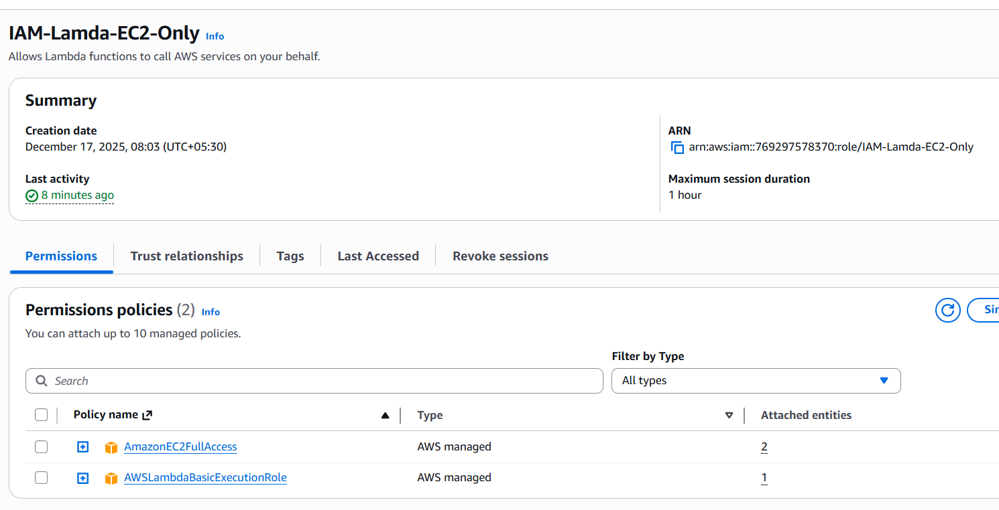
Created function
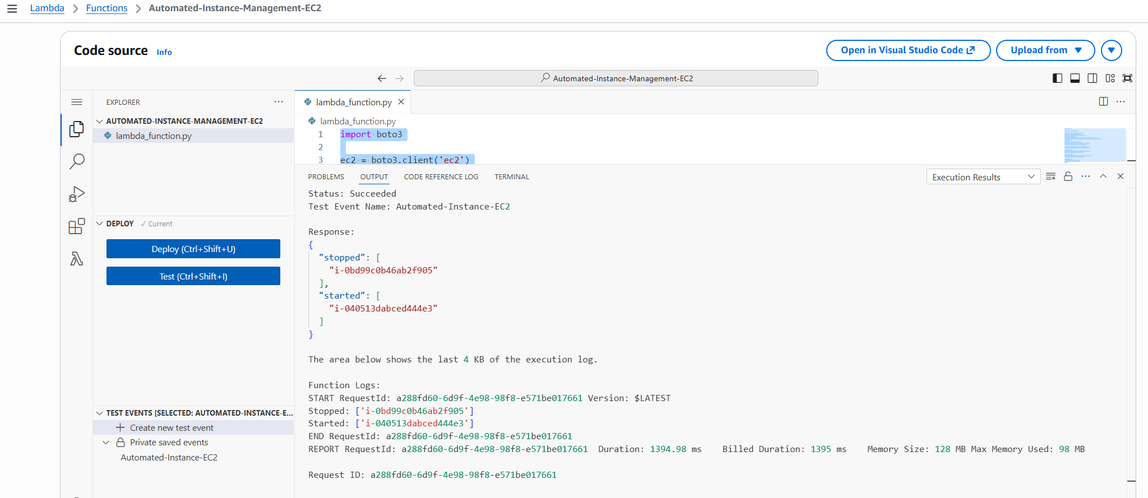
Script – To start the instances with Tag as “Action” and it’s “Auto-Start” and stop the instances with Tag as “Action” and it’s “Auto-Stop”
import boto3

ec2 = boto3.client('ec2')

def lambda_handler(event, context):
def fetch(action, state):
resp = ec2.describe_instances(
Filters=[
{'Name': 'tag:Action', 'Values': [action]},
{'Name': 'instance-state-name', 'Values': [state]}
]
)
return [i['InstanceId']
for r in resp['Reservations']
for i in r['Instances']]

to_stop = fetch('Auto-Stop', 'running')
to_start = fetch('Auto-Start', 'stopped')

if to_stop:
ec2.stop_instances(InstanceIds=to_stop)
print("Stopped:", to_stop)

if to_start:
ec2.start_instances(InstanceIds=to_start)
print("Started:", to_start)

return {
"stopped": to_stop,
"started": to_start
}

Attached permission
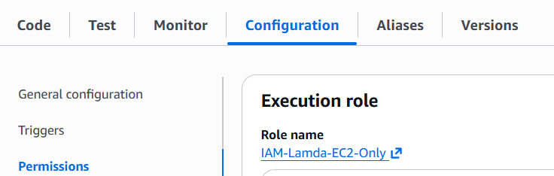

Test results
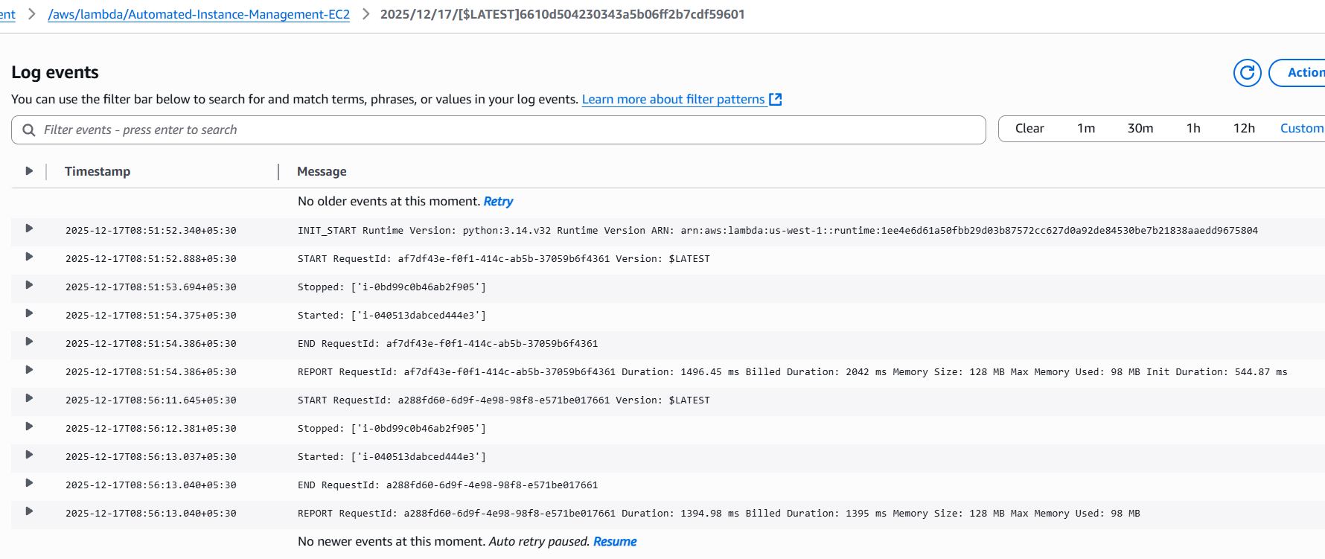
Invoke Lambda from ACLI to match real world example
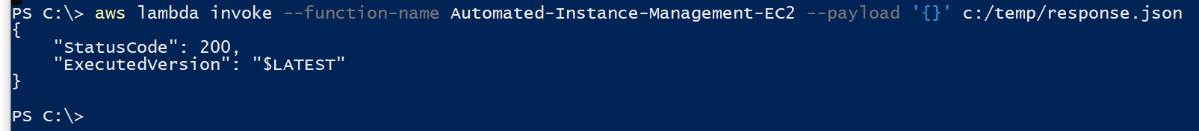
Response logs
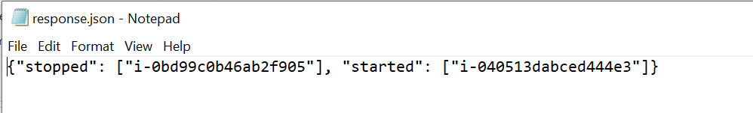
Status of stopping instance with Tag “Action” Value “Auto-Stop”
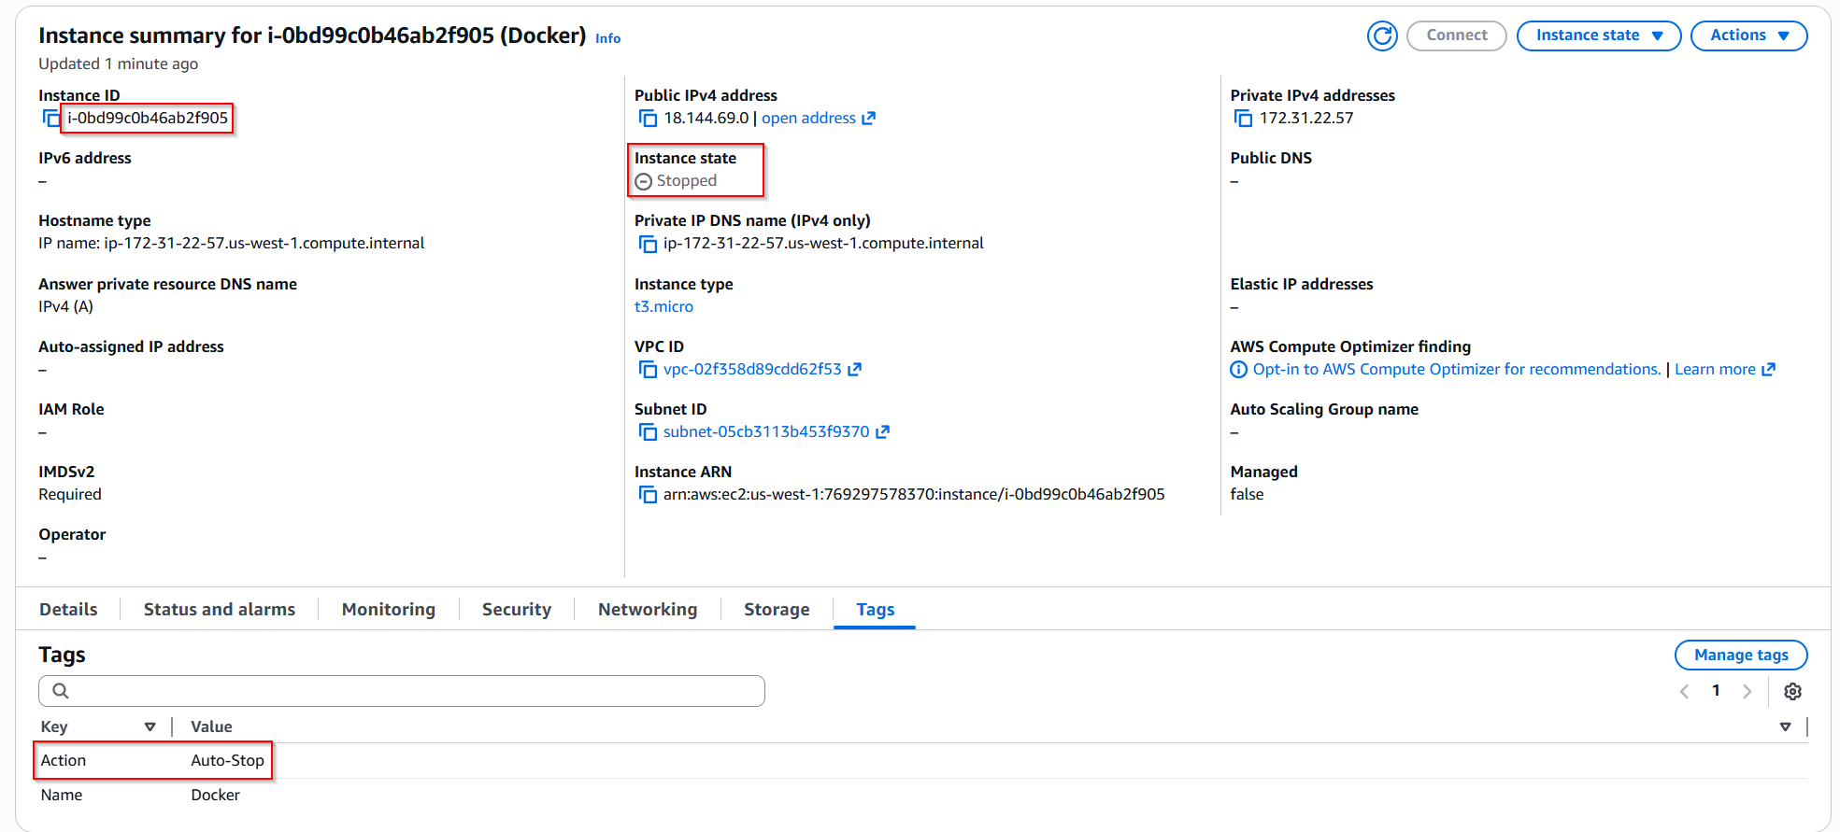

Status of starting instance with Tag “Action” Value “Auto-Start”
