Assignment 2: Automated S3 Bucket Cleanup Using AWS Lambda and Boto3
Objective: To gain experience with AWS Lambda and Boto3 by creating a Lambda function that will automatically clean up old files in an S3 bucket.
Task: Automate the deletion of files older than 30 days in a specific S3 bucket.
Instructions:
1. S3 Setup:
- Navigate to the S3 dashboard and create a new bucket.
- Upload multiple files to this bucket, ensuring that some files are older than 30 days (you may need to adjust your system's date temporarily for this or use old files).
2. Lambda IAM Role:
- In the IAM dashboard, create a new role for Lambda.
- Attach the `AmazonS3FullAccess` policy to this role. (Note: For enhanced security in real-world scenarios, use more restrictive permissions.)
3. Lambda Function:
- Navigate to the Lambda dashboard and create a new function.
- Choose Python 3.x as the runtime.
- Assign the IAM role created in the previous step.
- Write the Boto3 Python script to:
1. Initialize a boto3 S3 client.
2. List objects in the specified bucket.
3. Delete objects older than 5 days.
4. Print the names of deleted objects for logging purposes.
4. Manual Invocation:
- After saving your function, manually trigger it.
- Go to the S3 dashboard and confirm that only files newer than 5 days remain.

- Pre-requisites
- Create S3 bucket and upload files and keep it for 5 days in AWS
Created yunus-s3-bucket and uploaded few files on 18-Dec-2025 and one on 26-Dec
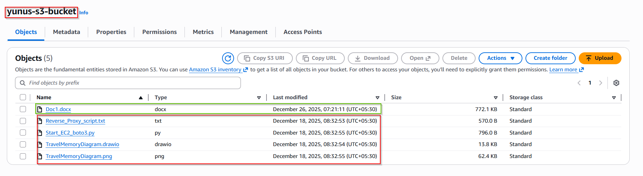
Create IAM role and provide only S3 access
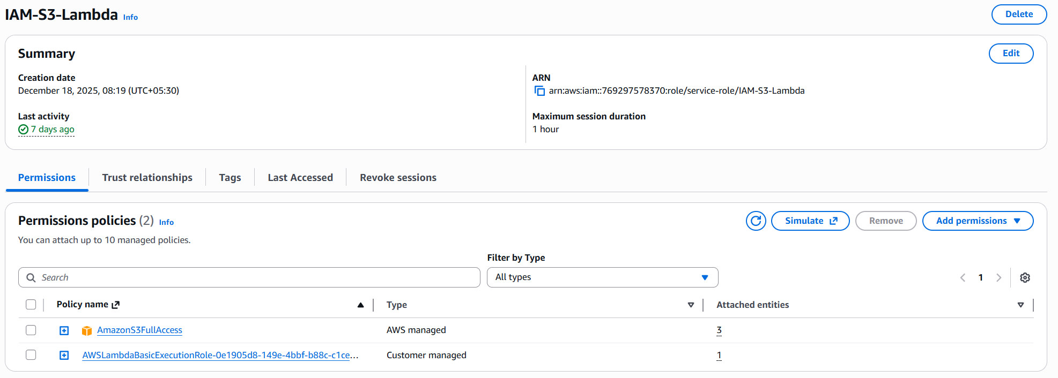

Create Lambda function and deploy it
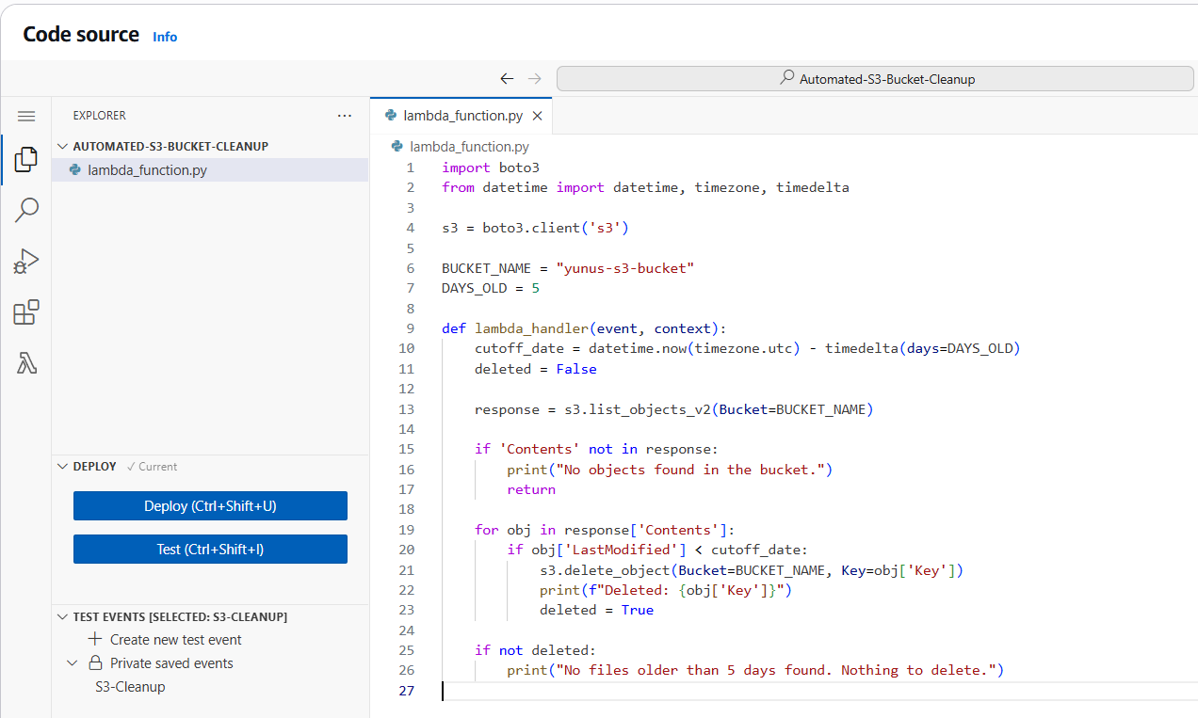

import boto3
from datetime import datetime, timezone, timedelta

s3 = boto3.client('s3')

BUCKET_NAME = "yunus-s3-bucket"
DAYS_OLD = 5

def lambda_handler(event, context):
cutoff_date = datetime.now(timezone.utc) - timedelta(days=DAYS_OLD)
deleted = False

response = s3.list_objects_v2(Bucket=BUCKET_NAME)

if 'Contents' not in response:
print("No objects found in the bucket.")
return

for obj in response['Contents']:
if obj['LastModified'] < cutoff_date:
s3.delete_object(Bucket=BUCKET_NAME, Key=obj['Key'])
print(f"Deleted: {obj['Key']}")
deleted = True

if not deleted:
print("No files older than 5 days found. Nothing to delete.")

Trigger manually by clicking Test and it should works successfully
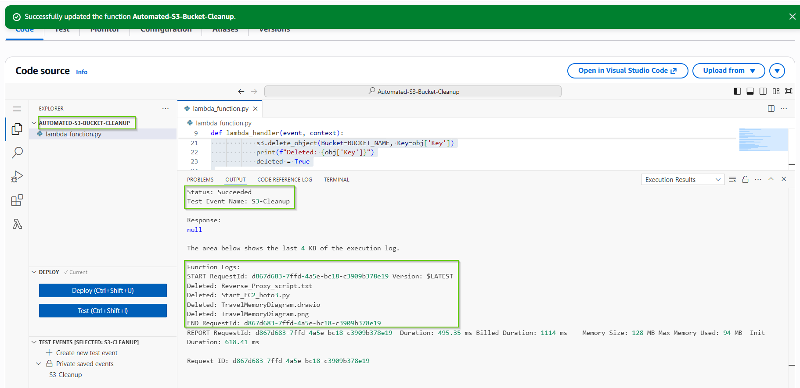

Open CloudWatch logs to see the results
No older events at this moment.
Retry
2025-12-26T07:34:47.796+05:30
INIT_START Runtime Version: python:3.14.v32 Runtime Version ARN: arn:aws:lambda:us-west-1::runtime:1ee4e6d61a50fbb29d03b87572cc627d0a92de84530be7b21838aaedd9675804
2025-12-26T07:34:48.418+05:30
START RequestId: d867d683-7ffd-4a5e-bc18-c3909b378e19 Version: $LATEST
2025-12-26T07:34:48.775+05:30
Deleted: Reverse_Proxy_script.txt
2025-12-26T07:34:48.839+05:30
Deleted: Start_EC2_boto3.py
2025-12-26T07:34:48.872+05:30
Deleted: TravelMemoryDiagram.drawio
2025-12-26T07:34:48.892+05:30
Deleted: TravelMemoryDiagram.png
2025-12-26T07:34:48.914+05:30
END RequestId: d867d683-7ffd-4a5e-bc18-c3909b378e19
2025-12-26T07:34:48.914+05:30
REPORT RequestId: d867d683-7ffd-4a5e-bc18-c3909b378e19 Duration: 495.35 ms Billed Duration: 1114 ms Memory Size: 128 MB Max Memory Used: 94 MB Init Duration: 618.41 ms
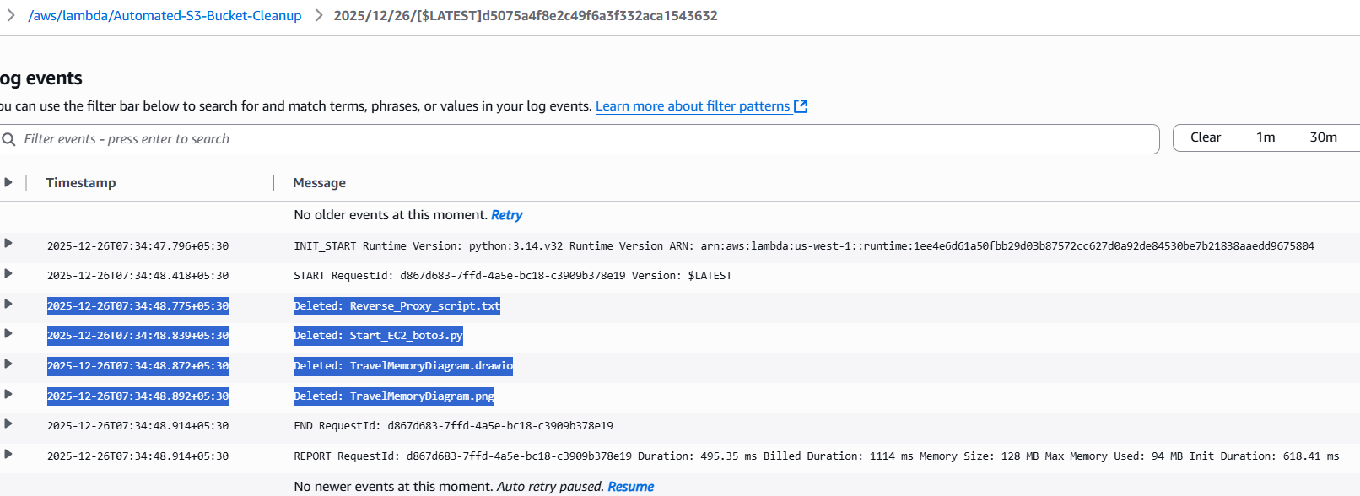

After deletion it is remain only one file
