Assignment 3: Monitor Unencrypted S3 Buckets Using AWS Lambda and Boto3
Objective: To enhance your AWS security posture by setting up a Lambda function that detects any S3 bucket without server-side encryption.
Task: Automate the detection of S3 buckets that don't have server-side encryption enabled.
Instructions:
1. S3 Setup:
- Navigate to the S3 dashboard and create a few buckets. Ensure that a couple of them don't have server-side encryption enabled.
2. Lambda IAM Role:
- In the IAM dashboard, create a new role for Lambda.
- Attach the `AmazonS3ReadOnlyAccess` policy to this role.
3. Lambda Function:
- Navigate to the Lambda dashboard and create a new function.
- Choose Python 3.x as the runtime.
- Assign the IAM role created in the previous step.
- Write the Boto3 Python script to:
1. Initialize a boto3 S3 client.
2. List all S3 buckets.
3. Detect buckets without server-side encryption.
4. Print the names of unencrypted buckets for logging purposes.
4. Manual Invocation:
- After saving your function, manually trigger it.
- Review the Lambda logs to identify the buckets without server-side encryption.

Create multiple S3 bucket and use KMS for one of them

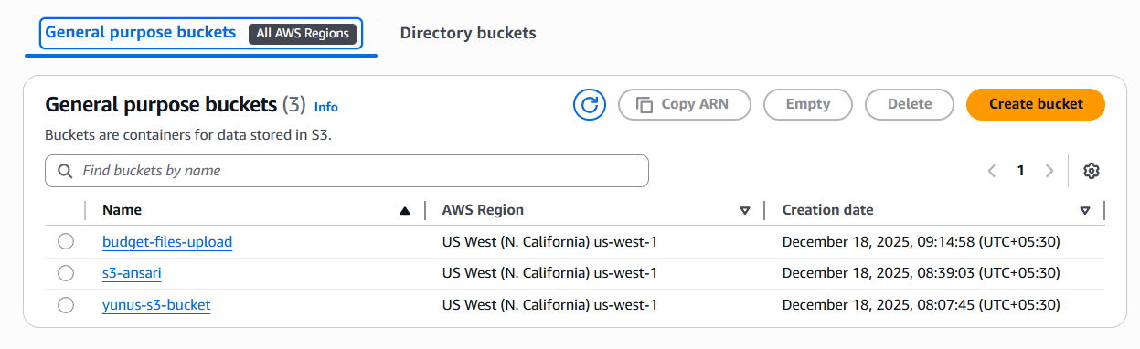
Created s3-ansari bucket and set KMS encryption
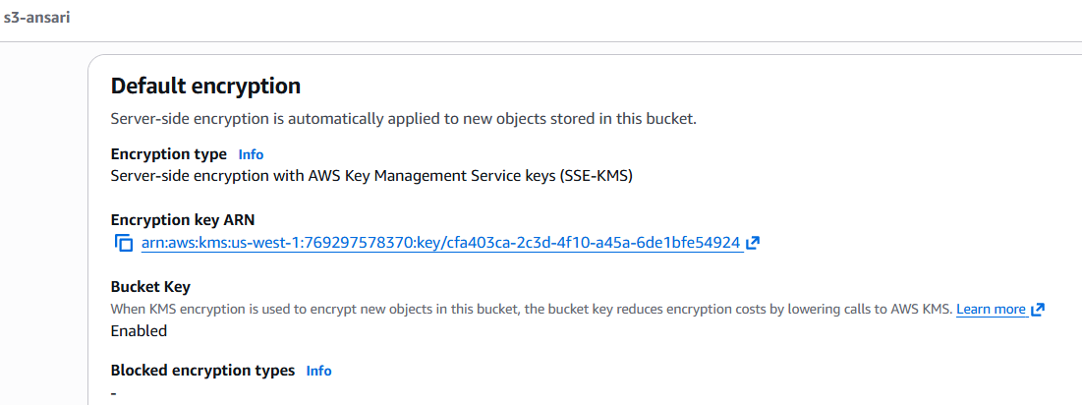

Create IAM policy to allow on S3 bucket
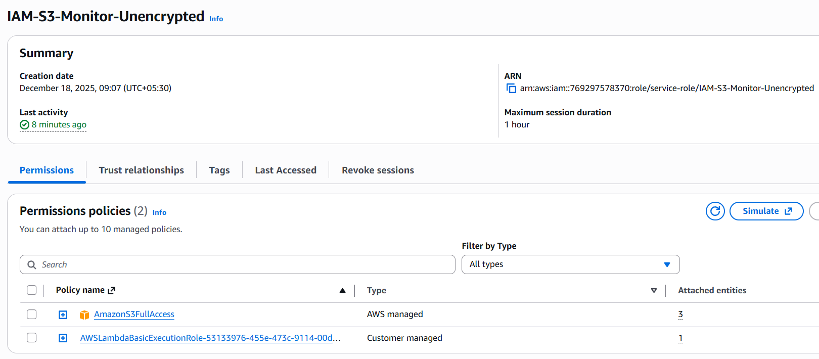

Create Lambda function and test and deploy
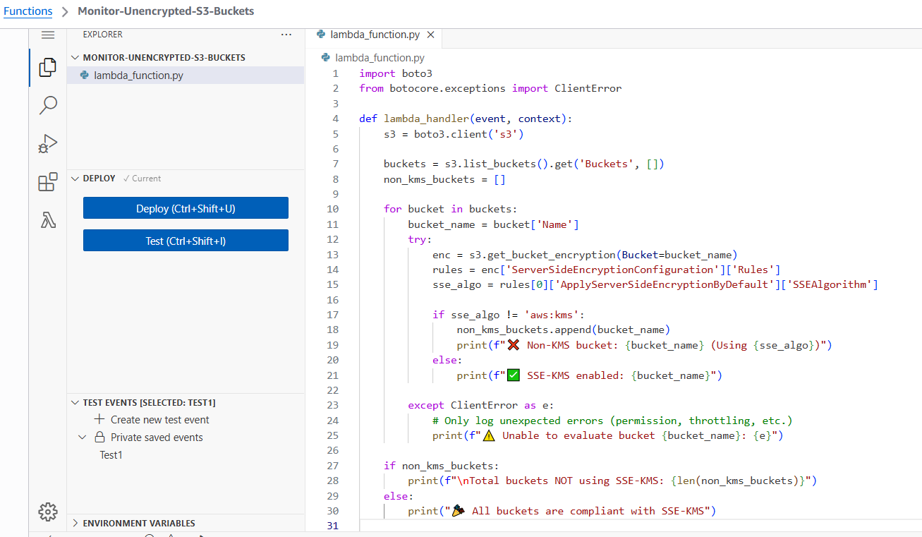

Script
import boto3
from botocore.exceptions import ClientError

def lambda_handler(event, context):
s3 = boto3.client('s3')

buckets = s3.list_buckets().get('Buckets', [])
non_kms_buckets = []

for bucket in buckets:
bucket_name = bucket['Name']
try:
enc = s3.get_bucket_encryption(Bucket=bucket_name)
rules = enc['ServerSideEncryptionConfiguration']['Rules']
sse_algo = rules[0]['ApplyServerSideEncryptionByDefault']['SSEAlgorithm']

if sse_algo != 'aws:kms':
non_kms_buckets.append(bucket_name)
print(f"❌ Non-KMS bucket: {bucket_name} (Using {sse_algo})")
else:
print(f"✅ SSE-KMS enabled: {bucket_name}")

except ClientError as e:
# Only log unexpected errors (permission, throttling, etc.)
print(f"⚠️ Unable to evaluate bucket {bucket_name}: {e}")

if non_kms_buckets:
print(f"\nTotal buckets NOT using SSE-KMS: {len(non_kms_buckets)}")
else:
print("🎉 All buckets are compliant with SSE-KMS")

return {
"non_kms_buckets": non_kms_buckets
}

Manually trigger to test it
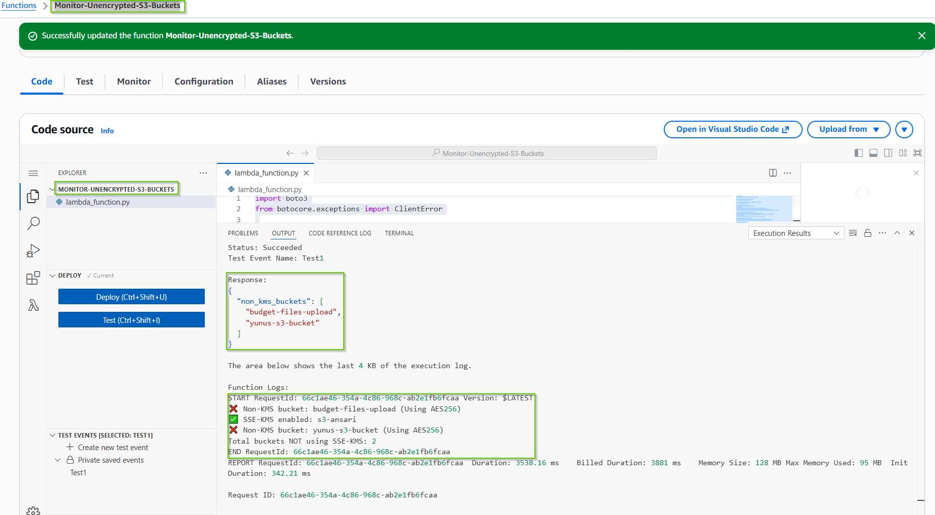

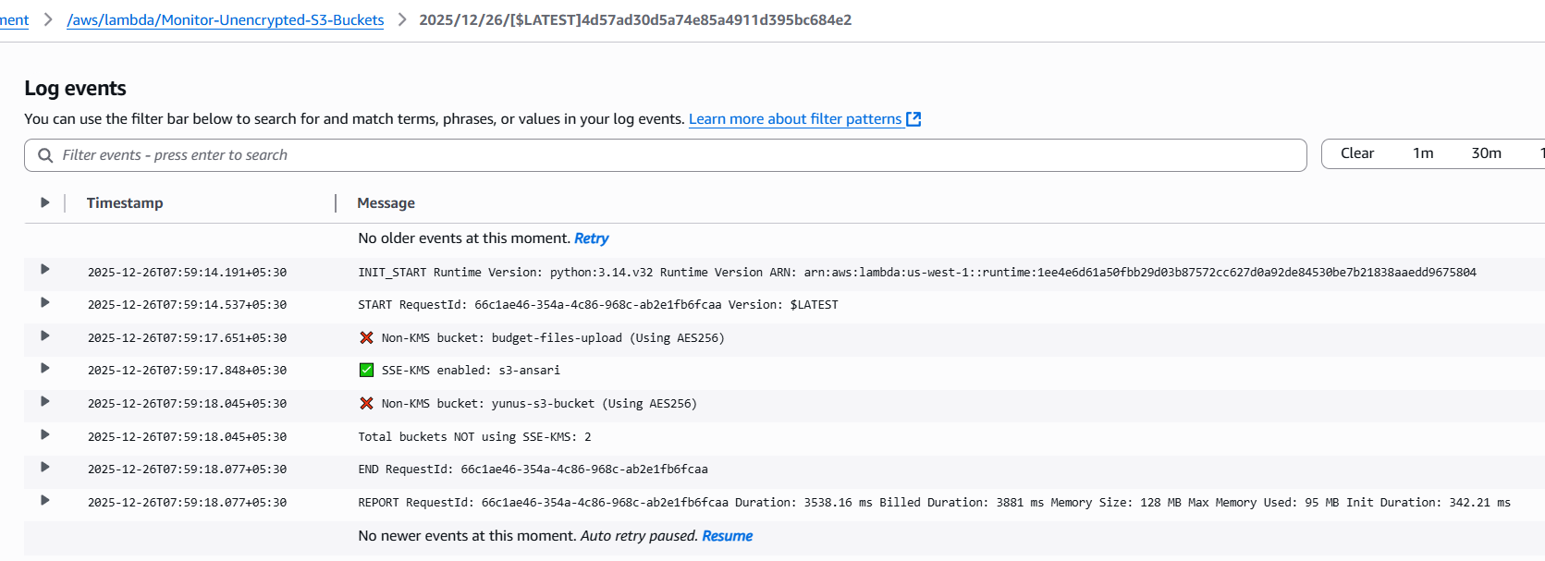
No older events at this moment. Retry
 | 2025-12-26T07:59:14.191+05:30 | INIT_START Runtime Version: python:3.14.v32 Runtime Version ARN: arn:aws:lambda:us-west-1::runtime:1ee4e6d61a50fbb29d03b87572cc627d0a92de84530be7b21838aaedd9675804
 | 2025-12-26T07:59:14.537+05:30 | START RequestId: 66c1ae46-354a-4c86-968c-ab2e1fb6fcaa Version: $LATEST
 | 2025-12-26T07:59:17.651+05:30 | ❌ Non-KMS bucket: budget-files-upload (Using AES256)
 | 2025-12-26T07:59:17.848+05:30 | ✅ SSE-KMS enabled: s3-ansari
 | 2025-12-26T07:59:18.045+05:30 | ❌ Non-KMS bucket: yunus-s3-bucket (Using AES256)
 | 2025-12-26T07:59:18.045+05:30 | Total buckets NOT using SSE-KMS: 2
 | 2025-12-26T07:59:18.077+05:30 | END RequestId: 66c1ae46-354a-4c86-968c-ab2e1fb6fcaa
 | 2025-12-26T07:59:18.077+05:30 | REPORT RequestId: 66c1ae46-354a-4c86-968c-ab2e1fb6fcaa Duration: 3538.16 ms Billed Duration: 3881 ms Memory Size: 128 MB Max Memory Used: 95 MB Init Duration: 342.21 ms
 |  | No newer events at this moment. Auto retry paused. Resume

