Assignment 5: Auto-Tagging EC2 Instances on Launch Using AWS Lambda and Boto3
Objective: Learn to automate the tagging of EC2 instances as soon as they are launched, ensuring better resource tracking and management.
Task: Automatically tag any newly launched EC2 instance with the current date and a custom tag.
Instructions:
1. EC2 Setup:
- Ensure you have the capability to launch EC2 instances.
2. Lambda IAM Role:
- In the IAM dashboard, create a new role for Lambda.
- Attach the `AmazonEC2FullAccess` policy to this role.
3. Lambda Function:
- Navigate to the Lambda dashboard and create a new function.
- Choose Python 3.x as the runtime.
- Assign the IAM role created in the previous step.
- Write the Boto3 Python script to:
1. Initialize a boto3 EC2 client.
2. Retrieve the instance ID from the event.
3. Tag the new instance with the current date and another tag of your choice.
4. Print a confirmation message for logging purposes.
4. CloudWatch Events:
- Set up a CloudWatch Event Rule to trigger the EC2 instance launch event.
- Attach the Lambda function as the target.
5. Testing:
- Launch a new EC2 instance.
- After a short delay, confirm that the instance is automatically tagged as specified.

IAM role for function
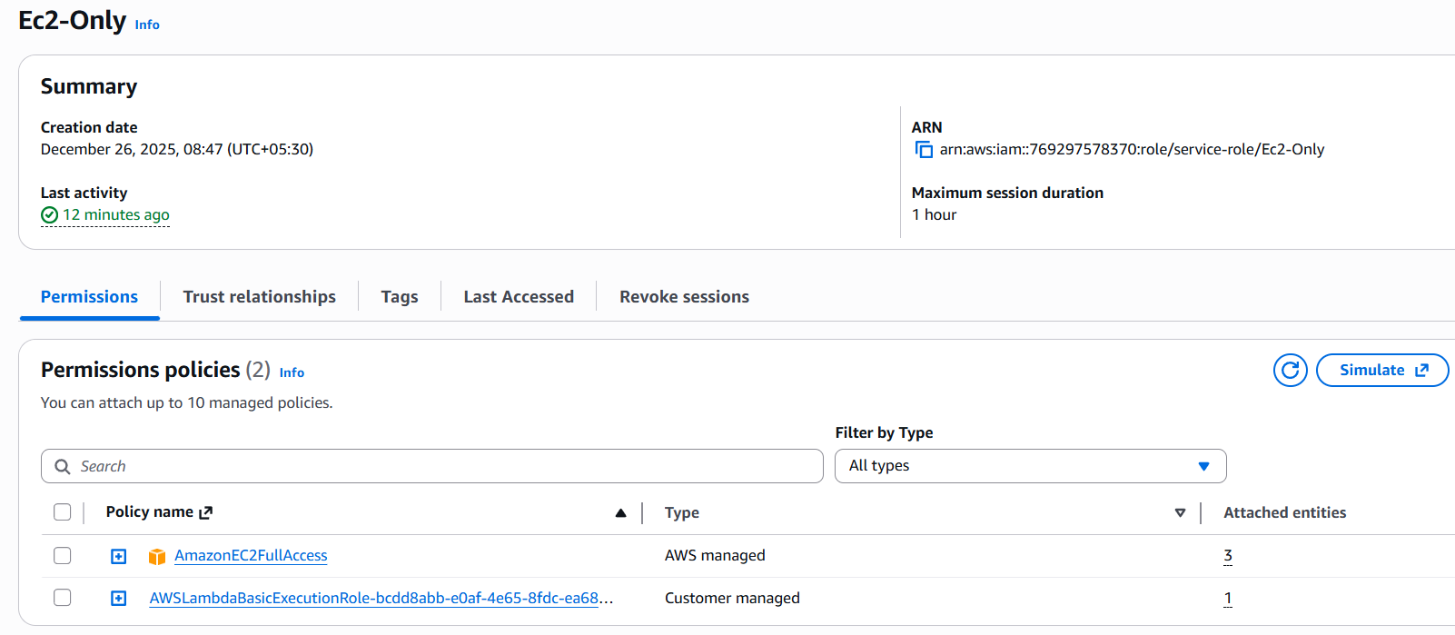

Create Lambda function – Deploy the code
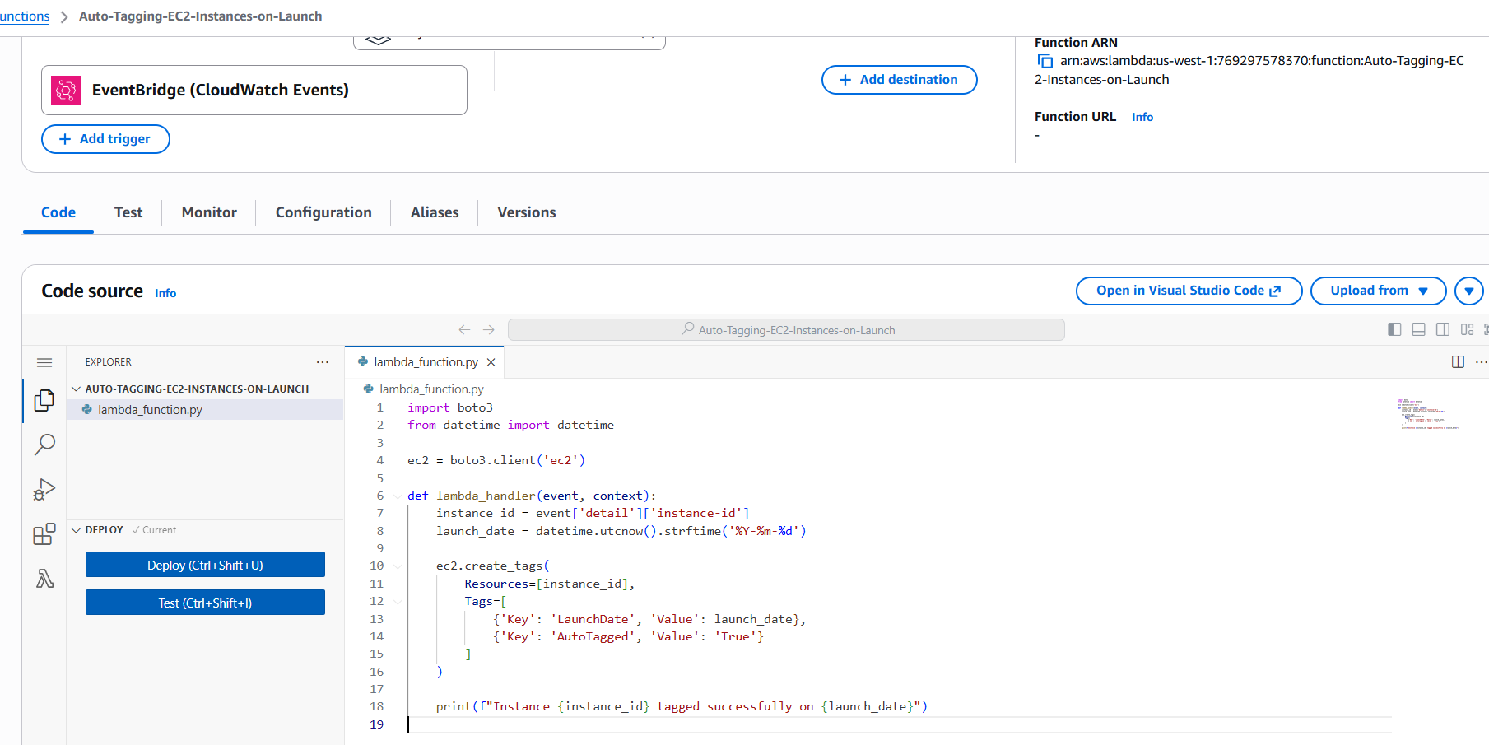
import boto3
from datetime import datetime

ec2 = boto3.client('ec2')

def lambda_handler(event, context):
instance_id = event['detail']['instance-id']
launch_date = datetime.utcnow().strftime('%Y-%m-%d')

ec2.create_tags(
Resources=[instance_id],
Tags=[
{'Key': 'LaunchDate', 'Value': launch_date},
{'Key': 'AutoTagged', 'Value': 'True'}
]
)

print(f"Instance {instance_id} tagged successfully on {launch_date}")

Set up a CloudWatch Event Rule – Go to Configuration >> Triggers >> Add trigger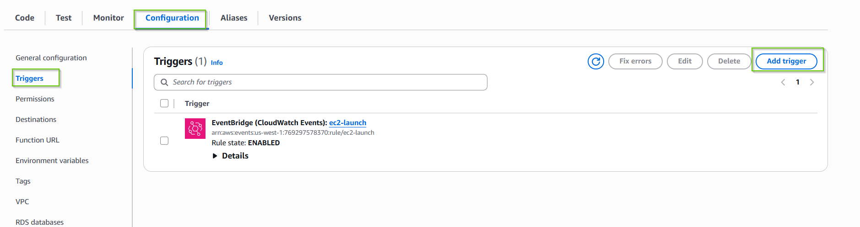
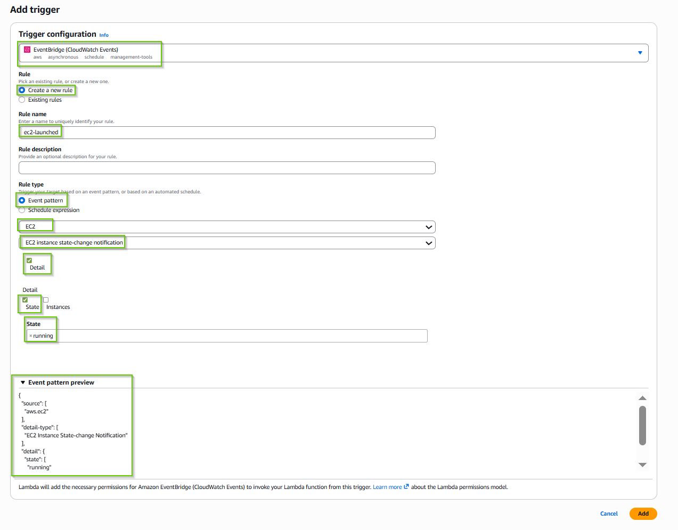
{
"source": [
"aws.ec2"
],
"detail-type": [
"EC2 Instance State-change Notification"
],
"detail": {
"state": [
"running"
]
}
}

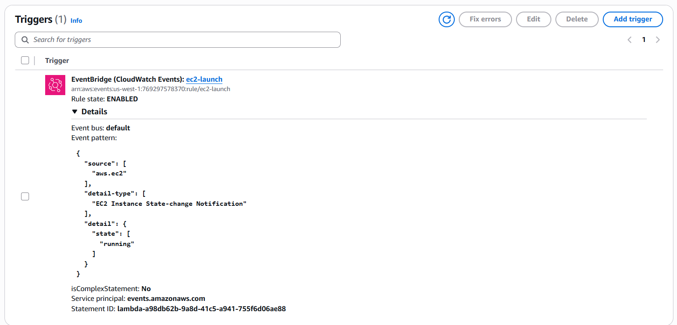

Now lunch new instance and it should tag automatically
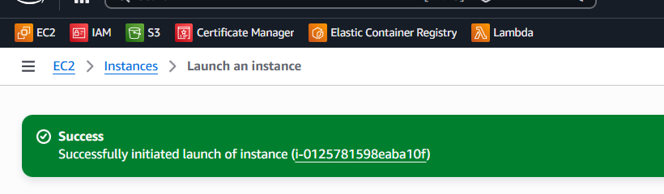

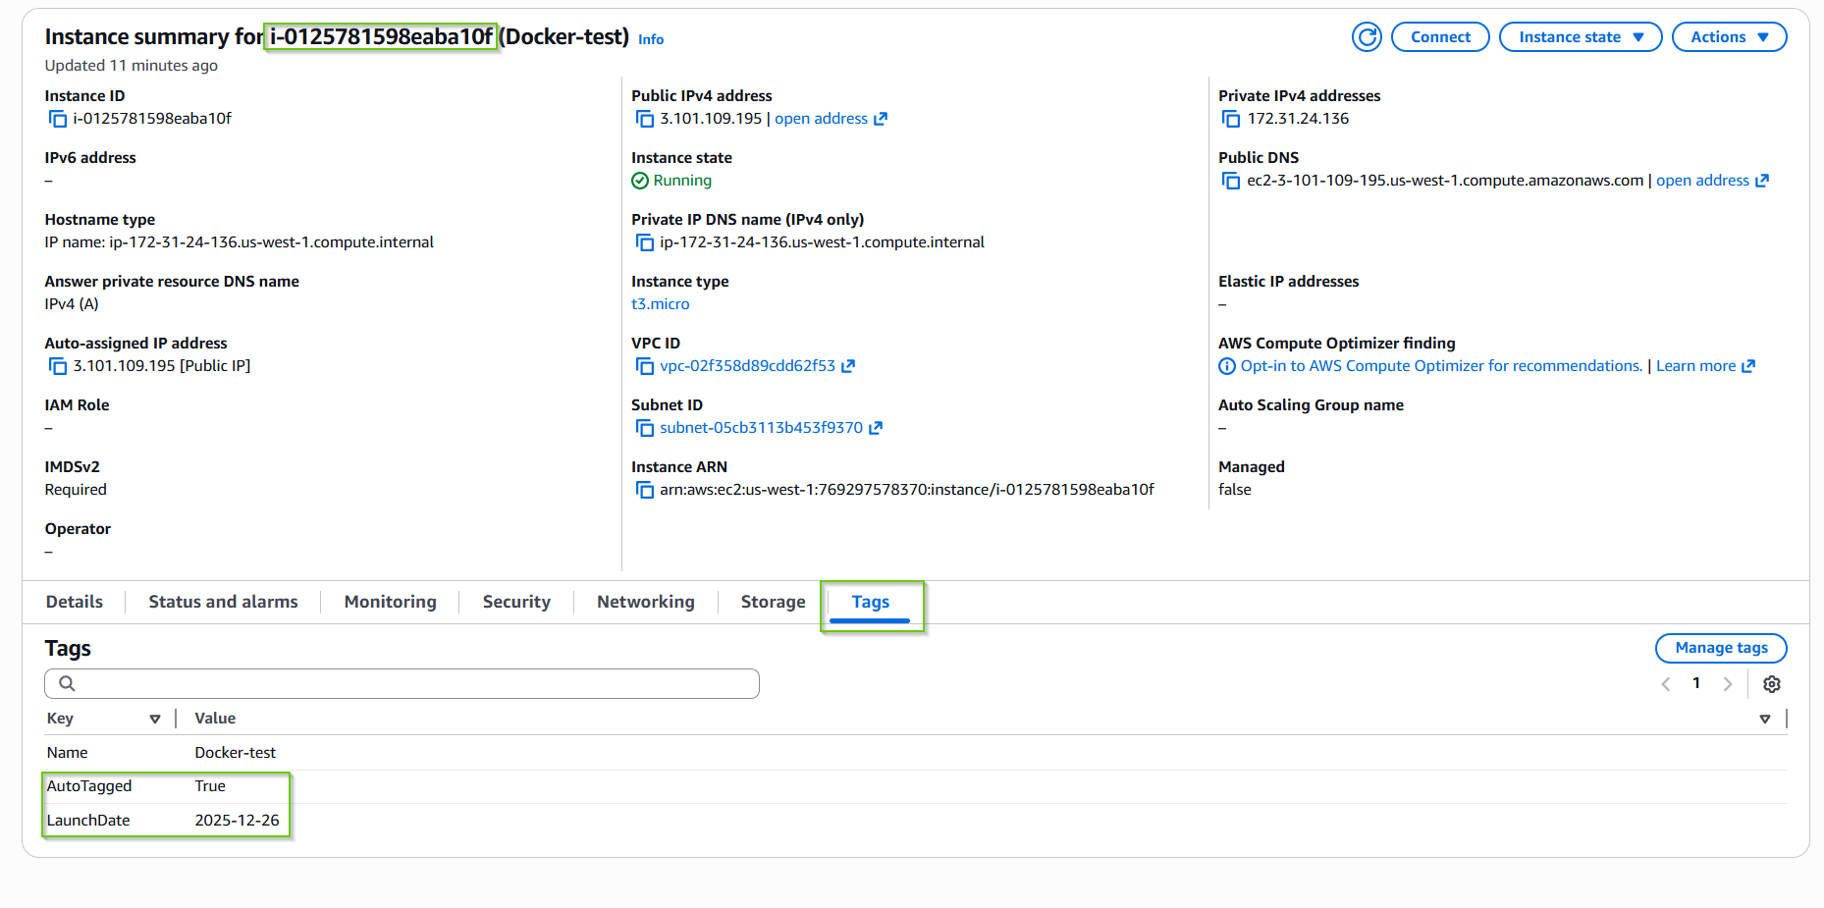

See the CloudWatch logs
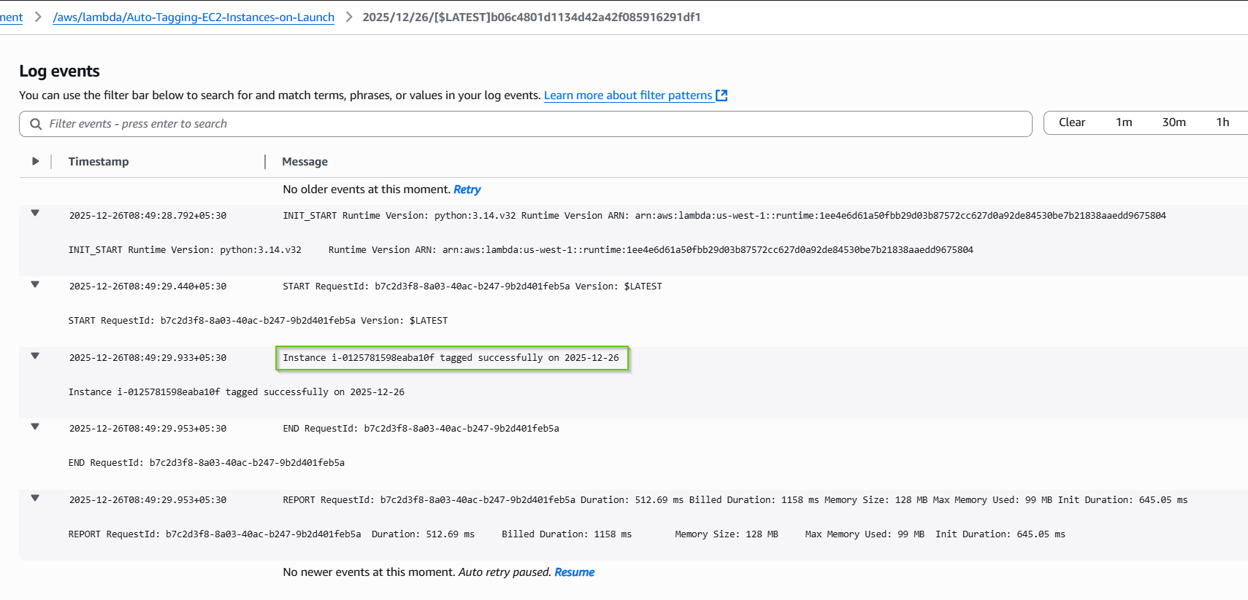

Timestamp |  | Message
 | Timestamp |  | Message
 |  |  | No older events at this moment. Retry
 | 2025-12-26T08:49:28.792+05:30  INIT_START Runtime Version: python:3.14.v32 Runtime Version ARN: arn:aws:lambda:us-west-1::runtime:1ee4e6d61a50fbb29d03b87572cc627d0a92de84530be7b21838aaedd9675804 |  | INIT_START Runtime Version: python:3.14.v32 Runtime Version ARN: arn:aws:lambda:us-west-1::runtime:1ee4e6d61a50fbb29d03b87572cc627d0a92de84530be7b21838aaedd9675804
 | 2025-12-26T08:49:29.440+05:30  START RequestId: b7c2d3f8-8a03-40ac-b247-9b2d401feb5a Version: $LATEST |  | START RequestId: b7c2d3f8-8a03-40ac-b247-9b2d401feb5a Version: $LATEST
 | 2025-12-26T08:49:29.933+05:30  Instance i-0125781598eaba10f tagged successfully on 2025-12-26 |  | Instance i-0125781598eaba10f tagged successfully on 2025-12-26
 | 2025-12-26T08:49:29.953+05:30  END RequestId: b7c2d3f8-8a03-40ac-b247-9b2d401feb5a |  | END RequestId: b7c2d3f8-8a03-40ac-b247-9b2d401feb5a
 | 2025-12-26T08:49:29.953+05:30  REPORT RequestId: b7c2d3f8-8a03-40ac-b247-9b2d401feb5a Duration: 512.69 ms Billed Duration: 1158 ms Memory Size: 128 MB Max Memory Used: 99 MB Init Duration: 645.05 ms |  | REPORT RequestId: b7c2d3f8-8a03-40ac-b247-9b2d401feb5a Duration: 512.69 ms Billed Duration: 1158 ms Memory Size: 128 MB Max Memory Used: 99 MB Init Duration: 645.05 ms
 |  |  | No newer events at this moment. Auto retry paused. Resume

