Assignment 9: Archive Old Files from S3 to Glacier Using AWS Lambda and Boto3
Objective: Automate the archival of files older than a certain age from an S3 bucket to Amazon Glacier for cost-effective storage.
Task: Automatically move files in an S3 bucket older than 6 months to Glacier storage class.
Instructions:
1. S3 Setup:
- Navigate to the S3 dashboard and create a bucket.
- Upload a mix of old and new files to this bucket.
2. Lambda IAM Role:
- In the IAM dashboard, create a new role for Lambda.
- Attach the `AmazonS3FullAccess` policy to this role.
3. Lambda Function:
- Navigate to the Lambda dashboard and create a new function.
- Choose Python 3.x as the runtime.
- Assign the IAM role created in the previous step.
- Write the Boto3 Python script to:
1. List objects in the S3 bucket.
2. Identify files older than 6 months.
3. Change the storage class of identified files to Glacier.
4. Log the archived files.
4. Testing:
- Manually trigger the Lambda function or set it to run periodically.
- Confirm that older files in the S3 bucket are moved to the Glacier storage class.

Create Lambda function
Note: We don’t old files so keeping 5 days older to move it in this script to prove it
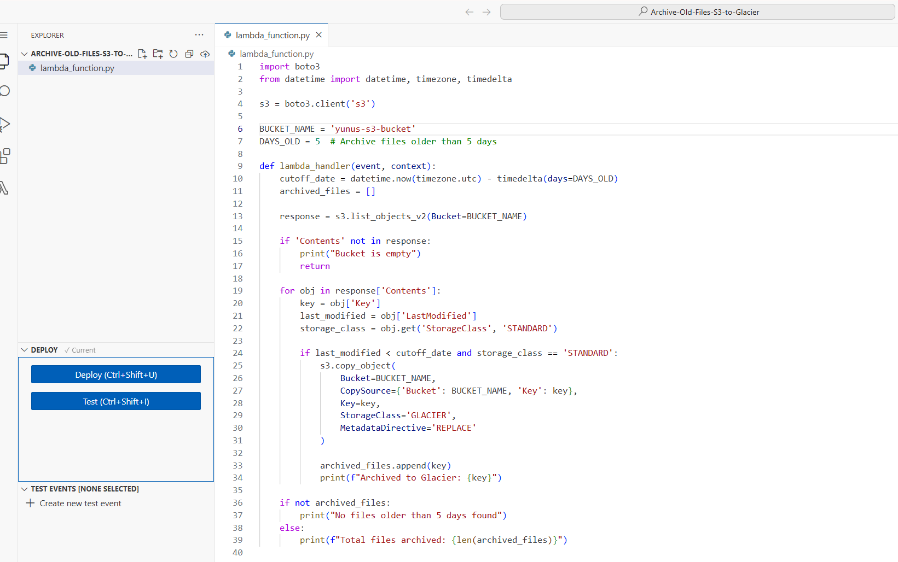
import boto3
from datetime import datetime, timezone, timedelta

s3 = boto3.client('s3')

BUCKET_NAME = 'yunus-s3-bucket'
DAYS_OLD = 5 # Archive files older than 5 days

def lambda_handler(event, context):
cutoff_date = datetime.now(timezone.utc) - timedelta(days=DAYS_OLD)
archived_files = []

response = s3.list_objects_v2(Bucket=BUCKET_NAME)

if 'Contents' not in response:
print("Bucket is empty")
return

for obj in response['Contents']:
key = obj['Key']
last_modified = obj['LastModified']
storage_class = obj.get('StorageClass', 'STANDARD')

if last_modified < cutoff_date and storage_class == 'STANDARD':
s3.copy_object(
Bucket=BUCKET_NAME,
CopySource={'Bucket': BUCKET_NAME, 'Key': key},
Key=key,
StorageClass='GLACIER',
MetadataDirective='REPLACE'
)

archived_files.append(key)
print(f"Archived to Glacier: {key}")

if not archived_files:
print("No files older than 5 days found")
else:
print(f"Total files archived: {len(archived_files)}")

Choose to create permission while creating function and attach S3Full access

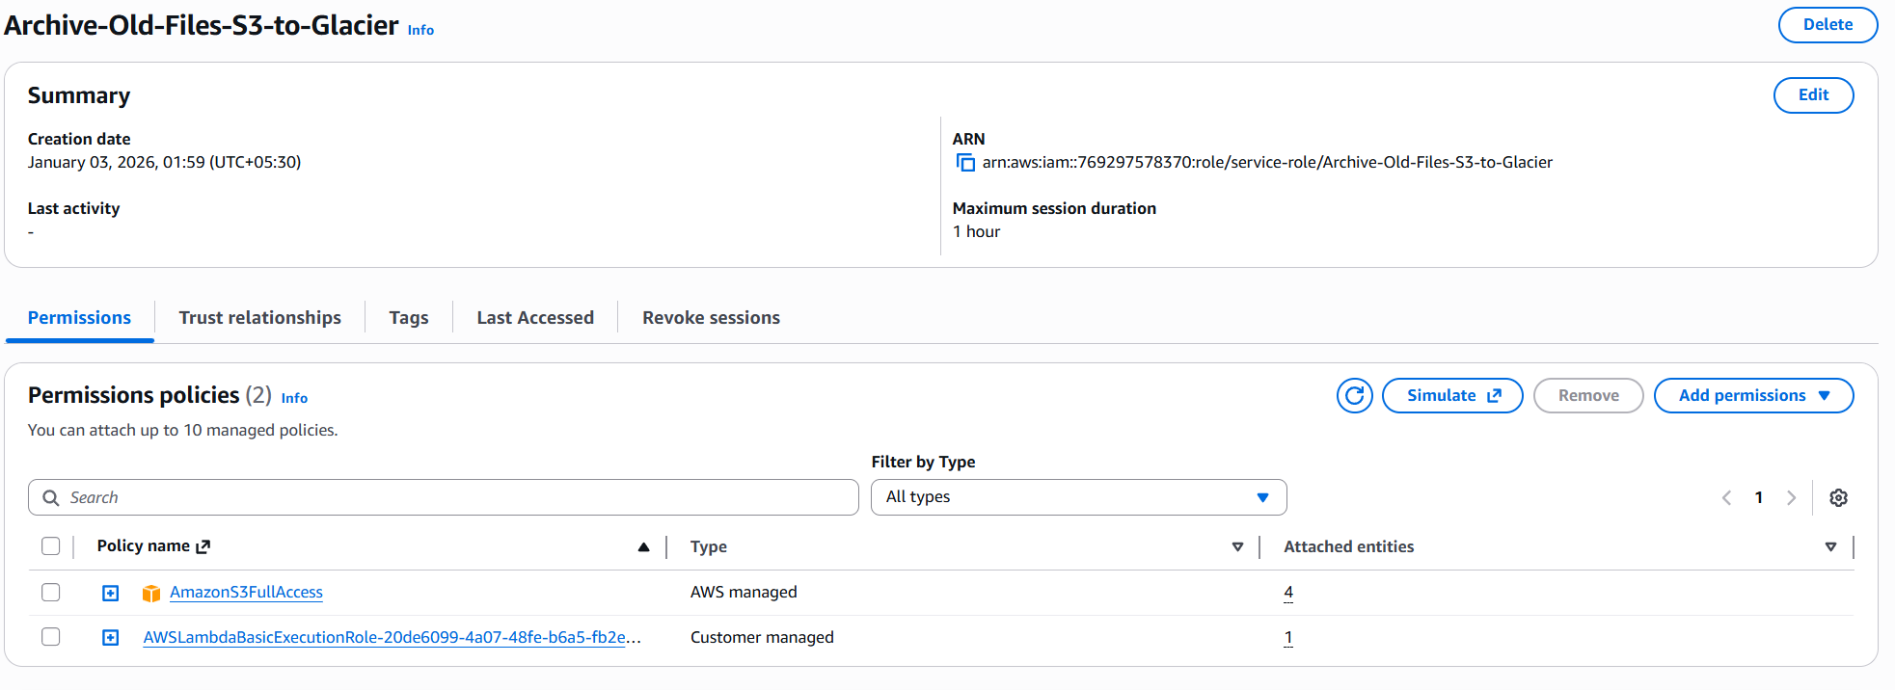
Taking snapshot before we run the test/deployment
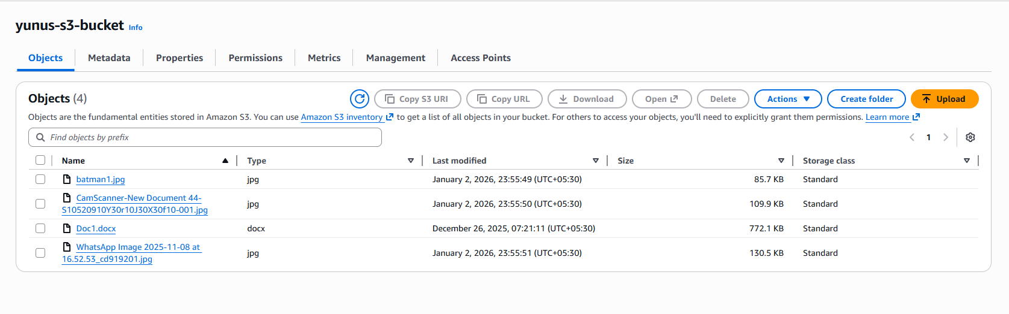
Test it
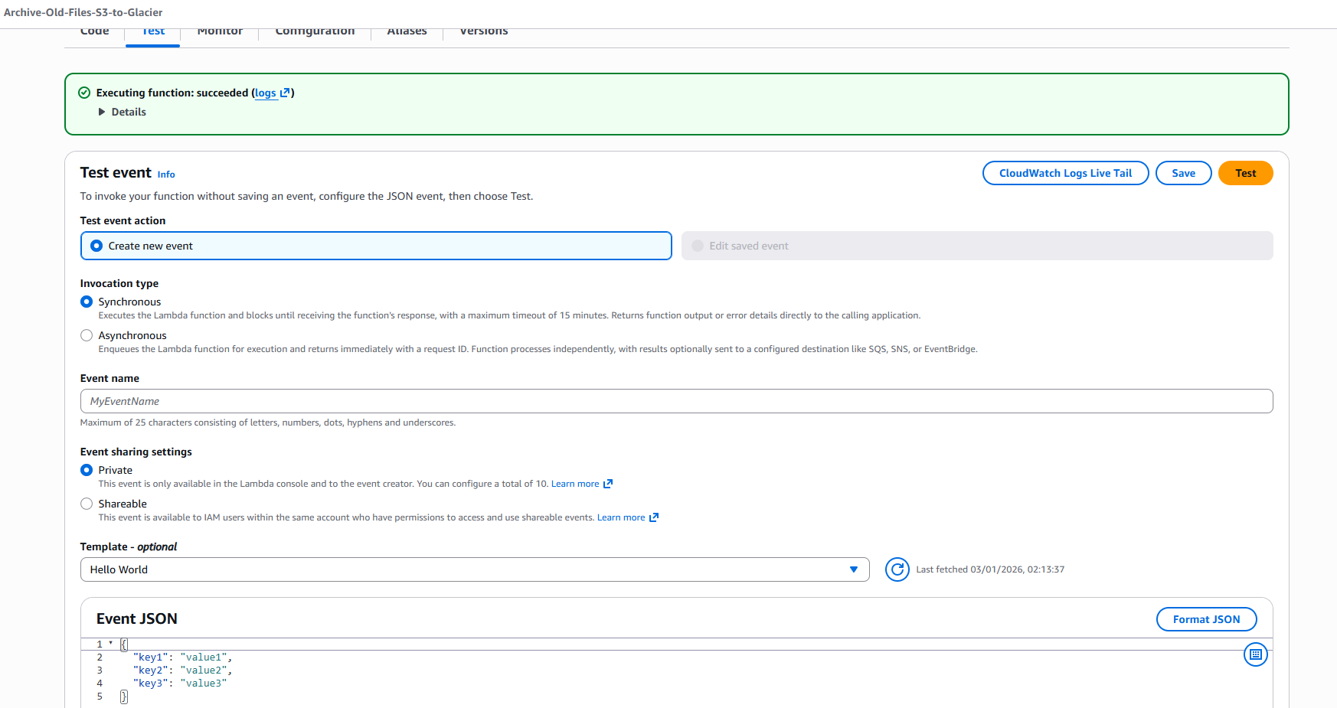
Deploy it
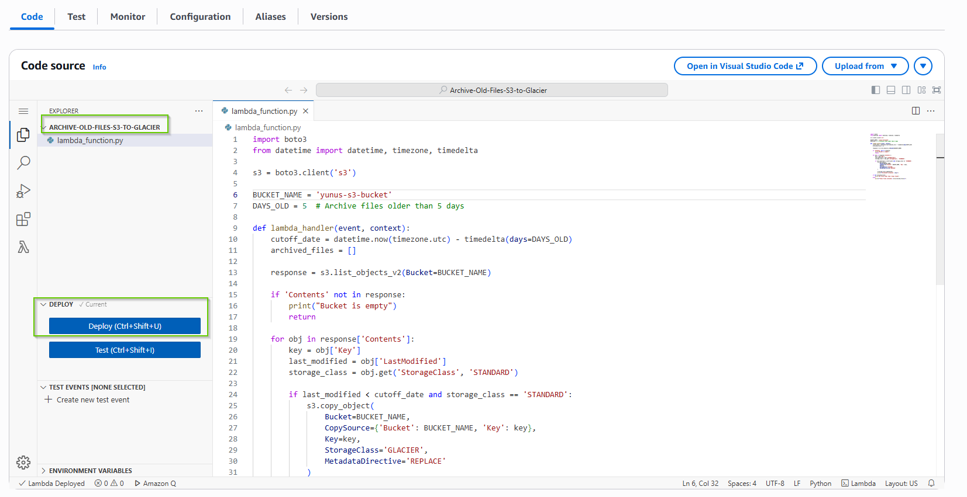
Schedule it using EventBridge
I set it up for 1 minute
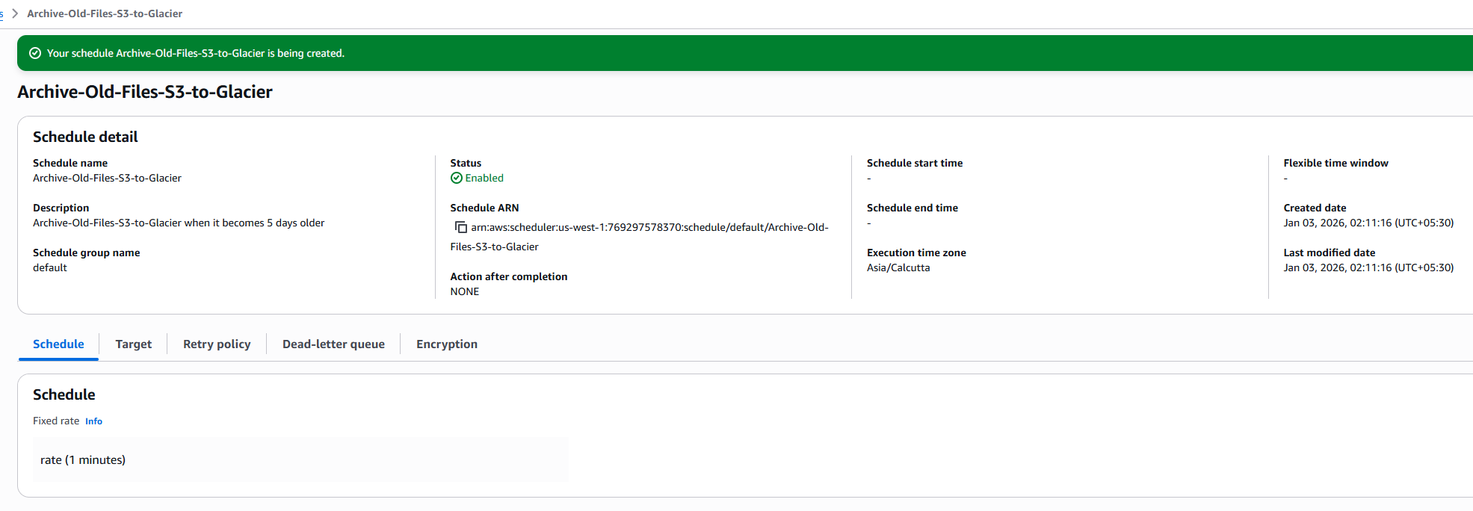
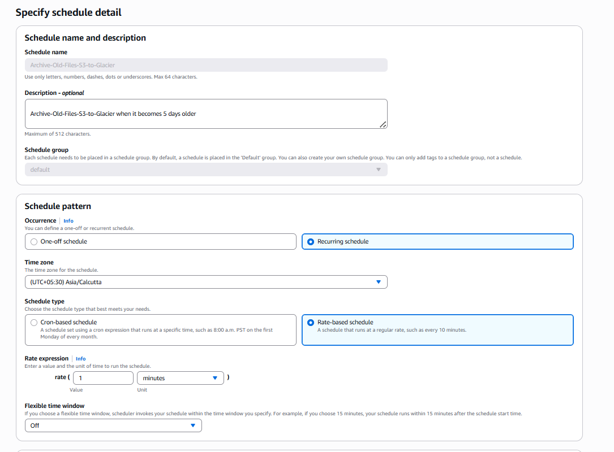

Select your Lambda function
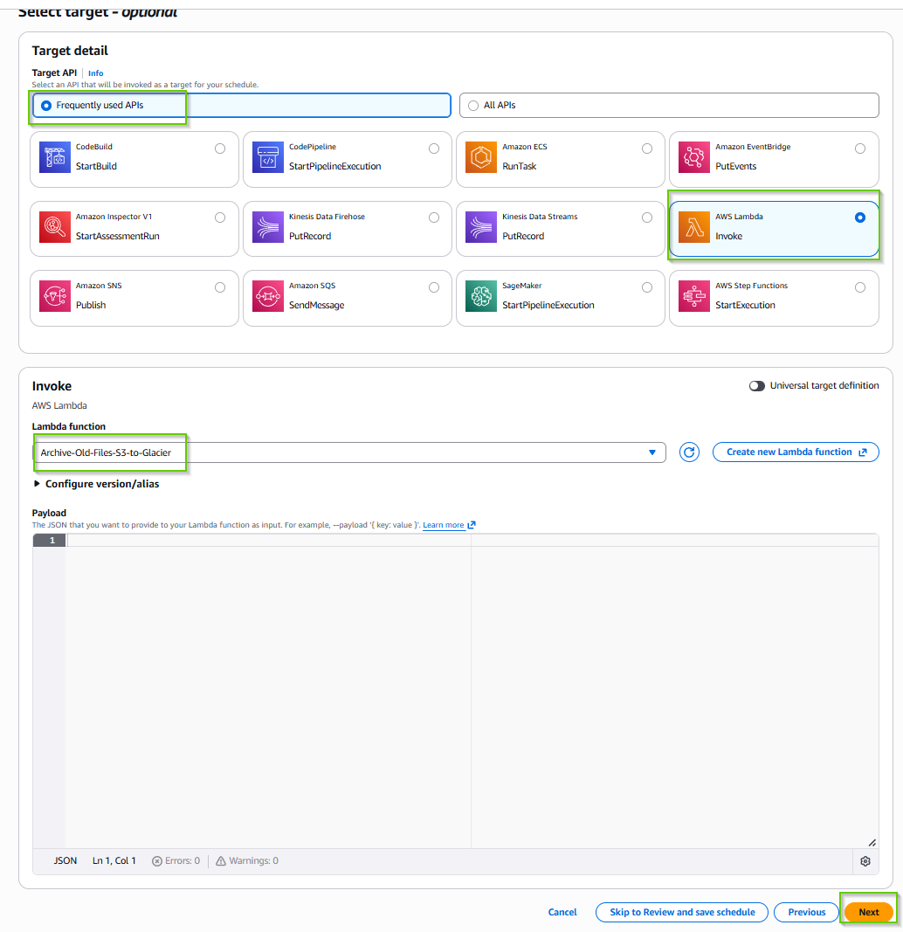

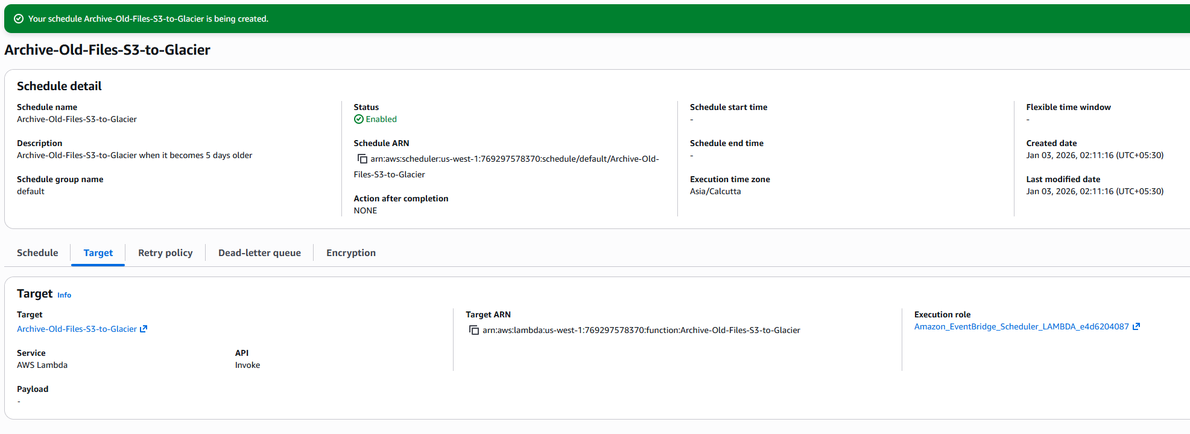

Watch the logs in CloudWatch
Timestamp |  | Message
 | Timestamp |  | Message
 |  |  | No older events at this moment. Retry
 | 2026-01-03T02:11:57.535+05:30  INIT_START Runtime Version: python:3.14.v32 Runtime Version ARN: arn:aws:lambda:us-west-1::runtime:1ee4e6d61a50fbb29d03b87572cc627d0a92de84530be7b21838aaedd9675804 |  | INIT_START Runtime Version: python:3.14.v32 Runtime Version ARN: arn:aws:lambda:us-west-1::runtime:1ee4e6d61a50fbb29d03b87572cc627d0a92de84530be7b21838aaedd9675804
 | 2026-01-03T02:11:58.032+05:30  START RequestId: 6669582d-6cc4-484f-8e58-ada9b0f2709f Version: $LATEST |  | START RequestId: 6669582d-6cc4-484f-8e58-ada9b0f2709f Version: $LATEST
 | 2026-01-03T02:11:58.473+05:30  Archived to Glacier: Doc1.docx |  | Archived to Glacier: Doc1.docx
 | 2026-01-03T02:11:58.473+05:30 |  | Total files archived: 1
 | 2026-01-03T02:11:58.477+05:30  END RequestId: 6669582d-6cc4-484f-8e58-ada9b0f2709f |  | END RequestId: 6669582d-6cc4-484f-8e58-ada9b0f2709f
 | 2026-01-03T02:11:58.477+05:30  REPORT RequestId: 6669582d-6cc4-484f-8e58-ada9b0f2709f Duration: 444.40 ms Billed Duration: 938 ms Memory Size: 128 MB Max Memory Used: 96 MB Init Duration: 493.56 ms |  | REPORT RequestId: 6669582d-6cc4-484f-8e58-ada9b0f2709f Duration: 444.40 ms Billed Duration: 938 ms Memory Size: 128 MB Max Memory Used: 96 MB Init Duration: 493.56 ms
 |  |  | No newer events at this moment. Auto retry paused. Resume
See the result on S3 bucket – it is moved to Glacier

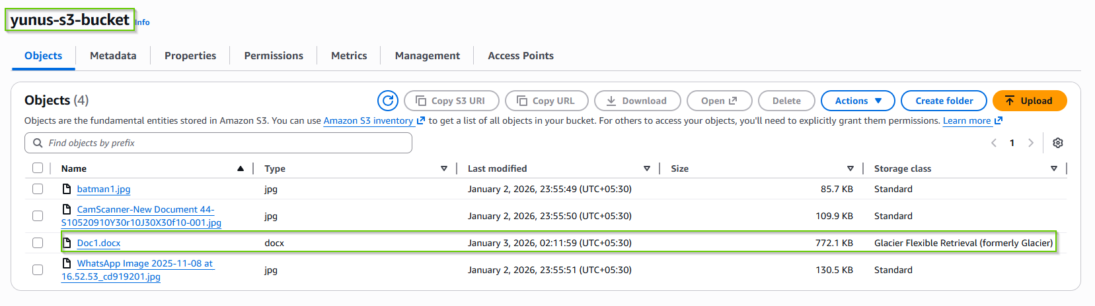

See the logs are running every minute and did not find any file older than 5 days
