Frontend Deployment Documentation – TravelMemory Application
This document provides step-by-step instructions for deploying the TravelMemory frontend application on AWS using Ubuntu, React.js, Nginx reverse proxy, SSL via Let’s Encrypt, AMI creation, and Application Load Balancer.

1. Technology Stack
- Frontend: React.js
- Runtime: Node.js
- OS: Ubuntu (AWS EC2)
- Reverse Proxy: Nginx
- SSL: Let’s Encrypt
- Load Balancer: AWS Application Load Balancer

2. EC2 Frontend Instance Setup
1. Launch Ubuntu t3.micro EC2 instance. – Follow the steps given in backend
2. Configure Security Group:
- SSH 22 (Anywhere)
- HTTPS 443 (Anywhere)
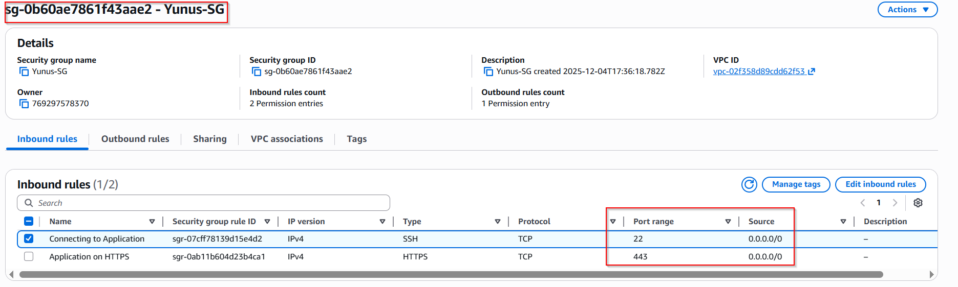
3. Update system
sudo apt update
sudo apt upgrade -y

4. Application Deployment
Clone repository:
git clone https://github.com/UnpredictablePrashant/TravelMemory
Update backend URL:
File: /TravelMemory/frontend/src/url.js
export const baseUrl = process.env.REACT_APP_BACKEND_URL || "https://api.ansarienterprise";

4. Install Node.js and NPM
sudo apt install nodejs -y
sudo apt install npm -y

5. Install Frontend Dependencies
cd TravelMemory/frontend
sudo npm install

6. Start Frontend Application
sudo npm start from /TravelMemory/frontend/
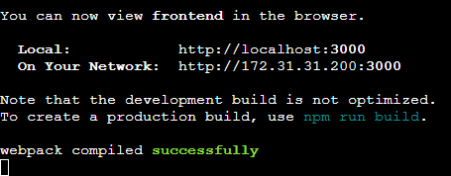
Verify:
http://<PRIVATE_IP>:3000/


7. Nginx Reverse Proxy Configuration – snapshots given in Backend document
sudo apt install nginx -y
Edit file:
sudo nano /etc/nginx/sites-available/default
server {
listen 80;
server_name ansarienterprise.site;
location / {
proxy_pass http://127.0.0.1:3000;
proxy_http_version 1.1;
proxy_set_header Upgrade $http_upgrade;
proxy_set_header Connection 'upgrade';
proxy_set_header Host $host;
proxy_cache_bypass $http_upgrade;
}
}
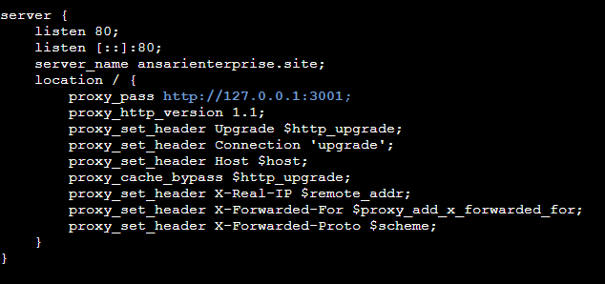

8. DNS and SSL Setup – snapshots given in Backend document
Add A record in Namecheap pointing to EC2 public IP.
Host: @
Value: <EC2_PUBLIC_IP>
TTL: Automatic
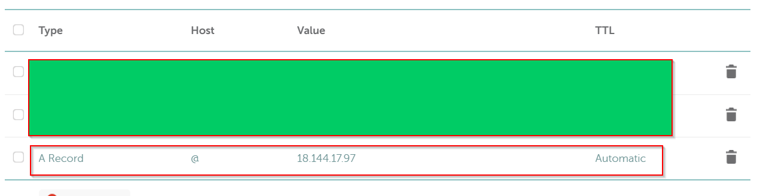
Install Certbot:
sudo apt install certbot python3-certbot-nginx -y
Reload Nginx to avoid any issues, this command will reload the nginx configuration:
sudo nginx -t
sudo systemctl reload nginx
Request SSL:
sudo certbot --nginx -d ansarienterprise.site
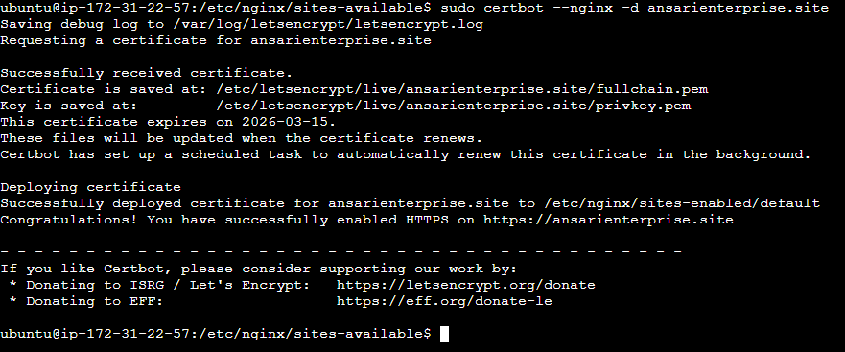

9. Final Verification
Start frontend:
sudo npm start from TravelMemory/frontend
Verify:
https://<PRIVATE_IP>/


10. AMI Creation
Create AMI named TravelMemory-FrontendAMI from this instance.
- Navigate to EC2 Dashboard.
- Select backend instance.
- Actions → Image and templates → Create image.
- Name the AMI as TravelMemory-FrontendAMI.
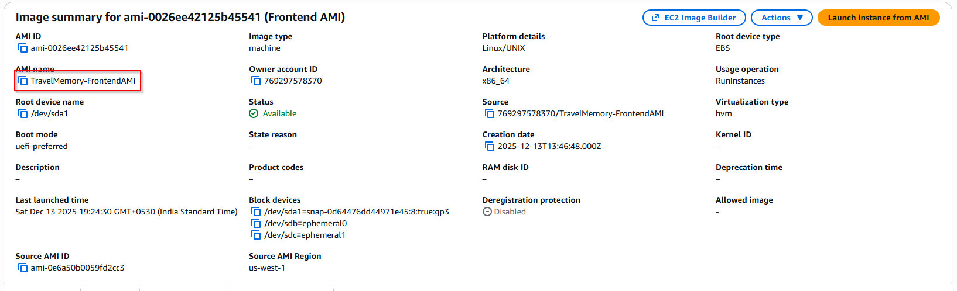

11. Second Instance Using AMI
Launch new EC2 using AMI.
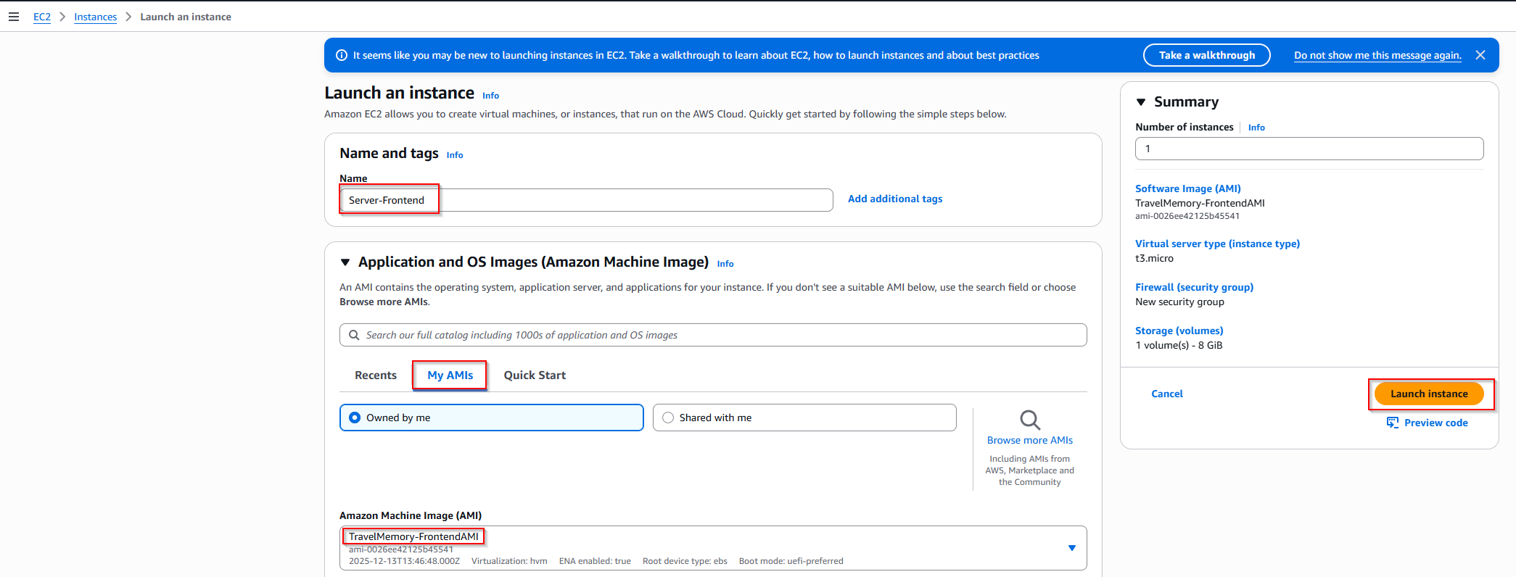
Start frontend using sudo npm start from /TravelMemory/frontend/
sudo npm start from /TravelMemory/frontend/
Verify application.
Verify:
https://<PRIVATE_IP>/


12. Load Balancer Configuration
Create HTTPS target group.
Create Application Load Balancer.
DNS Configuration for Load Balancer
Post this Configuration test your application

12.1 Target Group Configuration
1. Create target group with protocol HTTPS.
2. Port: 443.
3. Register both frontend EC2 instances.
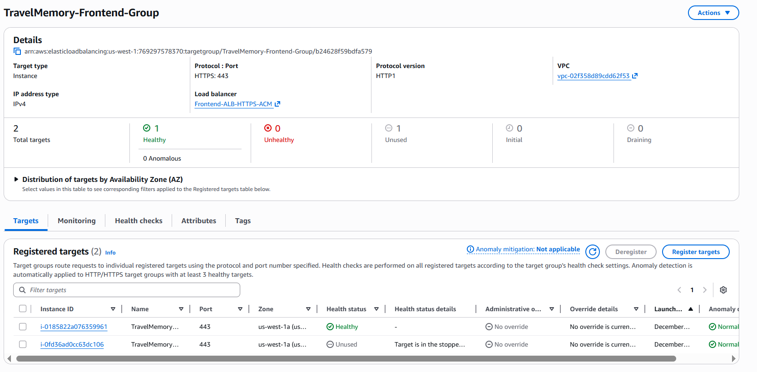

12.2 Create Application Load Balancer
1. Go to EC2 → Load Balancers.
2. Create Application Load Balancer.
3. Select HTTPS listener (443).
4. Attach ACM SSL certificate which was used earlier as we had requested for main domain i.e *.ansarienterprise.site
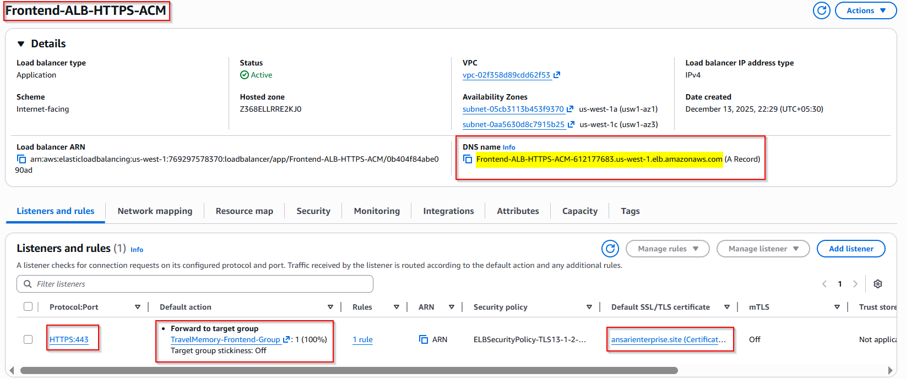
This record is already added in backend we will using existing certificate itself
In Namecheap, add the following record: which you get it from ACM after raising request
Type: CNAME
Host: api
Value: <ALB_DNS_NAME>
TTL: Automatic

Type: CNAME
Host: _75903ffe351805929356ff94f888b863
Value: _97d03e88b3f3b1bbc1d08b774ab3d59c.jkddzztszm.acm-validations.aws.
TTL: Automatic
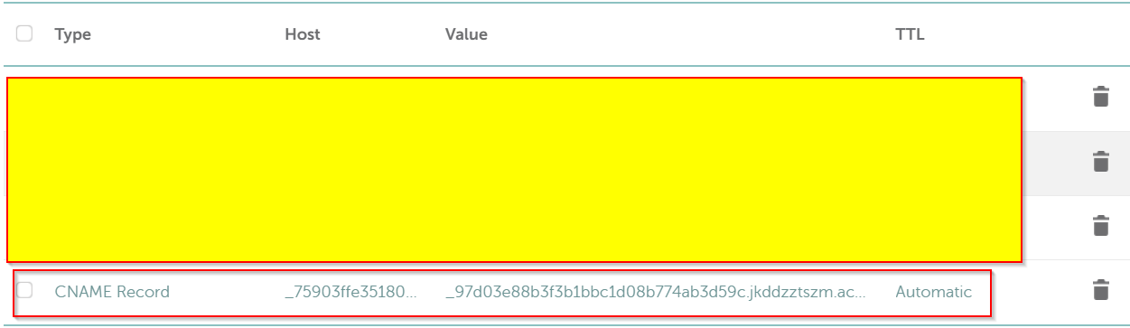

13.3 DNS Configuration for Load Balancer
In Namecheap, add the following record for frontend DNS name:
Type: CNAME
Host: www
Value: <ALB_DNS_NAME>
TTL: Automatic
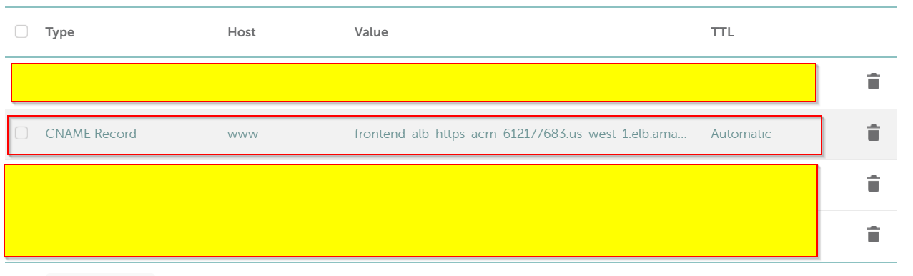

12.4 Post this Configuration test your application
In browser type https://www.ansarienterprise.site/
Expected Output:
Travel Memory website

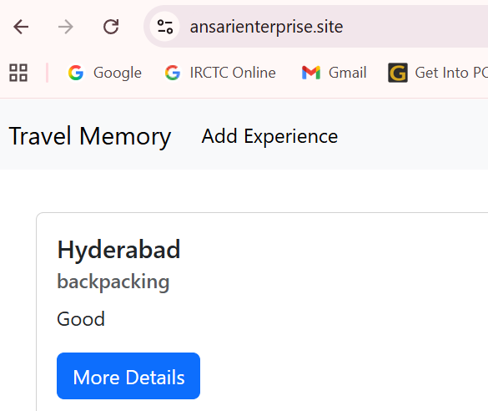

13. Conclusion for frontend
This document covers complete frontend deployment, SSL configuration, AMI creation, and high availability using AWS Application Load Balancer.

