# Appendix C: Modelibra Swing

The objective of this appendix is to show that Modelibra may be used as a model for Java Swing [Swing] applets or applications. There are two Swing projects presented in this appendix. The first project is called ModelibraRushHour and it based on the Rush Hour game [ThinkFun]. The second project is a calendar utility called ModelibraCalbadar. If you replace the **en** letters in the cal**en**dar word with the **ba** letters you will get the new cal**ba**dar word. This is done to prevent you from considering this utility too seriously. The first project is presented to show how Modelibra is used as a model of a graphical game. The second project is introduced to show the use of Modelibra sessions, actions and undos.

After a hard work of learning how to use Modelibra and Wicket in the development of dynamic web applications, you may reward yourself by playing the Rush Hour game and by creating more challenging parking positions. If you are really into it, you may decide to create some intelligent algorithms for creating and resolving parkings, or you may try to design a software game for one of puzzles at [Puzzles].

## ModelibraRushHour

The Rush Hour game has a few data windows and a graphical window for the game board. The game board has six rows and six columns with thirty six cells, where a cell is defined by its row and column. Several cars are positioned on the board horizontally or vertically. The cars are of different car model. They have different colors (in this book they have different shades of gray) and lengths (they cover two or three cells). The exit is on the right in the third row from the top. The goal of the game is to move the red car (the darkest car in this chapter) in the third row from the top out of the playing board. In order to do that you have to move other cars horizontally or vertically to make a free space for the red car to exit the board. You move a car one cell at the time by selecting it and clicking on the first available cell in the direction of your choice. Currently, the game has two areas, one for beginners and the other for intermediate users. New areas may be created by the game software. An area has multiple parkings, where each parking represents a new board with cars with more complex challenge in fun thinking.

The game uses Modelibra for the domain model of the Rush Hour game, ModelibraWicket for web views of the model, and Swing for game windows and the graphical view of the model. The default web application of the game model is used to create new areas and new parkings. The Swing part is used to present areas and area parkings to a user of the game in order to select a parking and play the game graphically. In this version of the game, rectangles with different colors and different lengths are used to represent cars. An advanced reader is invited to introduce car images and sound effects to make the game more appealing to young software developers.

### Rush Hour Project

The Eclipse project is called ModelibraRushHour and is located in the Modelibra repository at JavaForge in the trunk/App/ModelibraSwing directory. The project is created from the ModelibraWicketSkeleton project. The domain model of the game is designed in ModelibraModeler. The model XML configuration is generated from ModelibraModeler. Based on the XML configuration the code is generated as usual with Modelibra projects. Thus the game software has standard Modelibra and Wicket packages. In addition, there are new Swing packages created by hand (Figure B.1).

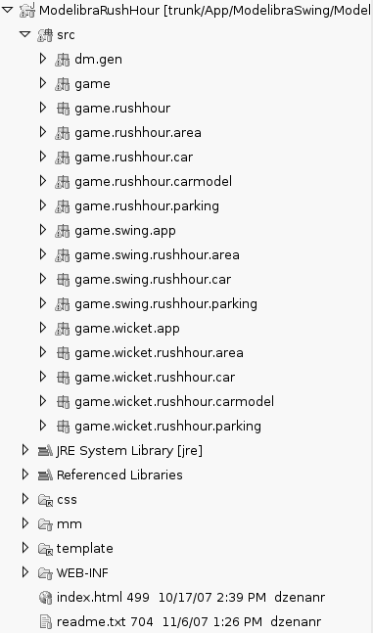**Figure B.1.** Eclipse project

### Rush Hour Model

The domain is called Game. The model is named RushHour (Figure B.2.). The model has four concepts: Area, Parking, CarModel and Car. Only the relationship between the Parking concept and the Car concept is internal (a lighter line in Figure B.2). The entry points into the model are the Area, Parking and CarModel concepts. The || sign in the upper left corner of the concept indicates an entry concept. An entry concept has also a darker border.

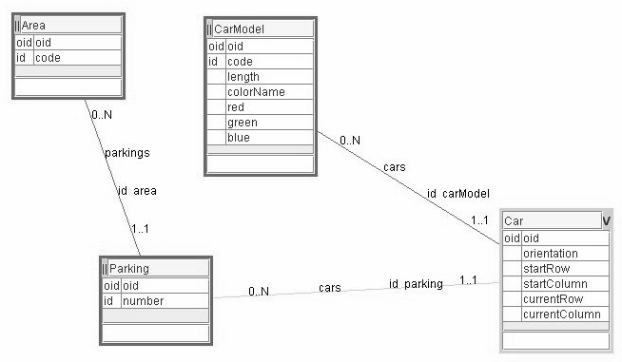**Figure B.2.** Rush Hour model

An area has many parkings. A parkings has many cars. A car is defined by its car model. The same car model may be used to define many cars. Since the Car concept has two parents, it is an intersection concept (the V sign in the upper right corner of the concept).

### Rush Hour Application

The main window of the Swing application (or applet since the game may be run either as an application or an applet) presents a choice of available areas (Figure B.3). The *Game* menu has the *Exit* menu item, while the *Help* menu has the *About...* and *Rules...* items. A click on the *Parkings* button for the selected area displays the new window with the list of available parkings (Figure B.4). The Parking 1 in the Beginner area is a simple car configuration to resolve (Figure B.5). This configuration is defined in a web page (Figure B.6).

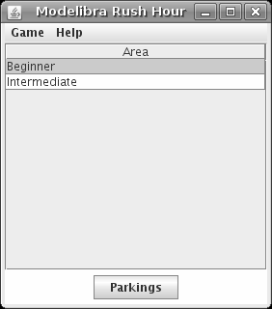

**Figure B.3.** Rush Hour areas

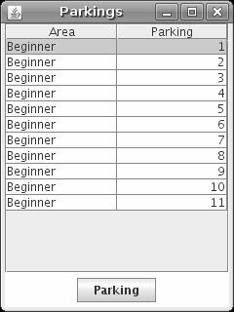**Figure B.4.** Rush Hour parkings

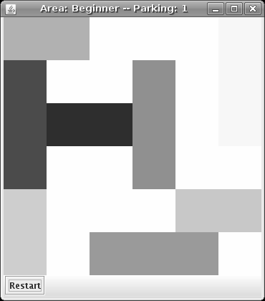

**Figure B.5.** Beginner area, Parking 1: graphical board

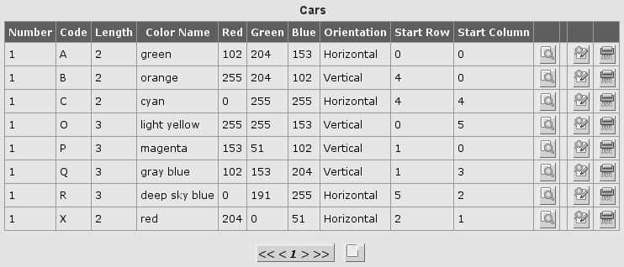**Figure B.6.** Beginner area, Parking 1: car configuration

### Rush Hour Configuration

The domain configuration is generated as the specific (not reusable) XML configuration, since future changes of the model are not planned.

<?xml version="1.0" encoding="UTF-8"?>

<domains>

<domain oid="1174415547218">

<code>Game</code>

<type>Specific</type>

<models>

<model oid="1174415568899">

<code>RushHour</code>

<author>Dzenan Ridjanovic</author>

<persistenceType>xml</persistenceType>

<persistenceRelativePath>

data/xml/game/rushhour

</persistenceRelativePath>

<defaultLoadSave>true</defaultLoadSave>

<concepts>

<concept oid="1174415643197">

<code>Parking</code>

<entitiesCode>Parkings</entitiesCode>

<entry>true</entry>

<properties>

<property oid="1174415718207">

<code>areaOid</code>

<propertyClass>java.lang.Long</propertyClass>

<required>true</required>

<reference>true</reference>

<referenceNeighbor>area</referenceNeighbor>

<essential>false</essential>

</property>

<property oid="1174416298442">

<code>number</code>

<propertyClass>

java.lang.Integer

</propertyClass>

<required>true</required>

<unique>true</unique>

<essential>true</essential>

</property>

</properties>

<neighbors>

<neighbor oid="1174415728834">

<code>cars</code>

<destinationConcept>Car</destinationConcept>

<inverseNeighbor>parking</inverseNeighbor>

<internal>true</internal>

<partOfManyToMany>false</partOfManyToMany>

<type>child</type>

<min>0</min>

<max>N</max>

</neighbor>

<neighbor oid="1174415718207">

<code>area</code>

<destinationConcept>Area</destinationConcept>

<inverseNeighbor>parkings</inverseNeighbor>

<internal>false</internal>

<partOfManyToMany>false</partOfManyToMany>

<type>parent</type>

<min>1</min>

<max>1</max>

<unique>true</unique>

</neighbor>

</neighbors>

</concept>

<concept oid="1174415652949">

<code>Car</code>

<entitiesCode>Cars</entitiesCode>

<properties>

<property oid="1174415732085">

<code>carModelOid</code>

<propertyClass>java.lang.Long</propertyClass>

<required>true</required>

<reference>true</reference>

<referenceNeighbor>

carModel

</referenceNeighbor>

<essential>false</essential>

</property>

<property oid="1174417282105">

<code>orientation</code>

<propertyClass>

java.lang.String

</propertyClass>

<maxLength>16</maxLength>

<required>true</required>

<defaultValue>Horizontal</defaultValue>

<essential>true</essential>

</property>

<property oid="1174427530720">

<code>startRow</code>

<propertyClass>

java.lang.Integer

</propertyClass>

<required>true</required>

<essential>true</essential>

</property>

<property oid="1174427533909">

<code>startColumn</code>

<propertyClass>

java.lang.Integer

</propertyClass>

<required>true</required>

<essential>true</essential>

</property>

<property oid="1174427542269">

<code>currentRow</code>

<propertyClass>

java.lang.Integer

</propertyClass>

<essential>false</essential>

</property>

<property oid="1174427547223">

<code>currentColumn</code>

<propertyClass>

java.lang.Integer

</propertyClass>

<essential>false</essential>

</property>

</properties>

<neighbors>

<neighbor oid="1174415728834">

<code>parking</code>

<destinationConcept>

Parking

</destinationConcept>

<inverseNeighbor>cars</inverseNeighbor>

<internal>true</internal>

<partOfManyToMany>false</partOfManyToMany>

<type>parent</type>

<min>1</min>

<max>1</max>

<unique>true</unique>

</neighbor>

<neighbor oid="1174415732085">

<code>carModel</code>

<destinationConcept>

CarModel

</destinationConcept>

<inverseNeighbor>cars</inverseNeighbor>

<internal>false</internal>

<partOfManyToMany>false</partOfManyToMany>

<type>parent</type>

<min>1</min>

<max>1</max>

<unique>true</unique>

</neighbor>

</neighbors>

</concept>

<concept oid="1174415685656">

<code>CarModel</code>

<entitiesCode>CarModels</entitiesCode>

<entry>true</entry>

<properties>

<property oid="1174415881805">

<code>code</code>

<propertyClass>

java.lang.String

</propertyClass>

<maxLength>16</maxLength>

<required>true</required>

<unique>true</unique>

<essential>true</essential>

</property>

<property oid="1174415885462">

<code>length</code>

<propertyClass>

java.lang.Integer

</propertyClass>

<required>true</required>

<essential>true</essential>

</property>

<property oid="1174427457610">

<code>colorName</code>

<propertyClass>

java.lang.String

</propertyClass>

<maxLength>16</maxLength>

<essential>true</essential>

</property>

<property oid="1174415916291">

<code>red</code>

<propertyClass>

java.lang.Integer

</propertyClass>

<required>true</required>

<essential>true</essential>

</property>

<property oid="1174415918089">

<code>green</code>

<propertyClass>

java.lang.Integer

</propertyClass>

<required>true</required>

<essential>true</essential>

</property>

<property oid="1174415920168">

<code>blue</code>

<propertyClass>

java.lang.Integer

</propertyClass>

<required>true</required>

<essential>true</essential>

</property>

</properties>

<neighbors>

<neighbor oid="1174415732085">

<code>cars</code>

<destinationConcept>Car</destinationConcept>

<inverseNeighbor>carModel</inverseNeighbor>

<internal>false</internal>

<partOfManyToMany>false</partOfManyToMany>

<type>child</type>

<min>0</min>

<max>N</max>

</neighbor>

</neighbors>

</concept>

<concept oid="1174415701627">

<code>Area</code>

<entitiesCode>Areas</entitiesCode>

<entry>true</entry>

<properties>

<property oid="1174416223456">

<code>code</code>

<propertyClass>

java.lang.String

</propertyClass>

<maxLength>16</maxLength>

<required>true</required>

<unique>true</unique>

<essential>true</essential>

</property>

</properties>

<neighbors>

<neighbor oid="1174415718207">

<code>parkings</code>

<destinationConcept>

Parking

</destinationConcept>

<inverseNeighbor>area</inverseNeighbor>

<internal>false</internal>

<partOfManyToMany>false</partOfManyToMany>

<type>child</type>

<min>0</min>

<max>N</max>

</neighbor>

</neighbors>

</concept>

</concepts>

</model>

</models>

</domain>

</domains>

### Rush Hour Classes

The GameConfig class obtains the domain configuration from the specific XML configuration of the project for the Game domain.

**package** game;

**import** org.modelibra.config.Config;

**import** org.modelibra.config.DomainConfig;

**public** **class** GameConfig **extends** Config {

**private** DomainConfig domainConfig;

**public** GameConfig() {

**super**();

domainConfig = getDomainConfig("Game", "Specific");

}

**public** DomainConfig getDomainConfig() {

**return** domainConfig;

}

}

The GenGame class constructs the RushHour model.

**package** game;

**import** org.modelibra.Domain;

**import** org.modelibra.config.DomainConfig;

**import** game.rushhour.RushHour;

**public** **abstract** **class** GenGame **extends** Domain {

**private** RushHour rushHour;

**public** GenGame(DomainConfig domainConfig) {

**super**(domainConfig);

rushHour = **new** RushHour(**this**);

}

**public** RushHour getRushHour() {

**return** rushHour;

}

}

The Game class inherits everything from the GenGame class. Here you can add some specific code at the model level.

**package** game;

**import** org.modelibra.config.DomainConfig;

**public** **class** Game **extends** GenGame {

**public** Game(DomainConfig domainConfig) {

**super**(domainConfig);

}

}

The GenRushHour class constructs model entry concepts.

**package** game.rushhour;

**import** game.rushhour.area.Areas;

**import** game.rushhour.carmodel.CarModels;

**import** game.rushhour.parking.Parkings;

**import** org.modelibra.IDomain;

**import** org.modelibra.Model;

**public** **abstract** **class** GenRushHour **extends** Model {

**private** Parkings parkings;

**private** CarModels carModels;

**private** Areas areas;

**public** GenRushHour(IDomain domain) {

**super**(domain);

parkings = **new** Parkings(**this**);

carModels = **new** CarModels(**this**);

areas = **new** Areas(**this**);

}

**public** Parkings getParkings() {

**return** parkings;

}

**public** CarModels getCarModels() {

**return** carModels;

}

**public** Areas getAreas() {

**return** areas;

}

}

The RushHour class inherits everything from the GenRushHour class. The specific getCars method is added to retrieve all cars for all parkings. There is no need to start with the Area entry concept, since Parking is also the entry concept.

**package** game.rushhour;

**import** game.rushhour.car.Car;

**import** game.rushhour.car.Cars;

**import** game.rushhour.parking.Parking;

**import** game.rushhour.parking.Parkings;

**import** org.modelibra.IDomain;

**public** **class** RushHour **extends** GenRushHour {

**public** RushHour(IDomain domain) {

**super**(domain);

}

/* ============================= */

/* ======= SPECIFIC CODE ======= */

/* ============================= */

**private** Cars cars;

**public** Cars getCars() {

**if** (isInitialized()) {

**if** (cars == **null**) {

setInitialized(**false**);

Cars allCars = **new** Cars(**this**);

Parkings parkings = getParkings();

**for** (Parking parking : parkings) {

Cars cars = parking.getCars();

**for** (Car car : cars) {

allCars.add(car);

}

}

cars = allCars;

setInitialized(**true**);

}

}

**return** cars;

}

}

The RushHourDb is a new class that will be used in the main Swing window to access the model of the game. In the class constructor, the game configuration is created first. Then, the domain configuration is obtained from the game configuration. Next, the game domain is constructed based on the domain configuration. The persistent game is created based on the game domain. Finally, The game model is found in the game domain. This game model will be used to get areas in order to display them in the main window of the game application (or applet).

**package** game.rushhour;

**import** game.Game;

**import** game.GameConfig;

**import** game.PersistentGame;

**import** org.apache.commons.logging.Log;

**import** org.apache.commons.logging.LogFactory;

**import** org.modelibra.config.DomainConfig;

**public** **class** RushHourDb {

**private** **static** Log *log* = LogFactory.*getLog*(RushHourDb.**class**);

**private** Game game;

**private** PersistentGame persistentGame;

**private** RushHour rushHour;

**public** RushHourDb() {

**super**();

**try** {

GameConfig gameConfig = **new** GameConfig();

DomainConfig domainConfig = gameConfig.getDomainConfig();

game = **new** Game(domainConfig);

persistentGame = **new** PersistentGame(game);

rushHour = game.getRushHour();

} **catch** (Exception e) {

*log*.error("Error in RushHourDb.constructor: " + e.getMessage());

}

}

**public** Game getGame() {

**return** game;

}

**public** RushHour getRushHour() {

**return** rushHour;

}

**public** **void** close() {

**if** (persistentGame != **null**) {

persistentGame.close();

}

}

}

The game application or applet is run by using the Start class from the game.swing.app package. In the Eclipse project this class is selected and in the pop-up menu the *Run As* menu item is chosen to decide if the application or the applet will be executed.

**package** game.swing.app;

**import** game.swing.rushhour.area.AreasWindow;

**import** javax.swing.JApplet;

**public** **class** Start **extends** JApplet {

AreasWindow areasWindow;

**public** **void** init() {

areasWindow = **new** AreasWindow();

}

**public** **void** start() {

areasWindow.setTitle("Modelibra Rush Hour");

areasWindow.setVisible(**true**);

}

**public** **void** stop() {

areasWindow.setVisible(**false**);

}

**public** **void** destroy() {

areasWindow.dispose();

}

**public** **static** **void** main(String[] args) {

Start app = **new** Start();

app.init();

app.start();

}

}

In both cases the init method will be called to construct an object of the AreasWindow class from the game.swing.rushhour.area package. In the default constructor of this class an object of the RushHourDb class will be created and the areas entities will be obtained from the model of the Rush Hour database.

**package** game.swing.rushhour.area;

**import** game.rushhour.RushHourDb;

**import** game.rushhour.area.Area;

**import** game.rushhour.area.Areas;

...

**public** **class** AreasWindow **extends** JFrame **implements** ListSelectionListener {

**private** RushHourDb rushHourDb;

**private** Areas areas;

**private** Area currentArea;

...

**public** AreasWindow() {

**super**();

rushHourDb = **new** RushHourDb();

areas = rushHourDb.getRushHour().getAreas();

areaTableModel = **new** AreaTableModel(areas);

...

}

**public** RushHourDb getRushHourDb() {

**return** rushHourDb;

}

...

}

The Swing code is not explained here, since this is not an objective of the book. A reader is invited to learn about Swing in one of free Java Swing books at [Books].

## ModelibraCalbadar

The Modelibra Calendar utility has the main window that displays the current month with days (dates) and the current date for the current year. By clicking on a date you may add a note. You may create or access a calendar for a year by changing the content of the year field. You may also save a calendar in an XML data file anywhere on a disk.

The utility uses Modelibra for the domain model of a calendar, ModelibraWicket for web views of the model, and Swing for windows. The default web application of the calendar model may be used to navigate through a large amount of data. An advanced reader is invited to introduce new calendar features to make the utility more appealing to software developers.

### Calendar Project

The Eclipse project is called ModelibraCalbadar and is located in the Modelibra repository at JavaForge in the trunk/App/ModelibraSwing directory. The project is created from the ModelibraWicketSkeleton project. The domain model of the calendar utility is designed in ModelibraModeler. The reusable XML configuration is generated from ModelibraModeler. Based on the reusable XML configuration the code is generated as usual with Modelibra projects. Thus the utility software has standard Modelibra and Wicket packages. In addition, there are new Swing packages created by hand.They all start with the util.swing prefix.

By default the calendar utility is shown in English. However, there are also French and Bosnian versions. By changing the lang property, in the Start.properties file of the util.swing.app package, from en to fr or ba, and by executing the application, you get the new international version.

### Calendar Model

The domain is called Util. The model is named Calbadar (Figure B.7.). The model is hierarchical and has five concepts: Calendar, Year, Month, Day and Note. All relationships are internal. The entry point into the model is the Calendar concept. Thus, all data will be saved in one file called calendar.xml.

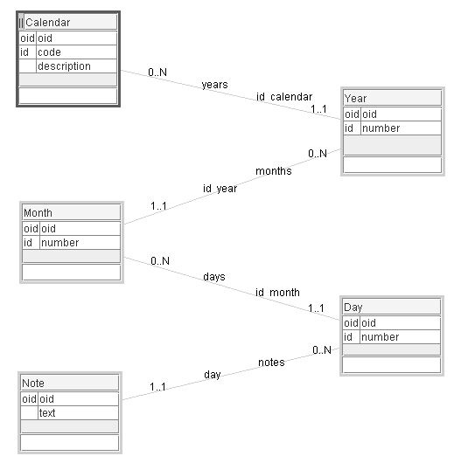

**Figure B.7.** Calbadar model

A calendar has many years. A year has 12 months. A month has at most 31 days. A day may have several notes.

### Calendar Application

The main window of the Swing application (or applet since the utility may be executed either as an application or an applet) presents a calendar for the current month with the current day (date) indicated by a darker background (Figure B.8). To change a year enter a four digit number, then press the keyboard *ENTER* key. If the entered year is not in the model, it will be created, together with its months and days. In this way you may create quite a lot of data in the XML data file and test the performance of Modelibra with respect to the XML persistency. To change a month and display it, enter a month number from 1 to 12, then press the *ENTER* key. You can also display the previous or the next month by clicking on the corresponding button. If you click on a day cell you may add or edit a note. You may view monthly notes and select a subset of them (*View* menu). By default, the data are saved in the calendar.xml file that is located within the project in the data directory defined by the persistenceRelativePath element in the reusable XML configuration. However, you may select a different directory where the data file will be saved and later on opened (*Calendar* menu). Finally any action can be undone (*Edit* menu, *Undo* menu item).

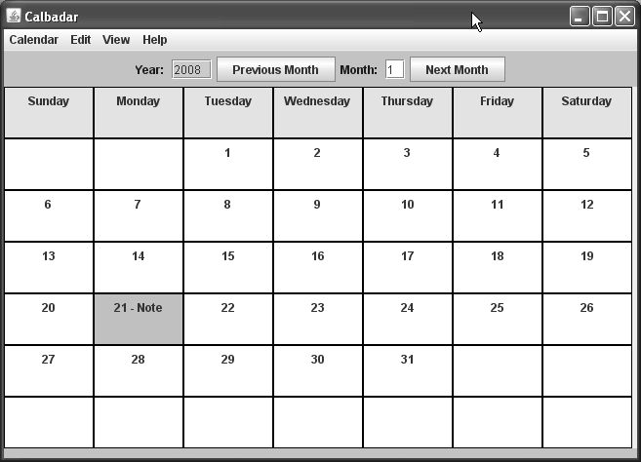

**Figure B.8.** Calendar main window

### Calendar Configuration

The domain configuration is generated from the domain model in ModelibraModeler as the reusable XML configuration.

<?xml version="1.0" encoding="UTF-8"?>

<domains>

<domain oid="1200866723313">

<code>Util</code>

<type>Reusable</type>

<models>

<model oid="1200867392284">

<code>Calbadar</code>

<author>Dzenan Ridjanovic</author>

<persistenceType>xml</persistenceType>

<persistenceRelativePath>

data/xml/util/calbadar

</persistenceRelativePath>

<defaultLoadSave>true</defaultLoadSave>

<concepts>

<concept oid="1200867415246">

<code>Calendar</code>

<entitiesCode>Calendars</entitiesCode>

<entry>true</entry>

<properties>

<property oid="1200867570220">

<code>code</code>

<propertyClass>java.lang.String</propertyClass>

<maxLength>16</maxLength>

<required>true</required>

<unique>true</unique>

<essential>true</essential>

</property>

<property oid="1200867574949">

<code>description</code>

<propertyClass>java.lang.String</propertyClass>

<maxLength>510</maxLength>

<essential>false</essential>

</property>

</properties>

<neighbors>

<neighbor oid="1200867480808">

<code>years</code>

<destinationConcept>Year</destinationConcept>

<inverseNeighbor>calendar</inverseNeighbor>

<internal>true</internal>

<partOfManyToMany>false</partOfManyToMany>

<type>child</type>

<min>0</min>

<max>N</max>

</neighbor>

</neighbors>

</concept>

<concept oid="1200867420806">

<code>Year</code>

<entitiesCode>Years</entitiesCode>

<properties>

<property oid="1200867579686">

<code>number</code>

<propertyClass>java.lang.Integer</propertyClass>

<required>true</required>

<defaultValue>2008</defaultValue>

<unique>true</unique>

<essential>false</essential>

</property>

</properties>

<neighbors>

<neighbor oid="1200867484479">

<code>months</code>

<destinationConcept>Month</destinationConcept>

<inverseNeighbor>year</inverseNeighbor>

<internal>true</internal>

<partOfManyToMany>false</partOfManyToMany>

<type>child</type>

<min>0</min>

<max>N</max>

</neighbor>

<neighbor oid="1200867480808">

<code>calendar</code>

<destinationConcept>Calendar</destinationConcept>

<inverseNeighbor>years</inverseNeighbor>

<internal>true</internal>

<partOfManyToMany>false</partOfManyToMany>

<type>parent</type>

<min>1</min>

<max>1</max>

<unique>true</unique>

</neighbor>

</neighbors>

</concept>

<concept oid="1200867422904">

<code>Month</code>

<entitiesCode>Months</entitiesCode>

<properties>

<property oid="1200867584000">

<code>number</code>

<propertyClass>java.lang.Integer</propertyClass>

<required>true</required>

<unique>true</unique>

<essential>true</essential>

</property>

</properties>

<neighbors>

<neighbor oid="1200867488792">

<code>days</code>

<destinationConcept>Day</destinationConcept>

<inverseNeighbor>month</inverseNeighbor>

<internal>true</internal>

<partOfManyToMany>false</partOfManyToMany>

<type>child</type>

<min>0</min>

<max>N</max>

</neighbor>

<neighbor oid="1200867484479">

<code>year</code>

<destinationConcept>Year</destinationConcept>

<inverseNeighbor>months</inverseNeighbor>

<internal>true</internal>

<partOfManyToMany>false</partOfManyToMany>

<type>parent</type>

<min>1</min>

<max>1</max>

<unique>true</unique>

</neighbor>

</neighbors>

</concept>

<concept oid="1200867423533">

<code>Day</code>

<entitiesCode>Days</entitiesCode>

<properties>

<property oid="1200867588433">

<code>number</code>

<propertyClass>java.lang.Integer</propertyClass>

<required>true</required>

<unique>true</unique>

<essential>true</essential>

</property>

</properties>

<neighbors>

<neighbor oid="1200867502217">

<code>notes</code>

<destinationConcept>Note</destinationConcept>

<inverseNeighbor>day</inverseNeighbor>

<internal>true</internal>

<partOfManyToMany>false</partOfManyToMany>

<type>child</type>

<min>0</min>

<max>N</max>

</neighbor>

<neighbor oid="1200867488792">

<code>month</code>

<destinationConcept>Month</destinationConcept>

<inverseNeighbor>days</inverseNeighbor>

<internal>true</internal>

<partOfManyToMany>false</partOfManyToMany>

<type>parent</type>

<min>1</min>

<max>1</max>

<unique>true</unique>

</neighbor>

</neighbors>

</concept>

<concept oid="1200867424382">

<code>Note</code>

<entitiesCode>Notes</entitiesCode>

<properties>

<property oid="1200867596402">

<code>text</code>

<propertyClass>java.lang.String</propertyClass>

<maxLength>1020</maxLength>

<required>true</required>

<essential>true</essential>

</property>

</properties>

<neighbors>

<neighbor oid="1200867502217">

<code>day</code>

<destinationConcept>Day</destinationConcept>

<inverseNeighbor>notes</inverseNeighbor>

<internal>true</internal>

<partOfManyToMany>false</partOfManyToMany>

<type>parent</type>

<min>1</min>

<max>1</max>

</neighbor>

</neighbors>

</concept>

</concepts>

</model>

</models>

</domain>

</domains>

The specific XML configuration is generated together with other files generated by the main method of the DmGenerator class in the dm.gen package. The only XML element added is the session element with the true value. In Modelibra, the default value of the session element is false. A reader is invited to change maximal cardinalities of some neighbors from N to a specific number.

<?xml version="1.0" encoding="UTF-8"?>

<domains>

<domain oid="1200866723313">

<code>Util</code>

<type>Specific</type>

<models>

<model oid="1200867392284">

<code>Calbadar</code>

<extension>true</extension>

<extensionDomain>Util</extensionDomain>

<extensionDomainType>Reusable</extensionDomainType>

<extensionModel>Calbadar</extensionModel>

<session>true</session>

<concepts>

...

</concepts>

</model>

</models>

</domain>

</domains>

### Calendar Classes

After the code generation, some specific code was added to specific classes of concepts. This was done to ease the application programming with the model and its concepts. The Calendar class creates a year with its months and provides some utility get and is methods.

**package** util.calbadar.calendar;

**import** org.apache.commons.logging.Log;

**import** org.apache.commons.logging.LogFactory;

**import** org.modelibra.IModel;

**import** org.modelibra.type.EasyCalendar;

**import** util.calbadar.year.Year;

**public** **class** Calendar **extends** GenCalendar {

**private** **static** Log *log* = LogFactory.*getLog*(Calendar.**class**);

**public** Calendar(IModel model) {

**super**(model);

}

/* ============================= */

/* ======= SPECIFIC CODE ======= */

/* ============================= */

**public** **void** createYear() {

createYear(EasyCalendar.*getOne*().getCurrentYear());

}

**public** Year createYear(**int** number) {

Year year = **new** Year(**this**);

year.setNumber(number);

year.createMonths();

getYears().add(year);

**return** year;

}

**public** Year getYear(Integer number) {

**return** (Year) getYears().getYear("number", number);

}

**public** Year getYear(**int** number) {

**return** getYear(**new** Integer(number));

}

**public** Year getCurrentYear() {

**int** currentYearNumber = EasyCalendar.*getOne*().getCurrentYear();

**return** getYear(currentYearNumber);

}

**public** **int** getCurrentYearNumber() {

**int** number = 0;

Year year = getCurrentYear();

**if** (year != **null**) {

number = year.getNumber().intValue();

}

**return** number;

}

**public** **boolean** isCalbadar() {

**boolean** result = **false**;

**if** (**this**.getCode().equals("Calbadar")) {

result = **true**;

}

**return** result;

}

}

The Year class creates its months and provides some utility get and is methods.

**package** util.calbadar.year;

**import** org.apache.commons.logging.Log;

**import** org.apache.commons.logging.LogFactory;

**import** org.modelibra.IModel;

**import** org.modelibra.type.EasyCalendar;

**import** util.calbadar.calendar.Calendar;

**import** util.calbadar.month.Month;

**public** **class** Year **extends** GenYear {

**private** **static** Log *log* = LogFactory.*getLog*(Year.**class**);

**public** Year(IModel model) {

**super**(model);

}

**public** Year(Calendar calendar) {

**super**(calendar);

}

/* ============================= */

/* ======= SPECIFIC CODE ======= */

/* ============================= */

**public** **void** createMonths() {

**for** (**int** m = 1; m < 13; m++) {

createMonth(m);

}

}

**private** **void** createMonth(**int** number) {

Month month = **new** Month(**this**);

month.setNumber(number);

month.createDays();

getMonths().add(month);

}

**public** Month getMonth(Integer number) {

**return** (Month) getMonths().getMonth("number", number);

}

**public** Month getMonth(**int** number) {

**return** getMonth(**new** Integer(number));

}

**public** Month getCurrentMonth() {

Month month = **null**;

**if** (isCurrent()) {

**int** currentMonthNumber = EasyCalendar.*getOne*().getCurrentMonth();

month = getMonth(currentMonthNumber);

}

**return** month;

}

**public** **int** getCurrentMonthNumber() {

**int** number = 0;

Month month = getCurrentMonth();

**if** (month != **null**) {

number = month.getNumber().intValue();

}

**return** number;

}

**public** **boolean** isCurrent() {

**boolean** result = **false**;

**if** (**this**.getNumber().intValue() == EasyCalendar.*getOne*()

.getCurrentYear()) {

result = **true**;

}

**return** result;

}

}

The Month class creates its days and provides some utility get and is methods.

**package** util.calbadar.month;

**import** java.util.Calendar;

**import** java.util.GregorianCalendar;

**import** java.util.Iterator;

**import** org.apache.commons.logging.Log;

**import** org.apache.commons.logging.LogFactory;

**import** org.modelibra.IModel;

**import** org.modelibra.PropertySelector;

**import** org.modelibra.type.EasyCalendar;

**import** util.calbadar.day.Day;

**import** util.calbadar.day.Days;

**import** util.calbadar.note.Note;

**import** util.calbadar.note.Notes;

**import** util.calbadar.year.Year;

**public** **class** Month **extends** GenMonth {

**private** **static** Log *log* = LogFactory.*getLog*(Month.**class**);

**public** Month(IModel model) {

**super**(model);

}

**public** Month(Year year) {

**super**(year);

}

/* ============================= */

/* ======= SPECIFIC CODE ======= */

/* ============================= */

**public** **void** createDays() {

GregorianCalendar calendar = **new** GregorianCalendar();

calendar.set(Calendar.*YEAR*, **this**.getYear().getNumber().intValue());

// First month is 0.

calendar.set(Calendar.*MONTH*, **this**.getNumber().intValue() - 1);

createDays(calendar);

}

**private** **void** createDays(GregorianCalendar calendar) {

**int** noOfDays = calendar.getActualMaximum(Calendar.*DAY_OF_MONTH*);

**for** (**int** i = 1; i <= noOfDays; i++) {

createDay(i);

}

}

**private** **void** createDay(**int** number) {

Day day = **new** Day(**this**);

day.setNumber(number);

getDays().add(day);

}

**public** **int** getFirstWeekFirstDayNumber() {

**int** monthNumber = getNumber().intValue();

GregorianCalendar calendar = **new** GregorianCalendar();

calendar.set(Calendar.*YEAR*, **this**.getYear().getNumber().intValue());

calendar.set(Calendar.*MONTH*, monthNumber - 1); // First month is 0.

calendar.set(Calendar.*DAY_OF_MONTH*, 1); // Sets the first wek.

**return** calendar.get(Calendar.*DAY_OF_WEEK*);

}

**public** Day getDay(Integer number) {

**return** (Day) getDays().getDay("number", number);

}

**public** Day getDay(**int** number) {

**return** getDay(**new** Integer(number));

}

**public** Day getCurrentDay() {

Day day = **null**;

**if** (isCurrent()) {

**int** currentDayNumber = EasyCalendar.*getOne*().getCurrentDay();

day = getDay(currentDayNumber);

}

**return** day;

}

**public** **int** getCurrentDayNumber() {

**int** number = 0;

Day day = getCurrentDay();

**if** (day != **null**) {

number = day.getNumber().intValue();

}

**return** number;

}

**public** **boolean** isCurrent() {

**boolean** result = **false**;

EasyCalendar easyCalendar = EasyCalendar.*getOne*();

**if** (**this**.getYear().getNumber().intValue() == easyCalendar

.getCurrentYear()) {

**if** (getNumber().intValue() == easyCalendar.getCurrentMonth()) {

result = **true**;

}

}

**return** result;

}

**public** Notes getNotes() {

Notes result = **new** Notes(getDay(1));

Days days = **this**.getDays();

Day day;

Note note;

**for** (Iterator x = days.iterator(); x.hasNext();) {

day = (Day) x.next();

Notes dailyNotes = day.getNotes();

**if** (dailyNotes != **null**) {

note = (Note) day.getNotes().first();

**if** (note != **null**) {

result.add(note);

}

}

}

**return** result;

}

**public** Notes getNotes(String selection) {

Notes selectedNotes = **null**;

PropertySelector propertySelector = **new** PropertySelector("text");

propertySelector.defineContain(selection);

selectedNotes = getNotes().getNotes(propertySelector);

**return** selectedNotes;

}

}

The Day class sets a valid day number and provides some utility get methods.

**package** util.calbadar.day;

**import** java.util.Date;

**import** org.apache.commons.logging.Log;

**import** org.apache.commons.logging.LogFactory;

**import** org.modelibra.IModel;

**import** org.modelibra.type.EasyCalendar;

**import** util.calbadar.month.Month;

**public** **class** Day **extends** GenDay {

**private** **static** Log *log* = LogFactory.*getLog*(Day.**class**);

**public** Day(IModel model) {

**super**(model);

}

**public** Day(Month month) {

**super**(month);

}

/* ============================= */

/* ======= SPECIFIC CODE ======= */

/* ============================= */

**public** **void** setNumber(Integer number) {

**int** no = number.intValue();

**if** ((0 <= no) && (no <= 31)) {

**super**.setNumber(number);

}

}

**public** Date getDate() {

**int** year = getMonth().getYear().getNumber().intValue();

**int** month = getMonth().getNumber().intValue();

**int** day = getNumber().intValue();

**return** EasyCalendar.*getOne*().getDate(year, month, day);

}

**public** String getDateText() {

Date date = **this**.getDate();

**return** EasyCalendar.*getOne*().getDateString(date);

}

}

There is no specific code in the Note class. However, there is the getContainTextNotes method in the Notes class. This methods selects a subset of nodes of the same parent that contain the given text. This is used in the *View/Monthly Notes...* window.

**package** util.calbadar.note;

**import** org.apache.commons.logging.Log;

**import** org.apache.commons.logging.LogFactory;

**import** org.modelibra.IModel;

**import** org.modelibra.PropertySelector;

**import** util.calbadar.day.Day;

**public** **class** Notes **extends** GenNotes {

**private** **static** Log *log* = LogFactory.*getLog*(Notes.**class**);

**public** Notes(IModel model) {

**super**(model);

}

**public** Notes(Day day) {

**super**(day);

}

/* ============================= */

/* ======= SPECIFIC CODE ======= */

/* ============================= */

**public** Notes getContainTextNotes(String subText) {

PropertySelector propertySelector = **new** PropertySelector("text");

propertySelector.defineContain(subText);

**return** getNotes(propertySelector);

}

}

There is one new class in the model's package with the CalbadarDb name. An object of this class is created by the Board class in the util.swing.calbadar.month package. The Board class is used in the MainWindow class of the util.swing.app package to display the current month. The Board class constructs an object of the CalbadarDb class in order to load data from the default location and the default file. The default constructor of the CalbadarDb class goes through several standard steps to obtain the domain configuration and to create the domain with its model based on that configuration. In addition, a persistent domain is created to provide the default XML persistency of data. The four **public** methods are called by the Board class.

**package** util.calbadar;

**import** org.apache.commons.logging.Log;

**import** org.apache.commons.logging.LogFactory;

**import** org.modelibra.config.DomainConfig;

**import** org.modelibra.exception.PersistencyException;

**import** org.modelibra.persistency.IPersistentEntities;

**import** org.modelibra.persistency.IPersistentModel;

**import** org.modelibra.persistency.PersistentEntities;

**import** org.modelibra.persistency.xml.XmlEntities;

**import** util.PersistentUtil;

**import** util.Util;

**import** util.UtilConfig;

**import** util.calbadar.calendar.Calendar;

**import** util.calbadar.calendar.Calendars;

**import** util.calbadar.day.Day;

**import** util.calbadar.month.Month;

**import** util.calbadar.year.Year;

**public** **class** CalbadarDb {

**private** **static** Log *log* = LogFactory.*getLog*(CalbadarDb.**class**);

**private** Util util;

**private** PersistentUtil persistentUtil;

**private** Calbadar calbadar;

**public** CalbadarDb() {

**super**();

**try** {

UtilConfig utilConfig = **new** UtilConfig();

DomainConfig domainConfig = utilConfig.getDomainConfig();

util = **new** Util(domainConfig);

persistentUtil = **new** PersistentUtil(util);

calbadar = util.getCalbadar();

} **catch** (Exception e) {

*log*.error("Error in CalbadarDb.constructor: " + e.getMessage());

}

}

**public** Util getUtil() {

**return** util;

}

**public** Calbadar getCalbadar() {

**return** calbadar;

}

**public** **void** close() {

**if** (persistentUtil != **null**) {

persistentUtil.close();

}

}

**private** **void** createCalbadarCalendar() {

Calendar calendar = **new** Calendar(calbadar);

calbadar.setInitialized(**false**);

calendar.setCode("Calbadar");

calendar.setDescription("Modelibra model -- Swing views.");

calendar.createYear();

calbadar.getCalendars().add(calendar);

calbadar.setInitialized(**true**);

}

**public** Calendar getCalbadarCalendar() {

Calendar calendar = **null**;

Calendars calendars = calbadar.getCalendars();

**if** (calendars != **null**) {

calendar = calendars.getCalendar("code", "Calbadar");

}

**return** calendar;

}

**public** **void** loadData() {

**boolean** defaultLoadSave = calbadar.getModelConfig().isDefaultLoadSave();

**if** (!defaultLoadSave) {

**try** {

persistentUtil.load();

} **catch** (PersistencyException e) {

*log*.error("Error in CalbadarDb.loadData: " + e.getMessage());

}

}

}

**public** **void** createData() {

createCalbadarCalendar();

}

**public** **void** emptyData() {

Calendar calbadarCalendar = getCalbadarCalendar();

calbadar.getCalendars().remove(calbadarCalendar);

}

**private** IPersistentEntities getPersistentCalendars() {

IPersistentModel persistentCalbadar = persistentUtil

.getPersistentModels().getPersistentModel("Calbadar");

IPersistentEntities persistentCalendars = persistentCalbadar

.getPersistentEntry("Calendars");

**return** persistentCalendars;

}

**public** XmlEntities getXmlCalendars() {

PersistentEntities persistentCalendars = (PersistentEntities)

getPersistentCalendars();

XmlEntities xmlCalendars = (XmlEntities) persistentCalendars

.getStoreEntities();

**return** xmlCalendars;

}

**public** **static** **void** main(String[] args) {

CalbadarDb calbadarDb = **null**;

**try** {

calbadarDb = **new** CalbadarDb();

calbadarDb.createData();

Calendar calbadarCalendar = calbadarDb.getCalbadarCalendar();

Year year = calbadarCalendar.getYear(2008);

Month month = year.getMonth(1);

Day day = month.getDay(21);

calbadarDb.close();

} **catch** (Exception e) {

*log*.error("Error in CalbadarDb.main: " + e.getMessage());

calbadarDb.close();

}

}

}

Only the Board class will be completely presented in this appendix. The calendar board of the current month is initialized in the default constructor. The board can be filled by a different month by using the fill method. Default data can be created by the createDefaultData method, or data can be loaded from the default file by the loadDefaultData method. Data can also be loaded from a specific location by the loadData method, and saved to that or a different location by the saveData method.

**package** util.swing.calbadar.month;

**import** java.awt.Color;

**import** java.awt.GridLayout;

**import** java.util.Iterator;

**import** javax.swing.JPanel;

**import** org.modelibra.Session;

**import** org.modelibra.persistency.xml.XmlEntities;

**import** util.calbadar.CalbadarDb;

**import** util.calbadar.calendar.Calendar;

**import** util.calbadar.day.Day;

**import** util.calbadar.month.Month;

**import** util.calbadar.year.Year;

**import** util.swing.calbadar.day.Cell;

**import** util.swing.param.Para;

**public** **class** Board **extends** JPanel {

**public** **static** **final** Color *HEADER_COLOR* = Color.*YELLOW*;

**public** **static** **final** Color *DAY_COLOR* = Color.*WHITE*;

**public** **static** **final** Color *CURRENT_DAY_COLOR* = Color.*LIGHT_GRAY*;

**public** **static** **final** **int** *BOARD_LENGTH* = 7;

**private** Cell[][] cells;

**private** CalbadarDb calbadarDb;

**private** Session session;

**private** Month month;

**public** Board() {

**super**();

init();

}

**public** CalbadarDb getCalbadar() {

**return** calbadarDb;

}

**public** Month getMonth() {

**return** month;

}

**private** **void** init() {

cells = **new** Cell[*BOARD_LENGTH*][*BOARD_LENGTH*];

**this**.setLayout(**new** GridLayout(*BOARD_LENGTH*, *BOARD_LENGTH*));

**for** (**int** v = 0; v < *BOARD_LENGTH*; v++) {

**for** (**int** h = 0; h < *BOARD_LENGTH*; h++) {

cells[v][h] = **new** Cell(**this**);

**this**.add(cells[v][h]);

**if** (v == 0) {

cells[v][h].setColor(*HEADER_COLOR*);

// Sunday, Monday, ...

cells[v][h].setDayName(Para.*getSingleton*().getText(

"day" + h));

} **else** {

cells[v][h].setColor(*DAY_COLOR*);

}

}

}

}

**private** **void** empty() {

**for** (**int** v = 1; v < *BOARD_LENGTH*; v++) {

**for** (**int** h = 0; h < *BOARD_LENGTH*; h++) {

cells[v][h].setColor(*DAY_COLOR*);

cells[v][h].setNumber(0);

cells[v][h].setDayName("");

cells[v][h].emptyNoteIndicator();

cells[v][h].setDay(**null**);

}

}

}

**public** **void** fill(Month month) {

**this**.month = month;

empty();

**int** noOfEmptyCells = month.getFirstWeekFirstDayNumber();

Day day = **null**;

**int** v = 1;

**int** h = noOfEmptyCells - 1;

**for** (Iterator x = month.getDays().getList().iterator(); x.hasNext();) {

day = (Day) x.next();

Integer number = day.getNumber();

**int** no = number.intValue();

cells[v][h].setNumber(no);

cells[v][h].setDay(day);

cells[v][h].updateNoteIndicator();

**if** (month.isCurrent()) {

**if** (no == month.getCurrentDayNumber()) {

cells[v][h].setColor(*CURRENT_DAY_COLOR*);

}

}

**if** (++h == *BOARD_LENGTH*) {

h = 0;

v++;

}

}

}

**private** **void** fill(Calendar calendar) {

**try** {

Year currentYear = calendar.getCurrentYear();

Month currentMonth = currentYear.getCurrentMonth();

**if** (currentMonth != **null**) {

fill(currentMonth);

}

} **catch** (Exception e) {

System.*out*.println("Fill data error from Board.fill: "

+ e.getMessage());

}

}

**public** **void** loadDefaultData() {

calbadarDb = **new** CalbadarDb();

session = calbadarDb.getCalbadar().getSession();

calbadarDb.loadData();

Calendar calbadarCalendar = calbadarDb.getCalbadarCalendar();

**if** (calbadarCalendar == **null**) {

calbadarDb.createData();

calbadarCalendar = calbadarDb.getCalbadarCalendar();

}

fill(calbadarCalendar);

}

**public** **void** createDefaultData() {

calbadarDb = **new** CalbadarDb();

session = calbadarDb.getCalbadar().getSession();

calbadarDb.createData();

Calendar calbadarCalendar = calbadarDb.getCalbadarCalendar();

fill(calbadarCalendar);

}

**public** Session getSession() {

**return** session;

}

**public** **void** loadData(String filePath) {

**try** {

XmlEntities calendars = calbadarDb.getXmlCalendars();

**if** (filePath != **null**) {

calendars.setDataFilePath(filePath);

}

calendars.load();

Calendar calbadarCalendar = calbadarDb.getCalbadarCalendar();

**if** (calbadarCalendar == **null**) {

calbadarDb.createData();

calbadarCalendar = calbadarDb.getCalbadarCalendar();

}

fill(calbadarCalendar);

} **catch** (Exception e) {

System.*out*.println("Load data error from Board.loadData: "

+ e.getMessage());

}

}

**public** **void** saveData(String filePath) {

**try** {

XmlEntities calbadars = calbadarDb.getXmlCalendars();

**if** (filePath != **null**) {

calbadars.setDataFilePath(filePath);

}

calbadars.save();

} **catch** (Exception e) {

System.*out*.println("Save data error from Board.saveData: "

+ e.getMessage());

}

}

**public** **void** emptyData() {

calbadarDb.emptyData();

session.getHistory().empty();

empty();

}

}

A user action can be undone by the *Undo* menu item in the *Edit* menu. The undo code is simple and it is provided in the MainMenu class of the util.swing.app package.

menuEditUndo.addActionListener(**new** ActionListener() {

**public** **void** actionPerformed(ActionEvent e) {

Session session = mainFrame.getBoard().getSession();

session.getHistory().undo();

}

});

The Session class comes from the org.modelibra.Session package.

## Web Links

[Books] Java Swing free books

http://www.javaolympus.com/freebooks/FreeJavaSwingBooks.jsp

[Puzzles] Puzzles

http://www.puzzles.com/

[Swing] Java Swing

http://java.sun.com/docs/books/tutorial/uiswing/

[ThinkFun] ThinkFun

http://www.thinkfun.com/