

A SYNOPSIS ON

**ONLINE TRAINING SYSTEM**

­

2023



Department of Statistics  
 MCA  
 Patna University

Patna

**SUBMITTED TO**

**North Bihar Power Distribution Company Limited**

Submitted By :-

Saurav Kumar  
 Reg No:-128202100026

Session-2020-2023

Semester-VIth

Supervised By :-

Kuldeep Sharma

NBPDCL

**INDEX**

1. Introduction **3**
2. About BSPHCL 3
3. Abstract **7**
4. Objective **7**
5. Scope of project **8**
6. Reports & Modules 9
7. Validation and Software Quality **10**
8. Features **11**
9. Software Requirement  **12**
10. Identification of Need **13**
11. Feasibility Study **14**

* Economic Feasibility
* Technical Feasibility
* Operational Feasibility

1. System Design  **14**
2. Preliminary Product Description **16**
3. Project Category **17**
4. Implementation Methodology 18
5. Tools **19**
6. System Analysis **20**
7. Data Dictionary **22**

1. Conclusion  **22**
2. Future Scope of Project **23**
3. Reference and Bibliography **24**

**Introduction of the Project Online Training System:**

The "Online Training System" has been developed to override the problems prevailing in the practicing manual system. This software is supported to eliminate and in some cases reduce the hardships faced by this existing system. Moreover this system is designed for the particular need of the company to carry out operations in a smooth and effective manner.

The application is reduced as much as possible to avoid errors while entering the data. It also provides error message while entering invalid data. No formal knowledge is needed for the user to use this system. Thus by this all it proves it is user-friendly. Online Training System , as described above, can lead to error free, secure, reliable and fast management system. It can assist the user to concentrate on their other activities rather to concentrate on the record keeping. Thus it will help organization in better utilization of resources.

Every organization, whether big or small, has challenges to overcome and managing the information of internship for those students who want to perform the internship from that particular institute. Every Online Training System has different aspects, therefore we design exclusive internship management systems that are adapted to your ease the task of the college users department university and as well as for the Vidyut Bhawan. This is designed to assist in strategic planning, and will help you ensure that your organization is equipped with the right level of information and details for your future goals. Also, for those busy executive who are always on the go, our systems come with remote access features, which will allow you to manage your workforce anytime, at all times. These systems will ultimately allow you to better manage resources and will also manage the newly intern.

**About BSPHCL**

Bihar State Power Holding Company Limited (BSPHCL), formerly Bihar State Electricity Board (BSEB) is a state-owned [electricity](https://en.wikipedia.org/wiki/Electricity) regulation board operating within the state of [Bihar](https://en.wikipedia.org/wiki/Bihar) in India. BSEB was established in 1958 as a statutory corporation under the Electricity (Supply) Act, 1948. As of November 2012, BSEB has nearly 1,700 officers and 14,850 employees. The derated capacity comes to just 530 MW. The BSEB was unbundled on 2 August 2011.[Power Finance Corporation](https://en.wikipedia.org/wiki/Power_Finance_Corporation) was the main consultant for BSEB's restructuring.

BSEB formally started functioning as 5 companies on 1 November 2012, namely:

* Bihar State Power Generation Company Limited (generation business)
* Bihar State Power Transmission Company Limited (transmission business)[[6]](https://en.wikipedia.org/wiki/Bihar_State_Power_Holding_Company_Limited#cite_note-6)
* [North Bihar Power Distribution Company Limited](https://en.wikipedia.org/wiki/North_Bihar_Power_Distribution_Company_Limited) (distribution business)
* [South Bihar Power Distribution Company Limited](https://en.wikipedia.org/wiki/South_Bihar_Power_Distribution_Company_Limited) (distribution business)
* Bihar State Power Holding Company Limited (apex holding company)

Electricity generation capacity in Bihar

The installed electricity generation capacity in Bihar was 6384.88 MW as of April 2020. There are newer projects under construction which will take total electricity generation capacity in Bihar to more than 12000 MW.  
  
Thermal power plants in Bihar  
  
 On 17 April 2018, Bihar state cabinet, headed by chief minister Nitish Kumar, gave its nod to handing over of Baruni Thermal Power Station, Kanti Thermal Power Station and Nabinagar Super Thermal Power Project to National Thermal Power Corporation.  
  
Administrative Setup

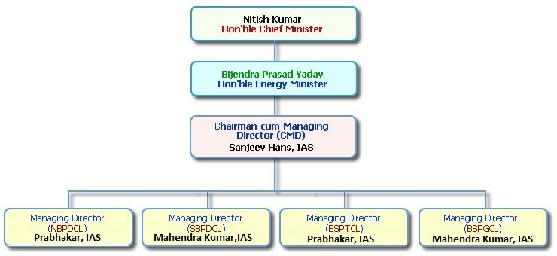

Duties, Mission and Objectives

The duties of the Company have been defined in Section 18 of the Electricity Supply Act, 1948. It has been charged with the responsibility of promoting a co-ordinated development of generation, supply and distribution of electricity in the State of Bihar on an efficient and economic basis of management.

Though BSPHCL deals in only one product, i.e., electrical power, its significance and utility value is enormous for the State. Almost all aspects of modern life-style are dependent on it in one way or another.

In order to ensure that its responsibilities are discharged effectively and efficiently, the Company has engaged nearly 1,700 officer and 14,850 staffs on various posts to generate its own power and to maintain proper distribution system. It arranges to supply the electricity properly to the consumers and maintain their equipments.

The responsibility of catering to entire state means BSPHCL must always be able to understand present as well as future trends of power consumption. It has to formulate and implement schemes for power generation so that growth in demand can be met successfully in time.

Sometimes, it also becomes necessary for BSPHCL to purchase power from outside agencies in order to meet the local demand.

As on today, the installed generating capacity of BSPHCL in terms of its Thermal and Hydro-Electrical plants, exceeds 559.2 MW.

The Company has its full-fledged Accounts and Audit Department for proper keep-up of its financial transaction as also to ensure efficient financial management on the commercial line.

The Company has also its personnel wing to safeguard the interest of all its employees. The bio-data and service records of the employee have been computerized at its Headquarters.

The entire organization of the Bihar State Power Holding Company Ltd. has been set up keeping in view the functions entrusted to it i.e., coordinated development of generation, transmission and distribution of electricity in the State.

[North Bihar Power Distribution Company Limited](https://en.wikipedia.org/wiki/North_Bihar_Power_Distribution_Company_Limited) (NBPDCL)

NBPDCL is a company registered under the provisions of Companies Act 1956 and is a fully owned subsidiary Company of BSPHCL.  
 The Company is engaged primarily in the business of distribution of Electricity.It has been vested with the distribution assets, interest in property, rights andliabilities of the erstwhile BSEB necessary for the business of distribution inits area of distribution comprising of all 21 districts of North Bihar (namely 1.West Champaran, 2. East Champaran, 3. Sitamadhi, 4. Sheohar, 5. Muzaffarpur, 6.Vaishali, 7. Saran, 8. Siwan, 9. Gopalgunj, 10. Mahubani, 11. Darbhanaga, 12. Samastipur,13. Begusarai, 14. Khagaria, 15. Saharsa, 16. Supaul, 17. Medhepura, 18. Araria,19. Katihar, 20. Purnea and 21. Kishangunj).  
  
The Company has been given the status of a Distribution licensee as per Section14 of the Electricity Act 2003. In order to fulfill the obligations of the Distributionlicensee as mandated under the provision of Bihar State Electricity Reforms TransferScheme 2012 and Electricity Act 2003, the main objects to be pursued by the company.  
  
[South Bihar Power Distribution Company Limited](https://en.wikipedia.org/wiki/South_Bihar_Power_Distribution_Company_Limited)(SBPDCL)  
  
As many of you may be aware that Government of Bihar has restructured the erstwhile Bihar State Electricity Board into five functionally independent state-owned companies viz. BSPHCL, SBPDCL, NBPDCL, BSPTCL & BSPGCL with effect from 1st November, 2012 under the provision of Bihar State Electricity Reforms Transfer Scheme 2012 and Electricity Act 2003.South Bihar Power Distribution Company Ltd. (SBPDCL) has been given the status of a Distribution Licensee as per Section 14 of the Electricity Act 2003 and engaged primarily in the business of distribution of Electricity andis serving more than 50 lacs consumers in 17 districts of South Bihar.  
 Presently, we are providing uninterrupted power supply in PESU, Area, Patna i.e. Capital of Bihar and also providing 23-24 Hrs assured power supply in the entire 17 district HQ of South Bihar. We are also giving you the assurance for replacementof defective transformer in the Urban areas in 24 hrs & in rural areas in 72 hrs.  
  
Bihar State Power Transmission Company Ltd (BSPTCL)

Functions of BSPTCL  
 To undertake transmission of electricity through intra-State transmission system;  
 To discharge all functions of planning and co-ordination relating to intra-state transmission system with - Central Transmission Utility; State Governments; generating companies; Regional Power Committees;  
 To ensure development of an efficient, co-ordinated and economical system of intra-State transmission lines for smooth flow of electricity from a generating station to the load centres;  
  
 Duties of BSPTCL  
To build, maintain and operate an efficient, co-ordinated and economical inter-State transmission system or intra-State transmission and to comply with the directions of the Regional Load Despatch Centre and the State Load Despatch Centre.  
  
Bihar State Power Generation Company Ltd (BSPGCL)

Bihar State Power Generation Company Limited is a state owned power generating utility incorporated in November 2012 after the unbundling of the erstwhile BSEB. BSPGCL has embarked on an ambitious plan to add substantial generating capacity.   
 BSPGCL is taking strong and steady steps for “Green Energy” development and efforts are on to establish solar PV grid projects in PPP mode. Apart from developing conventional sources of power, BSPGCL is also focusing on development of renewable energy. Presently it is taking up development of 250 MW solar projects at Kajra, Lakhisarai and Pirpainti, Bhagalpur in the State of Bihar.

**Abstract of the Project Online Training System:**

The purpose of Online Training System is to automate the existing manual system by the help –that their valuable data/information can be stored for a longer period with easy accessing and manipulation of the same. The required software and hardware are easily available and easy to work with.

Online Training System, as described above, can lead to error free, secure, reliable

and fast online training management system. It can assist the user to concentrate on their other activities and minimal flow rather to concentrate on the record keeping. Thus it will help organization in better utilization of resources. The organization can maintain computerized records of all the flow which are occurring from internship apply to certificate distribution without redundant entries. That means that one need not be distracted by information that is not relevant, while being able to reach the information.

The aim is to automate its existing manual system by the help of computerized equipments and full-fledged computer software, fulfilling their requirements, so that their valuable data/information can be stored for a longer period with easy accessing and manipulation of the same. Basically the project describes how to manage for good

performance and better services for the intern and providing .

**Objective of Project on Online Training System:**

The main objective of the Project on Online Training System is to manage the all flow of internship from starting to last stage. In this college , department and concerned authority i.e., Vidyut bhawan .The student have to apply for the internship and further process will be taken by the concerned authority either they will reject it aur they can allow that particular candidate for the internship work .The project is totally built at administrative end and thus only the administrator is guaranteed the access. The purpose of the project is to build an application program to reduce the manual work for managing the internship process, from applying to providing the certificate.

**Functionalities provided by Online Training System are as follows:**

* Provides the facility for the students to apply for the internship from any recognized university or from any department.
* Online Training System also manage the total flow.
* It tracks all the information of internship of the candidate, the trainer will also take time to time updates.
* Shows the information and description of the internship work.
* To reduce the load of the Vidyut Bhawan because manually managing the total flow becomes so much difficult.
* It deals with monitoring the work and also authority have the option to reject as well as accept the request.
* They can also directly contact to the concerned department for any doubts.

**Scope of the project Online Training System**

It may help collecting perfect management in details. In a very short time, the collection will be obvious, simple and sensible. It will help a person to know the management of passed year perfectly and vividly. It also helps in current all works relative to Online Training System. It will be also reduced the cost of collecting the management & collection procedure will go on smoothly

.

Our project aims at Business process automation, i.e. we have tried to computerize various processes of Online Training System.

* In computer system the person has to fill the various forms & number of copies of the forms can be easily generated at a time.
* In computer system, it is not necessary to create the manifest but we can directly communicate to save time.
* To assist the staff in capturing the effort spent on their respective working areas. To utilize resources in an efficient manner by increasing their productivity through automation.
* The system generates types of information that can be used for various purposes.
* It satisfy the candidates and organization requirements.
* Be easy to understand by the user and operator Be easy to operate
* Have a good user interface Be expandable.
* Providing the online certificate on time.

Reports of Online Training System:

* it generates reports on the internship work how the student is performing task
* the concerned organisation can apply for the internship on behalf of the candidate
* once it is applied to the concerned authority or in Vidyut Bhawan by the department or by the candidate , head of the trainer will decide whether it has to be accepted or rejected.
* if the project is selected by the candidate is according to the Vidyut Bhawan it will be carried on
* if the project which is to be carried by the student is not up to the expectation or according to the need his or her application will be rejected and send to the concerned college or department
* it also provides a report or you can say time to time report by the candidate that how much work is being done by the candidate
* once the is completed by the candidate the head of the trainer will issue the certificate to the name of the candidate

**Modules of Online Training System:**

* **Users**:- Will apply for the internship or simply they are the candidates who can visit the site.
* **College**:- The college will send the candidates form to the Vidyut Bhawan on behalf of the candidates who want to do internship work.
* **Head of trainer**: - He or She will approve reject forward the request to trainer , can see the certificate , can see the total projects and can generate the certificates .
* **Head of director:**- HOD will forward request to trainer , create certificate , send certificate and assign the trainer.
* **Trainer:**- Have the power to create students , forward project reports, forward synopsis.
* **Students:**- upload synopsis , upload project report, download certifcates.

**Input Data and Validation of Project on Online Training System**

* All the fields are validated and does not take invalid values
* Each form for can not accept blank value fields
* Avoiding errors in data Controlling amount of request
* Integration of all the modules/forms in the system. Preparation of the test cases.
* Preparation of the possible test data with all the validation checks. Actual testing done manually.
* Recording of all the reproduced errors.
* Modifications done for the errors found during testing. Prepared the test result scripts after rectification of the errors. Functionality of the entire module/forms.
* Validations for user input.
* Checking of the Coding standards to be maintained during coding. Testing the module with all the possible test data.
* Testing of the functionality involving all type of calculations etc,
* Commenting standard in the source files,

**The software quality plan we will use the following SQA Strategy:**

* In the first step we will select the test factors and ran/ them, The selected test factors such as reliability maintainability portability or etc will be placed in the matrix according to their ran/s,
* The second step is for identifying the phases of the development process, The phase should be recorded in the matrix,
* The third step is that identifying the business risks of the software deliverables, The risks will be ranked into three ran/s such as high,

medium and low,

**Features of the project Online Training System:**

* Product and Component based
* Creating & Changing Issues at ease
* Query Issue List to any depth
* Reporting & Charting in more comprehensive way
* Accounts to control the access and maintain security
* Simple Status & Resolutions
* Multi-level Priorities & Severities.
* Targets & Milestones for guiding the programmers
* Attachments & Additional Comments for more information.
* Robust database back-end
* Various level of reports available with a lot of filter criteria's
* Accuracy in work.
* Easy & fast retrieval of information.
* Well designed reports.
* Decrease the load of the person involve in existing manual system.
* Access of any information individually.
* Work becomes very speedy.
* Easy to update information



The Software Requirements Specification is produced at the culmination of the analysis task, The function and performance allocated to software as part of system engineering are refined by establishing a complete information description, a detailed functional and behavioral description, an indication of performance requirements and design constraints, appropriate validation criteria and other data pertinent to requirements,

The proposed system has the following requirements:

1. System needs store information about new request of internship,
2. System needs to help the trainer to deep information of projects.
3. System need to maintain quantity record,
4. System need to deep the record of all the request,
5. System need to update and delete the record,
6. System also needs a search area,
7. It also needs a security system to prevent data,

**Identification of need:**

The old manual system was suffering from a series of drawbacks. Since whole of the system was to be maintained with hands the process of keeping, maintaining and retrieving the information was very tedious and lengthy. The records were never used to be in a systematic order. there used to be lots of difficulties in associating any particular transaction with a particular context. If any information was to be found it was required to go through the different registers, documents there would never exist anything like report generation.

The reason behind it is that there is lot of information to be maintained and have to be kept in mind while running the business .For this reason we have provided features Present system is partially automated (computerized), actually existing system is quite laborious as one has to enter same information at three different places.

Following points should be well considered:

* Documents and reports that must be provided by the new system: there can also be few reports, which can help management in decision-making and certificate distribution, but since these reports do not get required attention, such kind of reports and information were also identified and given required attention.
* Details of the information needed for each document and report.
* The required frequency and distribution for each document.
* Probable sources of information for each document and report.
* With the implementation of computerized system, the task of keeping records in an organized manner will be solved. The greatest of all is the retrieval of information which will be at the click of the mouse, So the proposed system helps in saving the time in different operations and making information flow easy giving valuable reports

**Feasibility Study:**

After doing the project Online Training System, study and analyzing all the existing or required functionalities of the system, the next task is to do the feasibility study for the project. All projects are feasible - given unlimited resources and infinite time.

Feasibility study includes consideration of all the possible ways to provide a solution to the given problem. The proposed solution should satisfy all the user requirements and should be flexible enough so that future changes can be easily done based on the future upcoming requirements.

1. Economical Feasibility

This is a very important aspect to be considered while developing a project. We decided the technology based on minimum possible cost factor.

* All hardware and software cost has to be borne by the organization.
* Overall we have estimated that the benefits the organization is going to receive from the proposed system will surely overcome the initial costs and the later on running cost for system.

b) Technical Feasibility

This included the study of function, performance and constraints that may affect the ability to achieve an acceptable system. For this feasibility study, we studied complete functionality to be provided in the system, as described in the System Requirement Specification LSRS), and checked if everything was possible using different type of frontend and backend platform.

c) Operational Feasibility

No doubt the proposed system is fully GUI based that is very user friendly and all inputs to be taken all self-explanatory even to a layman. Besides, a proper training has been conducted to let know the essence of the system to the users so that they feel comfortable with new system. As far our study is concerned the clients are comfortable and happy as the system has cut down their loads and doing.

**System Design of Online Training System**

In this phase, a logical system is built which fulfils the given requirements. Design phase of software development deals with transforming the clients's requirements into a logically working system. Normally, design is performed in the following in the following two steps:

1.Primary Design Phase:

In this phase, the system is designed at block level. The blocks are created on the basis of analysis done in the problem identification phase. Different blocks are created for different functions emphasis is put on minimising the information flow between blocks. Thus, all activities which require more interaction are kept

in one block.

2.Secondary Design Phase:

In the secondary phase the detailed design of every block is performed.

The general tasks involved in the Design process are the following:

1. Design various blocks for overall system processes.
2. Design smaller, compact and workable modules in each block.
3. Design various database structures.
4. Specify details of programs to achieve desired functionality.
5. Design the form of inputs, and outputs of the system.
6. Perform documentation of the design.
7. System reviews.

**User Interface Design**

User Interface Design is concerned with the dialogue between a user and the computer. It is concerned with everything from starting the system or logging into the system to the eventually presentation of desired inputs and outputs. The overall flow of screens and messages is called a dialogue.

The following steps are various guiDelines for User Interface Design:

1. The system user should always be aware of what to do next.
2. The screen should be formatted so that various types of information, instructions and messages always appear in the same general display area.
3. Message, instructions or information should be displayed long enough to allow the system user to read them.
4. Use display attributes sparingly.
5. Default values for fields and answers to be entered by the user should be specified.
6. A user should not be allowed to proceed without correcting an error.
7. The system user should never get an operating system message or fatal error.

**Preliminary Product Description:**

The first step in the system development life cycle is the preliminary investigation to determine the feasibility of the system. The purpose of the preliminary investigation is to evaluate project requests. It is not a design study nor does it include the collection of details to describe the business system in all respect. Rather, it is the collecting of information that helps committee members to evaluate the merits of the project request and make an informed judgment about the feasibility of the proposed project.

Analysts working on the preliminary investigation should accomplish the following objectives:

* Clarify and understand the project request Determine the size of the project.
* Assess costs and benefits of alternative approaches.
* Determine the technical and operational feasibility of alternative approaches. Report the findings to management, with recommendations outlining the
* acceptance or rejection of the proposal.

**Benefit to Organization**

The organization will obviously be able to gain benefits such as savings in operating cost, reduction in paperwork, better utilization of human resources and more presentable image increasing goodwill.

* The Initial Cost

The initial cost of setting up the system will include the cost of hardware software LOS, add-on software, utilities) & labour (setup & maintenance). The same has to bear by the organization.

* Running Cost

Besides, the initial cost the long term cost will include the running cost for the system including the AMC, stationary charges, cost for human resources, cost for update/renewal of various related software.

* Need for Training

The users along with the administrator need to be trained at the time of implementation of the system for smooth running of the system. The client will provide the training site.

We talked to the management people who were managing a the financial issues of the center, the staff who were keeping the records in lots of registers and the reporting manager regarding their existing system, their requirements and their expectations from the new proposed system. Then, we did the system study of the entire system based on their requirements and the additional features they wanted to incorporate in this system.

Reliable, accurate and secure data was also considered to be a complex task without this proposed system. Because there was no such record for keeping track of all the activities, which was done by the Online Training System on the daily basis.

The new system proposed and then developed by me will ease the task of the organization in consideration. It will be helpful in generating the required reports by the staff, which will help them to track their progress and services.

Thus, it will ease the task of Management to a great extent as all the major activities to be performed, are computerized through this system.

**Project Category**

Relational Database Management System (RDBMS) : This is an RDBMS based project which is currently using MySQL for all the transaction statements. MySQL is an open source RDBMS System.

**Brief Introduction about RDBMS :**

A relational database management system (RDBMS) is a database management system LDBMS) that is based on the relational model as invented by E. F. Codd, of IBM's San Jose Research Laboratory. Many popular databases currently in use are based on the relational database model.

RDBMSs have become a predominant choice for the storage of information in new databases used for financial records, manufacturing and logistical information, personnel data, and much more since the 1980s. Relational databases have often replaced legacy hierarchical databases and network databases because they are easier to understand and use. However, relational databases have been challenged by object databases, which were introduced in an attempt to address the object-relational impedance mismatch in relational database, and XML databases.

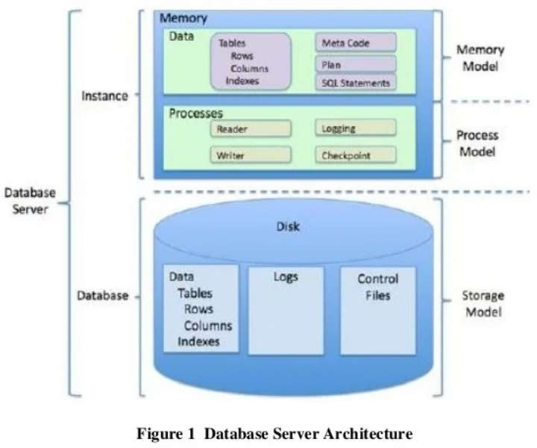

Implementation Methodology:

Model View Controller or MVC as it is popularly called, is a software design pattern for developing web applications. A Model View Controller pattern is made up of the following three parts:

* Model - The lowest level of the pattern which is responsible for maintaining data.
* View - This is responsible for displaying all or a portion of the data to the user.
* Controller - Software Code that controls the interactions between the Model and View.

MVC is popular as it isolates the application logic from the user interface layer and supports separation of concerns. Here the Controller receives all requests for the application and then works with the Model to prepare any data needed by the View. The View then uses the data prepared by the Controller to generate a final presentable response. The MVC abstraction can be graphically represented as follows.

MVC (Model View Controller Flow:) Diagram

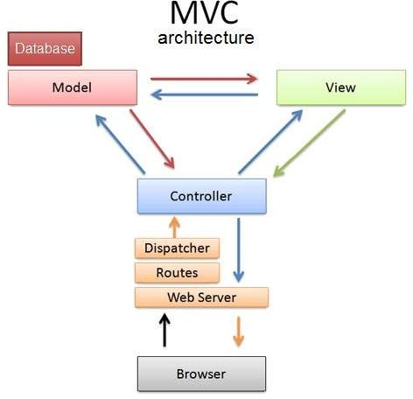

**Tools/Platform, Hardware and Software Requirement specification**

Software Requirement

|  |  |
| --- | --- |
| Name of Component | Specification |
| Operating System | Windows 7,Windows 10, Windows 11,Linux, |
| Language | Php,JS, |
| Others | HTML,CSS,JQueary, Ajax |
| Browsers | Mozila,Opera, Google Chrome |
| Database | Mysql |
| Web server | The Apache HTTP Server |

**Hardware Requirements**

:

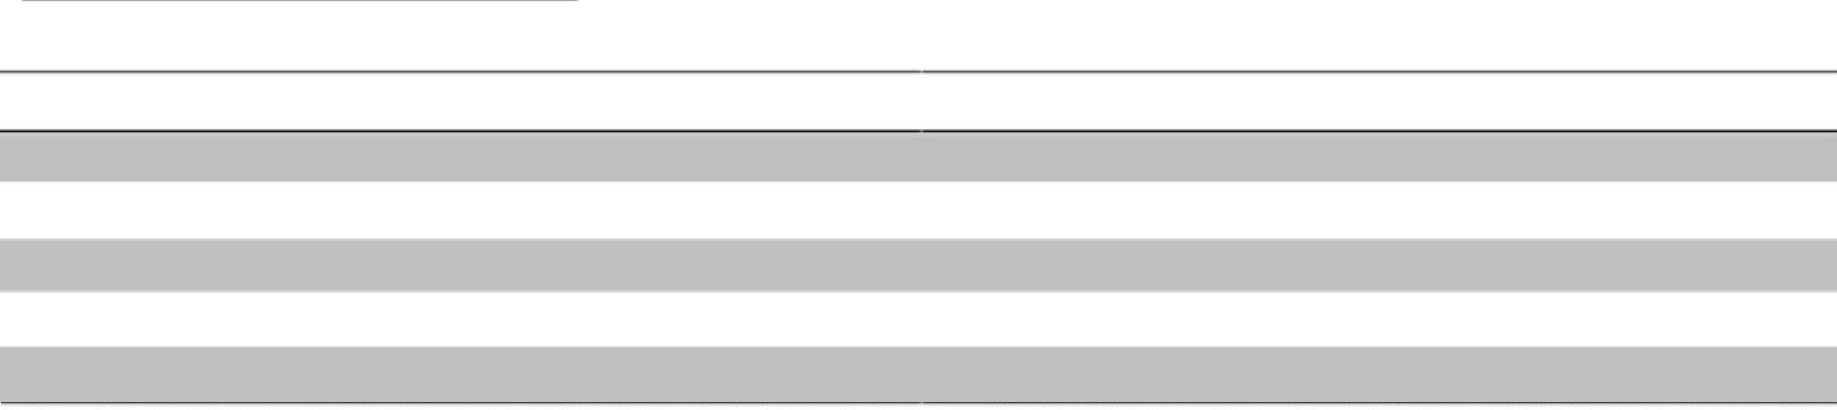

Name of coomponent Processor

RAM

Hard Disk Monitor Keyboad

Specification Pentium III 630MHz 128 MB

20 GB

15” color monitor

122 keys

**System Analysis:**

System analysis is a process of gathering and interpreting facts, diagnosing problems and the information about the Online Training System to recommend improvements on the system. It is a problem solving activity that requires intensive communication between the system users and system developers. System analysis or study is an important phase of any system development process. The system is studied to the minutest detail and analyzed. The system analyst plays the role of the interrogator and dwells deep into the working of the present system. The system is viewed as a whole and the input to the system are identified. The outputs from the organizations are traced to the various processes. System analysis is concerned with becoming aware of the problem, identifying the relevant and decisional variables, analyzing and synthesizing the various factors and determining an optimal or at least a satisfactory solution or program of action. A detailed study of the process must be made by various techniques like interviews, questionnaires etc. The data collected by these sources must be scrutinized to arrive to a conclusion. The conclusion is an understanding of how the system functions. This system is called the existing system. Now the existing system is subjected to close study and problem areas are identified. The designer now functions as a problem solver and tries to sort out the difficulties that the enterprise faces. The solutions are given as proposals. The proposal is then weighed with the existing system analytically and the best one is selected. The proposal is presented to the user for an endorsement by the user. The proposal is reviewed on user request and suitable changes are made. This is loop that ends as soon as the user is satisfied with proposal. Preliminary study is the process of gathering and interpreting facts, using the information for further studies on the system. Preliminary study is problem solving activity that requires intensive communication between the system users and system developers. It does various feasibility studies. In these studies a rough figure of the system activities can be obtained, from which the decision about the strategies to be followed for effective system study and analysis can be taken.

**Existing System of Online Training System:**

In the existing system the exams are done only manually but in proposed system we have to computerize the exams using this application.

* Lack of security of data. More man power.
* Time consuming.
* Consumes large volume of pare work. Needs manual calculations.
* No direct role for the higher officials

Proposed System of Online Training System:

The aim of proposed system is to develop a system of improved facilities. The proposed system can overcome all the limitations of the existing system. The system provides proper security and reduces the manual work.

* Security of data.
* Ensure data accuracy's.
* Proper control of the higher officials.
* Minimize manual data entry.
* Minimum time needed for the various processing.
* Greater efficiency.
* Better service.
* User friendliness and interactive.
* Minimum time required.

**Data Dictionary:**

This is normally represented as the data about data. It is also termed as metadata some times which gives the data about the data stored in the database. It defines each data term encountered during the analysis and design of a new system. Data elements can describe files or the processes.

Following are some major symbols used in the data dictionary

➢ = equivalent to

➢ + and

[] either/ or

() Optional entry

Following are some rules? which Defines the construction of Data Dictionary entries:

1. Words should be defined to understand for what they need and not the variable need by which they may be described in the program .
2. Each word must be unique. We cannot have two definition of the same client.
3. Aliases or synonyms are allowed when two or more enters shows the same meaning. For example a vendor number may also be called as customer number.
4. A self-defining word should not be decomposed. It means that the reduction of any information in to subpart should be done only if it is really required that is it is not easy to understand directly.

Data dictionary includes information such as the number of records in file, the frequency a process will run, security factor like pass word which user must enter to get excess to the information.

**Conclusion of the Project Online Training System:**

Our project is only a humble venture to satisfy the needs to manage their project work. Several user friendly coding have also adopted. This package shall prove to be a powerful package in satisfying all the requirements of the Organisation. The objective of software planning is to provide a frame work that enables the manger to make reasonable estimates made within a limited time frame at the beginning of the software project and should be updated regularly as the project progresses.

**Future Scope of the Project:**

In a nutshell, it can be summarized that the future scope of the project circles

around maintaining information regarding:

* We can add printer in future.
* We can give more advance software for Online Training System including more facilities
* We will host the platform on Cloud Based servers to make it accessible worldwide
* Integrate multiple load balancers to distribute the loads of the system
* Create the master and slave database structure to reduce the overload of the database queries
* Implement the backup mechanism for taking backup of codebase and database
* on regular basis on different servers

Limitation of Project on Online Training System

Although I have put my best efforts to make the software flexible, easy to operate but limitations cannot be ruled out even by me. Though the software presents a broad range of options to its users some intricate options could not be covered into it; partly because of logistic and partly due to lack of sophistication. punctuality of time was also major constraint, thus it was not possible to make the software foolproof and dynamic. Lack of time also compelled me to ignore some part such as storing old result of the candidate etc.

Considerable efforts have made the software easy to operate even for the people not related to the field of computers but it is acknowledged that a layman may find it a bit problematic at the first instance. The user is provided help at each step for his convenience in working with the software.

List of limitations which is available in the Online Training System:

* Excel export has not been developed for Electricity, Unit of Energy due to some criticality.
* The transactions are executed in off-line mode, hence on-line data for Bill, Store Record capture and modification is not possible.
* Off-line reports of Electricity, Electricity Board, Bill cannot be generated due to batch mode execution.

**References and Bibliography:**

* Google for problem solving
* https://[www.w3schools.com/MySQL/default.asp](http://www.w3schools.com/MySQL/default.asp)
* https://[www.learn-php.org/](http://www.learn-php.org/)
* https://[www.javatpoint.com/software-engineering-tutorial](http://www.javatpoint.com/software-engineering-tutorial)
* <http://www.jdbc-tutorial.com/>
* https://[www.tutorialspoint.com/php/](http://www.tutorialspoint.com/php/)
* <http://www.javatpoint.com/js-tutorial>
* https://docs.oracle.com
* https://httpd.apache.org/
* httpd.apache.org/docs/2.0/misc/tutorials.html