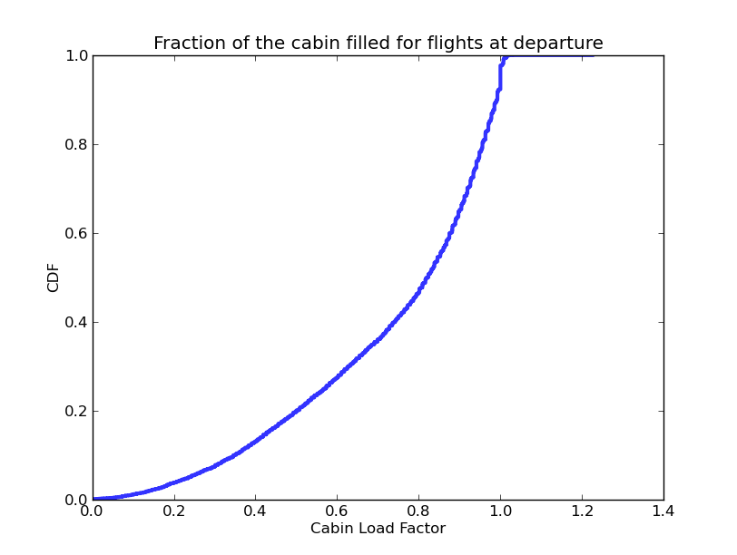

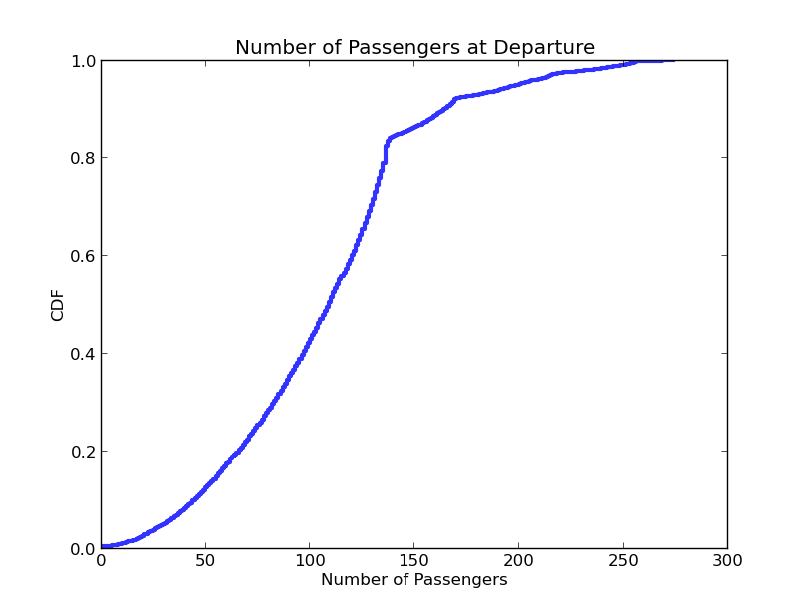

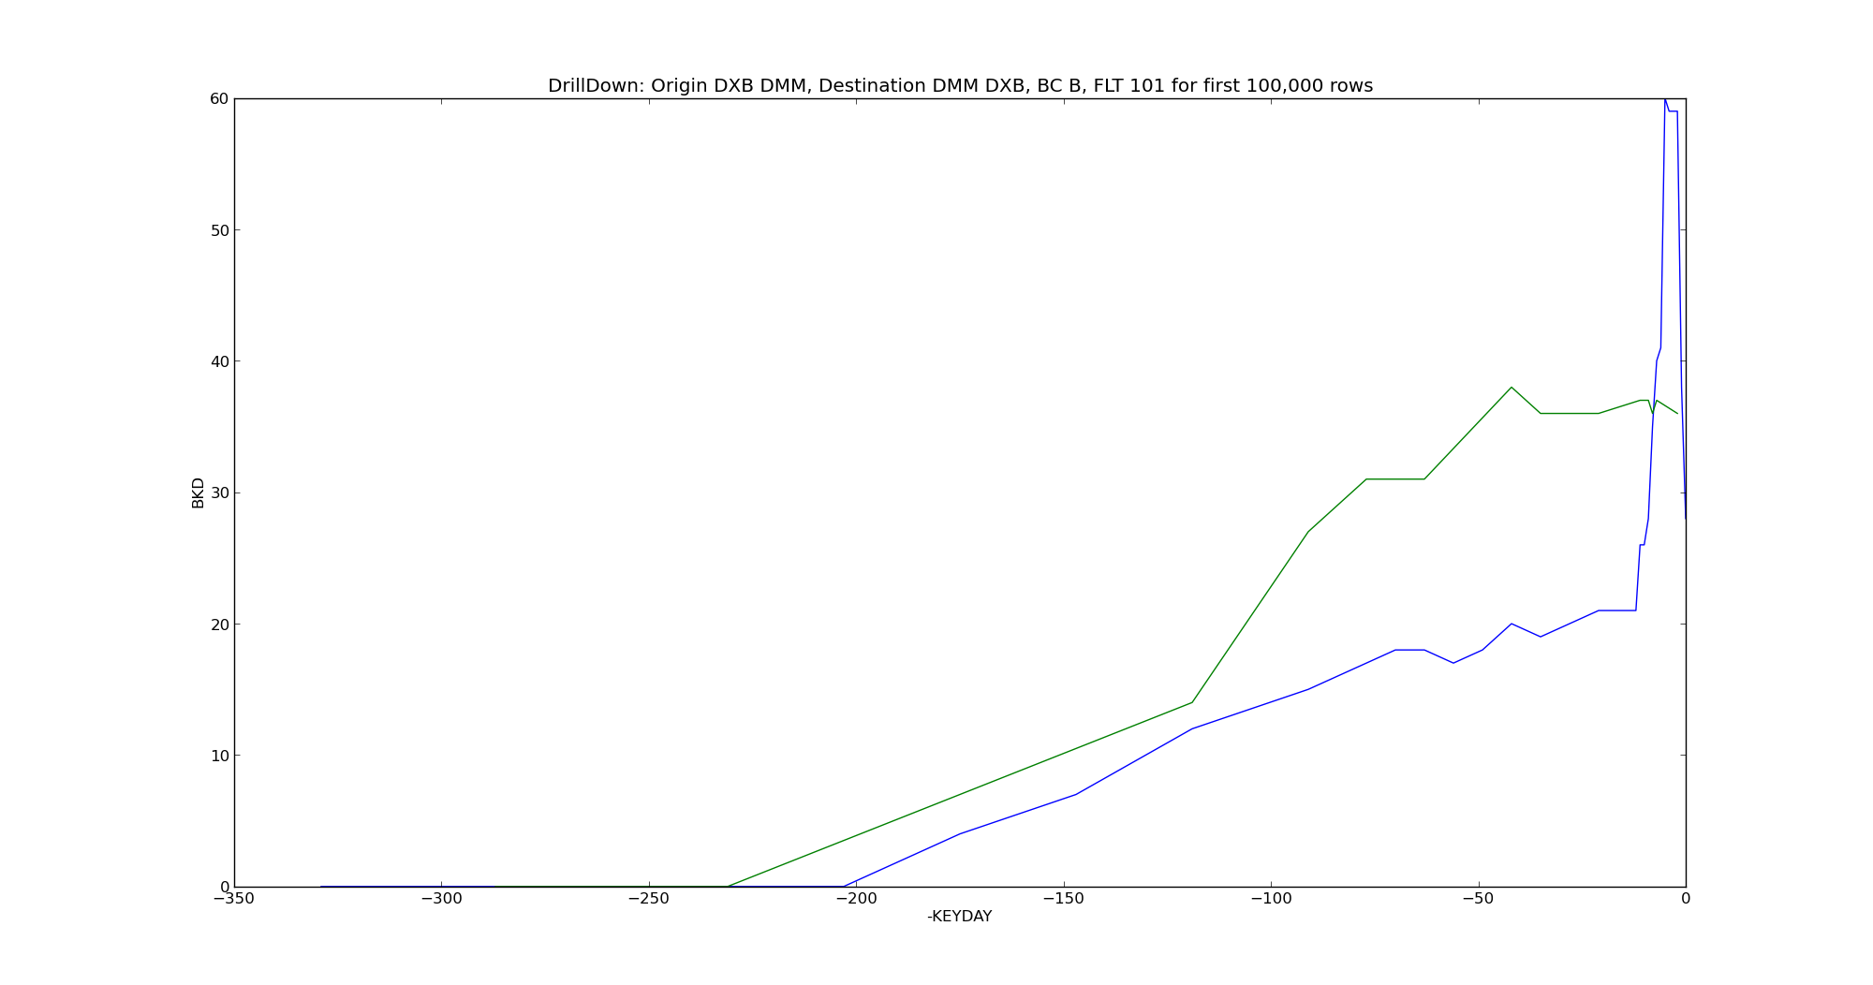

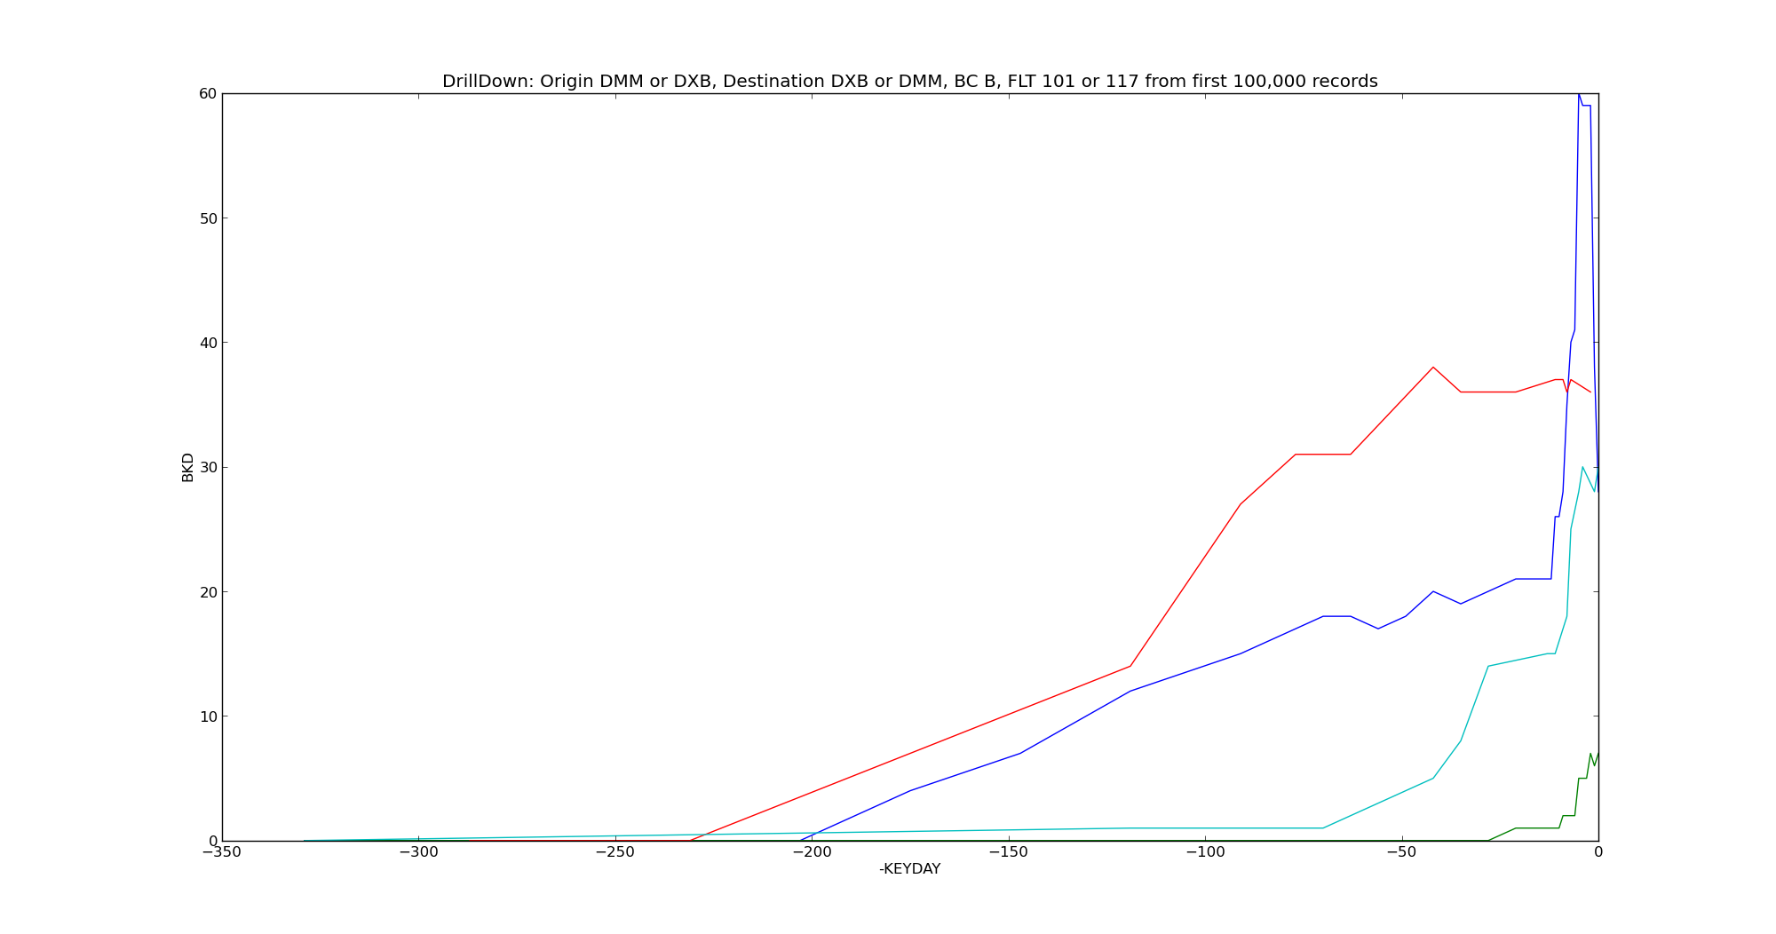

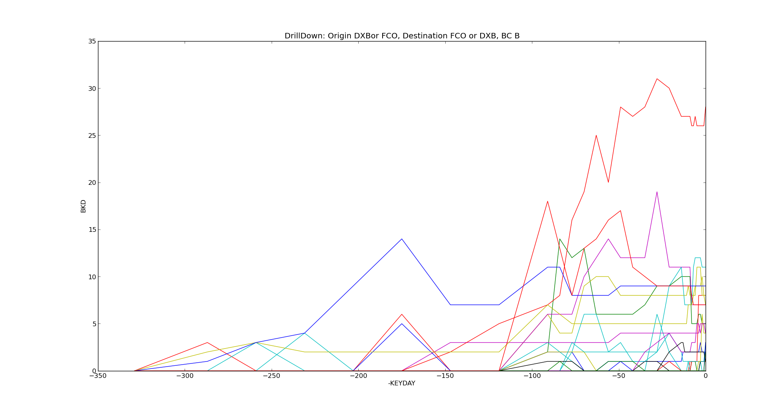

Total Number of Flights: 10884

Total Number of Passengers: 1168545
Averge Number of Passengers: 107.36
Median Number of Passengers: 109.0
Std of Number of Passengers: 48.03
25th Percentile: 75
75th Percentile: 133
Min Number of Passengers: 0.0
Max Number of Passengers: 274

Total Number of Directional Routes: 76

