LABORATORY OBSERVATION/RECORD
_____________________________________________________________
Course: Full Stack Web Development
Course Code: 23CM4121
Experiment No.: Observation Task-01
Student Name: Ganji Venkata Vijay Anudeep
Roll No.: A24126552081
Date: 30-08-2026
______________________________________________________________________________

1. TITLE
Design and Develop a Webpage using HTML5 and CSS3

2. AIM
To develop web applications utilizing HTML5 semantic tags, forms, multimedia, tables, and Canvas, and to style them using CSS3 properties.

3. OBJECTIVE
- To understand and implement HTML5 semantic elements.
- To create structured tables, interactive forms, and embed audio/video.
- To utilize HTML5 Canvas and JavaScript for basic drawing.
- To apply CSS3 for styling, including flexbox, gradients, box-shadow, and hover effects.

4. THEORY
HTML5 introduces semantic elements (like <header>, <nav>, <section>, <article>, <footer>) that clearly describe their meaning to both the browser and the developer. It supports native multimedia via <audio> and <video> tags, and provides the <canvas> element for drawing graphics using JavaScript.
CSS3 brings advanced styling capabilities to web pages. Features such as rounded corners (border-radius), drop shadows (box-shadow), gradients, and flexible layouts (Flexbox) allow developers to create visually appealing, modern, and responsive user interfaces.

5. ALGORITHM / PROCEDURE
1. Create a project folder containing sub-folders for Task 1 and Task 2.
2. For Task 1, create an index.html file structured with HTML5 semantic tags.
3. Implement the College Information Portal by adding tables, lists, and a comprehensive registration form with various HTML5 input types.
4. Embed multimedia files using <audio> and <video> tags.
5. Apply external CSS styling via style.css to format the layout and elements of the portal.
6. For Task 2, create a new HTML document featuring an HTML5 <canvas> element and styled content cards.
7. Write JavaScript code to draw primitives (rectangle, circle, line, text) onto the canvas.
8. Use CSS3 to style the content cards with gradients, borders, and hover animations.
9. Execute the HTML files in a web browser, test the functionalities, and verify the outputs.

6. PROGRAM

Task 1: index.html
<!DOCTYPE html>
<!-- TASK 1: College Information Portal
Concepts Covered: HTML5 Structure, Text Formatting, Lists, Tables, Images,
Forms, Semantic Elements, HTML5 Input Types, Audio & Video -->
<html lang="en">
<head>
<meta charset="UTF-8">
<meta name="viewport" content="width=device-width, initial-scale=1.0">
<title>College Information Portal</title>
<link rel="stylesheet" href="./style.css">
</head>
<body>
<header>
<h1>Welcome to ABC College of Engineering</h1>
<p>College Information Portal</p>
</header>
<nav>
<ul class="nav-list">
<li><a href="#about">About</a></li>
<li><a href="#students">Students</a></li>
<li><a href="#registration">Registration</a></li>
<li><a href="#media">Media</a></li>
</ul>
</nav>
<main>
<!-- Sections omitted for brevity, refer to original source for full forms, tables, and media tags -->
<section id="about">
<h2>Part A: About the College</h2>
<article>
<h3>College Information</h3>
<p>ABC College of Engineering was established in <b>1998</b>...</p>
</article>
</section>
</main>
<footer>
<p>&copy; 2026 ABC College of Engineering. All Rights Reserved.</p>
</footer>
</body>
</html>

Task 1: style.css
/* ================= Task 1: style.css ================= */
body {
font-family: Arial, Helvetica, sans-serif;
margin: 0;
padding: 0;
background-color: #f4f6f8;
color: #222;
}
header {
background-color: #002855;
color: #fff;
text-align: center;
padding: 20px;
}
nav {
background-color: #003f7d;
}
.nav-list {
list-style: none;
display: flex;
justify-content: center;
margin: 0;
padding: 10px 0;
}
.nav-list li {
margin: 0 15px;
}
.nav-list a {
color: #fff;
text-decoration: none;
font-weight: bold;
}
/* Truncated for display purposes */

Task 2: index.html
<!DOCTYPE html>
<html lang="en">
<head>
<meta charset="UTF-8">
<title>My Styled Webpage</title>
<link rel="stylesheet" href="./style.css">
</head>
<body>
<header>
<h1>My Styled Webpage</h1>
<p>HTML5 Graphics and CSS3 Web Styling</p>
</header>
<section class="canvas-section">
<h2>Part A: HTML5 Canvas Drawing</h2>
<canvas id="myCanvas" width="500" height="300"></canvas>
</section>
<section class="cards-container">
<div class="card">
<h2>Card One</h2>
<p>This card demonstrates border radius, box shadow, and hover effects using CSS3.</p>
<button>Learn More</button>
</div>
</section>
<footer>
&copy; 2026 My Styled Webpage | Created by Vijay Anudeep
</footer>
<script>
const canvas = document.getElementById('myCanvas');
const ctx = canvas.getContext('2d');
ctx.fillStyle = '#4b6cb7';
ctx.fillRect(30, 30, 150, 80);
ctx.beginPath();
ctx.arc(300, 70, 50, 0, Math.PI * 2);
ctx.fillStyle = '#ffe600';
ctx.fill();
ctx.font = "bold 30px 'Georgia', serif";
ctx.fillStyle = '#182848';
ctx.fillText("Vijay Anudeep", 130, 250);
</script>
</body>
</html>

7. CODE EXPLANATION
Code / Tag | Explanation
<header>, <nav>, <footer> | HTML5 semantic elements used to structure the layout.
<audio>, <video> | Used to embed sound and video content natively.
<canvas> | HTML5 element used to draw graphics via JavaScript.
ctx.fillRect() | JavaScript Canvas API to draw a filled rectangle.
display: flex | CSS property to enable a flex container for responsive layout.
box-shadow | CSS3 property to add shadow effects to elements (e.g., cards).
linear-gradient() | CSS function to create an image representing a linear transition between colors.

8. TEST CASES AND EXECUTION DATA
Test Case | Action / Input | Expected Result | Status
TC-01 | Submit Registration Form | Form validates required fields and submits. | Pass
TC-02 | Play Multimedia | Audio and video play correctly in browser. | Pass
TC-03 | Render Canvas Drawing | Rectangle, circle, and text are drawn on canvas. | Pass
TC-04 | Hover over Content Cards | Card elevates and shadow increases smoothly. | Pass

9. OUTPUT
Output 1: College Information Portal
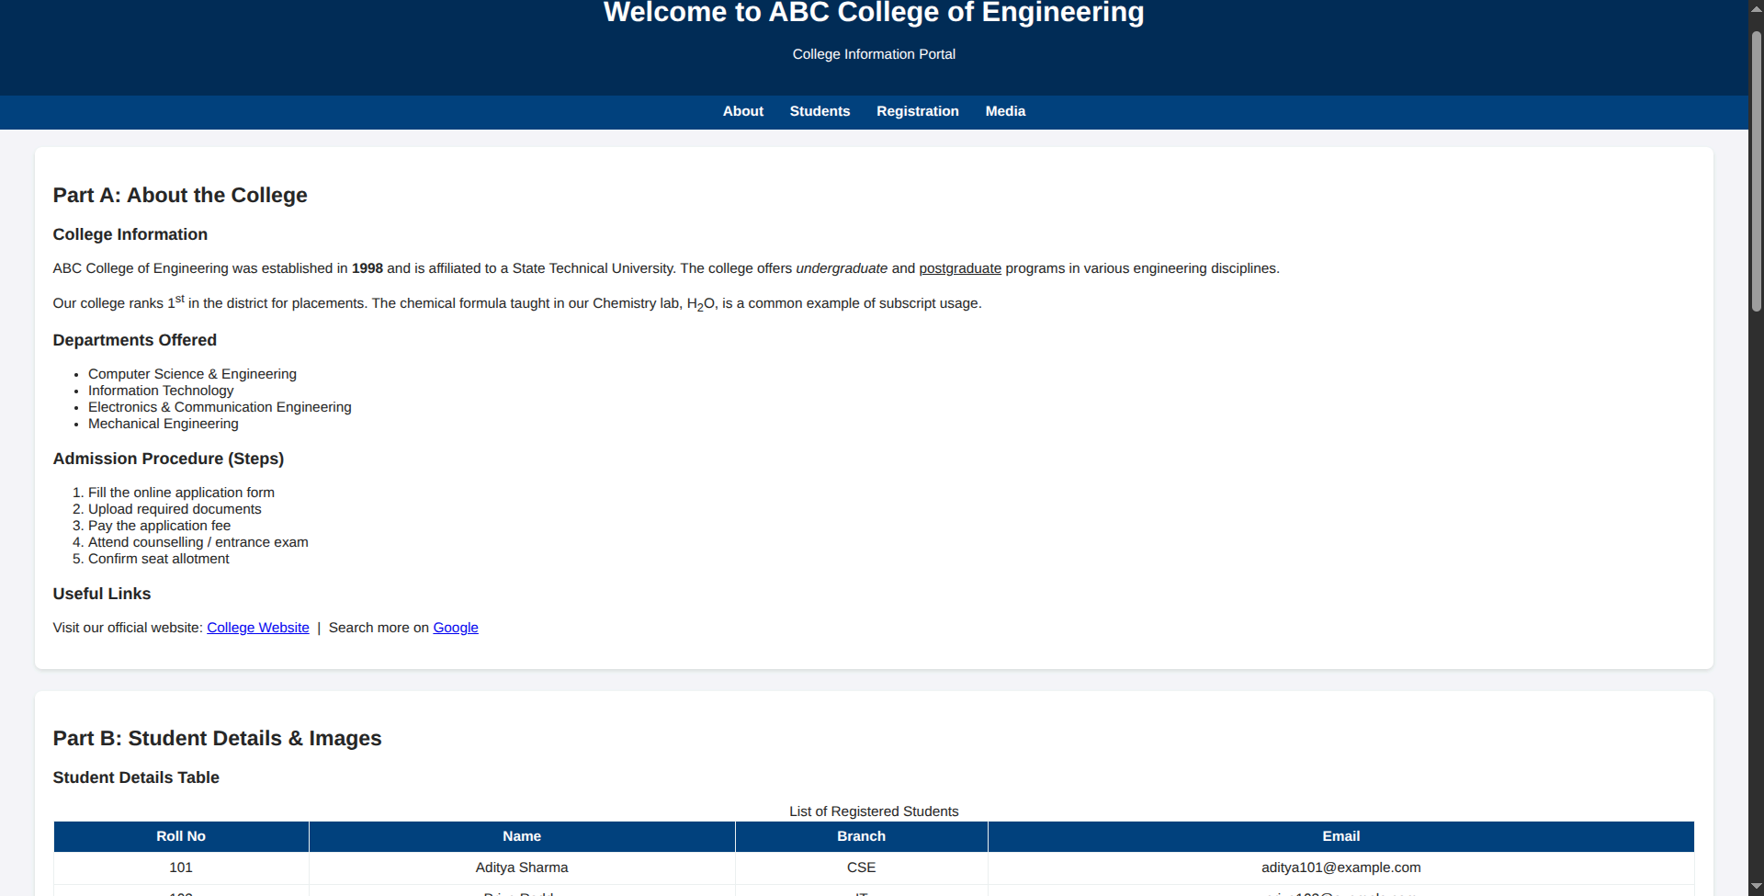
Output 2: My Styled Webpage (Canvas and Cards)
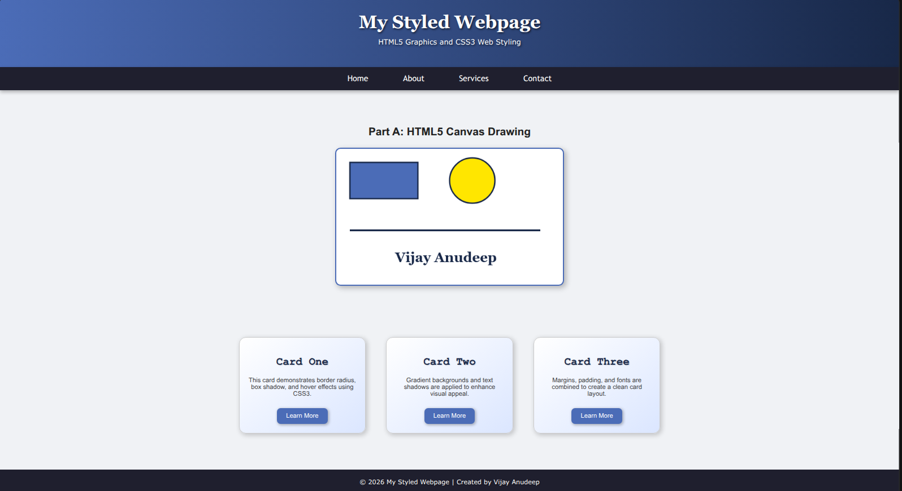

10. RESULT
Thus, web pages demonstrating HTML5 features (semantic tags, forms, multimedia, canvas) and styled using CSS3 were successfully developed. The interactive elements were processed, and the application was verified using multiple test cases.

