LABORATORY OBSERVATION/RECORD
Course: Full Stack Web Development
Course Code: 23CM4121
Experiment No.: Observation Task-02
Student Name: Ganji Venkata Vijay Anudeep
Roll No.: A24126552081
Date: 30-08-2026

- TITLE
Develop an Interactive To-Do List Application Using HTML, CSS, and JavaScript

- AIM
To develop a responsive interactive to-do list web application that allows users to add tasks, mark tasks as completed with a strike-through effect, delete tasks dynamically, and handle empty list states.

- OBJECTIVE
The objectives of this experiment are:

- To understand DOM manipulation using vanilla JavaScript.

- To handle user events like click and keydown (Enter key).

- To dynamically create, append, and remove HTML elements.

- To style dynamic web elements using CSS flexbox.

- To implement conditional UI states based on data length.

- THEORY
HTML provides the structural backbone of the to-do list, featuring an input field, an add button, an unordered list for tasks, and an empty state indicator paragraph.
CSS provides layout styling utilizing modern flexbox properties for alignment and classes to handle visual completion states (strike-through and gray color).
JavaScript handles the application logic by capturing input values, creating <li>, <span>, and <button> elements dynamically, attaching event listeners for toggling completion and removal, and managing the visibility message when the task list is empty.

- ALGORITHM / PROCEDURE

- Create the HTML structure with input fields, buttons, and an empty message paragraph.
- Link the external CSS stylesheet and JavaScript file.
- Style the layout using CSS for a centered container, clean typography, flexbox item alignment, and completed task styles.
- Select required DOM elements using document.getElementById.
- Define a function updateEmptyMessage() to toggle the display of the empty message depending on whether the task list has child elements.
- Define a function addTask() to read and trim the input value.
- Return early if the input is empty to prevent blank task creation.
- Create new li, span, completeBtn, and deleteBtn elements dynamically.
- Assign text content and event listeners for completion toggling and deletion to the respective buttons.
- Append the created child elements to the list item and attach the list item to the main task list.
- Clear the input box and invoke updateEmptyMessage().
- Attach an event listener to the add button for click events.
- Attach a keydown event listener to the input field to support task addition via the Enter key.
- Perform multiple test cases to verify application behavior.

6 PROGRAM

index.html

HTML
<!DOCTYPE html>
<html lang="en">
<head>
<link rel="stylesheet" href="./style.css">
<meta charset="UTF-8">
<meta name="viewport" content="width=device-width, initial-scale=1.0">
<title>Interactive To-Do List</title>
</head>
<body>
<h1>My To-Do List</h1>
<input type="text" id="taskInput" placeholder="Enter a task...">
<button id="addBtn">Add Task</button>
<ul id="taskList"></ul>
<p id="emptyMsg">No tasks available.</p>
</body>
<script src="./script.js"></script>
</html>
style.css

CSS
body {
font-family: Arial, sans-serif;
max-width: 420px;
margin: 40px auto;
}
h1 {
font-size: 22px;
}
#taskInput {
width: 65%;
padding: 6px;
}
#addBtn {
padding: 6px 12px;
}
ul {
list-style: none;
padding: 0;
}
li {
display: flex;
justify-content: space-between;
align-items: center;
padding: 8px;
margin-top: 6px;
border: 1px solid #ccc;
}
li span.done {
text-decoration: line-through;
color: gray;
}
li button {
margin-left: 6px;
}
script.js

JavaScript
const taskInput = document.getElementById('taskInput');
const addBtn = document.getElementById('addBtn');
const taskList = document.getElementById('taskList');
const emptyMsg = document.getElementById('emptyMsg');

function updateEmptyMessage() {
emptyMsg.style.display = taskList.children.length === 0 ? 'block' : 'none';
}

function addTask() {
const text = taskInput.value.trim();
if (text === '') return;

const li = document.createElement('li');
const span = document.createElement('span');
span.textContent = text;

const completeBtn = document.createElement('button');
completeBtn.textContent = 'Complete';

const deleteBtn = document.createElement('button');
deleteBtn.textContent = 'Delete';

completeBtn.addEventListener('click', () => {
span.classList.toggle('done');
});

deleteBtn.addEventListener('click', () => {
li.remove();
updateEmptyMessage();
});

li.appendChild(span);
li.appendChild(completeBtn);
li.appendChild(deleteBtn);
taskList.appendChild(li);

taskInput.value = '';
updateEmptyMessage();
}

addBtn.addEventListener('click', addTask);

taskInput.addEventListener('keydown', (e) => {
if (e.key === 'Enter') addTask();
});

updateEmptyMessage();

- CODE EXPLANATION

Code | Explanation
document.getElementById() | Selects specific elements from the DOM by their unique ID attributes.
document.createElement() | Dynamically generates new HTML elements in memory.
element.appendChild() | Inserts a child node into a parent element's DOM tree.
classList.toggle() | Adds or removes a CSS class name dynamically to toggle element styles.
element.remove() | Deletes the selected element directly from the DOM tree.
trim() | Removes whitespace from both ends of a string to prevent empty entries.
- TEST CASES AND EXECUTION DATA

Test Case | Input Action | Expected Result | Actual Result | Status
TC-01 | Click Add with empty input | Input ignored, no task added | No task added | Pass
TC-02 | Type "Buy Groceries" and click Add | Task appears in list with Complete & Delete buttons | Task appears correctly | Pass
TC-03 | Press Enter key with text "Read Book" | Task successfully added via keyboard shortcut | Task added successfully | Pass
TC-04 | Click "Complete" on added task | Task text gains strike-through formatting and gray color | Formatting applied correctly | Pass
TC-05 | Click "Delete" on a task | Task item is removed from list, empty message updates | Item removed successfully | Pass
- OUTPUT

Output 1: Initial Empty State
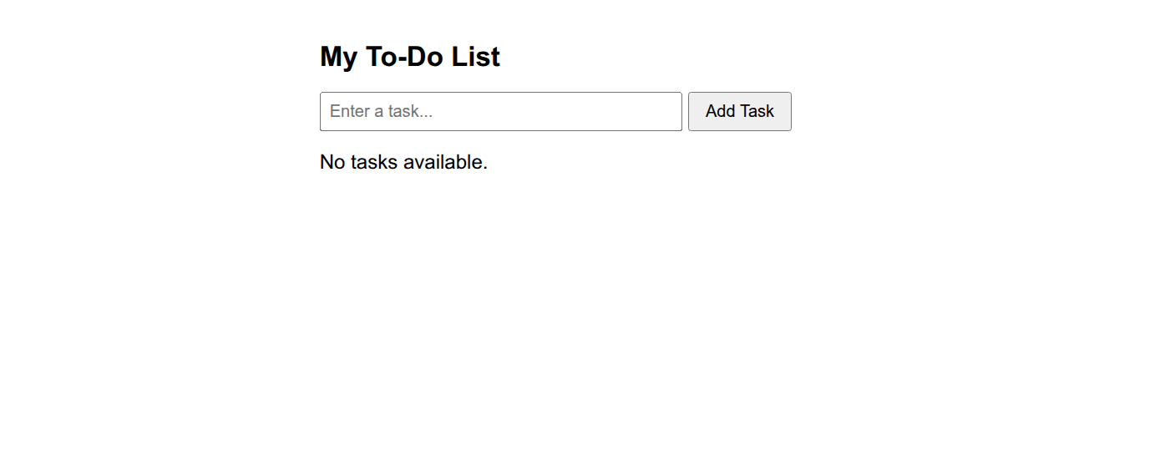

Output 2: Populated Task List with Actions
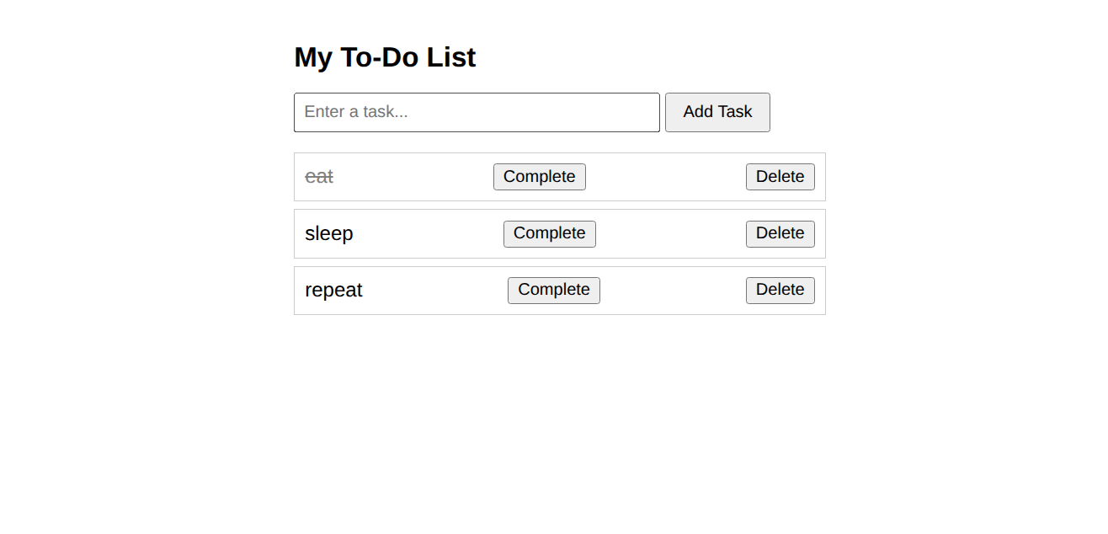

- RESULT
Thus, the interactive To-Do List application was successfully developed using HTML, CSS, and JavaScript. Dynamic DOM manipulation, event handling, and conditional empty state validation were successfully implemented and verified through test cases.

