

Empowerment Multi-Service Platform
By
 | [Student ID] | [Student Name]
 | [Student ID] | [Student Name]

Submitted in partial fulfilment of the requirements for accomplishing
[ELC479E] Computer Applications in Business

Business Information Systems Department
College of Management & Technology
Arab Academy for Science, Technology & Maritime Transport

[ 2025 – 2026 ]

This page intentionally left blank . . .

Table of Contents
Table of Contents i
List of Figures iii
List of Tables v
Acknowledgements vii
Chapter 1: Introduction 1
1.1 Background 1
1.2 Purpose 1
1.3 Report Outline 1
Chapter 2: Platform Backend Design 3
2.1 Database Design 3
2.2 Web Server Design 3
2.3 API Design 3

This page intentionally left blank . . .

List of Figures
Figure 1: Entity Relationship Diagram (ERD) of the platform database 4

This page intentionally left blank . . .

List of Tables
Table 1: Database entities 6

This page intentionally left blank . . .

Acknowledgements
We extend our deepest gratitude to the instructors and teaching assistants of [ELC479E] Computer Applications in Business for their unwavering support and insightful critiques throughout our learning journey. Their deep commitment to academic excellence and meticulous attention to detail have significantly shaped this report.
We are equally thankful to the chairman of the BIS Department, Dr. Nermeen Magdy, for her constructive feedback and essential suggestions that enhanced the quality of our work.
Our appreciation also goes to the faculty and staff in the Business Information Systems Department of the College of Management and Technology, Heliopolis, whose resources and assistance have been invaluable.

This page intentionally left blank . . .

Introduction
This report documents the design and implementation of the Empowerment Multi-Service Platform, a web-based marketplace that connects home-based women providers with customers who need homemade food, handmade products and household services. The objective of the project is to build a secure backend — a relational database, a Node.js web server and a RESTful API — that lets providers register, get verified and sell, and lets customers search, order, pay, review and chat with providers. Key concepts used throughout the report include the Entity Relationship Diagram (ERD), REST APIs, JSON Web Tokens (JWT) for authentication, and role-based access control.

Background
Many women have marketable skills such as cooking, handcrafts and household services, but cannot work outside the home because of family responsibilities, transport costs or social constraints. Selling through social media groups is common, yet it offers no identity verification for customers, no structured ordering or payment tracking, and no way to build a reputation through reviews. At the same time, customers increasingly look online for homemade food and trusted home services. These gaps motivated a dedicated platform that gives home-based women a safe, verified channel to earn an income from home.

Purpose
The purpose of the project is to design and implement the backend of a multi-service marketplace for home-based women providers. The specific objectives are:
- Design a normalised relational database of 16 tables covering users, providers, products, services, orders, payments, reviews and chat.
- Build a Node.js / Express web server connected to a MySQL database running on XAMPP.
- Expose a secure RESTful API with JWT authentication and role-based access for customers, providers and administrators.
- Keep customers safe through an admin verification workflow: providers upload documents and can sell only after approval.
- Support the full order flow: catalogue search, ordering food, crafts and bookable services, payment tracking, reviews and customer–provider chat.
- Test every endpoint with a Postman collection and an automated end-to-end test.

Report Outline
The remainder of this report is organised as follows. Chapter 2 presents the backend design of the platform: section 2.1 covers the database design, including the Entity Relationship Diagram (ERD), the attributes of each table and the relationships between them; section 2.2 explains the web server design using XAMPP and Node.js, including the folder structure, listening port, key code snippets and the object-oriented design of the models and controllers; and section 2.3 describes the API design, the list of endpoints and how they are tested with Postman.

This page intentionally left blank . . .

Platform Backend Design
Recently, online marketplaces have become among the most popular systems in our daily life, due to the spread of smartphones, the growth of e-commerce and online payment, and the need for flexible work opportunities. The Empowerment Multi-Service Platform applies this idea to home-based women providers, giving them a safe, verified channel to sell homemade food, handmade products and household services from home.
The main parts of the platform are as follows:
- Backend Database Server (MySQL / MariaDB, served by XAMPP)
- Backend Web Server (Node.js + Express.js)
- Backend APIs (RESTful JSON APIs secured with JWT)
- Frontend web application (consumes the APIs)
- Testing tools (Postman collection + automated Node.js test)
This chapter begins with the Database Design (section 2.1), illustrates the web server design using Node.js (section 2.2), and finally explains API design and testing (section 2.3).

Database Design
The database women_platform runs on MySQL (MariaDB) inside XAMPP and is managed through phpMyAdmin. It contains 16 tables, all using the InnoDB engine (needed for foreign keys and transactions) and the utf8mb4 character set, which supports Arabic text.

ER Diagram
Figure 1 shows the entities of the platform and the cardinality of each relationship. The detailed columns of each table are listed in the table attributes section that follows.
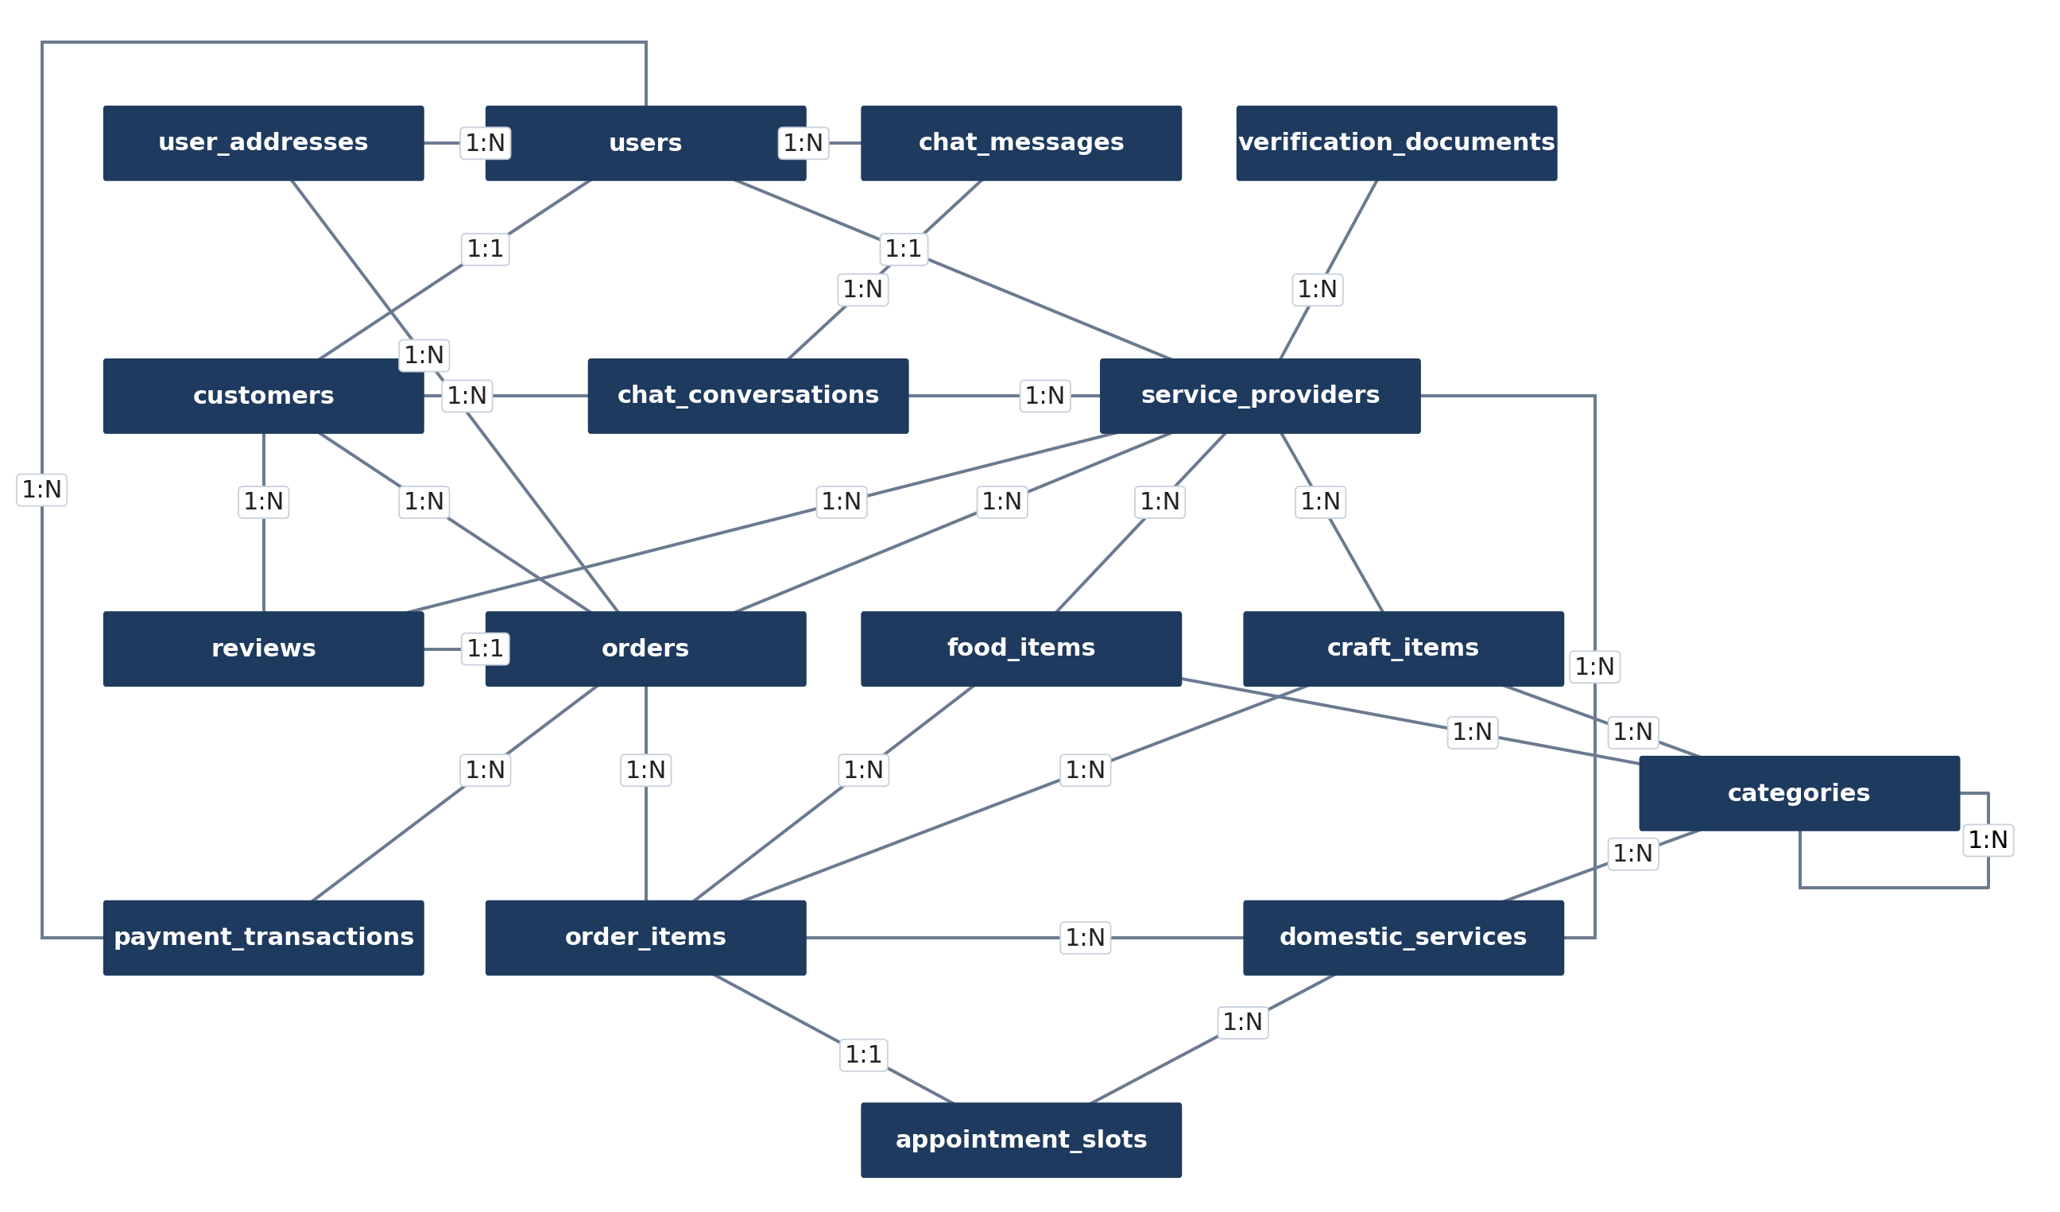
Figure 1: Entity Relationship Diagram (ERD) of the platform database

Table 1: Database entities
No. | Entity Name | Description
1 | users | Every account on the platform (customer, provider or admin): name, unique email, hashed password, phone and role.
2 | customers | Customer profile linked one-to-one to a user; holds loyalty points.
3 | service_providers | Provider (seller) profile linked one-to-one to a user: store name, national ID, average rating and verification status.
4 | verification_documents | Documents a provider uploads for admin verification (ID card, criminal record, birth certificate).
5 | user_addresses | Delivery addresses saved by a user (street, city, district, building, floor).
6 | categories | Product and service categories; a category can have a parent category.
7 | food_items | Homemade food listed by a provider: price, stock, availability, preparation time and nutrition facts.
8 | craft_items | Handmade products listed by a provider: price, stock, materials and whether they can be customised.
9 | domestic_services | Household services offered by a provider, priced by hourly rate and hours needed.
10 | appointment_slots | Bookable date and time slots for a domestic service.
11 | orders | An order placed by a customer with one provider: delivery address, status and amounts.
12 | order_items | The lines of an order: one food, craft or service item each, with quantity, price and booked slot.
13 | payment_transactions | Payments made for an order: amount, method (cash or card) and status.
14 | reviews | A customer’s rating (1–5) and comment for a completed order; one review per order.
15 | chat_conversations | A conversation between one customer and one provider.
16 | chat_messages | Messages sent inside a conversation, with read status.

Table Attributes
Tables 2 to 17 list the attributes of every table. PK = Primary Key, FK = Foreign Key, UQ = Unique.
Table 2: users attributes
Attribute | Type | Constraints
user_id | INT | PK, AUTO_INCREMENT
full_name | VARCHAR(100) | NOT NULL, not empty
email | VARCHAR(255) | NOT NULL, UQ, valid email format
password | VARCHAR(255) | NOT NULL (bcrypt hash)
phone_number | VARCHAR(30)
user_type | ENUM('customer', 'provider', 'admin') | NOT NULL
created_at | DATETIME | DEFAULT CURRENT_TIMESTAMP

Table 3: customers attributes
Attribute | Type | Constraints
customer_id | INT | PK
user_id | INT | FK → users, UQ
loyalty_points | INT | DEFAULT 0, ≥ 0

Table 4: service_providers attributes
Attribute | Type | Constraints
provider_id | INT | PK
user_id | INT | FK → users, UQ
store_name | VARCHAR(150) | NOT NULL
national_id | VARCHAR(30) | UQ
rating | DECIMAL(2,1) | DEFAULT 0 (average of reviews)
verification_status | ENUM('pending', 'accepted', 'rejected') | DEFAULT 'pending'

Table 5: verification_documents attributes
Attribute | Type | Constraints
document_id | INT | PK
provider_id | INT | FK → service_providers
document_type | ENUM('id_card', 'criminal_record', 'birth_certificate') | NOT NULL
file_url | VARCHAR(500) | NOT NULL
uploaded_at | DATETIME | DEFAULT CURRENT_TIMESTAMP

Table 6: user_addresses attributes
Attribute | Type | Constraints
address_id | INT | PK
user_id | INT | FK → users
street_address | VARCHAR(255) | NOT NULL
city | VARCHAR(100) | NOT NULL
district, building_number, floor | VARCHAR | optional

Table 7: categories attributes
Attribute | Type | Constraints
category_id | INT | PK
category_name | VARCHAR(100) | NOT NULL, UQ
description | TEXT
parent_category_id | INT | FK → categories (self-reference)

Table 8: food_items attributes
Attribute | Type | Constraints
food_item_id | INT | PK
provider_id | INT | FK → service_providers
category_id | INT | FK → categories
title | VARCHAR(150) | NOT NULL
description | TEXT
price | DECIMAL(10,2) | NOT NULL, ≥ 0
stock_quantity | INT | ≥ 0 (NULL = made to order)
is_available | BOOLEAN | DEFAULT TRUE
preparation_time_min | INT | > 0
nutrition_facts | TEXT
created_at | DATETIME | DEFAULT CURRENT_TIMESTAMP

Table 9: craft_items attributes
Attribute | Type | Constraints
craft_item_id | INT | PK
provider_id / category_id | INT | FK
title | VARCHAR(150) | NOT NULL
description | TEXT
price | DECIMAL(10,2) | NOT NULL, ≥ 0
stock_quantity | INT | ≥ 0
customizable | BOOLEAN | DEFAULT FALSE
material_used | VARCHAR(150)
created_at | DATETIME

Table 10: domestic_services attributes
Attribute | Type | Constraints
service_id | INT | PK
provider_id / category_id | INT | FK
title | VARCHAR(150) | NOT NULL
description | TEXT
hourly_rate | DECIMAL(10,2) | NOT NULL, ≥ 0
hours_needed | DECIMAL(4,1) | DEFAULT 1, > 0
created_at | DATETIME

Table 11: appointment_slots attributes
Attribute | Type | Constraints
slot_id | INT | PK
service_id | INT | FK → domestic_services
slot_date | DATE | NOT NULL
start_time / end_time | TIME | NOT NULL, end_time > start_time
is_booked | BOOLEAN | DEFAULT FALSE

Table 12: orders attributes
Attribute | Type | Constraints
order_id | INT | PK
customer_id | INT | FK → customers
provider_id | INT | FK → service_providers
delivery_address_id | INT | FK → user_addresses
special_instruction | TEXT
status | ENUM('pending', 'accepted', 'in_progress', 'completed', 'cancelled') | DEFAULT 'pending'
sub_total_amount, delivery_fee, total_amount | DECIMAL(10,2) | NOT NULL
order_date | DATETIME | DEFAULT CURRENT_TIMESTAMP

Table 13: order_items attributes
Attribute | Type | Constraints
order_item_id | INT | PK
order_id | INT | FK → orders
item_type | ENUM('food', 'craft', 'service') | NOT NULL
food_item_id / craft_item_id / service_id | INT | FK (one used, matching item_type)
slot_id | INT | FK → appointment_slots
unit_price | DECIMAL(10,2) | NOT NULL
quantity | INT | DEFAULT 1, ≥ 1
sub_total | DECIMAL(10,2) | NOT NULL

Table 14: payment_transactions attributes
Attribute | Type | Constraints
transaction_id | INT | PK
order_id | INT | FK → orders
user_id | INT | FK → users
amount | DECIMAL(10,2) | ≥ 0
payment_method | ENUM('cash', 'card') | NOT NULL
payment_status | ENUM('pending', 'success', 'failed') | DEFAULT 'pending'
created_at | DATETIME

Table 15: reviews attributes
Attribute | Type | Constraints
review_id | INT | PK
order_id | INT | FK → orders, UQ (one review per order)
customer_id / provider_id | INT | FK
rating | INT | 1 – 5
comment | TEXT
created_at | DATETIME

Table 16: chat_conversations attributes
Attribute | Type | Constraints
conversation_id | INT | PK
customer_id / provider_id | INT | FK, UQ together
created_at, last_message_at | DATETIME

Table 17: chat_messages attributes
Attribute | Type | Constraints
message_id | INT | PK
conversation_id | INT | FK → chat_conversations
sender_id | INT | FK → users
message_text | TEXT | NOT NULL
is_read | BOOLEAN | DEFAULT FALSE
sent_at | DATETIME

Relationships
Table 18 summarises the relationships between the entities shown in the ERD.
Table 18: Relationships between entities
Relationship | Type | Description
users – customers | 1 : 1 | A customer account extends one user (specialisation)
users – service_providers | 1 : 1 | A provider account extends one user
users – user_addresses | 1 : N | A user can save many addresses
service_providers – verification_documents | 1 : N | A provider uploads ID card, criminal record, etc.
service_providers – food_items / craft_items / domestic_services | 1 : N | A provider sells many products and services
categories – categories | 1 : N (recursive) | A category can have sub-categories
categories – items | 1 : N | Each item belongs to one category
domestic_services – appointment_slots | 1 : N | A service has many bookable time slots
customers – orders | 1 : N | A customer places many orders
service_providers – orders | 1 : N | Each order goes to one provider
orders – order_items | 1 : N | An order contains one or more lines
order_items – food/craft/service | N : 1 | Each line refers to exactly one item
appointment_slots – order_items | 1 : 1 | A booked slot is reserved by one order line
orders – payment_transactions | 1 : N | An order can have several payment attempts
orders – reviews | 1 : 1 | One review per completed order
customers – chat_conversations – service_providers | M : N | Resolved by chat_conversations (one per customer–provider pair)
chat_conversations – chat_messages | 1 : N | A conversation holds many messages

Referential actions: deleting a user cascades to their profile, addresses, items and orders (ON DELETE CASCADE); deleting a category or an item sets the reference to NULL (ON DELETE SET NULL), so order history and prices are kept.

Web Server Design
The backend is a Node.js + Express.js server listening on port 3000, connected to the XAMPP MySQL database on port 3306.

Technologies
Table 19: Technologies used in the backend
Component | Technology | Role
Local server package | XAMPP | Runs MySQL/MariaDB (port 3306) and Apache for phpMyAdmin
Runtime | Node.js | Runs the JavaScript backend
Web framework | Express.js 5 | Routing, middleware, JSON handling
DB driver | mysql2 | Connection pool + parameterised queries (prevents SQL injection)
Security | bcryptjs, jsonwebtoken | Password hashing and JWT login tokens

Setting up XAMPP
- Open the XAMPP Control Panel and start Apache and MySQL.
- Open http://localhost/phpmyadmin → Import → choose database/women_platform.sql → Import. This creates the women_platform database with its 16 tables and demo data.
- Copy .env.example to .env (shown below).
- Run npm install, then npm run dev (auto-reload) or npm start.
PORT=3000
DATABASE_URL=mysql://root:@localhost:3306/women_platform
JWT_SECRET=change-me-to-a-long-random-string
ADMIN_SECRET=dev-admin-secret

Folder Structure
The project follows a modular (feature-based) MVC structure: every feature has its own folder containing its routes (URLs), controller (request handling) and model (SQL).
women/
├── index.js # entry point: creates tables, starts the server
├── package.json
├── .env # configuration (port, DB URL, secrets)
├── postman_collection.json # API tests
├── database/
│ └── women_platform.sql # phpMyAdmin import file
├── src/
│ ├── app.js # Express app, mounts all routes
│ ├── db/
│ │ ├── connection.js # MySQL pool, query helpers, transactions
│ │ ├── schema.sql # 16 tables
│ │ └── seed.sql, seed.js # demo data
│ ├── middleware/
│ │ ├── auth.middleware.js # JWT, roles, verified provider
│ │ ├── error.middleware.js # errors -> JSON + status code
│ │ └── not-found.middleware.js # 404
│ ├── core/
│ │ ├── Model.js # parent class: CRUD SQL for any table
│ │ └── Controller.js # parent class: CRUD request handlers
│ └── modules/
│ ├── auth/ user/ address/ category/ provider/ document/
│ └── item/ slot/ order/ payment/ review/ chat/
│ (each: *.routes.js, *.controller.js, *.model.js)
└── test/
└── api.test.js # end-to-end test

Listening Port
The server listens on port 3000 (configurable through PORT in .env). MySQL listens on port 3306 and phpMyAdmin is served by Apache on port 80. The base URL of the API is http://localhost:3000/api. The entry point index.js checks the configuration, creates the tables and starts listening:
const app = require('./src/app');
const { init } = require('./src/db/connection');
const { PORT = 3000 } = process.env;
if (!process.env.JWT_SECRET || !process.env.DATABASE_URL) {
throw new Error('JWT_SECRET and DATABASE_URL must be set (copy .env.example to .env)');
}
init().then(() => {
app.listen(PORT, () => console.log(`API running on http://localhost:${PORT}`));
});

Code Snippets
Express application and route mounting (src/app.js):
const app = express();
app.use(express.json());
app.get('/api/health', (req, res) => res.json({ status: 'ok' }));
app.use('/api/auth', require('./modules/auth/auth.routes'));
app.use('/api/users', require('./modules/user/user.routes'));
app.use('/api/categories', require('./modules/category/category.routes'));
app.use('/api/providers', require('./modules/provider/provider.routes'));
app.use('/api/foods', itemRoutes(require('./modules/item/food.model'), 'Food item'));
app.use('/api/crafts', itemRoutes(require('./modules/item/craft.model'), 'Craft item'));
app.use('/api/services', itemRoutes(require('./modules/item/service.model'), 'Service'));
app.use('/api/orders', require('./modules/order/order.routes'));
// ... addresses, documents, slots, payments, reviews, conversations
app.use(notFound);
app.use(errorHandler);
Database connection to XAMPP MySQL (src/db/connection.js):
const pool = mysql.createPool({
uri: process.env.DATABASE_URL, // mysql://root:@localhost:3306/women_platform
decimalNumbers: true,
dateStrings: true,
});
// Runs fn(connection) inside a transaction; any error rolls everything back.
async function transaction(fn) {
const conn = await pool.getConnection();
try {
await conn.beginTransaction();
const result = await fn(conn);
await conn.commit();
return result;
} catch (err) {
await conn.rollback();
throw err;
} finally {
conn.release();
}
}
Authentication and authorisation middleware (src/middleware/auth.middleware.js):
function auth(req, res, next) {
const token = req.headers.authorization?.replace('Bearer ', '');
if (!token) return res.status(401).json({ message: 'Login required' });
try {
req.user = jwt.verify(token, process.env.JWT_SECRET);
next();
} catch {
res.status(401).json({ message: 'Invalid or expired token' });
}
}
const role = (...types) => (req, res, next) =>
types.includes(req.user.user_type) ? next()
: res.status(403).json({ message: `Only ${types.join(' or ')} accounts can do this` });
Example routes (src/modules/item/item.routes.js):
router.get('/', controller.list); // public search
router.get('/:id', controller.get);
router.post('/', auth, role('provider'), verifiedProvider, controller.create);
router.patch('/:id', auth, role('provider'), controller.loadOwn, controller.update);
router.delete('/:id', auth, role('provider'), controller.loadOwn, controller.remove);
Login controller (src/modules/auth/auth.controller.js):
class AuthController extends Controller {
async login(req, res) {
const { email, password } = req.body;
const user = await this.model.findByEmailWithPassword(email);
if (!user || !(await bcrypt.compare(String(password), user.password))) {
return res.status(401).json({ message: 'Wrong email or password' });
}
const profile = await this.model.findProfile(user.user_id);
res.json({ token: this.sign(profile), user: profile });
}
}
Central error handling (src/middleware/error.middleware.js) converts database errors into clear HTTP responses: a duplicate value returns 409, invalid data or a broken CHECK / foreign key returns 400, and anything else returns 500.

Object-Oriented Design
Models and controllers are written as classes. Two parent classes in src/core hold the code that every table needs: Model provides the five CRUD database operations and Controller provides the five CRUD request handlers. Each feature only adds what is special about it. Figure 2 shows the main classes.
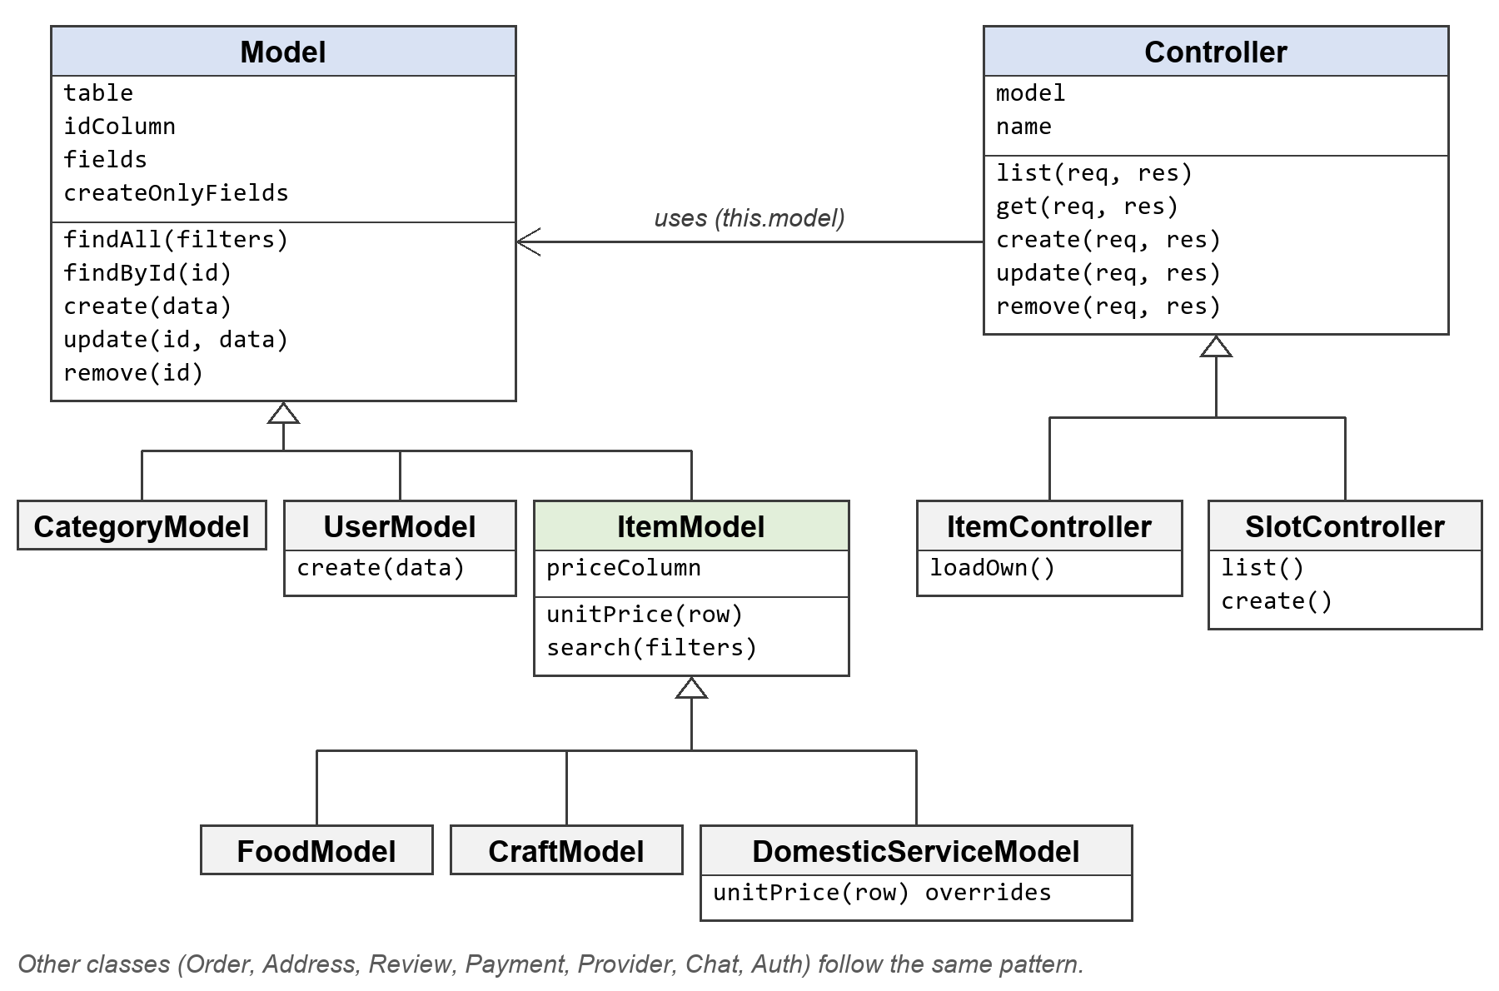
Figure 2: Class diagram of the models and controllers
A simple table needs only a few lines. Categories get the full CRUD (list, get, create, update and delete) from the two parent classes:
// category.model.js
class CategoryModel extends Model {
constructor() {
super('categories', 'category_id',
['category_name', 'description', 'parent_category_id']);
}
}
module.exports = new CategoryModel();
// category.controller.js
module.exports = new Controller(Category, 'Category');
The main object-oriented principles are applied as follows:
Class and object: every model and controller is a class, and each file exports one object of it, for example module.exports = new CategoryModel().
Inheritance: CategoryModel extends Model; FoodModel extends ItemModel, which extends Model (three levels); SlotController extends Controller.
Encapsulation: each model keeps its table name, columns and SQL inside the class. Only the listed fields can be written, so extra data in a request is ignored, and UserModel hides the password column from every query.
Polymorphism (overriding): DomesticServiceModel.unitPrice() returns hourly_rate × hours_needed, while food and craft items use their price. OrderModel calls unitPrice() without knowing which kind of item it has. UserModel.create() and MessageModel.create() override Model.create() and call super.create().
Abstraction: controllers call this.model.findById(id) and never write SQL themselves.

Request Flow
Every request passes through the same layers:
- The client (frontend or Postman) sends an HTTP request with a JSON body and the header Authorization: Bearer <token>.
- Express (app.js) passes it to the matching router (*.routes.js).
- Middleware checks the token, the role and, for selling, that the provider is verified.
- The controller (*.controller.js) validates the request and calls the model.
- The model (*.model.js) runs parameterised SQL on MySQL (XAMPP).
- The result returns to the client as JSON with an HTTP status code.

API Design
The API is RESTful, exchanges JSON and is protected with JWT tokens and role checks. A Postman collection of 63 requests tests the full business flow.

Design Principles
- RESTful: resources are nouns (/foods, /orders) and actions are HTTP methods (GET, POST, PATCH, DELETE).
- PATCH is used for updates: the client sends only the fields that change, for example just the price or the order status.
- JSON request and response bodies.
- JWT authentication: /auth/login and /auth/register return a token, sent afterwards in the header Authorization: Bearer <token> (valid for 7 days).
- Role-based access: customer, provider and admin; providers must be verified by an admin before selling.
- Standard status codes: 200 OK, 201 Created, 204 Deleted, 400 invalid data, 401 not logged in, 403 not allowed, 404 not found, 409 duplicate.

Endpoints
All endpoints share the base URL http://localhost:3000/api. Table 20 lists them by module.
Table 20: API endpoints
Module | Method | Endpoint | Access | Description
Health | GET | /health | Public | Server status
Auth | POST | /auth/register | Public | Register customer / provider / admin
Auth | POST | /auth/login | Public | Login, returns JWT
Auth | GET | /auth/me | Logged in | Current user profile
Users | GET | /users | Admin | List users (filters, e.g. pending providers)
Users | PATCH | /users/me | Logged in | Update my profile
Users | DELETE | /users/me | Logged in | Delete my account
Addresses | GET / POST | /addresses | Logged in | My addresses / add address
Addresses | GET / PATCH / DELETE | /addresses/:id | Owner | Read / update / delete
Categories | GET | /categories, /categories/:id | Public | List / get
Categories | POST / PATCH / DELETE | /categories(/:id) | Admin | Manage categories
Providers | GET | /providers, /providers/:id | Public | List / profile
Providers | PATCH | /providers/me | Provider | Update my store
Providers | PATCH | /providers/:id/verification | Admin | Accept / reject provider
Documents | GET | /documents | Provider, Admin | Verification documents
Documents | POST / DELETE | /documents(/:id) | Provider | Upload / delete document
Food / Crafts / Services | GET | /foods, /crafts, /services | Public | Search (q, max_price, provider_id, sort)
Food / Crafts / Services | GET | /foods/:id … | Public | Item details
Food / Crafts / Services | POST | /foods … | Verified provider | Add item
Food / Crafts / Services | PATCH / DELETE | /foods/:id … | Owner provider | Update / delete item
Slots | GET | /slots | Public | Slots of a service (service_id, is_booked)
Slots | POST / PATCH / DELETE | /slots(/:id) | Owner provider | Manage slots
Orders | POST | /orders | Customer | Place order (food, crafts, services + slot)
Orders | GET | /orders, /orders/:id | Logged in | My orders / order with items
Orders | PATCH | /orders/:id/status | Customer, Provider | accept → in_progress → completed / cancel
Payments | GET | /payments | Logged in | Payments (order_id)
Payments | POST | /payments | Customer | Pay (cash / card)
Payments | PATCH | /payments/:id/status | Provider | Confirm payment
Reviews | GET | /reviews | Public | Reviews (provider_id)
Reviews | POST | /reviews | Customer | Review a completed order
Reviews | PATCH / DELETE | /reviews/:id | Owner customer | Update / delete review
Chat | GET | /conversations | Customer, Provider | My conversations
Chat | POST | /conversations | Customer | Start conversation with provider
Chat | GET / POST | /conversations/:id/messages | Participants | Read / send messages

Example Requests
POST /api/auth/register — registers a provider and returns 201 Created with a JWT token and the new user:
{
"full_name": "Mona Ali",
"email": "mona@example.com",
"password": "secret123",
"phone_number": "01000000000",
"user_type": "provider",
"store_name": "Mona's Kitchen"
}
POST /api/orders (customer token) — returns 201 Created with the calculated sub_total_amount, total_amount and status "pending". Booking the same slot again returns 400.
{
"delivery_address_id": 1,
"special_instruction": "Please ring twice",
"items": [
{ "item_type": "food", "item_id": 1, "quantity": 2 },
{ "item_type": "service", "item_id": 1, "slot_id": 1 }
]
}

Postman Testing
The file postman_collection.json contains 63 requests in 11 folders. Each request has a test script that checks the status code and saves tokens and IDs (customerToken, foodId, orderId, …) into collection variables, so the whole collection runs end-to-end with the Collection Runner. To run it: Postman → Import → postman_collection.json → Run collection (folders in order), with baseUrl set to http://localhost:3000/api and adminSecret equal to ADMIN_SECRET in .env. Table 21 lists the test cases and the status code each one checks.
Table 21: Postman test cases and expected results
# | Folder | Test case | Expected
1 | Auth | Register admin / provider / customer | 201
2 | Auth | Login | 200 + token
3 | Auth | Login with wrong password | 401
4 | Auth | Get my profile / update profile | 200
5 | Categories | List categories | 200
6 | Categories | Create / update category (admin) | 201 / 200
7 | Categories | Create category as customer | 403
8 | Verification | Provider sells before verification | 403
9 | Verification | Upload document, list documents | 201 / 200
10 | Verification | Admin lists pending providers and accepts | 200
11 | Items | Create food, craft item, domestic service | 201
12 | Items | Create food with negative price | 400
13 | Items | Search foods (q=chocolate&max_price=200&sort=price) | 200
14 | Items | Update item as owner / as customer | 200 / 403
15 | Slots | Create slot, list free slots, update slot | 201 / 200
16 | Addresses | Add, list, update address | 201 / 200
17 | Orders | Place order (food + service) | 201
18 | Orders | Book the same slot again | 400
19 | Orders | Customer tries to accept order | 400
20 | Orders | Provider accepts → in_progress → completed | 200
21 | Payments | Pay cash, provider confirms, list payments | 201 / 200
22 | Reviews | Add review | 201
23 | Reviews | Second review for the same order | 409
24 | Reviews | Update review, list provider reviews | 200
25 | Chat | Start conversation, send, read, reply | 201 / 200
26 | Cleanup | Delete review, address, item, document, category, accounts | 204

In addition to Postman, npm test runs test/api.test.js, an end-to-end test with Node’s built-in test runner. It creates a temporary database women_platform_test, runs the full flow and drops it at the end, so real data is never touched.

