**Question 1**

**Top 5 Customer and Product and Sales Trend.**

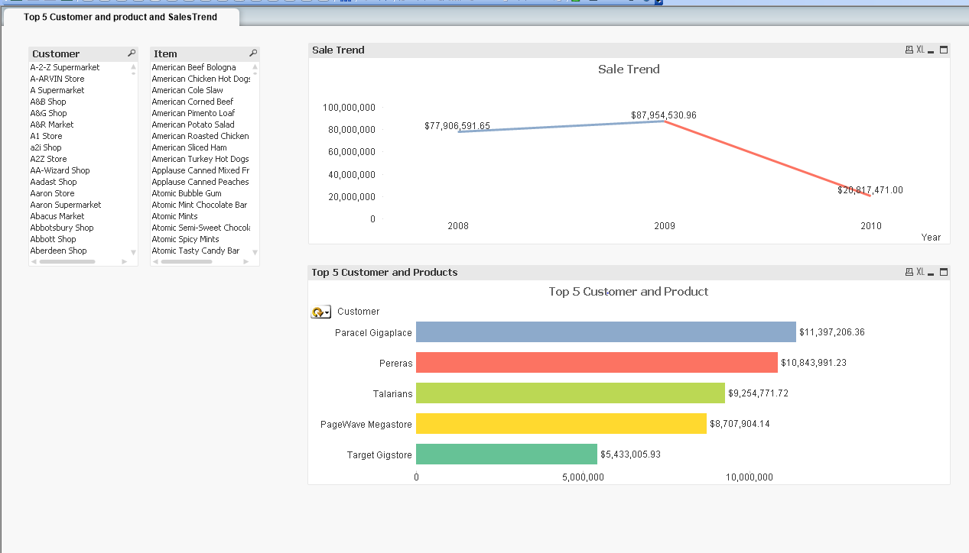

**Question 2**

**Bar Chart,Pie Chart and properties**

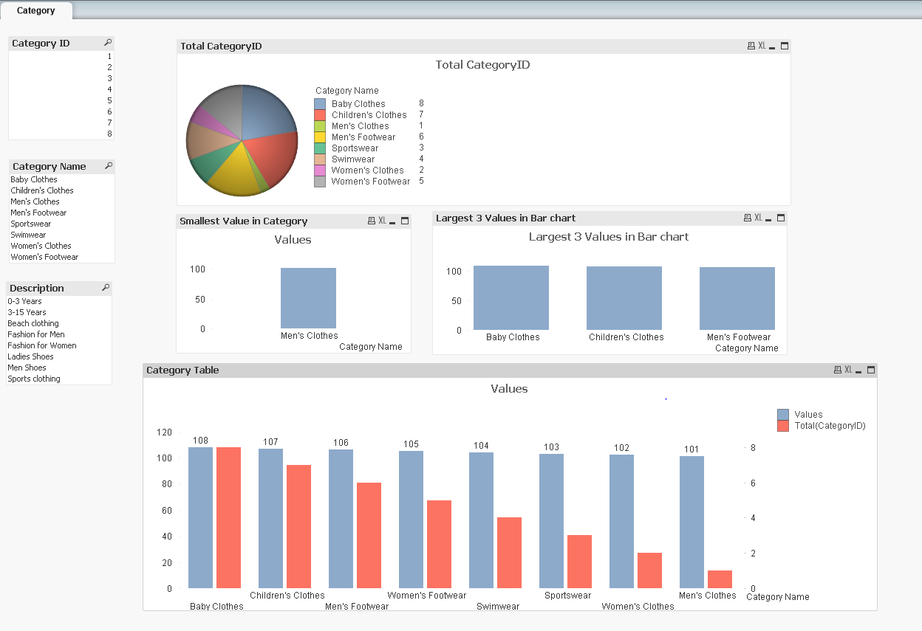

**Question 3**

**Qlik Sense**

**1)**

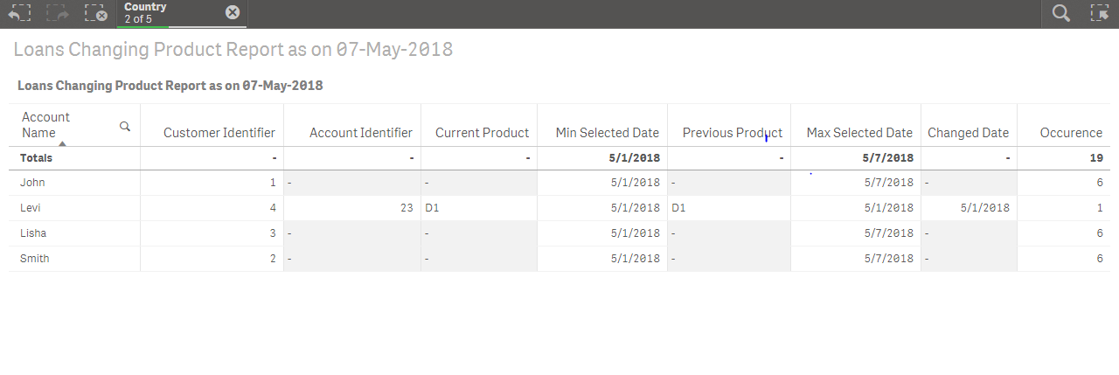

**2)**

