**Content**

Login Page

Product List Page

Product Detail Page

Cart Page

Bill Page

Purchase History Page

Logout Page

Login Page

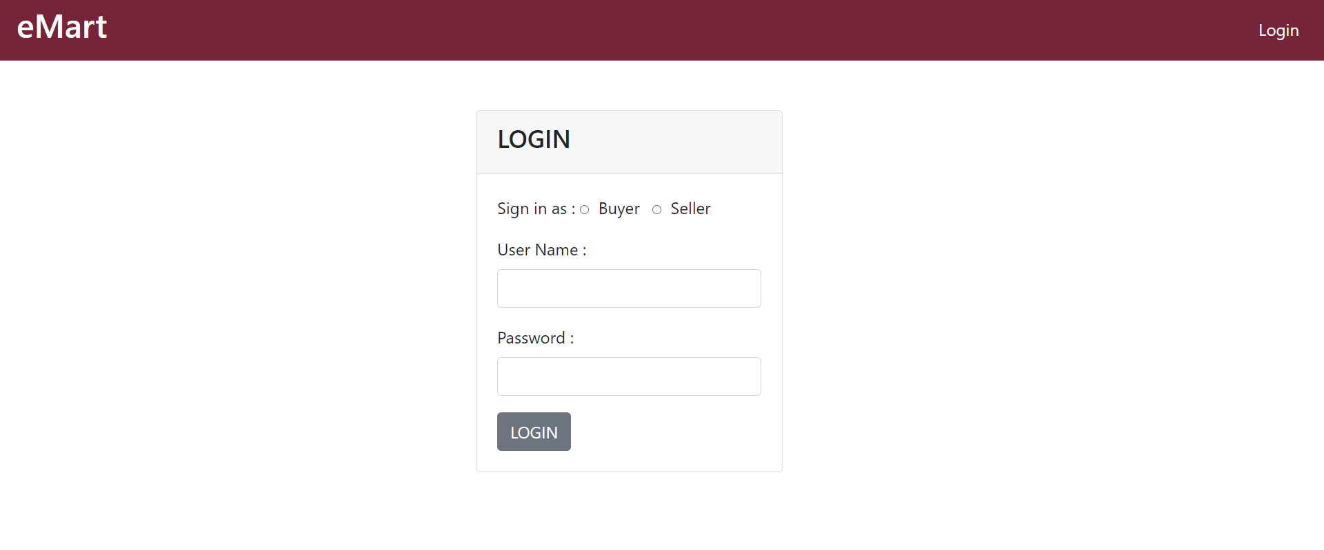

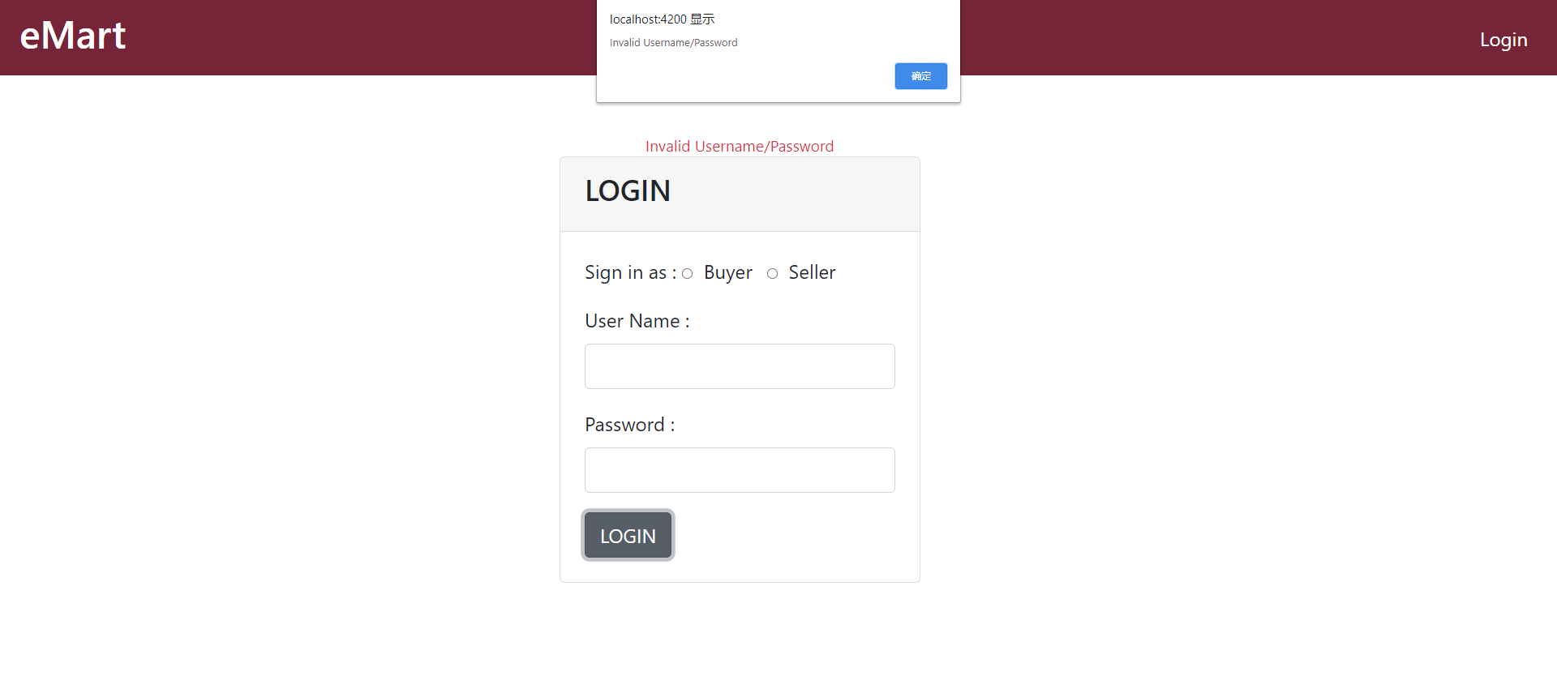

Product List Page

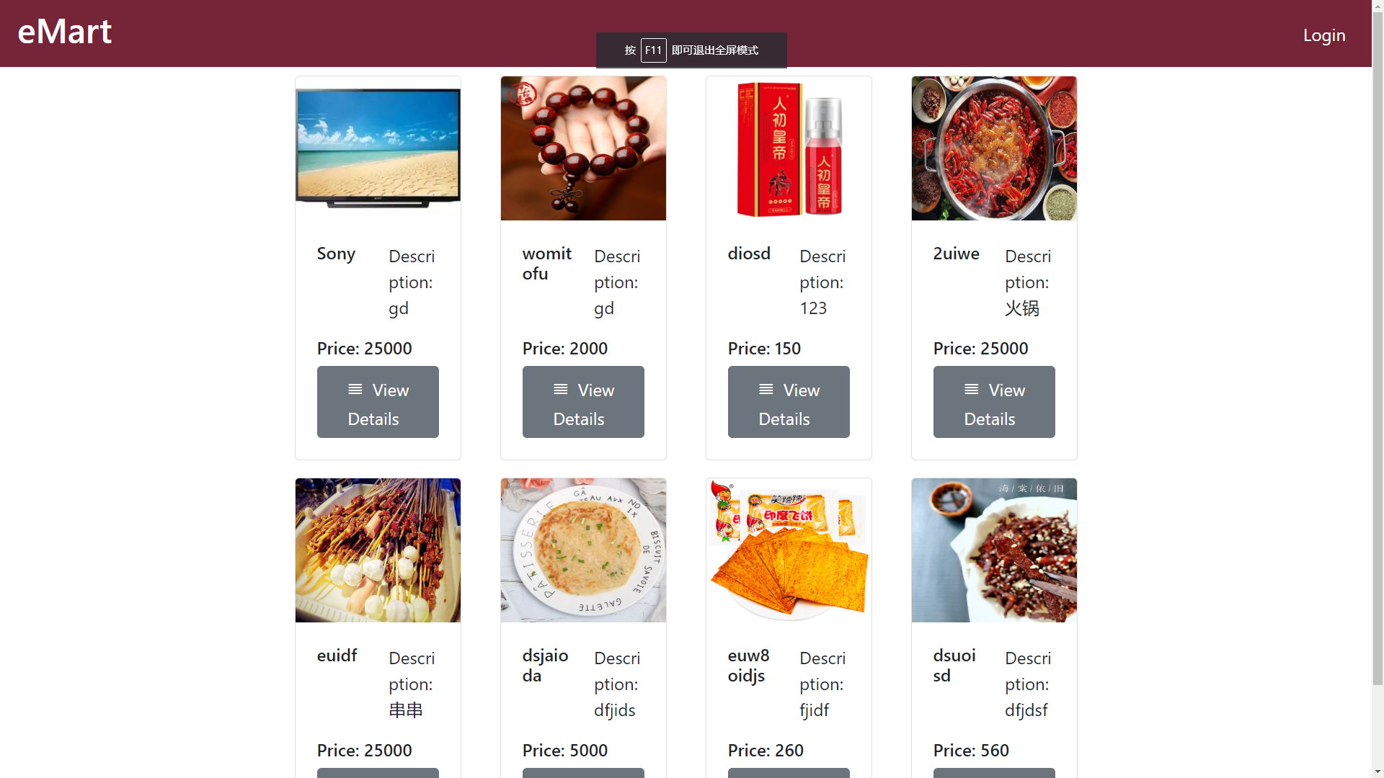

Product Detail Page

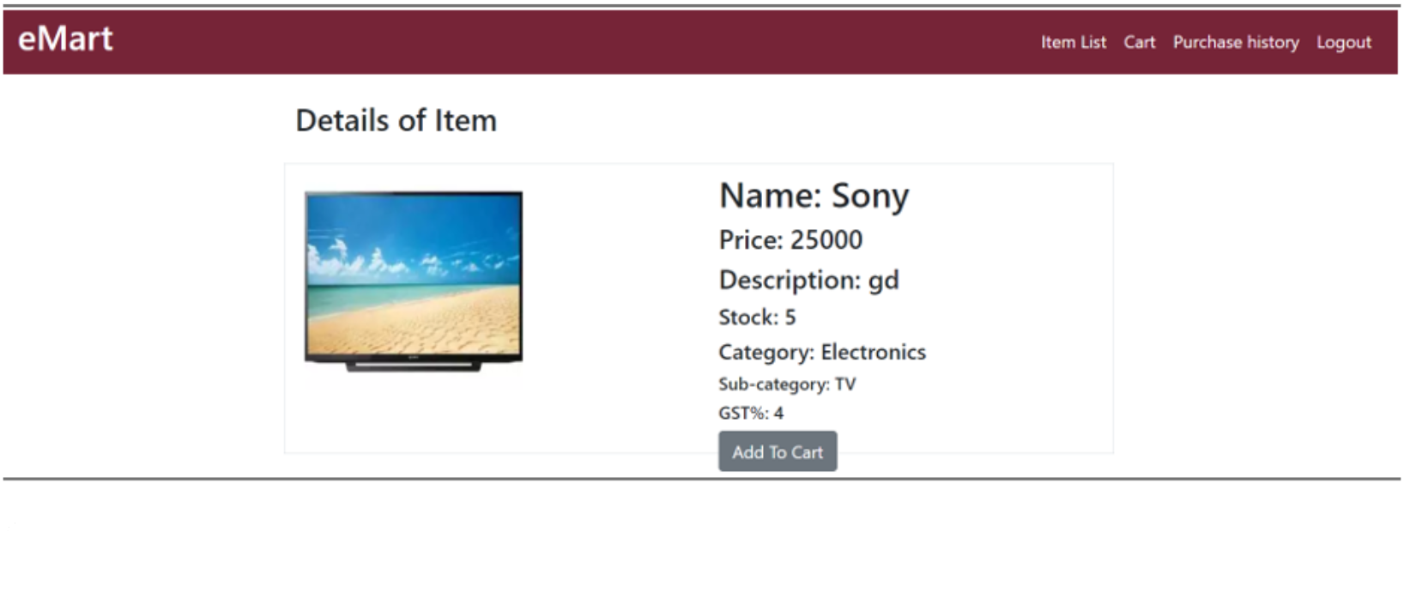

Cart Page

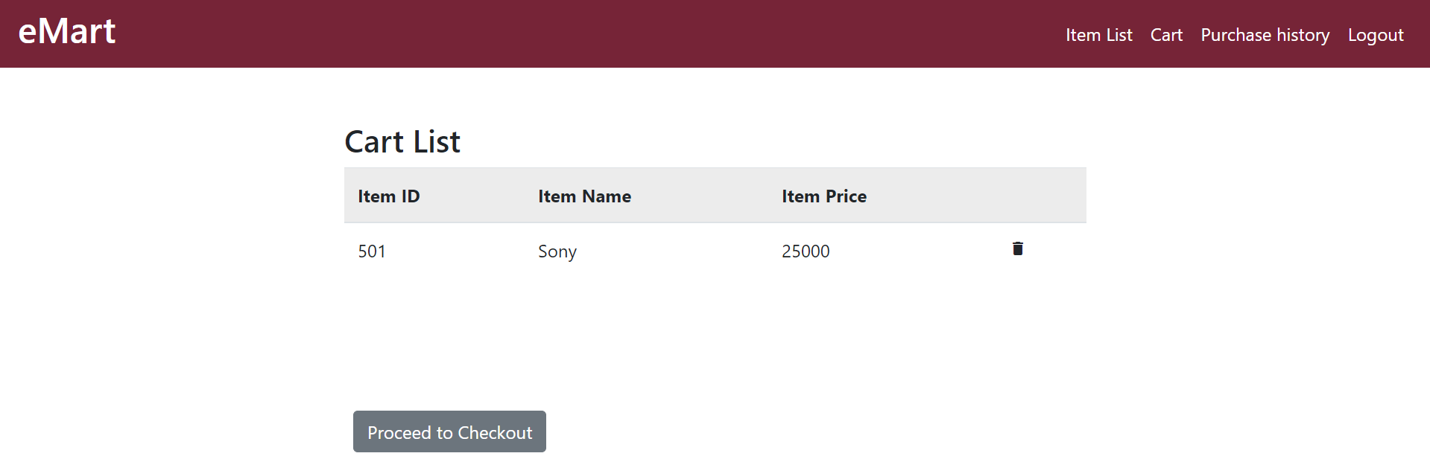

Bill Page

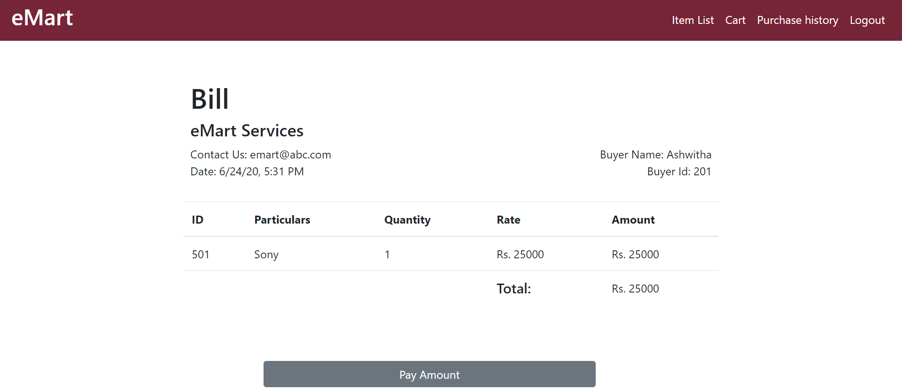

Purchase History Page

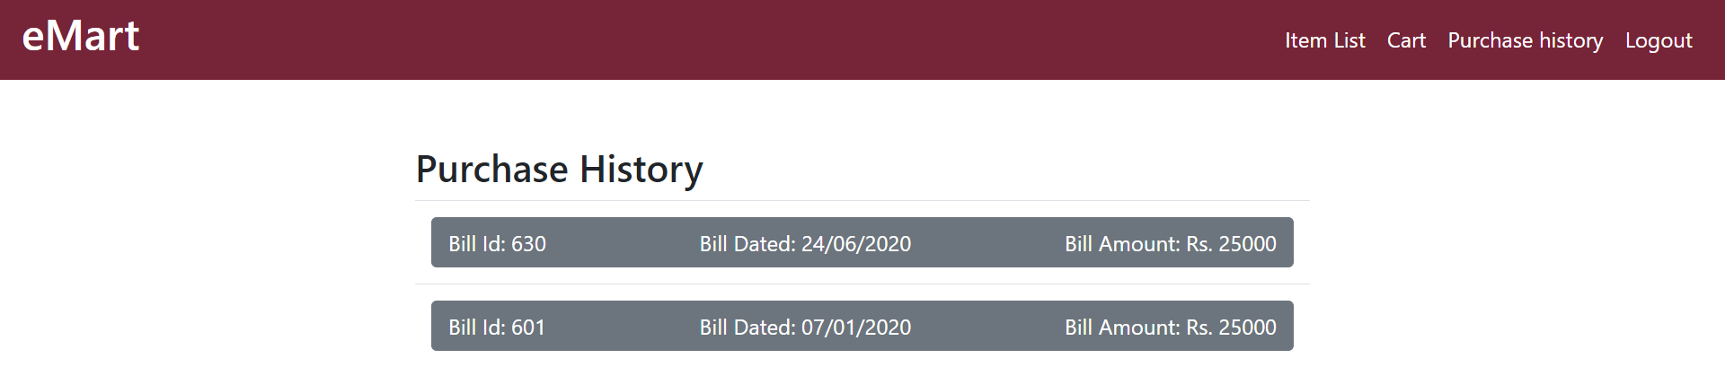

Logout Page

