**TDD using JUnit5 & Mockito**

# **Exercise 1: Setting Up JUnit**

## **Code:**

### ***Greeter.java:***

| public class Greeter {  public String sayHello(String name) {  return "Hello, " + name + "!";  } } |
| --- |

### 

### ***GreeterTest.java:***

| import org.junit.Test; import static org.junit.Assert.*;  public class GreeterTest {  @Test  public void testSayHello() {  Greeter greeter = new Greeter();  String result = greeter.sayHello("Alice");  assertEquals("Hello, Alice!", result);  } } |
| --- |

## 

## **Screenshot of Project Directories:**

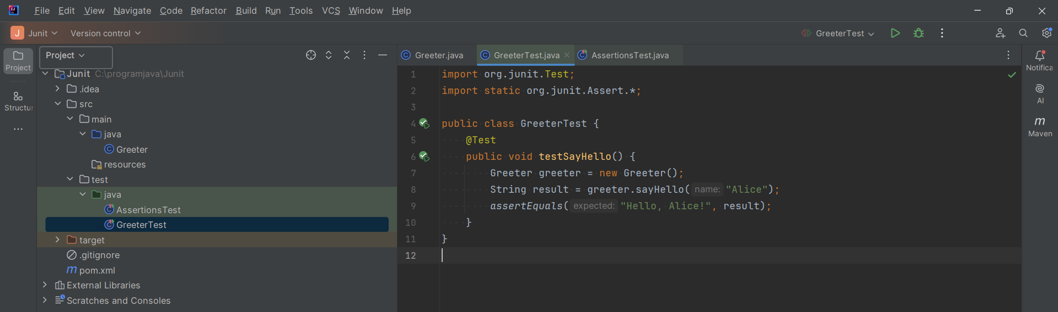

## **Output Screenshot:**

