**Spring REST using Spring Boot 3**

# **Hands-on1: Creating Microservices for account and loan**

### ***AccountController.java:***

| AccountController.java:package com.cognizant.account.controller;  import org.springframework.web.bind.annotation.*;  import java.util.Map; import java.util.HashMap;  @RestController @RequestMapping("/accounts") public class AccountController {   @GetMapping("/{number}")  public Map<String, Object> getAccountDetails(@PathVariable String number) {  Map<String, Object> response = new HashMap<>();  response.put("number", number);  response.put("type", "savings");  response.put("balance", 234343);  return response;  } } |
| --- |

### 

### ***Output:***

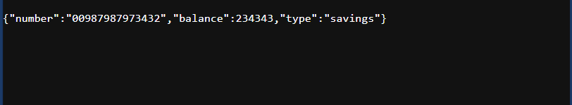

### 

### ***LoanController.java:***

| package com.cognizant.loan.controller;  import org.springframework.web.bind.annotation.*;  import java.util.Map; import java.util.HashMap;  @RestController @RequestMapping("/loans") public class LoanController {   @GetMapping("/{number}")  public Map<String, Object> getLoanDetails(@PathVariable String number) {  Map<String, Object> response = new HashMap<>();  response.put("number", number);  response.put("type", "car");  response.put("loan", 400000);  response.put("emi", 3258);  response.put("tenure", 18);  return response;  } } |
| --- |

### ***Output:***