|  |
| --- |
| **CSY 1018 - Web Development Assignment** |
| Year 1 / Term 1 |
| Submitted By:  Sahil Rajbhandari  UN ID: 16418509 |
|  |
|  |
|  |
|  |
|  |



**Acknowledgement**

I am thankful to the module leader of NAMI and the University of Northampton for providing us with the assignment that reviews our term and helps us to get more knowledge about the WEB DEVELOPMENT. During the assignment session, as it was an individual project, all the works have been done individually by me and no ideas or concepts were borrowed from colleagues.

Thank You

Sahil Rajbhandari

UN ID: 16418509

Table of Contents

Getting Started 4

Designs 4

Wireframes 4

Wireframe | HOME 4

Wireframe | ABOUT 5

Wireframe | CONTACT 6

Wireframe | CURRICULLUM VITAE 7

Wireframe | Useful Links 8

Sketches 9

Sketch | HOME 9

Sketch | ABOUT 10

Sketch | CONTACT 11

Sketch | Curriculum Vitae 12

Evidence of use of good practice 13

Response Speed 13

Performance Insights 13

OPERATION OF WEBSITE 14

Header 14

Navigation Bar 14

Links 14

Footer 15

Responsive View 15

Header 15

Navigation Bar 15

Links 16

Footer 16

Information in Webpages (in brief) 17

HOME page 17

ABOUT page 17

CONTACT page 17

CURRICULUM VITAE page 17

VALIDATION 17

Conclusion 18

References 18

# Getting Started

**The github link for my portofolio is: https://youridhasbeenhacked.github.io/csy1018-assign1/**

Creating a portfolio was a creative assignment. As I had no good concept about the layouts and designs for a web portfolio, I went through some of the websites of company and some portfolios themselves. Many of them were created using Web Languages such as JavaScript and PHP, but as we were bound to use only HTML 5 and CSS 3 properties, the webpage made is a static one. Some of the websites I went through for the creation of my webpage are:

* <http://www.tatamotors.com/>
* <https://joel.sh/about>
* <http://nami.edu.np/>

# Designs

In the designs section, a brief description of simple layouts of the webpages of my website is provided. Some designs and wireframes are made using Photo editing Software and some are hand made using pencil.

## Wireframes

Wireframe is a rough sketch about the website or a project that one is working on.

### Wireframe | HOME

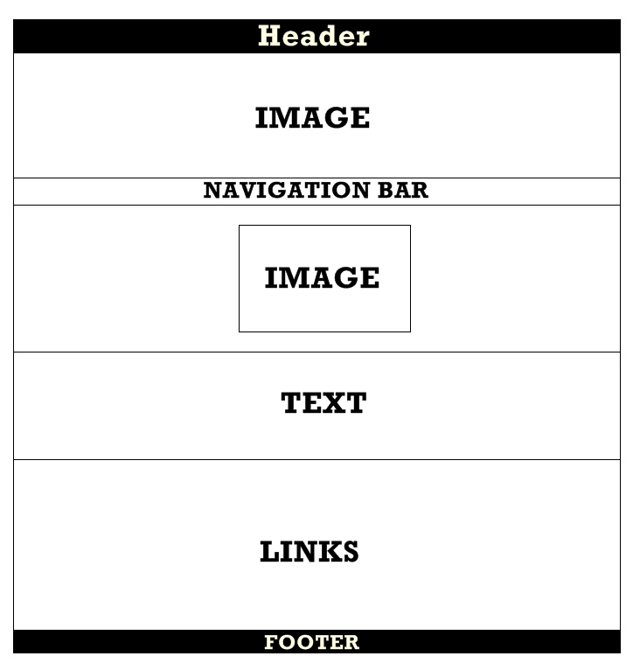

### Wireframe | ABOUT

### 



### Wireframe | CONTACT

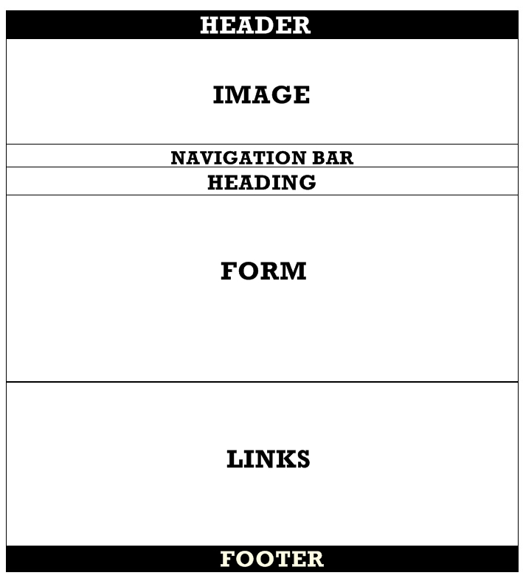

### Wireframe | CURRICULLUM VITAE

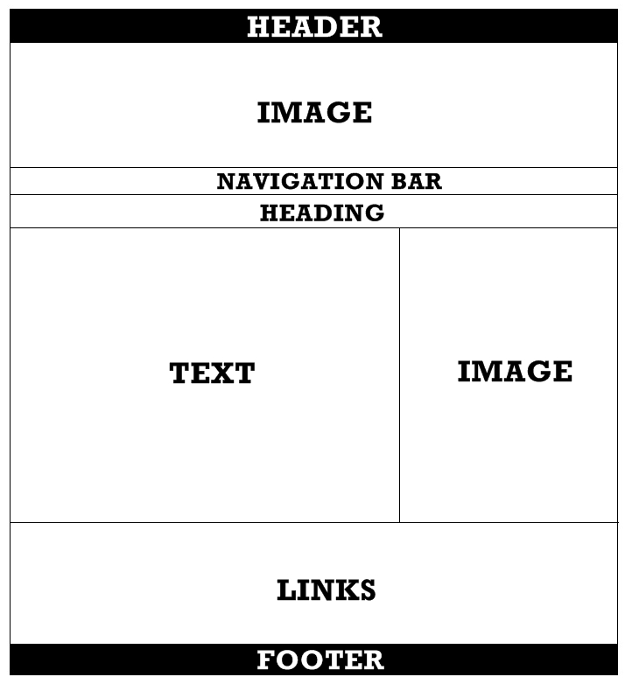

### Wireframe | Useful Links



## Sketches

Hand made (Written) sketches for different responsiveness of the website are made and shown below.

### Sketch | HOME

The HEADER, IMAGE SECTION, NAVIGATION BAR, LIST WITH LINKS and FOOTER sections will be of same layout for all four pages and operate in the same way. It will function in a similar way in any media devices. The navigation bar contains the links to other pages of the portfolio. The change is only made in Section part. For the HOME page, it will contain a div within a div to hold image and a text div for introduction.

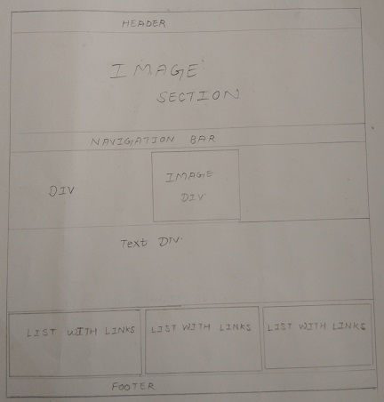 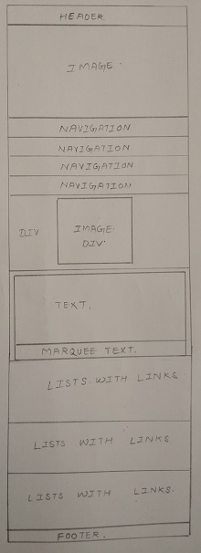

### Sketch | ABOUT

As the change is only in Section Part, it is similar to HOME page but the image and text are displayed in row and a new div is displayed in column to add text, but displayed in column in mobile view.

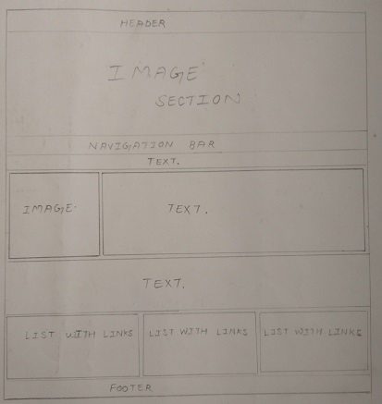 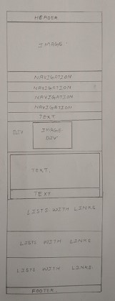

### Sketch | CONTACT

The section part contains the form to connect with the developer. Currently, the form is not dynamic. The ICONS section contains the call button and location button.

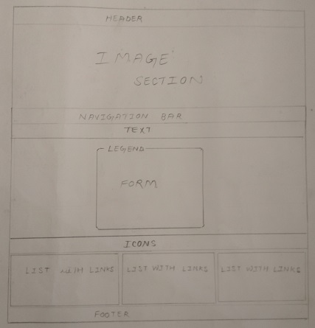 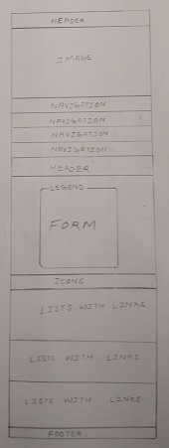

### \Sketch | Curriculum Vitae

The section part for CV contains heading to display text. A new div introduced is divided into two divs in row display - one for texts and another for image. These divs are displayed in column in mobile view.

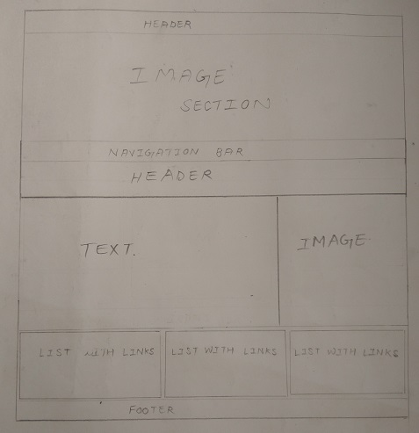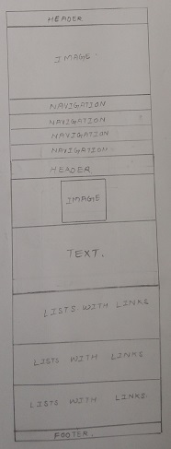

# Evidence of use of good practice

## Response Speed

The load time was checked via following link:

<https://tools.pingdom.com/>

The website loads within half a second which is of a good performance grade rating of 88. The size of the page is also 310 KB and that is a good one.

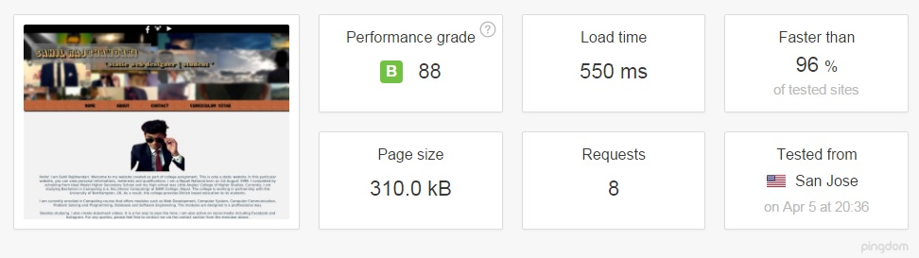

## Performance Insights

The performance overview of the website is shown below. The overall performance of the website to the users’ request is found good.

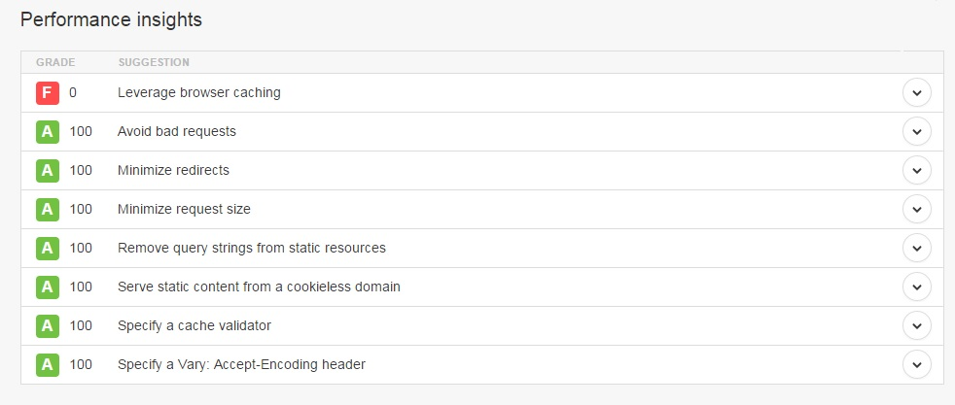

# OPERATION OF WEBSITE

In this section, I will be explaining briefly on how the website operates on user interface. The navigation between pages, forms and links will be explained. To make it easier to understand, I will be using the screenshots from my website.

## Header



This is the header part containing of three images that links to respective social media on clicking them. The first one is facebook, second one is Instagram and final one is YouTube. The contents are justified to center

## Navigation Bar



This is the navigation bar which navigates to a separate webpage of the same website on clicking over the items. The items are displayed in flex in row.

## Links

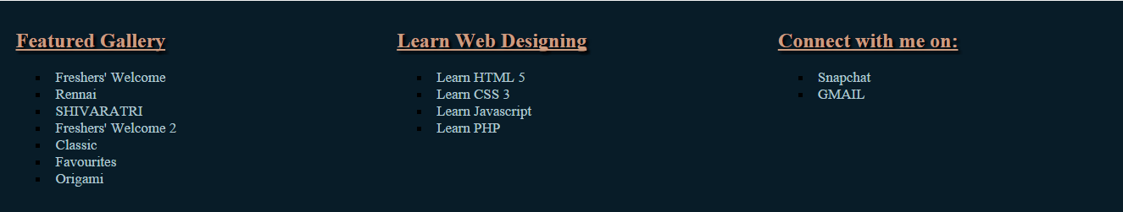

This section contains the list. The anchor tag is used but no links are provided yet. The list are in 3 different columns placed in row using flex property.

## Footer



This is the footer part that contains copyright of developer.

# Responsive View

## Header



When the browser width has max-width of 600px, the elements within the header are displayed in flex-end.

## Navigation Bar

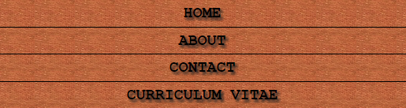

When the browser width has max-width of 600px, the elements of navigation bar are displayed in column using flex property.

### Links

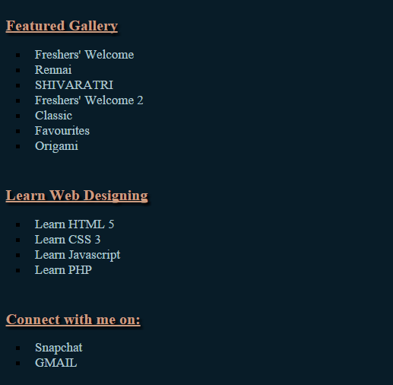

The lists within this div are displayed in column using flex property.

## Footer



The footer has no changes in 600px browser width.

# Information in Webpages (in brief)

## HOME page

The homepage of the website contains the basic welcome and introduction to the viewers of the website. The homage contains link to navigation pages through the navigation bar available. It also has links to social media as well. It contains a little part from all the other pages such as ABOUT, CONTACT and CV.

## ABOUT page

The ABOUT page mainly focuses on my personal information. The courses I am currently involved in. My professional experience in the particular field and similar courses completed in the past are also mentioned.

## CONTACT page

The CONTACT page contains a form to connect the website viewers to the developer directly. The form data needs to be filled up and submitted in order to interact with the user. No JavaScript validations are used in the form.

## CURRICULUM VITAE page

The CV page contains all the necessary information related to personal information, educational qualifications, professional experience, skills and relevant coursework and field activities. It also contains the image of developer (me).

## VALIDATION

After the validation was done, no errors were found in HTML or CSS codes but warnings were detected as shown below:

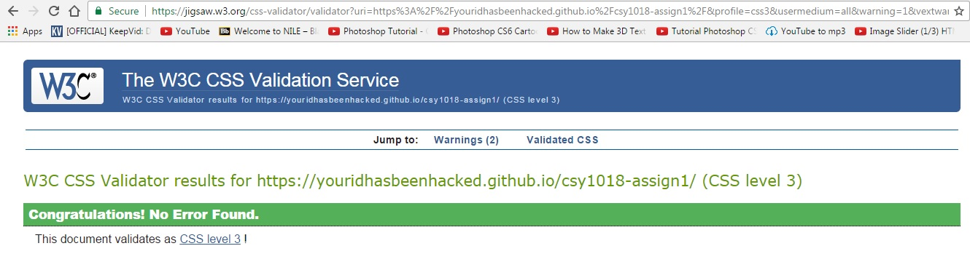

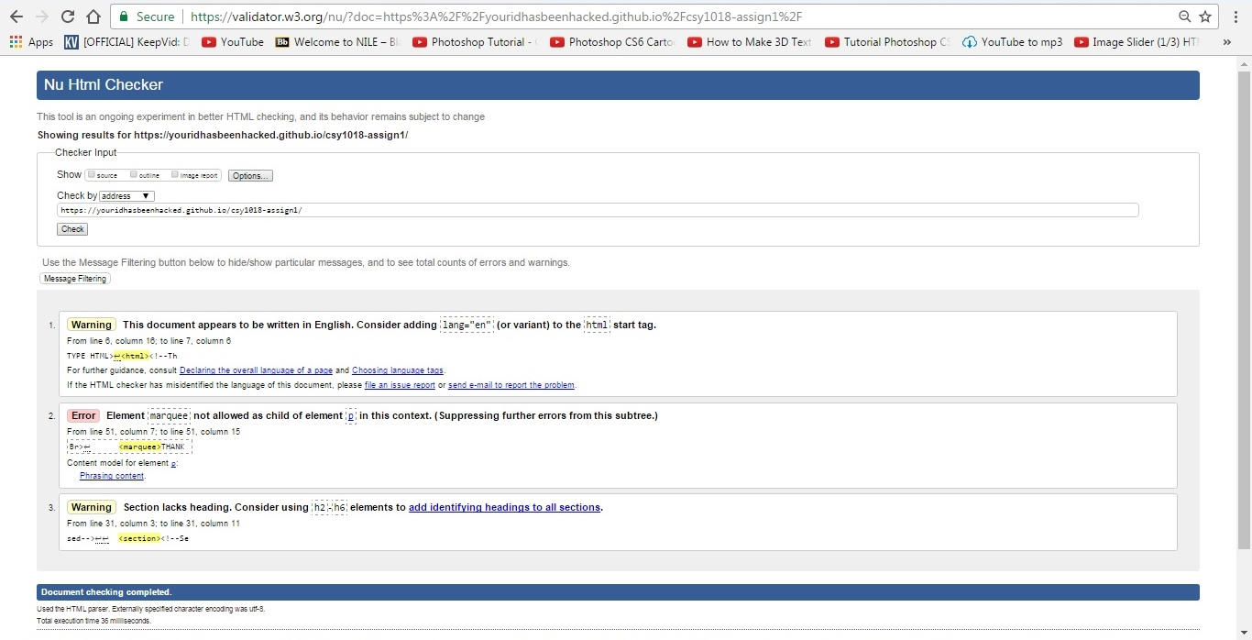

# Conclusion

Concluding the report, it was an assignment that was a good way to further enhance the students’ knowledge on web designing. We were encouraged to use all the properties taught till the end of Term 1 and add additional features to the website using assistance from W3schools.org.

# References

## Alfredo (2015), *Black White Social Media Icons FREE!* [*image*]. Available from: https://www.dealbuddy.com/free-social-media-icons/. [Accessed Date: March 16, 2017]

## Flaticon (2017), Youtube symbol Free Icon [image]. Available from: http://www.freepik.com/free-icon/youtube-symbol_717334.htm#term=logo&page=1&position=34. [Accessed Date: March 16, 2017]