|  |  |  |
| --- | --- | --- |
| Лабораторная работа №2.  Логическое проектирование базы данных | Ф.И.О. | Евдокимов Дмитрий Денисович |
| Группа | ИВТ-261 |
| Преподаватель | Аль-Мерри Гаис Мохаммед Салех |
| Дата сдачи | 28.02.2025 |

**ER-Диаграмма:**

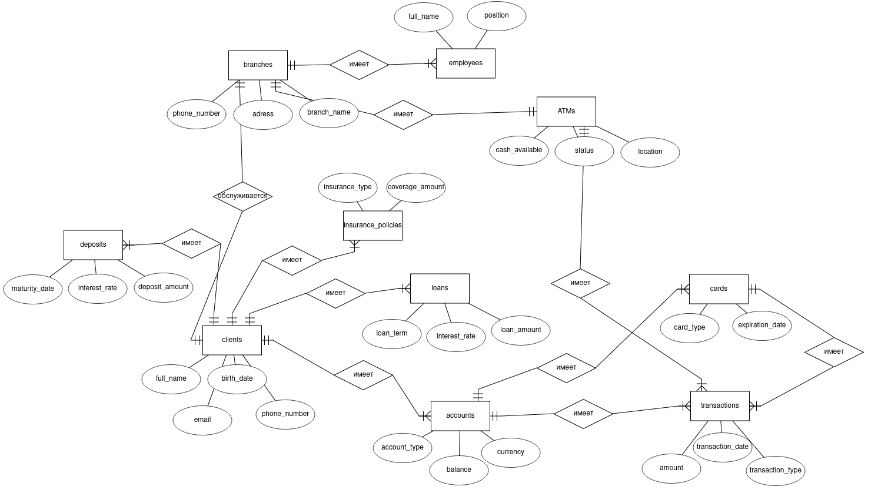

**Реляционная схема БД:**

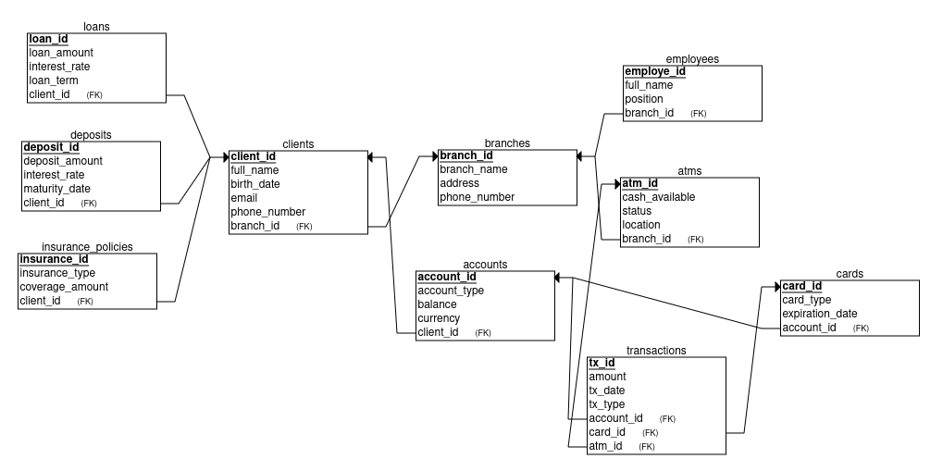

**Примеры сущностей:**

|  |  |  |  |
| --- | --- | --- | --- |
| **branches** | | | |
| branch_id | branch_name | address | phone_number |
| 0 | СберБанк | ул. Новороссийская, 14, корп. Б, Волгоград | 8 (800) 555-55-50 |
| 1 | СберБанк | ул. Гоголя, 4, Волгоград | 8 (800) 555-55-51 |

|  |  |  |  |
| --- | --- | --- | --- |
| **employees** | | | |
| employe_id | full_name | position | branch_id (fk) |
| 0 | Арефьев Сергей Алексеевич | Оператор Call-центра | 0 |
| 1 | Крупенко Павел Алексеевич | Менеджер организации продаж | 1 |

|  |  |  |  |
| --- | --- | --- | --- |
| **atms** | | | |
| atm_id (pk) | cash_available | status | branch_id (fk) |
| 0 | 500000,00 | работает | 0 |
| 1 | 700000,00 | работает | 1 |

|  |  |  |  |  |  |
| --- | --- | --- | --- | --- | --- |
| **clients** | | | | | |
| client_id (pk) | full_name | birth_date | email | phone_number | branch_id (fk) |
| 0 | Евдокимов Дмитрий Денисович | 01.10.2005 | rubykxx@gmail.com | +79023781950 | 0 |
| 1 | Дунаев Степан Алексеевич | 07.01.2006 | sdunaev677@gmail.com | +79956843727 | 1 |

|  |  |  |  |  |
| --- | --- | --- | --- | --- |
| **accounts** | | | | |
| account_id (pk) | account_type | balance | currency | client_id (fk) |
| 0 | debit | 10000,00 | USD | 0 |
| 1 | credit | 2122,34 | RUB | 1 |

|  |  |  |  |
| --- | --- | --- | --- |
| **cards** | | | |
| card_id (pk) | card_type | expiration_date | account_id (fk) |
| 0 | debit | 02.05.2027 | 0 |
| 1 | credit | 14.02.2028 | 1 |

|  |  |  |  |  |  |  |
| --- | --- | --- | --- | --- | --- | --- |
| **transactions** | | | | | | |
| tx_id (pk) | amount | tx_date | tx_type | account_id (fk) | card_id | atm_id |
| 0 | 3000,00 | 27.02.2025 | CASH_OUT | 0 | 0 | 0 |
| 1 | 1000,00 | 22.02.2025 | CASH_OUT | 1 | 1 | 1 |

|  |  |  |  |  |
| --- | --- | --- | --- | --- |
| **loans** | | | | |
| loan_id (pk) | loan_amount | interest_rate | loan_term | client_id (fk) |
| 0 | 333,00 | 5,0 | Пониженный процент | 0 |
| 1 | 1000,00 | 7,0 | Первый месяц без комиссии | 1 |

|  |  |  |  |  |
| --- | --- | --- | --- | --- |
| **deposits** | | | | |
| deposit_id (pk) | deposit_amount | interest_rate | maturity_date | client_id (fk) |
| 0 | 333,00 | 5,0 | 02.05.2027 | 0 |
| 1 | 1000,00 | 7,0 | 14.02.2028 | 1 |

|  |  |  |  |
| --- | --- | --- | --- |
| **insurance_policies** | | | |
| insurance_id (pk) | insurance_type | coverage_amount | account_id (fk) |
| 0 | car | 10000,00 | 0 |
| 1 | house | 20000,00 | 1 |