CURRICULUM VITAE

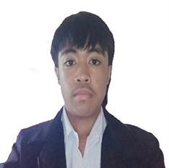
PADILLA, ADRIAN FLORES
Address: Blk 24. Lot. 12 Bay Garden Homes Brgy. Sto.
Domingo Bay, Laguna, 4033
Contact number: 09918413549
Email: adrianpadilla8296@gmail.com

A. Educational Background
College | 2024 – Present: | LSPU Los Baños  56PJ+PP9, Los Baños, 4030  Laguna Bachelor of Science in Information  Technology (BS IT)
Secondary | 2022 – 2024:  2018 – 2022: | TRACE College  El Danda St. Brgy. Batong Malake Los  Baños, Laguna  Maranatha Christian Academy  Brgy. Calo Bay, Laguna
Elementary  B. Skills | 2012 – 2018: | Gateway Learning Center Corp.  Kabaritan Brgy. Sto. Domingo Bay, Laguna
- Computer Literate
- Critical Thinking
- Collaboration
- Multi-tasking
C. Trainings/Workshops/Seminars Attended
November 9, 2018 Syensaya 2018
University of the Philippines Los Baños,
Laguna

April 6, 2024 | CODEX WORKSHOP 2024  Mapua University Pulo-Diezmo Road, Barangay Pulo / Diezmo, Cabuyao City, 4025 Laguna, Philippines
April, 2024 | Work Immersion 2024  Department of Agriculture Bay Municipality  Bay, Laguna

