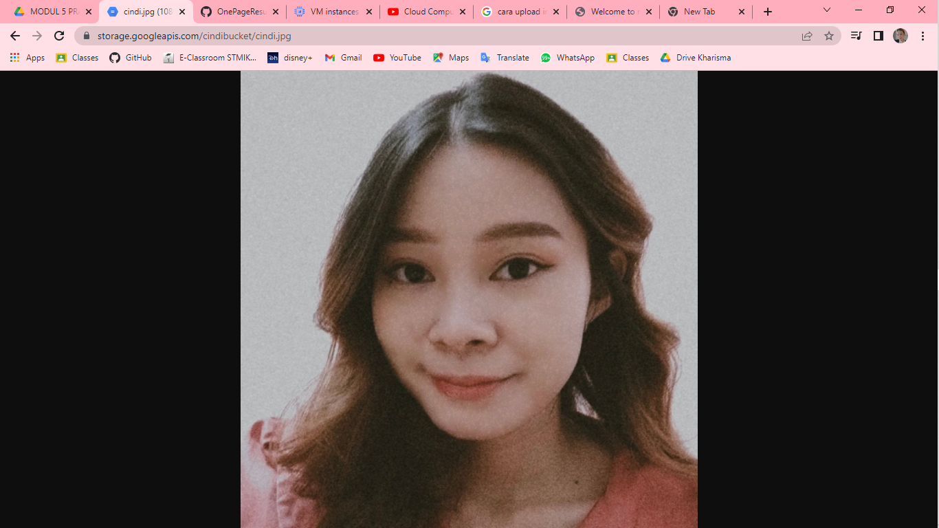
Link bucket: https://storage.googleapis.com/cindibucket/cindi.jpg
Berikut hasil setelah diedit.


